Project | IEEE 802.21.1 Media-Independent Service and Use Cases  <http://www.ieee802.org/21/>
Title | Use Case and Requirements on Media Independent Service for D2D Communications
DCN | 21-14-0039-00-SAUC
Date Submitted | March 16th, 2014
Source(s) | Hyunho Park (ETRI),  Hyeong-Ho Lee (ETRI)
Re: | IEEE 802.21 Session #61 in Beijing
Abstract | This document describes detailed use case and requirements on media independent service for D2D communications.
Purpose | To be part of 802.21.1 technical requirements document.
Notice | This document has been prepared to assist the IEEE 802.21 Working Group. It is offered as a basis for discussion and is not binding on the contributing individual(s) or organization(s). The material in this document is subject to change in form and content after further study. The contributor(s) reserve(s) the right to add, amend or withdraw material contained herein.
Release | The contributor grants a free, irrevocable license to the IEEE to incorporate material contained in this contribution, and any modifications thereof, in the creation of an IEEE Standards publication; to copyright in the IEEE’s name any IEEE Standards publication even though it may include portions of this contribution; and at the IEEE’s sole discretion to permit others to reproduce in whole or in part the resulting IEEE Standards publication. The contributor also acknowledges and accepts that IEEE 802.21 may make this contribution public.
Patent Policy | The contributor is familiar with IEEE patent policy, as stated in Section 6 of the IEEE-SA Standards Board bylaws <http://standards.ieee.org/guides/bylaws/sect6-7.html#6> and in Understanding Patent Issues During IEEE Standards Development http://standards.ieee.org/board/pat/faq.pdf

Contents List

1. General Description 3

2. Use Case for Network Assisted D2D Communication 3
2.1 Description 3
2.2 Actors 4
2.3 Pre-conditions 4
2.4 Triggers 5
2.5 Service Flows 5
2.6 Post-conditions 6
2.7 High Level Illustration 6
2.8 Signal Flows and Primitives/Messages 7
2.8.1 Peer discovery by using information server 7
2.8.2 Informing list of D2D communication technologies used by MN 8
2.8.3 Changing connection of D2D communication 9
2.9 Requirements 10

3. Use Case for D2D Communication without Network Assistance 12
3.1 Description 12
3.2 Actors 12
3.3 Pre-conditions 12
3.4 Triggers 12
3.5 Service Flows 13
3.6 Post-conditions 13
3.7 High Level Illustration 13
3.8 Signal Flows and Primitives/Messages 14
3.8.1 Changing connection of D2D communication 14
3.9 Requirements 15

- General Description

D2D (Device-to-Device) communication is direct data communication between MNs (Mobile Nodes) and attracts attentions in perspective of network resource management and communication service based on proximity. Applications of D2D communications can be social networking, advertisement, public safety, data sharing, and data offload.

For D2D communication, media independent service framework of IEEE 802.21 WG (Working Group) is able to help an MN to search for and connect to its peer. Medea independent service framework of IEEE 802.21 WG is common platform to support interworking between networks using IEEE802 and non-IEEE802 technologies, so that media independent service framework can be easily extended to a platform for D2D communications such as Wi-Fi Direct, 3GPP ProSe (Proximity Service), and IEEE 802.15.8 PAC (Peer Aware Communications).

The media independent service framework can apply to D2D communication with or without assistance of network entities such as a base station or an access point. For D2D communication with network assistance, network entities with media independent service framework provides configuration information for an MN to discover its peer and controls D2D connections of MNs. For D2D communication without network assistance, MNs with media independent service framework can find and select the most appropriate D2D technology that can offer the best QoS (Quality of Service) or QoE (Quality of Experience).

- Use Case for Network Assisted D2D Communication
  - Description

Communication service providers and network operators have interest in D2D communication because D2D communication can provide communication between MNs in close proximity with a small amount of network resource. By using D2D communication, MNs in close proximity can share data such as video clips or local information. Service providers of D2D communication can distribute local advertisement information or emergency information such as location of emergency shelters. Network operators can save network resources by offloading data to D2D communication. In addition, MNs can maintain privacy even though while performing social networking. For making a connection for D2D communication, it is difficult for an MN to discover its peer that is able to offer communication services (e.g., data sharing, local advertisement and emergency information) that the MN wants to receive.

Communication service providers and network operators will help an MN to search for and connect to its peer by assistance of network infrastructures. The D2D communication with network assistance can be called as NADC (Network-Assisted D2D Communication).

Media independent service framework, which is control plane of infrastructure network, can be the control plane for NADC. Media independent service framework provides network configuration information for MN and controls MN’s connection to access network by using PoS (Point of Service) and information server which are defined in IEEE 802.21-2008 standard as network-side instance of media independent service framework and server that provides network configuration information respectively. Thus, media independent service framework can provide configuration information of MN’s peer for MN and controls MN’s D2D connection with minor modification of information server and PoS.
  - Actors
- Jane: User of an MN that supports D2D communication.
- Smith: User of a candidate peer of Jane’s MN
- NADC provider: Communication service provider or network operator that supports NADC
  - Pre-conditions
- Jane may want D2D communications to share data or local information or receive emergency information if there is a peer node of Jane’s MN.
- Information server can offer configuration information to search for a peer node of Jane’s MN by using media independent service messages.
- Jane’s MN may communicate with information server.
- PoS may communicate with information server and other PoS by using media independent service messages.
- PoS may control MN’s connection to access networks or peer node of MNs by media independent service messages.
- NADC provider may want to serve D2D communication to Jane.
- NADC provider may operate its own PoS.
- Smith is in close proximity to Jane, and Smith’s MN is able to provide communication service that Jane wants to be served.
- Jane and Smith may not know each other, and thus Jane’s MN may not find Smith’s MN without network assistance.
  - Triggers

Jane’s MN or NADC provider is able to trigger D2D communication.
- Jane’s MN may request configuration information about a peer node (Smith’s MN) of Jane’s MN to information server.
- PoS of NADC provider may find a peer node (Smith’s MN) of Jane’s MN by using information server and give configuration information of Jane’s MN to make a connection between Jane’s MN and its peer node.
  - Service Flows

For NADC, both MN and NADC provider is able to initiate D2D communication. Therefore, service flows for NADC needs to be classified into MN-initiated D2D communication and NADC provider-initiated D2D communication.
- Service flows of MN-initiated D2D communication
- Jane’s MN requests information to connect with its peer to information server.
- Information server responds to Jane’s MN with configuration information to connect with a candidate peer (e.g., Smith’s MN) of Jane’s MN. The configuration information may be technology of D2D communication such as Wi-Fi Direct and PAC, identifier (e.g., MAC address and IP address) of the candidate peer, and frequency information that its candidate peer can use.
- Based on configuration information from information server, Jane’s MN searches for and connects to its peer node.
- Service flows of NADC provider-initiated D2D communication
- PoS of NADC provider requests information for a peer node of Jane’s MN to information server.
- Information server responds to PoS of NADC provider with configuration information to connect with a candidate peer (e.g., Smith’s MN) of Jane’s MN. The configuration information may be technology of D2D communication such as Wi-Fi Direct and PAC, identifier (e.g., MAC address and IP address) of the candidate peer, and frequency information that its candidate peer can use.
- The PoS of NADC provider sends the configuration information to Jane’s MN.
- Jane’s MN decide whether to use D2D communication. If Jane’s MN decide to use D2D communication, Jane’s MN tries to search for and connect to its peer node (Smith’s MN) by using the configuration information from PoS of NADC provider.
  - Post-conditions

Jane’s MN and Smith’s MN make a connection and transfer data directly.
  - High Level Illustration

Figure 1 shows control signaling for NADC by using media independent service messages. Information server provides configuration information for an MN’s peer. The configuration information of information server can be requested by MNs and PoS. PoS controls MNs’ connection of D2D communication by requesting MN to select D2D communication and assigning radio resource for D2D communication. NADC provider can operate its own PoS, and PoS of NADC provider can communicate with other PoSes.

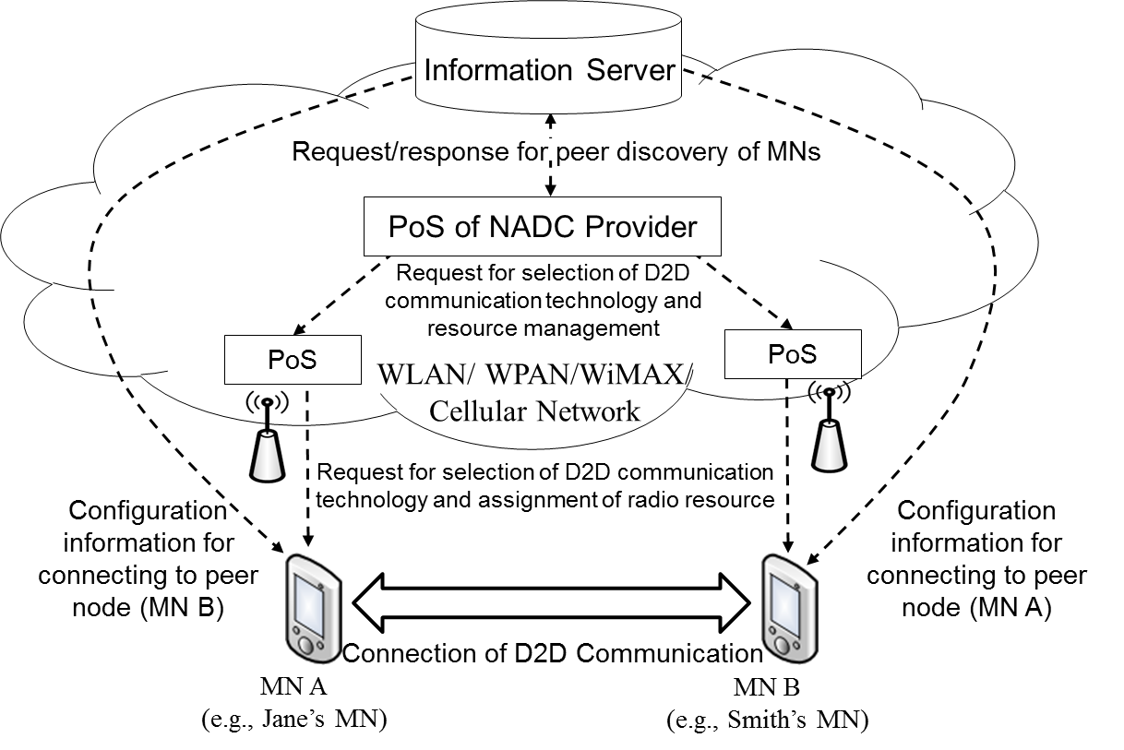

Fig. 1. Control signaling of NADC

  - Signal Flows and Primitives/Messages
    - Peer discovery by using information server
- Description

Information server provides configuration information that can help MN discover its peer.
- Signal flows

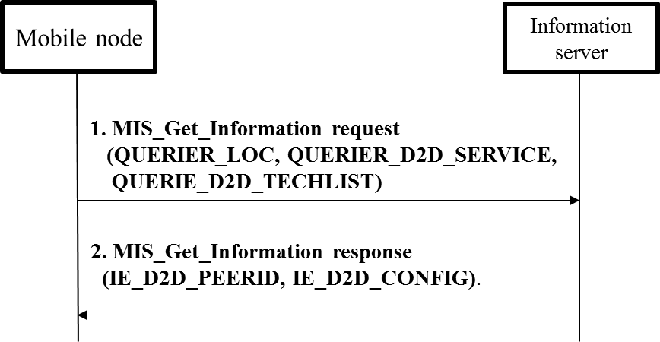

* MIH_Get_Information, which is the same as MIS_Get_Information in this contribution, and QUERIER_LOC are defined in IEEE 802.21-2008 standard.
- MN informs of its location (QUERIER_LOC), communication service (QUERIER_D2D_SERVICE), and available D2D service communication (QUERIE_D2D_TECHLIST) and requests proximity service communication.
- Information server responds with the peer’s identity (IE_D2D_PEERID) and configuration information (IE_D2D_CONFIG) to discover the peer.
- New parameters
Name | Description
QUERIER_D2D_SERVICE | Communication services (e.g., local information service, file transmission, and voice call) that MN wants to be served
QUERIER_D2D_TECHLIST | Available proximity service communication list (e.g., LTE D2D, Wi-Fi Direct, and PAC) of the MN that wants proximity service
IE_D2D_PEERID | Peer’s identity (e.g., MAC address, IP address, and IMSI (International Mobile Subscriber Identity))
IE_D2D_CONFIG | Configuration information (e.g., frequency band) to help the MN configure its peer
    - Informing list of D2D communication technologies used by MN
- Description

Information server or PoS collects list of D2D communication technologies used by MN.
- Signal flows

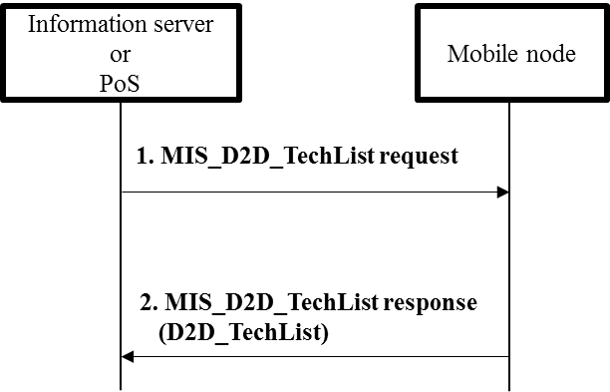
- Information server or PoS requests list of MN’s available D2D communication technologies.
- MN responds with list (D2D_TechList) of MN’s available D2D communication technologies (e.g., LTE D2D, PAC, and Wi-Fi Direct).
- New primitive/message
Primitive/Message | Description
MIS_D2D_TechList | This primitive/message is used for information server or PoS to know list of D2D communication technologies used by an MN
- New parameter
Parameter | Description
D2D_TechList | List of D2D communication technologies used by an MN
    - Changing connection of D2D communication
- Description

Information server or PoS changes communication technology of MN’s D2D connection. For example, information server or PoS changes Wi-Fi Direct of MN’s D2D connection into IEEE 802.15.8 PAC.
- Signal flow

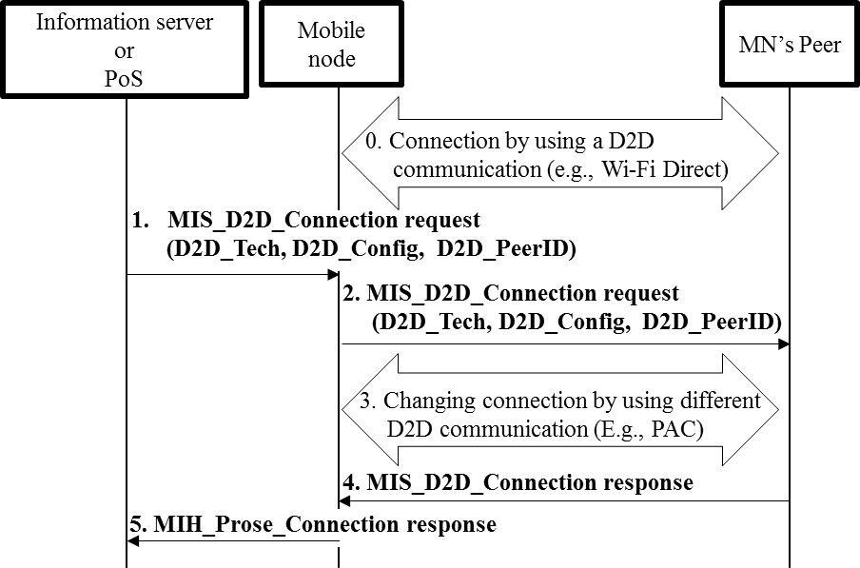
- Connection between MN and its peer by using D2D communication (e.g., Wi-Fi Direct): Out of Scope
- Information server or PoS requests MN to change its D2D communication technology into other D2D communication technology (e.g., PAC) by sending MIS_D2D_Connection request message.
- MN requests its peer to change its D2D communication into other D2D communication technology (e.g., PAC) by sending MIS_D2D_Connection request message.
- Changing D2D connection between MN and its peer by using other D2D communication (E.g., PAC): Out of Scope
- MN’s peer responds to MN with connection result (success or fail) by sending MIS_D2D_Connection response message.
- MN responds to information server or PoS with connection result (success or fail) by sending MIS_D2D_Connection response message.
- New primitive/message
Primitive/Message | Description
MIS_D2D_Connection | This primitive/message is used for an MN and its peer to make a connection of D2D communication technology.
- New parameters
Parameter | Description
D2D_Tech | Information of proximity service communication technologies that MN or its peer can use
D2D_Config | Configuration information (e.g., frequency band) to help the MN configure its peer
D2D_PeerID | Peer’s identity (e.g., MAC address, IP address, and IMSI)
  - Requirements

[REQ1] MN’s peer can provide communication service that the MN wants to receive.

[REQ2] MN and its peer should communicate by using the same D2D communication technology.

[REQ3] Information server should know proximity between mobile nodes.

[REQ4] Information server may derive proximity between MNs by using MNs’ location information (e.g., GPS information).

[REQ5] Information server should know communication services (e.g., local information service, file transmission, and voice call) that MNs can provide.

[REQ6] Information server should know D2D communication technologies that MNs can use.

[REQ7] PoS controls MNs’ D2D connection and control MNs’ radio resource for D2D communication.
- Use Case for D2D Communication without Network Assistance

  - Description

Various technologies for D2D communication have been developed recently. Smart devices such as smartphones and tablet PCs already implement Wi-Fi Direct. Future smart devices may implement developing technologies of D2D communication technologies such as 3GPP ProSe and PAC. For future smart devices, it is important for the smart devices to select the most appropriate technology of D2D communication that can support the best QoS or QoE.

By using D2D communication, smart MNs in close proximity can directly share data such as video clips or local information without network assistance. D2D communication can serve local advertisement information or emergency information such as location of emergency shelters.

Media independent service framework will support MNs to select appropriate technology of D2D communication without any network assistance. Existing media independent service framework can enable MNs to monitor link status, which is status (e.g., signal strength and data rate) of physical layer and data link layer by using MIES (Media Independent Event Service) and can select the most appropriate access network by using MICS (Media Independent Command Service) even without network assistance. Therefore, if MIES and MICS are extended for supporting D2D communication, it will be possible for MNs to monitor link status of D2D communications and select the most appropriate technology of D2D communication without network assistance.
  - Actors
- Jane: User of an MN that supports D2D communication.
- Smith: User of a peer node of Jane’s MN
  - Pre-conditions
- Jane and Smith communicate each other by using D2D communication.
- Jane’s MN and Smith’s MN implement multiple technologies of D2D communications.
- Jane’s MN may switch between technologies of D2D communications.
  - Triggers

When link status of D2D communication between Jane’s MN and Smith’s MN is deteriorated, the MNs may change technology of D2D communication.
  - Service Flows
- Jane’s MN and Smith’s MN transfers data through D2D communication “P” (e.g., Wi-Fi Direct).
- Jane’s MN detects that link status (e.g., signal strength and data rate) of D2D communication “P” is getting worse due to some reason such as radio interference.
- Jane’s MN discovers the most appropriate D2D communication “Q” (e.g., PAC) that is different from D2D communication “P” by monitoring link status of “Q.”
- Jane’s MN requests Smith’s MN to change D2D communication “P” into D2D communication “Q.”
- Jane’s MN and Smith’s MN make a connection by using D2D communication “Q.”
- Jane’s MN and Smith’s MN can transfer data through D2D communication “Q.”
  - Post-conditions

Jane’s MN and Smith’s MN can switch their technology of D2D communication.
  - High Level Illustration

Figure 2 shows control signaling for D2D communication without network assistance. The service flows are explained specifically in “3.5 Service Flows.”

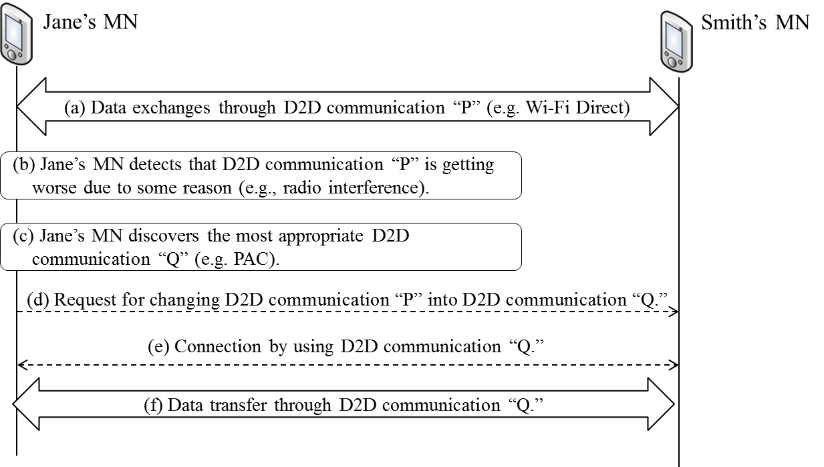

Fig. 2. Control signaling of D2D communication without network assistance

  - Signal Flows and Primitives/Messages
    - Changing connection of D2D communication
- Description

MN changes communication technology of its D2D connection depending on its link status. For example, MN changes Wi-Fi Direct of MN’s D2D connection into IEEE 802.15.8 PAC depending on its link status.
- Signal flows

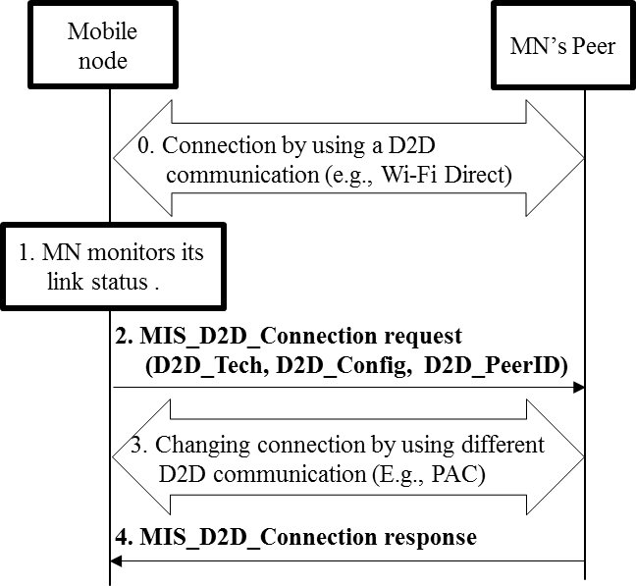
- Connection between MN and its peer by using D2D communication (e.g., Wi-Fi Direct): Out of Scope
- MN monitors its link status of current D2D communication technology and determines to change D2D communication technology into other D2D communication technology.
- MN requests its peer to change its D2D communication into different D2D communication technology (e.g., PAC) by sending MIS_D2D_Connection request message.
- Changing connection between MN and its peer by using other proximity service communication (E.g., PAC): Out of Scope
- MN’s peer responds to MN with connection result (success or fail) by sending MIS_D2D_Connection response message.
- New primitive/message

MIS_D2D_Connection primitive/message is explained in “2.8.3 Changing connection of D2D communication.”
- New parameters

D2D_Tech, D2D_Config, and D2D_PeerID are explained in “2.8.3 Changing connection of D2D communication.”
  - Requirements

[REQ1] MN’s peer can provide communication service that the MN wants to be served.

[REQ2] MN and its peer should communicate by using the same D2D service communication technology.

[REQ3] MN can monitors link status of D2D communication.

[REQ4] MN and its peer can change their D2D communication technology without any network assistance.

