Project | IEEE 802.21.1 Media-Independent Service and Use Cases  <http://www.ieee802.org/21/>
Title | Use Case, Architecture and Requirements on Media-Independent Interworking Service
DCN | 21-14-0020-00-MISU
Date Submitted | January 22, 2014
Source(s) | Yoshihiro Ohba (Toshiba), Ruben Salazar (Landis+Gyr), Randy Turner (Landis+Gyr), Subir Das (ACS)
Re: | IEEE 802.21 Session #60 in Los Angeles
Abstract | This document describes detailed use case, architecture and requirements on media-independent interworking service.
Purpose | To be part of 802.21.1 technical requirements document.
Notice | This document has been prepared to assist the IEEE 802.21 Working Group. It is offered as a basis for discussion and is not binding on the contributing individual(s) or organization(s). The material in this document is subject to change in form and content after further study. The contributor(s) reserve(s) the right to add, amend or withdraw material contained herein.
Release | The contributor grants a free, irrevocable license to the IEEE to incorporate material contained in this contribution, and any modifications thereof, in the creation of an IEEE Standards publication; to copyright in the IEEE’s name any IEEE Standards publication even though it may include portions of this contribution; and at the IEEE’s sole discretion to permit others to reproduce in whole or in part the resulting IEEE Standards publication. The contributor also acknowledges and accepts that IEEE 802.21 may make this contribution public.
Patent Policy | The contributor is familiar with IEEE patent policy, as stated in Section 6 of the IEEE-SA Standards Board bylaws <http://standards.ieee.org/guides/bylaws/sect6-7.html#6> and in Understanding Patent Issues During IEEE Standards Development http://standards.ieee.org/board/pat/faq.pdf

Definitions

Serving Network (SN): An access network to which Interworking Service is provided

Interworking Network (IN): An access network existing in the vicinity of Serving Network to provide Interworking Service to the Serving Network

End Device (ED): A node that is physically connected to Serving Network

Interworking Relay (IWR): A node that is physically connected to both Serving Network and Interworking Network to exchange Serving Network MAC frames with Interworking Gateway using a Virtual Link. More than one Interworking Relay may be connected to the Serving Network

Interworking Gateway (IWG): A node that is physically connected to Interworking Network to exchange Serving Network MAC frames with Interworking Relay through a Virtual Link. Interworking Gateway may also be connected to an external network

Use Case
It is becoming common that multiple different access technologies are available in the vicinity of end-devices. For example, Figure 1 shows an Advanced Metering Infrastructure network consisting of three types of media, i.e., IEEE 802.15.4, PLC (Power Line Communication) and 3G/LTE (Long Term Evolution). However, each end-device may support only one access technology especially if it is a constrained device. If the reachability to the core network from an end-device via its access technology is lost, then communication to the end-device will totally be lost. Expecting each constrained end-device to have multiple interfaces is not a viable solution. On the other hand, increasing gateway redundancy is also expensive.
In order to increase network availability for constrained end-devices with a minimum cost, there is a strong demand for an interworking service by which heterogeneous access networks with different types of media are interconnected in a tightly manner.
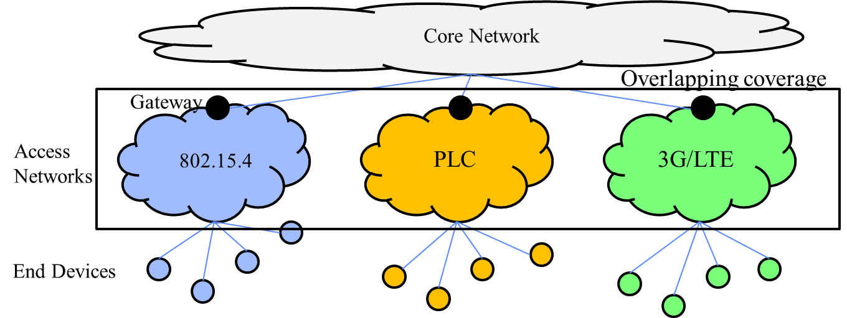
Figure 1 Interworking Use Case – AMI Network

Architecture and Requirements

Architecture

Reference Model
The reference model for Interworking Service is illustrated in Figure 2
In the reference model, a SN may have multiple EDs. There are at least one IWR in the SN. There are at least one IWG in an IN. A SN is typically a wireless mesh network such as an IEEE 802.15.4 Wireless PAN (WPAN) where there can be multiple hops between an ED and an IWR or it can be a single-hop wireless network such as IEEE 802.11 Wireless LAN (WLAN). In a SN, there may be a gateway (not shown in Figure 1) such as an IEEE 802.15.4 PAN coordinator connected to an external network, in addition to an IWR. A Virtual Link is dynamically established between an IWR and an IWG over an IN where the IN can be of any type of access network including 3G, LTE, PLC, WLAN and WPAN. MAC frames including data frames and management frames of an SN is transferred over the Virtual Link. The existence of the Virtual Link is transparent to the EDs, i.e., the EDs consider that the IWG is in the SN.

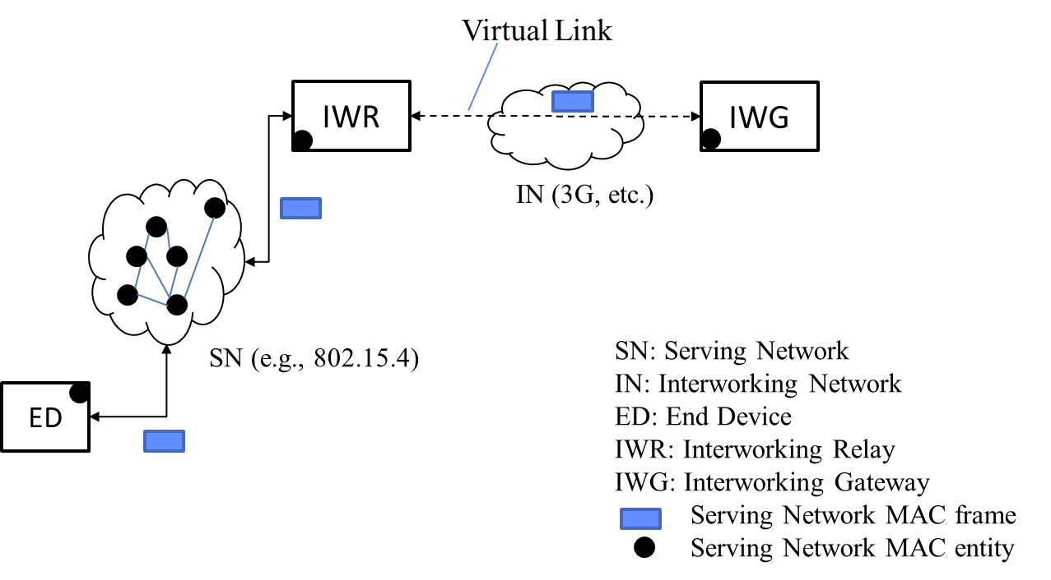
Figure 2 Interworking Service Reference Model

Consideration on 802.1 Bridging Architecture
In this section, similarity and difference between the Interworking Service model and IEEE 802.1 bridging model are discussed.
Interworking Service model is similar to IEEE 802.1ad provider bridging model in that MAC frames of one media are carried over another media.
On the other hand, Interworking Service model is distinct from IEEE 802.1ad provider bridging model in that an IN may not be a single VLAN. An IN may consist of a sequence of VLANs where each VLAN may not employ the same media type. An IN may consist of multiple IP subnets.
Therefore, a different type of solution from IEEE 802.1 bridge model is required to manage the virtual link of the Interworking Service reference model.

Protocol Stack
An example protocol stack in which SN employs a medium on which 6LoWPAN is used is shown in Figure 3
A Virtual Link corresponds to the Interworking Layer over which the SN protocol stack except for PHY layer overlays. The Interworking Layer sits on top of the IN protocol stack.

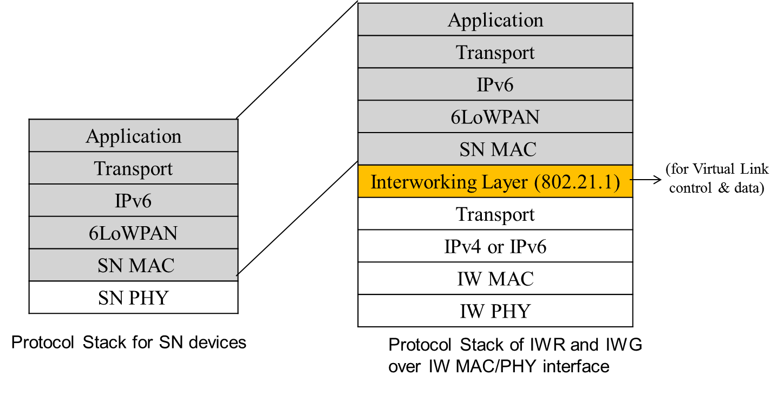
Figure 3 Example Protocol Stack for Interworking Service

Call Flows
Example call flows for IWR-initiated and IWG-initiated virtual link setup are shown in Figure 4 and Figure 5, respectively. Example call flows for IWR-initiated and IWG-initiated virtual link teardown are shown in Figure 6 and Figure 7. An example call flow for transmitting data over a virtual link is shown in Figure 8. Attributes carried in the messages exchanged between IWR and IWG are listed in Table 1.

(More explanation to be added here.)

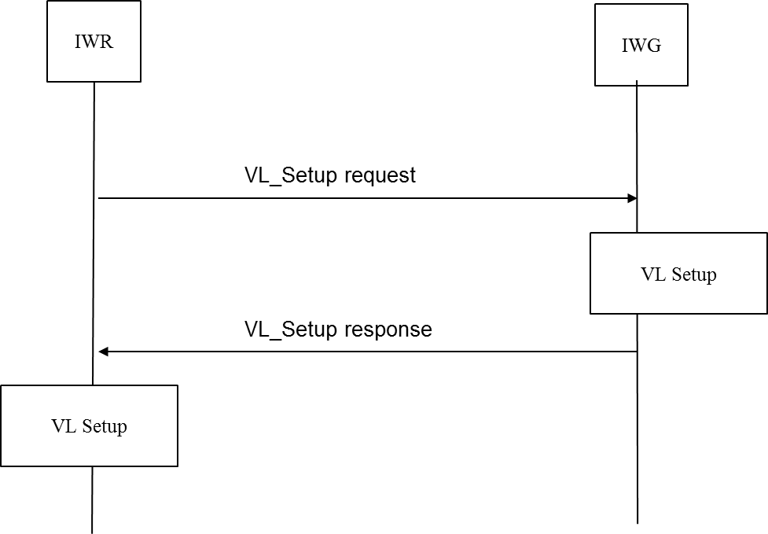
Figure 4 Call Flow (IWR-initiated Virtual Link Set-Up)

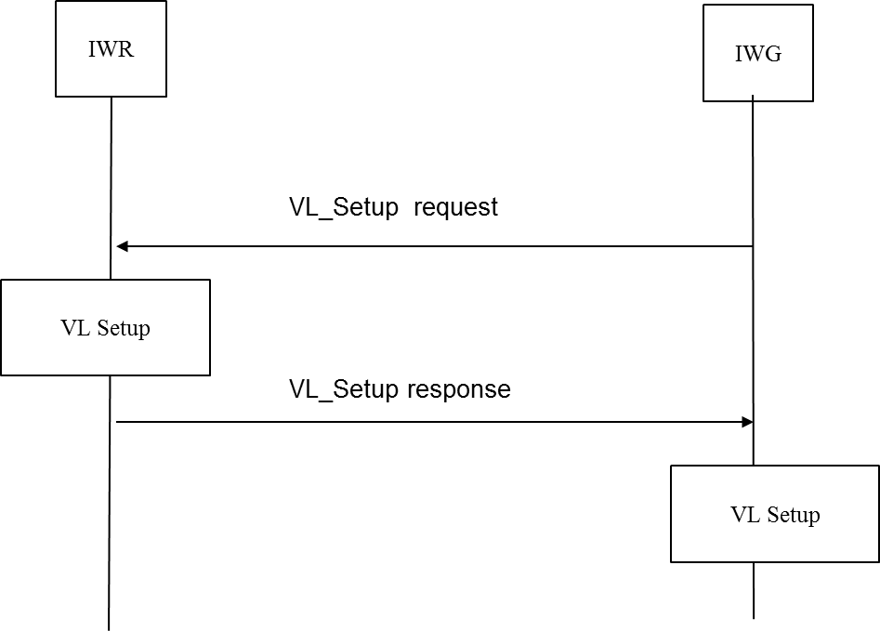
Figure 5 Call Flow (IWG-initiated Virtual Link Set-Up)
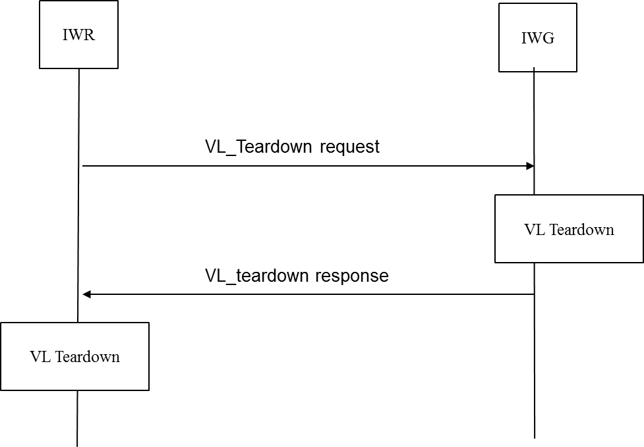
Figure 6 Call Flow (IWR-initiated Virtual Link Teardown)
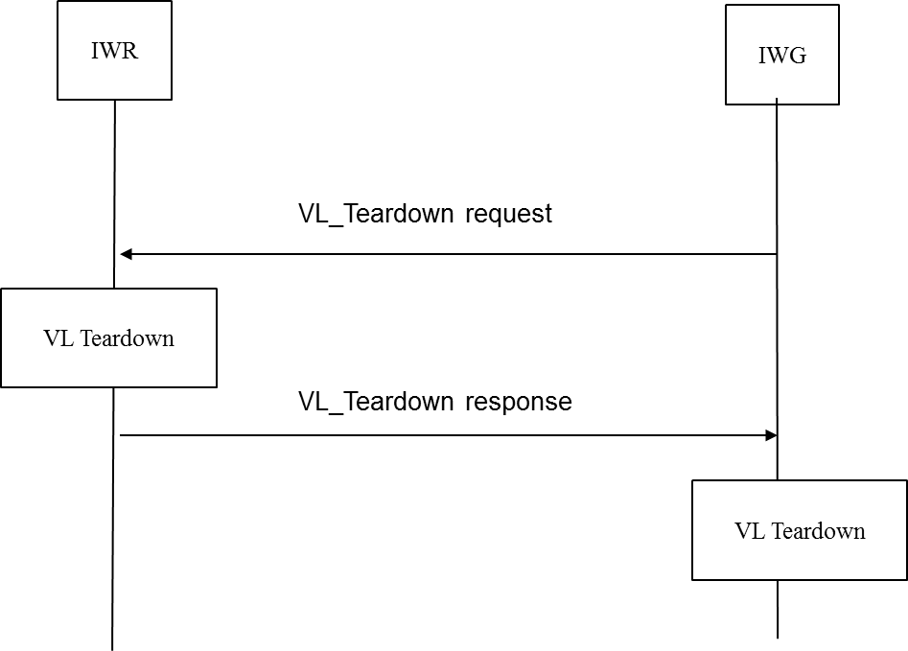

Figure 7 Call Flow (IWG-initiated Virtual Link Teardown)

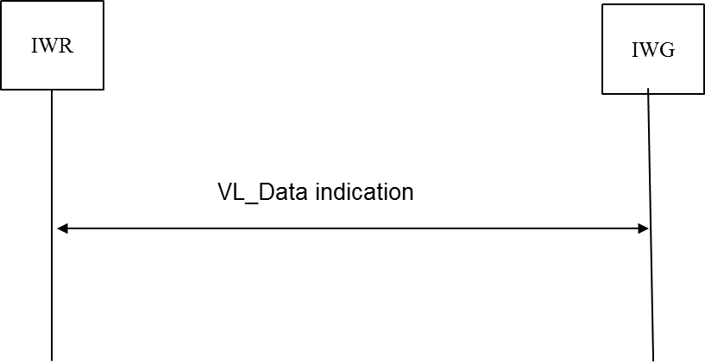
Figure 8 Call Flow (Transmitting Data over Virtual Link)

Table 1 Attributes Used for Interworking Service
 | VL_Setup request | VL_Setup response | VL_Teardown request | VL_Teardown response | VL_Data indication
IWR MAC Address | X | X
IWG MAC Address | X | X
SN MAC Type | X
Virtual Link ID |  | X | X | X | X
Status |  | X |  | X
SN MAC Frame |  |  |  |  | X

Requirements
The architectural requirements for Interworking Service are listed below.

- Interworking Service MUST provide a mechanism to exchange SN MAC frames between IWR and IWG over a virtual link
- Interworking Service MUST provide a mechanism to dynamically establish and terminate a virtual link between IWR and IWG
- Interworking Service MUST provide a mechanism to enable and disable exchanging SN MAC frames over a virtual link established between IWR and IWG
- Interworking Service MUST provide a mechanism for IWR to discover IWG
- Interworking Service MUST provide a mechanism for IWR to register and deregister with IWG
- Interworking Service MUST provide a mechanism to manage quality of service of a virtual link established between IWR and IWG
- Interworking Service MUST be designed such that existence of IWR and IWG is transparent to EDs
- Interworking Service MUST provide multicast traffic exchange over a virtual link established between IWR and IWG
- Interworking Service MUST provide a mechanism to filter packets exchanged over a virtual link
- Interworking Service MUST provide a mechanism to secure packets exchanged over a virtual link and packets used for controlling a virtual link

