DCN: 21-14-0005-00-SAUC

Title: Use Cases of Media Independent Service for D2D Communications

Data Submitted: January 18th, 2014

Authors: Hyunho Park (ETRI), Hyeong-Ho Lee (ETRI), Jin Seek Choi (Hanyang University, Korea Ethernet Forum), and Seung-Hwan Lee (ETRI)

  - General description

D2D (Device-to-Device) communication is direct data communication between MNs (Mobile Nodes) and attracts attentions in perspective of network resource management and communication service based on proximity. Applications of D2D communications can be social networking, advertisement, public safety, data sharing, and data offload.

For D2D communication, media independent framework and information server of IEEE 802.21 WG (Working Group) is able to help an MN to search for and connect to its peer. Medea independent framework of IEEE 802.21 WG is common platform to support interworking between networks using IEEE802 and non-IEEE802 technologies, so that media independent framework can be easily extended to a platform for D2D communications such as Wi-Fi Direct, ProSe (Proximity Service), and IEEE 802.15.8 PAC (Peer Aware Communications). Information server can provides network configuration information for MNs, and thus it will be able to help MNs to search for its peer.

The media independent service can apply to D2D communication with or without assistance of network entities such as a base station or an access point. For D2D communication with network assistance, information server is able to provide configuration information for an MN to discover its peer. Service providers of D2D communications also can control D2D connections of MNs by using PoS (Point of Service) that is network-side instance of media independent service. For D2D communication without network assistance, media independent service framework can help MNs to find the most appropriate D2D technology that can offer the best QoS (Quality of Service) or QoE (Quality of Experience).

  - Use case for Network Assisted D2D Communication
    - Description

Communication service providers and network operators have interest in D2D communication because D2D communication can provide communication between MNs in close proximity with a small amount of network resource. By using D2D communication, MNs in close proximity can share data such as video clips or local information. Service providers of D2D communication can serve local advertisement information or emergency information such as location of emergency shelters. Network operators can save network resources by offloading data to D2D communication. In addition, MNs can maintain privacy even though while performing social networking. For making a connection for D2D communication, it is difficult for an MN to search for its peer that is able to offer communication services (e.g., data sharing, local advertisement and emergency information) that the MN wants to receive.

Communication service providers and network operators will help an MN to search for and connect to its peer by assistance of network infrastructures. The D2D communication with network assistance can be defined as NADC (Network-Assisted D2D Communication). Network infrastructures can control plane for NADC.

Media independent service can be the control plane for NADC. Information server and PoS will be network entities to support control plane. In media independent service to support NADC, PoS will control connection between MNs of NADC, and information server
    - Actors

Jane: User of an MN that supports D2D communication.

Smith: User of a candidate peer of Jane’s MN

NADC provider: Communication service provider or network operator that supports NADC
    - Pre-conditions

Jane may want D2D communications to share data or local information or receive emergency information if there is a peer node of Jane’s MN.

Information server can offer configuration information to search for a peer node of Jane’s MN by using media independent service messages.

Jane’s MN may communicate with information server.

PoS may communicate with information server and other PoS by using media independent service messages.

PoS may control MN’s connection to access networks or peer node of MNs by media independent service messages.

NADC provider may want to serve D2D communication to Jane and own PoS.

Smith is in close proximity to Jane, and Smith’s MN is able to provide communication service that Jane wants to be served.

Jane and Smith do not know each other, and thus Jane’s MN cannot find Smith’s MN without network assistance.
    - Triggers

Jane’s MN may request information about a peer node (Smith’s MN) of Jane’s MN to information server.

PoS of NADC provider may find a peer node (Smith’s MN) of Jane’s MN by using information server and give Jane’s MN information to make a connection between Jane’s MN and its peer node.
    - Service Flow

For NADC, both an MN like Jane’s MN and NADC provider is able to initiate D2D communication. Therefore, service flow for NADC needs to be classified into MN-initiated D2D communication and NADC provider-initiated D2D communication.
      - Service flow of MN-initiated D2D communication
- Jane’s MN requests information to connect with its peer to information server.
- Information server responds to Jane’s MN with configuration information to connect with a candidate peer (e.g., Smith’s MN) of Jane’s MN. The configuration information may be technology of D2D communication such as Wi-Fi Direct and PAC, identifier (e.g., MAC address and IP address) of the candidate peer, and frequency information that its candidate peer can use.
- Based on configuration information from information server, Jane’s MN searches for and connects to its peer node.
      - Service flow of NADC provider-initiated D2D communication
- PoS of NADC provider requests information for a peer node of Jane’s MN to information server.
- Information server responds to PoS of NADC provider with configuration information to connect with a candidate peer (e.g., Smith’s MN) of Jane’s MN. The configuration information may be technology of D2D communication such as Wi-Fi Direct and PAC, identifier (e.g., MAC address and IP address) of the candidate peer, and frequency information that its candidate peer can use.
- The PoS of NADC provider sends the configuration information to Jane’s MN.
- Jane’s MN decide whether to use D2D communication. If Jane’s MN decide to use D2D communication, Jane’s MN tries to search for and connect to its peer node (Smith’s MN) by using the configuration information from PoS of NADC provider.
    - Post-conditions

Jane’s MN and Smith’s MN make a connection and transfer data directly.
    - High Level Illustration

Figure 1 shows control signaling for NADC by using media independent service messages. Information server serves configuration information of an MN’s peer. The configuration information of information server can be requested by MNs and PoS. PoS controls MNs’ connection of D2D communication by requesting MN to select D2D communication and assigning radio resource for D2D communication. NADC provider owns PoS and communicates other PoS.

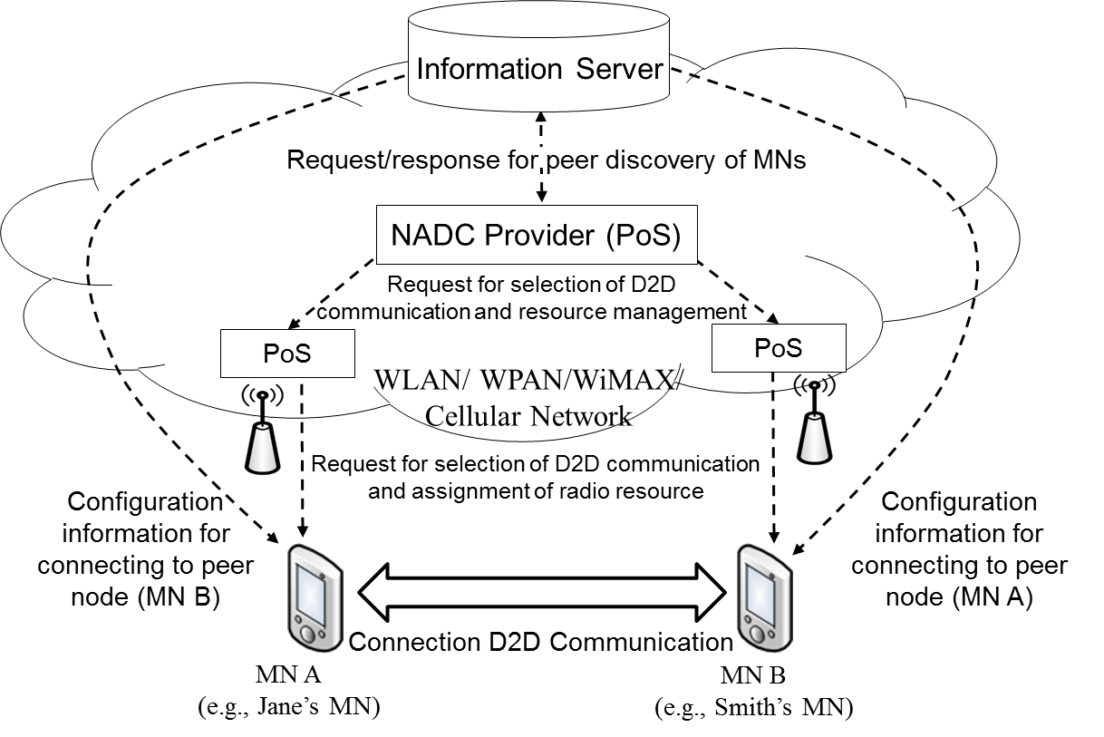

Fig. 1. Control signaling of NADC

    - Potential 802 requirements

Information server for NADC should provide configuration information for connecting to MNs’ peer node.

PoS should control MNs’ connection for D2D communication and control MNs’ radio resource.

  - Use case for D2D Communication without Network Assistance
    - Description

Various technologies for D2D communication have been developed recently. Smart devices such as smartphones and tablet PCs already implement Wi-Fi Direct. Future smart devices may implement developing technologies of D2D communication technologies such as ProSe and PAC. For the future smart devices, it is important for smart devices to select the most appropriate technology of D2D communication that can support the best QoS or QoE.

By using D2D communication, smart MNs in close proximity can directly share data such as video clips or local information without network assistance. D2D communication can serve local advertisement information or emergency information such as location of emergency shelters.

Media independent framework will support MNs to select appropriate technology of D2D communication without any network assistance. Existing media independent framework enables MNs to monitor link status, which is status (e.g., signal strength and data rate) of physical layer and data link layer, by using MIES (Media Independent Event Service) and select the most appropriate access network by using MICS (Media Independent Conmand Service) even without network assistance. Therefore, if MIES and MICS are extended for supporting D2D communication, it will be possible for MNs to monitor link status of D2D communications and select the most appropriate technology of D2D communication without network assistance.
    - Actors

Jane: User of an MN that supports D2D communication.

Smith: User of a peer node of Jane’s MN
    - Pre-conditions

Jane and Smith communicate each other by using D2D communication.

Jane’s MN and Smith’s MN implement multiple technologies of D2D communications.

Jane’s MN may switch among technologies of D2D communications.
    - Triggers

When link status of D2D communication between Jane’s MN and Smith’s MN is deteriorated, the MNs may change different technology of D2D communication.
    - Service Flow
- Jane’s MN and Smith’s MN transfers data through D2D communication “P” (e.g., Wi-Fi Direct).
- Jane’s MN detects that link status (e.g., signal strength and data rate) of D2D communication “P” is getting worse due to some reason such as radio interference by using MIES.
- Jane’s MN discovers the most appropriate D2D communication “Q” (e.g., PAC) that is different from D2D communication “P” by monitoring link status of “Q” with MIES.
- Jane’s MN requests Smith’s MN to change D2D communication “P” into D2D communication “Q” by using MICS message.
- Jane’s MN and Smith’s MN make a connection by using D2D communication “Q.”
- Jane’s MN and Smith’s MN can transfer data through D2D communication “Q.”
    - Post-conditions

Jane’s MN and Smith’s MN can switch their technology of D2D communication again depending on link status.
    - High Level Illustration

Figure 2 shows control signaling for D2D communication without network assistance and is explained in “1.3.5 Service Flow.”

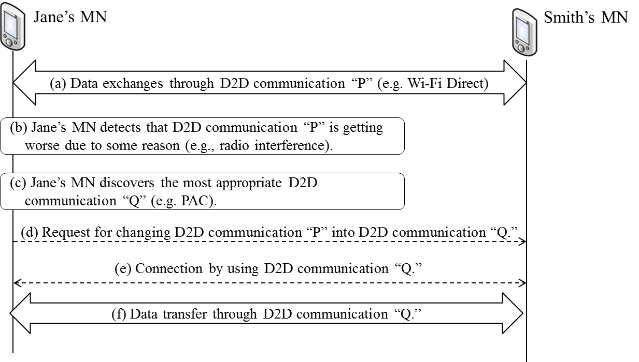

Fig. 2. Control signaling of D2D communication without network assistance

    - Potential 802 requirements

MIES should monitor link status of D2D communications.

MICS should include primitives to control D2D communications for MNs.

