IEEE P802.21
Media Independent Handover Services
Group manager, command center, and mobile nodes
Date: 2013-11-xx
Author(s):
Name | Affiliation | Address | Phone | email
Lily Chen | NIST | 100 Bureau Dr. Gaithersburg, MD 20878 | +1 (301) 975-6974 | Lily.Chen at nist.gov
Abstract
This contribution clarifies the relation between group manager, command center, and mobile nodes to resolve comment #97.

This contribution is based on the following issues.

Currently, the command center is defined as a MIH user. However, in many places, it is considered as a PoS.

It is also not clear the relation between the group manager and the command center.

Furthermore, a command center can be a multicast recipient. But in a lot of places, only MNs
The following figure illustrates a general understanding.
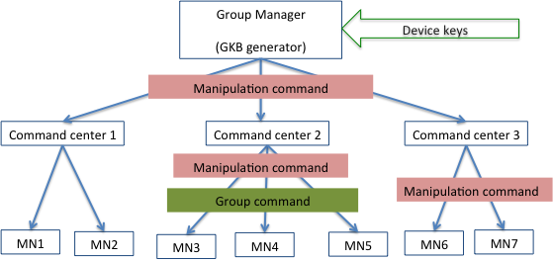

We need to make decision on
- Whether CC is a PoS or an MIH user in a PoS;
- Do we consider the “group manipulation command” from MG and CCs the same as from a CC to MNs?
We also need to correct wherever MNs are considered as the only multicast recipients.

