Project | IEEE 802.21d  <https://mentor.ieee.org/802.21>
Title | Security text for Multicast Group Management
DCN | 21-13-0146-03- Security text for Multicast Group Management
Date Submitted
Source(s) | Lily Chen, Karen Randall
Re:
Abstract | This contribution proposes changes to support the use of ECDSA and clarifies the use of AES-CCM.
Purpose | Proposed text to resolve comments 219 and 220
Notice | This document has been prepared to assist the IEEE 802.21 Working Group. It is offered as a basis for discussion and is not binding on the contributing individual(s) or organization(s). The material in this document is subject to change in form and content after further study. The contributor(s) reserve(s) the right to add, amend or withdraw material contained herein.
Release | The contributor grants a free, irrevocable license to the IEEE to incorporate material contained in this contribution, and any modifications thereof, in the creation of an IEEE Standards publication; to copyright in the IEEE’s name any IEEE Standards publication even though it may include portions of this contribution; and at the IEEE’s sole discretion to permit others to reproduce in whole or in part the resulting IEEE Standards publication. The contributor also acknowledges and accepts that IEEE 802.21 may make this contribution public.
Patent Policy | The contributor is familiar with IEEE patent policy, as stated in Section 6 of the IEEE-SA Standards Board bylaws <http://standards.ieee.org/guides/bylaws/sect6-7.html#6> and in Understanding Patent Issues During IEEE Standards Development http://standards.ieee.org/board/pat/faq.pdf

Insert the following references to Clause 2, Normative References
IEEE Std 802.1AR™-2009, IEEE Standard for Local and Metropolitan Area Networks: Secure Device Identity.
Insert the following references in Annex A for bibliography.
ANSI X9.62-2005, Public Key Cryptography for the Financial Services Industry: The Elliptic Curve Digital Signature Algorithm (ECDSA).¹
IETF RFC 5008, Suite B in Secure/Multipurpose Internet Mail Extensions (S/MIME), Housley, R., Solinas, J., September 2007.²
IETF RFC 5480, Elliptic Curve Cryptography Subject Public Key Information, Turner, S., Brown, D., Yiu, K., Housley, R., Polk, T., March 2009.
NIST FIPS 186-4, Digital Signature Standards (DSS), July 2013.³
¹ANSI publications are available from the Sales Department, American National Standards Institute, 25 West 43rd Street, 4th Floor, New York, NY 10036, USA (http://www.ansi.org/).
²IETF RFCs are available from the Internet Engineering Task Force Web site at http://www.ietf.org/rfc.html.
³NIST publications are available from the National Institute of Standards and Technology, NIST Public Inquiries, NIST, 100 Bureau Drive, Stop 3460, Gaithersburg, MD, 20899-3460, USA (www.nist.gov).

Insert the following text after the first paragraph of Clause 9.4.5.
In this specification, Elliptic Curve Digital Signature Algorithm (ECDSA) specified in in IEEE 802.1AR-2009, Secure Device Identity, by reference to NIST FIPS 186-4 and ANSI X9.62-2005 is used as the multicast signature scheme. In particular, NIST recommended elliptic curve P-256 and hash function SHA-256, specified in FIPS 180-4, are used to generate signatures. These algorithm identifiers are defined in Clause 9.4.5.4.
Insert the following clause:
9.4.5.4 Algorithm identifiers
The ECDSA signature method is defined in IEEE 802.1AR-2009, Secure Device Identity, by reference to NIST FIPS 186-4 and ANSI X9.62-2005.
If implementing ECDSA P-256, the SHA-256 message digest algorithm and the P-256 elliptic curve as defined in FIPS 186-4 Annex D, D.1.2.3, shall be used.
The signature algorithm shall be ecdsa-with-SHA256 as specified in IEEE 802.1AR by reference to RFC 5008. The object identifier is:
ecdsa-with-SHA256 OBJECT IDENTIFIER ::= { iso(1) member-body(2) us(840) ansi-X9-62(10045) signatures(4) ecdsa-with-sha2(3) 2 }
When the ecdsa-with-SHA256 algorithm identifier appears in the algorithm field as an AlgorithmIdentifier, the encoding shall omit the parameters field. That is, the AlgorithmIdentifier shall be a SEQUENCE of one component, the object identifier ecdsa-with-SHA256.
Suggest inserting the following text after Table 26 in Clause 9.4.6.
In Table 26, AES-CCM is an AES mode of operations specified in NIST SP 800-38C. AES-CCM provides confidentiality and data integrity.
In Table 26, ECDSA-256 uses curve P-256 and hash function SHA-256.
(Note remove entries in table 26 that reference/use ECDSA-224).
Notice that AES-CCM uses the group key, either MIGMEK or MIGEK. It can provide data integrity but not unique data origin authentication because the symmetric key is shared among a group of MNs. The data origin authentication is provided through ECDSA.
The data protection procedure is illustrated in Figure A and Figure B. [Include figures from Yoshikazu Hanatani’s contribution to illustrate the AES-CCM and signature.]
Figure A – Encapsulation
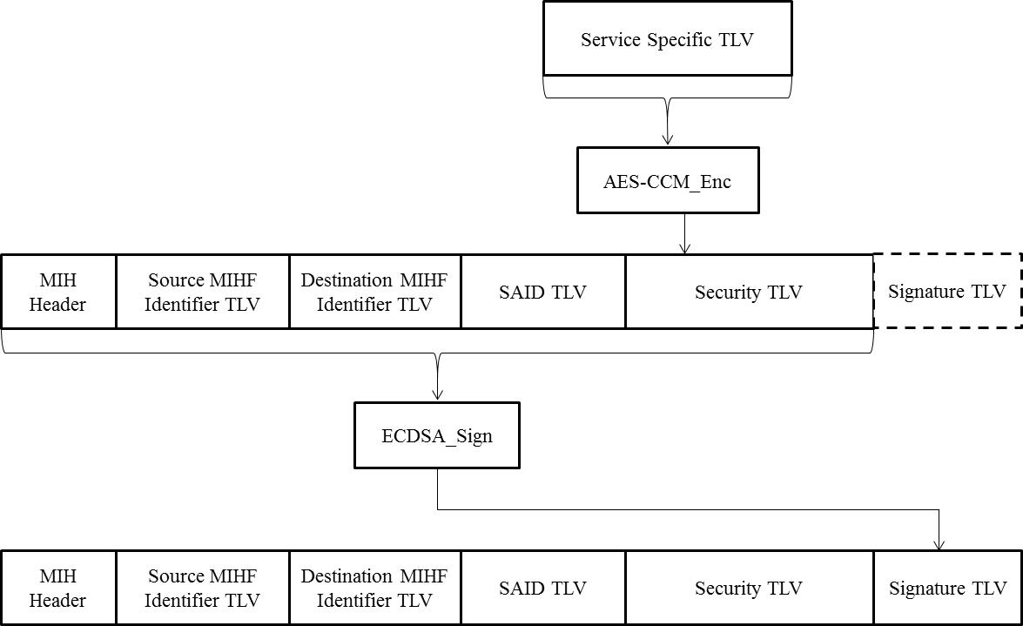

Figure B - Decapsulation
