Project | IEEE 802.21c  <https://mentor.ieee.org/802.21>
Title | Proposed remedy for the Proxy for Information Services
DCN
Date Submitted
Source(s) | Antonio de la Oliva, Subir Das
Re:
Abstract | This contribution removes all instances of translation mechanisms at the MIHF of the Proxy for Information Services.
Purpose | Proposes changes in the current draft
Notice | This document has been prepared to assist the IEEE 802.21 Working Group. It is offered as a basis for discussion and is not binding on the contributing individual(s) or organization(s). The material in this document is subject to change in form and content after further study. The contributor(s) reserve(s) the right to add, amend or withdraw material contained herein.
Release | The contributor grants a free, irrevocable license to the IEEE to incorporate material contained in this contribution, and any modifications thereof, in the creation of an IEEE Standards publication; to copyright in the IEEE’s name any IEEE Standards publication even though it may include portions of this contribution; and at the IEEE’s sole discretion to permit others to reproduce in whole or in part the resulting IEEE Standards publication. The contributor also acknowledges and accepts that IEEE 802.21 may make this contribution public.
Patent Policy | The contributor is familiar with IEEE patent policy, as stated in Section 6 of the IEEE-SA Standards Board bylaws <http://standards.ieee.org/guides/bylaws/sect6-7.html#6> and in Understanding Patent Issues During IEEE Standards Development http://standards.ieee.org/board/pat/faq.pdf

Section 5.9.2 Proxy for network discovery
The MN needs to communicate with the Information Server to discover a target access network. If the MN can directly access the Information Server, it can discover its target network by using MIH_Get_Information request and response messages. However, the MN may not always be able to directly access the Information Server. For example, an ANQP server may be used between the MN and WLAN access point (AP). On the other hand, the MN and the Information Server may be located in different networks and in different administrative domains. For example, while the MN may need to query via ANQP messages in an Wi-Fi access network while the information is available in an ANDSF server that is located in a cellular provider’s network. This scenario can be enabled if the Wi-Fi POA is SRHO-capable and an intermediate entity called proxy Information Server is available that can help forwarding the MN’s request to the ANDSF server.
Figure 11b gives an example call flow of the network discovery procedure using proxy Information Server. The goal of the MN is to discover the target network. The steps of the discovery procedure are as follows:
a) The MN requests information about the target network using MIH_CTRL_Transfer request or a non-MIH message such as an ANQP query.
b) In case the message received is not an MIH_CTRL_Transfer, the SRHO-capable PoA encapsulates the query message into the MIH_CTRL_Transfer request message (see clause 7.4.33).
c) The SRHO-capable PoA transmits or forwards the MIH_CTRL_Transfer request message to the proxy Information Server.
d) The proxy Information Server extracts the encapsulated payload message and forwards the MN’s request to another functional entity (a.k.a., MIH User). This entity is responsible to transmit MN’s request to the information server. The interface specification between this functional entity and the Information server (i.e., ANDSF server) is out of scope of this document. Note that any translation among different protocols (e.g., ANQP and ANDSF) is performed at the MIH User and is out of the scope of this specification.
e) The proxy Information Server transmits MIH_CTRL_Transfer response message to the SRHO- capable PoA by encapsulating the response that is obtained from the functional entity (i.e., MIH User).
f) In case the MN did not use MIH as protocol to transmit the original query, the SRHO-capable PoA decapsulates the MIH_CTRL_Transfer response message and forwards the content (e.g., ANQP response) to the MN. If the MN used MIH protocol for the initial query, then the MIHF forwards the MIH_CTRL_Transfer response message to the MN.

Annex T
(Informative)
Practical Uses of Proxy for Information Services
IEEE 802.11u defines a mechanism for the AP to contact an external information service upon receiving an ANQP query from an MN. The functionality of Proxy for Information Services can be used to simplify the interaction of the AP with heterogeneous information services such as MIIS or ANDSF.
Figure S.1 (a) presents a diagram of the functionality provided by the Proxy for Information Services. First the MN queries the AP using ANQP. The AP encapsulates this query in a MIH_CTRL_Transfer message, and forwards it to the Proxy for Information Services. Upon reception of the message, the MIHF at the Proxy decapsulates the message and forwards the ANQP query to the MIH User in charge of the translation function. The MIH User then performs the translation between ANQP and any other protocol used to contact the desired Information Repository (e.g., OMA-DM for ANDSF) and it also performs the communication with the external Information Repository. The translation and communication functionalities used by the MIH User to contact the external Information Repository are out of the scope of this specification.
Once the response is received from the external Information Repository, the process is reverted. The MIH User at the Proxy translates the information into an ANQP response and forwards it to the MIHF which encapsulates it in an MIH_CTRL_Transfer message and sends it to the AP. The AP then decapsulates the message and forwards the ANQP response to the MN.
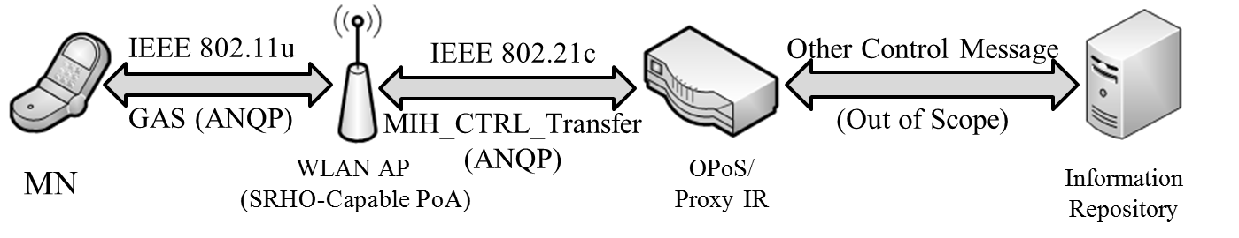
(a) ANQP Message Transfer using Proxy Information Server.

