**IEEE P802.21  
Media Independent Handover Services**

|  |  |  |  |  |
| --- | --- | --- | --- | --- |
| **Proposed Remedy for the 802.21c LB6b comments** | | | | |
| **Date:** 2013-05-30 | | | | |
| **Author(s):** | | | | |
| **Name** | **Affiliation** | **Address** | **Phone** | **email** |
| H. Anthony Chan Hyunho Park, Hyeong-Ho Lee, | Huawei ETRI,  ETRI, |  |  | [h.anthony.chan@huawei.com](mailto:h.anthony.chan@huawei.com) [hyunhopark@etri.re.kr](mailto:hyunhopark@etri.re.kr), [holee@etri.re.kr](mailto:holee@etri.re.kr) , |

Abstract

This document contains proposed remedy for “the 802.21c ballot 6b comments and resolution” document (DCN#21-13-0084-01). Also, this document proposes modification of texts on IEEE 802.21c Draft/D03.

**Remedy for the 802.21c LB6b comments**

1. Comment #12: Also change the next sentence "For single-radio performance improvement, … " to "To improve single radio handover performance, …"
2. Comment #109: Change to “Information Server.” The information server does not need to be in the originating network. Revise Figure 10a
3. Comment #85, 86, 87: Change the assumptions in 1.4 to the following:

a) The mobile device can transmit on only one radio at a time. The target radio shall not transmit while the originating radio is transmitting.

b) While the originating radio is receiving, the target radio shall not transmit in a manner causing interference to the originating radio receiver.

c) Prior to handover completion, only the originating radio link is used to support data transfer. (or delete it)

1. Comment #121: Change “proxy” to “TPoS / proxy PoA” in Figure 11b
2. Comment #122: Update Figure 11b according to comment
3. Comment #123: add “not available” under PHY(1) in TPoA. check with Antonio if okay?
4. Comment #35, 40, 115, 113, 114

The sub-clauses in 5.9 as modified according to 21-13-0101-01 are further rearranged as follows:

5.9 Proxy operations, 5.9.1 Introduction, 5.9.2 Proxy for network discovery, 5.9.3 Proxy for preregistration

* 1. Proxy operations
     1. Introduction

Proxy services bridge the signaling between the MN and the target network via the originating network or between the MN and the Information Server. In single radio handover, the MN may signal to the proxy PoA as if signaling to the target PoA (TPoA), and the TPoA may respond by signaling to the Proxy service as if signaling to the MN. The MN may signal to the proxy Information Server as if signaling to the Information Server, and the Information Server may respond by signaling to the Proxy service as if signaling to the MN.

The control frames from the MN tunneled via the originating network to the target network are consumed at the proxy PoA, which processes these control frames. Before replying to the control frames, the proxy PoA may communicate with the appropriate network entities in the target network to enable conducting any needed functions requested in the control frame. This proxy in the control plane may therefore execute any control functions in general, including but not limited to preregistration and proactive authentication of the MN.

The control frames from the MN tunneled via the OPoS to the Information Server are consumed at the Proxy Information Server. Before replying to the control frames, the proxy Information Server may communicate with the appropriate Information Server to enable conducting any needed functions requested in the control frame. Through the Proxy Information Server, even though the MN cannot communicate with the Information Server directly, the MN can discover the target network.

Proxy services may be located at a border router of the network.

In a WiMAX network, the proxy services may be implemented as an extension of the Signal Forwarding Function (SFF) [B5] and may reside at the Access Service Network Gateway (ASN-GW).

In a 3GPP network, the proxy services may be implemented as an extension of the Mobility Management Entity (MME).

In a 3GPP2 network, the proxy services may be implemented in the High-Rate Packet Data Signal-Forwarding Function (HRPD-SFF) and the existing functions of the Packet Control Function (PCF).

Control signals between the MN and the proxy service are implemented in a media independent manner using the functions of, respectively, the originating network PoS and target network PoS and the signaling messages defined in this specification.

In a distributed mobility management design, each network may have a mobility routing function. The mobility routing function enables a router to forward packets towards a mobile node according to the new location of a mobile node. The logical functions of mobility routing and of the Proxy may be co-located. The distributed mobility management architecture may then be shown in Figure 10a in which the Information Server contains the logical function of location management information and the proxy contains the logical function of mobility routing.

* + 1. Proxy for network discovery

The MN needs to communicate with the Information Server to discover a target access network. If the MN can directly access the Information Server, it can discover its target network by using the Information Server. However, the MN may not always be able to directly access the Information Server. For example, an ANQP server may be used between the MN and WLAN access point (AP). Moreover, the MN and the Information Server may use different radio technology. For example, while the MN may use ANQP while the Information Server is an ANDSF server. Then the MN will need to access the information server via the proxy Information Server.

Figure 11b shows the network discovery procedure using proxy Information Server. The MN sends query message for target network discovery.

1. The MN requests information about the target network using MIH_CTRL_Transfer request or a non-MIH message.
2. The SRHO-capable PoA encapsulates the query message into the MIH_CTRL_Transfer request message (see clause 7.4.33)
3. The SRHO-capable PoA transmits MIH_CTRL_Transfer request message to the proxy Information Server.
4. The proxy Information Server exchanges and translates the control message between the SRHO-capable PoA and information server. This step is out of scope.
5. The proxy Information Server transmits MIH_CTRL_Transfer response message to the SRHO-capable PoA.
6. The SRHO-capable PoA decapsulates the MIH_CTRL_Transfer request message.
7. The SRHO-capable PoA responds with information about the target network.

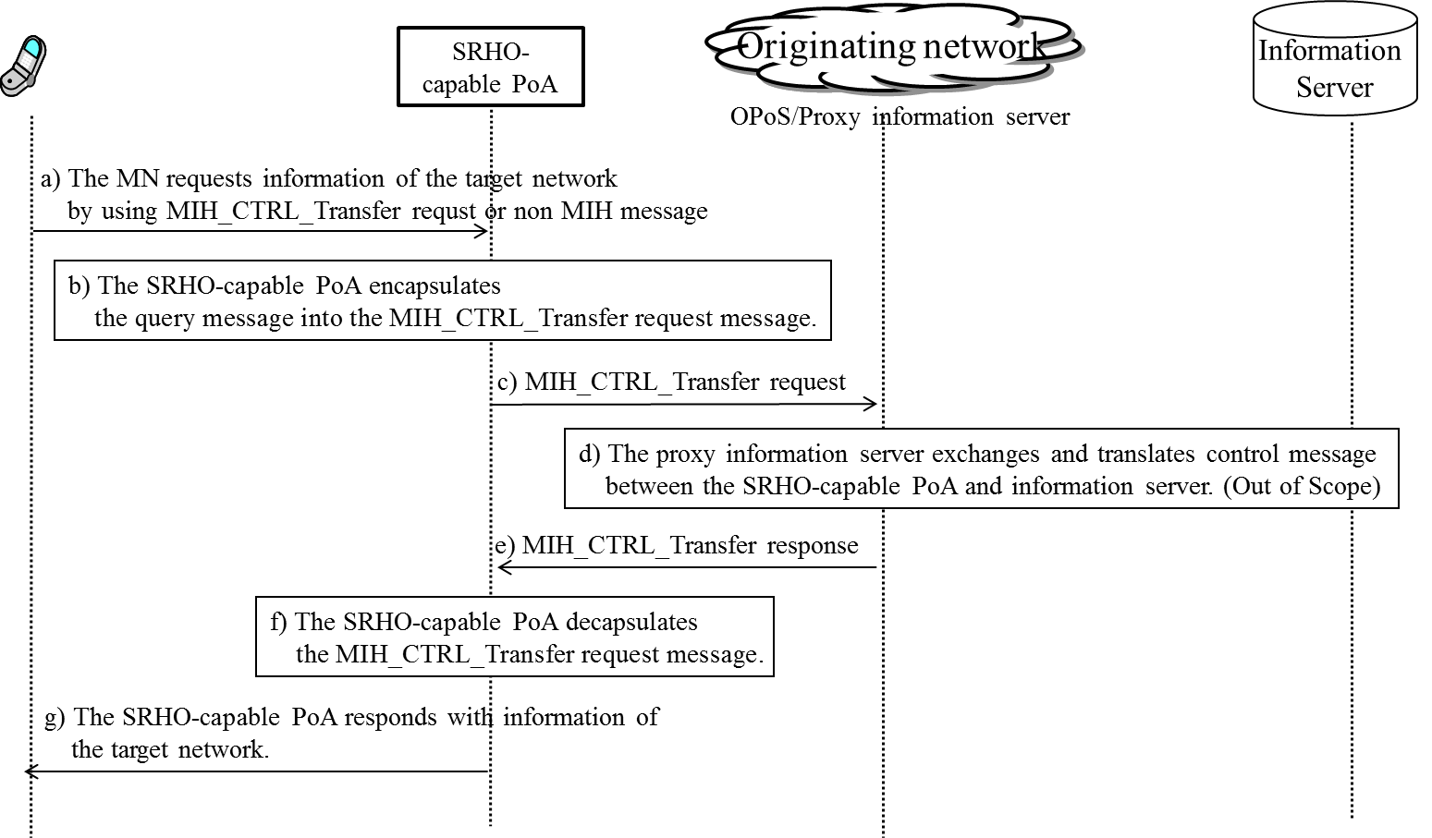

**Figure 11b. Network discovery using proxy Information Server**

Use cases and extension of the Proxy Information Server are included in Annex S.

* + 1. Proxy for preregistration

The MN needs to communicate eventually with the target network PoA (TPoA) to prepare for handover by performing network access procedure with the target access network. The first part of this communication is the transport of TCP or UDP / IP packets to the proxy PoA (Figures 11c and 11d). The second part of this communication depends on whether the TPoA –is SRHO-capable (Figure 11c) or whether it is a legacy PoA lacking such capability (Figure 11d). If the target PoA is SRHO-capable, the L2 frame is encapsulated into an MIH frame to be forwarded to the target radio.

Figure 11c shows the transport of the target radio L2 control frame as a payload of a MIH frame between the MN and the proxy PoA via the originating radio interface in the absence of the target link. In Figure 11c, the MN has 2 interfaces (1) and (2). It uses the wireless interface (1) with PHY(1) and L2(1) in its protocol stack to communicate with the corresponding protocol stack PHY(1) and L2(1) at the AP or Base Station. After that, the AP / BS uses some other link, e.g., Ethernet, with protocol stack PHY and L2 to get to the Proxy. The Proxy is usually not using wireless interface. Therefore, the Proxy simply shows PHY and L2 and not PHY(1) and L2(1) in its protocol stack.



**Figure 11c: Transport of L2 frame of target interface via MIH using the logical connection at the Target PoS to the SRHO-capable TPoA, showing the resulting protocol stack.**

Figure 11d also shows the transport of the target radio L2 control frame as a payload of a MIH frame between the MN and the proxy PoA via the originating radio in the absence the target link. However, the TPoA is not SRHO-capable so that the proxy PoA has to communicate with the TPoA using other control messages in order to proxy between the MN and the TPoA.

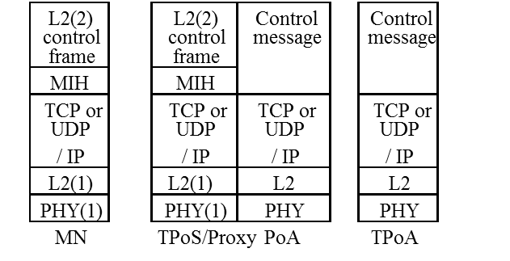

**Figure 11d. Transport of L2 frame via the proxy PoA, showing the resulting protocol stack.**

The procedures of communication between the MN and the TPoA are shown in Figure 11e and are described below.

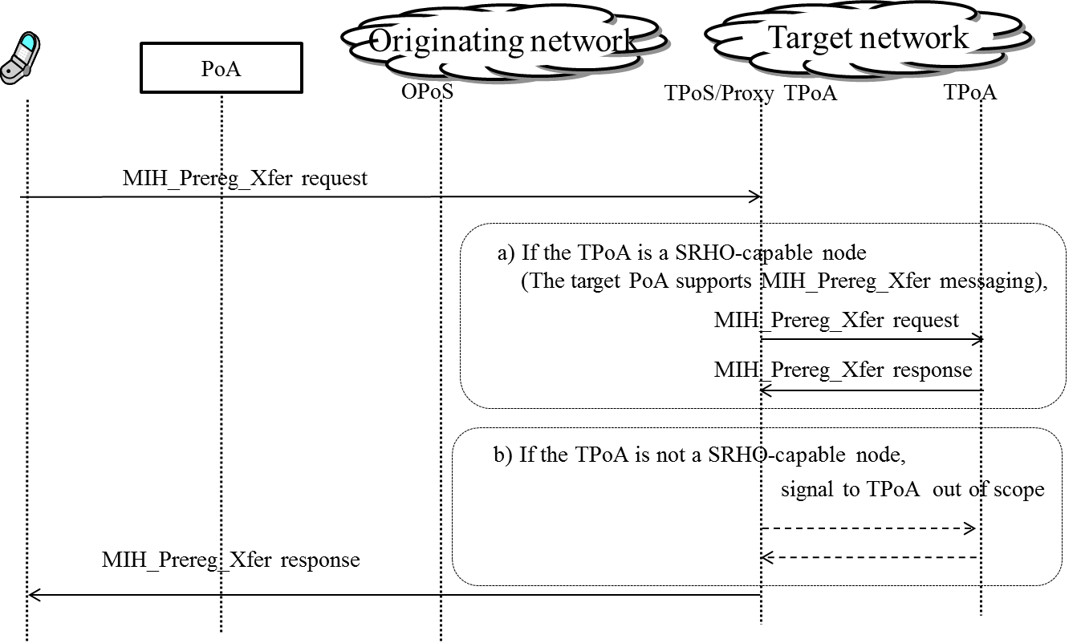

**Figure 11e. Communication between the MN and the TPoA.**

1. MN sends a message to the OPoS or directly to the TPoS / proxy PoA with a payload containing a target network L2 handover frame. If the message is directly sent to the TPoS / proxy PoA, the OPoS is bypassed. If the message is sent to the OPoS, then the OPoS will forward the message to the TPoS / proxy PoA.
2. Upon receiving this message from MN, the TPoS / proxy PoA helps to discover a suitable TPoA if not already known. It will determine whether the target PoA is SRHO-capable. If not, the TPoS / proxy PoA will communicate the link-layer frames to the target PoA using a mechanism that is outside the scope of this specification.
   1. TPoS or proxy PoA signals with this TPoA using MIH message if the TPoA is a SRHO-capable node (The target PoA supports MIH_Prereg_Xfer messaging.).
   2. Otherwise, proxy PoA may signal with the candidate target PoA using other L2-specific protocol messages. OPoS will relay the reply messages to MN, indicating whether the L2 handover is successful. Also, the reply will include an indication for the fact that the messages used for the proxy to PoA signal with the TPoA are outside the scope of this document. L2 frames can be passed to the target PoA either by way of proxy PoA or by MIH_Prereg_Xfer commands.

As shown above, MN and target network can exchange link-layer PDUs without using the target PoA’s physical radio channel. The exchanged single-radio control frames are processed by the MIHF which has the assigned transport layer protocol’s port number [RFC 5677].