**IEEE P802.21  
Media Independent Handover Services**

|  |  |  |  |  |
| --- | --- | --- | --- | --- |
| **Proposed Remedy for the 802.21c LB6b comments** | | | | |
| **Date:** 2013-05-30 | | | | |
| **Author(s):** | | | | |
| **Name** | **Affiliation** | **Address** | **Phone** | **email** |
| Hyunho Park, Hyeong-Ho Lee,  H. Anthony Chan | ETRI,  ETRI,  Huawei |  |  | [hyunhopark@etri.re.kr](mailto:hyunhopark@etri.re.kr), [holee@etri.re.kr](mailto:holee@etri.re.kr) ,  [h.anthony.chan@huawei.com](mailto:h.anthony.chan@huawei.com) |

Abstract

This document contains proposed remedy for “the 802.21c ballot 6b comments and resolution” document (DCN#21-13-0084-01). Also, this document proposes modification of texts on IEEE 802.21c Draft/D03.

**Remedy for the 802.21c LB6b comments**

1. Comment #62 (Clause: all, Page: 13, Line: 14) Link_IF_PreReg_Ready and MIH_IF_PreReg_Ready are used for preregistration as like MIH_Prereg_Xfer. For consistency of command name for preregistration, Link_Prereg_Ready and MIH_Prereg_Ready will be better than Link_IF_PreReg_Ready and MIH_IF_PreReg_Ready.

* Opinion: Accept.
* *To Editor: The modified IEEE 802.21c draft/D03, which is 21-13-00xxc-00-srho-draft-802.21c.docx, has Link_PreReg_Ready and MIH_PreReg_Ready. Please change Link_PreReg_Ready and MIH_PreReg_Ready to Link_Prereg_Ready and MIH_Prereg_Ready. In addition, please change figures in Annex R to the following figures.*

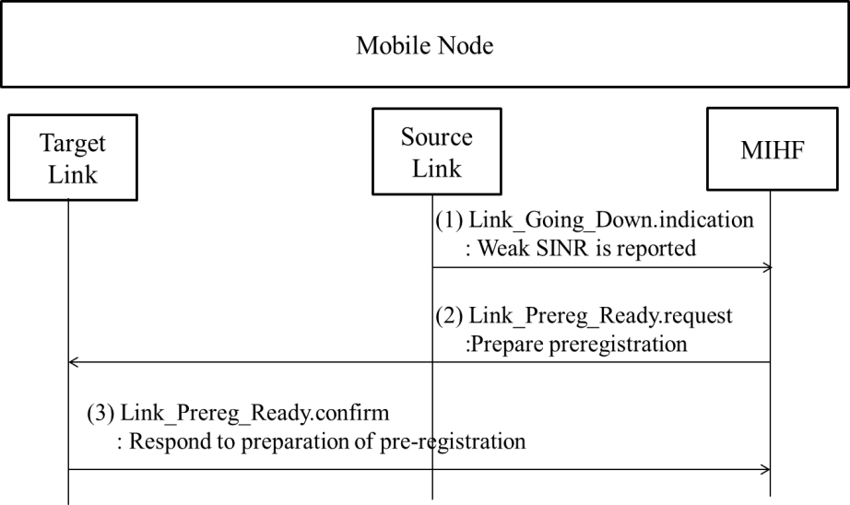

**Figure R.1- HO decision caused by weak SINR of the source link**

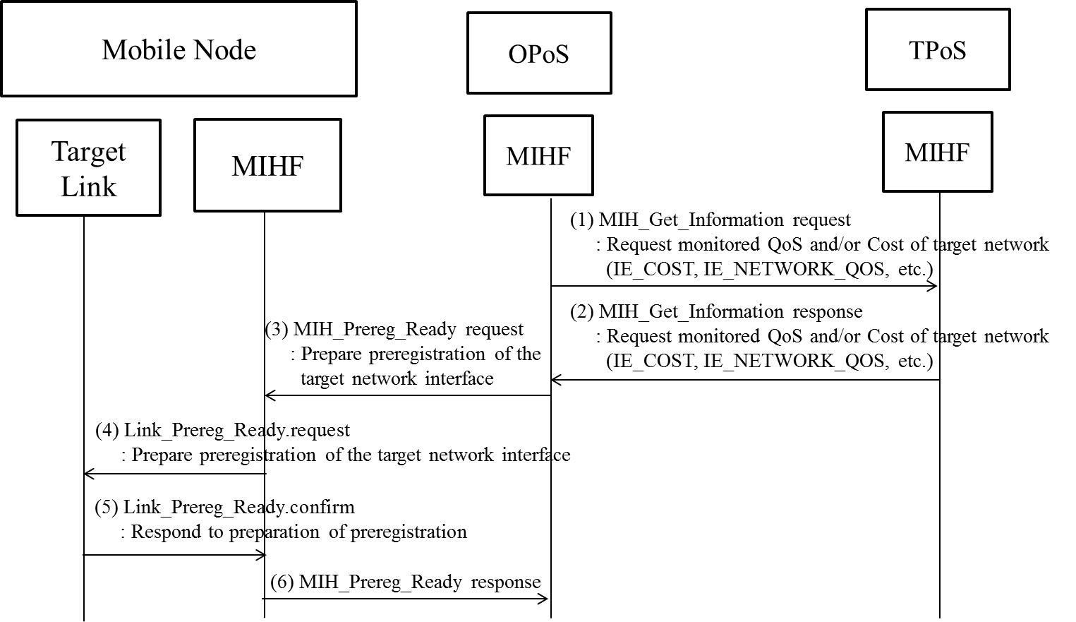

**Figure R.2- HO decision caused by QoS and/or cost**

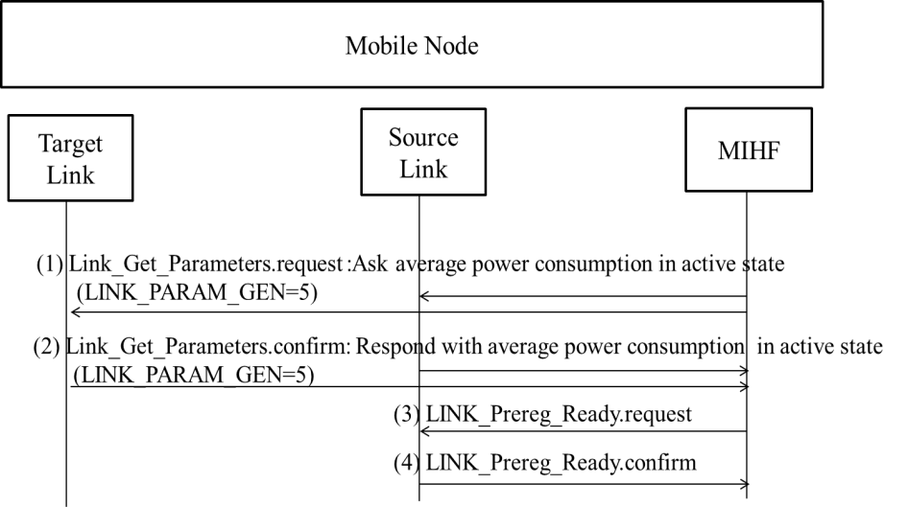

**Figure R.3- HO decision caused by power consumption comparison**

1. Comment #80 (Clause: R.2, Page: 57, Line: 12, Figure R.2) Figure R.2 shows handover decision based on comparison between originating and target networks. "Source Proxy" and "Target Proxy" needs to be changed into "OPoS" and "TPoS."

* Opinion: Accept.
* *To Editor: Regarding Figure R.2, please refer to remedy of comment #62.*

1. Comment #81 (Clause: R.2, Page: 58, Line: 1, 2, 3) "Source Proxy GW" and "Target Proxy GW" needs to be changed into "OPoS" and "TPoS."

* Opinion: Accept.
* *To Editor: Please change "Source Proxy GW" and "Target Proxy GW" into "OPoS" and "TPoS” in clause R.2.*

1. Comment #89 (Clause: 3, Page: 2) There is no definition of "Information Repository."

* Opinion: Accept. Definition of “Information Server” that was Information Repository is needed.
* *To Editor: Please insert definition of the following definition of “Information Server.”*

*Information server: Information server is a server providing information to discover a target network. The information server may be implemented in a Media Independent Information Server but may also be implemented with other standards such as the Access Network Discovery and Selection Function (ANDSF) defined in 3GPP or a server using Access Network Query Protocol (ANQP) defined in IEEE 802.11-2012.*

1. Comment #138 (Clause: 7.4.33, Page 29, Line: 1) I do not understand in which cases the primitive MIH_CTRL_Transfer can be used by an MN. If the MN wants to use a protocol such as ANQP or ANDSF, why should it encapsulate it in MIH? What is the scenario for this. Only allow this primitive to be used by PoSs.

* Opinion: Reject. If the MN can access to proxy information server that was proxy IR, the MN can send MIH_CTRL_Transfer message that encapsulates ANQP or ANDSF message. In the following modified clause “5.9.3 Proxy for information server,” we insert “The MN requests information of the target network by using MIH_CTRL_Transfer request message or non MIH messages” to show the MN can encapsulate ANQP or ANDSF message into MIH_CTRL_Transfer message.
* *To Editor: Please insert “Clause 5.9.3 shows the use of MIH_CTRL_Transfer message” before “See Annex S for examples” in clause 7.4.33.*

1. To resolve comments #60, #116, #119, and #120 that indicates proxy operations, the following clause “5.9 Proxy operations” are rewritten.
   1. Proxy operations

5.9.1 Introduction

Proxy services bridge the signaling between the MN and the target network via the originating network or between the MN and the information server. In single radio handover, the MN may signal to the proxy PoA as if signaling to the target PoA (TPoA), and the TPoA may respond by signaling to the Proxy service as if signaling to the MN. The MN may signal to the proxy information server as if signaling to the information server.

The control frames from the MN tunneled via the originating network to the target network are consumed at the proxy PoA, which processes these control frames. Before replying to the control frames, the proxy PoA may communicate with the appropriate network entities in the target network to enable conducting any needed functions requested in the control frame. This proxy in the control plane may therefore execute any control functions in general, including but not limited to preregistration and proactive authentication of the MN.

The control frames from the MN tunneled via the OPoS to the information server are consumed at the proxy information server. Before replying to the control frames, the proxy information server may communicate with the appropriate information server to enable conducting any needed functions requested in the control frame. Through the proxy information server, even though the MN cannot communicate with the IS directly, the MN can discover target network.

Proxy services may be located at a border router of the network.

In a WiMAX network, the proxy services may be implemented in an extension of the Signal Forwarding Function (SFF) [B5] and may reside at the Access Service Network Gateway (ASN-GW).

In a 3GPP network, the proxy services may be implemented as an extension of the Mobility Management Entity (MME).

In a 3GPP2 network, the proxy services may be implemented in the High-Rate Packet Data Signal-Forwarding Function (HRPD-SFF) and the existing functions of the Packet Control Function (PCF).

Control signals between the MN and the proxy service are implemented in a media independent manner using the functions of, respectively, the originating network PoS and target network PoS and the signaling messages defined in this specification.

In a distributed mobility management design, each network has a mobility routing function. The mobility routing function enables a router to forward packets towards a mobile node according to the new location of a mobile node. The logical functions of mobility routing and of the Proxy may be co-located. The distributed mobility management architecture is then shown in Figure 10a in which the Information server contains the logical function of location management information only and the proxy contains the logical function of mobility routing only.

5.9.2 Proxy for Target PoA

The MN needs to communicate eventually with the target PoA to prepare for handover by performing network access procedure with the target access network. The first part of this communication is the transport of TCP or UDP / IP packets to the proxy PoA. The second part of this communication depends on whether the target PoA supports MIHF in the 802 architecture or whether it is a legacy PoA lacking such support.

If the target PoA supports MIHF, the L2 frame is encapsulated into an MIH frame to be forwarded to the target radio. Figure 11b shows the transport of the target radio L2 control frame as a payload of a MIH frame between the MN and the proxy PoA via the source radio interface, in the absence of the target link. In Figure 11b, the MN has 2 interfaces (1) and (2). It uses the wireless interface PHY(1), L2(1) to communicate with the PHY(1), L2(1) at the AP or Base Station. After that, the AP / BS uses some other L2, e.g., Ethernet to get to the Proxy. The Proxy is usually not using wireless interface. Therefore, the Proxy simply shows PHY and L2 and not PHY(1) and L2(1).



**Figure 11b: Transport of L2 frame of target interface via MIH using the logical connection at the Target PoS to SRHO-capable TPoA, showing the resulting protocol stack.**

Figure 11c shows the transport of the target radio L2 control frame as a payload of a MIH frame between the MN and the proxy PoA via the source radio in the absence the target link. The proxy PoA communicates with the target PoA using other control messages in order to proxy between the MN and the target PoA.

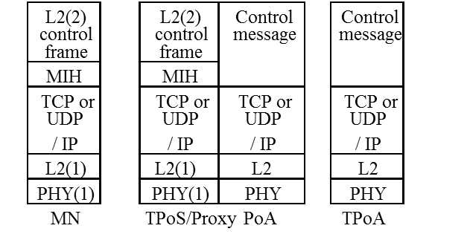

**Figure 11c. Transport of L2 frame via the proxy PoA, showing the resulting protocol stack.**

Figure 11d shows procedure of communication between the MN and the TPoA.

MN sends a message to the TPoS with a payload containing a target network L2 handover frame. Upon receiving this message from MN (either directly or via the OPoS: if the message is received directly from the MN, the OPoS is bypassed), TPoS or target proxy PoA helps to discover a suitable PoA if not already known, and the TPoS or proxy PoA communicates the link-layer frames to the target PoA using a mechanism that is outside the scope of this specification.

1. TPoS or proxy PoA signals with this target PoA using MIH message if the TPoA is a SRHO-capable node (The target PoA supports MIH_Prereg_Xfer messaging.).
2. Otherwise, proxy PoA may signal with the candidate target PoA using other L2-specific protocol messages. OPoS will relay the reply messages to MN, indicating whether the L2 handover is successful. Also, the reply will include an indication that proxy PoA signals with the target PoA using message(s) outside the scope of this document. L2 frames can be passed to the target PoA either by way of proxy PoA or by MIH_Prereg_Xfer commands.

As shown above, MN and target network can exchange link-layer PDUs without using the target PoA’s physical radio channel. The exchanged single-radio control frames are processed by the MIHF which has the assigned transport layer protocol’s port number [RFC 5677].

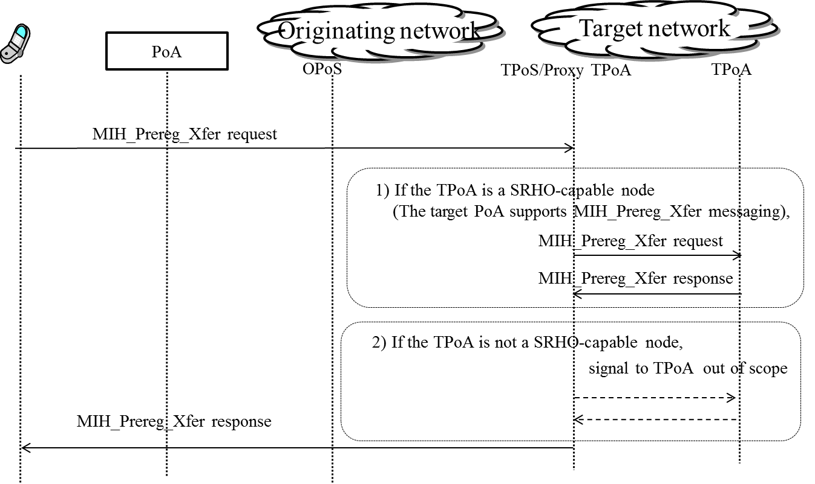

**Figure 11 d. Procedure of communication between the MN and the TPoA**

5.9.3 Proxy for information server

The MN needs to communicate eventually with the information server to discover a target access network. If the MN can access directly to the information server, it can discover its target network by using the information server. However, the MN cannot always directly access to the information server. For example, ANQP, which is one of information server, is used between the MN and WLAN access point (AP), and thus the MN cannot access directly to the ANQP server. Moreover, if the MN and information server use different radio technology, the MN cannot access directly to the information server. For example, while the MN uses ANQP, the information server can uses ANDSF. These kinds of the MNs can access to the information server by using proxy information server.

Figure 11e shows network discovery by using proxy information server. The MN sends query message for target network discovery.

1. The MN requests information of the target network by using MIH_CTRL_Transfer request or non MIH message
2. The SRHO-capable PoA encapsulates the query message into the MIH_CTRL_Transfer request message (see clause 7.4.33)
3. The SRHO-capable PoA transmits MIH_CTRL_Transfer request message to the proxy information server.
4. The proxy information server exchanges and translates control message between the SRHO-capable PoA and information server. This step is out of scope.
5. The proxy information server transmits MIH_CTRL_Transfer response message to the SRHO-capable PoA.
6. The SRHO-capable PoA decapsulates the MIH_CTRL_Transfer request message.
7. The SRHO-capable PoA responds with information of the target network.

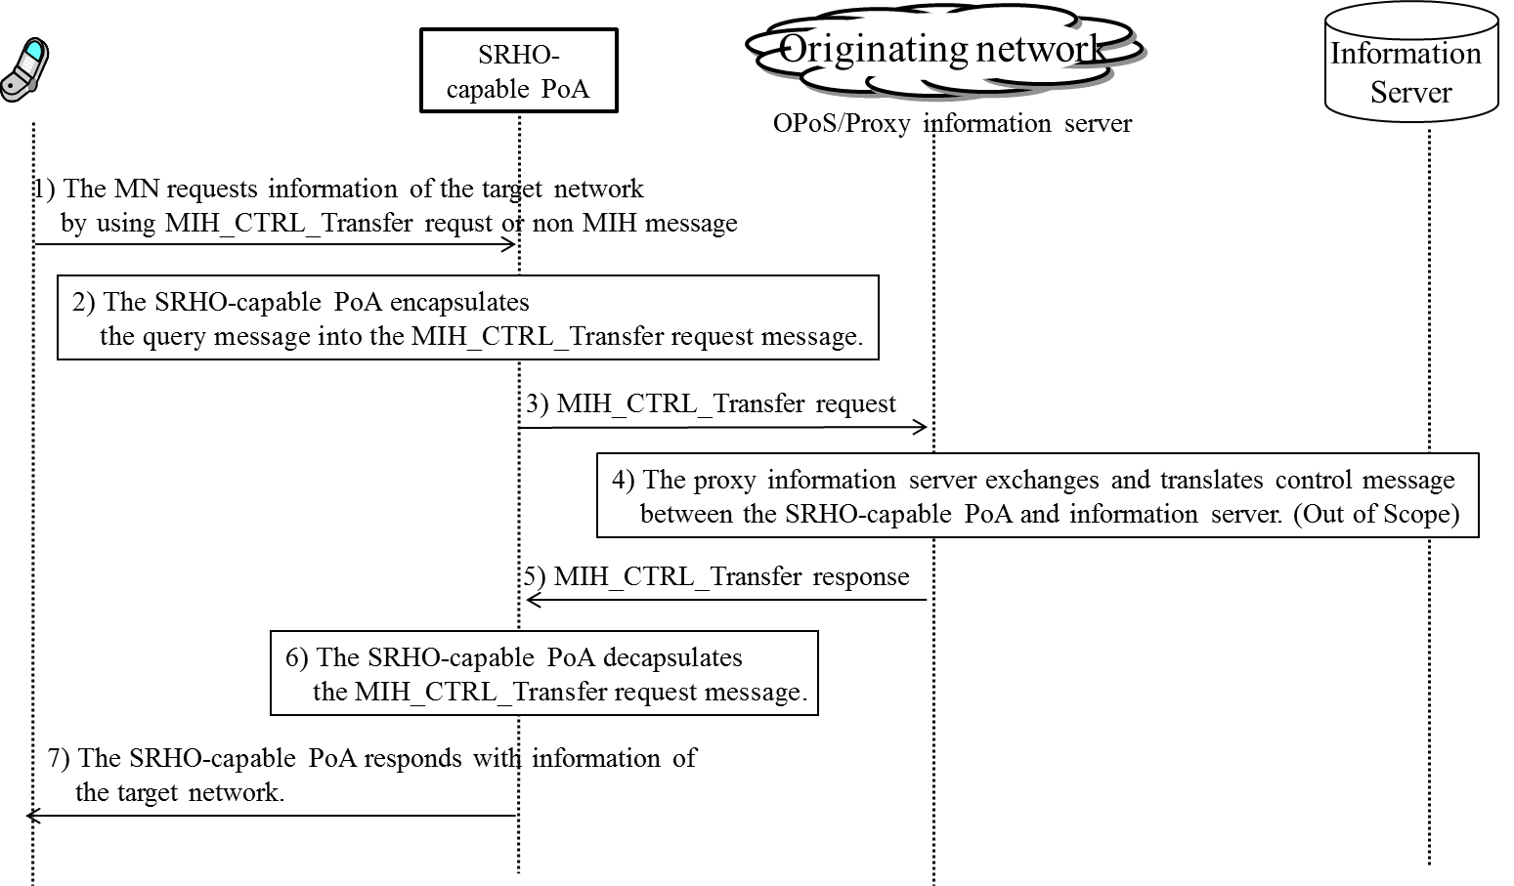

**Figure 11 e. network discovery by using proxy information server**

Use cases and extension of the proxy information server are included in Annex S.