IEEE P802.21
Media Independent Handover Services
Proposed Remedy for the 802.21c LB comments and resolution file (DCN# 21-13-0063-00)
Date: 2013-04-22
Author(s):
Name | Affiliation | Address | Phone | email
Hyunho Park, Hyeong-Ho Lee | ETRI |  |  | hyunhopark@etri.re.kr, holee@etri.re.kr
Abstract
This document contains proposed remedy for the 802.21c LB comments and resolultion file (DCN# 21-13-0063-00). Also, this document proposes modification of texts on IEEE 802.21c Draft/D02.

Remedy for the 802.21c LB comments and resolution file (DCN# 21-13-0063-00)
- Comment #193 (Clause: 7.4.32, Page: 23, Line: 10) what is the use case for the command? The sequence in Figure S-1 could be done by way of MIH_Prereg_Xfer command. Consider coalescing commands.
- Opinion: Reject, Purpose of MIH_IF_PreReg_Ready is used to select a target network interface for preregistration. After the target radio is selected by using MIH_IF_PreReg_Ready, the target can preregister to the target point of attachemt (PoA) by using MIH_Prereg_Xfer command. Thus, MIH_IF_PreReg_Ready is different from MIH_Prereg_Xfer. Moreover, Figure S-1 explains selecting a target network interface for preregistration. Thus, the MIH_Prereg-Xfer command cannot be used for Figure S-1.

- Comment #199 (Clause: 7.4.32, Page: 23, Line: 10) Sections 7.4.30 and 7.4.31 have both a short summary of their commands. 7.4.32 does not. The behaviour should be consistent in all sections. This happens also to 7.4.33.
- Opinion: Accept
- To Editor: Please inseret the summary, given below, of MIH_IF_ReReg_Ready primitive at the beginning of Clause 7.4.32.
“7.4.32 MIH_IF_PreReg_Ready
The primitives defined in 7.4.32 are used by SR-MIHF at MN to select a target network interface for preregistration. After the target network interface receives MIH_IF_PreReg_Ready.request, the target network interface responds with MIH_IF_PreReg_Ready.response. See Annex S for examples”
- To Editor: Please inseret the summary, given below, of MIH_CTRL_Transfer primitive at the beginning of Clause 7.4.33.
“7.4.33 MIH_CTRL_Transfer
The primitives defined in 7.4.33 are used by SR-MIHF of MN or PoS to transfer control messages encapsulated by MIH header. See Annex T for examples”

- Comment #200 (Clause: 7.4.33.1.4, Page: 25, Line: 8) This phrase is ambiguous. It makes it look that the MIHF must generate the message to the MIHF (i.e., itself). Souldn't it be to generate an indication to the MIH-User or a response to the originator MIHF?
- Opinion: Accept, The MIH_CTRL_Transfer request message should be toward the Proxy IR, as shown in Figure 10b. Thus, if MIHF of a mobile node (MN) receives the MIH_CTRL_Transfer.request from MIH-User, the MIHF of MN must generate an MIH_CTRL_Transfer request message towards the MIHF of Porxy IR.
- To Editor: Please change Clause 7.4.33.1.4 into the following sentences.
“7.4.33.1.4 Effect on receipt
After reception of this primitive, the MIHF of MN ot PoS must generate a MIH_CTRL_Transfer request message towards the MIHF of Proxy IR.”

- Comment #228 (Clause: F.3.4, Page: 49, Line: 1) Is power consumption the only interesting link parameter? How would this be used?
- Opinion: Accept. LINK_PARAM_GEN already exists in Table F.4 of IEEE 802.21 std., and we added type 5 to LINK_PARAM_GEN. Annex S.3 shows an example of the case when LINK_PARAM_GEN is 5, and thus “See Annex S.3 for examples” is needed for description. Texts for Figure S.3 are already in the Annex S. So we don’t need to add additional texts.
- To Editor: Please modify the description of LINK_PARAM_GE in Table F.4 as shown in the followings.
Data type name | Derived form | Description
LINK_PARAM_GEN | UNSIGNED_INT(1) | 5: Average power consumption in active state- the parameter value is represented as an UNSIGNED_INT(2). its measure is mW. See Annex S.3 for examples.  Value Range: 0 – 216-1 mW  6-255: (Reserved)

- Comment #240 (Clause: Q.1, Page: 58, Line: 21) Redundant command? Not clear why MIH_Prereg_Xfer command is unsuitable for this operation.
- Opinion: Reject. Annex Q.1 is proposed to support network discovery, but MIH_Prereg_Xfer is designed to deliver messages for preregistration. Network discovery is perfomed before preregistration. Thus, MIH_Prereg_Xfer command cannot be used for network discovery.

- Comment #242 (Clause: 12.3, Page: 53) Is this proxy service only for SRHO-Capable PoA? PoA is not restricted to a SRHO-Capable and non-SRHO-capable PoA. This distinction is more relevant in the MN.
- Opinion: Reject. For the proxy service for Information Repository in Clause 12.3, the SRHO-Capable PoA is needed to communicate with Proxy IR. The SRHO-Capable PoA performs encapsulation and decapsulation of MIH header between the MN and Proxy IR. Original PoA does not perform the encapsulation and decapsulation. Thus, the SRHO-Capable PoA is mandatory for “Proxy Service for Information Repository.”

- Comment 248 (Clause: T, Page 85, Line: 5) Better integration with SRHO commands. Should explain how ANQP results (for example) enable faster handover, if possible by way of integration with MIH_Prereg_Xfer or other commands defind in the 802.21c document
- Remarks in the 802.21c LB comments and resolution file (DCN# 21-13-0063-00): need to explain that network discovery has a broader scope than SRHO
- Opinion: Modified.
In Annex T, we propose to add texts about the necessity of Proxy IR for ANQP transfer that supports network discovery of WLAN. The Proxy IR for ANQP transfer can be used for both single radio handover and dual radio handover to reduce complexity of a WLAN AP.
About integration between MIH_CTRL_Transfer and MIH_Prereg_Xfer, we don’t agree with the integration because MIH_CTRL_Transfer message was designed to transfer control message for IR of other radio technology. MIH_Prereg_Xfer was not designed for supporting that kind of IR. Therefore, the MIH_Prereg_Xfer cannot be integrated with MIH_CTRL_Transfer message.
- To Editor: Please modify Annex T as shown in the followings. The modified ones are marked with memo.

Annex T
(Informative)
Practical Uses of Proxy IR for Information Repository
Since ANQP (Access Network Query Protocol) messages are defined between an MN and a WLAN AP, the WLAN AP needs translation function for the ANQP server that provides network information of WLAN to the MN. This translation function requires high complexity of the WLAN AP. To reduce the complexity of WLAN AP, Proxy IR for ANQP transfer can be used.
When the MN wants to receive ANQP messages, which include access network information, from the ANQP server, the MN can exchange with the ANQP server by using MIH_CTRL_Transfer messages as shown in Figure T.1 (a). As explained in Figure 53, if the MN wants to know WLAN access information by using ANQP messages, the WLAN AP as the SRHO-Capable PoA can only encapsulate ANQP messages with the MIH header using MIH_CTRL_Transfer messages. The WLAN AP exchanges MIH_CTRL_Transfer messages that encapsulate ANQP messages with the ANQP Proxy Server. Afterwards, the ANQP Proxy Server as the Proxy IR can signal with ANQP server through control messages for the ANQP server. The control messages between the ANQP Proxy Server and the ANQP server are out of scope in this standard.
The WLAN AP only encapsulates ANQP messages of the MN into MIH_CTRL_Transfer messages and decapsulates MIH_CTRL_Transfer message of ANQP Proxy Server, as shown in Figure T.1 (b). The encapsulation and decapsulation functions are simpler than the translation function for the original ANQP transfer. Therefore, complexity of the WLAN AP can be reduced by using Proxy IR for ANQP transfer.
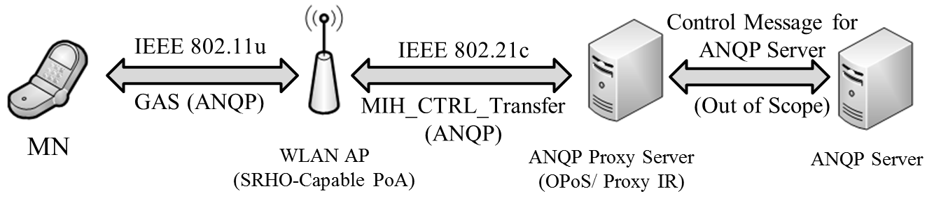
(a) ANQP Message Transfer using Proxy IR.

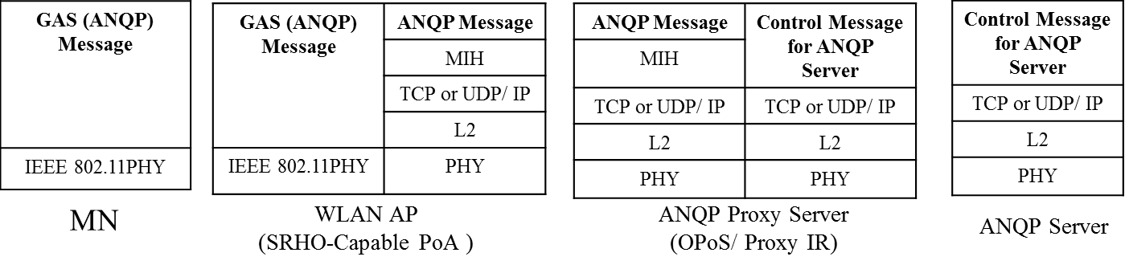
(b) Protocol Stacks for ANQP Transfer.
Figure T. 1 Proxy IR for ANQP Transfer.
The Figure T.2 shows Control Message Conversion for Information Repository. If the Information Repository does not support control messages that the MS can use, the Proxy IR converts the control message (Control Message A) for the MAN into other control message (Control Message B) for the Information Repository. The Proxy IR operates as a proxy of the Information Repository to the MN. To the Information Repository, the Proxy IR behaves like the MS that can communicate with the IR.

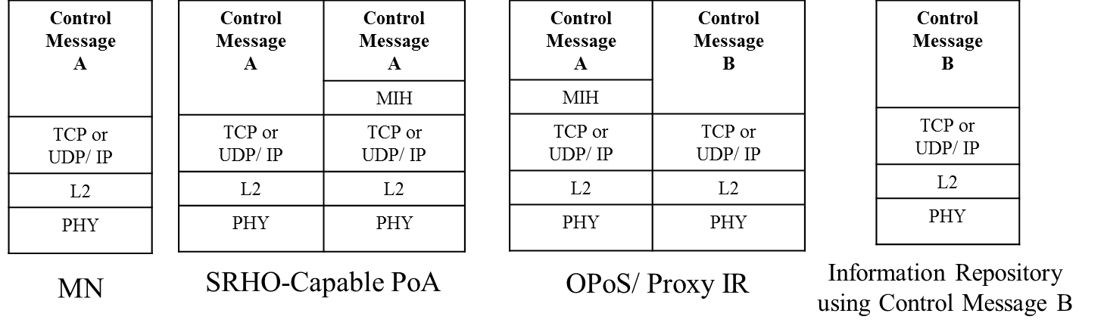
Figure T.2 Control Message Conversion for Information Repository.
If the MN uses ANQP messages but the Information Repository uses the other control messages such as ANDSF messages, the Proxy IR needs to convert ANQP messages to the other control messages. For this case, the WLAN AP as the SRHO-Capable PoA only encapsulates ANQP messages of the MN into MIH_CTRL_Transfer messages and decapsulates MIH_CTRL_Transfer messages of information server, as shown in Figure T.3 (a). Proxy IR converts the ANQP messages from the WLAN AP to the other control messages and vice versa. Hence, the MN can communicate with Information Repository by using the WLAN AP and the Proxy IR. To explain the ANQP conversion, the protocol stacks for MN, WLAN AP, Proxy, and Information Repository are shown in Figure T.3 (b).

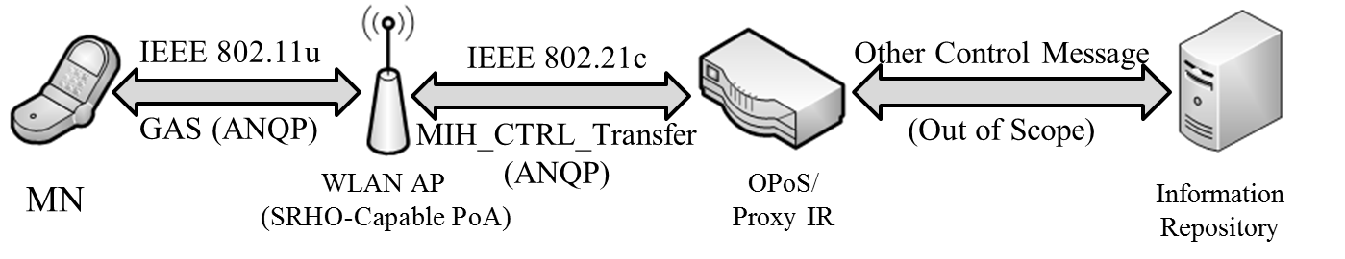
(a) ANQP Message Conversion using the Proxy IR.

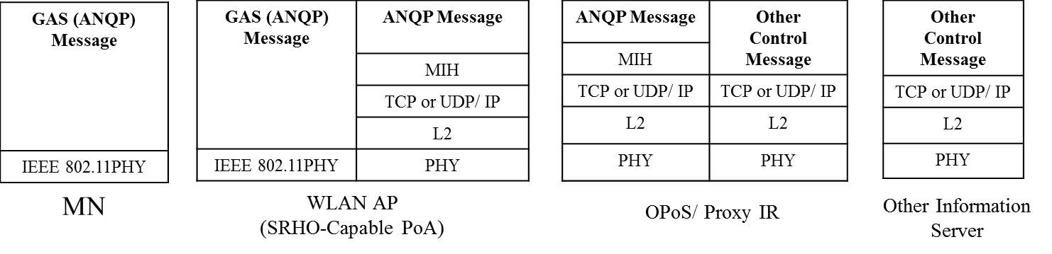
(b) Protocol Stacks for ANQP Conversion.
Figure T.3 Proxy IR for ANQP Conversion.

