IEEE P802.21
Media Independent Handover Services
Proposed Remedy for WG LB6a Comments (DCN# 21-13-0033-03-srho) on Annex Q of IEEE 802.21c Draft/D02
Date: 2013-04-04
Author(s):
Name | Affiliation | Address | Phone | email
Hyunho Park, Hyeong-Ho Lee | ETRI |  |  | hyunhopark@etri.re.kr, holee@etri.re.kr
Abstract
This document contains proposed remedy for WG LB6a Comments on Annex Q of IEEE 802.21c Draft/D02 based on the 802.21c LB comments file (DCN# 21-13-0033-03-srho). Also, this document proposes modification of texts on Annex Q of IEEE 802.21c Draft/D02.

Remedy for the WG LB6a Comments on Annex Q of IEEE 802.21c Draft/D02
- Comment #239 (Clause: Annex Q, Page: 52, Line 10). What is the purpose of this informative section?
- Opinion: Accept, More detailed purpose of Annex Q should be introduced in the beginning.
- To Editor: Please insert the following sentence at the beginning of Annex Q.
“The purpose of Annex Q is to introduce network discovery for single radio handover (SRHO). As shown in clause 1.4, the SRHO has restrictions on the use of radio interfaces to reduce interference between source and target radio interfaces and power consumption of mobile nodes.A mobile node is not free to use use the target radio when the source radio is operating. The Annex Q shows methods of network discovery under the restrictions of SRHO.”

- Comment #241 (Clause: Q.3, Page: 53, Line 23). I think this section does not make sense in a standard. Remove section.
- Opinion: Modified, Annex Q.3 is merged into Annex Q.2.

Follwing texts are modified Annex Q.

Annex Q Network discovery for single radio handover
(Informative)
The purpose of Annex Q is to introduce network discovery for single radio handover (SRHO). As shown in clause 1.4, the SRHO has restrictions on the use of radio interfaces to reduce interference between source and target radio interfaces and power consumption of mobile nodes.A mobile node is not free to use use the target radio when the source radio is operating. The Annex Q shows methods of network discovery under the restrictions of SRHO.

Q.1 Network discovery by listening to the target link
The first method is listening to the target link. When the mobile node can listen to the target link and signal strength of the source link decrease, the mobile node can scan candidate links and then can find the target link. Moreover, periodic scanning for the target link can support network discovery. This method serves the accurate detection of the target links, but the mobile node may follow the assumptions in subclause 1.4.
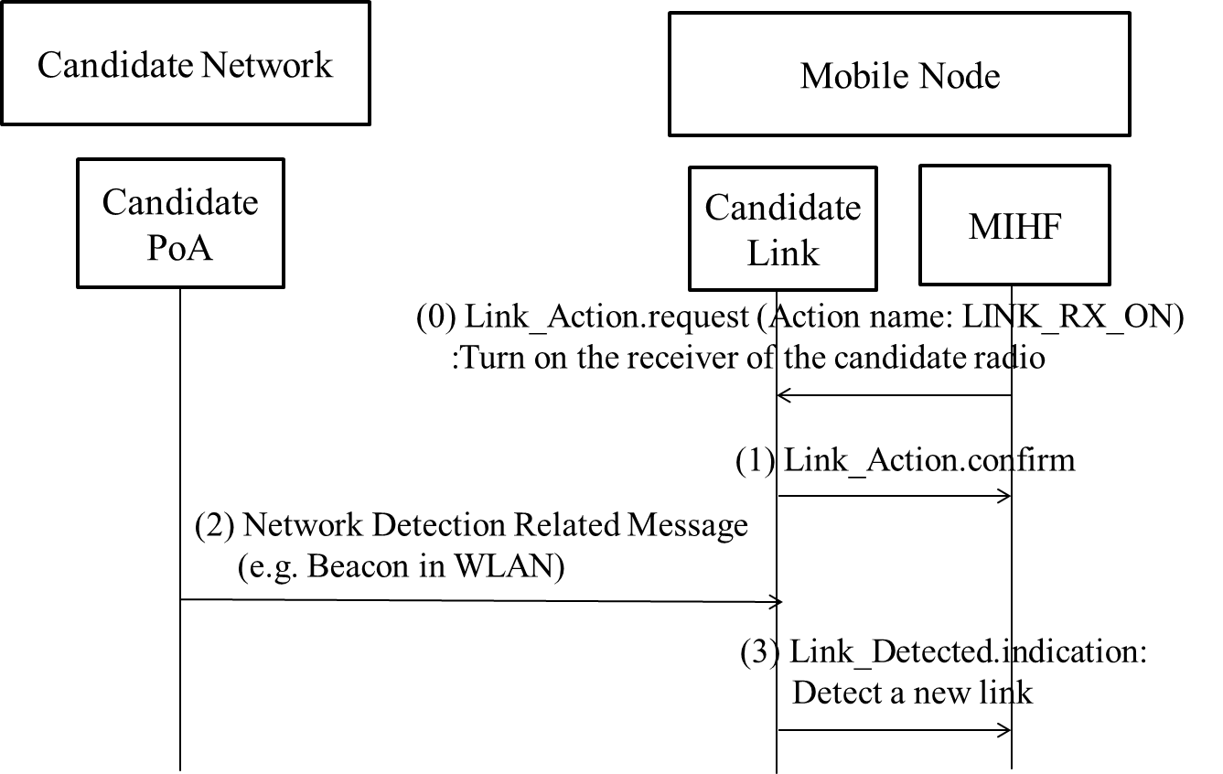
Figure Q.1- Network discovery by listening to the target link.
Figure Q.1 shows the case for network discovery listening to the target link with extended Link_Action. In (0) and (1), SR-MIHF turns on only the receiver of the candidate radio using Link_Action message with newly defined action name which is LINK_RX_ON. In (2), the candidate link listens to network detection related messages, such as beacon of IEEE 802.11 network. In (3), candidate link informs detection of a new link using Link_Detected message. This method serves the accurate detection of the target links, but the mobile node may follow the assumptions in subclause 1.4.

Q.2 Network discovery by using location information
The second method is network discovery based on the location information of the mobile node. This mechanism finds the target network using GPS (Global Positioning System) location information and interacting with the IR (Information Repository) explained in subclause 5.4.4. This mechanism will avoid the interference explained above. Although location information from global positioning system (GPS) can enhance network detection, the GPS also dissipates power in the mobile node which is often limited by the power capability of its battery. Also, the GPS systems performance is often degraded with the weak signals in an indoor environment. In the event of GPS signal loss, such as when entering a building, the last known location could be used. Moreover, it can be a huge load to the network to invoke a network information repository to support network discovery for the mobile nodes which are equipped with the GPS.

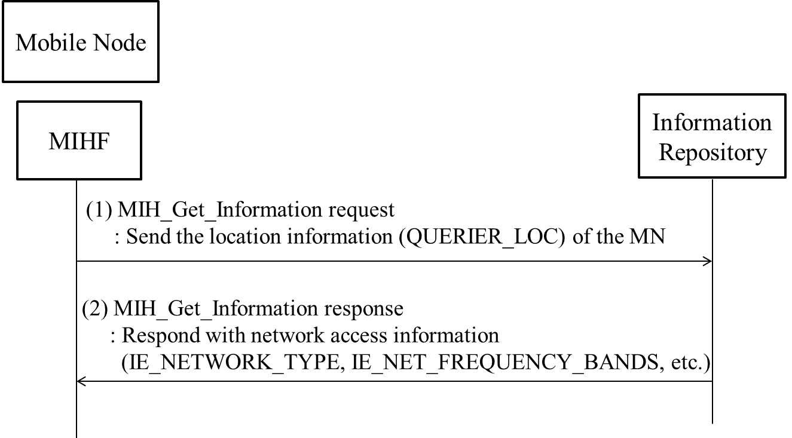
Figure Q.2- Network discovery using location information.
Figure Q.2 shows the case for network discovery using location information of the MN with QUERIER_LOC. In (1), the MN SR-MIHF sends the location information (QUERIER_LOC) of the MN through MIH_Get_Information request message. In (2), the IR SR-MIHF responds with network access information elements, such as IE_NETWORK_TYPE and IE_NET_FREQUENCY_BANDS.
Moreover, scheduled location information can be used for network discovery. The multi-radio MN can possess a lightweight software that includes schedule program, e.g., Google calendar, and many users are already managing their schedule through the use of a schedule program such as Google calendar. The schedule program usually shows the user’s location at the specific time. Based on user’s scheduled location information, the multi-radio MN can determine its available networks and the target radio.
The network discovery using scheduled location information can improve network discovery in indoor environments and reduce the network load. The GPS does not work correctly in indoor. The network discovery using the MN’s geo-location information using GPS is not appropriate in indoor. Moreover, periodical update of location information results in network load. The scheduled location information is not affected by indoor environment and does not need periodical update of location information. Thus, the network discovery using scheduled location information can be more efficient at indoor and network load than the conventional location information.
A usage of network discovery with the scheduled information is the same as follows. If Mr. Sam is scheduled to stay meeting room from 9AM to 11AM, the Mr. Sam’s multi-radio MN can discover a WLAN AP at the meeting room. In order to enhance this network discovery mechanism, the scheduled information can include the network information including information about link type, link identifier, link availability, link quality as defined in this standard. Using the network information, the mobile node can perform network discovery. If the MN knows the network information, it can try to connect to the network using that information.
In addition, records of user’s network access can enhance network discovery with or without the Information Repository. For example, if Mr. Sam had visited “Room #1” and accessed WLAN at some time. When Mr. Sam is scheduled to visit “Room #1” again, the recorded network information will show that Mr. Sam’s MN can connect the WLAN using the recorded WLAN access information.
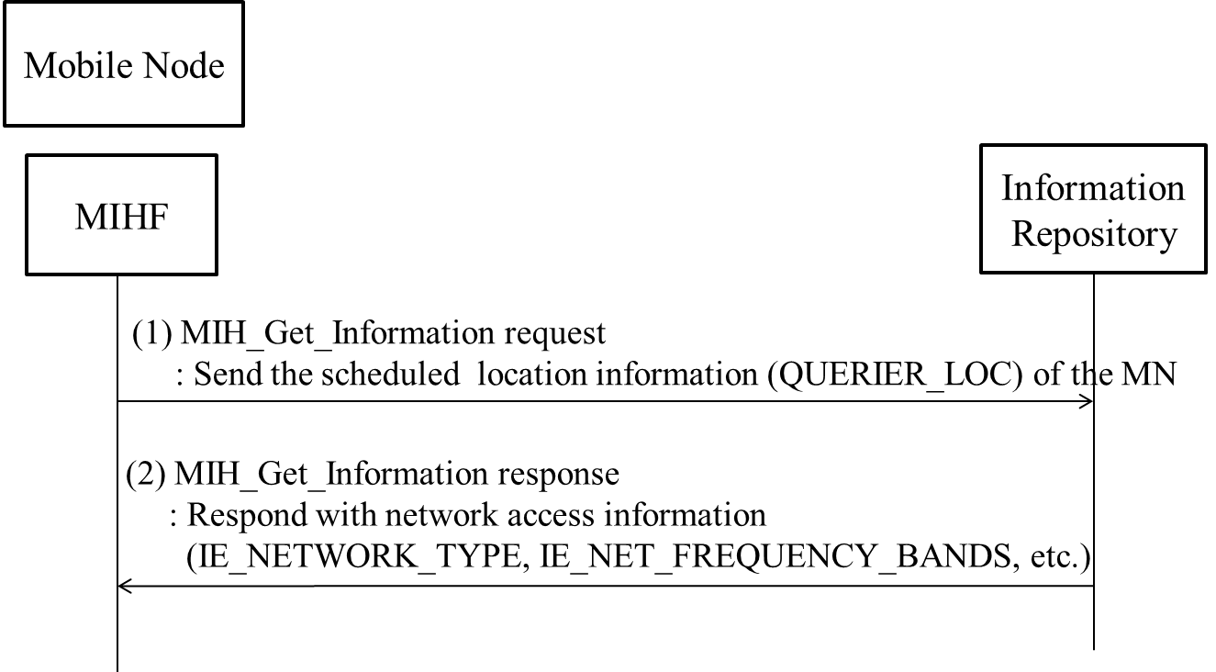
Figure Q.3- Network discovery using user scheduled location information.
Figure Q.3 shows the case for network discovery using scheduled location information of the MN with QUERIER_LOC. In (1), the MN SR-MIHF sends the scheduled location information (QUERIER_LOC) of the MN through MIH_Get_Information request message. In (2), the IR SR-MIHF responds with network access information elements, such as IE_NETWORK_TYPE and IE_NET_FREQUENCY_BANDS.

