IEEE P802.21
Media Independent Handover Services
Proposed Remedy for WG LB6a Comments on Annex Q, S, and T of IEEE 802.21c Draft/D02
Date: 2013-03-05
Author(s):
Name | Affiliation | Address | Phone | email
Hyunho Park, Hyeong-Ho Lee | ETRI |  |  | hyunhopark@etri.re.kr, holee@etri.re.kr
Abstract
This document contains proposed remedy for WG LB6a Comments on Annex Q, S, and T of IEEE 802.21c Draft/D02 based on the 802.21c LB comments file(21-13-0033-00c-CEP-srho-lb-comments-and-resolution.xlsx). Also, this document proposes modification of texts and figures of Annex Q, S, and T of 802.21c Draft/D02.

Remedy for the WG LB6a Comments on Annex Q, S, and T of IEEE 802.21c Draft/D02
- Comment #239 (Clause: Annex Q, Page: 52, Line 10). What is the purpose of this informative section?
- Opinion: Accept, The purpose of Annex Q is to introduce network discovery for single radio handover (SRHO). The SRHO has restrictions on the use of radio interfaces as shown in “1.4 Assumptions.” The Annex Q shows methods of network discovery under the restrictions of SRHO.
- To Editor: Please insert the following sentence at the beginning of Annex Q.
“The purpose of Annex Q is providing guideline of network discovery for SRHO.”

- Comment #240 (Clause: Q.1, Page: 52, Line: 21). Redundant command? Not clear why MIH_Prereg_Xfer command is unsuitable for this operation?
- Opinion: Reject, MIH_Prereg_Xfer commands are not appropriate for Annex Q.1. MIH_Prereg_Xfer commands are designed for preregistration procedure. The Annex Q deals with network discovery procedure before preregistration, and thus Annex Q has no relationship with MIH_Prereg_Xfer commands.

- Comment #241 (Clause: Q.3, Page: 53, Line 23). I think this section does not make sense in a standard. Remove section.
- Opinion: Reject, Network discovery using user schedule information can be a good network discovery for SRHO. User schedule information contains location information or network information in specific time. The location information or network information in specific time can help discovering networks. Thus, “Q.3 Network discovery: using user schedule information” is appropriate for network discovery for SRHO.

- Comment #242 (Clause: 12.3, Page: 53). Is this proxy service only for SRHO-Capable PoA? PoA is not restricted to a SRHO-Capable and non-SRHO-capable PoA. This distinction is more relevant in the MN.
- Clause 12.3 is not positioned on p. 53. This comment may indicate Figure 53 in Clause 12.3.
- Opinion: Reject, SRHO-Capable PoA is mandatory for Proxy Service of Information Repository. The SRHO-Capable PoA encapsulates control messages from MN into MIH messages to communicate with Proxy IR. The normal PoA cannot encapsulate control messages into MIH messages.

- Comment #247(Clause: S.2, Page: 84, Line: 2, Figure S.2). MIH_IF_PreReg_Ready response message is missing. Add MIH_IF_PreReg_Ready response message to Figure S.2.
- Opinion: Accept, The MIH_IF_PreReg_Ready response message is insterted in Figure S.2.
- To Editor: Please update Figure S.2 as follows.
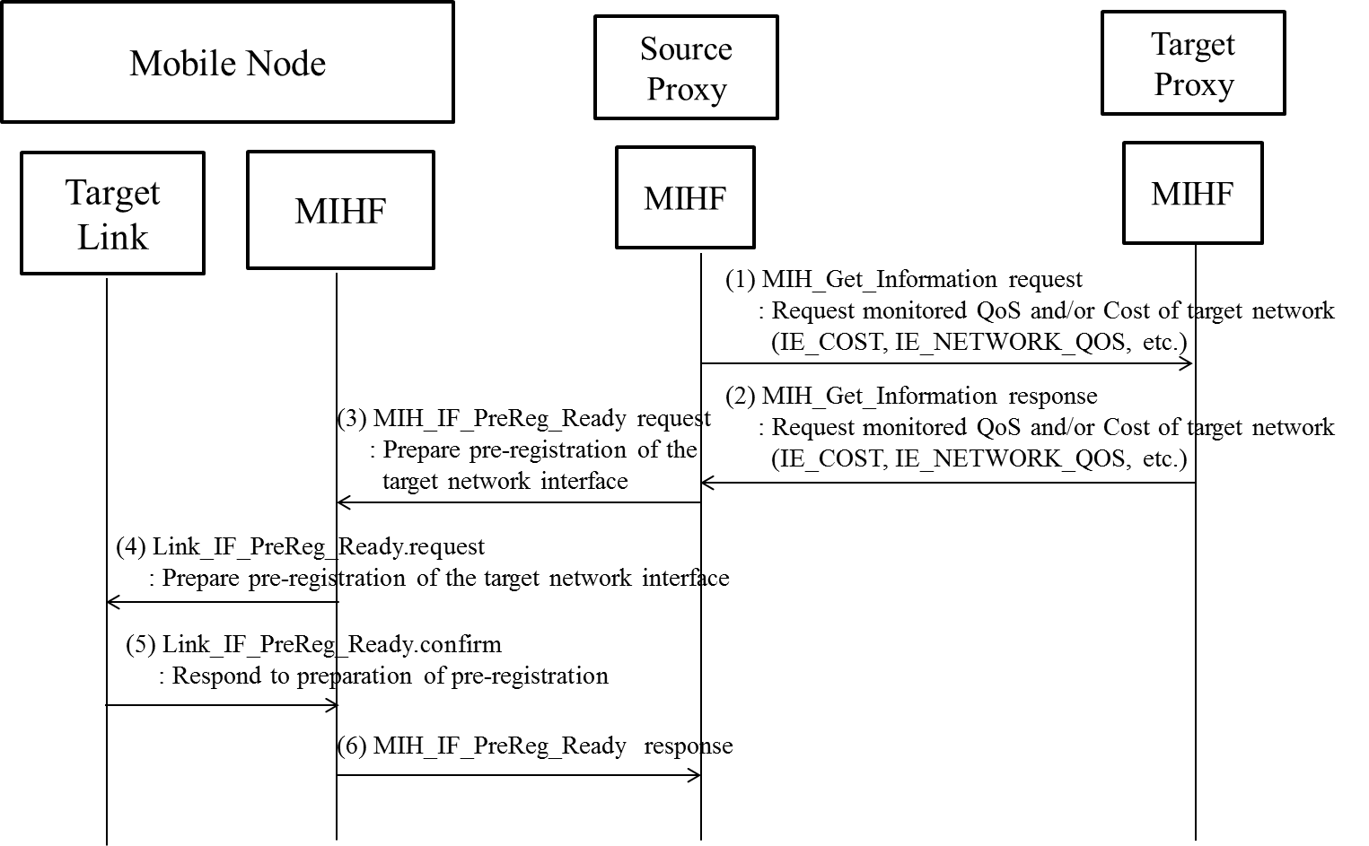
Figure S.2- HO decision caused by QoS and/or cost

- Comment #248 (Clause: Annext T, Page: 85, Line 5). Better integration with SRHO commands. Should explain how ANQP results (for example) enable faster handover, if possible by way of integration with MIH_Prereg_Xfer or other commands defind in the 802.21c document.
- Opinion: Clause, page number, and line number do not match. Thus, after asking commenter, Charles E. Perkins, about exact page and line number of comment #248 again, we will resolve comment #248.

- Comment #249 (Clause: Annex T, Page: 85, Line: 17, Figure T.1(a)). GAS exchange between MN and WLAN AP should be marked as out of scope. Add "out-of-scope" label below "GAS(ANQP)". Do the same for Figure T.3(a).
- Opinion: Accept, “Out of Scope” is added in Figure T.1.
- To Editor: Please update Figure T.1 (a) and Figure T.3 (a) as follows.
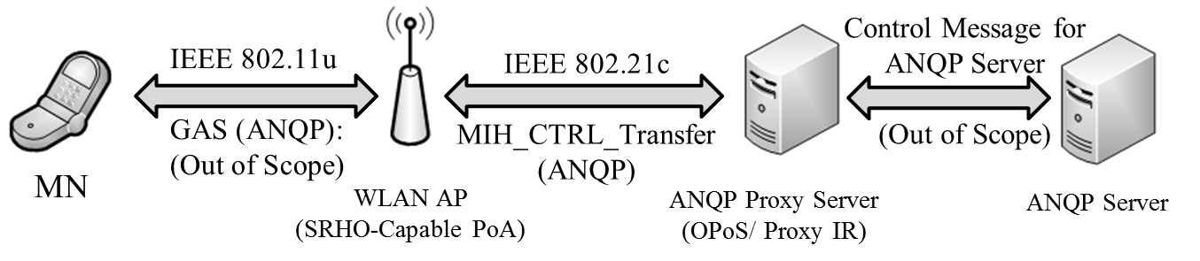
Figure T.1 (a) ANQP Message Transfer using Proxy IR.

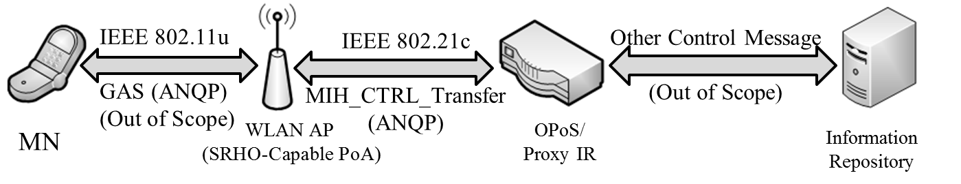
Figure T.3 (a) ANQP Message Conversion using the Proxy IR.

