Project | IEEE 802.21 Media Independent Handover Services  IEEE 802.21d: Multicast Group Management  <http://www.ieee802.org/21/>
Title | Proposal for IEEE 802.21d solution regarding the Generic Link ID parameter
Date Submitted | February 2013
Source(s)
Re: | IEEE 802.21d TG
Authors: | Daniel Corujo (ITAv), Carlos Guimarães (ITAv), Antonio de la Oliva (UC3M),
Abstract | This contribution provides a solution for the IEEE 802.21d
Purpose | Task Group Discussion and Acceptance
Notice | This document has been prepared to assist the IEEE 802.21 Working Group. It is offered as a basis for discussion and is not binding on the contributing individual(s) or organization(s). The material in this document is subject to change in form and content after further study. The contributor(s) reserve(s) the right to add, amend or withdraw material contained herein.

NOTE

1 – In this contribution we provide an example of the application of the Generic Link ID concept, into a MIH_Event_Subscribe. The intent is to generate discussion, in order to reach a consensus solution.

In order to support a Generic Link ID concept, there can be the need to specify a group of interfaces/technologies as intended target of the link command. The rationale is explained as follows.

Rationale for including a NET_TYPE_INC to support a Generic Link ID behavior
A multicast message may be destined to several links from different entities in order to perform the same operation in all of them (e.g. configure a specific threshold in all WLAN interfaces). For that, the reutilization of the NET_TYPE_INC data type into the command, into a field named MulticastLinkIdentifier, allows the specification of a group of destination links identified by its technology. The presented solution allows backwards compatibility.

When a message/primitive contains a LinkIdentifier or MulticastLinkIdentifier, one and only one must be presented in the message.

2 – When the MIHF receives a remote command towards several of it’s Link layers, how does he manage the responses of the separate link layers, in regards to it’s MIH response towards the requester MIHF? To explain the problem, lets assume the following example:

- The MIHF1 sends a multicast MIH_Link_Configure_Thresholds.request with a Generic Link ID to the MIHF2.
- The MIHF2 forwards the request to both Link SAPs.

The question is: How will the MIHF2 handle the responses from the Link SAPs? The state machines from the destination MIHF do not allow it to send several messages belonging to the same Transaction ID. Also, the available messages do not allow the MIHF to group all responses in a single response message. As a solution, for each response from the Link SAP the MIHF2 sends a response message to the MIHF1. This solution requires some changes to the state machine, which are shown in this document in the proposed changes affecting the respective section.

All changes are explicitly marked in bold.

7.4.15 MIH_Event_Subscribe

7.4.15.1 General

The MIH_Link_Configure_Thresholds is issued by an upper layer entity to configure parameter report thresholds of a lower layer. The destination of an MIH_Link_Configure_Thresholds command is local or remote. This command configures one or more thresholds on a link. When a given threshold is crossed, an MIH_Link_Parameters_Report notification shall be sent to all MIH users that are subscribed to this threshold-crossing event.

7.4.15.2 MIH_Link_Configure_Threshold.request

7.4.15.1.1 Function

This primitive is issued by an MIH user to configure thresholds of a lower layer link.

7.4.15.1.2 Semantics of service primitive

MIH_Link_Configure_Thresholds.request (

DestinationIdentifier,

LinkIdentifier,

MulticastLinkIdentifier

ConfigureRequestList

)

Parameters:

Name | Data type | Description
DestinationIdentifier | MIHF_ID | This identifies the local MIHF or a remote MIHF that will be the destination of this request.
LinkIdentifierª | LINK_TUPLE_ID | (optional) Identifier of the link to be configured.
MulticastLinkIdentifierª | NET_TYPE_INC | (optional) Identifier of a group of links to be configured
RequestedMIHEventList | LIST(LINK_CFG_PARAM) | A list of link threshold parameters.
ªThe primitive must contain the Link identifier TLV or Multicast link identifier TLV.

7.4.15.1.3 When generated

This primitive is invoked by an MIH user when it attempts to configure thresholds of a local or remote lower layer link.

7.4.15.1.4 Effect on receipt

If the destination of the request is the local MIHF itself, the local MIHF issues a Link_Configure_Thresholds request to the lower layer link to set the thresholds for the link according to the specified configuration parameters.

If the destination of the request is a remote MIHF, the local MIHF generates and sends an MIH_Link_Configure_Thresholds request message to the remote MIHF. Upon the receipt of the message, the remote MIHF then issues a Link_Configure_Thresholds request to the lower layer link to set the thresholds for the link according to the specified configuration parameters.

7.4.15.3 MIH_Link_Configure_Thresholds.confirm

7.4.15.3.1 Function

This primitive is issued by an MIHF to report the result of an MIH_Link_Configure_Thresholds request.

7.4.15.3.2 Semantics of service primitive

MIH_Link_Configure_Thresholds.confirm (

SourceIdentifier,

Status,

LinkIdentifier,

ConfigureResponseList

)

Parameters:

Name | Data type | Description
SourceIdentifier | MIHF_ID | This identifies the invoker of this primitive, which can be either the local MIHF or a remote MIHF.
Status | STATUS | Status of operation.
LinkIdentifier | LINK_TUPLE_ID | Identifier of the link configured
ConfigureResponseListª | LIST(LINK_CFG_STATUS) | A list of the configuration status for each requested link threshold parameter.

ªThis parameter is not included if Status does not indicate “Success.”

7.4.15.3.3 When generated

This primitive returns the result of an MIH_Link_Configure_Thresholds request to the requesting MIH user.

7.4.15.3.4 Effect on receipt

Upon receipt of the result, the MIH user makes appropriate evaluations and takes any suitable actions. However, if Status does not indicate “Success,” the recipient performs appropriate error handling.

CHANGE SECTION 8 ACCORDINGLY

8.2.3.7.1 Intra-state-machine procedures
a) IsMulticast.—This variable’s type is BOOLEAN. When its value is TRUE, it indicates that a message has a multicast destination MIHF_ID. Otherwise, its value is FALSE.
b) IsBroadcast.—This variable’s type is BOOLEAN. When its value is TRUE, it indicates that a message has a broadcast destination MIHF_ID. Otherwise, its value is FALSE.
c) ResponseSent – This variable’s type is BOOLEAN. When its value is TRUE, it indicates that a Response message has been sent. Otherwise, its value is FALSE.
8.2.3.7.4 Transaction destination state machine
The transaction destination state machine (see Figure 24) is started, and related transaction initiated, when a message related to a new transaction is received (MsgInAvail is TRUE).
The transaction terminates when it transits to the FAILURE state or SUCCESS state and any ACK related state machines, if started, were terminated. An instance of transaction destination state machine can cease to exist once the value of TransactionStatus is set to either SUCCESS or FAILURE.
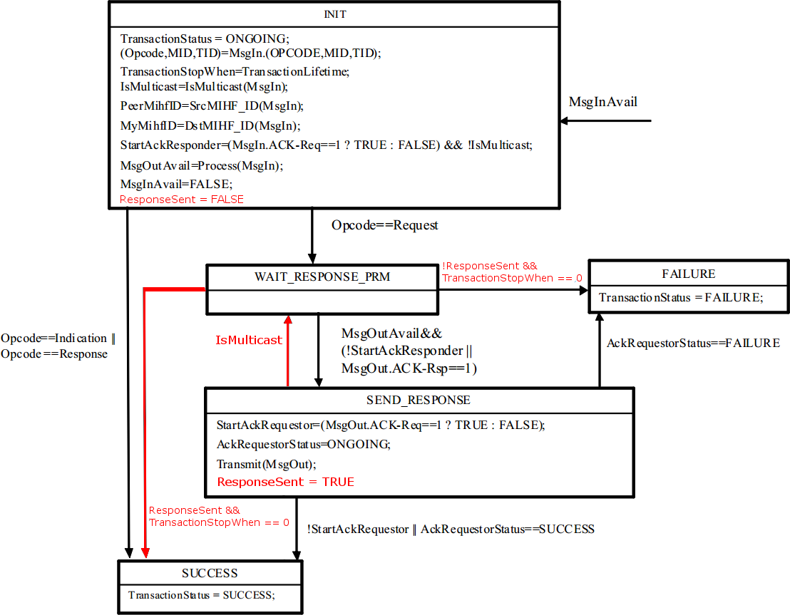
8.6.3 MIH messages for command service
8.6.3.3 MIH_Link_Configure_Thresholds request
The corresponding MIH primitive of this message is defined in 7.4.15.2.

This message is used to configure thresholds of the lower layer link. The message must contain the Link identifier TLV or Multicast link identifier TLV.

MIH Header Fixed Fields (SID=3, Opcode=1, AID=2)
Source Identifier = sending MIHF ID
(Source MIHF ID TLV)
Destination Identifier = receiving MIHF ID
(Destination MIHF ID TLV)
LinkIdentifier (optional)
(Link identifier TLV)
MulticastLinkIdentifier (optional)
(Multicast Link ID TLV)
ConfigureRequestList
(Register request code TLV)
8.6.3.4 MIH_Link_Configure_Thresholds response
The corresponding MIH primitive of this message is defined in 7.4.15.3.

This message returns the status of a thresholds configuration request. The MIHF generating this message generates MIH_Link_Parameters_Report indication message when the configured threshold is crossed.

MIH Header Fixed Fields (SID=3, Opcode=2, AID=2)
Source Identifier = sending MIHF ID
(Source MIHF ID TLV)
Destination Identifier = receiving MIHF ID
(Destination MIHF ID TLV)
Status
(Status TLV)
LinkIdentifier
(Link identifier TLV)
ConfigureResponseList (not included if Status does not indicate “Success”)
(Configure response list TLV)

Annex L
(normative)
Change Table L.2 as follows:

Table L.2—Type values for TLV encoding
TLV type name | TLV  type value | Data type
Requested resource set | 63 | REQ_RES_SET
Broadcast multimedia program ID | 76 | BCST_MMP_ID
Broadcast multimedia service ID | 77 | BCST_MMS_ID
Target MN group information | 78 | GROUP_INFO
Supported link actions list | 79 | SUPPORTED_LINK_ACTIONS_LIST
Multicast Groups list TLV | 80 | LIST(MULTICAST_GRP)
Group_Status TLV | 81 | LIST(  SEQUENCE(MIHF_ID,  STATUS,  VALID_TIMEa))
Mutlicast link ID | 82 | NET_TYPE_INC
(Reserved) | 64 82- 99 | (Reserved)
Vendor specific TLV | 100 | (Vendor specific)
(Reserved for experimental TLVs) | 101 - 255 | (Used for experimental purposes)

