IEEE P802.21
Media Independent Handover Services
802.21c proposed modification on Proxy Function
Date: 2012-12-20
Author(s):
Name | Affiliation | Address | Phone | email
Hyunho Park, Hyeong-Ho Lee | ETRI |  |  | hyunhopark@etri.re.kr, holee@etri.re.kr
Abstract
This document is the updated document of “802.21c proposed modification on Gateway Service: Proxy Function (DCN#21-12-0190-00)” that was discussed during the teleconference on December 18th. Compared to the previous document (DCN#21-12-0190-00), Section 12, Section 8.6.3, Annex F, and Annex L are updated, and Annex T, which deals with Practical Uses of Proxy Function, is newly made.

Text Update on “7.4 MIH_LINK_SAP primitives”
To Editor: Insert following messages into subsections of Section 7.4.
7.4.(XX) MIH_CTRL_Transfer
7.4.(XX).1 MIH_CTRL_Transfer.request
7.4.(XX).1.1 Function
This primitive delivers control messages encapsulated by MIH header. The control messages are messages to control networks. Therefore, the control messages are not only network specific control messages but also messages, such as ANQP and ANDSF messages, for interworking heterogenous networks.
7.4.(XX).1.2 Semantics of service primitive
MIH_CTRL_Transfer.request (
DestinationIdentifier,
CTRLInformation,
)
Parameters:
Name | Data type | Description
DestinationIdentifier | MIHF_ID | Identifies a remote MIHF as the destination of this request.
CTRLInformation | CTRL_PRTC_MSGS | Delivers control messages.

7.4.(XX).1.3 When generated
This primitive is generated by an MIH user to deliver control messages such as ANQP and ANDSF messages.
7.4.(XX).1.4 Effect on receipt
After reception of this primitive, the MIHF must generate an MIH_CTRL_Transfer request message towards the remote MIHF.
7.4.(XX).2 MIH_CTRL_Transfer.indication
7.4.(XX).2.1 Function
This primitive is used by the remote MIHF to notify the corresponding MIH user about the reception of an MIH_CTRL_Transfer request message.
7.4.(XX).2.2 Semantics of service primitive
MIH_CTRL_Transfer.indication (
SourceIdentifier,
CTRLInformation,
)
Parameters:
Name | Data type | Description
SourceIdentifier | MIHF_ID | Identifies the invoker, typically a remote MIHF.
CTRLInformation | CTRL_PRTC_MSGS | This delivers control messages.

7.4.(XX).2.3 When generated
This primitive is generated by a remote MIHF after receiving an MIH_CTRL_Transfer request message.
7.4.(XX).2.4 Effect on receipt
The MIH user must generate an MIH_CTRL_Transfer.response primitive.
7.4.(XX).3 MIH_CTRL_Transfer.response
7.4.(XX).3.1 Function
This primitive is used by an MIH user to provide control messages to the local MIHF.
7.4.(XX).3.2 Semantics of service primitive
MIH_CTRL_Transfer.response (
DestinationIdentifier,
CTRLInformation,
Status
)
Parameters:
Name | Data type | Description
DestinationIdentifier | MIHF_ID | This identifies a remote MIHF that will be the destination of this response.
CTRLInformation | CTRL_PRTC_MSGS | Delivers control messages.
Status | STATUS | Status of the operation. Code 3 (Authorization Failure) is not applicable.

7.4.(XX).3.3 When generated
This primitive is generated by the local MIHF after receiving an MIH_CTRL_Transfer.indication primitive.
7.4.(XX).3.4 Effect on receipt
The local MIHF may generate an MIH_CTRL_Transfer response messag.
7.4.(XX).4 MIH_CTRL_Transfer.confirm
7.4.(XX).4.1 Function
This primitive is used to notify the corresponding MIH user about the reception of an MIH_CTRL_Transfer response message.
7.4.(XX).4.2 Semantics of service primitive
MIH_CTRL_Transfer.confirm (
SourceIdentifier,
CTRLInformation,
Status
)
Parameters:
Name | Data type | Description
SourceIdentifier | MIHF_ID | This identifies the invoker, which is a remote MIHF.
CTRLInformation | CTRL_PRTC_MSGS | Delivers control messages.
Status | STATUS | Status of the operation. Code 3 (Authorization Failure) is not applicable.

7.4.(XX).4.3 When generated
This primitive is generated by the local MIHF after receiving an MIH_CTRL_Transfer response message.
7.4.(XX).4.4 Effect on receipt
The MIH user on the MN may generate an MIH_CTRL_Transfer.request primitive.

To Editor: Delete Table that was inserted in Section 8.4.1 for the gateway service.

Text Update on “8.6.3 MIH messages for command service”
To Editor: Insert following messages into subsections of Section 8.6.3.
8.6.3.(XX) MIH_CTRL_Transfer request
This message is used to deliver control messages such as ANQP and ANDSF message. The delivery of control messages is described in Section 12.3.
MIH Header Fields (SID=3, Opcode=1, AID=16)
Source Identifier = sending MIHF ID
(Source MIHF ID TLV)
Destination Identifier = receiving MIHF ID
(Destination MIHF ID TLV)
CTRLInformation
(Control Information TLV)

8.6.3.(XX+1) MIH_CTRL_Transfer response
This message is used to respond to MIH_CTRL_Transfer request message. Moverover, this message can deliver control messages such as ANQP and ANDSF message. The delivery of control messages is described in Section 12.3.
MIH Header Fields (SID=3, Opcode=2, AID=16)
Source Identifier = sending MIHF ID
(Source MIHF ID TLV)
Destination Identifier = receiving MIHF ID
(Destination MIHF ID TLV)
CTRLInformation
(Control Information TLV) (optional)

Text Update on “12. Gateway Service”

To Editor: Definition of Proxy Function is needed. Moreover, the Proxy Function should include transfer of L2 frames for pre-registration and control messages such as ANQP and ANDSF messages to enhance cooperation between heterogeneous networks using different control messages.
To Editor: Please change the name of section 12 from “12. Gateway Service” to “12. Proxy Function” because gateway service is determined not to be used, but Proxy Function is determined to be used.

To Editor: “Gateway service” in Section 12 should be changed into “Proxy Function”; MICF should be changed into MIHF.

To Editor: “interworking protocol,” “interworking protocol message,”and “interworking message” in Section 12.1 should be changed into “control message”.

To Editor: Please change the last paragraph, which is “For transfer and conversion of the L2 messages or other interworking protocols, the SID for “Gateway Service” is defined as “5.” The “Gateway Service” reduces system complexity and increases compatibility to the other networks,” in Section 12.1into the following paragraph:
“For transfer and conversion of other controls, MIH_CTRL_Transfer message can be used. The “Proxy Function” reduces system complexity and increases compatibility to the other networks.”
To Editor: Delete “12.3 L2 Message Transfer (SID=5, AID=1)” and “12.4 Interworking Protocol Delivery (SID=5, AID>1).”
To Editor: Insert following section as Section 12.3.
12.3 Transfer of Control Message
As extension of L2 message transfer in Figure 51, the transfer of control message, as shown in Figure 57, can be considered. If the corresponding network entity supports “Proxy Function,” the PoA can only encapsulate control messages with the MIHF header using MIH_CTRL_Transfer messages. The PoA uses the encapsulated messages to communicate with the corresponding network entity. The PoA only encapsulates control messages but does not need full function of the MIH. It means the implementation of the PoA can be simplified. Use cases and extension of the Proxy Function is included in Annex T.

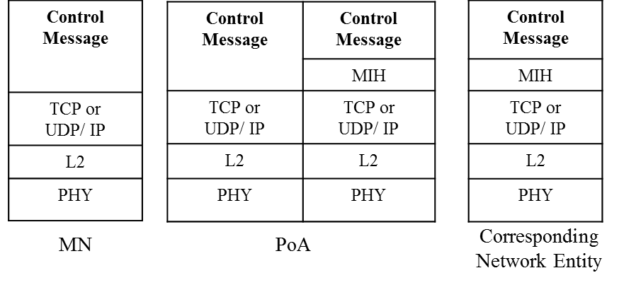
Figure 57. Proxy Function for Control Message Transfer

Annex F
To Editor: Insert the following Section F.3.16.
F.3.16 Data types for delivery of control messages
Table F.25- Data types for delivery of control messages
Data type name | Derived form | Definition
CTRL_PRTC_MSGS | SEQUENCE(  CTRL_TYPE,  CTRL_MSGS  ) | Represent which control messages are delivered. CTRL_TYPE represents a type of control messages. CTRL_MSGS represents control messages to be delivered.
CTRL_TYPE | UNSIGNED_INT(1) | A type to represent control messages.  0: ANQP  1~122: Reserved for other controls  123~255: Reserved for vendor specific uses
CTRL_MSGS | OCTET_STRING | Represents control messages to be delivered.

Annex L
To Editor: Insert the changed rows to Table L.1
MIH messages | AID
MIH messages for Service Management
MIH_CTRL_Transfer | 10
MIH_N2N_LL_Transfer | 11
MIH messages for Command Service
MIH_IF_PreReg_Ready | 13
MIH_TNMN_SA_Estab | 14
MIH_MNTN_SA_Estab | 15
MIH_CTRL_Transfer | 16

To Editor: Insert the following rows to Table L.2
TLV type name | TLV  type value | Data type
Control Information | 76 | CTRL_PRTC_MSGS

To Editor: Please insert the following Annex T.
Annex T
(Informative)
Practical Uses of Proxy Function
When the MN wants to receive ANQP messages of access network information from the information server, the WLAN AP (Access Point) can perform as a proxy between the MN and information server as shown in Figure T.1 (a). As explained in Figure 57, if the information server supports Proxy Function and ANQP, the PoA can only encapsulate control messages with the MIHF header using MIH_CTRL_Transfer messages. This information server can be called as ANQP Proxy Server. The WLAN AP only encapsulates ANQP messages of the MN into MIH_CTRL_Transfer messasges and decapsulates MIH_CTRL_Transfer message of ANQP Proxy Server, as shown in Figure T.1 (b). The WLAN AP does not need to have all functions of the MIH. It means the WLAN AP as a proxy of the MN can be implemented by using Proxy Function.

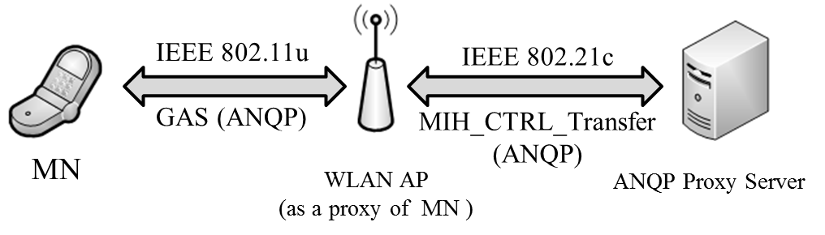
(a) ANQP Transfer using the WLAN AP as a Proxy

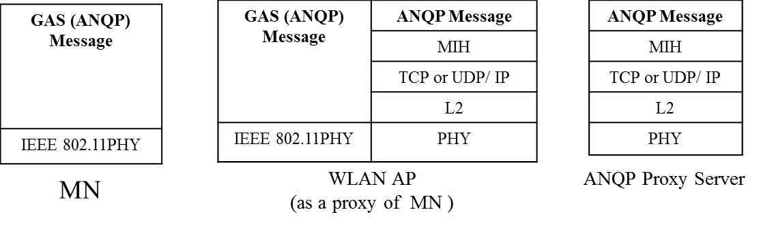

(b) Protocol Stacks for ANQP Transfer
Figure T. 1 ANQP Transfer from ANQP Proxy Server

As extension of L2 message conversion in Figure 52, the control message conversion, as shown in Figure T.2, can be considered. If the corresponding network entity does not support Proxy Function, the Proxy converts the control message (Control Message A) into other control message (Control Message B) for the corresponding network entity. The Proxy operates as a proxy with other control message to communicate with other control network entity, and thus enhances mobility signaling.

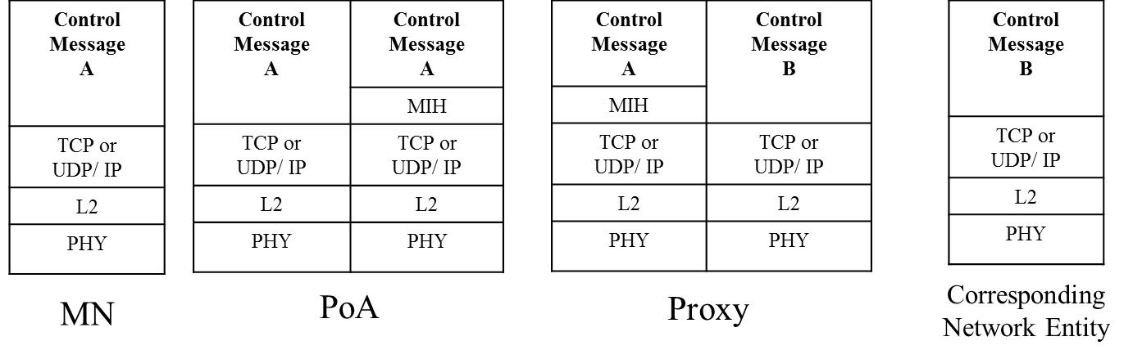
Figure T.2 Proxy Function for Control Message Conversion

If the information server does not support Proxy Function, the WLAN AP cannot communicate with the information server using the MIH_CTRL_Transfer messages. In this case, the Proxy bridges between the WLAN AP and the information server. The WLAN AP only encapsulates ANQP messages of the MN into MIH_CTRL_Transfer messasges and decapsulates MIH_CTRL_Transfer message of information server, as shown in Figure T.3 (a). Proxy converts the ANQP messages from the WLAN AP to the other control messages such as ANDSF messages and vice versa. Hence, the information server can communicate with the WLAN AP via the Proxy. To explain the ANQP conversion, the protocol stacks for MN, WLAN AP, Proxy, and information server are shown in Figure T.3 (b).
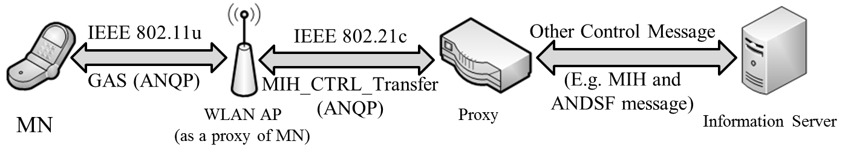
(a) ANQP Conversion using the Proxy
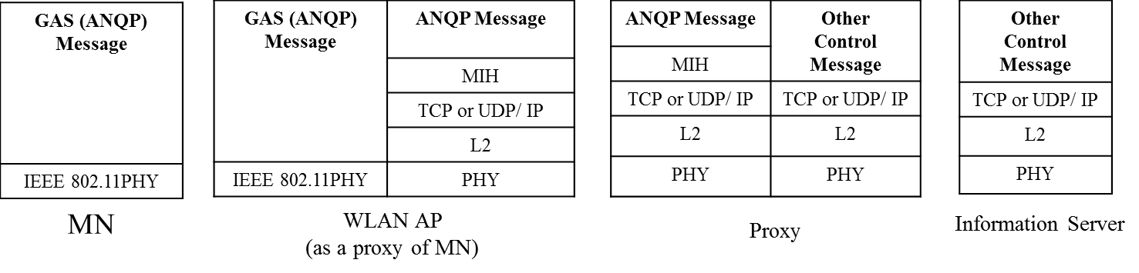
(b) Protocol Stacks for ANQP Conversion
Figure T.3 ANQP Conversion using Proxy

