IEEE P802.21
Media Independent Handover Services
802.21c proposed modification on Gateway Service: Proxy Function
Date: 2012-12-18
Author(s):
Name | Affiliation | Address | Phone | email
Hyunho Park, Hyeong-Ho Lee | ETRI |  |  | hyunhopark@etri.re.kr, holee@etri.re.kr
Abstract
This document contains Proxy Function, which is changed from Gateway Service that was mainly discussed in Section 12 of the IEEE 802.21c draft, “IEEE_P802_21c_D02-LB_rev_4 (DCN#21-12-0185-00).” The Proxy Function was proposed as a substitute during the teleconference on December 11th.

Text Update on “7.4 MIH_LINK_SAP primitives”
To Editor: Insert following messages into subsections of Section 7.4.
7.4.(XX) MIH_ITW_Transfer
7.4.(XX).1 MIH_ITW_Transfer.request
7.4.(XX).1.1 Function
This primitive delivers interworking messages encapsulated by MIH header.
7.4.(XX).1.2 Semantics of service primitive
MIH_ITW_Transfer.request (
DestinationIdentifier,
ITWInformation,
)
Parameters:
Name | Data type | Description
DestinationIdentifier | MIHF_ID | Identifies a remote MIHF as the destination of this request.
ITWInformation | ITW_PRTC_MSGS | Delivers interworking protocol messages.

7.4.(XX).1.3 When generated
This primitive is generated by an MIH user to deliver interworking messages.
7.4.(XX).1.4 Effect on receipt
After reception of this primitive, the MIHF must generate an MIH_ITW_Transfer request message towards the remote MIHF.
7.4.(XX).2 MIH_ITW_Transfer.indication
7.4.(XX).2.1 Function
This primitive is used by the remote MIHF to notify the corresponding MIH user about the reception of an MIH_ITW_Transfer request message.
7.3.(XX+1).2 Semantics of service primitive
MIH_ITW_Transfer.indication (
SourceIdentifier,
ITWInformation,
)
Parameters:
Name | Data type | Description
SourceIdentifier | MIHF_ID | Identifies the invoker, typically a remote MIHF.
ITWInformation | ITW_PRTC_MSGS | This delivers interworking protocol messages.

7.4.(XX).2.3 When generated
This primitive is generated by a remote MIHF after receiving an MIH_ITW_Transfer request message.
7.4.(XX).2.4 Effect on receipt
The MIH user must generate an MIH_ITW_Transfer.response primitive.
7.4.(XX).3 MIH_ITW_Transfer.response
7.4.(XX).3.1 Function
This primitive is used by an MIH user to provide interworking messages to the local MIHF.
7.4.(XX).3.2 Semantics of service primitive
MIH_ITW_Transfer.response (
DestinationIdentifier,
ITWInformation,
Status
)
Parameters:
Name | Data type | Description
DestinationIdentifier | MIHF_ID | This identifies a remote MIHF that will be the destination of this response.
ITWInformation | ITW_PRTC_MSGS | Delivers interworking protocol messages.
Status | STATUS | Status of the operation. Code 3 (Authorization Failure) is not applicable.

7.4.(XX).3.3 When generated
This primitive is generated by the local MIHF after receiving an MIH_ITW_Transfer.indication primitive.
7.4.(XX).3.4 Effect on receipt
The local MIHF may generate an MIH_ITW_Transfer response messag.
7.4.(XX).4 MIH_ITW_Transfer.confirm
7.4.(XX).4.1 Function
This primitive is used to notify the corresponding MIH user about the reception of an MIH_ITW_Transfer response message.
7.4.(XX).4.2 Semantics of service primitive
MIH_ITW_Transfer.confirm (
SourceIdentifier,
ITWInformation,
Status
)
Parameters:
Name | Data type | Description
SourceIdentifier | MIHF_ID | This identifies the invoker, which is a remote MIHF.
ITWInformation | ITW_PRTC_MSGS | Delivers interworking protocol messages.
Status | STATUS | Status of the operation. Code 3 (Authorization Failure) is not applicable.

7.4.(XX).4.3 When generated
This primitive is generated by the local MIHF after receiving an MIH_ITW_Transfer response message.
7.4.(XX).4.4 Effect on receipt
The MIH user on the MN may generate an MIH_ITW_Transfer.request primitive.

To Editor: Delete Table that was inserted in Section 8.4.1 for the gateway service.

Text Update on “8.6.3 MIH messages for command service”
To Editor: Insert following messages into subsections of Section 8.6.3.
8.6.3.(XX) MIH_ITW_Transfer request
This message is used to deliver interworking messages such as ANQP message. The delivery of interworking messages is described in Section 12.3. The message format of MIH_ITW_Transfer request is the same as follows.
MIH Header Fields (SID=3, Opcode=1, AID=16)
Source Identifier = sending MIHF ID
(Source MIHF ID TLV)
Destination Identifier = receiving MIHF ID
(Destination MIHF ID TLV)
ITWInformation
(Interworking Information TLV)

8.6.3.(XX+1) MIH_ITW_Transfer response
This message is used to respond to MIH_ITW_Transfer request message. Moverover, this message can deliver interworking messages such as ANQP message. The delivery of interworking messages is described in Section 12.3. The message format of MIH_ITW_Transfer request is the same as follows.
MIH Header Fields (SID=3, Opcode=2, AID=16)
Source Identifier = sending MIHF ID
(Source MIHF ID TLV)
Destination Identifier = receiving MIHF ID
(Destination MIHF ID TLV)
ITWInformation
(Interworking Information TLV)

Text Update on “12. Gateway Service”

To Editor: Definition of Proxy Function is needed. Moreover, the Proxy Function should include transfer of L2 frames for pre-registration and interworking protocol messages such as ANQP to enhance cooperation between heterogeneous networks using different interworking protocol messages.
To Editor: Please change the name of section 12 from “12. Gateway Service” to “12. Proxy Function” because gateway service is determined not to be used, but Proxy Function is determined to be used.

To Editor: “Gateway service” in Section 12 should be changed into “Proxy Function”; MICF should be changed into MIHF.
To Editor: Please change the last paragraph, which is “For transfer and conversion of the L2 messages or other interworking protocols, the SID for “Gateway Service” is defined as “5.” The “Gateway Service” reduces system complexity and increases compatibility to the other networks,” in Section 12.1into the following paragraph:
“For transfer and conversion of other interworking protocols, MIH_ITW_Transfer message can be used. The “Proxy Function” reduces system complexity and increases compatibility to the other networks.”
To Editor: Delete “12.3 L2 Message Transfer (SID=5, AID=1)” and “12.4 Interworking Protocol Delivery (SID=5, AID>1).”
To Editor: Insert following section as Section 12.3.
12.3 Transfer of Interworking Protocol Message
As extension of L2 message transfer in Figure 51, the transfer of interworking protocol message, as shown in Figure 57, can be considered. If the corresponding network entity supports “Proxy Function,” the PoA can only encapsulate interworking protocol messages with the MIHF header using MIH_ITW_Transfer messages. The PoA uses the encapsulated messages to communicate with the corresponding network entity. The PoA only encapsulates interworking protocol messages but does not need full function of the MIH. It means the implementation of the PoA can be simplified.
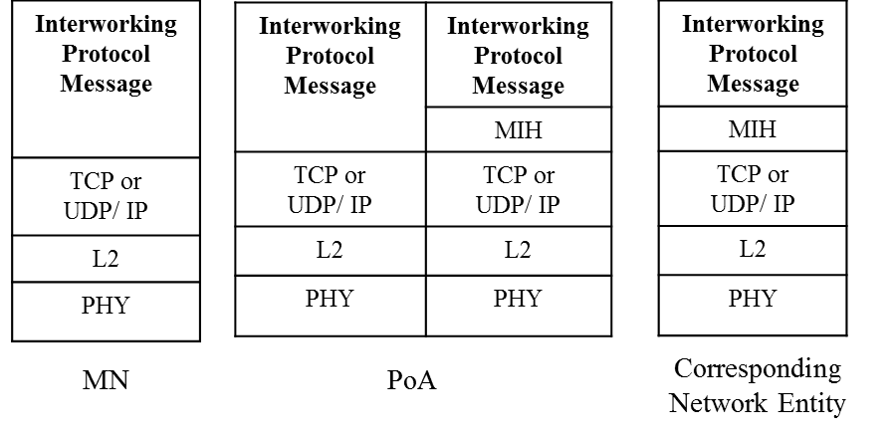
Figure 57. Proxy Function for Interworking Protocol Message Transfer
As extension of L2 message conversion in Figure 52, the interworking protocol message conversion, as shown in Figure 58, can be considered. If the corresponding network entity does not support “Proxy Function,” the Proxy converts the interworking protocol message into the control message for the corresponding network entity. The control message can be a different interworking protocol message. The Proxy operates as a proxy with other interworking protocols to communicate with other interworking network entity, and thus enhances mobility signaling.

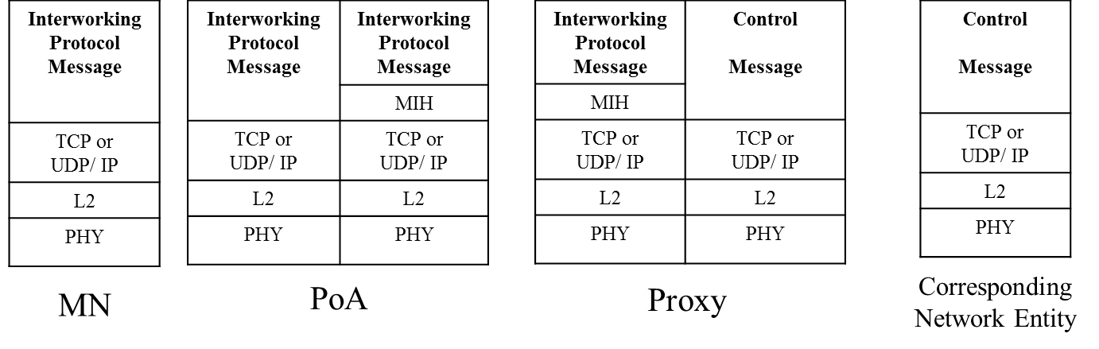
Figure 58. Proxy Function for Interworking Protocol Message Conversion

12.3.1 Examples of Interworking Protocol Delivery: ANQP Delivery
When the MN wants to receive ANQP messages of access network information from the Media Independent Information Server, the WLAN AP (Access Point) can perform as a proxy between the MN and Media Independent Information Server as shown in Figure 59 (a). As explained in Figure 57, if the Media Independent Information Server supports Proxy Function and ANQP, the PoA can only encapsulate interworking protocol messages with the MIHF header using MIH_ITW_Transfer messages. The WLAN AP only encapsulates ANQP messages of the MN into MIH_ITW_Transfer messasges and decapsulates MIH_ITW_Transfer message of Media Independent Information Server, as shown in Figure 59 (b). The WLAN AP does not need to have all functions of the MIH. It means the WLAN AP as a proxy of MN can be implemented by using Proxy Function.

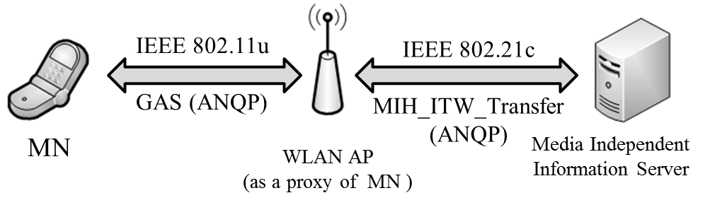

(a) ANQP Transfer using the WLAN AP as a Proxy

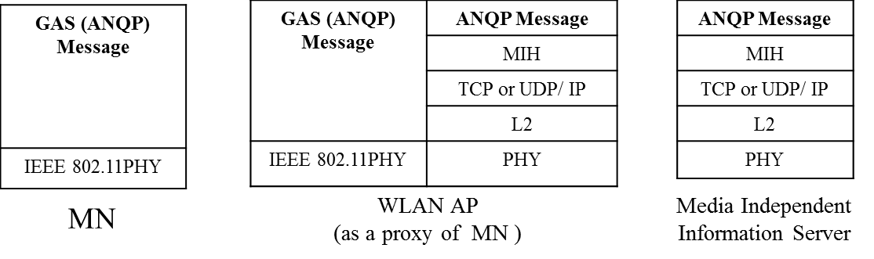

(b) Protocol Stacks for ANQP Transfer
Figure 59. ANQP Transfer from Media Independent Information Server

If the information server does not support Proxy Function, the WLAN AP cannot communicate with the information server using the MIH_ITW_Transfer messages. In this case, the Proxy is needed to bridge between the WLAN AP and the information server. The WLAN AP only encapsulates ANQP messages of the MN into MIH_ITW_Transfer messasges and decapsulates MIH_ITW_Transfer message of information server, as shown in Figure 60 (a). Proxy converts the messages from the WLAN AP to the other interworking protocol messages such as ANDSF messages and vice versa. Hence, the information server can communicate with the WLAN AP via the Proxy. To explain the ANQP conversion, the protocol stacks for MN, WLAN AP, Proxy, and information server are shown in Figure 60 (b).
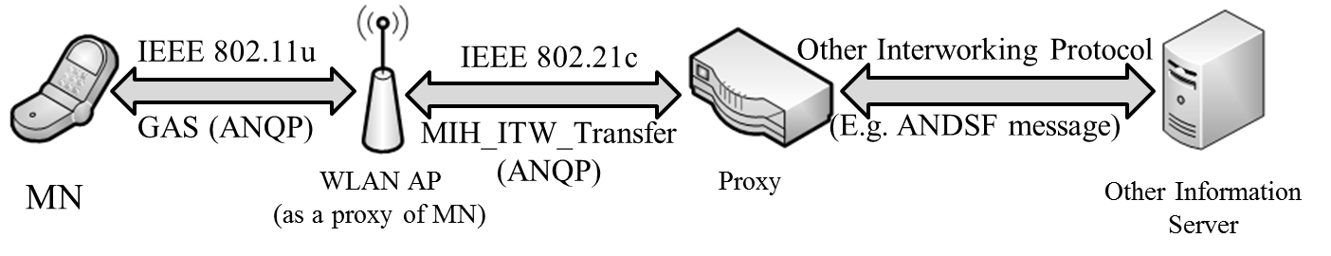
(a) ANQP Conversion using the Proxy
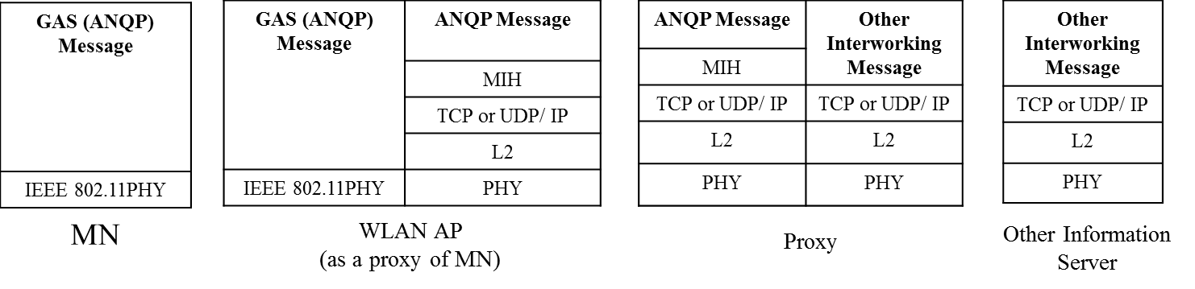
(b) Protocol Stacks for ANQP Conversion
Figure 60. ANQP Conversion from Media Independent Information Server

Annex F
To Editor: Insert the following Section F.3.16.
F.3.16 Data types for delivery of interworking protocol messages
Table F.25- Data types for delivery of interworking protocol messages
Data type name | Derived form | Definition
ITW_PRTC_MSGS | SEQUENCE(  ITW_TYPE,  ITW_MSGS  ) | Represent which interworking protocol messages are delivered. ITW_TYPE represents a type of interworking protocol messages. ITW_MSGS represents interworking protocol messages to be delivered.
ITW_TYPE | UNSIGNED_INT(1) | A type to represent an interworking protocol messages.  0: ANQP  1~122: Reserved for other interworking protocols  123~255: Reserved for vendor specific uses
ITW_MSGS | OCTET_STRING | Represents interworking protocol messages to be delivered.

Annex L
To Editor: Insert the changed rows to Table L.1
MIH messages | AID
MIH messages for Service Management
MIH_ITW_Transfer | 10
MIH_N2N_LL_Transfer | 11
MIH messages for Command Service
MIH_IF_PreReg_Ready | 13
MIH_TNMN_SA_Estab | 14
MIH_MNTN_SA_Estab | 15
MIH_ITW_Transfer | 16

To Editor: Insert the following rows to Table L.2
TLV type name | TLV  type value | Data type
Interworking Information | 76 | ITW_PRTC_MSGS

