IEEE P802.21
Media Independent Handover Services
802.21c proposed remedy on Annex Q and Annex S
Date: 2012-12-18
Author(s):
Name | Affiliation | Address | Phone | email
Hyunho Park, Hyeong-Ho Lee | ETRI |  |  | hyunhopark@etri.re.kr, holee@etri.re.kr
Abstract
This document contains revised figures in Annex Q and Annex S, and proposed remedy for 802.21c LB comments (DCN#21-12-0165-04).
Moreover, this document proposed to modify “IEEE_P802_21c_D02-LB_rev_4 (DCN#21-12-0185-00).”

Figures in Annex Q and Annex S
Figures in Annex Q and Annex S should be changed into black & white style.
Moreover, in order to understand figures easily, the figures formats are changed as follows.

- Figure Q.1- Network discovery listening to the target link
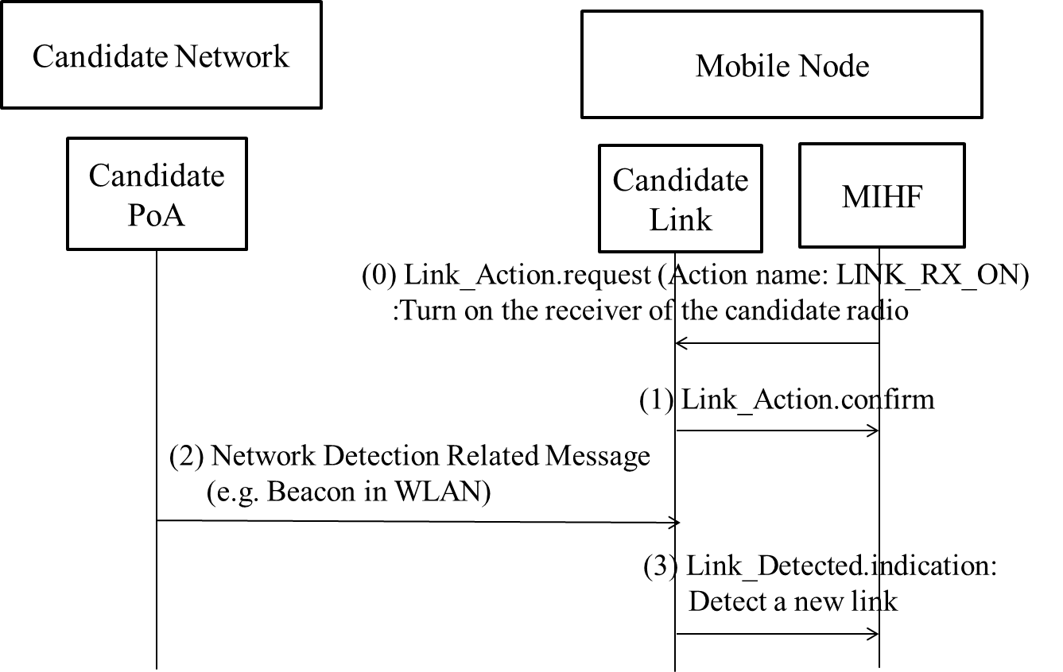

- Figure Q.2- Network discovery using location information
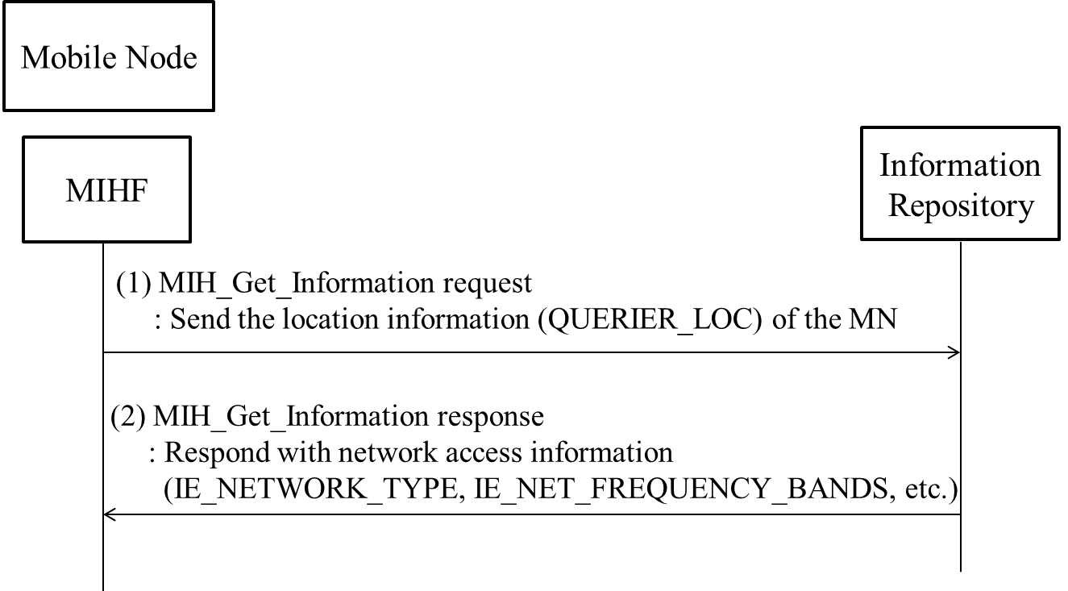

- Figure Q.3- Network discovery using user schedule information
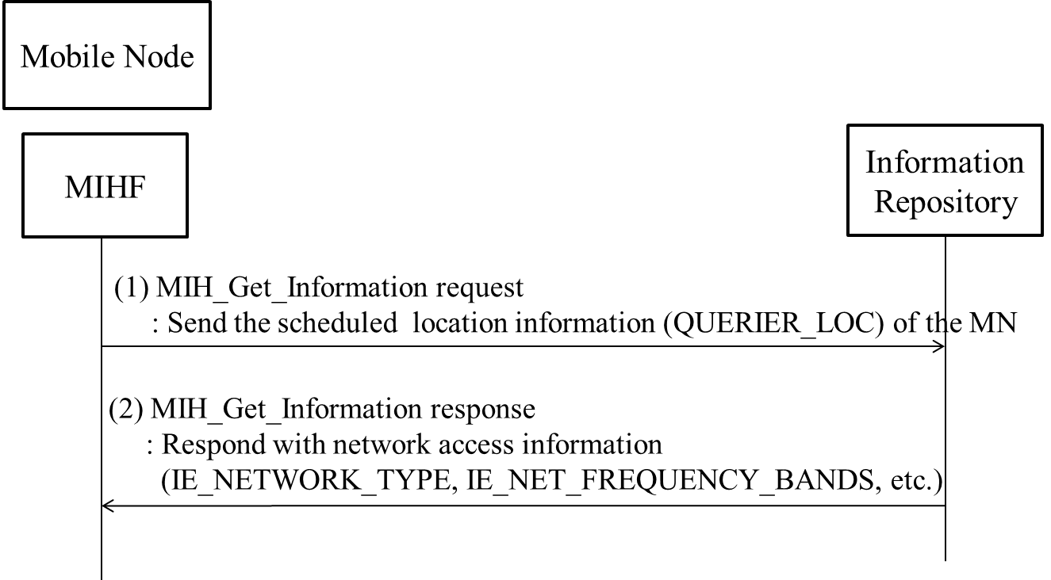
- Figure S.1- HO decision caused by weak SINR of the source link
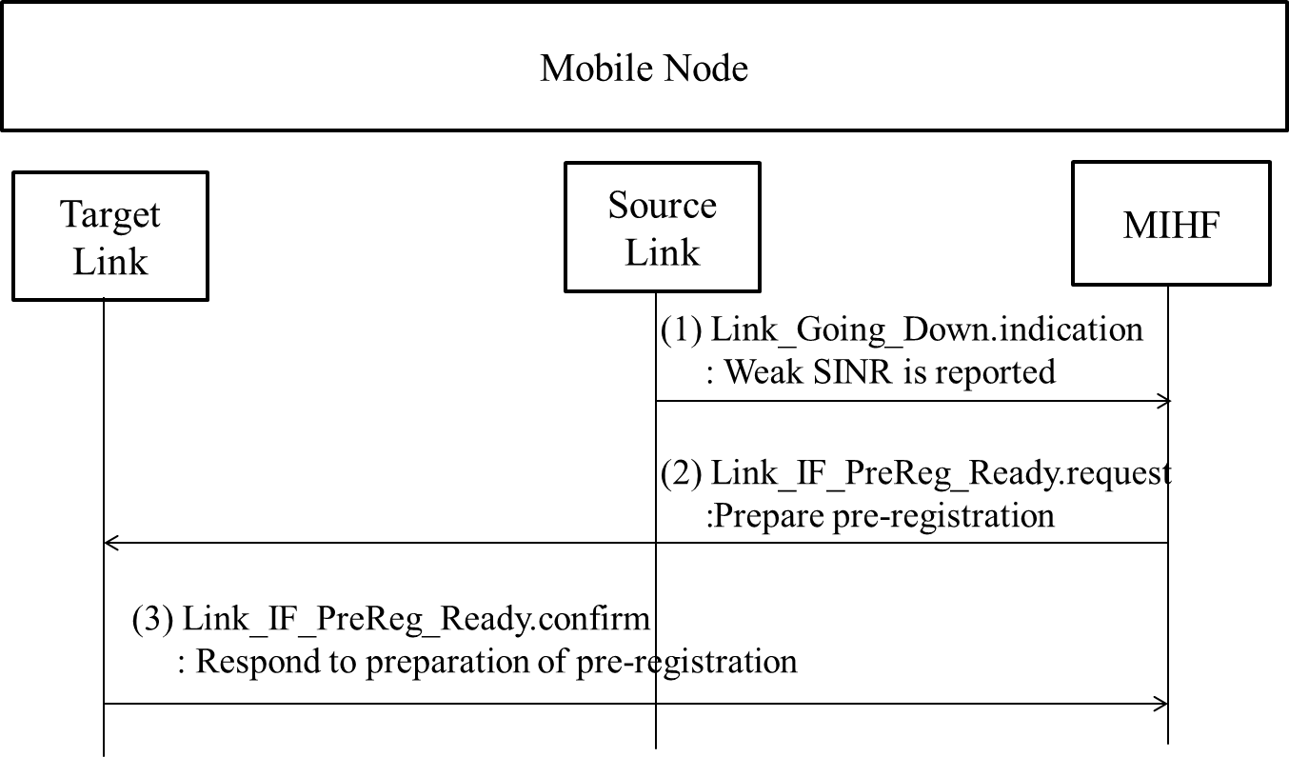

- Figure S.2- HO decision caused by QoS and/or cost
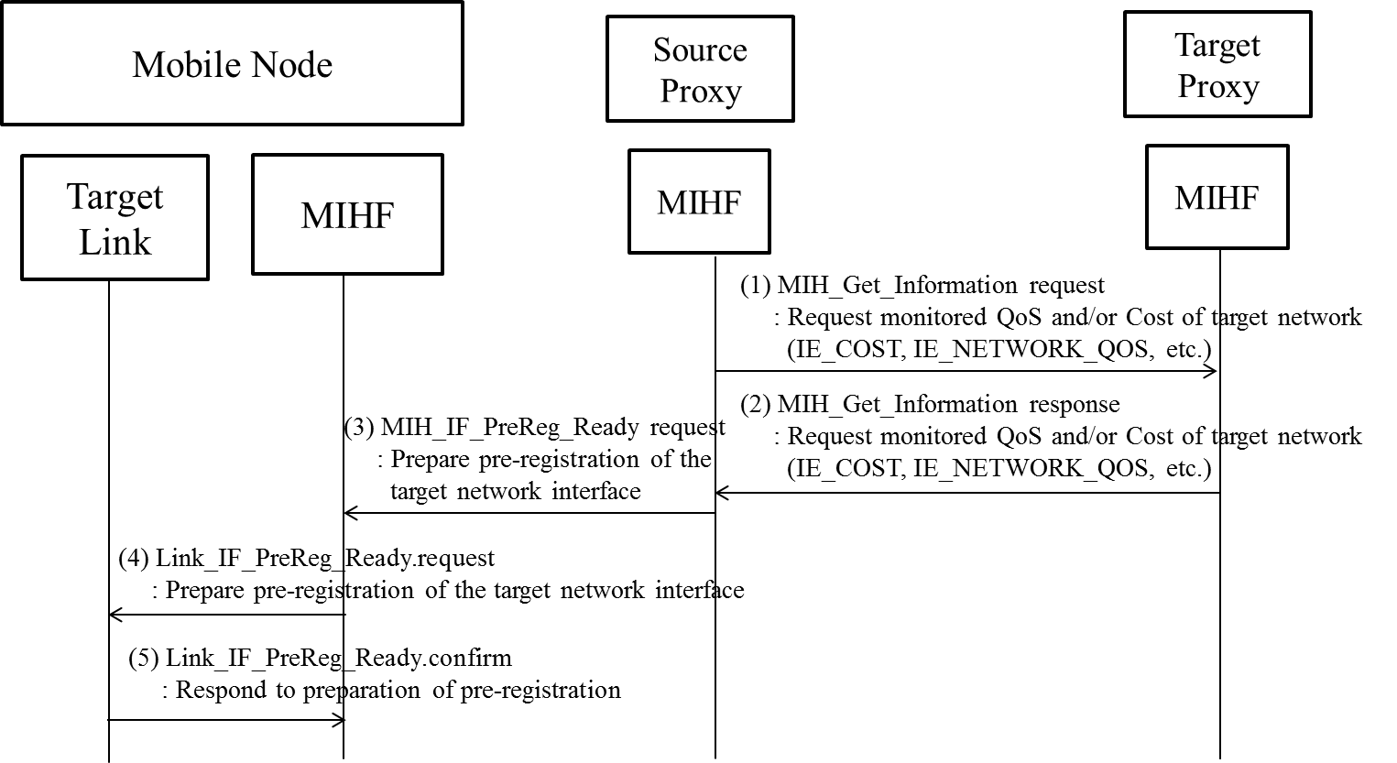

- Figure S.3- HO decision caused by power consumption comparison
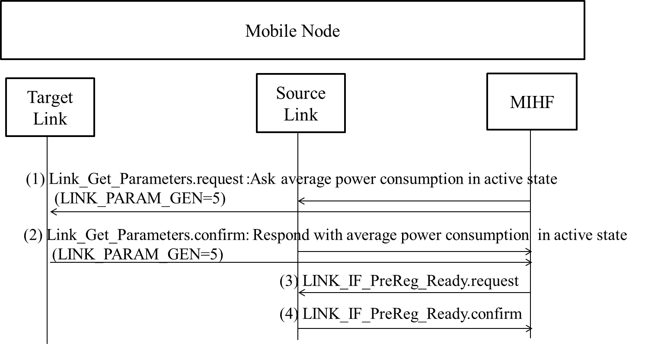
Remedy for 802.21c LB comments (DCN#21-12-0165-04)
- Comment #276
INSERT FOLLOWING DATA TYPE TO TABLE E.1.
MIH_LINK_SAP_primitive |  | IEEE Std 802.16 C_SAP | IEEE Std 802.16 M_SAP
Link_Action | Link_RX_ON | N/A | N/A

- Comment #133
- The same resolution as remedy for comment#252

- Comment #134
- In the last sentence in the first paragraph of Q.1, the editor already resolved based on the comment. However, the section that deals assumption was changed into Section 1.4.
To editor: please change the last sentence in the first paragraph of Q.1 to “This method serves the accurate detection of the target links, but the mobile node may follow the assumptions in Section 1.4.”

- Comment #16
- The same resolution as remedy for comment#254

- Comment #278
- Opinion: Reject
- Hyunho Park asked Daniel Corujo about Daniel Corujo’s intention. Daniel Corujo answered that Point 3, “Using user schedule information," is a sub-set or example of an application using the proposal from Point 2, "Using Local information.”
- Hyunho Park’s detailed opinion
  - Point 3 using schedule information does not consider only location information. It means that the Point 3 cannot be a part of Point 2. Figure for the point 3 is just one of example. The main idea of point 3 is to couple time and information for network discovery. The information for network discovery can be location information, but the information can also be access network information. The access network information can be SSID, frequency, network type, etc.

- Comment #136
- This document contains black and white figures of Annex S.

- Comment #262
- The comment #262 needs to be discussed because it deals with an editing issue.

