Five Criteria

17.5.1 Broad Market Potential

A standards project authorized by IEEE 802 shall have a broad market potential. Specifically, it shall have the potential for:
a) Broad sets of applicability.

Today, mobile phones, notebooks, laptops and other portable communication devices are often equipped with two or more access technologies such as IEEE 802.11, IEEE 802.16, GSM, UMTS, LTE, CDMA and other emerging cellular technologies. There is a need to maintain session continuity and service continuity when transitioning across these technologies to achieve a better user experience. The accessibility to broader types of network technologies with these devices will provide service in a larger geographic area and also provide more choices of network access. This will also help the network operators to balance the network load as traffic increases from one network to another. Media independent services is one of the attractive ways in providing such information and facilitating the seamless handover between heterogeneous access networks.

b) Multiple vendors and numerous users.

A wide variety of vendors are currently involved in building wireless products for the network equipment and mobile device market segments. With the number of multi-radio handset sales alone increasing from 6 million in 2006 to 500 million by 2012, affected market categories include smart phones, netbooks, and laptops – essentially anything with multiple radios. Vendors, operators and users are all affected by this multi-network device trend.

c) Balanced costs (LAN versus attached stations).

Media-independent mechanisms can potentially enable an efficient use of network resources compared to handovers based solely on media access information which requires scanning of all radio interfaces and thus keeping them always in active state even if it is not used for data transmission. While there is a cost involved in implementing the software on the devices to support media-independent services, it is very unlikely that this will represent a major increase of unit cost given the volume of the devices.

17.5.2 Compatibility

IEEE 802 defines a family of standards. All standards shall be in conformance with the IEEE 802.1 Architecture, Management, and Interworking documents as follows: 802. Overview and Architecture, 802.1D, 802.1Q, and parts of 802.1f. If any variances in conformance emerge, they shall be thoroughly disclosed and reviewed with 802.
Each standard in the IEEE 802 family of standards shall include a definition of managed objects that are compatible with systems management standards.

- IEEE 802.21-2008 and its amendments have been developed in conformance with the IEEE 802 Overview and Architecture. They will remain conformant after splitting them to Std 802.21.1
- Managed objects defined in Std IEEE 802.21-2008 and its amendments are consistent with existing policies and practices for IEEE 802 standards. These same objects will remain consistent after splitting to Std 802.21.1.

17.5.3 Distinct Identity

Each IEEE 802 standard shall have a distinct identity. To achieve this, each authorized project shall be:
- Substantially different from other IEEE 802 standards.
- One unique solution per problem (not two solutions to a problem).
- Easy for the document reader to select the relevant specification

Std IEEE 802.21-2008 and its amendments have already established their distinct identity. Currently there is no IEEE 802 standard that provides services within 802 networks such as heterogeneous network information, handover related events and commands. The project will split these services from Std 802.21-2008 and create a new document. This document will be clearly distinguishable, since it will only address features related to Media-Independent Services. The relationship with the 802.21-revision project and this project are depicted in the following figure.

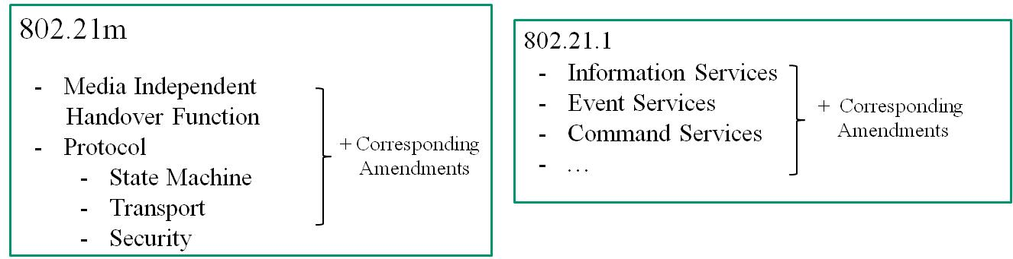

.

17.5.4 Technical Feasibility

For a project to be authorized, it shall be able to show its technical feasibility. At a minimum, the proposed project shall show:
a) Demonstrated system feasibility.
b) Proven technology, reasonable testing.
c) Confidence in reliability.

The project is feasible since most of the work is already published in Std IEEE 802.21-2008.

17.5.4.1 Coexistence of 802 wireless standards specifying devices for unlicensed operation

A working group proposing a wireless project is required to demonstrate coexistence through the preparation of a Coexistence Assurance (CA) document unless it is not applicable. The Working Group will create a CA document as part of the WG balloting process. If the Working Group elects not to create a CA document, it will explain to the EC the reason the CA document is not applicable.

A CA document is not necessary for this amendment. It will not change access mechanisms nor physical layer operation of IEEE networks at all, as this is already out of scope for IEEE 802.21.

17.5.5 Economic Feasibility

For a project to be authorized, it shall be able to show economic feasibility (so far as can reasonably be estimated) for its intended applications. At a minimum, the proposed project shall show:
a) Known cost factors, reliable data.
b) Reasonable cost for performance.
c) Consideration of installation costs.

The majority of this work will be splitting the text from the published Std IEEE 802.21-2008 standard and amendments; the economic feasibility for the Media Independent Handover Services product has already been established.

