Project | IEEE 802.21a  <https://mentor.ieee.org/802.21>
Title | ERP support
DCN | 21-11-0165-00-0sec
Date Submitted | September 28, 2011
Source(s) | Fernando Bernal-Hidalgo (University of Murcia), Rafael Marin-Lopez (University of Murcia)
Re:
Abstract | This document elaborates modifications that need to be carried out in the draft
Purpose | Proposes changes in the current draft
Notice | This document has been prepared to assist the IEEE 802.21 Working Group. It is offered as a basis for discussion and is not binding on the contributing individual(s) or organization(s). The material in this document is subject to change in form and content after further study. The contributor(s) reserve(s) the right to add, amend or withdraw material contained herein.
Release | The contributor grants a free, irrevocable license to the IEEE to incorporate material contained in this contribution, and any modifications thereof, in the creation of an IEEE Standards publication; to copyright in the IEEE’s name any IEEE Standards publication even though it may include portions of this contribution; and at the IEEE’s sole discretion to permit others to reproduce in whole or in part the resulting IEEE Standards publication. The contributor also acknowledges and accepts that IEEE 802.21 may make this contribution public.
Patent Policy | The contributor is familiar with IEEE patent policy, as stated in Section 6 of the IEEE-SA Standards Board bylaws <http://standards.ieee.org/guides/bylaws/sect6-7.html#6> and in Understanding Patent Issues During IEEE Standards Development http://standards.ieee.org/board/pat/faq.pdf

Ref. | 001
DRAFT SECTION | 8.6.1.12 MIH_Auth request
Modification type | Replace definition text
Text | This message is used for an MIHF in both MN and PoS to send EAP or ERP messages in an MIH service authentication.

Ref. | 002
DRAFT SECTION | 8.6.1.13 MIH_Auth response
Modification type | Replace definition text
Text | This message is used for an MIHF in both MN and PoS to send EAP or ERP messages in an MIH service authentication.

Ref. | 003
DRAFT SECTION | 8.6.1.11 MIH_Auth indication
Modification type | Replace definition text
Text | This is used for an MIHF to perform (D)TLS exchange with another MIHF to establish or terminate a (D)TLS-generated MIH SA, or to communicate with another MIHF to initiate an MIH service access authentication through EAP or ERP. In the former case, an AuthenticationContent shall be included to carry a TLS record of type handshake, change ciphersuite or alert message. In the latter case,  AuthenticationContent shall be included to carry an ERP payload message when ERP is initiated by a PoS. This message shall not be used when EAP is initiated by a PoS or when ERP is initiated by a MN, and MIH_Auth request message shall be used instead.

Ref. | 004
DRAFT SECTION | Figure 31—Main Stages with MN Initiated Authentication
Modification type | Update figure
Text | Remove ERP from figure in MIH Service Access Authentication Phase

Ref. | 005
DRAFT SECTION | Figure 32—Main Stages with Network Initiated Authentication
Modification type | Update figure
Text | Remove ERP from figure in MIH Service Access Authentication Phase

Ref. | 006
DRAFT SECTION | 9.2.1 MIH service access authentication
Modification type | Add figure
Figure | 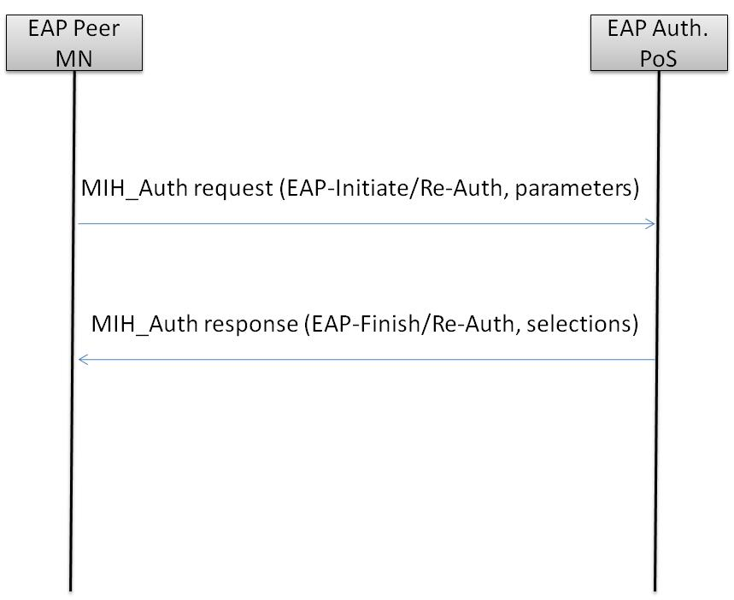
Title | Main stages with MN initiated re-authentication

Ref. | 007
DRAFT SECTION | 9.2.1 MIH service access authentication
Modification type | Add figure
Figure | 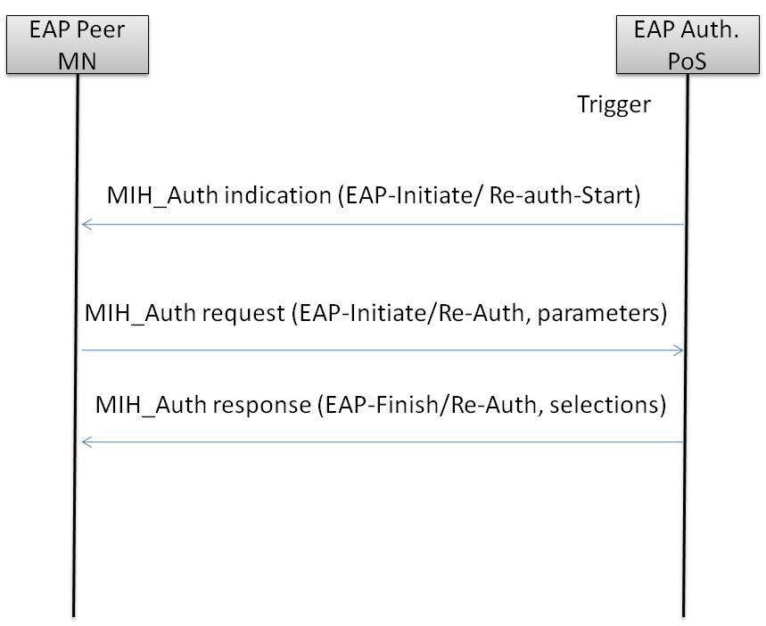
Title | Main Stages with Network Initiated Re-Authentication (1)

Ref. | 008
DRAFT SECTION | 9.2.1 MIH service access authentication
Modification type | Add figure
Figure | 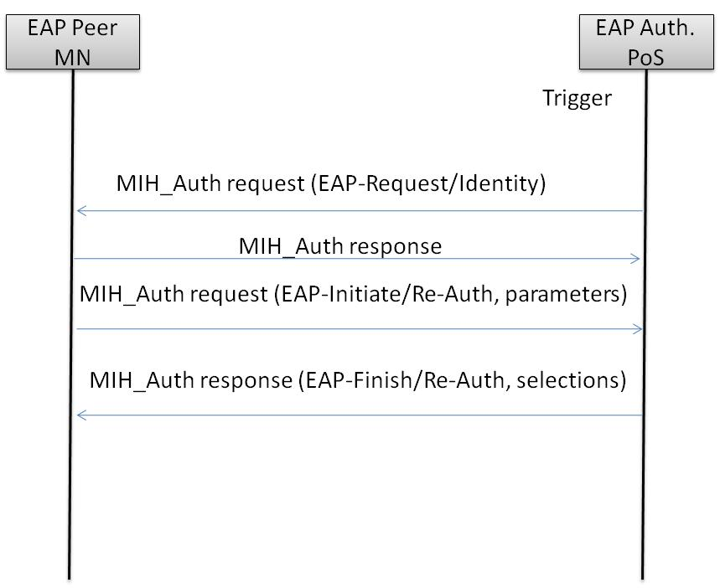
Title | Main Stages with Network Initiated Re-Authentication (2)

