Project | IEEE 802.21a  <https://mentor.ieee.org/802.21>
Title | Suggested Remedies on Fragmentation
DCN | 21-10-00xx-00-0sec
Date Submitted
Source(s) | Yoshihiro Ohba (Toshiba)
Re:
Abstract | This document contains remedies to 802.21a/D03 associated with the author’s LB5b comment #37.
Purpose | Proposes changes in the current draft
Notice | This document has been prepared to assist the IEEE 802.21 Working Group. It is offered as a basis for discussion and is not binding on the contributing individual(s) or organization(s). The material in this document is subject to change in form and content after further study. The contributor(s) reserve(s) the right to add, amend or withdraw material contained herein.
Release | The contributor grants a free, irrevocable license to the IEEE to incorporate material contained in this contribution, and any modifications thereof, in the creation of an IEEE Standards publication; to copyright in the IEEE’s name any IEEE Standards publication even though it may include portions of this contribution; and at the IEEE’s sole discretion to permit others to reproduce in whole or in part the resulting IEEE Standards publication. The contributor also acknowledges and accepts that IEEE 802.21 may make this contribution public.
Patent Policy | The contributor is familiar with IEEE patent policy, as stated in Section 6 of the IEEE-SA Standards Board bylaws <http://standards.ieee.org/guides/bylaws/sect6-7.html#6> and in Understanding Patent Issues During IEEE Standards Development http://standards.ieee.org/board/pat/faq.pdf

Proposal
[1] Revise the following text in Clause 8.4.2.1:
An MIH message is fragmented only when MIH message is sent natively over an L2 medium such as Ethernet. The message is fragmented when the message size exceeds aFragmentationThreshold. The size of each of the fragments is the same except the last one, which may be smaller. The maximum fragment size is defined as the maximum value of aFragmentationThreshold, which shall be equal to the Maximum Transmission Unit (MTU) (in octets) of the link layer that is on the path between two MIHF nodes, minus 44 octets, which is the maximum data expansion for each protected MIH PDUminus securityOverhead octets, which is the maximum expansion for each protected MIH PDU. When there is no MIH SA, securityOverhead is set to zero. The calculation of securityOverhead when there is an MIH SA is given in Annex K. When the MTU of the link layer between two MIHF nodes is known, the maximum fragment size is set to the MTU (in octets) minus 44 securityOverhead octets. The method of determining such an MTU is outside the scope of this standard. When the MTU of the link layer between two MIHF nodes is unknown, the maximum fragment size is set to the minimum MTU of 1500 1456 octets minus securityOverhead octets. When MIH message is sent using an L3 or higher layer transport, L3 takes care of any fragmentation issue, and the MIH protocol does not handle fragmentation in such cases.
[2] Revert the content of Figure K.1 to what is described in IEEE 802.21-2008.
[3] In Annex K, Insert the following text after Figure K.1 and before Figure K.2:
Calculation of securityOverhead when there is an MIH SA
To calculated securityOverhead when there is an MIH SA, the following parameters are used:
- x is 0 when Source MIHF Identifier TLV and Destination MIHF Identifier TLV are contained in the protected MIH message, otherwise, x is 1.
- y is 1 for TLS-generated MIH SA. Otherwise, y is 0.
- L_{SAID} denotes the octet length of the SA ID TLV carried in the protected MIH message. L_{SAID} depends on the implementation.
- L_{SID} denotes the octet length of the Source MIHF Identifier TLV optionally carried in the protected MIH message. L_{SID} depends on the implementation.
- L_{DID} denotes the octet length of the Destination MIHF Identifier TLV optionally carried in the protected MIH message. L_{DID} depends on the implementation.
- O_{SECTLV} denotes the overhead of the largest Security TLV carried in the protected MIH message.
- O_{TYPE}(y) denotes the overhead of the MIH data type contained in the largest Security TLV.
- O_{TLS} denotes the overhead of the largest TLS record.
O_{TLS} = 5, i.e., 1-octet TLSCiphertext.type plus 2-octet TLSCiphertext.version plus 2-octet TLSCiphertext.length [RFC5246].
- O_{ENC} denotes the overhead of encryption. O_{ENC} depends on the ciphersuite.
- O_{INTG} denotes the overhead of integrity protection. O_{INTG} depends on the ciphersuite.
securityOverhead is calculated as follows:
securityOverhead = L_{SAID} –x (L_{SID} + L_{DID})+ O_{SECTLV} + O_{TYPE}(y) + yO_{TLS} + O_{ENC} + O_{INTG}
Note that securityOverhead can be a negative value when x=1.
Since the maximum size of Security TLV is no more than the maximum size of Variable Payload of MIH message, which is 2^16-1 octets, the following values are given to O_{SECTLV} and O_{TYPE}(y).
- O_{SECTLV} = 3 (i.e., 1-octet TLV Type plus 2-octet TLV Length).
- O_{TYPE}(0) = 6, i.e., 1-octet CHOICE Selector in CHOICE(TLS_RECORD, MIH_SPS_RECORD) plus 2-octet Length field of ENCR_BLOCK data plus 1-octet CHOICE Selector in MIH_SPS_RECORD plus 2- octet Length field of INTG_BLOCK data.
- O_{TYPE}(1) = 3, i.e., 1-octet CHOICE Selector in CHOICE(TLS_RECORD, MIH_SPS_RECORD) plus 2-octet Length field of TLS_RECORD data.
Table show O_{ENC} and O_{INTG} values for the MIH ciphersuites for EAP-generated MIH SA.

Table N.1: Encryption and integrity protection overhead for EAP-generated MIH SA
Ciphersuite Code | Encryption | Integrity Protection | O_{ENC} | O_{INTG}
00000010 | AES-CBC | HMAC-SHA1-96 | 32( IV + padding) | 12 (MIC)
00000100 | Null | HMAC-SHA1-96 | 0 | 12 (MIC)
00000101 | Null | CMAC-AES | 0 | 12 (MIC)
00000110 | AES_CCM |  | 38 (SN+padding+MIC) | 0

For example, consider a case where Ciphersuite Code 00000010 (AES-CBC + HMAC-SHA1-96) is used for EAP-generated MIH SA (y=0) without containing Source MIHF Identifier TLV and Destination MIHF Identifier TLV in the protected MIH message (x=0), and the length of SAID TLV, the length of Source MIHF Identifier TLV, the length of Destination MIHF Identifier TLV are 30 octets, 20 octets and 30 octets , respectively. Then securityOverhead is computed as:
securityOverhead = L_{SAID} –(L_{SID} + L_{DID}) + O_{SECTLV} + O_{TYPE}(0) + O_{ENC} + O_{INTG}
= 30–(20+30)+3+6+44 = 33 (octets).
[4] Change Figure K.2 and its explanation as follows:
Figure K.2 shows the protected fragments for the original message shown in Figure K.1, when operating in the same condition as described in the above example with securityOverhead=33 (octets). The integer number within the curved-brackets of each field in Figure K.2 indicates the length of the field in octets. In Figure K.2, the fragment size before applying MIH protection is set to 1424 (=16*89) octets to have the fragment size of 1499 octets after applying MIH protection, which gives the largest number of 16-octet blocks (89) under the condition that the resulting protected fragment does not exeeds 1500 octets.

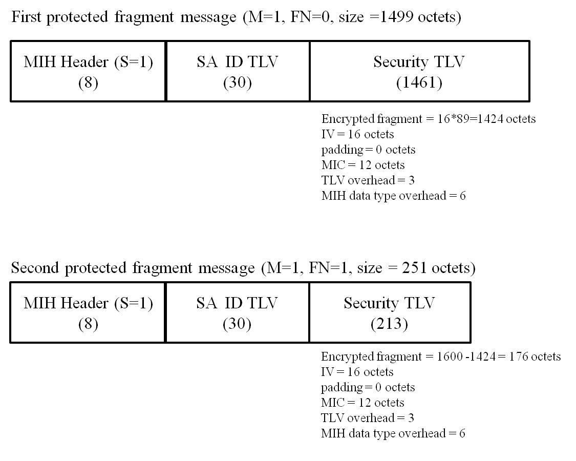
Figure K.2—Example of protected MIH fragment message

