Project | IEEE 802.21a  <https://mentor.ieee.org/802.21>
Title | Option III Draft updates
DCN | 21-10-0209-01-0sec
Date Submitted
Source(s) | Fernando Bernal-Hidalgo (University of Murcia), Rafael Marin-Lopez (University of Murcia)
Re:
Abstract | This document elaborates changes in the current draft
Purpose | Proposes changes in the current draft
Notice | This document has been prepared to assist the IEEE 802.21 Working Group. It is offered as a basis for discussion and is not binding on the contributing individual(s) or organization(s). The material in this document is subject to change in form and content after further study. The contributor(s) reserve(s) the right to add, amend or withdraw material contained herein.
Release | The contributor grants a free, irrevocable license to the IEEE to incorporate material contained in this contribution, and any modifications thereof, in the creation of an IEEE Standards publication; to copyright in the IEEE’s name any IEEE Standards publication even though it may include portions of this contribution; and at the IEEE’s sole discretion to permit others to reproduce in whole or in part the resulting IEEE Standards publication. The contributor also acknowledges and accepts that IEEE 802.21 may make this contribution public.
Patent Policy | The contributor is familiar with IEEE patent policy, as stated in Section 6 of the IEEE-SA Standards Board bylaws <http://standards.ieee.org/guides/bylaws/sect6-7.html#6> and in Understanding Patent Issues During IEEE Standards Development http://standards.ieee.org/board/pat/faq.pdf

DRAFT SECTION | 3. DEFINITION
Modification type | ADD
Text | PoS: acts as authenticator for the service authentication. Moreover, it is the entity that interacts with PoAs to facilitate key distribution services.  MIH Service AS: It is a backend authentication server for the MIH service authentication.  Candidate PoS: A PoS that is a potential target to the MN’s movement  Target PoS: A PoS that is the PoS selected for the MN’s movement  Serving PoS: A PoS that is the current PoS which provides access to the supported network services.  Candidate PoA: A PoA that is a potential target to the MN’s network attachment.  Target PoA: A PoA that is the PoA selected to perform a key distribution  Serving PoA: A PoA that is the current PoA where the MN is attached. Moreover, it provides network access to the MN.

DRAFT SECTION | 4. DEFINITION
Modification type | ADD
Text | PoS: Point of Service  PoA: Point of Attachment  MN: Mobile Node  MIH PDU: MIH Packet Data Unit

DRAFT SECTION | 9.2.2.1. MIH Service Access Authentication
Modification type | ADD
Line | 26
Text | Before providing any service to the MN, a media independent authentication must be performed in order to authenticate and authorize the credentials provided by the MN. Therefore, in order to achieve this objective, MN credentials and authentication servers (AS) are needed in the architecture. To clarify, Figure 2 depicts a general message flow (MN initiated) and Figure 3 depicts the same message flow but based on network initiated procedure, needed to achieve a Media Independent Authentication based on EAP.  Figure 2 General message flow MN initiated  Figure 3 General message flow network initiated
NOTE | References in provided text may be need to be updated in draft.

DRAFT SECTION | 9.2.2.1. MIH Service Access Authentication
Modification type | UPDATE
Lines | From 30 to 56
Text | Capability Discovery Phase. In this phase, both the MN and the PoS exchange unprotected MIH messages in order to obtain the services which can be selected by the MN. PoS provide a list of the available services and the MN is aware about the different capabilities provided by a certain PoS.  Media Independent Service Authentication phase. Before to start the MN authentication, between the MN and the PoS (MN initiated or Network initiated) a negotiation is performed in order to agree the ciphersuite to be used and others useful parameters. Once this negotiation is completed, the MN (acting as EAP peer) authenticates against a PoS (which is acting as EAP authenticator) using a MIH Service AS (acting as EAP server). To achieve this, EAP is transported by MIH protocol between the MN and the PoS which manages the MN authentication. In order to carry out the authentication, the PoS may need a backed authentication server (i.e. MIH Service AS such as an AAA server) to verify the MN’s credentials. It is assumed in this document, that the EAP method performed between the EAP peer and the EAP Server is able to export key material. Thus, after performing the authentication, key material (i.e. MSK) will be shared between the MN and the PoS. So, this key material is exported to both MN’s and PoS’ MIH lower-layer and it is available to protect the rest of the MIH signalling exchanged between the PoS and the MN (how to MIH is protected is explained in section 2.5). In order to protect the MIH signaling, the exported MSK is used as root key to derive new session keys which are use to protect the MIH packets. How this key hierarchy is derived is described in section 2.5. Note that, the authentication procedure could be based in ERP in order to perform a fast re-authentication procedure; in that case, an rMSK is used as root key to derive the key hierarchy and protect the MIH signaling.  Service Access phase. At this point, the MN is authenticated and authorized to use the MIH services, agreed and provided by the PoS. The Media Independent Service Authentication phase is already completed and the MIH protocol is protected by using the key material obtained in the Media Independent Service Authentication Phase. This phase is related with section 2.4 for key derivation and section 2.5 for protecting MIH protocol.  Termination phase. When the MN and the PoS desire to release resources and the MN’ state related with the provided services.
NOTE | References in provided text may be need to be updated in draft.

DRAFT SECTION | 9.2.2.1. MIH Service Access Authentication
Modification type | UPDATE REFERENCE  This is the figure that is being referenced.
Line | 25
Text

DRAFT SECTION | New Section (CIPHERSUITE)
Modification type | NEW
Text | Confidentiality algorithms Reference  ENCR_AES_CBC NIST 800-38A  ENCR_NULL  Integrity algorithms Reference  INTR_HMAC_SHA_96 FIPS 180-1  INTR_CMAC_AES NIST 800-38B  Confidentiality and Integrity algorithms Reference  AUTH_ENC_AES_CCM NIST 800-38C  KDF algorithms Reference  PRF_CMAC_AES NIST 800-108  PRF_HMAC_SHA1 NIST 800-108  The ciphersuites are coded as follows:  Code Integrity Algorithm Encryption Algorithm Length (bits)  00000000 NULL NULL 0  00000001 AES_CBC NULL 128  00000010 AES_CBC HMAC-SHA1-96 256  00000011 AES_CBC CMAC-AES 256  00000100 NULL HMAC_SHA1-96 128  00000101 NULL CMAC_AES 128  00000110 AES_CCM 128  A default cipher suite is needed in order to avoid mismatch between MN and PoS in terms of cipher suite.  AES_CCM needs counter generation function and a formatting function. Moreover, a NONCE generation is needed.These functions are defined in Appendix A of [NIST-SP800-38C] with the following parameters:  - The nonce length n is 12  - The tag length t is 16  - The value of q is 3
NOTE | This section will require some updates

DRAFT SECTION | 6.5.4 Information elements
Modification type | ADD
Text | Name of information element Description Data type  IE_POS_KEY_DIST_INFO Information about the key distribution mechanisms supported by the PoS KEY_DIST_LIST  IE_POS_INTR_ALG_INFO Information about the integrity algorithms supported by the PoS. INT_ALG_LIST  IE_POS_ENCR_ALG_INFO Information about the encryption algorithms supported by the PoS. CIPH_ALG_LIST  IE_POS_KDF_INFO Information about the key derivation functions supported by the PoS. KDF_LIST
Note | The following information elements should be specified within the IE_CONTAINER_NETWORK within a new subcategory named PoS-specific information elements.

DRAFT SECTION | 9.2.2.2 Key derivation and key hierarchy
Modification type | REPLACE  This section should be replaced with the text provided
Text | To protect the MIH messages during Service Access Phase, a key hierarchy needs to be derived from the key material (i.e. MSK) exported during EAP/ERP authentication carried out during the Media Independent Service Authentication phase. The proposed hierarchy is showed in the Figure 4.  Figure 5 Key hierarchy proposed  Using the MSK or rMSK provided by the EAP authentication, as a root key, two keys are derived: MIIK (Media Independent Integrity Key), this key is used to provide integrity protection to the MIH protocol and MIEK (Media Independent Encryption Key), used to provide confidentiality to the MIH protocol. This key hierarchy has been based on the key hierarchy described in [ProAuthMihSec].  Note: it is assumed that the EAP method performed is available to export key material (MSK or rMSK).  How to generate the key hierarchy is described as follows:  Parameters:  - MSK or rMSK – master session key established through an EAP or EAP re-authentication. When the MSK or rMSK is 128 bits long, the PRF used for key derivation can be HMAC-SHA1, HMAC-SHA-256, or AES-CMAC. But if MSK is longer than 128 bits, then HMAC-SHA-1 or HMAC-SHA-256 shall be used as a PRF in key derivation.  - L – the length of keying material. L = |MIIK| + |MIEK|, that is, the sum of the binary length of MIIK and MIEK.  - h – The output length of the PRF used in key derivation.  - For HMAC-SHA-1, h = 160  - For HMAC-SHA-256, h = 256  - For CMAC-AES, h = 128  - n = the number of iterations of PRF in order to generate L bit keying material  The key derivation for MIH session keys can be described by the following procedure:  Fixed values:  - h - The length of the output of the PRF in bits, and  - t - The length of the binary representation of the counter I and L. A default value of t is 32.  Input: K = MSK or rMSK, Nonce-P, Nonce-S, and L.  Process:  - n: = ⎡L/h⎤.  - If n > 2^{t}-1, then indicate an error and stop.  - result(0):= ∅  - For i = 1 to n, do  - K(i) := PRF (K, “MISK” || [i]₂ || Nonce-P || Nonce-S || ciphersuite code || [L]₂)  - result (i) := result(i-1) || K(i)  7. Return: MISK, i.e., the leftmost L bits of result(n).  Output: MISK.  The MISK is parsed in such a way that  MISK = MIIK || MIEK.
Note | This section will require updates.  References in provided text may be need to be updated in draft.

DRAFT SECTION | New Section under section 9.2.2 called MIH Packet protection, OR  9.2.3 MIH Security Asssociation
Modification type | NEW or ADD (section 9.2.3 MIH Security Association)
Text | In this section we define how the MIH protocol messages are protected by using MIEK and MIIK. This is carried out in the Authenticated/Authorized Service Access Phase. Once Media Independent Service Authentication phase finishes with success, MIH lower-layer can access to key material, which is used to protect MIH messages. Specifically, using the MSK or rMSK as root key and using the key hierarchy defined in the previous section, the MIH protocol is protected by encrypting the MIH message using the MIEK and providing integrity protection uses MIIK. Whereas, encryption is optional, integrity protection is mandatory when MISK is available. Moreover, there are some algorithms which provide confidentiality and integrity (i.e. AUTH_ENC_AES_CCM); therefore, MIEK will be used as the key for performing these algorithms.  Four situations related with the protection of the MIH messages are possible in this document: Confidentiality and Integrity protection by using an encryption and an integrity algorithm, respectively; Confidentiality and Integrity protection by using a single algorithm which provides confidentiality and integrity; only integrity protection and no protection. Figure 5 summarizes these cases.  Figure 6 MIH packet protection procedure  MIH protocol is protected by means of the MIHF layer. A new MIHS (MIH Security) Header is needed to indicate that the payload after MIHS is a whole protected MIH message. This new header contains a new bit S used to indicate if the message is confidentiality protected or not, definition of this header is provided in [OPT2]. To merge both our proposal and [OPT2] we propose to define a Security TLV to transport the protected MIH PDU instead of the current defined TLS TLV.
Note | References in provided text may be need to be updated in draft.

DRAFT SECTION | NEW section (State termination)
Modification type | NEW
Text | A termination phase has been defined to provide a mechanism to allow the MN to release the resources kept by MN and PoS (such as keys, authorization lifetime, etc...) associated to the authentication. We provide two alternatives to proceed: define a termination message or/and session lifetime. In the following we explain the meaning of each alternative.  - Termination message: Allows the MN to finalize, explicitly, the current state. This could be useful when the MN changes to another PoS. Allows release resources from the serving PoS which the MN leaves it. This option is currently supported by MIH_Termination_Auth primitive and MIH_Termination_Auth MIH protocol message.  - State timeout: Provides a mechanism to finalize the established state after a certain period of time. This state timeout must be equal or lower than the EAP authentication timeout. Using this option it is guarantee that the state is always closed. This option is currently supported by the lifetime tlv included in MIH_AUTH request and MIH_AUTH response messages which will define in section 2.7.3.5.
Note | References in provided text may be need to be updated in draft.

DRAFT SECTION | 7.4.1.1.2 and 7.4.1.2.2 and 7.4.1.3.2 and 7.4.1.4.2
Modification type | UPDATE
Text | CipherRequiredFlag and IndetityOpt must me removed.

DRAFT SECTION | 7.4.29.1.2
Modification type | UPDATE
Text | Nonce must be removed.  AUTH must be removed

DRAFT SECTION | 7.4.29.1.2
Modification type | ADD
Text | Name Data type Description  Status STATUS Status of the authentication  Add this TLV.

DRAFT SECTION | 7.4.29.1.3
Modification type | UPDATE
Text | This primitive is generated after receiving an MIH_Start_Auth indication or an MIH_Auth.confirm. Also in network initiated authentication this primitive could be generated by a trigger (e.g. radio link variations, resource management reasons, etc).

DRAFT SECTION | 7.4.29.2.2
Modification type | UPDATE  Modify AuthenticationInformation description
Line | 58
Text | This transport the EAP or ERP packet.

DRAFT SECTION | 7.4.29.3.2
Modification type | UPDATE
Text | Nonce must be removed.  AUTH must be removed

DRAFT SECTION | 7.4.29.3.2
Modification type | UPDATE  Modify AuthenticationInformation description
Line | 38
Text | This transport the EAP or ERP packet.

DRAFT SECTION | 7.4.29.3.3
Modification type | REMOVE
Line | From 51 to 52
Text | “This primitive provides the required information to authenticate an MN”

DRAFT SECTION | NEW section (MIH_Auth.confirm)
Modification type | ADD
Line | 59 after section 7.4.29.3.4
Text | Function  This primitive is used by an MIHF to indicate to an MIH User that a MIH_Auth response was received.  Semantics of service primitive  MIH_Auth.confirm (  SourceIdentifier,  AuthenticationInformation  )  Name Data type Description  SourceIdentifier MIHF_ID This identifies the invoker of this primitive.  AuthenticationInformation AUTH_INFO_VALUE This transport the EAP or ERP packet.  When generated  This primitive is generated after receiving a MIH_Auth response message.  Effect on receipt  A MIH User receiving this primitive must generate a MIH_Auth.request primitive.

DRAFT SECTION | 7.4.30 and subsections
Modification type | UPDATE  In all subsections MIH_Finish_Auth
Text | MIH_Termination_Auth

DRAFT SECTION | 7.4.30.1.2 and 7.4.30.2.2
Modification type | REMOVE
Text | IntegrityAuth

DRAFT SECTION | NEW section (MIH_Termination_Auth.confirm)
Modification type | ADD
Line | 34 after section 7.4.30.3.4
Text | Function  This primitive is used to notify to the corresponding MIH User about the termination of the established state.  Semantics of service primitive  MIH_Termination_Auth.confirm (  SourceIdentifier  )  Name Data type Description  SourceIdentifier MIHF_ID This identifies the invoker, which is a remote MIHF.  When generated  This primitive is generated by a MIHF to terminate the current state after receiving a MIH_Termination_Auth response message.  Effect on receipt  The established state terminates.

DRAFT SECTION | 8.6.1.1 and 8.6.1.2
Modification type | REMOVE
Text | CipherRequiredFlag and IdentityOpt

DRAFT SECTION | 8.6.1.12
Modification type | REPLACE  This section should be replaced with the text provided
Text | MIH Header Fields (SID = 1, Opcode = 1, AID =7)  Destination Identifier = receiving MIHF ID  (Destination MIHF ID TLV)  Source Identifier = sending MIHF ID  (Source MIHF ID TLV)  Nonce (optional)  (Nonce TLV)  AuthenticationInformation (optional)  (Authentication TLV)  Lifetime (optional)  (Lifetime TLV)  Status (optional)  (STATUS TLV)  KeyDistributionMechanismList (optional)  (Key Distribution Mechanism List TLV)  IntegrityAlgorithmList (optional)  (Integrity Protection List TLV)  CipherAlgorithmList (optional)  (Encryption Algorithm List TLV)  KDF-List (optional)  (KDF List TLV)  IdentityOpt (optional)  (Identity TLV)  AUTH (optional)  (AUTH TLV)

DRAFT SECTION | 8.6.1.13
Modification type | REPLACE  This section should be replaced with the text provided
Text | MIH Header Fields (SID = 1, Opcode =2, AID =7)  Destination Identifier = receiving MIHF ID  (Destination MIHF ID TLV)  Source Identifier = sending MIHF ID  (Source MIHF ID TLV)  Nonce (optional)  (Nonce TLV)  AuthenticationInformation (optional)  (Authentication TLV)  Lifetime (optional)  (Lifetime TLV)  Status (optional)  (STATUS TLV)  KeyDistributionMechanismList (optional)  (Key Distribution Mechanism List TLV)  IntegrityAlgorithmList (optional)  (Integrity Protection List TLV)  CipherAlgorithmList (optional)  (Encryption Algorithm List TLV)  KDF-List (optional)  (KDF List TLV)  IdentityOpt (optional)  (Identity TLV)  AUTH (optional)  (AUTH TLV)

DRAFT SECTION | 8.6.1.14 and 8.6.1.15
Modification type | UPDATE
Text | MIH_Termination_Auth

DRAFT SECTION | 8.6.1.14 and 8.6.1.15
Modification type | UPDATE  IntegrityAuth row
Text | AUTH (optional)  (AUTH TLV)

DRAFT SECTION | NEW section (TLVs included by MIHF in MIH Messages)
Modification type | NEW
Text | Name Data type Description  Lifetime LIFETIME This TLV represent the period of time that a key is valid for being used.  AUTH AUTH_VALUE Integrity data to verify that a message has not been modified.

DRAFT SECTION | 10.2 Bundle media access authentication to MIH service access authentication
Modification type | Replace
Lines | From 41 to 51
Text | Regarding the key hierarchy proposed for Media Independent Service Authentication phase in section 2.4, for the bundle option with WI#1 option B we propose to extend the existing hierarchy to derive different Media Specific Pairwise Master Keys (MS-PMKs). Using the MSK/rMSK exported from the EAP/ERP authentication, a new key called MS-ROOT is derived. A set of MS-PMKs can be derived from the MS-ROOT key, acting as root key. An MS-PMK can be used as shared secret between the PoS and the MN to carry out a media-specific EAP authentication in the reactive pull key distribution mechanisms or optimized proactive pull key distribution. Alternatively, they can be used directly by the target PoA and the MN to perform a security association protocol which allows to protect the data link.  Figure 14 Key hierarchy proposed  Note: If a Key Distribution Mechanism is not selected, MS-ROOT and MS-PMK do not need to be derived.  The MS-ROOT key can be derived by the following procedure.  Input: K (= MSK or rMSK), Nonce-P, Nonce-S, and L.  Process:  - MS-RK := PRF (K, “MSROOTKEY” || Nonce-P || Nonce-S )  - Return: MS-RK.  Output: MS-RK.  MS-RK can be 128 bits, 160 bits or 256 bits depending on the PRF used.  Multiple MS-PMK can be derived from MS-ROOT key (MS-RK) for different PoAs. Each PoA is defined by its link-layer address.  It is assumed that the same PRF is used for both MIH session keys and for MS root key. When the MSK or rMSK is 128 bits long, the PRF used for key derivation can be HMAC-SHA1, HMAC-SHA-256, or AES-CMAC. But if MSK is longer than 128 bits, then HMAC-SHA-1 or HMAC-SHA-256 shall be used as a PRF in key derivation.  The MS-PMK can be derived by the following procedure.  Input: MS-RK, MN_LINK_ID, POA_LINK_ID.  Process:  - MS-PMK := PRF (MS-RK, “MS-PMK” || MN_LINK_ID || POS_LINK_ID )  - Return: MS-PMK.  Output: MS-PMK.  MS-PMK can be 128 bits, 160 bits or 256 bits depending on the PRF used in the above. The MS-PMK will be distributed to the PoA identified by POA_LINK_ID. It will be used by the PoA to derive media specific session keys. The key derivation for media specific session keys is out of the scope of this standard.
Note | This section will require updates.  References in provided text may be need to be updated in draft.  May it is better top ut this text under a new subsection under section 10.2

DRAFT SECTION | 10.2.2 Reactive pull key distribution
Modification type | ADD  If you consider that it is needed
Text | It is performed after the MN moves to the target PoA. It assumes that both the MN and the PoS shares a symmetric key. In particular a specific derived MS-PMK for this purpose. The reactive key distribution implies the execution of a media-specific EAP/ERP authentication between the MN and the target PoA. In this media-specific EAP/ERP authentication, the EAP/ERP peer is the MN, the EAP/ERP authenticator is the target PoA and the PoS acts as AAA/EAP server. The EAP authentication is performed by using the MS-PMK shared between the MN and the PoS. Since an EAP method based on symmetric keys or ERP must be used for this reactive media-specific EAP authentication, which does not involve any MIH signaling. In order to optimize the mechanism a new identity, provided during the negotiation carried out in the media independent service authentication phase (see section 2.1), is used to contact with the PoS (acting as AAA/EAP).

DRAFT SECTION | 10.2.3 Proactive pull key distribution
Modification type | Replace  Section name to Optimized Proactive Pull Key distribution
Text | This mechanism allows the MN to perform a proactively media-specific authentication with the target PoA without being directly connected to the wireless link of the target PoA by means sending link-layer frames through the PoS to the target PoA. The key hierarchy shared between the MN and the PoS is used in order to derive a shared key to be used in the key distribution process, where the PoS will be acting as a local AAA and using the identity provided during the Media Independent Service Authentication phase the PoS could be contacted to perform the key distribution mechanism. To perform this key distribution mechanism the primitives provided in section [A??] are used with the security extension provided in section [B??]
NOTE | [A??] must reference to the new section MIH_LL_Auth  [B??] must reference to the new subsection SECURTIY under MIH_LL_Auth

DRAFT SECTION | 7.4.31.1.2 and 7.4.31.3.2 and 7.4.32.1.2 and 7.4.32.3.2
Modification type | REMOVE
Text | IntegrityAuth

DRAFT SECTION | 7.4.31.1.2 and 7.4.31.3.2 and 7.4.32.1.2 and 7.4.32.3.2
Modification type | UPDATE  PoAIndentifier description
Text | This identifies the link address of the PoA.

DRAFT SECTION | 7.4.31.2.2
Modification type | REPLACE
Text | MIH_Push_Key.indication (  MSPMK,  PoAIdentifier,  LinkId  )  Name Data type Description  MSPMK KEY It is the MS-PMK to be pushed.  PoAIdentifier PoA_ID This identifies the link address of the PoA.  LinkId Link_Addr This contains the MAC address of the MN’s active interface.  lifetime LIFETIME Indicates the period of time that a key tansported in MSPMK is valid for being used.

DRAFT SECTION | 7.4.31.3.2
Modification type | REPLACE
Text | MIH_Push_Key.response (  DestinationIdentifier,  PoAIndentifier,  Status  )  Name Data type Description  DestinationIdentifier MIHF_ID This identifies a remote MIHF that will be the destination of this request.  PoAIdentifier PoA_ID This identifies a PoA.  Status STATUS Represent the operation result.

DRAFT SECTION | NEW section (MIH_Push_Key.confirm)
Modification type | NEW  After section 7.4.31.3.4
Text | Function  This primitive is used to notify the MIH user (in MN side) about the status of the requested operation.  Semantics of service primitive  MIH_Push_Key.confirm (  PoAIdentifier,  Status  )  Name Data type Description  PoAIdentifier PoA_ID This identifies a PoA.  Status STATUS Represent the operation state.  When generated  This primitive is generated after receiving a MIH_Push_Key message.  Effect on receipt  A media specific key must be installed in the MAC layer.

DRAFT SECTION | 7.4.32.1.1
Modification type | REPLACE
Text | This primitive is used by the MN to request a key installation in a target PoA using link-layer frames to be authenticated. The authentication is performed proactively.

DRAFT SECTION | 7.4.32.1.2 and 7.4.32.2.2 and 7.4.32.3.2
Modification type | REPLACE  ProactivePullInformation
Text | Column DATA TYPE: PROACT_PULL_LL_FRAMES  Column DESCRIPTION: This contains link-layer frames both the MN and the PoA in other to perform a proactive authentication.

DRAFT SECTION | 7.4.32 and SUBSECTIONS
Modification type | REMOVE  This subsections must be removed for the text.

DRAFT SECTION | 7.4.34 MIH_Pro_Auth and subsections
Modification type | REPLACE  The new section must be named MIH_LL_Auth
TEXT | This section provides the primitives needed in order to carry out the MN authentication using link layer frames over MIH between the MN and the PoS where the authenticator will be the target PoA.  MIH_LL_Auth.request  Function  This primitive is used to perform an authentication based on link-layer frames.  Semantics of service primitive  MIH_LL_Auth.request (  DestinationIdentifier,  PoAIndentifier,  LLInformation,  )  Name Data type Description  DestinationIdentifier MIHF_ID This identifies a remote MIHF that will be the destination of this request.  PoAIdentifier PoA_ID This identifies a PoA.  LLInformation LL_FRAMES This contains link-layer frames  When generated  This primitive is generated by a MIH User to start the authentication process based on link-layer frames.  Effect on receipt  The local MIHF shall generate a MIH_LL_Auth request message to the remote MIHF.  MIH_LL_Auth.indication  Function  This primitive is used by the remote MIHF to notify the corresponding MIH user about the reception of a MIH_LL_Auth request message.  Semantics of service primitive  MIH_LL_Auth.indication (  SourceIdentifier,  PoAIndentifier,  LLInformation,  )  Name Data type Description  SourceIdentifier MIHF_ID This identifies the invoker, which is a remote MIHF.  PoAIdentifier PoA_ID This identifies a PoA.  LLInformation LL_FRAMES This contains link-layer frames.  When generated  This primitive is generated by remote MIHF after receiving a MIH_LL_Auth request message.  Effect on receipt  The MIH user must generate a MIH_LL_Auth.response primitive.  MIH_LL_Auth.response  Function  This primitive is used by a MIH user to provide the link-layer frames to the local MIHF.  Semantics of service primitive  MIH_LL_Auth.response (  DestinationIdentifier,  PoAIndentifier,  LLInformation,  Status  )  Name Data type Description  DestinationIdentifier MIHF_ID This identifies a remote MIHF that will be the destination of this request.  PoAIdentifier PoA_ID This identifies a PoA.  LLInformation LL_FRAMES This contains link-layer frames both the MN and the PoA in other to perform a proactive authentication.  Status STATUS Status of the authentication  When generated  This primitive is generated after receiving a MIH_LL_Auth.indication primitive.  Effect on receipt  The local MIHF must generate a MIH_Proact_Pull response in order to provide the required information until the authentication is finished.  MIH_LL_Auth.confirm  Function  This primitive is used to notify the corresponding MIH user about the reception of a MIH_Proact_Pull response.  Semantics of service primitive  MIH_LL_Auth.confirm (  LLInformation,  Status  )  Name Data type Description  LLInformation LL_FRAMES This contains link-layer frames both the MN and the PoA in other to perform a proactive authentication.  Status STATUS Status of the authentication  When generated  This primitive is generated by the remote MIHF after receiving a MIH_LL_Auth response message.  Effect on receipt  The MIH user must generate a MIH_LL_Auth.request primitive until the authentication is completed.

DRAFT SECTION | NEW SUBSECTION in section 7.4.34
Modification type | NEW  This subsection must be called Security to MIH_LL_Auth
Text | The MIH messages (MIH_LL_Auth request and MIH_LL_Auth response) can be protected using [A??] or [B??]. In this document we describe how these messages can be protected using [B??].  The protection of these message provides a new service called Proactive pull key distribution which allows the MN to perform a proactively media-specific authentication with the target PoA without being directly connected to the wireless link of the target PoA by means sending link-layer frames through the PoS to the target PoA.  To use the mechanisn in [B??] we need to extend the MIH messages definied in section [C??]. This extension consists in add a AUTH TLV to the MIH_LL_Auth request and MIH_LL_Auth response messages. In the next figure is depicted the proactive pull key distribution mechanism.  Proactive Pull key distribution
NOTE | [A??] reference section where option 2 (TLS) is used  [B??] reference to section where option 3 MIH packet protection is described  [C??] reference to the new section where MIH_LL_Auth message are defined.

DRAFT SECTION | 8.6.1.16
Modification type | REPLACE
Text | MIH Header Fields (SID = 1, Opcode = 1, AID = 9)  Destination Identifier = receiving MIHF ID  (Destination MIHF ID TLV)  Source Identifier = sending MIHF ID  (Source MIHF ID TLV)  PoAIdentifier  (PoA Identifier TLV)  LinkId  (Link ID TLV)  AUTH (optional)  (AUTH TLV)

DRAFT SECTION | 8.6.1.17
Modification type | REPLACE
Text | MIH Header Fields (SID = 1, Opcode = 2, AID = 9)  Destination Identifier = receiving MIHF ID  (Destination MIHF ID TLV)  Source Identifier = sending MIHF ID  (Source MIHF ID TLV)  PoAIdentifier  (PoA Identifier TLV)  Status  (Status TLV)  AUTH (optional)  (AUTH TLV)

DRAFT SECTION | 8.6.1.18
Modification type | REMOVE

DRAFT SECTION | 8.6.1.19
Modification type | REMOVE

DRAFT SECTION | 8.6.1.20
Modification type | REMOVE

DRAFT SECTION | 8.6.1.21
Modification type | REPLACE  Section name must be update to MIH_LL_Auth request
Text | MIH Header Fields (SID = 1, Opcode = 1, AID = 12)  Destination Identifier = receiving MIHF ID  (Destination MIHF ID TLV)  Source Identifier = sending MIHF ID  (Source MIHF ID TLV)  PoAIdentifier  (PoA Identifier TLV)  LLInformation  (Pull Information TLV)

DRAFT SECTION | 8.6.1.22
Modification type | REPLACE  Section name must be update to MIH_LL_Auth response
Text | MIH Header Fields (SID = 1, Opcode = 2, AID = 12)  Destination Identifier = receiving MIHF ID  (Destination MIHF ID TLV)  Source Identifier = sending MIHF ID  (Source MIHF ID TLV)  PoAIdentifier  (PoA Identifier TLV)  LLInformation  (Pull Information TLV)  Status (optional)  (Status TLV)

DRAFT SECTION | ANNEX N
Modification type | ADD  If it is required or may be it could be in order section
Text | 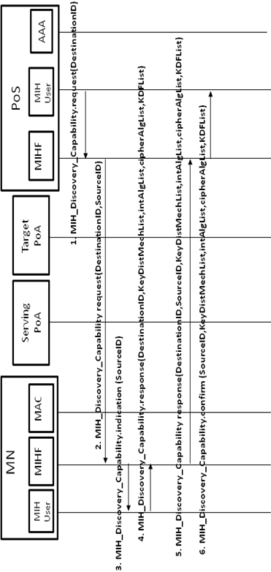  Capability Discovery phase messages (PoS initiated)

DRAFT SECTION | ANNEX N
Modification type | ADD  If it is required or may be it could be in order section
Text | 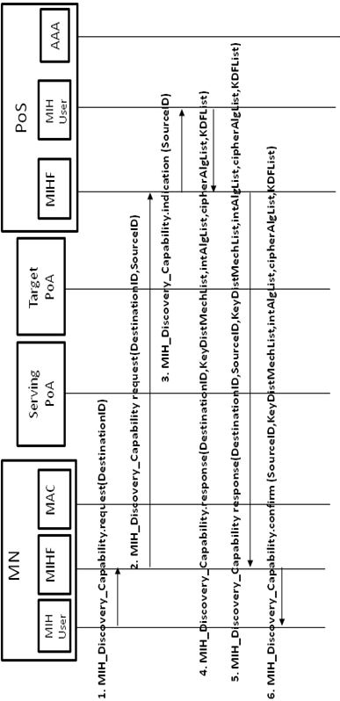  Capability Discovery phase messages (MN initiated)

DRAFT SECTION | ANNEX N
Modification type | ADD  If it is required or may be it could be in order section
Text | 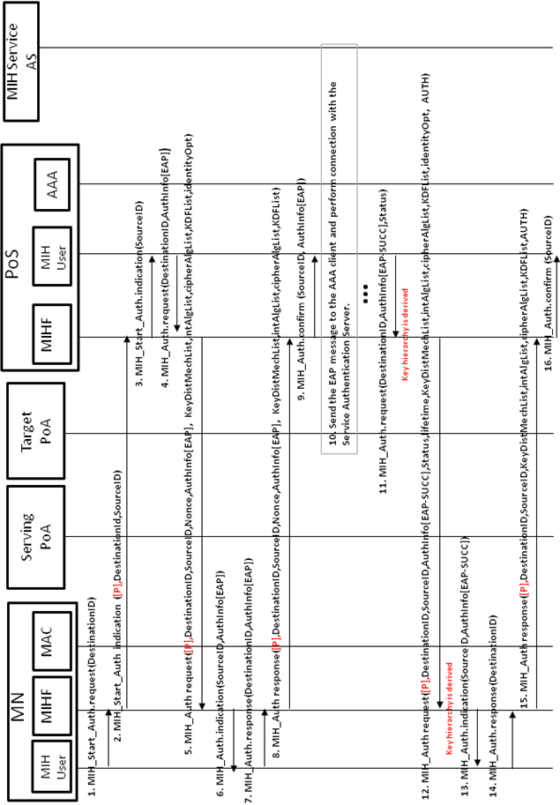  Media Independent Service Authentication MN initiated messages  Some aspects which need further consideration:  Negotiation phase to negotiate the cipher suite to be used is performed in the firsts two MIH_AUTH messages (request/response).  The authentication process is based in EAP.  KeyDistMechList identifies the Key Distribution Mechanism List TLV. This is used to select a key distribution mechanism (Push, Reactive Pull, Proactive Pull, or Optimized Proactive Pull). If this TLV is present, it is signaling that the bundle option is active and the key distribution mechanism selected by this TLV is going to be used to perform the bundle.  Flag P is used to indicate that the MN is trying to authenticate with a PoS in a different domain. This flag is in MIH Header on bit 0 in RESERVED2 field.  Status is used to indicate the state of the authentication, if it has been successful or not.  The last two messages have an AUTH TLV and they include the ciphersuite and the other related parameters negotiated before, in order to securely confirm that these parameters (cipher suite, key distribution mechanism, etc) have been those exchanged during the first MIH_Auth exchange. This AUTH TLV is checked both the MN and the PoS.

DRAFT SECTION | ANNEX N
Modification type | ADD  If it is required or may be it could be in order section
Text | 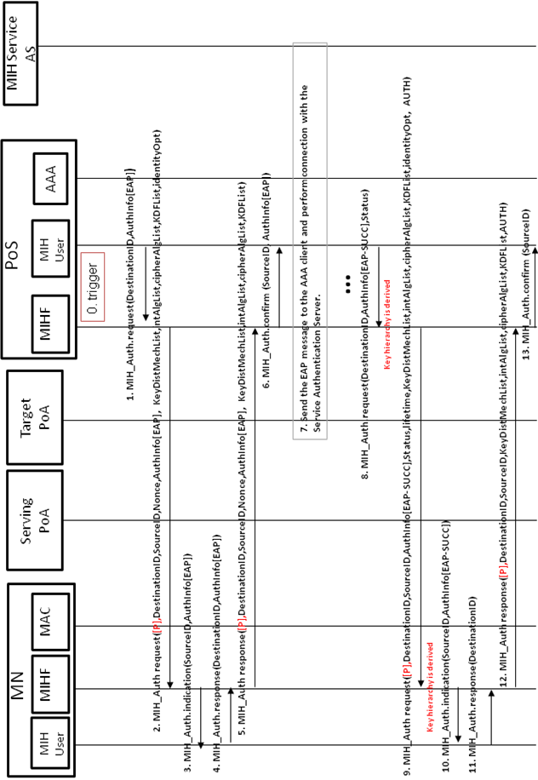  Media Independent Service Authentication Network initiated messages

DRAFT SECTION | ANNEX N
Modification type | ADD  If it is required or may be it could be in order section
Text | 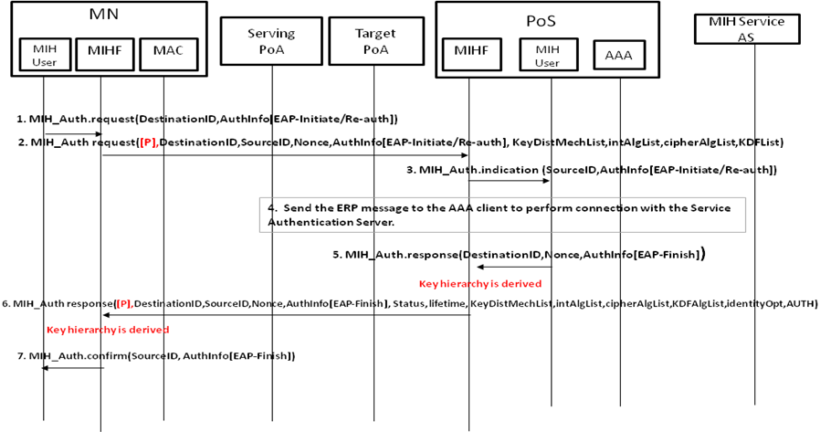  Media Independent Service Authentication MN initiated based on ERP  Some aspects to be considered:  The authentication process is based on ERP.  In the MN initiated scenario, the negotiation phase performed in the firsts two messages is in a different way. In this case, the MN proposes its supported parameters (cipher suite, key distribution mechanism, etc) and the PoS chooses which ones are going to be used, unlike the EAP authentication case where the PoS proposes and the MN chooses.  To check the negotiated parameters, in the last message the PoS sends the proposed parameters by the MN and its own selection. This message is integrity protected. At the MN side, the parameters can be checked due to the MN has its proposal and the selection made by the PoS is integrity protected.

DRAFT SECTION | ANNEX N
Modification type | ADD  If it is required or may be it could be in order section
Text | 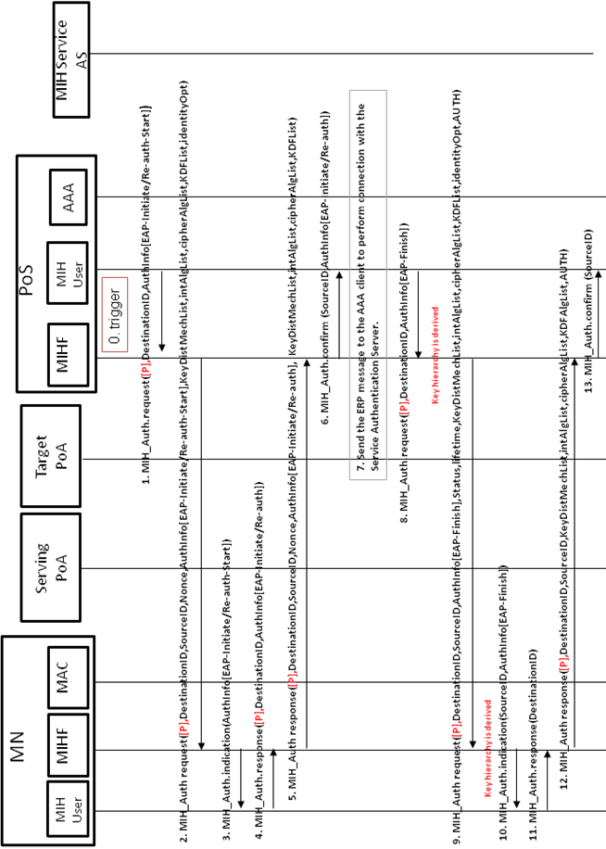  Media Independent Service Authentication Network initiated based on ERP  Some aspects to consider:  The authentication process is based on ERP.  Negotiation phase to negotiate the cipher suite to be used is performed in the firsts two MIH_AUTH messages (request/response).  KeyDistMechList identifies the Key Distribution Mechanism List TLV. This is used to select a key distribution mechanism (Push, Reactive Pull, Proactive Pull, or Optimized Proactive Pull). If this TLV is present, it is signaling that the bundle option is active and the key distribution mechanism selected by this TLV is going to be used to perform the bundle.  Flag P is used to indicate that the MN is trying to authenticate with a PoS in a different domain. This flag is in MIH Header on bit 0 in RESERVED2 field.  Status is used to indicate the state of the authentication, if it has been successful or not.  The last two messages have an AUTH TLV and they include the ciphersuite and the other related parameters negotiated before, in order to securely confirm that these parameters (cipher suite, key distribution mechanism, etc) have been those exchanged during the first MIH_Auth exchange. This AUTH TLV is checked both the MN and the PoS.  To initiate the Media independent Authentication by the network a trigger is needed.

DRAFT SECTION | ANNEX N
Modification type | ADD  If it is required or may be it could be in order section
Text | 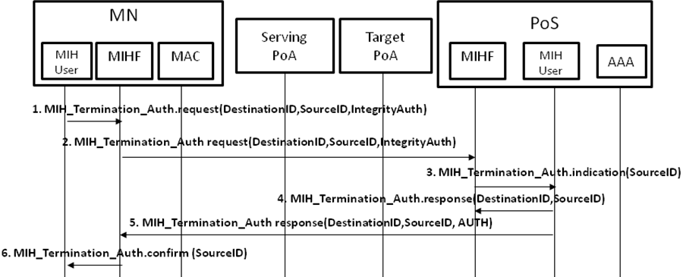  Finalization phase messages

DRAFT SECTION | ANNEX N
Modification type | ADD  If it is required or may be it could be in order section
Text | Link layer authentication messages

DRAFT SECTION | ANNEX N
Modification type | ADD  If it is required or may be it could be in order section
Text | 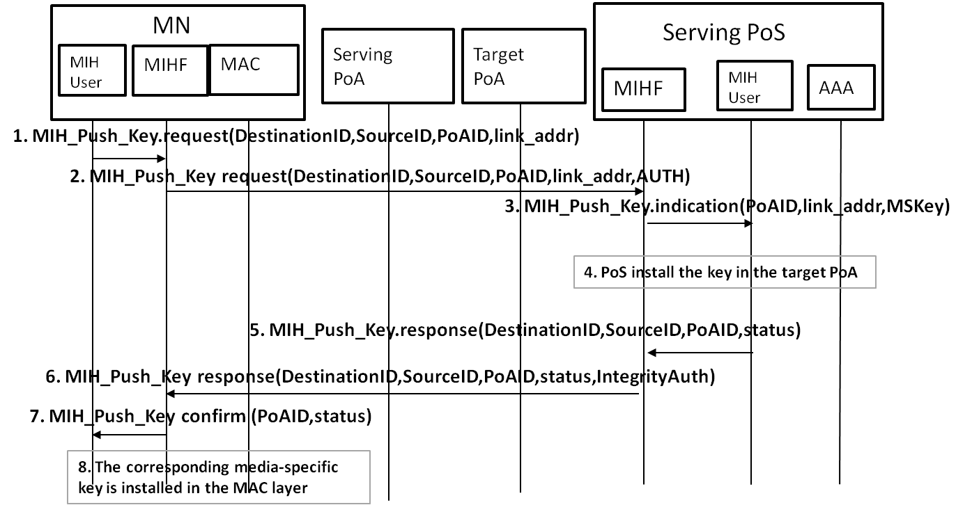  Push key distribution messages

DRAFT SECTION | ANNEX N
Modification type | ADD  If it is required or may be it could be in order section
Text | proactive pull key distribution messages

DRAFT SECTION | ANNEX N
Modification type | ADD  If it is required or may be it could be in order section
Text | 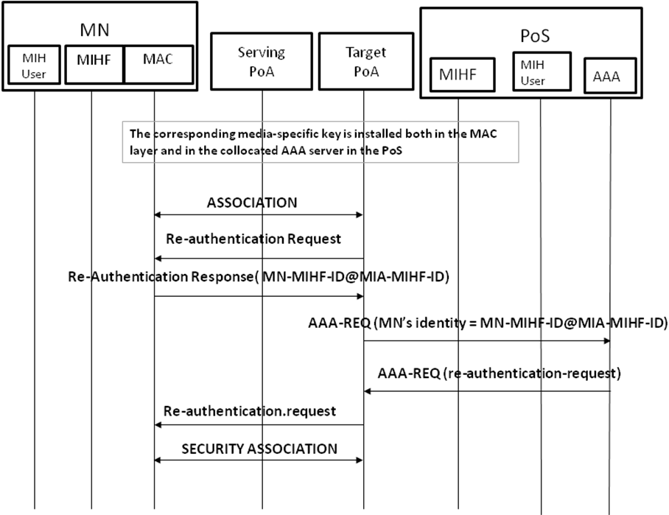  Reactive pull key distribution messages
Note | To perform this key distribution mechanism there is no need of use MIH protocol. It is a media-specific authentication which could be optimized by acting the PoS like a AAA server.

DRAFT SECTION | NEW section (Data types definition)
Modification type | NEW
Text | Data Type Name Derived from Definition  KEY_DIST_LIST BITMAP(8) A list of key distribution methods available. Bitmap values: Bit 0: Push Key distribution. Bit 1: Proactive Pull Key Distribution. Bit 2: Optimized Proactive Pull Key Distribution. Bit 3: Reactive Pull Key Distribution. Bit 4-7: (Reserved)  INT_ALG_LIST BITMAP(8) A list of integrity algorithms available. Bitmap values: Bit 0: INTR_HMAC_SHA_96 Bit 1: INTR_CMAC_AES Bit 2: INTR_NULL Bit 3-7: (Reserved)  CIPH_ALG_LIST BITMAP(8) A list of encryption algorithms available. Bitmap values: Bit 0: ENCR_AES_CBC Bit 1: AUTH_ENC_AES_CCM Bit 2 : ENCR_NULL Bit 3-7: (Reserved)  KDF-List BITMAP(8) A list of Key Derivation Functions available. Bitmap values: Bit 0: PRF_CMAC_AES Bit 1: PRF_HMAC_SHA1 Bit 2-7: (Reserved)  ID_OPT OCTET_STRING Represents a new identity provided for optimization purposes.  NONCE_VALUE UNSIGNED_INT(2) Represents a random value.  AUTH_INFO_VALUE OCTET_STRING Represents the authentication information used to authenticate.  AUTH_VALUE OCTET_STRING Represent an integrity string to verify data integrity.  INTEGRITY_DATA OCTET_STRING Represents the integrity data of a message.  KEY OCTET_STRING Represents a key  LL_FRAMES OCTET_STRING Represents the information needed to carry out a key installation.  STATUS ENUMERATED This is an extension of STATUS TLV defined in IEEE 802.21, it must be updated to support: 5: Authentication Failure  LIFETIME UNSIGNED_INT(2) Represents the period of time that a key is valid for being used.  POA_ID LINK_ADDR A data type to represent an address of any link layer

DRAFT SECTION | NEW section
Modification type | NEW  This section must be called Alternatives to transport EAP
Text | In this section we analyze PANA (RFC 5191) as an alternative to transport EAP between the MN and the PoS in order to authenticate the MN. Using PANA as protocol the current architecture would be updated as follows: MN would be acting as PaC (PANA Client) and PoS as PAA (PANA Authentication Agent) and PoA as EP (Enforcement Point).  PANA is a protocol (RFC 5191) defined under the IETF and defines a network-layer transport for EAP. Moreover, it is a secure protocol where a security association is created after successfully completion of the EAP authentication creating a MSK. Using this cryptographic material protocol messages could be protected. Furthermore, PANA provides pre-authentication supports (RFC 5873) which allows a MN to establish a PANA session with a target PoS/PAA before to perform the movement. Therefore, PANA protocol provides all the necessary mechanisms to perform a secure seamless handover between the MN and its serving PoS (PAA).  Thus, PANA achieves the same objectives as MIH protocol (protocol security and seamless handover). But PANA has some lacks which are inherent to its definition which provokes that it could not be used instead of MIH protocol. We have identified a main issue, this is, PANA is a network-layer protocol (it works under UDP). PANA assumes that the MN has IP connectivity. Therefore, to use PANA, the MN always needs IP connectivity to perform the PANA procedure to get network access. To solve this issue PANA pre-authentication could be used (performing an authentication with the target PoS (PAA)). In this way, when the MN arrives to the target network, it only needs to perform the security association with the target PoA. If the MN is moving quickly and the pre-authentication procedure takes long time (for example, an EAP-TLS authentication), the MN could lose its connectivity with the Serving PoA before complete the pre-authentication procedure. Then, if the MN moves finally to the target PoA the pre-authentication procedure cannot be completed therefore, there is neither IP connectivity nor key material. In that case, to gain network access the MN must perform a full EAP authentication where the delay can be very high. Therefore, the use of pre-authentication it is not a valid solution in all cases.  On the other hand, if we are using MIH protocol, which could be carried over any technology, the same problem is present (if the MN moves quickly connectivity could be lost) but, MIH protocol allows, if the connectivity has been lost, to resume the unfinished pre-authentication through the target PoA without the need of re-start the (pre-)authentication. All the progress carried out before losing connection is valid and the authentication can continue in the same point before the lost of connectivity. This advantage cannot be carried out in PANA, due to its IP connectivity requirement. In fact, PANA may not continue since a complete media-specific EAP authentication may be required with the target PoA to send IP traffic, which basically spoils the benefits of having a PANA pre-authentication mechanism.  In the following, we explain a scenario where this issue is represented.  In the Figure[A??], the MN is attached to a Serving WiFi PoA and it has been authenticated with the PoS (the PoA could be collocated with the PoS) in a domain A and it has IP connectivity (number 1 in the figure). Moreover, the MN is moving quickly (number 2) and through the IEEE 802.21 information server knows that, in that area, there are a WiFi PoA and WiMAX PoA, which belongs to another domain (domain B) . The MN realizes that the connectivity with the Serving WiFi PoA is going down. At this point, there are two options: either using PANA or using MIH protocol in order to perform an authentication with the discovered PoS which manage WiFi PoA and WiMAX PoA .  If PANA is used, the MN starts a pre-authentication procedure against the candidate PoS (target PoS, due to it has been selected to perform the authentication) through the Serving WiFi PoA. Once the process has started, due to the MN is moving, the connectivity with the Serving WiFi PoA is lost before the pre-authentication process could have been completed. Therefore, when the MN enters in the WiMAX PoA range a full media-specific EAP authentication process needs to be performed from the beginning since PANA cannot continue since it needs IP connectivity to be used.  If MIH protocol is used, also, the connectivity would have been lost but, MIH has an advantage, since it can be directly carried over link-layer frames. Thus, when the MN enters in the WiMAX PoA range, it can resume the (pre-)authentication process in the point before the MN lost the network connectivity and to finish the authentication process initiated in Domain A. Thus, there is no need to start a new authentication process. So that, for example, if the network connectivity is lost when only one message remains, MIH protocol can finish the authentication sending the last message over WiMAX link-layer and PANA needs to start a new authentication process.  scenario using a PoA as a bridge  Another issue (if we consider to co-locate the PoS with the PoA), even though this is not a limitation, we believe that in terms of deployment is easier to convince a technical IEEE vendor to implement, in its products (i.e. antennas, access points, etc), an IEEE technology like IEEE 802.21 rather than implement a PANA agent, which is an IP layer protocol.
NOTE | [A??] references the figure provided in this text.

