IEEE 802.21
Media Independent Handover
Proposal for Support of Broadcast Services
Date: January 04, 2010
Authors: Catherine Livet, InterDigital Communications
Michelle Perras, InterDigital Communications
Teodor Buburuzan, TUBS
e-Mail: Catherine.Livet@interdigital.com
Michelle.Perras@interdigital.com
Buburuzan@ifn.ing.tu-bs.de

Abstract
This document is a draft specification of the 802.21b TGs Proposal.

Table of Contents
1 Introduction 4
2 References 4
3 Abbreviations and Acronyoums 5
4 Modified MIH_SAP 5
5 Modified and new IEs for 802.21b 5
5.1.1 Link related data types 5
5.1.2 Multicast MIH Messages 6

Introduction
802.21b Task Group was created to support the Broadcast Services in MIH. This document presents a proposal to address the requirements and uses cases for the support of Broadcast Services as defined in [3].
A Broadcast session can be handed over according to the following scenarios
- From (1 DO and 1 Bidirectional) to (1 Bidirectional)
- E.g. for a DVB session with the Return channel over 3GPP
- The DVB Session is HO from DVB to 3GPP
- The return channel remains on 3GPP
- From (1 Bidirectional) to (1 DO and 1 Bidirectional)
- E.g. for a 3GPP session with Return Channel over 3GPP
- The 3GPP session is HO to DVB
- The Return channel remains on 3GPP if still available
- Return Channel HO only scenario
- E.g. for a DVB session with Return Channel over 3GPP
- The DVB data remains on DVB
- The return channel HO from 3GPP to WLAN
- From (1 DO) to (1 Bidirectional) with no return channel
- E.g. a DVB session is HO to 3G

The assumptions are the following
- Multiple radios may be used simultaneously at the mobile.
- Service Distribution/Management might be based on different broadcasting services using different Mobility Management Protocol (MMP)
- OMA BCAST, IPDC, IP Multicast…
- Different Distribution Networks (i.e. Air Interface) are also considered
- DVB/NGH, 3GPP MBMS, 3GPP2 BCMCS, MediaFLO, DMB
- When the HO is complete, the Service Distribution is responsible for the service redirection to the new technology
- The service may have to be initialized on the new interface if not already started

References

- IEEE 802.21-2008, Standard for Local and Metropolitan Area Networks: Media Independent Handover Services, January 2009.
- July, 2009/0129r1-bcst “ Call for Technical Proposals on Handovers with Broadcast Networks”
- July, 2009/0041r4-bcst “Use Cases and Requirements for Handovers with Broadcast Services”

Abbreviations and Acronyoums

Insert the following new acronyoums at appropriate locations in Clause 4 of IEEE 802.21 2009
BCST |  | BroadCast
DVB |  | Digital Video Broadcast
DO |  | Downlink Only
DMB |  | Digital Media Broadcast
MMP |  | Mobility Management Protocol
SD |  | Service Distribution
SM |  | Service Management

Modified MIH_SAP
The broascast services require Content/Service Distribution and Service Management to transmit multimedia content. They implement a Mobility Management Protocol (MMP) such as OMA BCAST, IPDC or IP Multicast.
For the support of 802.21b, these MMP can be seen as new MIH User interfacing with MIH Function through MIH_SAP.
The new MIH_SAP messages allows the MMP to provide user related information such as program viewed, numbers of users listening a unicast / multicast program to the MIH server. It can also allows the MIH server to setup a new service in the destination broadcast technology prior to move a user to this technology.
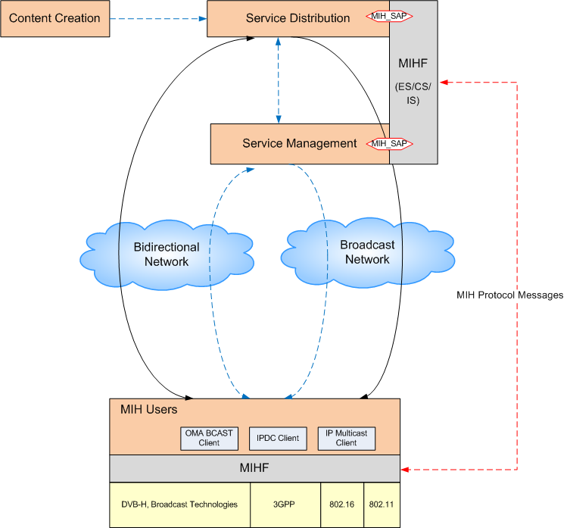

Modified and new IEs for 802.21b

Link related data types
In current specification, when performing a handover from a link source to a link destination, both links are assumed to be bidirectional and supporting some unicast type of transmission. In case of handover involving broadcast type technology, the direction of the link (bidirectional or downlink only) and the type of casting (multicast or broadcast) need to be considered to be able to perform the best handover with the most appropriate link technology.
Therefore, LINK_TYPE needs to be extended to incorporate the broadcast technologies now supported by 802.21b. A new IE is defined, CAST_TYPE, which provides the type of casting of the link and is added as optional to the LINK_ID definition.

Modify the Table F.4 of IEEE 802.21-2008 to add the following:

Data Type Name | Derived from | Definition
LINK_TYPE | UNSIGNED_INT(1) | Represents the link type.  Number assignments:  0: Reserved  1: Wireless – GSM  2: Wireless – GPRS  3: Wireless – EDGE  15: Ethernet  18: Wireless – Other  19: Wireless - IEEE 802.11  22: Wireless - CDMA2000  23: Wireless – UMTS  24: Wireless - cdma2000-HRPD  27: Wireless - IEEE 802.16  28: Wireless - IEEE 802.20  29: Wireless - IEEE 802.22  TBD : DVB-H  TBD : DVB-NGH  TBD : MediaFLO  TBD : DMB  …
CAST_TYPE | UNSIGNED_INT(1) | Represents the type of cast of the link.  Number assignments:  TBD : Multicast  TBD: Broadcast
LINK_ID | SEQUENCE(  LINK_TYPE  LINK_ADDR  (new optional) CAST_TYPE  ) | The identifier of a link that is not associated with the peer node. The LINK_ADDR contains the address of this link.  If CAST_TYPE is absent, the default link type is unicast

Multicast MIH Messages
In current specification, while the MIH Protocol allows to transmit a multicast MIH Message as described in section 8.2.3, the only situation where multicast data frames are used is for MIHF Discovery, as defined in section 8.2.4.3.
An MIHF (the requestor) discovers its peer MIH functions and capabilities by multicasting or unicasting an
MIH_Capability_Discover request message to either its multicast domain or a known MIHF ID, respectively.

In section 8.3.1 where MIHF ID is described, Multicast MIHF ID is defined as an MIHF ID of zero length. A multicast MIHF ID can be used when destination MIHF ID is not known to a source MIHF. The MIHF ID is of type MIHF_ID. (See F.3.11.)

As in section 8.6, “All MIH messages carry a source MIHF ID followed by a destination MIHF ID as the first two TLVs of the MIH protocol payload part of the message. Multicast MIHF ID can be used in MIH_Capability_Discover request and response messages as its destination MIHF ID.”

For the support of broadcast services, the following needs to be added:
Others MIH Messages than MIH_Capability_Discover request can be either unicast or multicast.
For instance, most of the Command Req from the MIH Information Server to the MIH Users could be multicast. Only users supporting a uplink to to respond will send back the message response to the multicast message.

- MIH Messages for Management Service that can be either unicats or multicast
  - None

- MIH Messages for Event Service that can be either unicats or multicast
  - None, as they are all Indication messages, i.e. uplink messages

- MIH Messages for Command Service
  - MIH_Link_Get_Parameters_Req
  - MIH_Link_Configure_Thresholds_Req
  - MIH_Link_Actions_Req
  - MIH_Net_HO_Commit_Req

- MIH Messages for Information Service
  - MIH_Push_Information_Ind

