**IEEE P802.19**

**Wireless Coexistence**

|  |  |  |
| --- | --- | --- |
| Project | IEEE P802.19 Wireless Coexistence WG | |
| Title | Proposed draft text related to Suspendable CSMA/CA on IEEE 802.15.4 | |
| Date Submitted | July 31, 2025 | |
| Source | Takenori Sumi, Mitsubishi Electric | E-mail: Sumi.Takenori@dc.MitsubishiElectric.co.jp |
| Abstract | This submission contains a proposed draft text about Suspendable CSMA/CA on IEEE 802.15.4 std | |
| Purpose | For developing the TG3a draft. | |
| Notice | This document has been prepared to assist the IEEE P802.19. It is offered as a basis for discussion and is not binding on the contributing individual(s) or organization(s). The material in this document is subject to change in form and content after further study. The contributor(s) reserve(s) the right to add, amend or withdraw material contained herein. | |
| Release | The contributor acknowledges and accepts that this contribution becomes the property of IEEE and may be made publicly available by IEEE P802.19. | |

## Discussion

IEEE 802.15.4-2024 noted that the new access mechanism for wireless coexistence between IEEE 802.15.4 and other systems. The mechanism defined “Suspendable CSMA/CA” enables to improve IEEE 802.15.4 device performance on such as packet delivery rate, retry timeout, and packet failure caused by the exceeding of Number of Backoffs (NB). From the view point of IEEE 802.19.3a recommended practice, Suspendable CAMA/CA defined on IEEE 802.15.4-2024 is recommended to be involved on the amendment.

## Proposed draft text

***TG3a editor: Please add a new subclause 9.3.xx before 9.3.11 of IEEE 802.19.3-2021 as follows:***

**9.3.xx Suspendable CSMA/CA**

**9.3.xx.1. Necessity of backoff suspension**

This section validates the necessity of backoff suspension in IEEE 802.15.4 standard from protocol perspective [BXXa][BXXb]. As more and more communication technologies have been developed, IoT network environment has changed dramatically in terms of the device resource and capability, the number of devices in a network and the number of homogeneous and/or heterogeneous coexisting networks. For example, the sensor devices are conventionally battery powered. However, the grid-powered and solar-powered sensor devices have been emerging in recent years. Therefore, IoT communication technologies need to take advantages of more capable sensor devices to make network more reliable and efficient. Backoff suspension is one of functions that needs to be supported by IEEE 802.15.4 standard to benefit sensor devices without power constraint. Backoff suspension can bring benefits including: (1) improving IEEE 802.15.4 network reliability and (2) allowing IEEE 802.15.4 networks to better coexist with more channel access aggressive networks such as IEEE 802.11 networks. Figure XXa demonstrates that backoff suspension can reduce backoff failure of IEEE 802.15.4 devices, in which device A represents one of other IEEE 802.15.4 device, device B is a standard IEEE 802.15.4 backoff device and device C is a Suspendable IEEE 802.15.4 backoff device. These devices contend for channel access for transmission. At time T1, device A receives data transmission request and starts backoff. Both device B and device C receive data transmission request at time T2 and start backoff. Assume they also draw the same number of the unit backoff periods and therefore, need to backoff for the same amount of time. At time T3, device A finishes backoff and starts CCA operation, which detects idle channel. Thus, device A performs CCA to transmission turnaround. At time T4, device A starts data transmission.

Since device C senses channel in each unit backoff period, it detects transmission of device A and therefore, suspends its backoff process. On the other hand, device B does not suspend its backoff and completes backoff at time T5 and performs CCA. However, at time T5, device A still transmits. As a result, device B detects busy channel and returns backoff failure at time T7. Meanwhile, device C detects the end of device A transmission at time T6 and resumes remaining backoff. At time T8, device C completes backoff and starts CCA operation, which detects idle channel as well. Accordingly, device C performs CCA to transmission turnaround. At time T9, device C successfully transmits its data. It is possible that device C may also detect busy channel, but device B detects busy channel for sure, i.e., 100% of backoff failure. If the transmission of device A completes before time T5, both device B and device C will succeed backoff. However, device C will backoff more time due to suspension. If transmission of device A starts after time T7, both device B and device C will succeed backoff with same amount of backoff time.

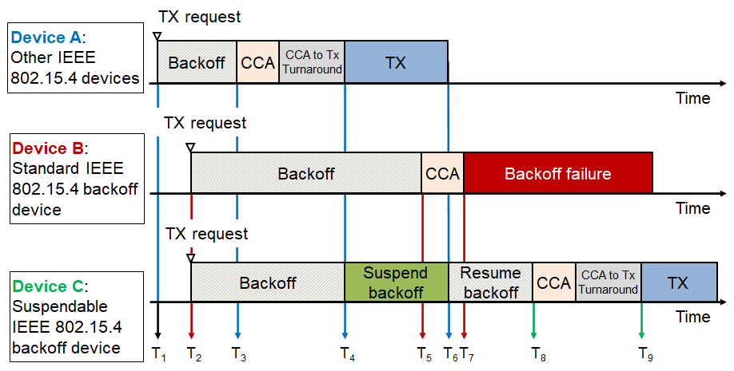

Figure XXa —Reduction of backoff failure by backoff suspension

**9.3.xx.2. Suspendable CAMA/CA mechanism**

Figure XXb shows the operation of Suspendable CSMA/CA transmission when other devices transmit data during backoff period. In details, if CCA is busy during the backoff delay period, the backoff timer shall be suspended until sensing the channel indicates that the channel is clear or macSuspended-CsmaMaxTime is exceeded. Upon CCA detecting clear, the backoff time shall resume. If macSuspendedCsmaMaxTime is exceed, backoff ends in ”Failure” and CSMA/CA algorithm terminates with a channel access failure.

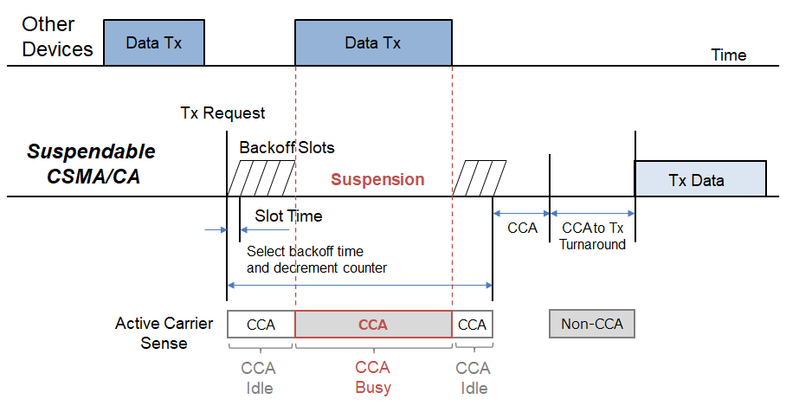

Figure XXb —Example of suspendable CSMA/CA behavior

***TG3a editor: Please add sentence on Section 9.3.11. of IEEE 802.19.3-2021 with modification highlighted red as follows:***

**9.3.11. Recommendation for distributed coexistence**

Multiple distributed coexistence methods have been introduced. Some methods may improve coexistence performance and some methods may not be ideal candidates. Table 6 shows the recommendations for distributed coexistence methods.

Table 6 —Recommendations for distributed coexistence methods

|  |  |  |
| --- | --- | --- |
| **Method** | **Recommendation** | **Reference** |
| Distributed transmission time delay | When an IEEE 802.11ah/IEEE 802.15.4g device is aware of the coexistence of IEEE 802.15.4g/IEEE 802.11ah devices. | 9.3.6 |
| α–Fairness based ED-CCA | When an IEEE 802.11ah device is aware of the coexistence of IEEE 802.15.4g devices and the detected energy level is between the IEEE 802.15.4g receiver sensitivity and the IEEE 802.11ah ED threshold. | 9.3.7 |
| Q-Learning based CSMA/CA | When an IEEE 802.11ah device is aware of the coexistence of IEEE 802.15.4g devices and its BC reaches zero with idle channel status. | 9.3.8 |
| Prediction-based transmission  time delay | When an IEEE 802.11ah device is aware of the coexistence of  IEEE 802.15.4g devices. | 9.3.9 |
| Hybrid CSMA/CA | When an IEEE 802.15.4g device is aware of severe interference on its channel. | 9.3.10 |
| Suspendable CSMA/CA | When an IEEE 802.15.4g device is aware of the coexistence of IEEE 802.11ah devices. | 9.3.xx |

***TG3a editor: Please add the following references into Bibliography:***

**Bibliography**

[BXXa] IEEE Std 802.15.4™-2024, IEEE Standard for Low-Rate Wireless Networks.

[BXXb] T. Sumi, et al., IEEE 802.11ah and IEEE 802.15.4g SUN OFDM PHY Coexistence Simulation for Case 1-3 with Suspendable CSMA/CA, doc.: IEEE 802.19-25/0006r0.