IEEE P802.19
Wireless Coexistence

Project | IEEE P802.19 Wireless Coexistence WG
Title | Recommended Practice for Local and Metropolitan Area Networks - Part 19: Coexistence Methods for 802.11 and 802.15.4 based systems operating in the Sub-1 GHz Frequency Bands
Date Submitted | November 13, 2019
Source | Jianlin Guo (MERL)  Philip Orlik (MERL)  Yukimasa Nagai (MERL)  Takenori Sumi (Mitsubishi Electric)  Benjamin A. Rolfe (MERL/BCA)  Joerg ROBERT | E-mail: guo@merl.com  porlik@merl.com  nagai@merl.com Sumi.Takenori@dc.MitsubishiElectric.co.jp  ben@blindcreek.com  joerg.robert@fau.de
Abstract | This document is a contribution to the Recommended Practice: summarizing contributions received to date
Purpose | To provide a specification framework for developing the draft
Notice | This document has been prepared to assist the IEEE P802.19. It is offered as a basis for discussion and is not binding on the contributing individual(s) or organization(s). The material in this document is subject to change in form and content after further study. The contributor(s) reserve(s) the right to add, amend or withdraw material contained herein.
Release | The contributor acknowledges and accepts that this contribution becomes the property of IEEE and may be made publicly available by IEEE P802.19.

- Overview
  - Scope
This recommended practice provides guidance on the implementation, configuration and commissioning of systems sharing spectrum between IEEE Std 802.11ah-2016 and IEEE Std 802.15.4 Smart Utility Networking (SUN) Frequency Shift Keying (FSK) Physical Layer (PHY) operating in Sub-1 GHz frequency bands.
  - Need for the Project
Many millions of devices based on IEEE Std 802.15.4 are currently operating in Sub-1 GHz frequency bands, and the field is expanding rapidly. Critical applications, such as grid modernization (smart grid) and internet of things (IoT) are using the low to moderate data rate capabilities of IEEE Std 802.15.4. IEEE Std 802.11ah-2016 may operate in the same Sub-1 GHz frequency bands and provides higher data rate capabilities than IEEE Std 802.15.4. In consideration of the current usage, as well as anticipation of yet unforeseen usage models enabled by the standards within the scope of this recommended practice, and to fully realize the opportunity for successful deployment of products sharing the spectrum, strategies and tactics to achieve good coexistence performance are critical. This recommended practice enables IEEE Std 802.15.4 and IEEE Std 802.11ah-2016 to most effectively operate in license exempt Sub-1 GHz frequency bands, by providing best practices and coexistence methods. This recommended practice uses existing features of the referenced standards and provides guidance to implementers and users of IEEE 802(R) wireless standards.
- Normative reference

TBD

- Definitions, acronyms and abbreviations
  - Definitions (TBD)
  - Acronyms and abbreviations (TBD)

- Overview of the Sub-1 GHz frequency band systems

Many Internet of Things (IoT) applications require low bandwidth communications over a long distance at low cost and low power. IEEE 802.11ah, IEEE 802.15.4g, IEEE 802.15.4w, LoRa and SigFox are the emerging technologies that fulfill these requirements by using the Sub-1 GHz (S1G) frequency bands to achieve long communication range. These technologies have different names for network management device: AP for 802.11ah, PANC for 802.15.4g and 802.15.4w, Gateway for LoRa and BS for Sigfox. Using these technologies, a network can support thousands of connected devices.

802.11ah and 802.15.4g are WLAN standards with 1km communication range. 802.15.4w, LoRa and Sigfox are LPWAN technologies and they have communication range from 15 km to 50 km.

Document #19-19/0046r1 and document #19-19/0064r0 overview major wireless systems in the Sub-1 GHz frequency band.

4.1 IEEE 802.11ah

IEEE 802.11ah standard, marketed as Wi-Fi HaLow, is a wireless communication PHY and MAC layer standard that operates in the unlicensed Sub-1 GHz frequency bands. 802.11ah defines a narrow band orthogonal frequency division multiplexing (OFDM) PHY to make it suitable for IoT applications.

Frequency band allocation is region dependent, e.g., 902-928 MHz band in United States, 863-868 MHz band in Europe and 915-928 MHz band in Japan. 802.11ah supports a wide range of bandwidths with mandatory 1 MHz channel and 2 MHz channels and optional 4 MHz, 8 MHz and 16 MHz channels.

802.11ah specifies same data rate for uplink traffic and downlink traffic. With 1 spatial stream, 802.11ah enables a data rate up to 78 mbps at short ranges and 150 kbps up to 1 km. With 4 spatial streams, 802.11ah enables a data rate up to 346 mbps at short ranges. Support for 1 MHz channel and 2 MHz channel with 1 spatial stream is mandatory. Support for 1 MHz channel and 2 MHz channel with 2, 3 or 4 spatial streams is optional. Support for 4 MHz channel, 8 MHz channel, and 16 MHz channel with 1, 2, 3 or 4 spatial streams is optional.

The maximum allowed transmission power is region dependent and ranges from 3 mW to 1000 mW, e.g., 1000 mW in United States, 250 mW in Japan and 25 mW in Europe.

In order to support large numbers of stations, the 802.11ah extends the range of Association IDs (AIDs), i.e., the number of associated stations, from 2048 up to 8192 per AP, and organizes stations in a four level hierarchical structure to improve station management scalability. Stations are grouped together based on their similarities. Each station is assigned a four level AID structure encompassing page, block, sub-blocks and station fields. 802.11ah network can be organized in start topology, mesh topology or tree topology.

In terms of channel access, 802.11ah typically applies CSMA/CA specified via Enhanced Distributed Channel Access (EDCA) function, which implements service differentiation by classifying the traffic into four different access categories with different priorities. As such, the different backoff parameter set is specified for different access category (AC). The time division multiple access (TDMA) based channel access can also be achieved through HCF Controlled Channel Access (HCCA) function, which uses polling mechanism to assign transmission opportunity (TXOP) to QoS enabled stations.

In addition, 802.11ah specifies several features for spectrum efficiency and power efficiency. Some of these features can be applied for coexistence improvement.

The restricted access window (RAW) mechanism reduces contention by clustering stations into RAW groups and slots, only allowing the stations in one group to contend for the channel at any time slot. As such, it effectively combines the efficiency of CSMA/CA and the determinism of TDMA into a dynamically adaptable MAC scheduler. RAW has been shown to significantly reduce collision probability and interference in dense networks, resulting in a potential throughput increase of 50% or more.

The S1G stations that are associated with a S1G AP transmit and receive on the channel or channels that are indicated by the AP as the enabled operating channels for the basic service set (BSS). Subchannel selective transmission (SST) is a feature specified by 802.11ah to allow stations to rapidly select and switch to different channels between transmissions to counter fading over narrow subchannels.

4.2 IEEE 802.15.4g

IEEE 802.15.4g, marketed as Wi-SUN (Wireless Smart Utility Network), is a PHY amendment to the IEEE Std 802.15.4-2011. 802.15.4g is specifically designed for long range communication. In other words, it is a long range extension of the IEEE 802.15.4 standard family, arguably the most popular network solution for IoT applications. It was originally designed for smart metering applications but is getting more and more popular in long range IoT applications. 802.15.4g can operate both in the Sub-1 GHz frequency bands and the 2.4 GHz frequency bands.

802.15.4g specifies alternate PHYs in addition to those of IEEE Std 802.15.4-2011. The alternate PHYs support principally outdoor Wi-SUN applications under multiple regulatory domains. Three SUN PHYs are defined:
- Multi-rate and multi-regional frequency shift keying (MR-FSK) PHY
- Multi-rate and multi-regional orthogonal frequency division multiplexing (MR-OFDM) PHY
- Multi-rate and multi-regional offset quadrature phase-shift keying (MR-O-QPSK) PHY

Even 802.15.4g primarily defines new PHYs, it also specifies the MAC modifications needed to support new PHY implementation. Besides baseline 802.15.4-2011 MAC, 802.15.4e is used as additional MAC. The CSMA/CA is main channel access mechanism specified in 802.15.4-2011, where different backoff processes take place depending on the beacon-enabled network or non-beacon-enabled network. In beacon-enabled network, TDMA based channel access is specified in the contention free period (CFP) via guaranteed time slot (GTS) mechanism. In non-beacon-enabled network or contention access period (CAP) of the beacon-enable network, CSMA/CA based channel access is employed.

802.15.4e was published in 2012 as an amendment to the MAC protocol defined by IEEE Std 802.15.4-2011, mainly for improving the adoption of sensor node communication for industrial applications. One of the most promising new features in 802.15.4e is time-slotted channel hopping (TSCH), which is a TDMA based channel access mechanism and designed specifically to provide deterministic performance, ultra-low power consumption and network robustness, minimizing the impact of wireless unreliability. In TSCH mode, the slotframe replaces conventional superframe, and therefore, no beacon is required. Instead, nodes are synchronized by obtaining synchronization information from enhanced beacon and communicate by following a TDMA schedule called TSCH schedule.

The star topology and mesh topology are typical network architectures for 802.15.4g network organization.

The maximum transmission power is region dependent, e.g., 1000 mW in United States, 25 mW in Europe and 250 mW in Japan. The transmission range is up to 1 km. Its inherent multihop capabilities give it a unique edge to other technologies.

The frequency band allocation is also region dependent, e.g., for the S1G frequency band, 902-928 MHz in United States, 169 MHz in Europe and 920-928 MHz in Japan. Depending on the PHY configuration, the bandwidth of channels ranges from 200 kHz to 1200 kHz. In 802.15.4g-2012, the data rate ranges from 6.25 kbps to 800 kbps. IEEE 82.15.4x, an amendment to 802.15.4g, extends the data rate to 2.4 Mbps.

4.3 IEEE 802.15.4w

IEEE 802.15.4w Task Group is defining a LPWAN extension to the IEEE Std 802.15.4 LECIM PHY layer to cover network cell radii of typically 10-15km in rural areas and deep in-building penetration in urban areas. It uses the LECIM FSK PHY modulation schemes with extensions to lower bitrates, e.g. payload bitrate typically < 30 kb/s. It extends the frequency bands to additional Sub-GHz unlicensed and licensed frequency bands to cover the market demand. For improved robustness in channels with high levels of interference, it defines mechanisms for the fragmented transmission of Forward Error Correction (FEC) code-words, as well as time and frequency patterns for the transmission of the fragments. Furthermore, it defines lower code rates of the FEC in addition to the K=7 R=1/2 convolutional code. Modifications to the MAC layer, needed to support this PHY extension, are defined.

802.15.4w channel width ranges from 2.3 kHz to 19 kHz. Its PHY is generally considered as GMSK. The instantaneous PHY data rate is from 600 bps to 9 kbps. The effective data rate is from 60 bps to 900 bps. The frequency band allocation is region dependent, e.g., 902-928 MHz band in the United States, 169 MHz and 863-870 MHz bands in Europe, and 920-928 MHz band in Japan. 25mW transmission power for typical use case and 500 mW maximum transmission power in Europe. The communication range is up to 51 km. 802.15.4w can use either TDMA or ALOHA for channel access. 802.15.4w network can have start or mesh topology.

This standard is still under development. It considers coexistence with other 802.15.4 systems and 802.11ah systems.

4.4 LoRa

LoRa (Long Range) is a physical layer technology for creating long range communication links. It makes use of a radio modulation technique, chirp spread spectrum (CSS) that has a very high sensitivity and thus increases communication range. The Long Range Wide Area Network (LoRaWAN) defines the communication MAC protocol and system architecture for the network on top of the LoRa PHY layer.

The star network architecture defined by LoRaWAN. It is designed to allow low power devices to communicate with Internet connected applications over long range wireless connections. LoRaWAN can be mapped to the second and third layer of the OSI model. It is implemented on top of LoRa or FSK modulation in industrial, scientific and medical (ISM) radio bands. The LoRaWAN protocols are defined by the LoRa Alliance and formalized in the LoRaWAN specification.

The frequency band allocation is region dependent. In the United States, LoRaWAN operates in the 902-928 MHz frequency band. Unlike the European band, the United States band has dedicated uplink and downlink channels. In Europe, LoRaWAN operates in the 863-870 MHz frequency band with a duty cycle as low as 1% or even 0.1%. In Japan, LoRaWAN operates in 920-923 MHz frequency band. LoRaWAN can use channels with a bandwidth of either 125 kHz, 250 kHz or 500 kHz, depending on the region or the frequency plan.

In the United States, the LoRa band has dedicated uplink and downlink channels. The band is divided into 8 sub-bands that each have 8x125 kHz uplink channels, 1x500 kHz uplink channel and 1x500 kHz downlink channel.

In Europe, LoRaWAN defines ten channels. Eight of them are 125 kHz LoRa channels that, depending on the used spreading factor, offer data rates from 250 bps to 5.5 kbps. By dynamically adapting the spreading factor, a trade-off between data rate and range can be achieved. In addition, there is also a single high data rate 250 kHz LoRa channel at 11 kbps and a single FSK channel at 50 kbps.

The maximum transmission power can be as high as 1000 mW. In Europe, the maximum uplink transmission power is 25 mW and the maximum downlink transmission power is 500 mW.

LoRa data rate ranges from 0.3 kbps to 5.5 kbps. The communication range is up to 15 km. Both end device and gateway use same radio.

Uplink data originating from end devices is received by one or multiple gateways. These gateways act as transparent (non-intelligent) bridges, relaying the data to a cloud-based network server. In case downlink traffic is available, the cloud server decides which gateway has the best connectivity with the end device, and the downlink traffic is transmitted from this gateway. As a result, all intelligence resides in this network server, which manages the network, filters redundant received packets, performs security checks, schedules acknowledgments through the optimal gateway, performs adaptive data rate, etc.

Three devices classes have been defined: Class A, Class B and Class C. All LoRaWAN devices must implement Class A functions, whereas Class B and Class C are extensions to the specification of Class A.

Class A devices support bi-directional communication between a device and a gateway and allow download traffic right after an upload slot. Uplink transmission from the end device to the network server can be sent at any time (randomly), i.e., ALOHA channel access. The end device then opens two receive windows at specified times after an uplink transmission. If the server does not respond in either of these receive windows, the next opportunity will be after the next uplink transmission from the device. The server can respond either in the first receive window or in the second receive window, but should not use both windows.

Class B devices extend Class A by adding scheduled receive windows for downlink traffic from the server. Using time-synchronized beacons transmitted by the gateway, the devices periodically open receive windows. As a result, Class B schedules separate upload windows.

Class C devices extend Class A by keeping the receive windows open unless they are transmitting. This allows for low latency communication but is many times more energy consuming than Class A devices, thereby trading in battery lifetime for lower downlink communication latency.

4.5 SigFox

SigFox is a proprietary technology for long range IoT applications. It is an ultra-narrowband technology. It uses different radio for uplink and downlink. The standard radio transmission method called binary phase shift keying (BPSK) is used for uplink and Gaussian Frequency Shift Keying (GFSK) is used for downlink. It takes very narrow chunks of spectrum and changes the phase of the carrier radio wave to encode the data. The bandwidth of uplink channel is region dependent, e.g., 600 Hz in the United States and 100Hz in Europe. The downlink channel is 1.5 kHz. This allows the receiver to only listen in a tiny slice of spectrum that mitigates the effect of noise. This results in great sensitivity, which allows for long-range communication up to 50 km in rural areas and up to 10 km in urban areas, provided there is no interference. The uplink data rate is 600 bps in the United States and 100 bps in Europe. The downlink data rate is 600 bps worldwide. The SigFox network is typically in star topology.

The frequency band allocation for SigFox is region dependent, e.g., 915 MHz in the United States, 868 MHz in Europe and 433 MHz in Asia. The maximum transmission power is also region dependent, e.g., 158 mW uplink in United States and 25 mW uplink power in Europe, 500 mW downlink power in Europe and 1000 mW downlink power in United States. Europe also requires 1% uplink duty cycle and 10% downlink duty cycle.

In contrast to the inexpensive radio of the end devices, the base stations use a sophisticated software-defined radio platform to simultaneously monitor the full frequency spectrum and look for SigFox signals, e.g., full 192 kHz spectrum in Europe. The random access, i.e, ALOHA, is a key feature to achieve a high quality of service. The transmission is unsynchronized between the base station and the device. To guarantee 99.9% reliability, the device emits a message on a random frequency and then sends 2 replicas on different frequencies and time, which is called “time and frequency diversity”, to ensure it will correctly be received by at least one of the base stations in range.

The SigFox technology is suitable for very specific, very low data rate uplink IoT applications. Due to its popularity, it must be taken into account as a potentially harmful interferer for the other low power technologies.

Table 1 Summary of Sub-1 GHz frequency band technologies
Technology | PHY Modulation | Channel  Bandwidth | PHY Data Rate | Typical TX Range | Max TX Power | Channel Access | Coexistence Mechanism
IEEE 802.11ah | OFDM | 1/2/4/8/16 MHz | 150bps- 78Mbps | 1 km | 1000mW | CSMA/  TDMA | Energy detection
IEEE 802.15.4g | FSK/  OFDM/  O-QPSK | 200/400/  600/800/  1200 kHz | 6.25kbps-2.4Mbps | 1 km | 1000mW | CSMA/  TDMA/  ALOHA | Energy detection
IEEE 802.15.4w | GMSK | 2.3 kHz–  19 kHz | 600bps-9kbps | 50 km | 1000mW | TDMA/  ALOHA | Energy detection
LoRa | CSS/FSK | 125/250/  500 kHz | 300bps–5.5 kbps | 15 km | 1000mW | TAMA/  ALOHA | No
SigFox | BPSK(up),  QFSK(down) | 0.1/0.6/  1.2 kHz | 100–600 bps | 50 km | 1000mW | ALOHA | No

- Use cases of the Sub-1 GHz frequency band technologies

The Sub-1 GHz frequency band technologies are developed for IoT applications such as smart utility, smart city, field monitoring and building automation. However, based on characteristics of each technology, use cases vary.

5.1 802.11ah

802.11ah device has yet been deployed. However, Wi-Fi Alliance has marketed this technology as Wi-Fi HaLow to promote its product development and application. As a result, Japan recently formed the 802.11ah Promotion Council (AHPC) to promote deployment of 802.11ah technology. AHPC proposed use case scenarios for 802.11ah in document #19-19/0047r3 and IEEE 802.11 WG group proposed use case scenarios for 802.11ah in document #11-10/1044r0 and #11-10/1206r1. These use cases include
- Home security network
- Contents synchronization between home server and vehicles
- Power management for office
- Wireless sensor network backbone in process automation industry
- Efficient field work and inspection at factory
- Remote monitoring of wildlife to prevent damage of agricultural crops
- Surveillance camera system using edge computing
- Advanced water pipe management
- Backup network for cellular drone
- Detecting deterioration of infrastructure by wireless vibration sensors
- Push notification customer support
- Advanced management in public transportation
- Bridging and mesh backhaul
- Smart power
- Smart grid
- Smart meter
- Smart lighting
- Intelligent transportation system (ITS)
- Smart city
- Industrial process sensor
- Health care
- Wearable
- Home/building automation
- Smart appliance
- Hot spot

Some of use cases are for outdoor, e.g., smart grid, ITS and agriculture. Some of the use cases are for indoor, e.g., home/building automation.

Some of use cases incur low network traffic, e.g., smart meter and health care.
Some of use cases require high throughput to support video transmission, e.g., agricultural monitoring and video surveillance.

Some of use cases requires thousands of devices, e.g., smart meter.

5.2 802.15.4g

802.15.4g was originally designed for smart metering applications. As such, it was market as Wi-SUN. Millions of 802.15.4g devices have been deployed. In Japan, more 20 million smart meters already deployed by TEPCO, more 65 million smart meters scheduled for deployment by 2023, most utilities have chosen wireless mesh using 802.15.4 FSK at 920 – 928MHz for AMI connection, and smart meter to HEMS controller connection uses 802.15.4 FSK at 920 – 928MHz. Wi-SUN Alliance has proposed following use case scenarios for 802.15.4g in document #15-19/0341r0:
- Smart utilities
  - Advanced metering infrastructure (AMI)
  - Peak load management
  - Distribution automation
  - EV charging stations
  - Gas and water metering
  - Leak detection
- Smart cities
  - Street lighting
  - Smart parking
  - Traffic and transport systems
  - Environmental sensing
  - Infrastructure management
- Smart home
  - Smart thermostats
  - Air conditioning
  - Heating
  - Energy usage displays
  - Health
  - Well-being applications
- M2M
  - Agriculture
  - Structural health monitoring (e.g. bridges, buildings, etc.)
  - Monitoring
  - Asset management
- Industrial plant monitoring

5.3 802.15.4w

802.15.4w can be applied to all use cases for LoRa and SigFox

5.4 LoRa

Typical use cases for LoRa can be divided into two categories:
- Smart city
  - Smart lighting
  - Air quality and pollution monitoring
  - Smart parking and vehicle management
  - Facilities and infrastructure management
  - Fire detection and management
  - Waste management
- Industrial
  - Radiation and leak detection
  - Smart sensor technology
  - Item location and tracking
  - Shipping and transportation

5.5 SigFox

Followings are candidate use scenarios for SigFox:
- Supply chain and logistics
- Manufacturing
- Smart cities such as Smart lighting and Public transport
- Utilities and energy
- Smart buildings and security
- Retail
- Agriculture and environment
- Home and lifestyle
- Service and vehicle monitoring
- Road and structure sensors

For 802.15.4w, LoRa and SigFox systems, the main use-cases are focusing on monitoring applications. Hence, highly asymmetrical traffic can be expected with typical focus on the uplink.

- Sub-1 GHz spectrum allocation
This section is informative and could be an annex
6.1 Japan

As presented in document #19-19/0049r0, there are currently three standards in the 920 MHz band for IoT devices based on radio type and transmission power: ARIB STD-T106, ARIB STD-T107 and ARIB STD-T108. These standards regulates the spectrum for different use cases as follows.

- ARIB STD-T106 “920MHz-band RFID Equipment For Premises Radio Station”. This standard specifies on Radio Frequency Identification (RFID) equipment that uses the frequency 916.7 MHz or more and 920.9 MHz or less. This RFID refers to the identification of mobile objects that the radio equipment performs the identification by receiving the radio wave emitted from a responder. The target systems are high output power type passive tag system.
- ARIB STD-T107 “920MHz-band RFID Equipment for Specified Low Power Radio Station”. This standard specifies on the Radio Frequency Identification (RFID) equipment that uses the frequency of 916.7 MHz or more and 923.5 MHz or less. Thos RFID refers to the identification of mobile objects that radio equipment performs the identification by receiving the radio wave emitted from a responder. The target system is a medium-or-low output type passive tag system.
- ARIB STD-T108 “920MHz-band Telemeter, Telecontrol and Data Transmission Radio Equipment”. This standard document specifies two standards: Land Mobile stations, and Specified Low-Power Radio Stations.
  - This standard for Land Mobile Stations uses the frequency of 920.5 MHz or more and 923.5 MHz or less, and 250 mW or less for transmission power. A radio channel shall consist of up to 5 consecutive unit radio channels which are defined that their center frequencies are located from 920.6 MHz to 923.4 MHz with 200 kHz separation and their bandwidth are 200 kHz. However, it is prohibited to simultaneously use both the unit radio channels giving priority to passive tag system whose center frequencies are located from 920.6 MHz to 922.2 MHz and the unit radio channels whose center frequencies are located 922.4 MHz or more.
  - This standard for Specified Low-Power Radio Stations uses the frequency of 915.9 MHz or more 929.7 MHz or less. Transmission power shall be 20 mW or less. However, it shall be 1 mW or less for radio channels consisting of at least one of channels whose center frequencies are located from 916.0 MHz to 916.8 MHz or from 928.15 MHz to 929.65 MHz. A radio channel shall consist of up to 5 consecutive unit channels which are defined that their center frequencies are located from 916.0 MHz to 916.8 MHz and from 920.6 MHz to 928.0 MHz with 200 kHz separation and their bandwidth are 200 kHz or which are defined that their center frequencies are located from 928.15 MHz to 929.65 MHz with 100 kHz separation and their bandwidth are 100 kHz. However, it is prohibited to simultaneously use both the unit channels giving priority to prioritized passive tag system whose center frequencies are located from 920.6 MHz to 922.2 MHz and the unit channels whose center frequencies are located 922.4 MHz or more.
  - This standard also defines operational rule for coexistence with other system by two types of carrier sense times; short CS station using carrier sense time of 128 us or more and long CS station using carrier sense time of 5 ms or more. Short CS stations are efficient to have low power consumption with batteries, by means of short data communication with long duration. Total transmission time of short CS stations shall be 10% or less of duration on ARIB STD-T108. IEEE 802.15g operates as short CS station on STD-T108.

Figure 6.x shows the channel plan for 920 MHz-band radio equipment that standardized on ARIB STD-T106, T107 and T108.

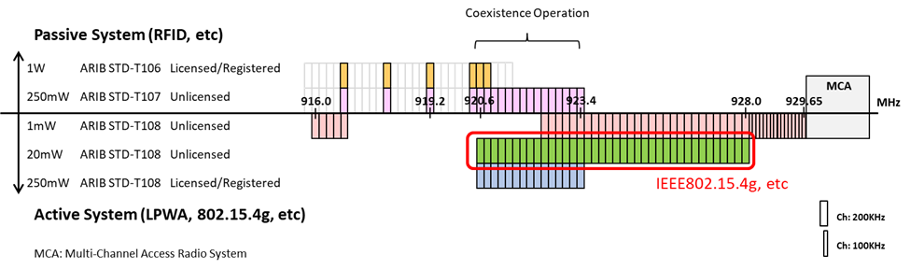
Figure 6.x 920MHz-band Channel Plan in Japan

6.2 United States

TBD (Need help)

6.3 Europe

As shown in document #19-19/0063r1, the spectrum allocation for Europe is given in ETSI EN 300 220-2 Annex B and Annex C. Table 1 lists the most relevant operational bands according to Annex B that EU wide harmonized. Operational bands that are listed in Annex C ant are not EU wide harmonized mainly define additional frequencies between 870 MHz and 920 MHz.

Table 1: Within the scope of this document most relevant EU wide harmonized operating bands according to
ETSI EN 300 220 -2 V3.2.1 (June 2018) Annex B
Name: Frequency range | Max TX Power (e.r.p.) | Max Bandwidth | Usage Restriction
D: 169,4000 MHz to 169,4875 MHz | 500 mW | 50 kHz | ≤ 1% duty cycle, ≤ 10% duty cycle for metering devices
H: 433,050 MHz to  434,790 MHz | 10 mW | Whole band | ≤ 10 duty cycle
J: 433,050 MHz to  434,790 MHz | 10 mW | 25 kHz
K: 863 MHz to 865 MHz | 25 mW | Whole band | < 0.1% duty cycle or polite spectrum access
L: 865 MHz to 868 MHz | 25 mW | Whole band | < 1% duty cycle or polite spectrum access
M: 868,000 MHz to  868,600 MHz | 25 mW | Whole band | < 1% duty cycle or polite spectrum access
N: 868,700 MHz to  869,200 MHz | 25 mW | Whole band | < 0.1% duty cycle or polite spectrum access
O / P*): 869,400 MHz to 869,650 MHz | 500 mW | Whole band | < 10% duty cycle or polite spectrum access
P: 869,700 MHz to  870,000 MHz | 5 mW | Whole band
Q: 869,700 MHz to  870,000 MHz | 25 mW | Whole band | < 1% duty cycle or polite spectrum access
*) Band P is most likely a typo in ETSI EN 300 220-2 V3.2.1 and should be named band O.

The latest version of ETSI EN 300 220-2 allows the use of polite spectrum access instead of a classical duty cycle. The definition of polite spectrum access is given in the latest revision of ETSI EN 300 220-1. It is a precise definition of CCA and timing parameters, e.g. a maximum transmit duration of 1s for a single transmission. The maximum duty cycle is given by 2.7% per 200 kHz portion of spectrum usage. Hence it can be sig that can be significantly increased if a narrow-band system uses frequency hopping. A system with a bandwidth of less than 200 kHz hopping in the 600 kHz wide band M could therefore reach a duty cycle of 8.1%. This means a significant extension compared to the classical 1% duty cycle.

Table 2 shows the theoretical applicability of the different EU wide harmonized band for the different systems. Caused by its high bandwidth 802.11ah is restricted to the operational bands K and L only. Furthermore, the minimum bandwidth of 125 kHz does not allow the use of LoRa on bands D and J.
Table 2: Theoretical applicability of the different system on the EU wide harmonized available operational bands, green: can be used, yellow: can be used but potential issues (see text below), red: cannot be used
Band | 802.11ah | 802.15.4g | 802.15.4w | LoRa | SigFox
D
H
J
K
L
M
N
O / P*) |  |  |  | Preferred Downlink | Preferred Downlink
P
Q

Potential issues with operational bands K and L:
The operational bands K and L from 863 MHz to 868 MHz are also used by Radio Frequency Identification (RFID) systems. The maximum allowed transmit power is 2 W e.r.p., which is significantly higher than the 25 mW that allowed for communication systems. The RFID signal itself can be described as almost continuous signals with low signal bandwidth. Hence, in dense RFID application scenarios with many RFID interrogators (e.g. airports) significant interference in bands K and L can be expected, which may negatively impact communication performance. The exact performance degradation is subject to future work. However, it can be expected that broadband systems will be more affected than narrow-band systems. Only the impact on 802.15.4w will be very low, as the system is designed to cope with such types of interferers.

Potential issues with operational band O:
The so-called high power band O allows a transmit power of up to 500 mW e.r.p. in the 868 MHz band with a duty cycle of up to 10%. Consequently, the band is used as downlink frequency for typical LoRa or SigFox networks. Additionally, additional long-range systems also utilize this band. Consequently, it is highly crowed and significant levels of interference can be expected.

- 802.11ah and 802.15.4g/802.15.4w coexistence mechanisms and issues

In terms of the coexistence, 802.11ah, 802.15.4g and 802.15w provide some coexistence functions via carrier sense multiple access/with collision avoidance (CSMA/CA) mechanism. However, LoRa and SigFox do not address the coexistence.

Document #19-19/0046r1 summarizes the coexistence mechanisms of 802.11ah and 802.15.4g.

7.1 802.11ah coexistence mechanism

From a coexistence perspective, 802.11ah is the only S1G frequency band standard that addresses the coexistence with other non-802.11 systems including IEEE 802.15.4 and IEEE 802.15.4g.

An S1G STA uses ED based CCA with a threshold of –75 dBm per MHz to improve coexistence with other S1G systems. If a S1G STA detects energy above that threshold on its channel, then the following mechanisms might be used to mitigate interference:
- Change of operating channel
- Sectorized beamforming
- Change the schedule of RAW(s), TWT SP(s), or SST operating channels
- Defer transmission for a particular interval

However, the features such as sectorization, beamforming, RAW, TWT and SST are optional in 802.11ah standard.

7.2 802.15.4g coexistence mechanism

802.15.4g provides method to facilitate inter-PHY coexistence, i.e, among devices that use different 802.15.4g PHYs.

In order to mitigate interference among different 802.15.4g PHYs, a multi-PHY management (MPM) scheme is specified. For this purpose, the MPM scheme facilitates interoperability and negotiation among potential coordinators with different PHYs by permitting a potential coordinator to detect an operating network during its discovery phase using the common signaling mode (CSM) appropriate to the band being used. The CSM mechanism can be used in conjunction with the clear channel assessment (CCA) mechanism to provide coexistence control. The CSM is a common PHY mode that uses the Filtered 2FSK modulation with the 200 kHz channel and the 50 kbps data rate. An 802.15.4g device acting as a coordinator and with a duty cycle greater than 1% shall support CSM.

In a beacon-enabled network, an existing coordinator shall transmit an enhanced beacon (EB) at a fixed interval by using CSM. Any intending coordinator shall first scan for an EB until the expiration of the enhanced beacon interval or until an EB is detected, whichever occurs first. If an intending coordinator detects an EB, it shall either occupy another channel, achieve synchronization with the existing network, or stop communication.

In a non-beacon-enabled network, an existing coordinator should transmit an enhanced beacon (EB) periodically using the CSM. Any intending coordinator shall first scan for an EB until the expiration of the enhanced beacon interval for non-beacon-enabled network or until an EB is detected, whichever occurs first.

802.15.4g does not specifically address the coexistence with non-802.15.4g systems. However, based on CCA mode, 802.15.4g coexistence approach can be different.

802.15.4g allows following CCA modes
- ED
- CS and ED
- CS
- ALOHA

It can be seen that that the first two CCA modes use the ED mechanism and the last two CCA modes do not use the ED mechanism.

If the ED is used in CSMA/CA mechanism, the ED based coexistence is implicitly perform. In this case, CCA returns busy channel status if the detected energy is above the specified ED threshold.

If ED is not used, the alternative coexistence methods need to be specified, e.g., channel switching and changing backoff parameters.

7.3 802.15.4w

Document #15-18/0510r5 defines coexistence methods of 802.15.4w, which offers passive coexistence by design. 802.15.4w uses frequency diversity, time diversity and strong forward error correction for reliable communication in densely used license-exempt frequency bands. It can also use CCA mechanism for coexistence.

7.4 Lora

There is no coexistence mechanism provided by LoRa. It uses ALOHA channel access mechanism.

7.5 Sigfox

There is no coexistence mechanism provided by SigFox. It uses ALOHA channel access mechanism.

The low bitrate means that sending a SigFox packet requires a transmission time in the order of seconds, making it likely to collide with other technologies. Since
SigFox does not employ any collision-avoidance techniques, and since such narrowband transmissions are the worst type of interferers for other systems, a single SigFox device can easily interfere with wideband Sub-1 GHz frequency band technologies such as LoRa, 802.11ah and 802.15.4g.

7.6 Noise and interference measurement in the 920 MHz band

In the Sub-1 GHz bands, besides 802.11ah and 802.15.4g, there are also other radio devices such as RFID transmitting the radio signals that can interfere with 802.11ah system and 802.15.4g system. In addition, some machinery can also emit powerful radio noise, which can also have severe impact to 802.11ah system and 802.15.4g system.

To investigate radio noise and interference, researchers at Advanced Telecommunications Research Institute International (ATR) have performed radio noise measurement in Japan. The spectrum utilization was measured at different environment including railway station, university campus, a large exhibition center during an event on the R&D of wireless communication technologies, a football stadium with a game and a building. Document #19-19/0043r3 and document #19-19/0064r0 show measurement results of radio noise and interference. It reveals that there several types of machinery emitting powerful radio noise and may have severe impact on wireless communication system. The loudspeakers in the stadium cause higher noise level. At underground train station, train continuously emits radio noise at multiple frequencies over the 920 MHz band. The radio noise becomes more powerful during train door opening. At open space railway station, multiple unknown signals are measured over the 916 to 920 MHz band. Some signals have a bandwidth of 1 MHz and received power from -70 dBm to -80 dBm. In university campus measurement, there are several unknown continuous signals at some frequencies as well as signals of RFID used in next door library. Some of these signals are very strong at -95 dBm per 1 kHz. In exhibition center measurement, many exhibitors demonstrated their wireless systems using the 920 MHz band including IEEE 802.11ah, wireless power transfer system, original communication system, etc. There are many signals with different transmission patterns such as spectrum shape and duty cycle. A wireless power transfer system can cause severe interference. There are several sources of the noise in football stadium. Many cellular signals emitted during the game and the halftime (when many audiences are in the stadium). Some wideband noise is also observed. Noise level increases as audience increases before the game. This could be due to cellular signals (maybe siderobe). In addition, a wireless system for referee is employed in the game. Noise level is even higher at the top floor. It is expected to be spurious from loudspeakers placed at the roof of the stadium. The measurement was also conducted in a university building. At certain area, the channel was quiet and no specific interference was observed. However, at area where many audio and visual equipment such as video cameras and loudspeakers are installed, wideband noise was observed. It is assumed to be the spurious from video cameras and loudspeakers because the noise level becomes even higher as the received antenna got closer to them. These noise and interference have severe impact on the performance of 802.11ah and 802.15.4g.

7.7 Coexistence performance of 802.11ah and 802.15.4g

Extensive simulations on 802.11ah and 802.15.4g coexistence have been conducted. The coexistence performance have been presented in documents #19-17/0087r3, #19-18/0006r1, #19-18/0016r1, #19-18/0056r3, #19-19/0019r1, and #19-19/0055r4. The simulation parameters are set based on document #19-19/0021/r1. The PHY data rate for 802.11ah is 300 kbps and PHY data rate for 802.15.4g is 100 kbps. In the simulation, the network traffic scenarios, where the further coexistence enhancement is needed, are simulated. For the networks with 50 nodes and 100 nodes, two offered network load scenarios are simulated, i.e., 20 kbps and 40 kbps. The offered network load is uniformly distributed among network nodes. For 802.11ah node, the duty cycle is 0.13% and 0.26%. For 802.15.4g node, the duty cycle is 0.4% and 0.8%. These duty cycles are lower than the constraint specified by any regulation. Using these scenarios, interesting findings have been discovered.

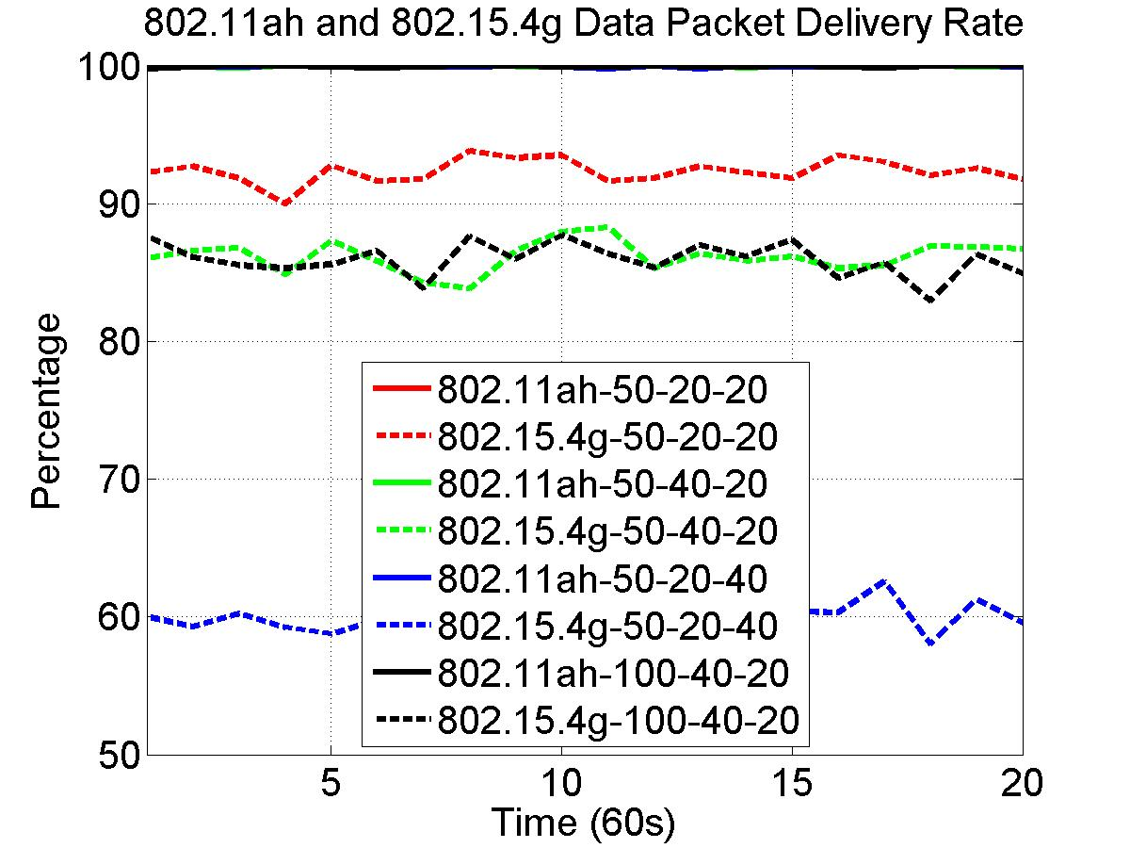
Figure 7.x 802.11ah and 802.15.4g Data Packet Delivery Rate

Figure 7.x shows data packet delivery rate by 802.11ah network and 802.15.4g network, in which data packet delivery rate is measured as the ratio of the number of packets successfully delivered and total number of packets transmitted, solid lines represent 802.11ah network performance and dash lines illustrate 802.15.4g network performance. In the figure, 50-20-20 indicates 50 nodes for 802.11ah network, 50 nodes for 802.15.4g network, 20 kbps offered load for 802.11ah network, 20 kbps offered load for 802.15.4g network, and so on. Figure x reveals following observations:
- For all scenarios, 802.11ah network delivers near 100% of the data packets, which indicates that network traffic and network size have less impact on 802.11ah packet delivery rate.
- 802.11ah network traffic has impact on 802.15.4g packet delivery rate. 802.15.4g network packet delivery rate decreases as 802.11ah network traffic increases.
- 802.15.4g network traffic has more effect on its data packet delivery rate. 802.15.4g network packet delivery rate decreases significantly as its network traffic doubles.
- The network size has little effect on 802.15.4g network packet delivery rate.

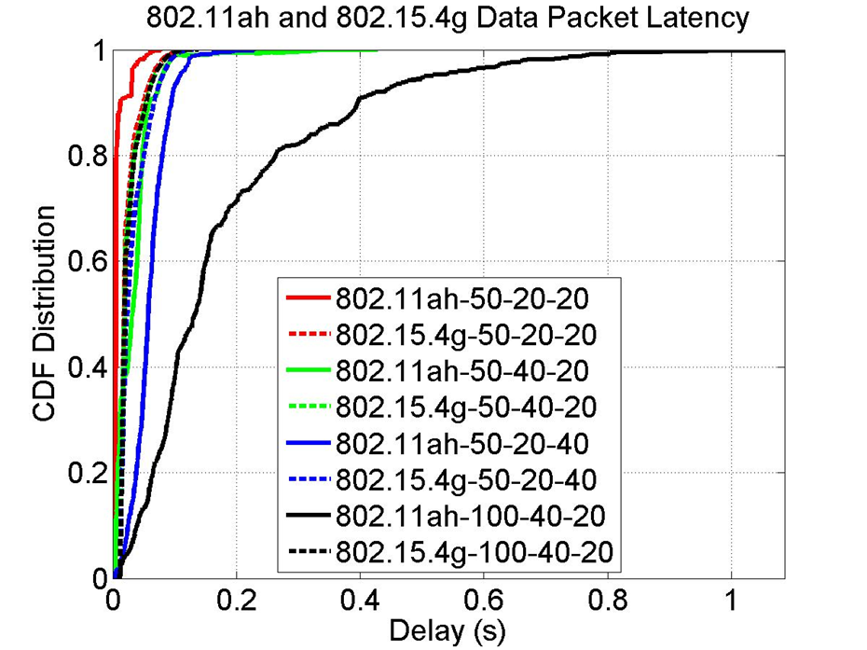
Figure 7.y 802.11ah and 802.15.4g Data Packet Latency

Figure 7.y shows data latency by 802.11ah network and 802.15.4g network, in which data packet latency is measured as time difference from the time packet transmission process starts to the time the packet receiving is successfully confirmed. In other words, the data packet latency is given by Backoff Time + Data TX Time + ACK Waiting Time + ACK RX Time. Figure x shows following observations:
- For all scenarios, 802.15.4g network achieves similar packet latency, which indicates that 802.15.4g data packet is either delivered with the bounded delay or dropped and therefore, network traffic and network size have little impact on 802.15.4g packet latency.
- 802.11ah network traffic has impact on its packet latency. 802.11ah data packet latency increases as its network traffic increases.
- 802.15.4g network traffic has more impact on 802.11ah data packet latency. 802.11ah network data packet latency increases more as 802.15.4g network traffic doubles.
- Network size has major influence on 802.11ah packet latency. 802.11ah packet latency increases significantly as the number of nodes doubles, which indicates that 802.11ah packet can be infinitely delayed.

These observations show that 802.11ah network and 802.15.4g network interfere with each other. Based on these findings, the coexistence technologies for 802.11ah and 802.15.4g need to
- Maintain 802.15.4g data packet delivery rate, which is of the first priority.
- Bound 802.11ah data packet latency, which is of the second priority.

7.8 Coexistence performance of 802.11ah and 802.15.4w

802.15.4w is designed for long range (~50km) transmission with very low transmission power by using very low payload bitrate (~1kbps), which results in high probability of collision with interferer. In addition, the focus of 802.15.4w is almost completely on uplink traffic.

Due to its very low reception levels (e.g.,-140dBm), other systems such as 802.11ah (-75dBm ED threshold) may not able to detect the 802.15.4w transmission. Listen before talk (CCA) will not work well due to hidden node problem.

Document #19-19/0064r3 shows coexistence simulation of 802.15.4w and 802.11ah, in which all simulations assume a distance of 10m between the signal transmitter and the victim receiver. The distance between the victim receiver and the interfering transmitter varies. The results shown are the worst-case results without CCA and any interference cancellation techniques. Even coexistence simulations show no significant interference between 802.11ah and 802.15.4w, the interference occurs when the interfering transmitter is close to the victim receiver, e.g., for 802.11ah victim with MCS3 code, the FER is close 10⁰ when 802.15.4w interfering transmitter is within 5 meters to the victim 802.11ah receiver and for 802.15.4w victim with 19kS/s symbol rate, the FER is close 10⁰ when 802.11ah interfering transmitter is within 1 meter to the victim 802.15.4w receiver. Furthermore, the simulation is performed with three nodes only, i.e., one signal transmitter, one victim receiver and one interferer. As the number of nodes increases, 802.15.4w expects to suffer strong interference from other systems including 802.11ah system due to their system design.

7.9 Factors that cause coexistence issues between 802.11ah and 802.15.4g

Document #19-19/0055r4 summarizes factors that can impact coexistence performance of 80211ah and 802.15.4g. The functional differences between 802.11ah and 802.15.4g result in the coexistence behavior of 802.11ah network and 802.15.4g network. Followings are key CSMA/CA factors:
- ED threshold
802.11ah defines following ED thresholds:
- -75 dBm for primary 1 MHz channel
- -72 dBm for primary 2 MHz channel and secondary 2 MHz channels
- -69 dBm for secondary 4 MHz channel
- -66 dBm for secondary 8 MHz channel
802.15.4g ED threshold depends on PHY. The ED threshold range is as follows:
- [-100 dBm, -78 dBm] for OFDM PHY
- [-100 dBm, -80 dBm] for O-QPSK PHY
- [-100 dBm, -78 dBm] for FSK PHY with FEC
- [-94 dBm, -72 dBm] for FSK PHY without FEC
It can be seen that 802.15.4g ED threshold is lower than 802.11ah ED threshold.
- CSMA/CA
802.11ah CSMA/CA and 802.15.4g CSMA/CA are much different. 1) 802.11ah allows immediate channel access. 802.15.4g, however, requires backoff no matter how long channel has been idle. 2) 802.11ah backoff parameters are much smaller than 802.15.4g backoff parameters, which results in 802.11ah backoff is much faster than 802.15.4g backoff. 3) 802.11ah device must perform CCA in each backoff time slot. However, 802.15.4g device performs CCA after the backoff procedure completes. 4) 802.11ah requires backoff suspension, i.e., 802.11ah device must suspend backoff procedure if channel is detected to be busy and can decrease backoff counter only if the channel is idle. On the other hand, 802.15.4g has no backoff suspension.
- Channel width
802.11ah channel width is in the unit of MHz, i.e., 1 MHz/2 MHz/4 MHz/8 MHz/16 MHz. However, 802.15.4g channel width is in the unit of kHz, i.e., 200 kHz/400 kHz/600 kHz/800 kHz/1200 kHz.
- Data rate
802.11ah defines PHY data rate from 150 kbps to 78 Mbps for one spatial stream and 346 Mbps for four spatial streams. On the hand, original 802.15.4g specifies PHY data rate from 6.25 kbps to 800 kbps. 802.15.4x, an amendment to 802.15.4g, extends the PHY data rate to 2.4 Mbps.
- 802.11ah BDT
Bidirectional TXOP (BDT) allows 802.11ah devices transmit data packet after a SIFS time period, which is even shorter than DIFS time period used in immediate channel access.

In summary, following factors are in favor of 802.11ah
- Higher ED threshold allows 802.11ah more transmission opportunity and causing more collision to 802.15.4g packet. More specifically, readable 802.15.4g packets with receiving power level within the range [802.15.4g RS, 802.11ah ED Threshold] are ignored by 802.11ah ED based CCA mechanism, which may result in collision to 802.15.4g packet.
- Immediate channel access allows 802.11ah more transmission opportunity
- Smaller backoff parameters allows 802.11ah more transmission opportunity and causing more interference to 802.15.4g transmission process
- Wider 802.11ah channel indicates that an 802.11ah network can simultaneously interfere with multiple 802.15.4g networks
- Higher PHY data rate enables 802.11ah higher throughput, i.e., delivers more data.
- Bidirectional TXOP provides 802.11ah with more transmission opportunity

Following factors are not in favor of 802.11ah
- 802.11ah must perform CCA in each backoff time slot. Backoff procedure can proceed only if channel is detected to be idle. On other hand, 802.15.4g backoff procedure is not interrupted.
- 802.11ah backoff suspension can cause long backoff time, which increases transmission opportunity for 802.15.4g. Theoretically, an 802.11ah packet can be infinitely delayed. On the other hand, non-suspension 802.15.4g backoff allows bounded delay for 802.15.4g packet. In fact, this factor is in favor of 802.15.4g and it increases more channel access opportunity for 802.15.4g devices. When 802.11ah devices are on backoff suspension, 802.15.4g devices may get chance to make transmission early.
- Lower PHY data rate of 802.15.4g indicates that an 802.15.4g packet transmission can take more time than an 802.11ah packet does and therefore, can cause more latency for 802.11ah.

7.10 Can coexistence performance of 802.11ah and 802.15.4g be improved?

Section 7.7 shows that even with duty cycle less than 1% and network size smaller than 100, the coexistence methods defined in 802.11ah and 802.15.4g standards do not work well in some scenarios. Therefore, additional coexistence mechanisms are needed to achieve better performance.

It is obvious that coexistence performance of 802.11ah and 802.15.4g can be improved. For example, if either network performs a channel switching operation so that two networks operate on non-overlapping frequency bands. As a result, there is no more interference.

Document #19-18/0027r1 describes α-fairness based ED-CCA and Q-Learning based backoff for 802.11ah to improve coexistence with 802.15.4g. The α-fairness based ED-CCA method is proposed for 802.11ah to mitigate its interference on 802.15.4g caused by its higher ED threshold. The Q-Learning based backoff is introduced to address the interference caused by the faster backoff of 802.11ah, i.e., to avoid interfering with 802.15.4g packet transmission process. Simulation results show that both methods can improve coexistence performance.

Document #19-18/0085r2 describes a prediction based self-transmission control method for 802.11ah to ease its interference impact on 802.15.4g. This method is an enhancement to one of coexistence features defined in 802.11ah standard. Simulation results demonstrates that this method can also improve coexistence performance of 802.11ah and 802.15.4g networks.

Document #19-19/0070r0 shows that selection of different network profiles can also improve the coexistence performance.

- Coexistence model

For both 802.11ah and 802.15.4g, there are different coexistence methods available. These coexistence methods have different features.

In terms the scope of coexistence operation, some coexistence methods, e.g., channel switching, perform coexistence operations on entire network and some coexistence methods, e.g., frame resize, perform coexistence operations by a group of nodes or on individual node.

In terms of coexistence coordination, some coexistence methods, e.g., deferring transmission time, can be performed in a fully distributed way and some coexistence methods, e.g., 802.11ah RAW and 802.15.4g frequency hopping, need network level coordination. Some coexistence methods, e.g., hybrid coordination based coexistence, may even need inter-network level coordination.

Based on the features of different coexistence methods, different coexistence model can be configured.

8.1 Coexistence operations

Document #19-19/0058r2 and document #19-19/0059r3 summarize the coexistence operations that can be applied for 802.11ah network and 802.15.4g network. This Recommended Practice classifies coexistence operations into following categories:
- Centralized coexistence
Assume a coordinator such as a hybrid device can communicate with both 802.11ah network and 802.15.4g network. This coordinator collects information from both networks, analyzes the information and makes optimal coexistence decision. The coordinator then instructs networks to take coexistence actions including channel switching, beamforming, RAW scheduling, superframe structuring and deferring transmission.
The coordinator can command a network, a group of nodes or a single node to perform coexistence operation. In this case, any node in the network does not make any coexistence decision. All network nodes perform coexistence operation instructed by the coordinator.
- Cooperated (or collaborated) coexistence
Assume a coordinator can communicate with both 802.11ah network and 802.15.4g network. This coordinator collects information from both networks and relays information between networks so that 802.11ah network is aware of 802.15.4g network and 802.15.4g network is aware of 802.11ah network. Based on information received from coordinator, each network makes coexistence decision spontaneously without instruction from coordinator. However, a network performs cooperated (or collaborated) coexistence operation in the sense of
  - The network informs other network via the coordinator about coexistence operation performed.
  - Other network then makes decision based on the information received from the coordinator, e.g., 802.11ah network switches its channel to a different frequency band that no longer overlaps with 802.15.4g channel, in this case, 802.15.4g network may not need to take further coexistence action.
The coexistence operations that can be performed in a cooperated fashion include channel switching, 802.11ah RAW scheduling, 802.15.4g superframe structuring, etc.
- Distributed network coexistence
A network is aware of external interference but does not know the source of the interference. In this case, network level coexistence operation can be independently performed by a network, i.e., all devices in a network perform same coexistence operation. The coexistence operations can be performed by 802.11ah network include channel switching, RAW scheduling, beamforming, etc. The coexistence operations can be performed by 802.15.4g network include channel switching, superframe structuring, frequency hopping, etc.
- Distributed device coexistence
Coexistence operation is independently performed by a device.
802.11ah device can perform coexistence operations including transmission deferring, α-fairness based ED-CCA, Q-Learning based backoff, etc. 802.15.4g device can perform coexistence operations including backoff parameter change, packet size change, etc.

8.2 Coexistence model

Document #19-19/oo56r3 defines the coexistence model for 802.11ah and 802.15.4g. This Recommended Practice classifies coexistence model based on two criteria, i.e., network coordination and scope of coexistence operation.

8.2.1 Coexistence model based on network coordination

Coordinated coexistence requires coordination among networks, i.e., the involved networks work collaboratively to mitigate interference. On the other hand, distributed coexistence does not need any coordination among from networks, i.e., each network or device performs coexistence operation independently. Figure x shows coexistence model based on network coordination.

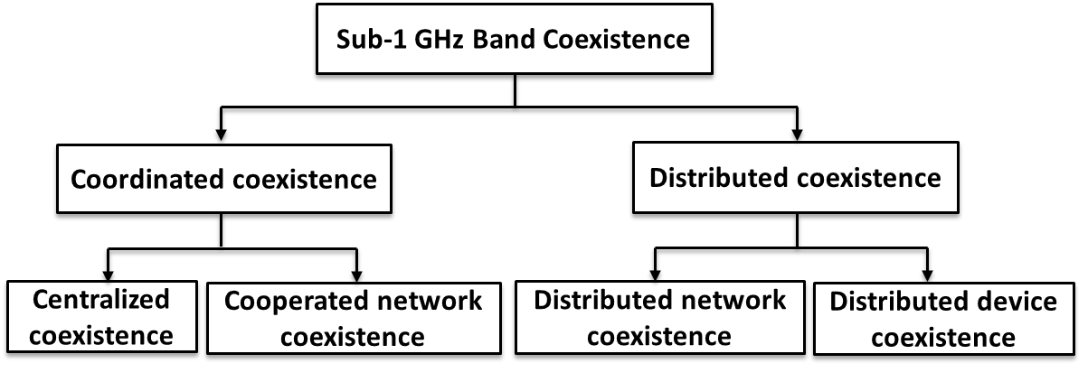
Figure x Coexistence Architecture Based On Network Coordination

8.2.2 Coexistence model based on scope of the operation

Coexistence can be performed at network level or device level. Network level coexistence requires all devices in a network to perform same coexistence operation, e.g., channel switching. Device level coexistence does not need all devices in a network to perform same coexistence operation. Coexistence operation is perform by a group of devices or a single device, e.g., deferring transmission. Figure x shows coexistence architecture based on level of operation.

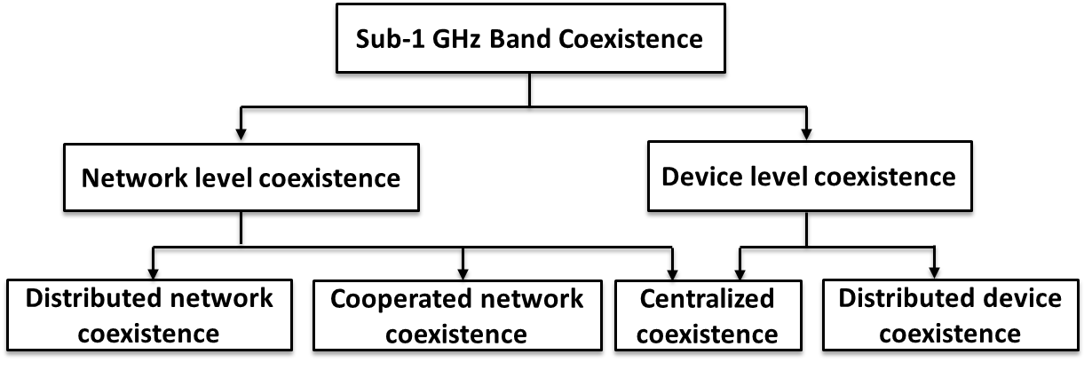
Figure x Coexistence Architecture Based On Level of Operation

- 802.11ah and 802.15.4g Coexistence Recommendations

There are multiple coexistence methods available for 802.11ah network and 802.15.4g network. Some of methods need cooperation between 802.11ah and 802.15.4g network and some of methods do not need network cooperation. Based on how the coexistence operation performed, the coexistence methods can be categorized into coordinated coexistence and distributed coexistence. Both coexistence method categories have advantages and disadvantages.

Coordinated coexistence has following advantages
      - More information sources, e.g., operation channel, network load and data pattern.
      - Information accuracy, e.g., the number of nodes and locations of nodes.
      - Globalized optimization
Coordinated coexistence has following disadvantages
- Coordinator availability
- Communication overhead caused by information acquisition
- Scalability issue
- High cost due to the extra device and energy consumption on information acquisition
- Implementation complexity
Distributed coexistence has following advantages
- Easy to implement
- Low communication overhead
- Flexibility
- Low cost
Distributed coexistence has following disadvantages
- Lack of information
- Local decision

In general, coordinated coexistence should provide better performance.

Furthermore, in each category, some of methods are suitable for a network and some of methods fit a group of devices or an individual device in a network.

9.1 Coordinated coexistence

Coordinated coexistence assumes there is a device such as a gateway or a hybrid device that can communicate with both 802.11ah network and 802.15.4g network and therefore, can coordinate the coexistence. Coordinated coexistence can be considered as a generalization of 802.15.4g CSM mechanism. Instead of listening for enhanced beacon, 802.11ah AP or 802.15.4g PANC listen for information from the coordinator to acquire information from the coordinator about existence of other networks.

Followings are potential information exchange between 802.11ah AP/802.15.4g PANC and the coordinator:
- 802.11ah AP and 802.15.4g PANC shall report their operating channel information to coordinator
    - Report updated channel information after channel switching
- 802.11ah and 802.15.4g PANC may report their traffic information to coordinator
    - Report latest traffic if traffic information changes
- 802.11ah AP and 802.15.4g PANC may report their network information to coordinator
    - Node density, node deployment, location, etc.
- Coordinator may evaluate channels (or frequency bands) based on collected information
    - Send information to 802.11ah APs and 802.15.4g PANCs

The coordinated coexistence methods can be further categorized into
- Centralized coexistence, where a powerful coordinator is available and
- Cooperated/collaborated coexistence, where only a limited function coordinator is available

9.1.1 Centralized coexistence

A powerful coordinator can completely manage the coexistence between networks, in which coordinator collects information of networks, analyses information and makes decision on coexistence control. Once a coexistence decision is made, coordinator sends the coexistence command to a network/a group of devices/a single device. Network/device performs coexistence operation received from coordinator. The centralized coexistence operations include
- Channel switching
- 802.11ah RAW scheduling
- 802.15.4g superframe structuring
- 802.11ah beamforming
- Transmission power setting
- Etc.
9.1.1.1 Centralized channel switching
The channel switching is an operation in which entire network changes operation channel. It can be considered as a special case of the channel hopping. Channel switching is easy to implement.
Channel switching is a favor coexistence operation to be performed, especially for centralized coexistence, where the coordinator can determine operation channels for 802.11ah network and 802.15.4g network to achieve the best possible performance. For example, the coordinator may assign a channel for 802.11ah network and another channel for 802.15.4g network such that these two channels do not share frequency band as long as such channels are available. Another advantage of the centralized channel switching is that the coordinator can make sure that two networks do not randomly switch to channels that share frequency band.
Even the channel switching is ideal coexistence mechanism. However, due to spectrum allocation constraint in the Sub-1 GHz band, free channel is not always available to switch. In that case, 802.11ah network and 802.15.4g network are forced to share the spectrum, which is real coexistence.
9.1.1.2 Centralized 802.11ah RAW and 802.15.4g superframe construction
To achieve better coexistence performance, 802.11ah RAW should be applied together with the superframe structuring of the beacon-enabled 802.15.4g network. With the decision made by the powerful coordinator, this approach should provide good coexistence performance.
Figure x shows an example of centralized 802.11ah RAW scheduling and 802.15.4g superframe construction, in which the coordinator commands 802.11ah AP to allocate three RAWs, one for 802.15.4g beacon transmission, one for 802.15.4g CFP period and one for 802.11ah CFP period. It can be seen that the RAW allocated to 802.11ah coincides with 802.15.4g inactive period, where 802.11ah beacon can also be transmitted.
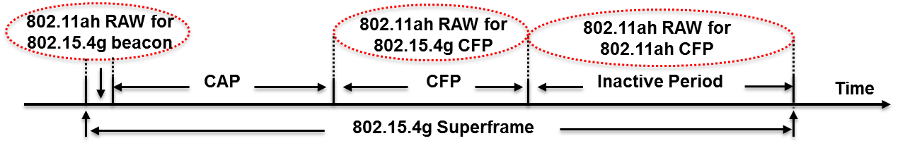
It can be seen that this coordinated RAW aims to protect higher priority data transmitted in the CFP from the interference.

This method is suitable for the beacon-enabled 802.15.4g network and the load information of both 802.11ah network and 802.15.4g network is available to the coordinator.

However, for the nonbeacon-enabled 802.15.4g network, this coordinated Raw may not provide much benefit.

9.1.1.3 Centralized 802.11ah beamforming

With the help of the powerful coordinator, 802.11ah beamforming can also be an efficient coexistence method, especially when the locations of both 802.11ah nodes and 802.15.4g nodes are available to the coordinator, where the coordinator may instruct 802.11ah nodes to form their beams away from 802.15.4g network, especially when the geometrical areas of 802.11ah network and 802.15.4g network are partially overlapped.

Figure x shows an example of 802.11ah beamforming, in which the coordinator directs a portion of 802.11ah STAs to point beam away from 802.15.4g network.
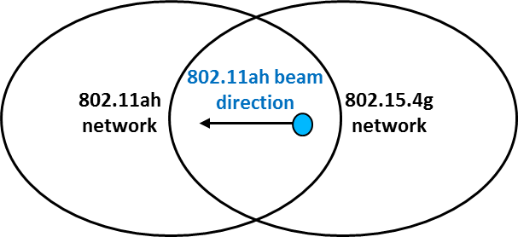
The advantage of this method is that it can be applied to by 802.11ah network to coexist with both the beacon-enabled 802.15.4g network and the nonbeacon-enabled 802.15.4g network.

However, in practice, the locations of networks nodes may not be available.

9.1.1.4 Centralized transmission power setting

Even though the maximum transmission power is regulated by the authority, it is possible for devices to dynamically adjust their transmission power without violating regulation and communication protocol. Increasing transmission power may reduce the relay overhead and decreasing transmission power may achieve multi-geometrical channel access.

Adjust transmission power may be a feasible coexistence method for the centralized coexistence control with certain data patterns and/or geometric node placement, in which the centralized coordinator can manage nodes to make TDMA based transmission.

However, this approach may not work well for CSMA based transmission.

9.1.2 Cooperated/collaborated coexistence

In this case, the coordinator has limited capability and therefore, the coordinator is not able to manage coexistence between networks. It only relays information between networks. Instead, 802.11ah AP and 802.15.4g PANC collect information from their network and exchange information via the coordinator. Based on information collected and exchanged, 802.11ah AP/802.15.4g PANC makes decision on whether a coexistence action is needed. If yes, it requires its devices to perform a coexistence operation. After completion of operation, 802.11ah AP/802.15.4g PANC sends information to 802.15.4g/802.11ah network via the coordinator.

802.11ah AP and 802.15.4g PANC may collect following information from devices:
- ED ratio, i.e., number of ED above ED threshold in a time period
- Packet delivery ratio
- Packet latency
- Etc.
802.11ah STA and 802.15.4g node may also spontaneously report their observations to their AP and PANC.
The cooperated/collaborated coexistence operations include
- Channel switching
- 802.111ah RAW
- 802.15.4g superframe construction
- 802.11ah beamforming
- Transmission power setting
- Etc.

9.1.2.1 Cooperated channel switching
Channel switching is still a favor coexistence operation to be performed. With the help of the coordinator, 802.11ah network can obtain certain information about 802.15.4g network. Similarly, 802.15.4g network can get some information about 802.11ah network. Therefore, 802.11ah AP or 802.15.4g PANC can still select a channel with the lower probability of the interference. It is also possible for 802.11ah AP or 802.15.4g PANC to select a channel that does not share frequency band with other network.
However, in this case, it is possible to select a channel that provides worse performance. For example, if both 802.11ah AP and 802.15.4g PANC detect a less congested channel at same time and then switch their networks to that channel.
9.1.2.2 The cooperated RAW
Similarly as in the centralized RAW, 802.11ah RAW should be applied together with the superframe structuring of the beacon-enabled 802.15.4g network.
In this case, 802.11ah network may inform 802.15.4g network via the coordinator about its RAW scheduling. Accordingly, 802.15.4g network may plan its superframe based on the 802.11ah RAW allocation. On the other hand, 802.15.4g network may inform 802.11ah network via the coordinator about its superframe structure. Accordingly, 802.11ah network may allocate its RAW based on the 802.15.4g superframe structure.
However, it is possible that two networks make changes at same time, which results in the worse performance.
This method is suitable for the beacon-enabled 802.15.4g network and the load information of both 802.11ah network and 802.15.4g network have certain patterns.
9.1.2.3 Cooperated 802.11ah beamforming
With the help of the coordinator, 802.11ah beamforming is still a possible coexistence method, especially when the locations of both 802.11ah AP and 802.15.4g nodes are available to 802.11ah nodes so that 802.11ah nodes can form their beams away from 802.15.4g network, especially when 802.11ah AP and 802.15.4g PANC are located not near to each other.
9.1.2.4 Cooperated transmission power setting
Without a centralized scheduling, it is difficult to realize TDMA based transmission between two networks. Therefore, transmission power adjustment may not provide the expected coexistence result.
9.2 Distributed coexistence

Coordinator can effectively manage the coexistence of 802.11ah network and 802.15.4g network. However, availability of the coordinator is uncertain. Therefore, 802.11ah network and 802.15.4g network need to have capability to perform distributed coexistence without assistance of coordinator.

Even this section assumes no network coordinator available, the coexistence methods may perform better with the help of the network coordinator.

Without coordinator, it is difficult for an 802.11ah network/802.15.4g network to be aware of existence of 802.15.4g network/802.11ah network. However, using ED mechanism, an 802.11ah STA/802.15.4g node can detect if a non-802.11ah/non-802.15.4g system exist. If ED is not used by 802.15.4g, other method can be used for this purpose, e.g., the ratio of channel occupancy time by 802.15.4g network and total channel busy time.

The distributed coexistence can be divided into
- Network level operation
  - Channel switching
  - ED threshold setting
  - Transmission power setting
  - Backoff parameter setting
  - Frequency hopping
  - Etc.
- Device level operation
  - Beamforming by 802.11ah
  - Transmission time delay
  - α-Fairness based ED-CCA by 802.11ah
  - Q-Learning based CSMA/CA by 802.11ah
  - Prediction based transmission delay by 802.11ah
  - Frame size setting
  - Etc.
9.2.1 Channel switching
Without a coordinator, channel switching becomes a random operation. In other words, switching channel may provide better performance and it may also provide worse performance. Therefore, channel switching may not be a feasible solution in this case.
9.2.2 ED threshold setting
Dynamic ED threshold configuration by 802.11ah device may improve coexistence performance of 802.15.4g network, e.g., lowering 802.11ah ED threshold allows 802.11ah devices to detect more 802.15.4g transmissions. However, changing ED threshold violates the standard. Therefore, ED threshold adjustment is a not a favor operation.
9.2.3 Transmission power setting
Without a coordinator, transmission power adjustment becomes a random operation. Therefore, it is a not a favor operation.
9.2.4 802.11ah beamforming
Without a coordinator, beamforming becomes a random operation. Therefore, it is a not a favor operation.
9.2.5 802.11ah transmission time delay
802.11ah transmission time delay is a feasible solution to improve 802.15.4g coexistence performance. Therefore, 802.11ah device is recommended to use this method. However, this method may degrade 802.11ah network performance, especially packet latency.
9.2.6 802.11ah α-Fairness based ED-CCA
The α-Fairness based ED-CCA is a device level coexistence method for 802.11ah. It is proposed to mitigate 802.11ah interference impact on 802.15.4g caused by the higher ED threshold (document #19-18/0027r1 and published in IEEE WCNC 2018) as illustrated in figure xx.
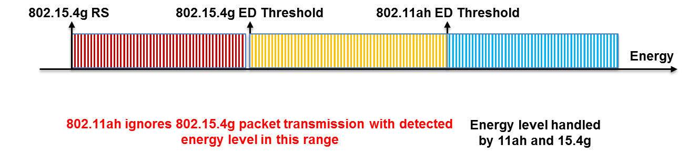
The issue is that if the energy level of 802.15.4g transmission detected by 802.11ah falls in [802.15.4g Receiver Sensitivity, 802.11ah ED Threshold], the transmission is readable by 802.15.4g. However, 802.11ah ignores it. In this case, should 802.11ah ED-CCA report idle channel or busy channel? From 802.15.4g perspective, 802.11ah should report busy channel if the energy source is 802.15.4g and reports idle channel otherwise. The challenge is that 802.11ah may not be able to identify the source of the energy, which could be 802.15.4g node, far away 802.11ah STA or other device. Using α-Fairness based ED-CCA, if the detected energy level is within [802.15.4g Receiver Sensitivity, 802.11ah ED Threshold], 802.11ah ED-CCA reports channel status based on a probability generated by the α-Fairness technique.
This method can be applied to the network with any number of nodes. It is suitable for the case where 802.11ah network load is higher so that it consumes higher channel resource. This method can improve the performance of 802.15.4g network. However, it requires backoff procedure modification and may degrade performance of 802.11ah network if its offered load is very high. Furthermore, this method requires a metric from both networks. Even an 802.11ah node can estimate 802.15.4g metrics such as channel occupancy time and ED detection ratio, these metrics do not directly reflect 802.15.4g network performance. For example, an 802.15.4g network may have longer channel occupancy time, but it may still have lower packet delivery rate.
9.2.7 802.11ah Q-Learning based CSMA/CA
The Q-Learning based CSMA/CA is a device level coexistence method for 802.11ah. It is proposed to mitigate 802.11ah interference impact on 802.15.4g transmission process caused by the faster CSMA/CA of 802.11ah (document #19-18/0027r1), e.g., 802.15.4g performs RX2TX turn around and 802.15.4g waits for ACK as shown in figure xx.
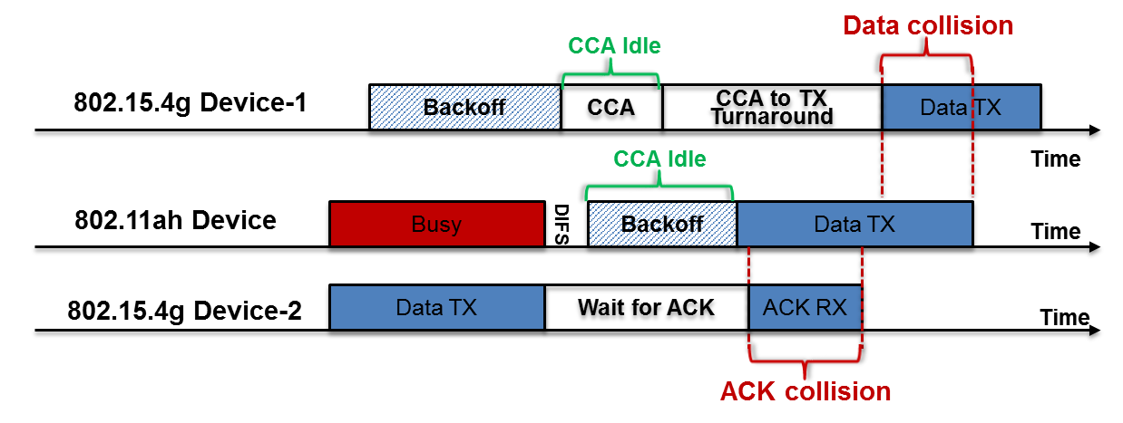
During these time period, channel is idle, but an 802.15.4g transmission process is taking place. Therefore, when the backoff counter (BC) reaches to 0 and 802.11ah ED-CCA reports idle channel, should 802.11ah transmit or not? The challenge is that 802.11ah does not know if an 802.15.4g transmission process is in progress or not. Using Q-Learning based CSMA/CA, if BC > 0 or ED-CCA reports busy channel, the backoff process continues as specified by 802.11ah. If BC = 0 and ED-CCA reports idle channel, 802.11ah applies Q-Learning to make a decision, i.e, transmit or re-backoff or defer some time.
This method can be applied to the network with any number of nodes. It is also suitable for the case where 802.11ah network load is higher so that it consumes higher channel resource. This method can improve the performance of 802.15.4g network. However, it requires backoff procedure modification and may degrade performance of 802.11ah network if its offered load is very high. In addition, the definition of reward function is the key for this method and it requires information from 802.15.4g network. Even an 802.11ah node can estimate 802.15.4g metrics such as channel occupancy time and ED detection ratio, these metrics do not directly reflect 802.15.4g network performance.
Since the α-Fairness based ED-CCA and the Q-Learning based CSMA/CA aim to address different coexistence issues, an 802.11ah device can apply both methods simultaneously. In fact, applying both methods provides better performance than each individual method.
9.2.8 802.11ah prediction based transmission delay
Prediction based transmission delay is a device level coexistence method proposed for 802.11ah to avoid interfering with upcoming 802.15.4g transmission (document #19-18/0085r0 and published in IEEE ICUFN 2017). It is an advanced version of 802.11ah transmission delay, where if an 802.11ah detects energy on its channel with level above its ED threshold, the STA will delay its transmission for some time. Prediction approach applies a prediction algorithm to predict future 802.15.4g transmission and configures a suspension interval around predicted transmission time and suspends its transmission in the suspension interval. Figures xx shows concept of this approach.
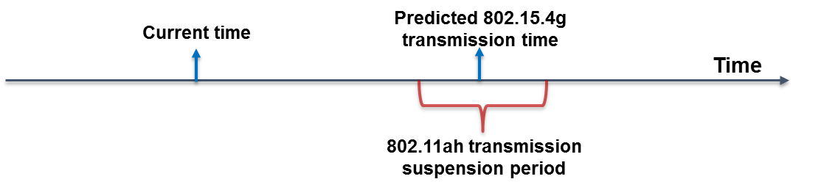
This method fits well for the networks with small number of nodes. The main advantage of this method is that it does not require any protocol change. It is a generalization of 802.11ah transmission delay mechanism. This method can improve 802.15.4g network performance. However, it may degrade 802.11ah network performance if its offered load is very high.

9.2.9 802.15.4g frequency hopping
802.15.4g frequency hopping is a network level coexistence method, in which all nodes perform channel hopping according to hopping sequences. Primary goal of the frequency hopping is to improve reliability by mitigating interference impact and adapting to environment.
Document #19-19/00xxr0 summarizes frequency hopping for 802.15.4g FSK PHY. It shows that for more than 20 nodes and 10% duty cycle, the probability of transmission success using one channel, i.e., no frequency hopping, is nearly zero. As number of channels increases, the probability of transmission success increases, e.g., for 64 channels, 20 nodes achieve nearly 100% of transmission success, even 500 nodes can achieve 20% of transmission success.
Even frequency hopping improves the reliability, it incurs latency. In fact, frequency hopping can add significant latency depending on implementation choices. In addition, it requires more frequency spectrum to perform hopping, which is a limitation for some regions in the Sub-1 GHz bands. Therefore, application developers should make judgement on the use of the frequency hopping for interference mitigation in the presence of 802.11ah devices.
9.2.10 802.15.4g hybrid CSMA/CA

As described in section 7, even both 802.11ah and 802.15.4g use CSMA/CA for channel access, they have different functional features. Most of features are in favor of 802.11ah, e.g., ED threshold and backoff parameters. As a result, 802.11ah has considerable advantage over 802.15.4g in channel access contention. Therefore, 802.11ah is much more reliable compared to 802.15.4g in the success of transmission. 802.15.4g was published four years early than 802.11ah. As a result, coexistence with other systems was not a focus for 802.15.4g development. Therefore, 802.15.4g inherits the CSMA/CA procedure in its baseline standard 802.15.4-2011, which works well for homogeneous 802.15.4g devices. To compete with more aggressive 802.11ah devices, 802.15.4g devices need to improve their channel access probability. They need to exploit the weakness of 802.11ah CSMA/CA. Section 7 states that 802.11ah CCA per backoff time slot and backoff suspension two functions that are in favor of 802.15.4g. Therefore, the hybrid CSMA/CA is proposed for 802.15.4g to increase its channel opportunity while competing with 802.11ah as shown in figure below.

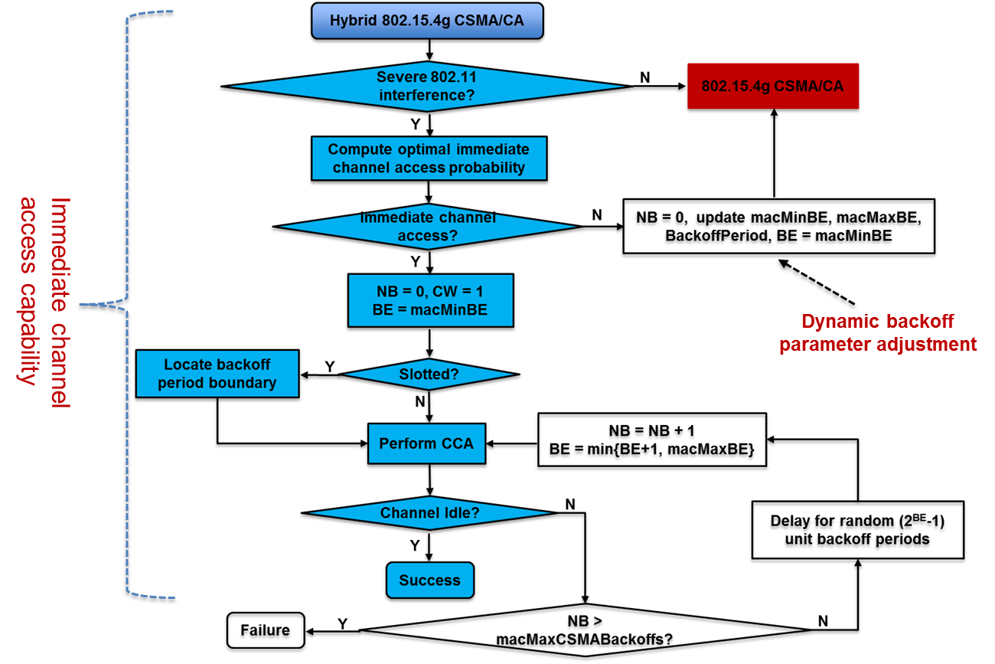

It can be seen that hybrid CSMA/CA allows 802.15.4g for immediate channel access when 802.11ah interference is severe. However, if multiple 802.15.4g devices perform immediate channel access, collision can occurs. Therefore, an optimal probability is applied such that approximately one 802.15.4g device in a neighborhood should perform immediate channel access. The immediate channel improves 802.15.4g reliability. To consider 802.11ah latency issue, the 802.15.4g devices that do not perform immediate channel access should increase their backoff parameters.

The 802.15.4g hybrid CSMA/CA is a device level coexistence method. Several metrics can be used to determine the severity of 802.11ah interference.

To perform immediate channel access, an 802.15.4g devices only needs to set macMaxBE = macMinBE = 0.

This can be easily implemented and aims to address both 802.15.4g reliability and 802.11ah latency. It does not require any protocol change. A key advantage of this method is that it does not degrade 802.11ah network reliability while improving 802.15.4g network reliability. In some cases, it improves the performance of both 802.11ah network and 802.15.4g network. Therefore, it is recommended for 802.15.4g device development.

9.3 Network load and duty cycle recommendations
As expected, the network load has major impact on 802.11ah and 802.15.4g coexistence performance. As the network load increases, the network performance degrades. However, in practice, the network load is determined by application, which indicates that lower layer technology is not able to adjust network load. Therefore, there is no much to be recommended for the network load.
For the radio device operating in the license-exempt bands, the duty cycle is regulated by the government. For example, in the Sub-1 GHz bands, Japan requires that an active radio device cannot have a duty cycle greater than 10%. Europe even requires 1% of duty cycle for some Sub-1 GHz bands. As a result, there is no much to be recommended for the duty cycle.
9.4 Network size recommendations
Also as expected, network size, i.e., number of nodes in a network, impacts coexistence performance of 802.11ah network and 802.15.4g network.
In fact, the number of the devices can be adjusted during application deployment, which indicates that application developer has opportunity to determine network size based on cost consideration for the best performance.
Recommendations
- If the network load is lower for 802.11ah network and 802.15.4g network, the network size does not impact coexistence performance very much. Therefore, the application developer should deploy as less devices as possible for cost purpose.
- If network load for 802.11ah network is higher and network load for 802.15.4g network is lower, the application developer should deploy 802.11ah devices as less as possible for cost purpose and especially for latency critical applications.
- If the network load for 802.15.4g network is higher and the network load for 802.11ah network is lower, the application developer should deploy 802.15.4g devices as more as possible if the device is cheap, especially for reliability critical applications.
9.5 Frame size recommendations
Frame size is a flexible parameter that can be configured without any restriction as long as application data is delivered to right destination with appropriate reliability and latency. However, the frame size selection should be based on the scenarios of the network load and the network size.
Scenario-1: smaller network size, higher 802.11ah load and lower 802.15.4g load
802.11ah frame size impact: 802.11ah frame size has little impact on 802.15.4g packet latency. 802.11ah frame size has impact on 802.15.4g packet delivery rate. Larger and medium 802.11ah frame size result in similar 802.15.4g packet delivery rate. However, smaller 802.11ah frame size decreases 802.15.4g packet delivery rate. 802.11ah frame size also impacts 802.11ah packet delivery rate. Smaller 802.11ah frame size results in lower 802.11ah packet delivery rate compared to larger and medium frame sizes. 802.11ah frame size has major impact on 802.11ah packet latency. Larger frame size increases 802.11ah packet latency compared to medium frame size. Smaller frame size significantly increases 802.11ah packet latency, 80% of 802.11ah packets delivered with latency greater 25 seconds, which is much longer than packet latency for larger and medium frame sizes. Therefore, 802.11ah node should send packet with medium frame size.
802.15.4g frame size impact: 802.15.4g frame size has no impact on 802.11ah packet delivery rate and has little impact on 802.15.4g packet latency. However, 802.15.4g frame size has impact on 802.15.4g packet delivery rate and 802.11ah packet latency. Smaller frame size decreases 802.15.4g packet delivery rate compared to medium frame size. Larger frame size slightly improves 802.15.4g packet delivery rate compared to medium frame size. In other words, 802.15.4g packet delivery rate is proportional to 802.15.4g frame size. 802.15.4g packet size has impact on 802.11ah packet latency. 802.11ah packet latency decreases slightly for smaller 802.15.4g frame size and increases moderately for larger 802.15.4g frame size. In other words, 802.11ah packet latency is also proportional to 802.15.4g frame size. Therefore, 802.15.4g node should send packet with larger packet size.
Scenario-2: smaller network size, lower 802.11ah load and higher 802.15.4g load
802.11ah frame size impact: 802.11ah frame size has no impact on 802.11ah packet delivery rate. 802.11ah frame size has little impact on 802.15.4g packet delivery rate and 802.15.4g packet latency. However, 802.11ah frame size has moderate impact on 802.11ah packet latency. Larger frame size slightly increases 802.11ah packet latency compared to the medium frame size. Smaller frame size has longer packet latency than both larger and medium frame sizes. Therefore, 802.11ah node should send packet with medium frame size.
802.15.4g frame size impact: 802.15.4g frame size has no impact on 802.11ah packet delivery rate and has little impact on 802.15.4g packet latency. However, 802.15.4g frame size has major impact on 802.15.4g packet delivery rate. Smaller frame size significantly decreases 802.15.4g packet delivery rate compared to medium frame size. On the other hand, larger frame size improves 802.15.4g packet delivery rate compared to medium frame size. In other words, 802.15.4g packet delivery rate is proportional to 802.15.4g frame size. 802.15.4g packet size also has major impact on 802.11ah packet latency. Smaller 802.15.4g frame size largely increases 802.11ah packet latency. Overall, 802.11ah packet latency increases as 802.15.4g packet decreases. In other words, 802.11ah packet latency is inversely proportional to 802.15.4g frame size. Therefore, 802.15.4g node should send packet with larger packet size.
Scenario-3: larger network size, higher 802.11ah load and lower 802.15.4g load
802.11ah frame size impact: 802.11ah frame size has slight impact on 802.11ah packet delivery rate. Smaller frame size slightly decreases 802.11ah packet delivery rate. 802.11ah frame size has moderate impact on 802.15.4g packet delivery rate. Larger 802.11ah frame size slightly increases 802.15.4g packet delivery rate compared to medium frame size. However, smaller 802.11ah frame size moderately decreases 802.15.4g packet delivery rate compared to medium frame size. 802.11ah frame size has little impact on 802.15.4g packet latency. 802.11ah frame size has major impact on 802.11ah packet latency. Larger frame size moderately increases 802.11ah packet latency compared to medium frame size. Smaller frame size significantly increases 802.11ah packet latency, 85% of 802.11ah packets delivered with latency greater 50 seconds, which is much longer than packet latency for larger and medium frame sizes. Therefore, 802.11ah node should send packet with medium frame size.
802.15.4g frame size impact: 802.15.4g frame size has little impact on 802.11ah packet delivery rate and 802.15.4g packet latency. However, 802.15.4g frame size has impact on 802.15.4g packet delivery rate and 802.11ah packet latency. Smaller frame size moderately decreases 802.15.4g packet delivery rate compared to medium frame size. Larger frame size slightly improves 802.15.4g packet delivery rate compared to medium frame size. In other words, 802.15.4g packet delivery rate is proportional to 802.15.4g frame size. 802.15.4g packet size has impact on 802.11ah packet latency. 802.11ah packet latency decreases slightly for smaller 802.15.4g frame size and increases moderately for larger 802.15.4g frame size. In other words, 802.11ah packet latency is also proportional to 802.15.4g frame size. Therefore, 802.15.4g node should send packet with larger packet size.
Scenario-4: larger network size, lower 802.11ah load and higher 802.15.4g load
802.11ah frame size impact: 802.11ah frame size has little impact on 802.11ah packet delivery rate. Larger frame size slightly decreases 802.11ah packet delivery rate. 802.11ah frame size has slight impact on 802.15.4g packet delivery rate and 802.15.4g packet latency. However, 802.11ah frame size has moderate impact on 802.11ah packet latency. Larger frame size increases 802.11ah packet latency compared to the medium frame size. Smaller frame size has longer packet latency than both larger and medium frame sizes. Therefore, 802.11ah node should send packet with medium frame size.
802.15.4g frame size impact: 802.15.4g frame size has little impact on 802.11ah packet delivery rate and 802.15.4g packet latency. However, 802.15.4g frame size has major impact on 802.15.4g packet delivery rate. Smaller frame size significantly decreases 802.15.4g packet delivery rate compared to medium frame size. On the other hand, larger frame size improves 802.15.4g packet delivery rate compared to medium frame size. In other words, 802.15.4g packet delivery rate is proportional to 802.15.4g frame size. 802.15.4g packet size also has major impact on 802.11ah packet latency. Larger 802.15.4g frame size slightly increases 802.11ah packet latency. Smaller 802.15.4g frame size significantly increases 802.11ah packet latency. Therefore, 802.15.4g node should send packet with larger frame size if the 802.15.4g packet delivery rate is critical and 802.15.4g node should send packet with medium frame size if the 802.11ah packet latency is critical.
9.6 Backoff parameter recommendations
In some cases, it may be possible to configure backoff parameters. In that case, backoff parameter should be selected for better coexistence performance. The selection of backoff parameter depends on the scenarios of the network load and the network size.
Scenario-1: smaller network size, higher 802.11ah load and lower 802.15.4g load
802.11ah backoff contention window size impact: 802.11ah contention window size has no impact on 802.11ah packet delivery rate. 802.11ah contention window size has little impact on 802.15.4g packet delivery rate and 802.15.4g packet latency. 802.11ah contention window size has moderate impact on 802.11ah packet latency. Smaller contention window moderately increases 802.11ah packet latency compared to default contention window size configuration. Larger contention window size increases 802.11ah packet latency further more. Therefore, 802.11ah node should follow standard backoff contention window configuration.
802.15.4g backoff parameter impact: 802.15.4g backoff parameters have no impact on 802.11ah packet delivery rate. 802.15.4g backoff parameters have impact on 802.15.4g packet delivery rate. Smaller backoff parameters decrease 802.15.4g packet delivery rate compared to medium backoff parameters. Larger backoff parameters improve 802.15.4g packet delivery rate compared to medium backoff parameters. In other words, 802.15.4g packet delivery rate is proportional to 802.15.4g backoff parameters. 802.15.4g backoff parameters have small impact on 802.11ah packet latency and 802.15.4g packet latency. Both smaller and larger backoff parameters slightly decrease 802.11ah packet latency. However, 802.15.4g packet latency is proportional to backoff parameters. Therefore, 802.15.4g node should send packet with larger backoff parameters if 802.15.4g packet delivery rate is critical and send packet with smaller backoff parameters if 802.15.4g packet latency is critical.
Scenario-2: smaller network size, lower 802.11ah load and higher 802.15.4g load
802.11ah backoff contention window size impact: 802.11ah contention window size has no impact on 802.11ah packet delivery rate and 802.15.4g packet latency. 802.11ah contention window size has little impact on 802.15.4g packet delivery rate. However, 802.11ah contention window size has moderate impact on 802.11ah packet latency. Larger contention window size increases 802.11ah packet latency compared to the default contention window size. Smaller contention window size further increases 802.11ah packet latency. Therefore, 802.11ah node should follow standard backoff contention window size configuration.
802.15.4g backoff parameter impact: 802.15.4g backoff parameters have no impact on 802.11ah packet delivery rate. 802.15.4g backoff parameters have impact on 802.15.4g packet latency. Smaller backoff parameters decrease 802.15.4g packet delivery rate compared to medium backoff parameters. Larger backoff parameters improve 802.15.4g packet delivery rate compared to medium backoff parameters. In other words, 802.15.4g packet delivery rate is proportional to 802.15.4g backoff parameters. 802.15.4g backoff parameters have small impact on 802.11ah packet latency and 802.15.4g packet latency. Smaller backoff parameters slightly increase 802.11ah packet latency. Larger backoff parameters decrease 802.11ah packet latency. In other words, 802.11ah packet latency is inversely proportional to 802.15.4g backoff parameters. However, 802.15.4g packet latency is proportional to backoff parameters, i.e., smaller backoff parameters decrease 802.15.4g packet latency and larger backoff parameters increase 802.15.4g packet latency. Therefore, 802.15.4g node should send packet with larger backoff parameters if 802.15.4g packet delivery rate is critical and send packet with smaller backoff parameters if 802.15.4g packet latency is critical.
Scenario-3: larger network size, higher 802.11ah load and lower 802.15.4g load
802.11ah backoff contention window size impact: 802.11ah contention window size has no impact on 802.15.4g packet latency. 802.11ah contention window size has little impact on 802.11ah packet delivery rate and 802.15.4g packet delivery rate. However, 802.11ah contention window size has impact on 802.11ah packet latency. Smaller 802.11ah contention window size moderately decreases 802.11ah packet latency compared to default contention window size. Larger contention window size increases packet latency of 70% of 802.11ah packets and decreases packet latency 30% of 802.11ah packets. Therefore, 802.11ah node should send packet using smaller contention window size.
802.15.4g backoff parameter impact: 802.15.4g backoff parameters have little impact on 802.11ah packet delivery rate. However, 802.15.4g backoff parameters have impact on 802.15.4g packet delivery rate, 802.11ah packet latency and 802.15.4g packet latency. Compared to medium backoff parameters, smaller backoff parameters slightly decrease 802.15.4g packet delivery rate and larger backoff parameters slightly improve 802.15.4g packet delivery rate. In other words, 802.15.4g packet delivery rate is proportional to 802.15.4g backoff parameters. 802.15.4g backoff parameters have small impact on 802.15.4g packet latency. 802.15.4g backoff parameters have moderate impact on 802.11ah packet latency. Smaller 802.15.4g backoff parameters moderately decrease 802.11ah packet latency compared to medium backoff parameters. Larger 802.15.4g backoff parameters further decrease 802.11ah packet latency. Therefore, 802.15.4g node should send packet with larger backoff parameters.
Scenario-4: larger network size, lower 802.11ah load and higher 802.15.4g load
802.11ah backoff contention window size impact: 802.11ah contention window size has little impact on 802.11ah packet delivery rate, 802.15.4g packet delivery rate and 802.15.4g packet latency. However, 802.11ah contention window size has impact on 802.11ah packet latency. Larger contention window size increases 802.11ah packet latency compared to default contention window size. Smaller 802.11ah contention window size decreases 802.11ah packet latency compared to the default contention window size. Therefore, 802.11ah node should send packet with smaller backoff contention window size.
802.15.4g backoff parameter impact: 802.15.4g backoff parameters have little impact on 802.11ah packet delivery rate. However, 802.15.4g backoff parameters have impact on 802.15.4g packet delivery rate, 802.11ah packet latency and 802.15.4g packet latency. Compared to medium backoff parameters, larger backoff parameters slightly increase 802.15.4g packet delivery rate compared to smaller and medium backoff parameters. 802.15.4g backoff parameters have impact on 802.15.4g packet latency. Compared to medium backoff parameters, smaller 802.15.4g backoff parameters moderately decrease 802.15.4g packet latency and larger 802.15.4g backoff parameters moderately increase 802.15.4g packet latency. 802.15.4g backoff parameters have moderate impact on 802.11ah packet latency. Compared to medium backoff parameters, smaller 802.15.4g backoff parameters moderately increase 802.11ah packet latency and larger 802.15.4g backoff parameters decrease 802.11ah packet latency. In other words, 802.11ah packet latency is inversely proportional to 802.15.4g backoff parameters. Therefore, 802.15.4g node should send packet with larger backoff parameters if 802.11ah packet latency is critical and send packet with smaller backoff parameters if 802.15.4g packet latency is critical.
9.7 PHY parameter recommendations
802.11ah ED threshold is at least 10 db higher than 802.15.4g receiver sensitivity, which causes readable 802.15.4g packet transmission ignored by 802.11ah channel sensing. As a result, the probability of collision between 802.11ah transmission and 802.15.4g transmission increases. Therefore, it is recommended that if it is possible, 802.11ah device should adjust its ED threshold if it has detected the coexistence of 802.15.4g devices. For example, α-fairness mechanism can be applied for this purpose.
802.11ah CCA time is much shorter than 802.15.4g CCA time. Therefore, it is recommended that if it is possible, 802.11ah device should increase its CCA time if it has detected the coexistence of 802.15.4g devices. The increased CCA time allows 802.11ah devices to detect more 802.15.4g packet transmissions.
9.8 Application based recommendations
Application developers should select technology based on application requirements such as network load, distribution of network load, data packet delivery rate, data packet latency, cost, device lifetime, power source and deploy environment. It is costly if the deployed system does not work well.
Application developer should consider the potential of coexistence with other systems already deployed or to be deployed. If coexistence is possible, coexistence factors such as interference mitigation technology availability and coexistence behavior of the technology should be considered. The devices should be deployed to positions that have better communication potential and less interference from other devices. Application developers are recommended to provide device with the capability to detect interference sources.
Application developers should also organize data in an efficient way such as lower layer technologies have better chance for successful transmission.
9.9 Coexistence method selection

Multiple coexistence methods may be available for each network/device. An 802.11ah network/device needs to select a coexistence method that suits the condition of the network/device well.

Figure xx shows flow chart of coexistence method selection for 802.11ah network.

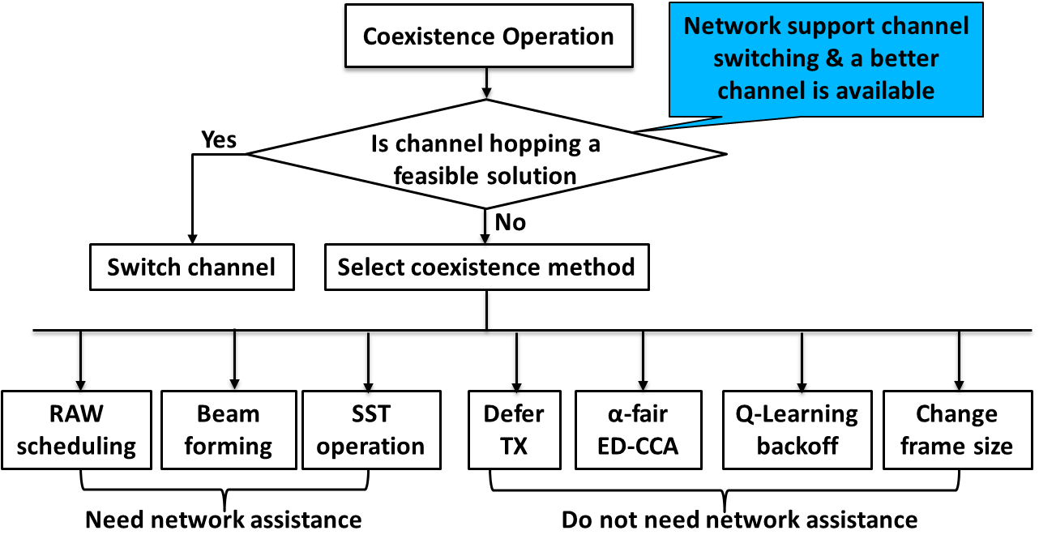
Coexistence Method Selection for 802.11ah

Similarly, there are multiple coexistence methods available for 802.15.4g network/device. An 802.15.4g network/device also needs to select a coexistence method that fits condition of 802.15.4g network/device well.

Figure x shows flow chart of coexistence method selection for 802.15.4g network.
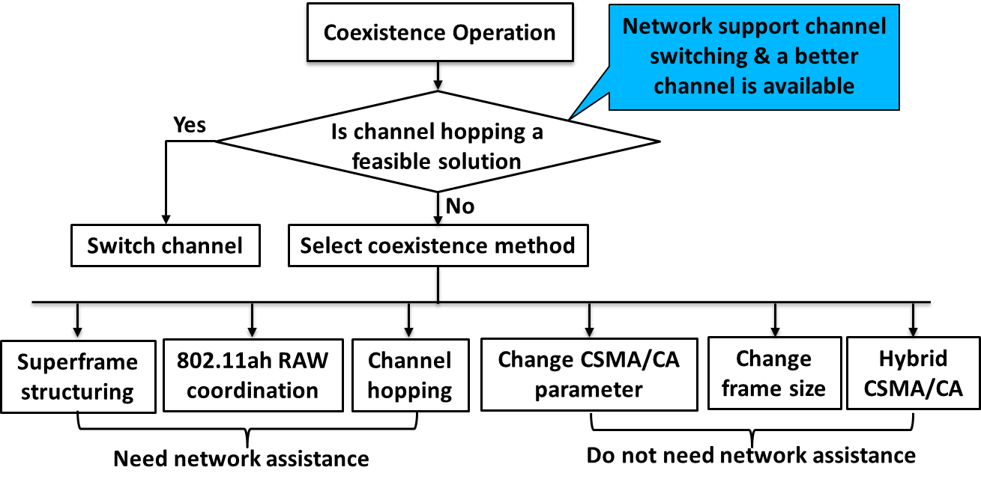
Coexistence Method Selection for 802.15.4g

- Conclusion
TBD
- References
TBD
Annex A
Evaluation and simulation practice
Simulation profiles
Evaluation metrics (e.g., packet delivery ratio and latency) and thresholds (application dependent)
Propagation models
Model for stations below roof height (stations have similar height)
Model for stations above or below roof height (stations have different height, e.g., for smart utility, data collectors are mounted on the electric pole, which is much higher than smart meters mounted on the house)

