IEEE P802.19
Wireless Coexistence

Project | IEEE P802.19 Wireless Coexistence WG
Title | Proposal for “Section 6.1 Japan” on Recommended Practice for Local and Metropolitan Area Networks - Part 19: Coexistence Methods for 802.11 and 802.15.4 based systems operating in the Sub-1 GHz Frequency Bands
Date Submitted | July 16, 2019
Source | Yukimasa Nagai (MERL)  Jianlin Guo (MERL)  Yukimasa Nagai (MERL)  Philip Orlik (MERL)  Benjamin A. Rolfe (MERL/BCA)  Takenori Sumi (Mitsubishi Electric) | E-mail: nagai@merl.com  guo@merl.com  porlik@merl.com  ben@blindcreek.com  Sumi.Takenori@dc.MitsubishiElectric.co.jp
Abstract | This document is the proposed draft of “Section 6.1 Japan” on Recommended Practice. PPT version can be found on 19-19/0050r0.
Purpose | To respond 802.19.3 Task Group’s call for proposal.
Notice | This document has been prepared to assist the IEEE P802.19. It is offered as a basis for discussion and is not binding on the contributing individual(s) or organization(s). The material in this document is subject to change in form and content after further study. The contributor(s) reserve(s) the right to add, amend or withdraw material contained herein.
Release | The contributor acknowledges and accepts that this contribution becomes the property of IEEE and may be made publicly available by IEEE P802.19.

- Sub-1 GHz spectrum allocation
6.1 Japan
There are currently there standards for 920 MHz band for IoT Devices by radio types and transmission powers: ARIB STD-T106, ARIB STD-T107 and ARIB STD-T108 for different use cases.

- ARIB STD-T106 “920MHz-band RFID Equipment For Premises Radio Station”. This standard specified on Radio Frequency Identification (RFID) equipment that uses the frequency 916.7 MHz or more and 920.9 MHz or less to the identification of mobile objects that the radio equipment performs by receiving the radio wave emitted from a responder. The target systems are high output power type passive tag system.
- ARIB STD-T107 “920MHz-band RFID Equipment for Specified Low Power Radio Station”. This standard specifies on the Radio Frequency Identification (RFID) equipment that uses the frequency of 916.7 MHz or more and 923.5 MHz or less to the identification of mobile objects that radio equipment performs by receiving the radio wave emitted from a responder. The target system is a medium-or-low output type passive tag system.
- ARIB STD-T108 “920MHz-band Telemeter, Telecontrol and Data Transmission Radio Equipment”. This standard specified two standards: Land Mobile stations, and Specified Low-Power Radio Stations.
  - This standard for Land Mobile Stations uses the frequency of 920.5 MHz or more and 923.5 MHz or less, and 250 mW or less for transmission power. A radio channel shall consist of up to 5 consecutive unit radio channels which are defined that their center frequencies are located from 920.6 MHz to 923.4 MHz with 200 kHz separation and their bandwidth are 200 kHz. However, it is prohibited to simultaneously use both the unit radio channels giving priority to passive tag system whose center frequencies are located from 920.6 MHz to 922.2 MHz and the unit radio channels whose center frequencies are located 922.4 MHz or more.
  - This standard for Specified Low-Power Radio Stations uses the frequency of 915.9 MHz or more 929.7 MHz or less. Transmission power shall be 20 mW or less. However, it shall be 1 mW or less for radio channels consisting of at least one of channels whose center frequencies are located from 916.0 MHz to 916.8 MHz or from 928.15 MHz to 929.65 MHz. A radio channel shall consist of up to 5 consecutive unit channels which are defined that their center frequencies are located from 916.0 MHz to 916.8 MHz and from 920.6 MHz to 928.0 MHz with 200 kHz separation and their bandwidth are 200 kHz or which are defined that their center frequencies are located from 928.15 MHz to 929.65 MHz with 100 kHz separation and their bandwidth are 100 kHz. However, it is prohibited to simultaneously use both the unit channels giving priority to prioritized passive tag system whose center frequencies are located from 920.6 MHz to 922.2 MHz and the unit channels whose center frequencies are located 922.4 MHz or more.
  - This standard also defines operational rule for coexistence with other system by two types of carrier sense times; short CS station using carrier sense time of 128 us or more and long CS station using carrier sense time of 5 ms or more. Short CS stations are efficient to have low power consumption with batteries, by means of short data communication with long duration. Total transmission time of short CS stations shall be 10% or less of duration on ARIB STD-T108. IEEE 802.15g operates as short CS station on STD-T108.

Figure 6.x shows the channel plan for 920 MHz-band radio equipment that standardized on ARIB STD-T106, T107 and T108.

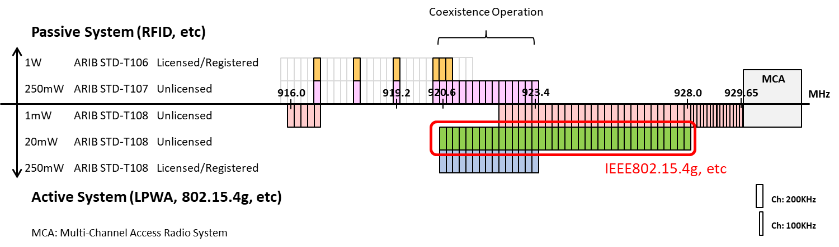
Figure 6.x 920MHz-band Channel Plan in Japan

Reference

- ARIB STD-T106, “920MHz-Band RFID Equipment for Premises Radio Station and Land Mobile Radio Station,” Version 2.0, April 12, 2019. (https://www.arib.or.jp/english/std_tr/telecommunications/desc/std-t106.html)
- ARIB STD-T107, “920MHz-Band RFID Equipment for Specified Low Power Radio Station,” Version 1.1, October 17, 2017. (https://www.arib.or.jp/english/std_tr/telecommunications/desc/std-t107.html)
- ARIB STD-T108, “920MHz-Band Telemeter, Telecontrol and Data Transmission Radio Equipment,” Version 1.3, April 12, 2019. (https://www.arib.or.jp/english/std_tr/telecommunications/desc/std-t108.html)
- MIC, http://www.soumu.go.jp/main_content/000544861.pdf, 2018/04/10
- MIC, http://www.soumu.go.jp/main_content/000550848.pdf, 2018/05/14
- MIC, http://www.soumu.go.jp/main_content/000551143.pdf, 2018/05/15

