IEEE 802.19.1a
Wireless Coexistence
Comment resolutions on CID124 and CID125
Date: 2016-09-12
Author(s):
Name | Company | Address | Phone | Email
Sho Furuichi | Sony |  |  | Sho.Furuichi@sony.com

Abstract
This document provides comment resolutions on CID124 and CID125.
Comment ID | Page No. | Section | Line No. | Type (General, Editorial, Technical) | Comments | Proposed changes | Resolutions
124 | 108 | 7.2.3 | 11 | Technical | Replace all the "WSO" by "GCO" through this subclause. | Need suggestion from proponent | same as comment 25, change to editorial, resolved
125 | 112 | 7.2.3.1.3 | 16 | Technical | WSO (GCO) operation is out of scope of the standard. The algorithm description should be changed so that CE operation supports this algorithm. | need change proposal | wait for contributions

===== (Text starts)
7.2.3 Information service for moving GCO
7.2.3.1 Proxy coexistence service
7.2.3.1.1 Introduction
It is very important for a coexistence system to manage GCOs operating anywhere. For example, there is a case that multiple CMs manage different regions and that moving GCO has to change its serving CM through its connected CE when the located region of the GCO is changed by moving as shown in Figure X.1. It is ideal that the GCO can change its serving CM smoothly, but there is a possibility that the GCO cannot establish the connection with the other CM due to connection timeout and so on. In such a situation, the coexistence in a new region is not compensated for the GCO because the GCO does not communicate with the CM managing within the new region.
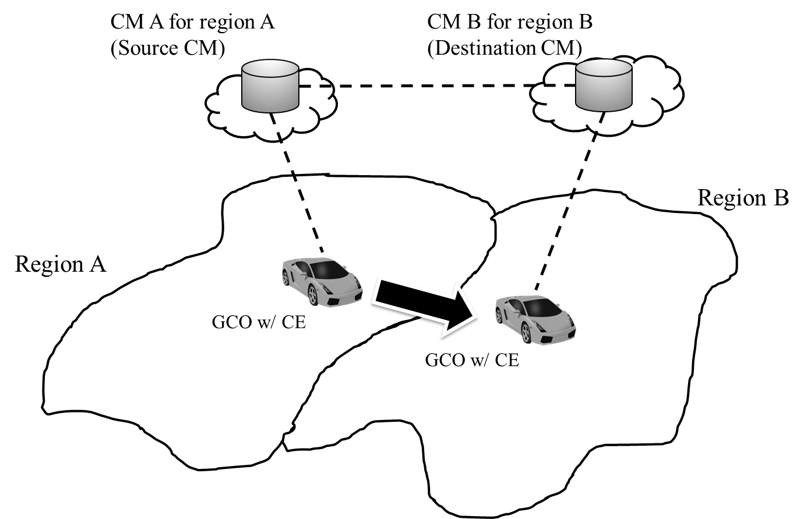
Figure 99 — Moving GCO changes its serving CM when moving across the region

7.2.3.1.2 Algorithm description for proxy coexistence service
The proxy coexistence service algorithm is focused on providing coexistence service especially for moving GCO. Figure 100 shows the flowchart of the proxy coexistence service algorithm.
The processes are as follows.
- P#1
Process P#1 is the CM association procedure as specified in 5.2.20. The CE shall perform this procedure when the CE needs to establish connection with the CM after booting or to change the serving CM.
- P#2
Process P#2 is the subscription procedure as specified in 5.2.1.1. The CE shall perform the subscription procedure to subscribe coexistence service from the CM that manages the region where GCO is located.
- P#3
Process P#3 is the registration procedure as specified in 5.2.2.1. The CE shall perform the GCO registration procedure when it has successfully finished the GCO subscription procedure.
- P#4
Process P#4 is the proxy coexistence service procedure as specified in 5.2.20. The CE shall perform this procedure when the GCO needs to continue to subscribe coexistence service even if the connection establishment with the CM in the located-region is failed. While subscribing the proxy coexistence service, at the same time the CE shall perform the CM association procedure. Figure 96 shows the graphical example of proxy coexistence service.

The branch conditions are as follows.
- BC#1
This branch condition shall be conducted based on the status of the CM association procedure. If the status represents the connection is established, go to P#2. Otherwise, go to BC#2.
- BC#2
This branch condition shall be conducted based on the history of the coexistence service subscription of the WSO. If the WSO has been subscribed the coexistence service in the previous located region, go to P#4. Otherwise, go to P#1.
- BC#3
This branch condition shall be conducted based on the geo-location of the GCO. If the geo-location of the GCO is out of the management region of the serving CM, go to P#1. Otherwise, continue to monitor the geo-location of the GCO.

Figure 100 —Flow chart of proxy coexistence service algorithm
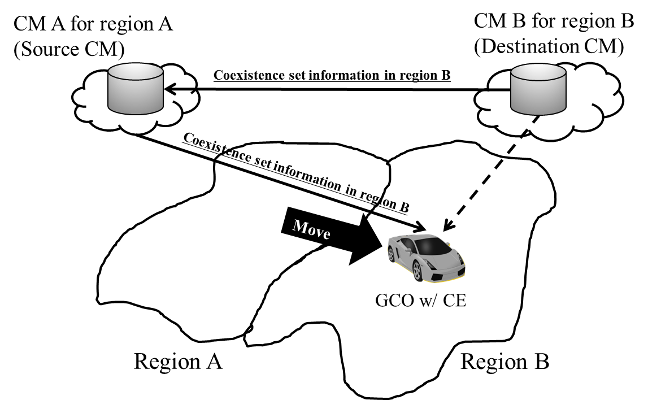
Figure 101 —Graphical example of proxy coexistence service

7.2.3.2 Coexistence report for moving GCO

In the case of managing moving GCO, it is very difficult for CM to keep providing the optimized coexistence report for the GCO because geo-location is always changed and the coexistence set information becomes less useful (i.e. operation based on the less useful information causes giving and receiving harmful interference). Generally speaking, region-specific coexistence set information is less optimum than the location-specific. On the other hand, from the view point of necessity of information update frequency, the region-specific coexistence set information is more appropriate for the moving GCO than the location-specific. However, even if the GCO uses spectrum based on the region-specific coexistence report, it is highly possible that the GCO gives and receives harmful interference in multiple GCO environment because the other GCOs may use spectrum based on the same coexistence report. As such, region-specific coexistence report that makes less harmful interference is needed for moving GCO.
In order to degrade the possibility of giving and receiving harmful interference at moving GCO, multiple coexistence reports (coexistence report set) such as shown in Figure 102 and 103 can be utilized.
Figure 102—Example of multiple coexistence report set
Figure 103 —Example of mapping to the multiple coexistence report set to the same geographical map
Coexistence report set has the following features:
- Within one coexistence report, in each region, different frequency channel from the adjacent region is set.
- Between different coexistence reports, at the same region, different frequency channel is set.

7.2.3.3 Algorithm description
The processes are as follows.
- P#1
P#1 is the procedure operated at CE where the CE obtains the region-specific coexistence report set and sends it to the GCO the CE serves through the providing coexistence report procedure as specified in 5.2.3.6 or the proxy coexistence service procedure as specified in 5.2.20.
- P#2
In the process P#2, the CE selects one coexistence report from the region-specific coexistence report set.
- P#3
In the process P#3, the CE selects and configures operational parameter of GCO based on the selected coexistence report in the process P#2.
- P#4
In the process P#4, the CE enables GCO to start operation.
- P#5
In the process P#5, the CE monitors state and operation of GCO based on the current operational parameter.
The branch conditions are as follows.
- BC#1
This branch condition shall be conducted based on the geo-location of the GCO. If the CE finds the GCO cannot operate based on the current region-specific coexistence report due to its current geo-location, go to BC#2. Otherwise, go to P#5.
- BC#2
This branch condition shall be conducted based on the geo-location of the GCO. If the CE finds the current coexistence report set does not include the region-specific coexistence report corresponding to the current geo-location of the GCO, go to P#1. Otherwise, go to P#2.

Operation flow is shown in as follows.
Figure 104 Operational flow of CE

======(Text ends)

