IEEE 802.19.1a
Wireless Coexistence
Text proposal on coexistence service for moving WSO
Date: 2016-03-16
Author(s):
Name | Company | Address | Phone | Email
Sho Furuichi | Sony |  |  | Sho.Furuichi@jp.sony.com
Naotaka Sato | Sony |  |  | naotaka.sato@ieee.org
Chen Sun | Sony China |  |  | Chen.Sun@sony.com.cn

Abstract
This document provides text proposal on proxy coexistence service.

r1 provides highlight and comment in order to make clear which is modification or new addition.
Yellow highlight represents modification part.

5.2.xx Proxy coexistence service procedure
A CE shall perform the proxy coexistence procedure to start communicating with CM when the CE needs to obtain a coexistence report information from the non-serving CM. An illustrative example of this procedure is shown in Figure X. CEProxyCoexistenceServiceRequest, CMProxyCoexistenceServiceRequest and CoexistenceReportResponse messages are defined in Annex C.
Figure X —Proxy coexistence service procedure

After the CE receives a primitive request for a proxy coexistence service report from the WSO, the CE shall generate a CEProxyCoexistenceServiceRequest message and send this message to the CM1. The CE operations related to generating and sending a CEProxyCoexistenceServiceRequest message are specified in 6.4.
After the CM1 receives a CEProxyCoexistenceServiceRequest message from the CE, the CM1 shall generate a CMProxyCoexistenceServiceRequest message, and shall send this CMProxyCoexistenceServiceRequest message to the CM2. The CM operations related to generating and sending message CMProxyCoexistenceServiceRequest are specified in 6.3.
After the CM2 receives a CMProxyCoexistenceServiceRequest message from the CM1, the CM2 shall generate a CoexistenceReportResponse message, and shall send this CoexistenceReportResponse message to the CM1. After the CM1 has received a CoexistenceReportResponse message from the CM2, the CM1 shall generate a CoexistenceReportResponse message, and shall send this CoexistenceReportResponse message to the CE. The CM operations related to generating and sending a CoexistenceReportResponse message are specified in 6.3.
After the CE receives a CoexistenceReportResponse message from the CM1, the CE shall send the received coexistence report to the WSO. The CE operations related to receiving the CoexistenceReportResponse message and sending the coexistence report to the WSO is specified in 6.4.

/////

6.3 CM operation
6.3.4.9 Providing coexistence report
When a CM requires to provide a coexistence report to a WSO, the CM shall perform the providing coexistence report procedure described in 5.2.3.6. The CM shall generate and send the CoexistenceReportResponse message to the CE that serves this WSO.
The following table shows CxMessage fields in CoexistenceReportResponse message.
Parameter | Data type | Value
header | CxHeader | requestID
payload | CxPayload | coexistenceReportResponse

The following table shows the parameters in the coexistenceReportResponse payload.
Parameter | Data type | Value
coexistenceReport | CoexistenceReport | Shall be set to indicate coexistence report in providing single coexistence report. Setting both coexistenceReport and listOfCoexistenceReport is not needed.
listOfCoexistenceReports | ListOfCoexistenceReports | Shall be set to indicate coexistence report in providing multiple coexistence report. Setting both coexistenceReport and listOfCoexistenceReport is not needed.

The following table shows the parameters in the coexistenceReport
Parameter | Data type | Value
networkID | OCTET STRING | Network ID
wsoID | OCTET STRING | WSO ID
listOfRecommended  OperationFrequencies | ListOfRecommended  OperationFrequencies | As specified in following table

The following table shows ListOfRecommendedOperationFrequencies parameter element.
Parameter | Data type | Value
frequencyRange | FrequencyRange | Shall be set to indicate the recommended operation frequency range.
txPowerLimit | REAL | Shall be set to indicate the power limit in the frequency range.
availableStartTime | GeneralizedTime | Shall be set to indicate start time of the recommended operation frequency range if applicable.
availableStopTime | GeneralizedTime | Shall be set to indicate stop time of the operation recommended frequency range if applicable.
resolutionBandwidth | REAL | Shall be set to indicate the resolution bandwidth of available frequency where WSO is operating, if applicable.
locationValidity | REAL | Shall be set to indicate radius of the circle centered on the reported geo-location of the WSO, outside of which the recommended operation frequencies are not valid, if this parameter is available.

The following table shows the parameters in the ListOfCoexistenceReports parameter element.
Parameter | Data type | Value
region | Region | Shall be set to indicate the region information that represents the below listOfRecommendedOperationFrequencies is valid if available.
listOfRecommended  OperationFrequencies | ListOfRecommended  OperationFrequencies | As specified in the above table

6.3.4.x Proxy coexistence service procedure
When a CM receives CEProxyCoexistenceServiceRequest from CE, CM shall perform the proxy coexistence service procedure described in 5.2.3.x. The CM shall generate and send the CMProxyCoexistenceServiceRequest message to the other CM.
The following table shows CxMessage fields in CMProxyCoexistenceServiceRequest message.
Parameter | Data type | Value
header | CxHeader | requestID
payload | CxPayload | cmProxyCoexistenceServiceRequest

The following table shows the parameters in the cmProxyCoexistenceServiceRequest payload.
Parameter | Data type | Value
cmID | CxID | CM ID
listOfCEs | ListOfCEs | List of CEs to be served proxy service.

The following table shows the parameters in the listOfCEs.
Parameter | Data type | Value
ceID | CxID | CE ID
listOfWSOs | ListOfWSOs | List of WSOs to be served proxy service.

The following table shows the parameters in the listOfWSOs.
Parameter | Data type | Value
wsoID | OCTET STRING | Shall be set to indicate WSO ID.
wsoDescriptor | WSODescriptor | Shall be set to indicate the WSO parameters.

The following table shows WSODescriptor parameter element.
Parameter | Data type | Value
networkType | NetworkType | Shall be set to indicate network type as specified in regulations if applicable.  Depending on regulatory rule, the value can be as follows:  [Operation in TV band under FCC Part 15]  “fixed”, “mode1” or “mode2”  [Operation in TV band under ETSI EN 301 598]  “typeA” or “typeB”
emissionClass | EmissionClass | Shall be set to indicate the emission class if applicable. The value can be “class1”, “class2”, “class3”, “class4” or “class5”.
wsoType | WSOType | Shall be set to indicate the WSO type, “master” or “slave”.
networkTechnology | NetworkTechnology | Shall be set to indicate current operating network technology
addNetworkTechnology | SEQUENCE OF NetworkTechnology | Optionally present. If present, this parameter shall be set to indicate the sequence of its operable network technology type(s)
wsoRegulatoryID | OCTET STRING | Shall be set to indicate the regulatory ID of WSO.

6.4 CE operation
6.4.3.8 Providing coexistence report
After a CE has received a CoexistenceReportResonse message from the CM to which it is subscribed, the
CE shall perform the providing coexistence report procedure described in 5.2.3.6. The CE shall generate and send the CxMediaCoexistenceReportResponse primitive to the WSO/RLSS it serves. The following table shows CxMedia fields in CxMediaCoexistenceReportResponse primitive.
Parameter | Data type | Value
coexistenceReport | CoexistenceReport | Shall be set to indicate coexistence report in providing single coexistence report. Setting both coexistenceReport and listOfCoexistenceReport is not needed.
listOfCoexistenceReports | ListOfCoexistenceReports | Shall be set to indicate coexistence report in providing multiple coexistence report. Setting both coexistenceReport and listOfCoexistenceReport is not needed.

The following table shows the parameters in the coexistenceReport
Parameter | Data type | Value
networkID | OCTET STRING | Network ID
wsoID | OCTET STRING | WSO ID
listOfRecommended  OperationFrequencies | ListOfRecommended  OperationFrequencies | As specified in following table

The following table shows ListOfRecommendedOperationFrequencies parameter element.
Parameter | Data type | Value
frequencyRange | FrequencyRange | Shall be set to indicate the recommended operation frequency range.
txPowerLimit | REAL | Shall be set to indicate the power limit in the frequency range.
availableStartTime | GeneralizedTime | Shall be set to indicate start time of the recommended operation frequency range if applicable.
availableStopTime | GeneralizedTime | Shall be set to indicate stop time of the operation recommended frequency range if applicable.
resolutionBandwidth | REAL | Shall be set to indicate the resolution bandwidth of available frequency where WSO is operating, if applicable.
locationValidity | REAL | Shall be set to indicate radius of the circle centered on the reported geo-location of the WSO, outside of which the recommended operation frequencies are not valid, if this parameter is available.

The following table shows the parameters in the ListOfCoexistenceReports parameter element.
Parameter | Data type | Value
region | Region | Shall be set to indicate the region information that represents the below listOfRecommendedOperationFrequencies is valid if available.
listOfRecommended  OperationFrequencies | ListOfRecommended  OperationFrequencies | As specified in the above table

6.4.3.x Proxy coexistence service
After a CE has received a CxMediaProxyCoexistenceServiceRequest from the WSO it serves, the CE shall generate and send the CEProxyCoexistenceServiceRequest message to the CM.
The following table shows CxMessage fields in CEProxyCoexistenceServiceRequest message.
Parameter | Data type | Value
header | CxHeader | requestID
payload | CxPayload | ceProxyCoexistenceServiceRequest

The following table shows the parameters in the ceProxyCoexistenceServiceRequest payload.
Parameter | Data type | Value
ceID | CxID | CE ID
listOfWSOs | ListOfWSOs | List of WSOs to be served proxy service.

The following table shows the parameters in the listOfWSOs.
Parameter | Data type | Value
wsoID | OCTET STRING | Shall be set to indicate WSO ID.
wsoDescriptor | WSODescriptor | Shall be set to indicate the WSO parameters.

The following table shows WSODescriptor parameter element.
Parameter | Data type | Value
networkType | NetworkType | Shall be set to indicate network type as specified in regulations if applicable.  Depending on regulatory rule, the value can be as follows:  [Operation in TV band under FCC Part 15]  “fixed”, “mode1” or “mode2”  [Operation in TV band under ETSI EN 301 598]  “typeA” or “typeB”
emissionClass | EmissionClass | Shall be set to indicate the emission class if applicable. The value can be “class1”, “class2”, “class3”, “class4” or “class5”.
wsoType | WSOType | Shall be set to indicate the WSO type, “master” or “slave”.
networkTechnology | NetworkTechnology | Shall be set to indicate current operating network technology
addNetworkTechnology | SEQUENCE OF NetworkTechnology | Optionally present. If present, this parameter shall be set to indicate the sequence of its operable network technology type(s)
wsoRegulatoryID | OCTET STRING | Shall be set to indicate the regulatory ID of WSO.

After a CE has received a CoexistenceReportResonse message from the CM, the CE shall generate and send the CxMediaCoexistenceReportResponse primitive to the WSO/RLSS it serves. The following table shows CxMedia fields in CxMediaCoexistenceReportResponse primitive.
Parameter | Data type | Value
coexistenceReport | CoexistenceReport | Shall be set to indicate coexistence report in providing single coexistence report. Setting both coexistenceReport and listOfCoexistenceReport is not needed.
listOfCoexistenceReports | ListOfCoexistenceReports | Shall be set to indicate coexistence report in providing multiple coexistence report. Setting both coexistenceReport and listOfCoexistenceReport is not needed.

The following table shows the parameters in the coexistenceReport
Parameter | Data type | Value
networkID | OCTET STRING | Network ID
wsoID | OCTET STRING | WSO ID
listOfRecommended  OperationFrequencies | ListOfRecommended  OperationFrequencies | As specified in following table

The following table shows ListOfRecommendedOperationFrequencies parameter element.
Parameter | Data type | Value
frequencyRange | FrequencyRange | Shall be set to indicate the recommended operation frequency range.
txPowerLimit | REAL | Shall be set to indicate the power limit in the frequency range.
availableStartTime | GeneralizedTime | Shall be set to indicate start time of the recommended operation frequency range if applicable.
availableStopTime | GeneralizedTime | Shall be set to indicate stop time of the recommended operation frequency range if applicable.
resolutionBandwidth | REAL | Shall be set to indicate the resolution bandwidth of available frequency where WSO is operating, if applicable.
locationValidity | REAL | Shall be set to indicate radius of the circle centered on the reported geo-location of the WSO, outside of which the recommended operation frequencies are not valid, if this parameter is available.

The following table shows the parameters in the ListOfCoexistenceReports parameter element.
Parameter | Data type | Value
region | Region | Shall be set to indicate the region information that represents the below listOfRecommendedOperationFrequencies is valid if available.
listOfRecommended  OperationFrequencies | ListOfRecommended  OperationFrequencies | As specified in the above table

/////
7.x.y Information service for moving WSO
7.x.y.1 Proxy coexistence service
7.x.y.1.1 Introduction
It is very important for a coexistence system to manage WSOs operating anywhere. For example, there is a case that multiple CMs manage different regions and that moving WSO has to change its serving CM through its connected CE when the located region of the WSO is changed by moving as shown in Figure X.1. It is ideal that the WSO can change its serving CM smoothly, but there is a possibility that the WSO cannot establish the connection with the other CM due to connection timeout and so on. In such a situation, the coexistence in a new region is not compensated for the WSO because the WSO does not communicate with the CM managing within the new region.
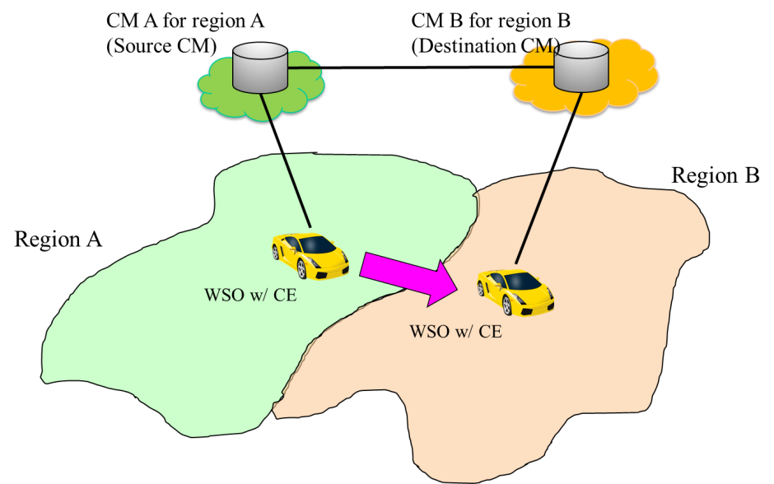
Figure X.1 — Moving WSO changes its serving CM when moving across the region

7.x.y.1.2 Algorithm description for proxy coexistence service
The proxy coexistence service algorithm is focused on providing coexistence service especially for moving WSO. Figure X shows the flowchart of the proxy coexistence service algorithm.
The processes are as follows.
- P#1
Process P#1 is the CM association procedure as specified in 5.2.xx. The CE shall perform this procedure when the CE needs to establish connection with the CM after booting or to change the serving CM.
- P#2
Process P#2 is the subscription procedure as specified in 5.2.1.1. The CE shall perform the subscription procedure to subscribe coexistence service from the CM that manages the region where WSO is located.
- P#3
Process P#3 is the registration procedure as specified in 5.2.2.1. The CE shall perform the WSO registration procedure when it has successfully finished the WSO subscription procedure.
- P#4
Process P#4 is the proxy coexistence service procedure as specified in 5.2.xx. The CE shall perform this procedure when the WSO needs to continue to subscribe coexistence service even if the connection establishment with the CM in the located-region is failed. While subscribing the proxy coexistence service, at the same time the CE shall perform the CM association procedure. Figure X.3 shows the graphical example of proxy coexistence service.

The branch conditions are as follows.
- BC#1
This branch condition shall be conducted based on the status of the CM association procedure. If the status represents the connection is established, go to P#2. Otherwise, go to BC#2.
- BC#2
This branch condition shall be conducted based on the history of the coexistence service subscription of the WSO. If the WSO has been subscribed the coexistence service in the previous located region, go to P#4. Otherwise, go to P#1.
- BC#3
This branch condition shall be conducted based on the geo-location of the WSO. If the geo-location of the WSO is out of the management region of the serving CM, go to P#1. Otherwise, continue to monitor the geo-location of the WSO.

Figure X.2 —Flow chart of proxy coexistence service algorithm
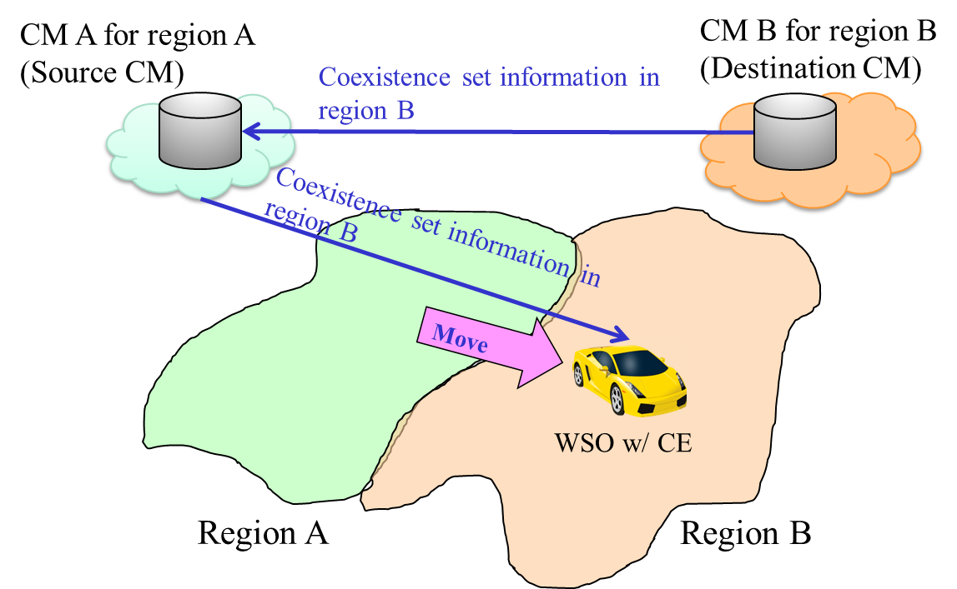
Figure X.3 —Graphical example of proxy coexistence service

7.x.y.2 Coexistence report for moving WSO

In the case of managing moving WSO, it is very difficult for CM to keep providing the optimized coexistence report for the WSO because geo-location is always changed and the coexistence set information becomes less useful (i.e. operation based on the less useful information causes giving and receiving harmful interference). Generally speaking, region-specific coexistence set information is less optimum than the location-specific. On the other hand, from the view point of necessity of information update frequency, the region-specific coexistence set information is more appropriate for the moving WSO than the location-specific. However, even if the WSO uses spectrum based on the region-specific coexistence report, it is highly possible that the WSO gives and receives harmful interference in multiple WSO environment because the other WSOs may use spectrum based on the same coexistence report. As such, region-specific coexistence report that makes less harmful interference is needed for moving WSO.
In order to degrade the possibility of giving and receiving harmful interference at moving WSO, multiple coexistence reports (coexistence report set) such as shown in Figure X.4 and X.5 can be utilized.
Figure X.4 —Example of multiple coexistence report set
Figure X.5 —Example of mapping to the multiple coexistence report set to the same geographical map
Coexistence report set has the following features:
- Within one coexistence report, in each region, different frequency channel from the adjacent region is set.
- Between different coexistence reports, at the same region, different frequency channel is set.

7.x.y.3 Algorithm description
The processes are as follows.
- P#1
P#1 is the procedure operated at CE where the CE obtains the region-specific coexistence report set and sends it to the WSO the CE serves through the providing coexistence report procedure as specified in 5.2.3.6 or the proxy coexistence service procedure as specified in 5.2.3.x.
- P#2
In the process P#2, the WSO selects one coexistence report from the region-specific coexistence report set.
- P#3
In the process P#3, the WSO configures its operational parameter based on the selected coexistence report in the process P#2.
- P#4
In the process P#4, the WSO starts operation.
- P#5
In the process P#5, the WSO continues operation based on the current operational parameter.
The branch conditions are as follows.
- BC#1
This branch condition shall be conducted based on the geo-location of the WSO. If the WSO cannot operate based on the current region-specific coexistence report due to its current geo-location, go to BC#2. Otherwise, go to P#5.
- BC#2
This branch condition shall be conducted based on the geo-location of the WSO. If the current coexistence report set does not include the region-specific coexistence report corresponding to the current geo-location of the WSO, go to P#1. Otherwise, go to P#2.

Operation flow is shown in as follows.
Figure X.5 Operational flow of CE and WSO

Annex A (normative) Data types
--List of coexistence reports
ListOfCoexistenceReports ::= SEQUENCE OF SEQUENCE {
--Regional information corresponding to the recommended frequencies.
region Region OPTIONAL,
--List of recommended operation frequencies
listOfRecommendedOperationFrequencies ListOfRecommendedOperationFrequencies OPTIONAL
}

--List of CEs
ListOfCEs ::= SEQUENCE OF SEQUENCE {
--CE ID
ceID CxID OPTIONAL,
--List of WSOs
listOfWSOs ListOfWSOs OPTIONAL,
...
}

--List of WSOs
ListOfWSOs ::= SEQUENCE OF SEQUENCE {
--WSO ID
wsoID OCTET STRING OPTIONAL,
--WSO descriptor
wsoDescriptor WSODescriptor OPTIONAL,
...
}

--WSO descriptor
WSODescriptor ::= SEQUENCE {
--Network type
networkType NetworkType OPTIONAL,
--Emission class
emissionClass EmissionClass OPTIONAL,
--WSO type
wsoType WSOType OPTIONAL,
--Network technology
networkTechnology NetworkTechnology OPTIONAL,
--Operable network technology type(s)
addNetworkTechnology SEQUENCE OF NetworkTechnology OPTIONAL,
--Regulatory ID of WSO
wsoRegulatoryID OCTET STRING OPTIONAL,
...
}

NetworkType ::= ENUMERATED {
--“Fixed” in FCC rule
fixed,
--“Mode I” in FCC rule
mode1,
--“Mode II” in FCC rule
mode2,
--“Type A” as specified in ETSI EN 301 598
typeA,
--“Type B” as specified in ETSI EN 301 598
typeB,
...
}

--Emission class
EmissionClass ::= ENUMERATED {
--“Class 1” as specified in ETSI EN 301 598
class1,
--“Class 2” as specified in ETSI EN 301 598
class2,
--“Class 3” as specified in ETSI EN 301 598
class3,
--“Class 4” as specified in ETSI EN 301 598
class4,
--“Class 5” as specified in ETSI EN 301 598
class5,
...
}

--WSO Type
WSOType ::= ENUMERATED {
--“Master”
master,
--“Slave”
slave,
...
}

Annex C (normative) Messages
--Response for coexistence report
CoexistenceReportResponse ::= SEQUENCE {
--Coexistence report information
coexistenceReport CoexistenceReport OPTIONAL,
--Channel priority information
channelPriority ChannelPriority OPTIONAL,
--Coexistence report set
listOfCoexistenceReports ListOfCoexistenceReports OPTIONAL
}

--CEProxyCoexistenceServiceRequest
CEProxyCoexistenceServiceRequest ::= SEQUENCE {
--CE ID
ceID CxID OPTIONAL,
--List of WSOs
listOfWSOs ListOfWSOs OPTIONAL,
...
}

--CMProxyCoexistenceServiceRequest
CMProxyCoexistenceServiceRequest ::= SEQUENCE {
--CM ID
cmID CxID OPTIONAL,
--List of CEs
listOfCEs ListOfCEs OPTIONAL,
...
}

