IEEE P802.19
Wireless Coexistence
IEEE 802.19.1 overview presentation notes
Date: 2014-09-09
Author(s):
Name | Company | Address | Phone | email
Stanislav Filin | NICT |  |  | sfilin@nict.go.jp
Abstract

Notice: This document has been prepared to assist IEEE 802.19. It is offered as a basis for discussion and is not binding on the contributing individual(s) or organization(s). The material in this document is subject to change in form and content after further study. The contributor(s) reserve(s) the right to add, amend or withdraw material contained herein.

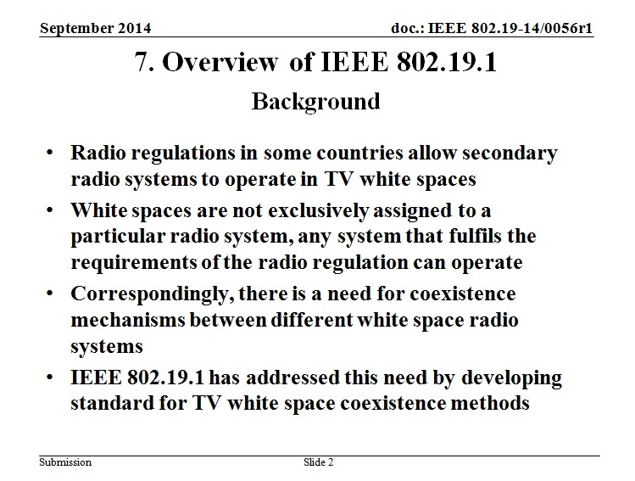
Radio regulations in some countries allow secondary radio systems to operate in TV white spaces.
White spaces are not exclusively assigned to one particular radio system. Any radio system that satisfies radio regulations for primary user protection can use white spaces.
Correspondingly, there is a need for coexistence mechanisms between different white space radio systems.
To address this need, the IEEE 802 Executive Committee initiated project P802.19.1 to develop standard for “TV White Space Coexistence Methods” in December 2009. The standard was published in June 2014.

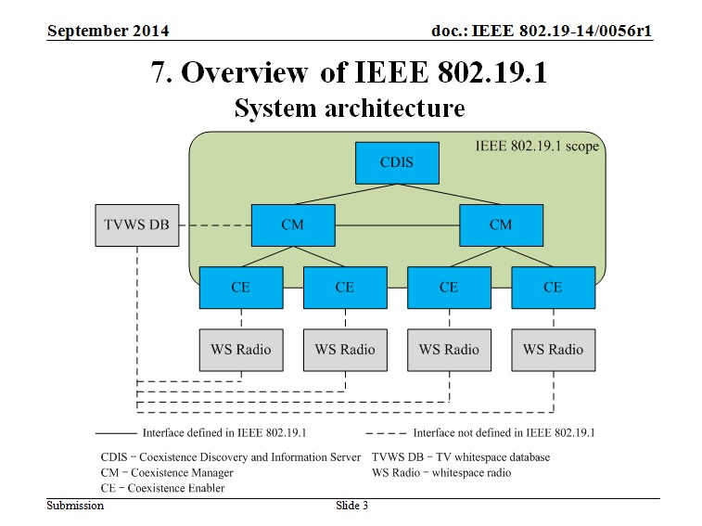
The IEEE 802.19.1 system architecture is designed to perform three key tasks required to solve coexistence problem between different white space radio systems:
1. Discovery of white space radio systems that need to coexist with each other (CDIS logical entity)
2. Changing operating parameters of this white space radio systems in a way that improves their performance (CM logical entity)
3. Providing a unified interface between different types of white space radio systems and a coexistence system (CE logical entity)

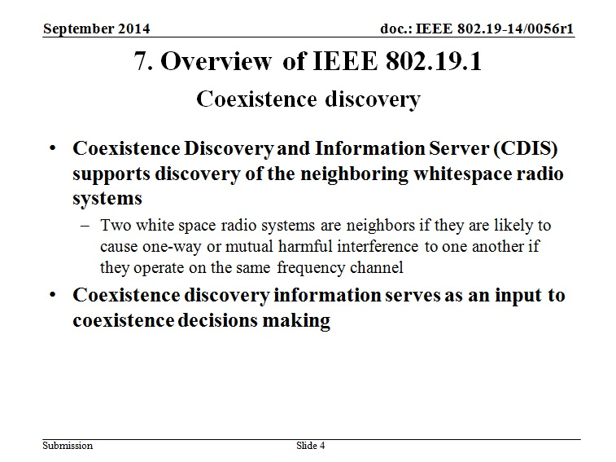
Coexistence Discovery and Information Server (CDIS) supports discovery of the neighboring whitespace radio systems. Two white space radio systems are neighbors if they are likely to cause one-way or mutual harmful interference to one another if they operate on the same frequency channel.
Neighbor relationships between white space radio systems depend on multiple parameters. The most obvious parameters are the locations of the white space radio systems and their radiated power, which in turn depends on transmission power, antenna height, antenna pattern, and propagation loss. The next set of parameters characterizes the receivers of a potential victim, for example, receiver sensitivity, noise floor or minimum required SNR. Also, different radio access technologies may have different ranges of operating SINR values and may have different levels of robustness to interference and to different type of interference. Finally, signal propagation is different in different frequency bands.
There are many different ways to take into account all these factors. As a result different neighbor discovery algorithms with different performance and complexity can be developed and implemented. Some examples of such algorithms are given in the IEEE standard 802.19.1.
Coexistence discovery information serves as an input to coexistence decision making.

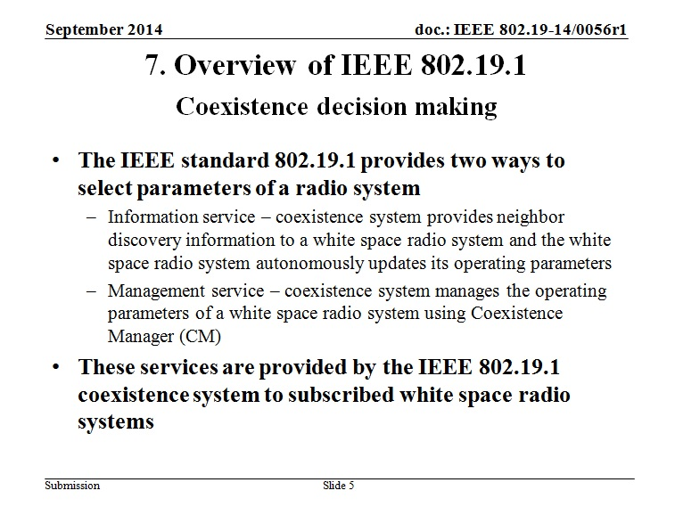
The IEEE standard 802.19.1 provides two ways to solve the second task:
1. Information service
2. Management service
Within the information service, the coexistence system provides neighbor discovery information to a white space radio system and the white space radio system autonomously updates its operating parameters.
Within the management service, the coexistence system manages the operating parameters of a white space radio system. To provide the management service, a logical entity called a Coexistence Manager (CM) is defined.
A CM collects registration information from white space radio systems it serves, neighbor discovery information from a CDIS, and available frequency bands information from a TV white space database. The CM evaluates this information and makes coexistence decisions on operating parameters of the white space radio systems it serves. Then the CM requests corresponding reconfiguration of the white space radio systems it serves.
The IEEE 802.19.1 standard is designed to adapt only high-level operating parameters of a white space radio system, for example, its operating channel, large-scale transmission schedule, and transmission power.
Similar to coexistence discovery, there can be multiple algorithms for making coexistence decisions on a white space radio system operating parameters. Examples of such algorithms are provided in the IEEE 802.19.1 standard.

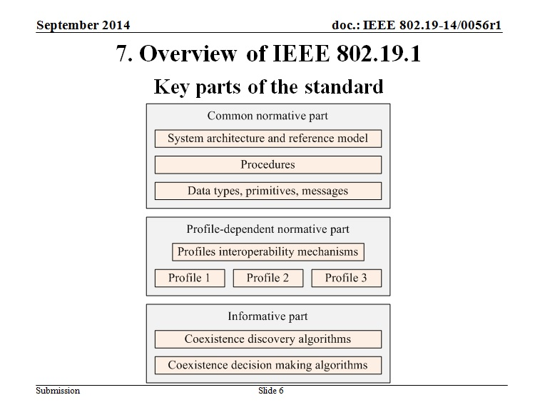
The key components of the standard are shown on the slide.
Procedures describe messages and primitives exchange among the coexistence system entities (CDIS, CM, and CE) and external entities (TVWS database and white space radio systems). Procedures use defined messages, primitives, and data types.
Examples of the procedures are:
- Subscription
- Registration
- Procedures for coexistence discovery
- Procedures for reconfiguration
- Procedures for negotiation between different CMs.
IEEE 802.19.1 draft standard defines detailed operation of its entities: CDIS, CM, and CE.
Entity operation is profile-dependent. Several profiles are defined for CDIS, CM, and CE operation in order to provide cost-efficient support of different deployment scenarios and use cases.
However, profiles are interoperable with each other:
- CDIS is able to serve a CM operating according to any profile
- CMs operating according to different profiles are able to exchange information with each other.
Also, as was mentioned before, the standard describes several coexistence discovery and decision making algorithms as implementation examples.

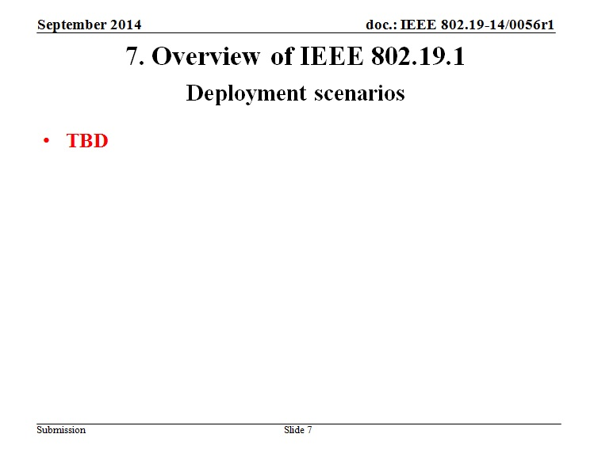

TBD

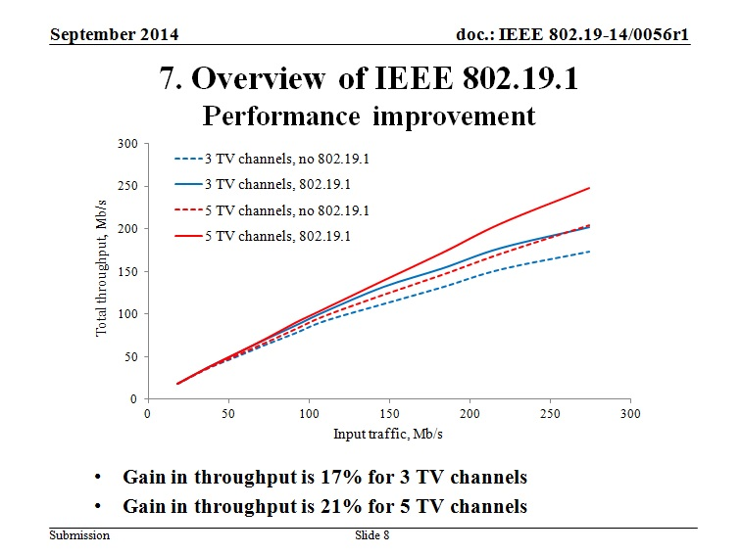
Example of performance evaluation of improvement to system performance introduced by IEEE 802.19.1 system is shown in the slide.
This performance evaluation was done by simulation using QualNet software. IEEE 802.11af APs and IEEE 802.22 BSs were distributed in a given area and their throughput was collected. Then the number of APs and BSs was increased and new simulation is run. One simulation run is one point on one curve.
The number of BSs was from 1 to 15, and the number of APs was from 5 to 75. Each BS/AP serves 3 stations. 3 (blue lines) and 5 (red lines) available TV channels were simulated. Two cases were compared: IEEE 802.19.1 coexistence system is either not used (dotted lines) or used (solid lines).
Gain in total throughput reaches 17% for 3 channels and 21% for 5 channels. The gain increases as the number BSs and APs increases.

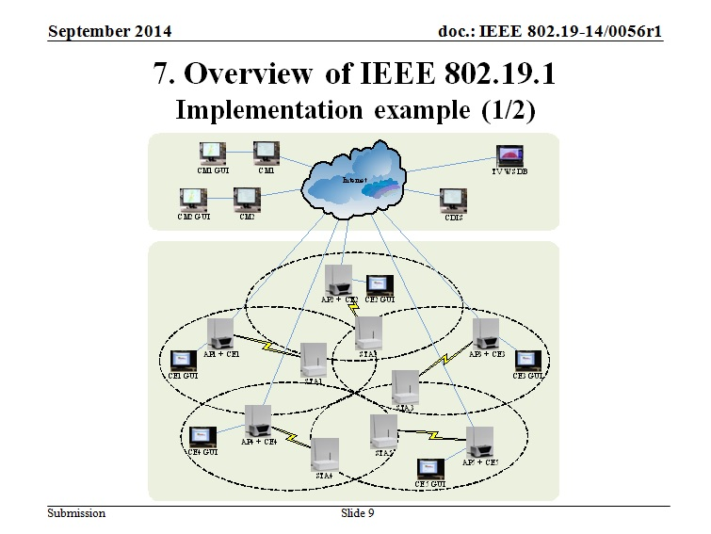
This slide shows example of implementation of the IEEE 802.19.1 coexistence system comprising one CDIS, two CMs, and five CEs installed in five 802.11 TV whitespace APs.
Four TV channels are available. AP1, AP2, and AP3 have 5MHz bandwidth, while AP4 and AP5 have 10 MHz bandwidth (designed in a way that 3 TV channels are required). Correspondingly, APs 1, 2, and 3 can do self-coexistence with each other. Also, APs 4 and 5 can do self-coexistence with each other. However, there is no celf-coexistence mechanism between 5MHz and 10MHz APs.

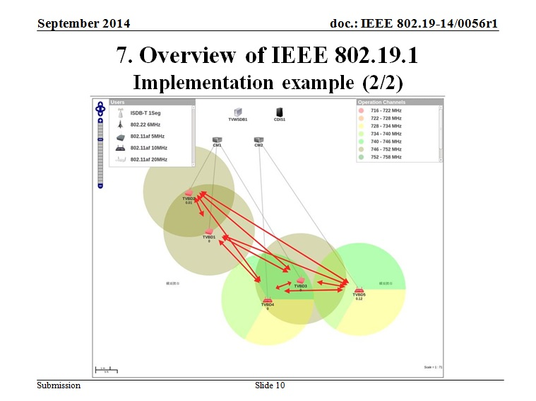
IEEE 802.19.1 has created the following configuration for these five radio systems in 4 available channels: APs 1, 2, and 3 operate in one available TV channel using self-coexistence mechanism of 802.11, while APs 4 and 5 operate in remaining three available TV channels.

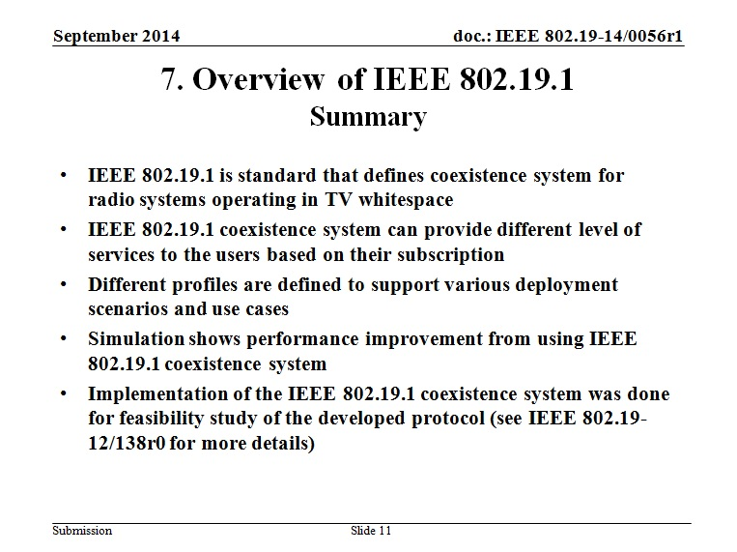
IEEE 802.19.1 is the standard that defines a coexistence system for radio systems operating in TV whitespace.
IEEE 802.19.1 coexistence system can provide different level of services to the users based on their subscription.
Different profiles are defined to support various deployment scenarios and use cases.
Simulation shows performance improvement from using IEEE 802.19.1 coexistence system.
Implementation of the IEEE 802.19.1 coexistence system was done for feasibility study of the developed protocol (see IEEE 802.19-12/138r0 for more details).

