IEEE P802.19
Wireless Coexistence
TG1 May 2013 Interim Minutes
Date: 2013-05-16
Author(s):
Name | Company | Address | Phone | email
Hyunduk Kang | ETRI | 138 Gajeong-Ro, Yuseong-Gu, Daejeon, 305-700, South Korea | +82-42-860-1074 | henry@etri.re.kr

The document contains IEEE 802.19 TG1 minutes from the May 2013 interim.

Monday May 13th, 2013 AM2
The meeting was called to order at 11:15.

Appoint for acting chair
The TG1 vice chair, Hyunduk Kang, appointed for the TG1 acting chair for the May 2013 plenary since the TG1 chair resigned.

Call for secretary
Nobody from the TG1 volunteered for secretary for the meeting and the TG1 acting chair acted as the recording secretary for the TG1 for the May 2013 plenary.

IEEE IPR statement
The chair informed the TG about the IEEE patent policy and showed the set of 4 slides identified as “Highlights of the IEEE-SA Standards Board Bylaws on Patents in Standards” available at the IEEE PATCOM web site (http://standards.ieee.org/board/pat/pat-slideset.ppt).
The chair made a call for essential patents: No one came forward.

Approval of January 2013 TG1 meeting minutes
Motion: Approve TG1 minutes (19-13/0037r3) from the January 2013 interim meeting
Moved by: S.Filin
Seconded by: M.Kasslin
Motion passes with unanimous consent

Review and discuss TG1 status and objectives for this session
The chair presented an opening report (19-13/0059r0).

Call for submissions, discussions and approval of agenda
The chair gave an introduction to agenda proposal in 19-13/0058r0. A set of contributions were assigned a time slot in the agenda that was updated accordingly.
Motion: Approve TG1 agenda (19-13/0058r1) for the May 2013 interim
Moved by: M.Kasslin
Seconded by: S.Filin
Motion passes with unanimous consent
The meeting was recessed at 12:00.

Monday May 13th, 2013 PM1
The meeting was called to order at 13:10.

Comment resolutions
- Assigned all editorial comments
- Assigned and close 45 technical comments. 17 technical comments are opened.
- New revision (19-13/0057r1) of the comment resolution file was prepared containing comment resolution proposals for the addressed comments.
The meeting was recessed at 15:25.

Tuesday May 14th, 2013 AM1
The meeting was called to order at 8:30.

Comment resolutions
- Assigned and close 13 technical comments. 4 technical comments are opened.
The meeting was recessed at 9:51.

Tuesday May 14th, 2013 PM1
The meeting was called to order at 13:35.

Comment resolutions
- S.Filin of NICT presented contribution 19-13/0061r0, 19-13/0062r0.
- New revision (19-13/0057r2) of the comment resolution file was prepared containing comment resolution proposals for the addressed comments.

Agenda review
The TG1 agenda was updated to reschedule contributions from ETRI, NICT, NOKIA.
Motion: Approve TG1 agenda (19-13/0058r2) for the May 2013 interim
Moved by: S.Filin
Seconded by: I.Reede
Motion passes with unanimous consent

The meeting was recessed at 15:05.

Wednesday May 15th, 2013 AM1
The meeting was called to order at 8:30.

Comment resolutions
- H.Kang of ETRI presented contribution 19-13/0064r0, 19-13/0065r0, 19-13/0066r0, 19-13/0067r0, 19-13/0068r0, 19-13/0069r0, 19-13/0070r0.
- New revision (19-13/0057r3) of the comment resolution file was prepared containing comment resolution proposals for the addressed comments.

Agenda review
The TG1 agenda was updated to reschedule contributions from NICT, NOKIA, Fujitsu.
Motion: Approve TG1 agenda (19-13/0058r3) for the May 2013 interim
Moved by: S.Filin
Seconded by: I.Reede
Motion passes with unanimous consent

The meeting was recessed at 9:45.

Wednesday May 15th, 2013 AM2
The meeting was called to order at 10:30.

Comment resolutions
- G. Farhadi of Fujitsu presented contribution 19-13/0063r0.
- New revision (19-13/0057r3) of the comment resolution file was updated containing comment resolution proposals for the addressed comments.

Discussion on PAR extension
- Draft for PAR extension is prepared

The meeting was recessed at 15:28.

Wednesday May 15th, 2013 PM1
The meeting was called to order at 13:34.

Comment resolutions
- S.Filin of NICT presented contribution 19-13/0071r0, 19-13/0072r0, 19-13/0072r1.
- New revision (19-13/0057r3) of the comment resolution file was updated containing comment resolution proposals for the addressed comments.

The meeting was recessed at 14:49.

Thursday May 16th, 2013 AM1
The meeting was called to order at 8:30.

Comment resolutions
- M.Kasslin of Nokia presented contribution 19-13/0073r0, 19-13/0074r1.
- S.Filin of NICT presented contribution 19-13/0071r2.
- New revision (19-13/0057r4) of the comment resolution file was prepared containing comment resolution proposals for the addressed comments.

Move to forward PAR extension request document to the WG and request WG chair to take whatever action is required to extend the PAR
Moved by: S.Filin
Seconded by: H.Kang
Vote: /Y, /N, /A = 6/0/0
Motion passes

Agenda review
The TG1 agenda was updated to reschedule contributions from NOKIA.
Motion: Approve TG1 agenda (19-13/0058r4) for the May 2013 interim
Moved by: S.Filin
Seconded by: I.Reede
Motion passes with unanimous consent

The meeting was recessed at 9:40.

Thursday March 21st, 2013 AM2
The meeting was called to order at 11:30

Comment resolutions
- M.Kasslin of Nokia presented contribution 19-13/0073r1, 19-13/0074r2, 19-13/0024r3.
- New revision (19-13/0057r4) of the comment resolution file was updated containing comment resolution proposals for the addressed comments.

The meeting was recessed at 12:00.

Thursday March 21st, 2013 PM1
The meeting was called to order at 13:30

Review and vote on comment resolutions
Motion: Approve comment resolutions in file 19-12/0057r4
Moved by: S.Filin
Seconded by: M.Kasslin
Vote: 9/Y, 0/N, 0/A
Motion passed

Review and vote on next steps
Motion: Request the TG editor to prepare by May 31, 2013, a new 802.19.1 draft which builds upon the DF3.03 and incorporates the changes approved by the TG1 during the May 2013 interim meeting
Moved by: M.Kasslin
Seconded by: S.Filin
Vote: 11/Y, 0/N, 0/A
Motion passed

Motion: Kindly ask the 802.19 WG chair to start a new 30-days WG Letter Ballot on the new 802.19.1 draft no later than June 7, 2013
Moved by: M.Kasslin
Seconded by: S.Filin
Vote: 8/Y, 0/N, 3/A
Motion passed

Plan for July 2013 plenary and teleconferences
The TG agreed to have teleconferences before the July 2013 plenary as follows:
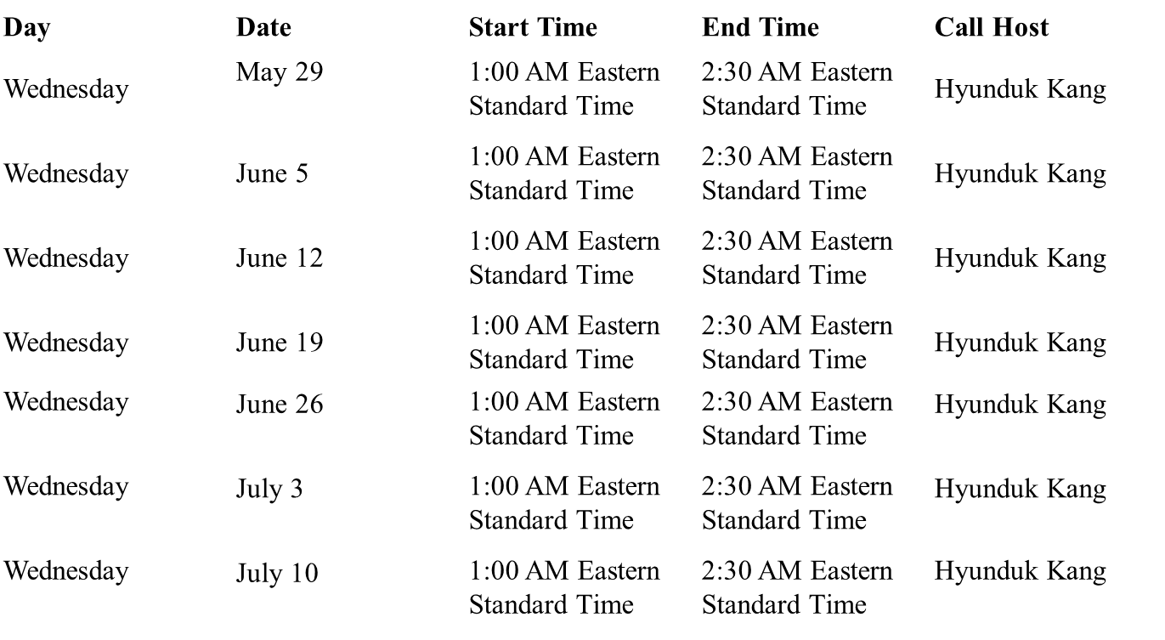

The TG1 is expected to start resolving comments from the WG LB in the July 2013 plenary.

The meeting was adjourned at 14:00.

