IEEE P802.19  
Wireless Coexistence

|  |  |  |  |  |
| --- | --- | --- | --- | --- |
| How to Utilize Mobility Information for Coexistence Decisions | | | | |
| Date: 2013-03-20 | | | | |
| Author(s): | | | | |
| Name | Company | Address | Phone | email |
| Golnaz Farhadi | Fujitsu Labs of America | 1240 E. Arques Avenue M/S 345, Sunnyvale, CA 94085, USA | +1-408-530-4510 | gfarhadi@us.fujitsu.com |
| Tsuyoshi Shimomura | Fujitsu Labs. Ltd. | 3-2-1 Sakado, Takatsu-ku, Kawasaki, Kanagawa, Japan | +81-44-8749066 | tcsimomura@jp.fujitsu. com |

Abstract

This contribution provides use cases on how the mobility information can help with more intelligent decision making for resource allocation.

**Notice:** This document has been prepared to assist IEEE 802.19. It is offered as a basis for discussion and is not binding on the contributing individual(s) or organization(s). The material in this document is subject to change in form and content after further study. The contributor(s) reserve(s) the right to add, amend or withdraw material contained herein.

**Discussion**

The support for the mobility information in the coexistence management system was approved by the IEEE 802.19.1 TG in the document 19-12/0204r7. We propose to add an informative annex on use cases for the coexistence decisions using mobility information.

**Annex X**

**(Informative)**

**Use Cases for using mobility information in the coexistence management system**

**X. 1. Introduction**

Having mobility information enables coexistence decisions that not only avoid frequent spectrum handoffs for the mobile WSOs but also reduce reconfiguration of resources for the co-located fixed WSOs. WSO mobility information parameters may include an option for maxSpeed, WSO speed/ direction, or the WSO route.

The mobility information may be realized in coexistence decision scenarios where all networks are subscribed to one CM or different networks are subscribed to different CMs. For the latter case where multiple CMs are involved, the message passing between the CMs may be carried out as specified in the current draft. This may be done by including the channel(s) or frequency range(s) reserved for the mobile WSO in the message exchanged between the CMs.

The mobility information can be updated at least as often as the location update from the WSO to the CM based on the current draft. In addition, according to FCC rules, a Mode II personal/portable device may load channel availability information for multiple locations in the vicinity of its current location, and use that information in its operation. For example, the mobility information may be updated at least every 60 seconds, if mobility information changed.

**X.2. CM using mobility information to support moving WSOs**

A CM may utilize the mobility information as following.

* ***CM using “maxSpeed” information:*** The CM can calculate an area around the mobile WSO based on the “maxSpeed” value. This enables the CM to allocate channels (or frequency ranges) that cover the surrounding area of the mobile WSO as large as possible. The maxSpeed may also help the CM to find WSOs that may be co-located with the mobile WSO in its location(s). Thereby, the CM may avoid assigning   the same frequency bands already allocated to the moving WSO. This, in turn, reduces resource reconfigurations for the other fixed WSOs which would be otherwise needed to avoid interference with the mobile WSO.
* ***CM using speed/direction or WSO route to support moving WSOs***: More detailed mobility information (or equivalently the WSO route as location per time) will help the CM to make more precise decisions on 1) the frequency assignment for the mobile WSO and 2) the WSOs that might be impacted by the mobile WSO and hence better planning for their frequency assignment accordingly. Having better precision will result in higher total achievable throughput compared to the previous case where only the maxSpeed is provided. For example, there may be fixed WSOs located in all directions around the mobile WSO. Using only the “maxSpeed” information, the CM may assume many next locations for the mobile WSO. Without knowledge of the speed/direction, the CM may overestimate the number of WSOs that might be impacted by the mobile WSO leading to a more conservative channel assignment. Furthermore, assuming a large area for the roaming of mobile WSO may limit the number of channels that the CM may allocate to the mobile WSO in order to avoid reconfigurations.

The following example illustrates resource allocation using mobility information. Consider Figure X.1 with network 1 as the mobile WSO. In this scenario, networks 1, 2 and 3 are in the interference range of each other at the current location of mobile WSO. The mobile WSO at its next location will interfere with networks 4 and 5. It is assumed the channels “a”, “b”, “c”, “d” are available at the current location while channels “a”, “b”, “e”, “f” at the next location. Suppose that network 1 requires two channels for its operation while the other networks require one channel. Having the knowledge of the mobile WSO information, the CM allocates

* For current location
  + Network 1: channels a and b
    - CM reserves channels “a, b” to be used for WSO in its next location
  + Network 2: channel c
  + Network 3: channel d
  + Network 4: channel e
    - CM avoids scheduling Network 4 over channels “a” or “b” (even if they might have better channel quality)
  + Network 5: channel f
    - CM avoids scheduling Network 5 over channels “a” or “b”
* For next location of Network 1
  + Each network continues to operate over the channels assigned previously without any reconfigurations.



Figure X.1. A mobile WSO neighboring with networks 2 and 3 in its current location and with networks 4 and 5 in its next location.

Figure X.2 shows an example coexistence decision algorithm using WSO mobility information. The processing of “Make coexistence decision “ and “Select new frequency for next location” may use similar algorithms in subclauses 10.4.1 and 10.4.2 of the current draft. In Figure X.2, the prediction for the next location is based on the mobility information provided to the CM. The channel assignment for a network at a given location takes into account the potential interference from a mobile WSO that may arrive in that location. This may lead to temporal interference if the prediction is not accurate. By having a short update period for the mobility information, this interference can be reduced. On the other hand, the geolocation information (for mobile WSO) is updated based on the current draft. Therefore, the frequency assignment for the col-located fixed WSOs may be changed based on the update location information if different from the predicted location.

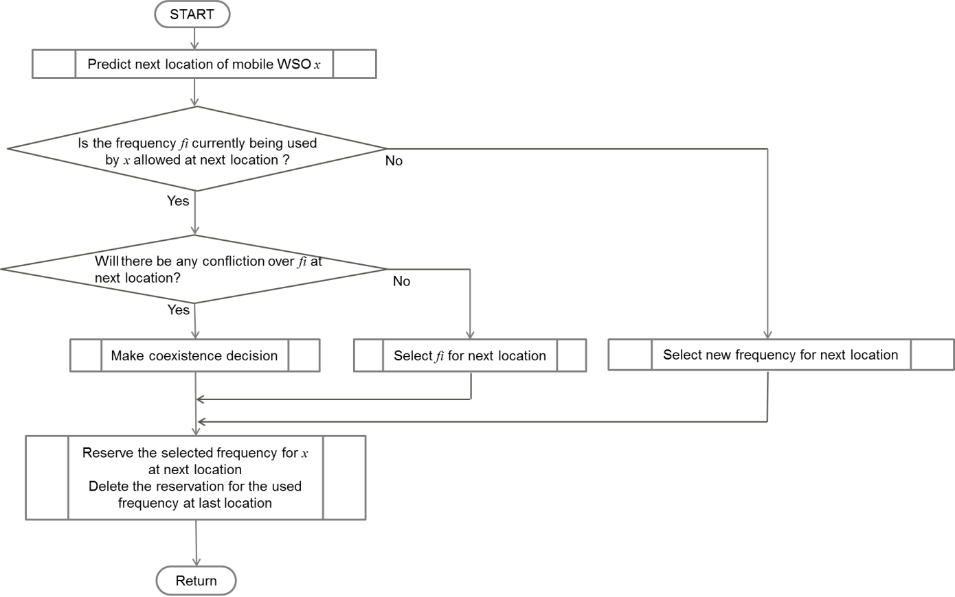

Figure X.2. An example of the coexistence algorithm for the mobile WSO.