IEEE P802.19
Wireless Coexistence
Basic principles of coexistence discovery
Date: 2013-02-27
Author(s):
Name | Company | Address | Phone | email
Jari Junell | Nokia |  |  | jari.junell@nokia.com
Mika Kasslin | Nokia |  |  | mika.kasslin@nokia.com
Abstract
This document is an initial draft submission to IEEE 802.19 TG1 that contains a relatively high level description of coexistence discovery scheme that is proposed for 802.19.1 draft.
Notice: This document has been prepared to assist IEEE 802.19. It is offered as a basis for discussion and is not binding on the contributing individual(s) or organization(s). The material in this document is subject to change in form and content after further study. The contributor(s) reserve(s) the right to add, amend or withdraw material contained herein.

Introduction
Coexistence discovery is functionality with which the IEEE 802.19.1 compliant coexistence system finds out those WSOs that may interfere with each other. The following clauses explain the phases of coexistence discovery and responsibilities of each related entity. Figure 1 provides an overview of the entity interactions that relate somehow to coexistence discovery.

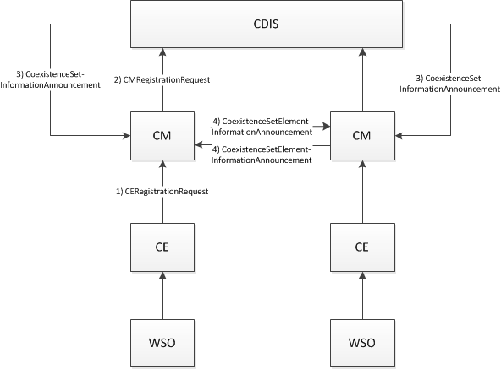
Figure 1: Steps within the coexistence discovery functionality

Design principles
One of the main design principles of the coexistence discovery mechanism proposed in this submission is that the coexistence discovery is done on WSO level. In practice this means that in the coexistence discovery one analyzes whether WSOs may interfere with each other.

As per the current WSO definition, a WSO is either a device or a network of devices. Further, in the current design each WSO is given just one location. In case of a WSO being a device, the location is the device’s location and in case of a WSO being a network of devices, the location is location of the master device of the network. In fact, the objective of the coexistence discovery is to find out those devices that may interfere with each other with their radio transmissions. In case of a network we don’t, however, know all the device locations and thus coexistence discovery is based on device location estimates. This method should be limited to those devices whose maximum transmission power is below a pre-defined threshold. All those devices that have maximum transmission power above the pre-defined threshold would be represented as a WSO. With this basic rule we can assure that the coexistence discovery mechanism has a reasonable performance in finding out those WSOs that may interfere each other.

All the above means that the 802.19.1 specification would have a rule for WSOs that would disallow WSOs of network type when the maximum transmission power is above a certain threshold. The transmission power threshold should be frequency band specific to accommodate different propagations conditions in different bands.

Other design principles are as follows:
- CDIS is the main entity that is responsible for the coexistence discovery
- CM may perform coexistence discovery for those WSOs that are registered to it (i.e. those WSOs that are represented by those CEs that the CM serves)

Initialization of the coexistence discovery
The coexistence discovery shall be initiated by a CM. A CM shall initiate the coexistence discovery by sending the following information to the CDIS:
- Entity identification information
  - CE identifier
  - WSO identifier
- Interference level estimation information
  - WSO type (device or network)
  - WSO location
  - WSO Tx frequency range
  - WSO Rx frequency range
  - WSO Tx antenna properties
  - WSO Rx antenna properties
  - WSO Max Tx power per Hz
  - WSO Rx tolerable interference level per Hz
  - WSO Rx sensitivity level per Hz
The CM gets all the WSO related information from the CE in a CERegistrationRequest message. A CERegistrationRequest message is used to register a new WSO and to update registration information. The CM shall initiate the coexistence discovery by sending a CERegistrationRequest message to the CDIS. The CM shall send a CERegistrationRequest message when any of the following events happen:
- Upon receiving request for a new registration for a WSO from the CE
- Upon receiving request for an update of a WSO registration from the CE where the update request contains at least one of the interference level estimation information

CDIS actions on coexistence discovery
Upon receiving a CMRegistrationRequest message from a CM the CDIS shall initiate coexistence discovery algorithm to find out the coexistence set for the WSO to which the CMRegistrationRequest applies. The algorithm uses the received parameters of the WSO, existing parameters of other WSOs and propagation model.

An example of four scenarios is shown in Figure 2: fixed-fixed, fixed-Mode II, Mode II-fixed and Mode II-Mode II. The power spectral density with direction of arrival to the receiver(s) is reported at least in two locations, Mode II device and e.g. the highest interference, in case of a Mode II device as an interfered object. If the Mode II device is an interfering object, the interference caused by it to another WSO is estimated at least from two different locations; Mode II device and e.g. location causing the highest interference power spectral density to another WSO.

The algorithm results in both those WSOs that may cause potentially harmful interference to the WSO and those WSOs may be harmfully interfered by the WSO. The CDIS shall transmit a CoexistenceSetInformationAnnouncement message to a CM to indicate those other WSOs that may cause interference to receiver(s) of a WSO that the CM serves. In other words, the message is used to tell a CM who are those WSO transmitters that may cause harmful interference to a WSO receiver or WSO receivers that the CM serves.

The minimum information to a CM serving a possibly interfered WSO includes
- Entity identification information
  - CM identifier and address
  - CE identifier
  - WSO identifier
- Power spectral density and direction of arrival
  - For fixed device at its location
  - For Mode II device at its location and at least in one critical location within the communication area of Mode II device
  - One or more frequencies to which the power spectral density included

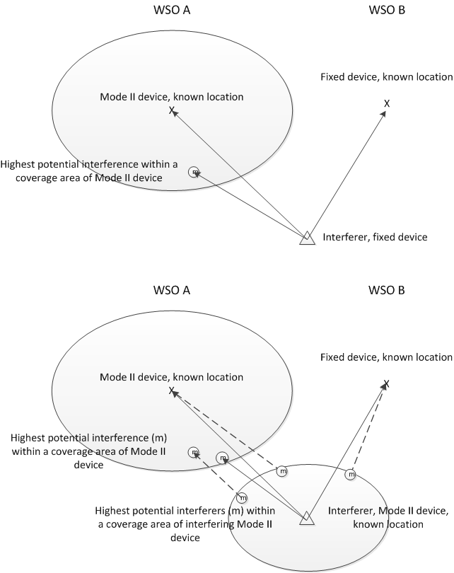
Figure 2: An example of interference spectrum density estimation to a Mode II network (WSO A) and fixed device (WSO B), when interferer is either a fixed device or a network formed by Mode II device

Interaction between CMs
Once a CM has received information from the CDIS about potential interferers of a WSO it serves, the CM may analyze further whether the potential interferer is really capable of interfering the WSO the CM serves. When the potential interferer is served by another CM, the CM shall conduct a CoexistenceSetElementInformationAnnouncement message exchange with the other CM to acquire more information about the potential interferer and to announce the existence of interference situation to the other CM.

