IEEE P802.19  
Wireless Coexistence

|  |  |  |  |  |
| --- | --- | --- | --- | --- |
| Mobility Information for the Coexistence Management System | | | | |
| Date: 2013-01-16 | | | | |
| Author(s): | | | | |
| Name | Company | Address | Phone | email |
| Golnaz Farhadi | Fujitsu Labs of America | 1240 E. Arques Avenue M/S 345, Sunnyvale, CA 94085, USA | +1-408-530-4510 | gfarhadi@us.fujitsu.com |
| Tsuyoshi Shimomura | Fujitsu Labs. Ltd. | 3-2-1 Sakado, Takatsu-ku, Kawasaki, Kanagawa, Japan | +81-44-8749066 | tcsimomura@jp.fujitsu. com |

Abstract

This contribution provides motivations and use cases on how the mobility information can help with more intelligent decision making for resource allocation and how to incorporate this mobility information with relevant procedures and messages defined in the IEEE 802.19.1 draft DF3-02 related to the comments 36-55 in the LB document #12-024r4.

**Motivation**

**Notice:** This document has been prepared to assist IEEE 802.19. It is offered as a basis for discussion and is not binding on the contributing individual(s) or organization(s). The material in this document is subject to change in form and content after further study. The contributor(s) reserve(s) the right to add, amend or withdraw material contained herein.

Consider the following scenarios

1. Spectrum handoff for the mobile WSO:

WSOs may require switching to another channel or frequency range as they move. This is because the white space spectrum availability depends on the time and the location. At a given instant of time, the channel available at the current location may not be available at the next location. Hence, spectrum handoff is required to avoid interference to the primary users.

1. Recourse reconfiguration for the neighbor WSOs:

Switching to another operating frequency by the mobile WSO may conflict with the other co-located WSOs in the neighborhood of the mobile WSO in its next location. In another scenario, the mobile WSO may not change its operating frequency for its next location. However, the same channel or frequency band may be allocated to another WSO in the interference range of mobile WSO in its next location(s) beforehand. In these cases, the CM needs to reconfigure the resources for these WSOs in order to avoid interference between and among these networks. These reconfigurations not only incur the signaling overhead to notify the new resources but more importantly impose spectrum handoff for these fixed WSOs.

The mobility information enables coexistence decisions that not only avoid frequent the spectrum handoff for the mobile WSOs but also reduce reconfiguration of resources (and hence overhead) for the colocated fixed WSOs. Consequently, the coexistence management system can achieve more seamless connectivity and better user experience.

**Mobility Information Parameters**

WSO mobility information parameters may include an option for mobility state (maxSpeed), WSO speed/ direction, or the WSO route.

MobilityInformation :: = CHOICE{

maxSpeed REAL, --km/h

}

**Use Cases**

Some of the use cases that can benefit from the mobility information parameters are given in the following:

* ***How does “maxSpeed” of WSO help?*** 
  + The CM can calculate an area around the mobile WSO based on the “maxSpeed” value. This enables the CM to allocate channels (or frequency ranges) that cover the surrounding area of the mobile WSO as large as possible.
  + The maxSpeed may also indicate the mobility state as whether e.g. low, moderate, or high mobility. This mobility state can help the CM to find the WSOs that may be co-located with the the mobile WSO in its location(s). Thereby, the CM may avoid assigning   the same frequency bands already allocated to the moving WSO. This, in turn, reduces reconfiguration for the other fixed WSOs which would be otherwise needed to avoid interference with the moving WSO. Figure 1 shows an example coexistence decision algorithm using the WSO mobility information.

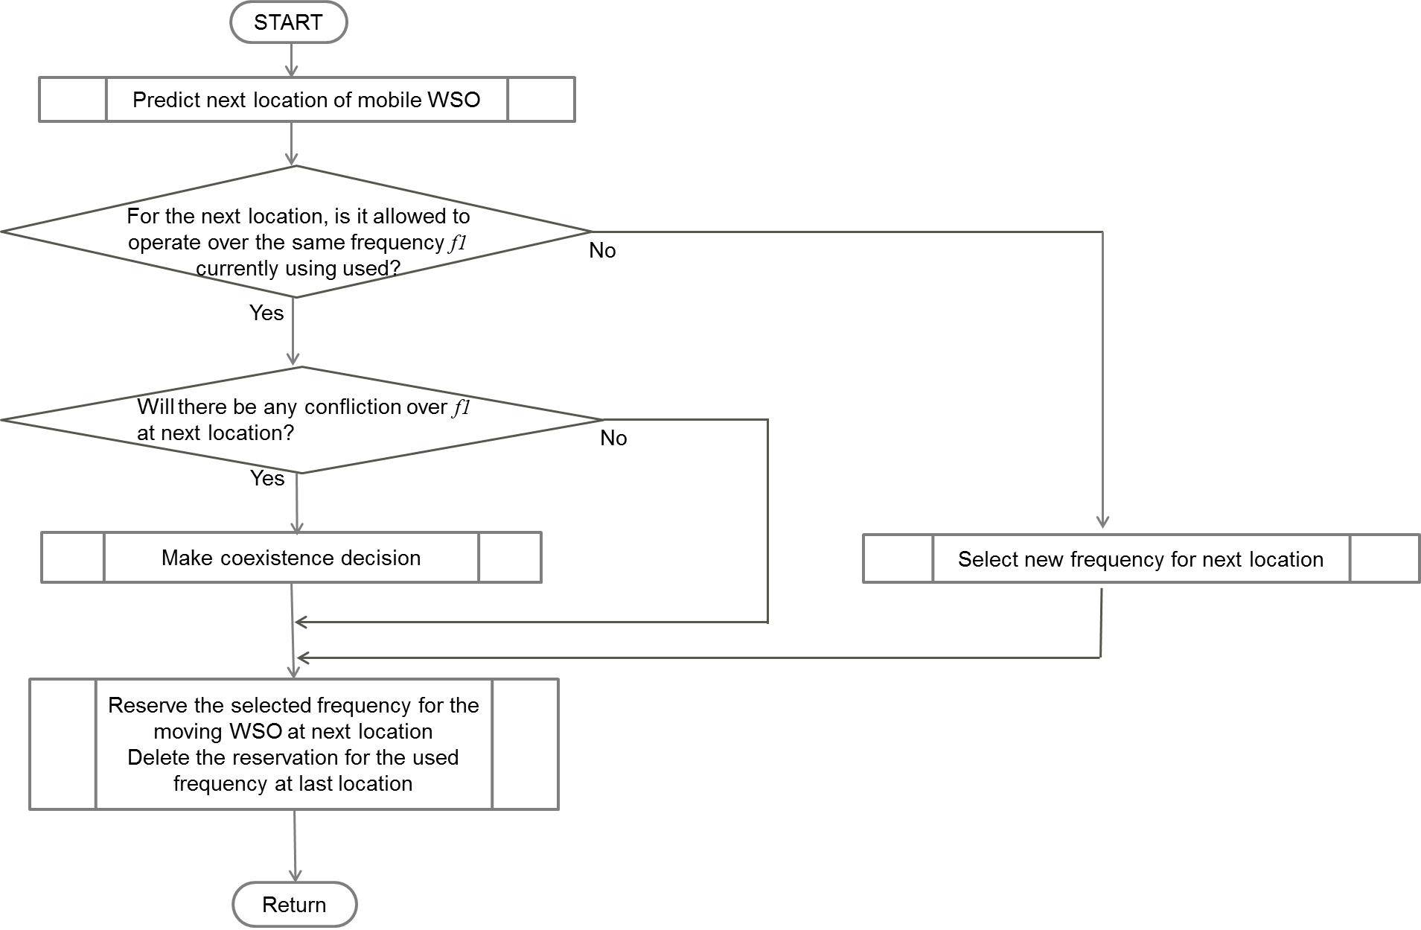

Figure 1. An example of the coexistence algorithm for the mobile WSO (The processing of “Make coexistence decision “ and “Select new frequency for next location” may use similar algorithms in subclause 10.4.1 and 10.4.2 of the current draft.)

The following example further illustrates this use case

* + - Figure 2 shows 5 networks with network 1 as the mobile WSO. The networks 1, 2 and 3 are in the interference range of each other. The mobile WSO at its next location will interfere with networks 4 and 5. It is assumed the channels “a”, “b”, “c”, “d” are available at the current location while channels “a”, “b”, “e”, “f” at the next location. Suppose that network 1 require 2 channels and the other networks 1 channel. Having the knowledge of the mobile WSO information, the CM allocates
      * For current time t_0
        + Net 1: a, b 🡪 reserve “a, b” to be used for the next location
        + Net 2: c
        + Net 3: d
        + Net 4: e 🡪 avoid scheduling in “a” or “b” (even if they might have better quality)
        + Net 5: f 🡪 avoid scheduling in “a” or “b”
      * For next location of the network 1 where we have networks 1, 4, 5:
        + each network will continue to operate over the channels assigned previously @t_0 without any handoffs.



Figure 2. A mobile WSO neighboring with networks 2 and 3 in its current location and with networks 4 and 5 in its next location.

* ***How does more detailed mobility information such as speed/direction or WSO route help?*** 
  + More detailed mobility information (or equivalently the WSO route as location per time) will help the CM to make more precise decisions on 1) the frequency assignment for the mobile WSO and 2) the WSOs that might be impacted by the mobile WSO and hence better planning for their frequency assignment accordingly. Having better precision will result in higher total achievable throughput compared to the previous use case where only the maxSpeed is provided. For example, there may be fixed WSOs located in all directions around the mobile WSO. Using only the “maxSpeed” information, the CM may assume many next locations for the mobile WSO. Without knowledge of the speed/direction, the CM may overestimate the number of WSOs that might be impacted by the mobile WSO leading to a more conservative channel assignment. Furthermore, assuming a large area for the roaming of mobile WSO may limit the number of channels that the CM can allocate to the mobile WSO in order to achieve seamless connectivity.
* ***How does mobility information help with decision making at WSO (instead of CM)?*** 
  + One other use case for having mobility information (e.g. maxSpeed or speed&direction/route) is that the CM may provide additional information in the coexistence report e.g. on the neighbor WSOs that might be mobile or the channel tags on the available channels for the mobile WSO ( e.g. Primary tag to indicate whether a channel or a frequency range remains available for WSO next location). This can help with WSO decision making on what channels to use so as to i) reduce spectrum handoffs by choosing the appropriate operating channels based on the channel tag information and ii) achieve an efficient coexistence management by sharing of the channels with primary tags among multiple mobile WSOs.

**Realizations in IEEE 802.19.1**

The mobility information may be realized in coexistence decisions scenarios where all networks are subscribed to one CM or different networks to different CMs. For the latter case where multiple CMs are involved, the message passing between the CMs may be carried out as specified in the current draft. This may be done by including the channel(s) or frequency range(s) reserved for the mobile WSO in the message exchanged between the CMs.

**Mobility Information Update**:

The location of the WSO may change but the mobility information may not. The update for the mobility information can be at least as often as the location update from the WSO to the CM based on the current draft. In addition, according to FCC rules, a Mode II personal/portable device may load channel availability information for multiple locations around, *i.e.*, in the vicinity of, its current location and use that information in its operation

For example, the mobility information may be updated at least every 60 seconds, if mobility information changed. Then, if the mobile WSO changes speed or direction in the meantime, the update information enables highly accurate estimation for the next location.

**Mobility Information Parameters in IEEE 802.19.1**

It is proposed to include the definition of MobilityInformation data type in the IEEE 802.19.1 draft as defined above. WSO mobility information is optional and may be used in the following primitives and messages

* in registration response (and updates) from WSO to CE and consequently CE and CM registration requests
  + resolutions to comments 36-39 and 48, 49

GetRegInfo.response (

networkID,

networkTechnology,

networkType,

mobilityInformation,

deviceRegulatoryID,

deviceSN,

availableChannelsInfo,

constOfChUses,

discoveryInformation,

ACLR,

ACS,

guranteedQoSOfBackhaulConnection,

listOfSupportedResources,

minTxPower,

txScheduleSupported,

networkTechnologyReconfigurationSupported,

addNetworkTechnology,

listOfOperatingResources,

radioEnvironmentInformation,

requiredResource,

measurementCapability,

status

)

The mobility information parameter data type and description to be added to Table 15 as defined above.

NewRegInfo.indication (

networkID,

networkTechnology,

networkType,

mobilityInformation,

availableChannelsInfo,

constOfChUses,

discoveryInformation,

ACLR,

ACS,

guranteedQoSOfBackhaulConnection,

listOfSupportedResources,

minTxPower,

txScheduleSupported,

networkTechnologyReconfigurationSupported,

addNetworkTechnology,

listOfOperatingResources,

radioEnvironmentInformation,

measurementCapability,

requiredResource

)

The mobility information parameter data type and description to be added to Table 17 as defined above.

CERegistrationRequest ::= SEQUENCE {

-- Indicates whether this is new registration or registration update

operationCode OperationCode,

-- Network identifier, e.g., BSS ID

networkID OCTET STRING,

-- Network technology, e.g., 802.11af, 802.22

networkTechnology NetworkTechnology,

-- Network type, e.g., fixed, mode 2

networkType NetworkType,

-- Regulatory ID of the WSO, e.g. FCC ID

-- WSO mobility information

mobilityInformation MobilityInformation, OPTIONAL

deviceRegulatoryID OCTET STRING,

-- Serial number of the WSO

deviceSN OCTET STRING,

-- Information about available white space resources

availableChannelsInfo AvailableChannelsInfo,

-- Information for discovery

discoveryInformation DiscoveryInformation,

-- Adjacent channel leakage ratio of the TVBD device

aCLR REAL,

-- Adjacent channel selectivity of the receiver

aCS REAL,

…

}

CMRegistrationRequest ::= SEQUENCE {

-- Maximum number of controllable WSOs

maximumNumberOfControlableWSO INTEGER,

-- The geo-location of the CM

geolocationCM Geolocation,

-- The coverage radius of the CM in meters

coverageRadiusCM REAL,

-- Indicates whether this is new registration, registration update,

-- or deletion of WSO

operationCode OperationCode,

-- CE identifier to which this message applies

ceID CxID,

-- Network identifier, e.g., BSS ID

networkID OCTET STRING,

-- Network technology, e.g., 802.11af, 802.22

networkTechnology NetworkTechnology,

-- Network type, e.g., fixed, mode 2

networkType NetworkType,

-- WSO mobility information

mobilityInformation MobilityInformation, OPTIONAL

-- Information for discovery

discoveryInformation DiscoveryInformation,

-- Adjacent channel leakage ratio of the WSO device

aCLR REAL,

-- Adjacent channel selectivity of the receiver

aCS REAL,

-- Guaranteed QoS of backhaul connection in the WSO device

guarQoSOfBackhaulConnection GuaranteedQoSOfBackhaulConnection,

-- List of supported resources: channel numbers or frequencies

listOfSupportedResources CHOICE {

-- List of supported channel numbers

listOfSuppChNumber ListOfSupportedChNumber,

-- List of supported frequencies

listOfSuppFrequencies ListOfSupportedFrequencies },

-- Measurement capability of the WSO

measurementCapability MeasurementCapability

}

* in resource reconfiguration requests from WSO and CE
  + resolutions to comments 40, 41, and 50:

ResourceReconfiguration.request (

networkType,

geolocation,

mobilityInformation,

newOperatingResource,

maximumPowerLevel,

desiredOccupancy

)

The mobilityInformation parameter data type and description to be added to Table 32 as defined above.

ResourceReconfigurationRequest ::= SEQUENCE {

-- WSO type

wsoType WSO_TYPE,

-- Registered geolocation

geolocation GEO_LOC,

--WSO mobility information

mobilityInformation MobilityInformation, OPTIONAL

-- New operating resource: channel number or frequency range 21

newOperatingResource CHOICE { ….

….

}

…

}

* in information request and response
  + resolutions to comments 42, 43, 51, 52

ReqInfoDescrElement ::= ENUMERATED {

sinr,

desiredBandwidth,

desiredOccupancy,

desiredQoS,

desiredCoverage,

channelNumber,

mobilityInformation,

subscribedService

...

}

ReqInfoValueType ::= CHOICE {

sinrValue REAL,

desiredBandwidthValue REAL,

desiredOccupancyValue REAL,

desiredQoSValue REAL,

desiredCoverageValue REAL,

channelNumberValue REAL,

mobilityInformation MobilityInformation,

SubscribedServiceValue SubscribedService

otherValue ANY

}

ReqInfoDescr ::= SEQUENCE OF ENUMERATED{

sinr,

desiredBandwidth,

desiredOccupancy,

desiredQoS,

desiredCoverage,

channelNumber,

mobilityInformation,

subscribedService,

interferenceLevel,

fairness,

threshold,

…

}

ReqInfoValue ::= SEQUENCE OF SEQUENCE{

reqInfoDescr ReqInfoDescr,

reqInfoValue CHOICE {sinrValue REAL, desiredBandwidthValue

REAL, desiredOccupancyValue REAL, desiredQoSValue REAL, desiredCoverageValue REAL, channelNumberValue REAL, mobilityInformation MobilityInformation, interferenceLevelValue REAL, fairnessValue REAL, thresholdValue REAL, otherValue ANY}

subscribedService SubscribedService

}

The coexistence management system may request from the WSO its mobility status and hence measurement is not required (withdrawing comments 42-47, 53-55).