IEEE P802.19
Wireless Coexistence
Why to Change Radio Environment Information Description?
Date: 2012-12-12
Author(s):
Name | Company | Address | Phone | email
Jari Junell | Nokia | Otaniementie 19, 02150 Espoo, Finland | +358-718036575 | jari.junell@nokia.com
Mika Kasslin | Nokia | Otaniementie 19, 02150 Espoo, Finland | +358-718036294 | mika.kasslin@nokia.com
Abstract
This document contains explanatory description of radio environment information use. This is a follow-up contribution to discussion on proposed changes to the coexistence protocol messages and related data types in one of the recent TG1 teleconferences.
Notice: This document has been prepared to assist IEEE 802.19. It is offered as a basis for discussion and is not binding on the contributing individual(s) or organization(s). The material in this document is subject to change in form and content after further study. The contributor(s) reserve(s) the right to add, amend or withdraw material contained herein.

Case Description
Let’s assume two cases shown in figures, 1X and 2X, which are similar from the WSO_A point of view, but otherwise they are different.
The CE_A registers to CM1 which gets from the CDIS the coexistence set (CS) of the WSO_A. The CDIS informs the CM1 about the CS of the CE_A. It informs also those CMs which serve CEs which belong to the CS of the CE_A. Thus also CM2 and CM3 receive the CS information from the CDIS.
The CMs, which serve CEs that have interference relationship with the CE_A, exchange information with the CM1.

Radio Environment Information Content

Current Definitions
Main information delivered from the CE_A point of view as per the current draft is as follows:
- CDIS to CM
  - Coexistence set (CS): CE_B, CE_D (these are coexistence set elements)
  - CMs serving the coexistence set elements and their contact info
  - Technology used by the WSOs of the coexistence set elements
  - Estimate of interference level between WSO_A - WSO_B, WSO_A - WSO_D and direction/type
- CM to CM
  - Some general data (in form of reqInfoValue) about the CE_B and the CE_D by their CMs to the CM1
  - Supported frequencies of the CE_B and the CE_D to the CM1
  - Operating resources of the CE_B and the CE_D to the CM1
  - WSO capabilities of the CE_B and the CE_D to the CM1 Note! Description of this information is incomplete in the current draft since there is no data type definition.
  - Subscribed service of the CE_B and the CE_D to the CM1

The Proposal
We propose the following information to be made available for each CM in the exemplary case with focus on the CE_A:
- CDIS to CM
  - As of today
- CM to CM
  - As of today Except that the WSO capabilities need to be defined
Additionally, we propose the following new information to be made available
  - Coexistence set of the CE_B and the CE_D
    - Allocations and technology
  - CM contact info for those coexistence set elements
  - Other environment information like non 802.19.1 networks/occupancy and free frequency locations
The proposal means in practice the following:
- WSO capabilities are defined while the definition is missing in the current draft
- The CM1 (management service) or the WSO_A (information service) knows whether the WSO_B and the WSO_D able to interfere each other
- The CM1 (management service) or the WSO_A (information service) knows limitations of the WSO_B and the WSO_D (WSO_C, WSO_E, unknown network)

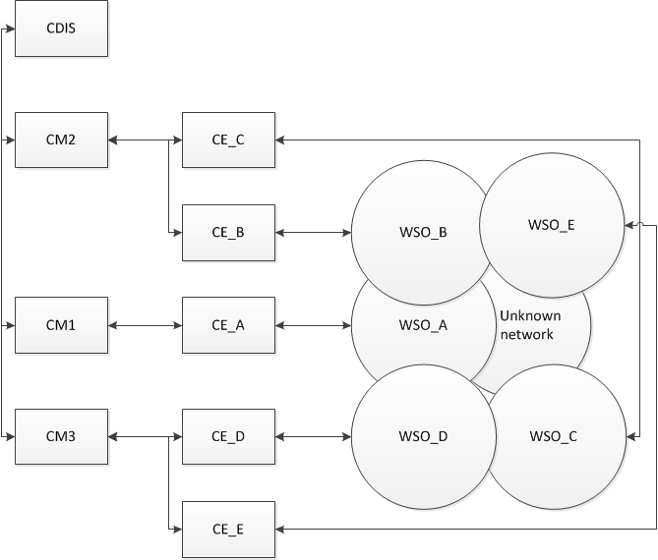
Figure 1: Case 1X

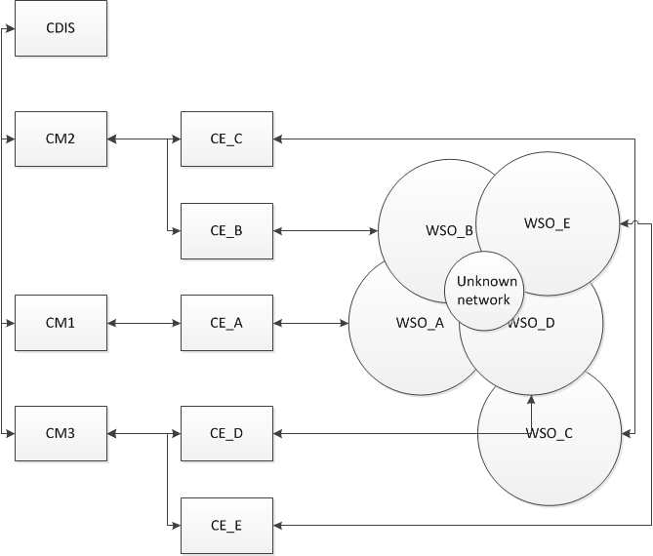
Figure 2: Case 2X

