IEEE P802.19
Wireless Coexistence
Frequency range notation
Date: 2013-01-14
Author(s):
Name | Company | Address | Phone | email
Tsuyoshi Shimomura | Fujitsu Labs. Ltd. | 3-2-1 Sakado, Takatsu-ku, Kawasaki, Kanagawa, Japan | +81-44-8749066 | tcsimomura@jp.fujitsu. com
Golnaz Farhadi | Fujitsu Labs of America | 1240 E. Arques Avenue M/S 345, Sunnyvale, CA 94085, USA | +1-408-530-4510 | gfarhadi@us.fujitsu.com
Jari Junell | Nokia | Otaniementie 19, 02150 Espoo, Finland | +358-718036575 | jari.junell@nokia.com
Mika Kasslin | Nokia | Otaniementie 19, 02150 Espoo, Finland | +358-718036294 | mika.kasslin@nokia.com
Abstract
This document contains proposed modifications to frequency range notation in section 6.5.

Discussion
Notice: This document has been prepared to assist IEEE 802.19. It is offered as a basis for discussion and is not binding on the contributing individual(s) or organization(s). The material in this document is subject to change in form and content after further study. The contributor(s) reserve(s) the right to add, amend or withdraw material contained herein.

Some WSOs may use frequency only based on the channelization of original TV channel, others may not. For example, 802.11af and 802.15.4m support the usage of a partial TV channel and/or multiple channels. Using the information of detailed channel configuration which each WSO supports, a CM may allocate frequency resource more efficiently. This kind of WSO capabilities can be included by revising current definition of ListOfSupportedFrequencies.

In a summary, “ListOfSupportedFrequencies” needs to include following information,
- Each frequency range the WSO is supporting. Usually this is a list of all non-contiguous bands
- Each bandwidth the WSO is supporting in a given frequency range. There are two possibilities in bandwidth information: the true signal BW or the minimum space the signal requires to operate (channel bandwidth). At least the channel bandwidth has to be given.
- The combination of channels for aggregation the WSO is supporting.
- Minimum channel raster by which the devices in the WSO are able to fine tune the location in the spectrum. This raster can be e.g. the min resolution of the synthesizer in the device or min specified step size defined in the radio standard used by the WSO.

Proposal

Revise the definition of “ListOfSupportedFrequencies” as follows,

ListOfSupportedFrequencies ::= SEQUENCE OF SEQUENCE {
-- The frequency borders of each possible sub band or channel
supportedFrequency FrequencyRange,

-- Extra channel configuration (subchannelization or channel aggregation) supported or not
extrachannelizationIsSupported BOOLEAN,

-- Extra channel configuration description
extrachannelizationDescription ExtraChannelizationDescription OPTIONAL
}

FrequencyRange ::= SEQUENCE {
startFreq REAL,
stopFreq REAL
}

extraChannelizationDescription ::= SEQUENCE{

-- Maximum number of channels supported in channel aggregation
maxNuCH INTEGER,

--Min channel raster for fine tuning of frequency
minChRaster REAL OPTIONAL,
-- Maximum supported bandwidth per channel
maxCHBW REAL,

-- Minimum supported bandwidth per channel
minCHBW REAL,

-- Resolution for additional channel bandwidth between minCHBW and maxCHBW
resolutionSBW REAL,

-- Offset of the start frequency in the case of maxCHBW
offsetFreqMaxCHBW REAL,

-- Offset of the start frequency in the case of minCHBW
offsetFreqMinCHBW REAL,

-- Offset always based on the Primary Channelization or not
OffsetPerPrimaryChannelization BOOLEAN
}

Appendix
Informative illustration for explaining the above parameters.

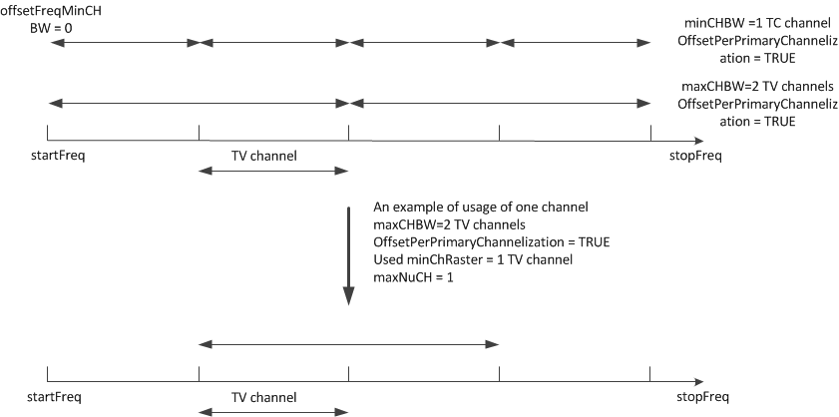

Fig1. Support of Channel binding

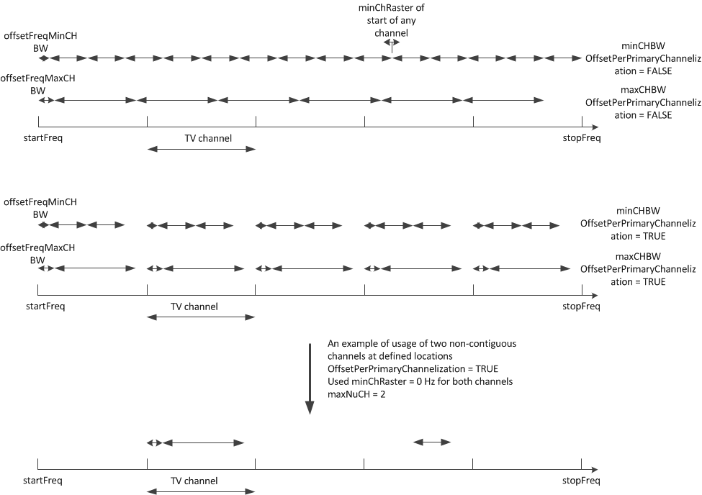
Fig. 2 support of channel aggregation

