IEEE P802.19
Wireless Coexistence
Frequency range scaling step definition for channel allocation
Date: 2012-11-14
Author(s):
Name | Company | Address | Phone | email
Golnaz Farhadi | Fujitsu Labs of America | 1240 E. Arques Avenue M/S 345, Sunnyvale, CA 94085, USA | 1-408-530-4510 | gfarhadi@us.fujitsu.com
Tsuyoshi Shimomura | Fujitsu Labs Limited
Abstract
This document is a submission to IEEE 802.19 TG1 proposing resolution to comment CID#137 of the Letter Ballot IEEE 802.19-12-0204r0 to clause 6.5 on specifying the minimum frequency range unit for the supported frequencies.
Notice: This document has been prepared to assist IEEE 802.19. It is offered as a basis for discussion and is not binding on the contributing individual(s) or organization(s). The material in this document is subject to change in form and content after further study. The contributor(s) reserve(s) the right to add, amend or withdraw material contained herein.

CID | Comment | Category | Page Number | Subclasue | Line Number | Proposed change
68 | The minimum scaling step for the supported frequencies should be specified. | Technical | 38 | 5.3.2 | 10 | Revise the definition of "ListOfSupportedFrequencies" as follows,  ListOfSupportedFrequencies ::= SEQUENCE OF SEQUENCE {  frequencyRange FrequencyRange,  scalingStep REAL, --kHz  }
137 | The minimum scaling step for the supported frequencies should be specified. | Technical | 93 | 6.5 | 32 | Revise the definition of "ListOfSupportedFrequencies" as follows,  ListOfSupportedFrequencies ::= SEQUENCE OF SEQUENCE {  startFreq REAL,  stopFreq REAL,  scalingStep REAL, --kHZ  }

Discussion

The CM may allocate only a slice of its supported frequency to a WSO under its subscription. Alternatively, the WSO may choose a channel slice out of its available channels to operate. The minimum frequency unit supported, (i.e. resolution), should be specified in the draft.
For example, the basic unit of TVWS usage in Japan is a segment with bandwidth 428.6 kHz. A WSO may use one segment or several segments. Some WSOs can adaptively use different numbers of segments. For example, multiple WSOs can share a single TV channel based upon frequency division multiplexing access (FDMA). Therefore, how a WSO can efficiently indicate its supportable frequency range is a problem to be resolved. This problem can be resolved by adopting
- a new “MinimumFreqUnit” parameter which indicates the frequency range resolution.
- an optional “CarrierFreqOffset” parameter which indicates the offset to the center frequency of the band (i.e. (StopFreq – StartFreq)/2).
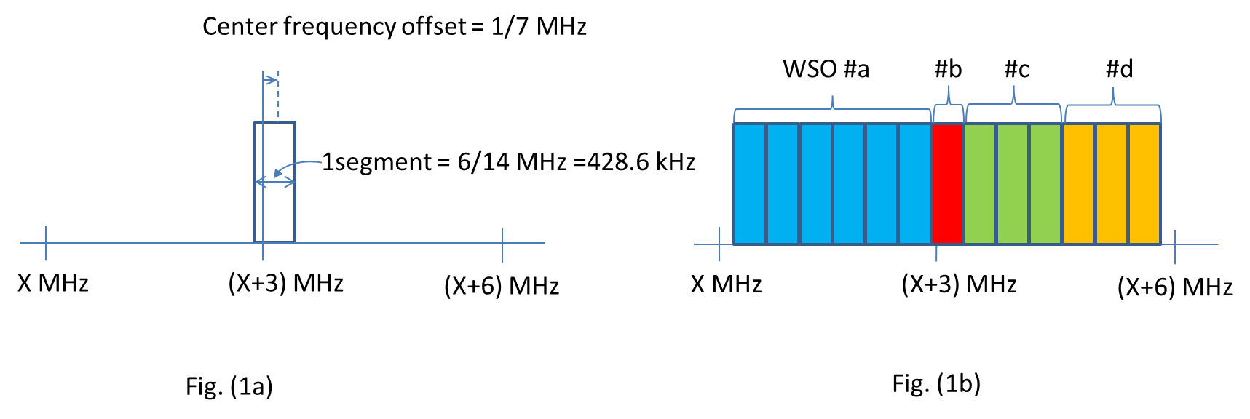
Use Case
In Japan, 13 segments can be used in a TV channel of 6MHz (Fig. (1a) and (1b)). To indicate that a WSO is capable to use from 1segmaent to 13 segments in a frequency range from X to X+6 MHz, the following expression is required under current specification draft.

{
{X+offset, X1+offset},{ X1+offset, X2+offset},,,,{X12+offset, X13+offset},
{X+offset, X2+offset},{X1+offset, X3+offset},,,,{X11+offset, X13+offset},
{X+offset, X3+offset},{X1+offset, X4+offset},,,,{X10+offset, X13+offset},
{X+offset, X4+offset},{X1+offset, X5+offset},,,,{X9+offset, X13+offset},
{X+offset, X5+offset},,,,,,
{X+offset, X6+offset},,,,,,
{X+offset, X7+offset},,,,,,
{X+offset, X8+offset},,,,,,
{X+offset, X9+offset},,,,,,
{X+offset, X10+offset},,,,,,
{X+offset, X11+offset}, {X1+offset, X12+offset},{X2+offset, X13+offset},
{X+offset, X12+offset},{X1+offset, X13+offset},
{X+offset, X13+offset}
}
where X(i+1) = X(i) + 0.4286 for i=1,…, 13.

In order to reduce the overhead, we propose the following:
{X (MHz), X+6 (MHz), 428.6 kHz, offset}
where
X : start frequency
X+6 : stop frequency
428.6 : MinimumFreqUnit
Offset : CarrierFreqOffset

Proposed resolution

It is proposed to revise the definition of "ListOfSupportedFrequencies" as follows,

ListOfSupportedFrequencies ::= SEQUENCE OF SEQUENCE {
StartFreq REAL,
StopFreq REAL,
MinimumFreqUnit REAL, --kHZ
CarrierFreqOffset REAL, --kHz, Optional
}

