IEEE P802.19
Wireless Coexistence
A coexistence decision algorithm proposal
Date: 2011-11-09
Author(s):
Name | Company | Address | Phone | email
Jari Junell | Nokia | Itämerenkatu 11-13, 00180 Helsinki, Finland | +358-718036575 | jari.junell@nokia.com
Mika Kasslin | Nokia | Itämerenkatu 11-13, 00180 Helsinki, Finland | +358-718036294 | mika.kasslin@nokia.com
Päivi Ruuska | Nokia | Visiokatu 1, 33720 Tampere, Finland | +358-718035433 | paivi.m.ruuska@nokia.com
Abstract
This document is a submission to IEEE 802.19 TG1 about coexistence decision algorithms. The proposed solution is independent on the resource allocation algorithm. Several different algorithms may be used, but this decision making procedure gives an unambiguous and consistent result. Fairness in the context of the coexistence decisions is defined and the reasoning why it is very important in this kind of environment to attract WSOs to join the coexistence system and to accept the outcomes of coexistence decisions.

THIS IS AN INTERMEDIATE VERSION RELEASED FOR A PRESENTATION ON THE ALGORITHM DURING THE NOVEMBER 2011 PLENARY MEETING. THE FINAL ONE WILL BE DELIVERD LATER.
Notice: This document has been prepared to assist IEEE 802.19. It is offered as a basis for discussion and is not binding on the contributing individual(s) or organization(s). The material in this document is subject to change in form and content after further study. The contributor(s) reserve(s) the right to add, amend or withdraw material contained herein.

The contribution has two main sections from which the first one (Background information) discusses the reasons behind the proposal. The second section (Text proposal for the candidate draft) contains text that is being proposed to be incorporated into the latest candidate draft. The section contains some instructions to the technical editor to facilitate the editing work.

1 Background information
The latest candidate draft contains a set of alternative coexistence decision algorithms for CM implementations. We believe there is not an algorithm that is designed to work effectively in situations with spectrum scarcity.

2 Text proposal for the candidate draft

Editorial instruction: Have the following sub-sections added to the section 9 under the sub-section 9.4 and update the figure numbering as appropriate.

9.4.7 Algorithm H
9.4.7.1 Introduction
This is algorithm H for coexistence decisions in a CM that builds upon a basic concept according to which serves both a white space object (WSO) registered to it and the other WSOs in the WSO’s coexistence set. The CM shall make coexistence decisions on those WSOs that are subscribed to the management service. Those WSOs that are subscribed to the information service are taken into account in the coexistence decisions but for them coexistence decisions are not made.
This decision making algorithm has been designed to be effective in the situations with scarcity of spectrum. As a part of the algorithm the CM estimates whether the resource allocation outcome to the WSO and to the elements of its coexistence set meets the fairness criterion. This algorithm is based on the Coexistence Value (CV) parameter and considers fairness in the coexistence decisions on the WSO and the coexistence set elements (CSEs). The design is intended to avoid a WSO to take resources of another WSO even if it is not eligible to those resources. Similarly the algorithm is designed to avoid a WSO to keep too many resources when other WSOs are lacking resources. This algorithm also generates slowness to resource changes in the environment.
9.4.7.2 The main flow of decision making
Figure 1 is a high level illustration of the algorithm in form of a flow diagram. The flow starts when the CM identifies a need for a new resource allocation for a WSO registered to it and subscribed to the coexistence management service. First, the CM shall check availability of any free channels from the WSO’s environment information data and coexistence set elements. The CM shall allocate a free channel to the WSO, if it satisfies the needs of the WSO. If free channels are not available or they don’t satisfy the needs of the WSO, the CM shall continue either to the resource advertisement or to full resource allocation analysis.
The CM may proceed to the resource advertisement procedure, if the WSO has already resources. In the resource advertisement procedure the CM clarifies availability of suitable resources advertised by the coexistence set elements. The CM borrows a resource for the WSO, if a suitable one is found. Otherwise the CM shall continue to the final step in the resource allocation flow, which is resource allocation analysis to the coexistence set. The actual resource allocation change may be allowed to only some elements of the coexistence set.
The CM makes a resource allocation analysis to the coexistence set. For some members of the coexistence set the CM is allowed to make changes in resource allocation. The concept of Coexistence Value (CV) is used in this context. The CV illustrates a measure of WSO’s eligibility to resources and the CM shall use it in the coexistence decision algorithm to assess eligibility of the WSO to the new resources. This coexistence decision algorithm is presented in the following sub-sections.

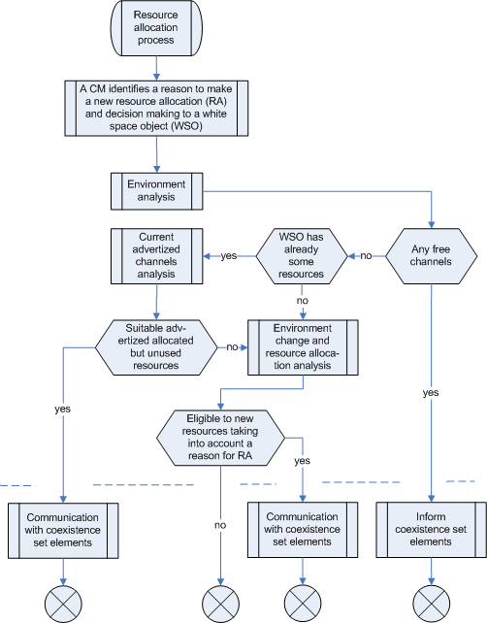

Figure 1: An example of resource allocation process with decision making

9.4.7.3 Advertisement procedure
TBD

9.4.7.4 Coexistence value

Coexistence value (CV) parameter defines a measure, which is used within a coexistence set to evaluate the coexistence set elements’ eligibility to resources. Coexistence values are absolute values, all which are normalized to available resources within the coexistence set in the decision making procedure. The CV parameter value is based on three parameters: 1) number of nodes in the network managed by the WSO, 2) the relation between the resources allocated to the WSO, and the resources used by the WSO, and 3) a possible regulatory preference. The WSO’s resource usage shall be represented with a channel utility value and a regulator priority value. The first two parameters are evaluated over a certain period to get slowness into a change rate of a CV value.
There is defined a time period Ts over which both the peak node number and channel utility value are evaluated. There are two other time periods: T1 including N1 Ts periods, and T2 including N2 Ts periods, see e.g. figure 2. From both periods, T1 and T2, the average values of node number and channel utility value are stored. T1 represents short time period dynamic part and T2 represents long term historic part. They are used in the calculation of CV.
A coexistence value is formulated as follows: CV = F1*F2*F3, where
- F1 is an average mapped node number calculated from formula (a*c1+b*c2)/(a+b)
  - a = b = 1 (weighting factors)
  - c1 = average mapped node number over all Ts periods within a period T1
  - c2 = average mapped node number over all Ts periods within a period T2
  - mapped node number = 0.2 (if number of nodes is 1), N-1 (if number of nodes N is 2,3,…,11) and 10 (if number of nodes N is >11)
- F2 is an average mapped utility value with respect to allocated resources calculated from formula (d*g1+b*g2)/(d+e)
  - d = e = 1 (weighting factors)
  - g1 = average mapped channel utility value of Ts over a period T1
  - g2 = average mapped channel utility value of Ts over a period T2
  - mapped channel utility value = 0.4 (between channel utility value of 0-0.3), 1 (between channel utility value of 0.8-1), linearly changing between 0.4 to 1 (between channel utility value of 0.3-0.8). Transmission buffer full is always full channel utility.
- F3 is a possible regulatory preference to a certain service. If no preferences are defined, then F3 is 1.
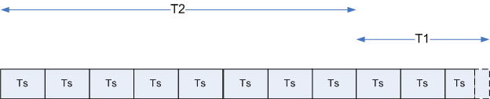
Figure 2: An example of relationship between Ts, T1 and T2

9.4.7.5 The decision making procedure
The decision making procedure is divided into two parts
- CM preliminary decision making based on the result of resource allocation algorithm. The actual resource allocation algorithm is not defined here. The decision making algorithm is only interested in its outcome. Several resource allocation algorithms may be applied in this context.
- Final decision making based on the outcome of preliminary decision making and trigger of resource allocation process
Figure 3 illustrates a principal flow of resource allocation analysis. A CM calculates resource allocations to a coexistence set in the extent defined by the services. The fairness of the outcome is tested in decision point 1. If a fair solution has been found, then the process moves directly to the final decision making. Otherwise depending on the used resource allocation algorithm a possibility to another configuration alternative in a resource allocation calculation in checked. If such alternative is available, the same procedure is repeated. Otherwise the second decision point is entered. There the best resource allocations, which failed the fairness test, are checked again and based on the outcome a preliminary solution is either found or not. With this result the process moves to the final decision making.
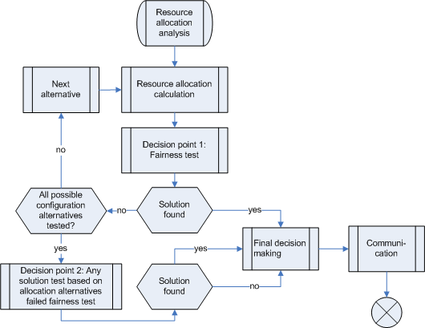
Figure 3: An illustrative example of resource allocation calculation and decision making

The preliminary decision making takes following parameters as input:
- Coexistence set and white space object
- Resource allocation proposal from resource allocation algorithm
- Requested and existing resource(s)
- Entitlement to resources: Coexistence values (CV)
The main steps in a preliminary decision making, decision point 1, are:
- Coexistence set elements have the amount of resources they requested/currently have => a fair solution (as itself)
- Otherwise calculate if a fair solution is met in a resource allocation proposal
The calculation of a fair solution has the following steps:
- For each WSO within a coexistence set is calculated a quality factor value (and normalized), which is a ratio of the allocated resources to a value that represents the amount of resources to which the coexistence user is entitled to. The resource entitlement value is represented by a coexistence value (CV)
- Two values are calculated from these normalized quality factor values
  - Spread, e.g. a variance
  - Max width, e.g. difference of extremes
- A fair solution: a sum of the spread factor and square of the width factor is less than a pre-defined threshold defined as follows:
ε < σ² + Δ², where
  - σ² = variance of normalized quality factor values
  - Δ² = max difference between normalized quality factor values
  - R_{i} = planned resource allocation of a WSO i
  - CV_{i} = Coexistence value of a WSO i
  - Quality factor q of network i = R_{i} / CV_{i}
  - Normalization value nv = Σ(R_{i} /CV_{i} )
  - Normalized quality factor value for network i = q_{i}/nv
Decision point 2 checks the existence of any solution, if a fair solution is not found. The closest to fair allocation is chosen to be the solution for checking the type of communication of a result. After decision point 2 the procedure moves to the final decision making.
The final decision making is illustrated in Figure 4. As an input it gets the outcome of the preliminary decision making, parameters related to preliminary decision making such as its input parameters and quality factor values, and a trigger, which initiated the resource allocation calculation. The possible outcomes of preliminary decision making and triggers for resource allocation are listed below.
- Outcome of the preliminary decision making
  - Fair solution
  - A solution from failed fairness test
  - No solution
- Trigger for resource allocation
  - Request for excess resources
  - A new WSO
  - Appearance of incumbent in a channel used currently by a WSO
  - Unknown increase of interference
  - Other
The CM shall make a decision, to whom and what are communicated from the final decision making, which is based on the inputs presented above. The outcome criterion of the final decision making is shown below:
- Excess resource as a trigger
  - Fair solution & requesting WSO gets more resources: Communicate the resource allocation to CMs of coexistence set according to the conflict handling procedure
  - A solution from failed fairness test & accepted revised check & requesting WSO gets more resources: Communicate the resource allocation to CMs of coexistence set
  - Other cases: Inform requesting WSO that it is not eligible to new resources
- Other causes as a trigger
  - Fair solution or any solution from failed fairness test: Communicate the resource allocation to CMs of coexistence set
  - No solution: Inform WSO that no solution is found
The accepted revised check is done when a fair solution is not found and the trigger has been an excess resource need by a WSO. It takes into account all coexistence set elements, which are not satisfied to resource allocation proposal, i.e. there resource allocation is less than the current one. The revised check is accepted, if in all these cases the normalized quality factor value is more than an average.

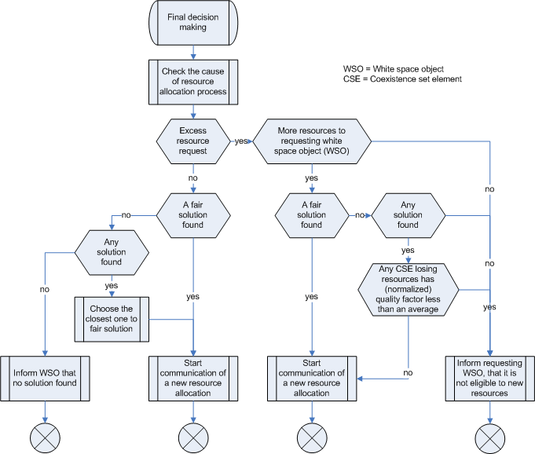
Figure 4: The flow to make the final decision and related communication

