IEEE P802.19
Wireless Coexistence
Comparison of Different Neighbor Discovery Methods
Date: 2011-08-30
Author(s):
Name | Company | Address | Phone | email
Jari Junell | Nokia Research Center | Itämerenkatu 11-13, 00180 Helsinki, Finland | +358-718036575 | jari.junell@nokia.com
Mika Kasslin | Nokia Research Center | Itämerenkatu 11-13, 00180 Helsinki, Finland | +358-718036294 | mika.kasslin@nokia.com
Abstract
This document is a submission to IEEE 802.19 TG1 about neighbor discovery. This is a continuation to the discussion about neighbor discovery with focus on simulation results.
Notice: This document has been prepared to assist IEEE 802.19. It is offered as a basis for discussion and is not binding on the contributing individual(s) or organization(s). The material in this document is subject to change in form and content after further study. The contributor(s) reserve(s) the right to add, amend or withdraw material contained herein.

Introduction

This document presents simulations results of neighbor discovery between two networks using 3 different methods. Also a simple simulation of sensitivity to propagation model error is presented. This document is a continuation to discussion presented in documents IEEE 802.19-11/0005r1 by AmeriSys and InterDigital, IEEE 802.19-11/0051r0 by Nokia and IEEE 802.19-11/0064r0 by NICT.
First, a short explanation of the 3 different methods is given. Then, the simulation setup is presented and finally simulation results with conclusions are drawn.
Methods for neighbor discovery
There have been discussions about 3 methods, which could be used for neighbor discovery. An area method is explained shortly in IEEE 802.19-11/0051r0. There a communication range of a known fixed or TVBD II device is defined as well as an interference range of the network. Decision criterion for neighborhood is that the communication range of one network overlaps with communication plus interference range of another network.
A modified area method is as the area method except that the communication area is reduced by a certain percentage. Therefore the networks have to be closer to each other to be deemed as neighbors.
A statistical method proposed by NICT is explained in IEEE 802.19-11/0064r0. There for each network separation a CDF is produced using several samples of uniformly distributed TVBDs (in each sample one random TVBD in each network within a communication range). A predefined confidence value from CDF is taken as a received power level.
At each chosen separation distance between the known TVBD (fixed, Mode II) of both networks a decision is made based on the criterion of each method. For simulation purposes 5000 “true” TVBD position cases are generated based on the uniform distribution in a polar coordination (1, 5 or 20 random TVBDs in each network). The highest received power level between these two networks is calculated according to positions of TVBDs in networks in each case. These two networks are neighbors if it is above the interference limit value otherwise not. These results are compared to the decisions in each method and match, false alarm and missed detection ratios are calculated. Match means that the outcome of “true” case and the decision are equal (neighbor, not neighbor).
Simulation setup
The purpose of this simulation setup is to analyze differences between the methods proposed by Nokia and NICT. The three methods that were simulated and analyzed are as follows:
- Area method (define the communication and interference areas around the known Mode II/fixed TVBD)
- Modified area method (define the communication and interference areas around the known Mode II/fixed TVBD. The areas of communication ranges are reduced by a certain percentage to improve the decision match to imitated real locations. 10 and 25% are used in simulations)
- Statistical method (generate CDF at each simulated distance difference between two known TVBD positions by generating one random location to both networks 100 times and calculating the received signal strength in each case. From this set of received signal strength values take the 90% value as a reception value)
The simulation setup builds upon the following principles:
- Both networks are using omnidirectional antennas
- Both networks are transmitting at the same power level: 100 mW
- Center frequency is fixed to 700 MHz (error in communication and interference ranges of other center frequencies is not considered in this document. If attenuation exponent is fixed, then for the same received power level required distance separation is directly comparable to center frequency.)
- Sensitivity level for reception is -88 dBm (see NICT document IEEE 802.19-11/0064r0)
- Interference level limit is 3 dB above the noise level (NF = 10 dB)
- Bandwidth of the signal is 5 MHz
- Propagation model is L (r) = 10log (4πr/λ)^{α} (excluding the antenna height term), alpha = 2.6 in the first setup
- The received power level is Prx_b = Ptxmax_a + Gt_a(θ_B) + Gr_b(θ_A) – L(r between a and b)
- Two networks are put in a straight line at different distances: a starting point is well beyond the neighborhood limit and an end point is well within the neighborhood limit, see the figure below.
- At each distance the simulation is repeated 5000 times using uniformly distributed TVBD locations (number of randomly located TVBDs in each network either 1 or 5 or 20) within a communication range around the known TVBD location.
  - If any received power level in a single simulation is above the interference level limit, two networks are considered as neighbors
  - Simulations results are compared to decisions of all three methods and match, false alarm and missed detection values are generated. Note that each simulation imitates a sample of “true” TVBD locations. Only uniform distribution is used within a communication range.
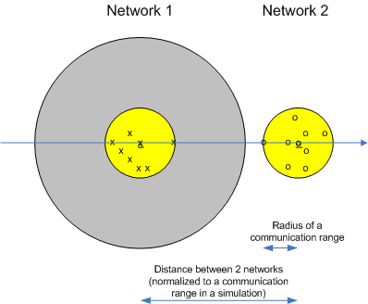
Figure: Setup for simulations, where networks 1 and 2 have identical parameters. Therefore it is enough that the neighborhood is defined from network 2 perspective. The same result applies other way round. Communication ranges are shown to both networks and interference range to only network 1.
Another simulation setup is also made, where the sensitivity of above results to alpha in propagation model is checked.
Simulation results
Nine different plot sets are presented, each plot set having one plot with area reduction of 10% and another of 25%. The plot sets are
- Match probability as a function of distance between two known TVBD locations in two networks. Curves for three methods and 1 random TVBD (+known location TVBD)
- False alarm probability as a function of distance between two known TVBD locations in two networks. Curves for three methods and 1 random TVBD (+known location TVBD)
- Missed detection probability as a function of distance between two known TVBD locations in two networks. Curves for three methods and 1 random TVBD (+known location TVBD)
- Match probability as a function of distance between two known TVBD locations in two networks. Curves for three methods and 5 random TVBDs (+known location TVBD)
- False alarm probability as a function of distance between two known TVBD locations in two networks. Curves for three methods and 5 random TVBDs (+known location TVBD)
- Missed detection probability as a function of distance between two known TVBD locations in two networks. Curves for three methods and 5 random TVBDs (+known location TVBD)
- Match probability as a function of distance between two known TVBD locations in two networks. Curves for three methods and 20 random TVBDs (+known location TVBD)
- False alarm probability as a function of distance between two known TVBD locations in two networks. Curves for three methods and 20 random TVBDs (+known location TVBD)
- Missed detection probability as a function of distance between two known TVBD locations in two networks. Curves for three methods and 20 random TVBDs (+known location TVBD)

The figure below shows the match probabilities as a function of distance between two networks (case 1). It can be seen that area and modified area methods give very low match probability in a separation range of about -3.7…-1.7 * communication range. Statistical method gives much better result. The match probability of modified area method in a certain region is improving when increasing the reduction percentage from 10 to 25.
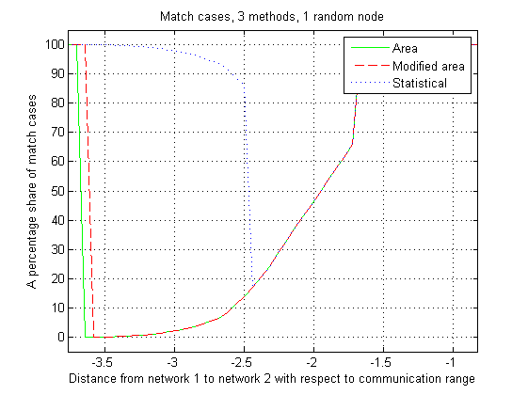
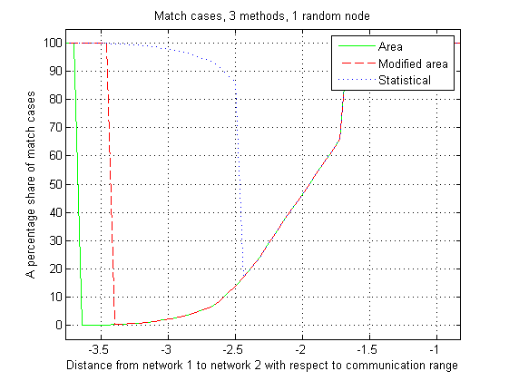
The figure below shows the false alarm probabilities as a function of distance between two networks (case 2). It can be seen that the bad result of area and modified area methods in a certain separation range between networks is caused by a high false alarm rate. This means that these methods make conservative neighborhood estimation. The false alarm probability of modified area method in a certain region is improving when increasing the reduction percentage from 10 to 25.
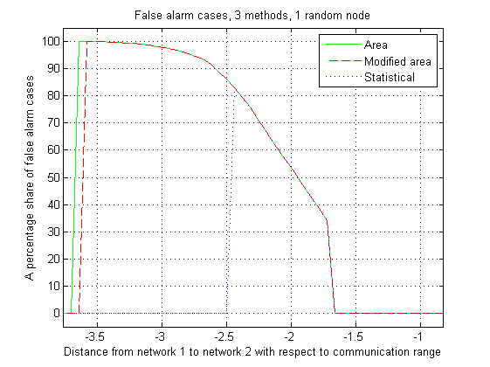
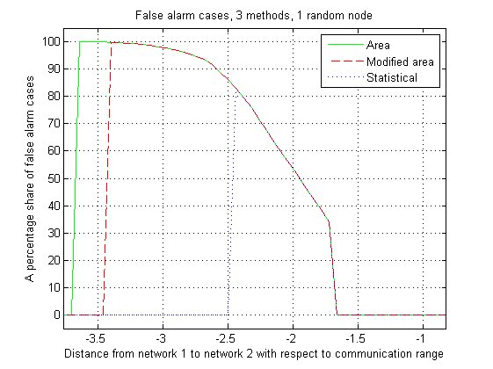
The figure below shows the missed detection probabilities as a function of distance between two networks (case 3). It can be seen that area and modified area methods have no missed detections, which is understandable against the conservative approach. Statistical method has missed detections. The area reduction from 10 to 25% has no effect on missed detection probability in a modified area method.
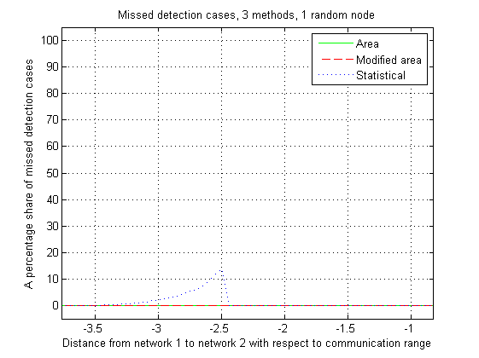
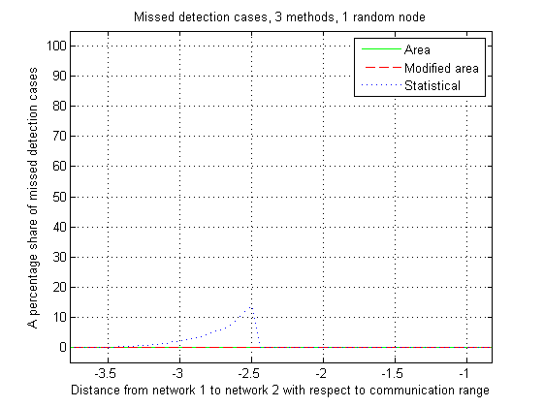
The figure below shows the match probabilities as a function of distance between two networks (case 4: 5 random nodes). It can be seen that area and modified area methods improve match probability compared to case 1. In the contrary the result of a statistical method is deteriorating. The match probability of modified area method in a certain region is improving when increasing the reduction percentage from 10 to 25.
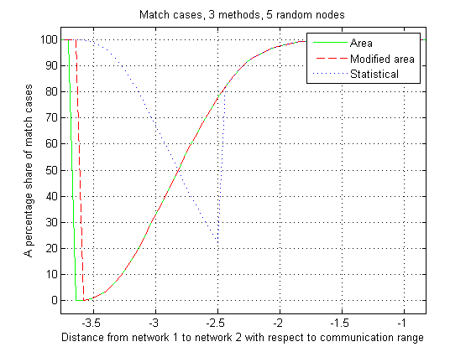
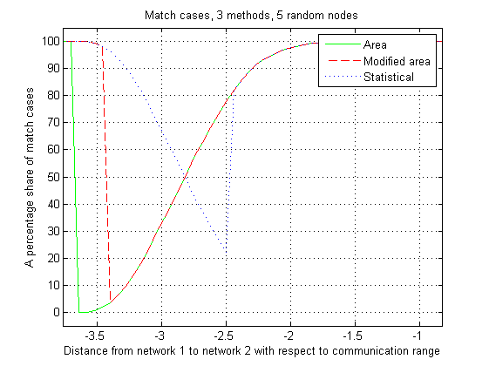
The figure below shows the false alarm probabilities as a function of distance between two networks (case 5). When increasing number of random TVBDs in a network, it can be seen, that there is a great improvement in a false alarm rate of all methods. The false alarm probability of modified area method in a certain region is improving when increasing the reduction percentage from 10 to 25.
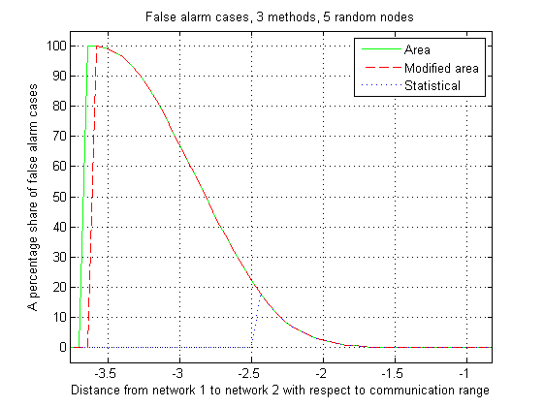
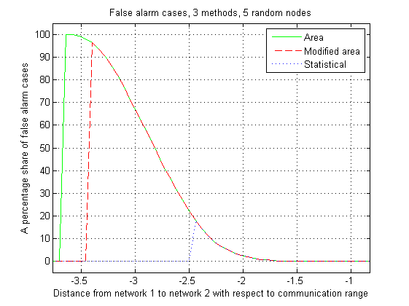
The figure below shows the missed detection probabilities as a function of distance between two networks (case 6). It can be seen that area and modified area methods have no missed detections, which is understandable against the conservative approach. The missed detection probability of a statistical method is deteriorating compared to case 3 (1 random TVBD vs. 5 random TVBDs). There is only very small increase in a small range of missed detection probability for modified area method, when increasing the area reduction from 10 to 25%.
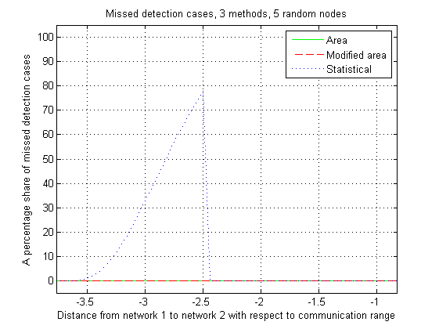
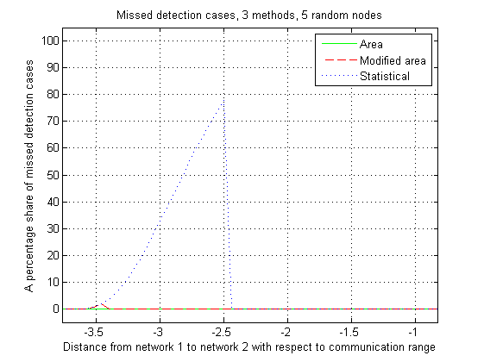
The figure below shows the match probabilities as a function of distance between two networks (case 7: 20 random nodes). It can be seen that area and modified area methods improve still match probability compared to case 4. A statistical method is now the worst one. The match probability of modified area method in a certain region is improving when increasing the reduction percentage from 10 to 25.
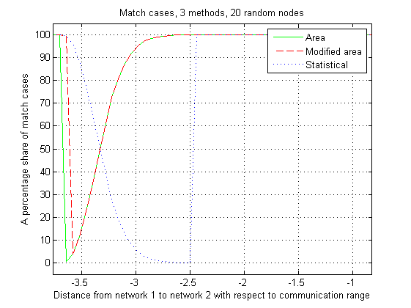
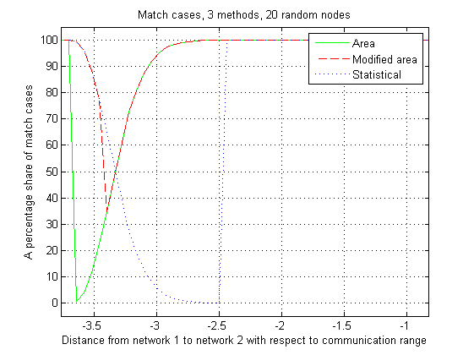
The figure below shows the false alarm probabilities as a function of distance between two networks (case 8). When increasing number of random TVBDs in a network, it can be seen, that there is a great improvement in a false alarm rate of all methods. Actually in this simulation there were no false alarms for statistical method. The false alarm probability of modified area method in a certain region is improving when increasing the reduction percentage from 10 to 25.
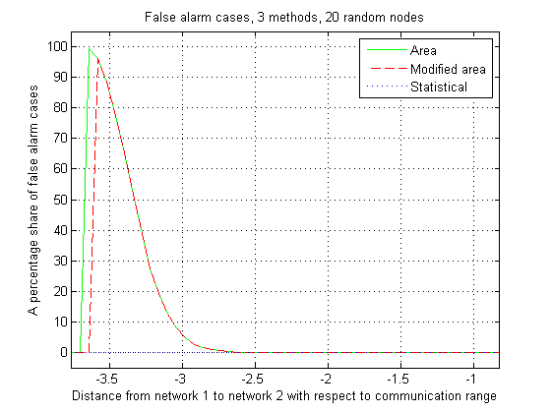
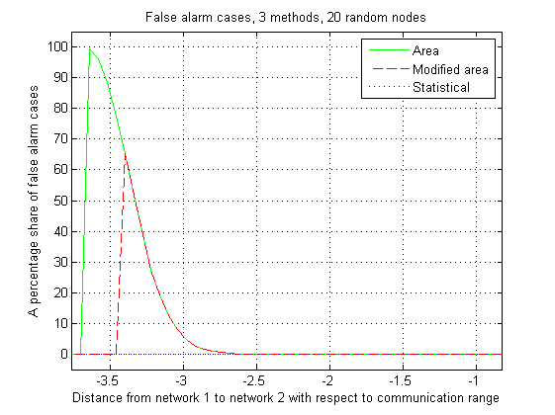
The figure below shows the missed detection probabilities as a function of distance between two networks (case 9). It can be seen that area and modified area (in one point very small missed detection probability) methods have no missed detections, which is understandable against the conservative approach. The missed detection probability of a statistical method is deteriorating compared to both earlier cases. The deterioration becomes bigger when increasing the reduction percentage from 10 to 25% in a modified area method.
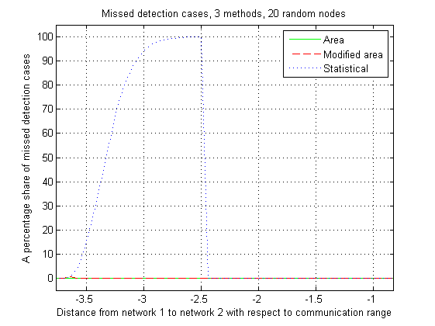
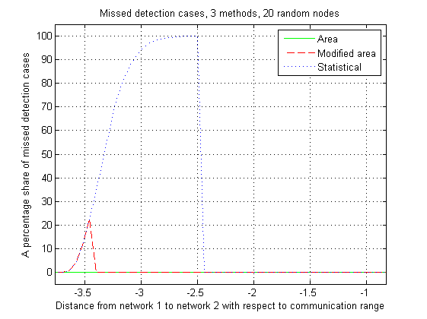
Conclusions
- As a natural conclusion there is a transition range between two networks, where the neighborhood is changed from never a neighbor case to always a neighbor case.
- Statistical method gives better match results in a transition range compared to area methods when the number of random TVBDs is very low, but it turns to be other way round at higher number of random TVBDs
- Area methods do not have any missed detection cases except when in a modified area method both the number of TVBDs and area reduction percentage is high. This guarantees that there is a communication link to a potential neighbor networks which can be released if by measurements the true neighborhood cannot be verified after the neighborhood definition.
- Statistical method has quite high missed detection probabilities at certain separation ranges. It is difficult to identify unidentified true neighbors later.
The effect of a wrong alpha value in a propagation model to results
The earlier simulations are expecting that the propagations models are perfect (at least propagation model gives the same attenuation at the border of a communication range). One can also draw a conclusion from the earlier simulations that transition range from the totally no neighbor case to always neighbor case is between about 1.7…3.7 times the communication range.
The following simulations show, how the change of alpha in a propagation model (there could be also different kind of propagations models) effects on the attenuation and via that information to location of a transition range.
The following two figures show the cases, where
- There are 3 different alpha value attenuation curves
- Each curve attenuates until the border of communication range (worst case), then it is expected that there is a TVBD which will transmit back thus increasing the interference further away from the known TVBD location.
- Red line shows the transition range of each alpha value.
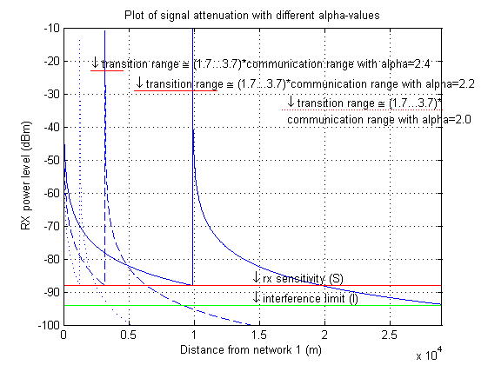

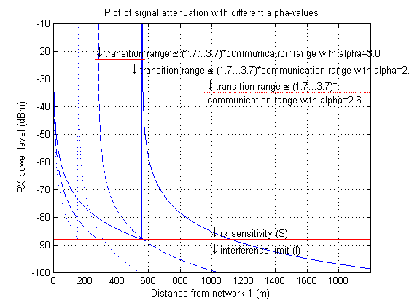
Conclusions:
- If there is even a moderate error in alpha of a propagation model, then the above results are not at all valid. As can be seen in the first figure, the transition ranges do not even overlap each other. In the second figure there is a small overlap.
- The method itself does not matter so much (take the most simple one), because there is always error in a propagation model.
- It is better to take a conservative approach to an alpha of a propagation model because it is easier to drop neighbors (having information of possible neighbors and have a communication link) than to add them (measure an unknown network, how to identify it and make a communication link with it).
- All information is helpful to make a choice of an alpha value
  - Indoor/outdoor
  - Height of a transmission antenna
  - Urban/suburban/rural
- Propagation measurement information in different environments, and propagation models derived from those measurements, would be very helpful to understand the propagation especially at
  - Low power transmitters
  - Indoor
  - Low HAAT values

