IEEE P802.19
Wireless Coexistence
TVBD Neighbor Discovery Algorithm Examples
Date: 2011-05-11
Author(s):
Name | Company | Address | Phone | email
Jari Junell | Nokia Research Center | Itämerenkatu 11-13, 00180 Helsinki, Finland | +358-718036575 | jari.junell@nokia.com
Mika Kasslin | Nokia Research Center | Itämerenkatu 11-13, 00180 Helsinki, Finland | +358-718036294 | mika.kasslin@nokia.com
Abstract
This document is a submission to IEEE 802.19 TG1 about TVBD neighbor discovery. We hope to have this topic to be in the agenda of TG1 now on until we have in the TG1 agreement on the procedures.
Notice: This document has been prepared to assist IEEE 802.19. It is offered as a basis for discussion and is not binding on the contributing individual(s) or organization(s). The material in this document is subject to change in form and content after further study. The contributor(s) reserve(s) the right to add, amend or withdraw material contained herein.

Introduction

This document deals with some principles of neighborhood in TVWS and discusses a potential way to determine which TVBDs are neighbors of a TVBD. Now on in this document the process of determining neighboring TVBDs of a TVBD is called TVBD neighbor discovery. Previously this topic has been discussed in document IEEE 802.19-11/0005r1 by AmeriSys and InterDigital.
First we need to define what we mean with neighbors in this context. Two TVBDs are neighbors if they both can interfere with each other or even if only one can interfere the other. We don’t, however, always know locations of TVBDs but only the Mode II and Fixed device locations are known; Mode I device locations are not known. Similarly we can’t expect many Mode I devices to use the coexistence system services but for the IEEE 802.19.1 coexistence system the TVBDs that are using the services of the coexistence system via CEs are Mode II or Fixed devices. But we need to have means to take into account in neighbor calculations also the Mode I TVBDs even if they are not connected to the coexistence system and their location is not necessarily known.
In the case the TVBD that uses the coexistence system services serves Mode I TVBDs the system design needs to be such that it estimates locations of those Mode I TVBDs and especially those locations in which they would cause most interference to other TVBDs. For those registered TVBDs that serve only other registered TVBDs for which the location is known in the coexistence system there is no need to estimate TVBD location and potential related interference.
In this document we assume that the TVBD neighbor discovery is performed by a coexistence discovery and information server (CDIS). It may, however, happen in any other entity as well as long as the performing entity has all the required information.

Input parameters from a TVBD via a CE to the TVBD neighbor discovery

Following information needs to be considered as input for neighbor discovery calculations:
- Geo-location of the Mode II or Fixed device
- Location related parameters (optional)
  - HAAT (h_{T} and h_{R})
  - Environment type: Indoor/outdoor, urban/suburban/rural, (office, home, mall, floor number …)
- Supported frequencies
- Minimum SINR for the network to operate (SINRmin)
- Noise figure (NF) or minimum receiver (RX) sensitivity (optional). A default value is used, if not given.
- Maximum transmission power Ptxmax/EIRP (see location related parameters)
- Antenna directivity D(θ, ϕ)
  - θ is an azimuth angle and ϕ is an elevation angle (implicitly included in later equation) and antenna loss La (Combination of directivity and antenna loss is antenna gain)

TVBD neighbor discovery calculations

A CDIS performs TVBD neighbor calculations for each TVBD that has been registered to it. Calculations are done in TVBD pairs and if the TVBDs under consideration serve Mode I TVBDs, the CDIS needs to estimate the worst case location of the Mode I TVBDs and base the calculations on those estimates. Only those TVBDs that have overlap in operating frequency capabilities are taken into account in the TVBD neighbor calculations. But on the other hand, actual operating frequency is not taken into account in the calculations. We don’t want to end up modifying the neighbor list every time the TVBD’s operating frequency changes.
The CDIS has also the following parameters or functions to enable calculation:
- Propagation model (L(r, x)), L is an attenuation, r is a distance between a transmitter and receiver, x is all other parameters needed to define the attenuation at distance r. The following formula can be used to evaluate the attenuation between the transmitter and receiver
L (…) = 10log (4πr/λ)^{α} – 20log(h_{T}*h_{R}),
where λ is a wavelength, α is an environment related attenuation exponential (free space = 2, otherwise higher. Environment indicator and maximum transmission power can be used to define this value).
- Interference margin Im. This value defines the limit above noise level at a receiver input of two TVBDs. Note: the actual noise level at lower frequencies. Neighborhood power level limit is a mean value around which slow fading is varying the level.
With these parameters the CDIS defines whether a TVBD and a potential Mode I device it may serve and another TVBD are mutual interferers or if only one of them is the source and the other one is a victim.
Here we haven’t considered the frequency that is used in the calculations. We shouldn’t this entirely up to the implementations since if the range of the supported frequencies is large compared to the center frequency, the outcome of the analysis may vary a lot. We wonder if the specification should give clear rules in which ones of the commonly supported frequencies the analysis should be done.

Case examples
The following simple examples are intended to illustrate how the TVBD neighbor discovery process could operate in a CDIS. The basic calculation is shown below following the Figure 1 in general.
- Find the potential neighbors based on their location and maximum transmission power and list them in each transmission power level starting from the closest one. Let’s call these neighbor candidates.
  - This submission doesn’t consider how the CDIS obtains the list of these neighbor candidates.
- Start the evaluation from the closest neighbor candidate. It is up to the algorithm to check what the case between these two networks is. E.g. first check if informed locations have overlapping communication range. If not then expand to interference ranges. Some possible scenarios are given in Figure 2 and Figure 3.
- Find the highest potential interferer location in network A to any node in network B with the interference level and vice versa. This may be evaluated from communication and interference areas of both networks and their intersection:
Prx_B = Ptxmax_A(highest interferer) + Gt_A(θ_B) + G_B(θ_A) – L(r1, r2),
where Prx_B can be either b1 or b2 and Ptxmax_A can be either a1 or a2.
- L(r1, r2) is the joint attenuation between the node at informed location of network A (B) and the most interfered node in network B (A). The link alternatives for direction from A to B according to Figure 1 can be
  - a1 → b1
  - a1 → b2
  - a1 → a2 → b2
  - a1 → a2 → b1
- The joint attenuation may have two components, where the first one is for network’s internal link and the second one between the networks (units in dB):
- L(r1) = Ptxmax + Gtx(θrx) + Grx(θtx) – SNIRmin – N; N = N0+NF
- L(r2) between the most interfering link of two networks (always the last link, the L(r1) is used only if there are two links in calculation)
- Neighborhood definition (Prx1 is an interferenceLevelToNeighbor and Prx2 is an interferenceLevelFromNeighbor):
  - Overlapping communication areas: Prx1 and Prx2 levels high, (mutual) neighbors, see Figure 2 upper part
    - As a detail if possible the information that is those TVBD devices, whose locations have been informed, within each other’s communication area?
  - Prx1 and Prx2 > Im+N (N=No+NF): (mutual) neighbors, see Figure 2 lower part
  - Prx1 and Prx2 < Im+N (N=No+NF): Not any kind of neighbors
  - Prx1 > Im+N and Prx2 < Im+N (N=No+NF): One sided neighborhood, network A is the interference source
  - Prx1 < Im+N and Prx2 > Im+N (N=No+NF): One sided neighborhood, network A is an interference victim
Prx above would be actually 10*lg (10^(Prx,calculated/10)+10^(N/10)) when measured in e.g. RSSI.
It is also worth to note that in real environments the highest interference between Mode I TVBDs is not always caused by the devices at a maximum distance from the informed location of the registered device in CDIS.

TVBD neighbor discovery outcome

The parameters provided by the CDIS as the outcome of the TVBD neighbor discovery are as follows:
- Interference direction
  - Mutual, Source, Victim
- Prx1 and Prx2

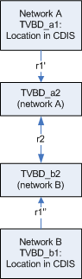
Figure 1: An illustration of TVBD neighbor calculation between two TVBDs representing two networks

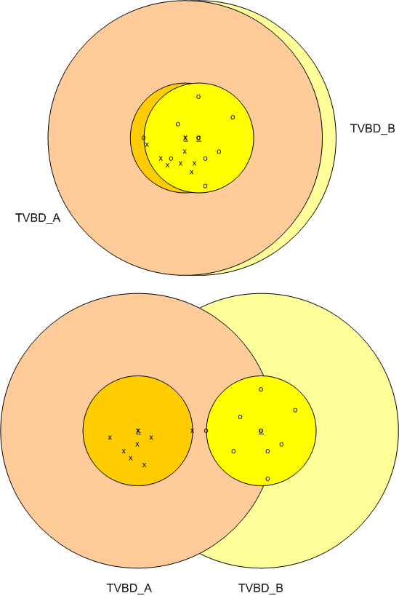
Figure 2: Examples of (mutual) neighbors case (shown both communication and interference coverage areas)

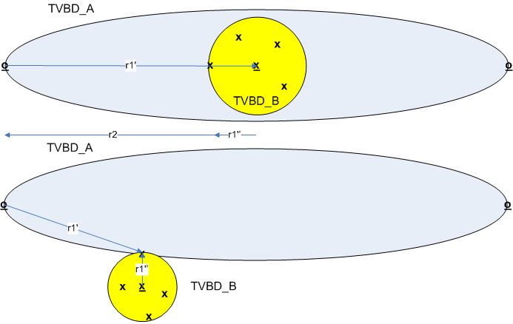
Figure 3: Examples of one sided interference case (only shown the communication coverage areas)

