IEEE P802.18  
Radio Regulatory Technical Advisory Group (RR-TAG)

|  |  |  |  |  |
| --- | --- | --- | --- | --- |
| Proposed Response to Nigeria NCC’s consultation re: the lower 6 GHz band | | | | |
| Date: 2025-08-21 | | | | |
| Author(s): | | | | |
| Name | Company | Address | Phone | email |
| Edward Au | Self | Ottawa, ON, Canada |  | edward.ks.au@gmail.com |
| Pelin Salem | Cisco Systems | San Jose, CA, United States |  | Pelin.salem@ieee.org |

Abstract

This document drafts a proposed response to an ongoing public consultation from Nigeria NCC, entitled “Regulatory Guidelines for the use of the lower part of the 6 GHz (5925 – 6425) MHz band in Nigeria”.

**Notice:** This document has been prepared to assist IEEE 802.18. It is offered as a basis for discussion and is not binding on the contributing individual(s) or organization(s). The material in this document is subject to change in form and content after further study. The contributor(s) reserve(s) the right to add, amend or withdraw material contained herein.

Electronic filing 2 September 2025

Dear Dr. Aminu Maida,

IEEE 802 LAN/MAN Standards Committee (LMSC) thanks the Nigerian Communications Commission (NCC) for issuing the consultation “Regulatory Guidelines for the use of the lower part of the 6 GHz (5925 – 6425) MHz band in Nigeria” and for the opportunity to provide feedback.

IEEE 802 LMSC is a leading consensus-based open standards development committee for networking standards that are used by industry globally. It produces standards for networking devices, including wired and wireless local area networks (“LANs” and “WLANs”), wireless specialty networks (“WSNs”), wireless metropolitan area networks (“Wireless MANs”), and wireless regional area networks (“WRANs”). Technologies produced by implementers of our standards are a critical element for all networked applications today.

IEEE 802 LMSC is a committee of the IEEE Standards Association and of Technical Activities, two of the Major Organizational Units of the IEEE. IEEE has over 460,000 members in more than 190 countries and its core purpose is to foster technological innovation and excellence for the benefit of humanity. IEEE is also a major accredited standards development organization whose standards are recognized worldwide. In submitting this document, IEEE 802 LMSC acknowledges that other components of IEEE Organizational Units may have perspectives that differ from, or compete with, those of IEEE 802 LMSC[1].

Please find below the responses of IEEE 802 LMSC to this consultation.

***It is the right time to authorize Wi-Fi devices to operate in 5925 MHz to 6425 MHz in Nigeria***

IEEE 802 LMSC commends NCC’s effort in expanding the operation of Wi-Fi devices, based on IEEE 802.11 technologies, to the 5925 MHz to 6425 MHz frequency band (a.k.a., the lower 6 GHz band). Many countries region have authorized the lower 6 GHz band for licence exempt operation at the proposed or similar transmit power limits. Adopting similar spectrum access rules will create economies of scale and produce a robust equipment market, benefitting Nigeria’s businesses, consumers, as well as increasing the societal benefits.

***Wi-Fi access to the 6425 MHz to 7125 MHz is needed to support the Gigabit connectivity***

In regards to allocation on the 6425 MHz to 7125 MHz frequency band, IEEE 802 LMSC respectfully asks NCC to reconsider its decision based on the following points. As pointed out by the proposed footnote 5.457E in the consultation, the ITU World Radiocommunications Conference 2023 (WRC-23) explicitly recognized that the 6425 MHz to 7125 MHz frequency band is used for the implementation of wireless access systems (WAS), including radio local area networks (RLANs). Many countries and regions including the USA, Canada, South Korea, and Saudi Arabia have already allocated the entire 6 GHz band (i.e., 5925 MHz to 7125 MHz band) for license-exempt operation. Availability of the entire 6 GHz band for license-exempt use will create economies of scale and produce a robust equipment market, benefitting Nigeria’s businesses, consumers, and economy, while providing societal benefits.

In January 2024, Wi-Fi Alliance introduced[2] Wi-Fi CERTIFIED 7™ based on IEEE Std 802.11be-2024 technology[3]. With Wi-Fi 7 products already in the market, Wi-Fi deployments are going through a second generation upgrade in the entire 6 GHz band globally[4]. The global 6 GHz channelization in IEEE Std 802.11be-2024 is designed to accommodate multiple 160 MHz and 320 MHz channels throughout the 5925 MHz to 7125 MHz band, if available. NCC’s current designation of 500 MHz of the 6 GHz band from 5925 MHz to 6425 MHz for license-exempt operation provides for only one 320 MHz channel, while the entire 5925 MHz to 7125 MHz band would allow three such channels to support the Gigabit connectivity in Nigeria.

With only the lower 500 MHz available for Wi-Fi, there will not be enough 80 MHz channels in the 6 GHz band to enable deployments of dense networks that will require at least 7 to 9 nonoverlapping channels. As a result, many dense Wi-Fi network deployments utilizing the 6 GHz band will still be limited to 40 MHz channels. Without larger channel sizes, gigabit speeds in WiFi connections cannot be achieved in Nigeria.

Figure 1 illustrates a 7-channel plan which minimizes co-channel interference between APs. With 500 MHz in the 5 GHz and 6 GHz bands, there are less than seven 80 MHz channels, which limits the use of those wider channels. Wider channels equate to higher throughput and lower latency.

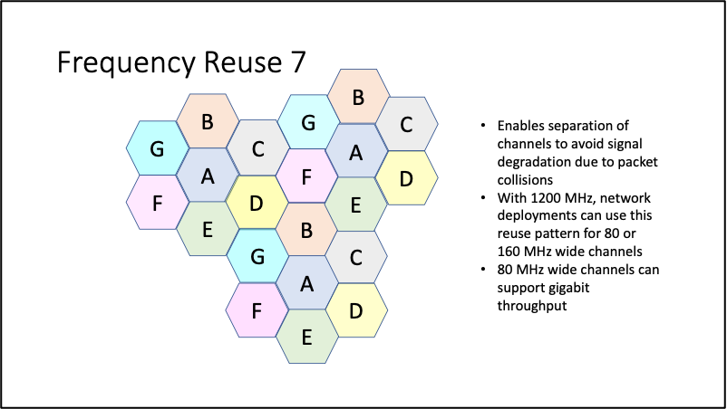

*Figure 1: Frequency Reuse 7 Channel Plan*

If RLAN were given access to the 6425 MHz to 7125 MHz band however, it would allow 80 MHz channels, but would provide seven 160 MHz channels supporting the high throughput requirements of high density networks such as those in universities, hospitals, schools and shopping centres. In addition, 1200 MHz is needed to support novel applications which would benefit from three 320 MHz channels. This includes technologies such as augmented, virtual and mixed reality, which require wider channels to ensure lower latency as recently shown by a medical school training use case demonstration[5]. Similarly, local processing of artificial intelligence workloads will require higher throughput to support the large datasets.

Additionally, with access to additional 320 MHz channels, Wi-Fi devices can build upon IEEE Std 802.11az-2022[6] to offer sub-1 meter positioning accuracy, which results in new innovative use cases such as micro-targeting for retail and warehouse asset tracking.

**Conclusion**

IEEE 802 LMSC thanks NCC for the opportunity to provide this submission and supports NCC’s regulation on the use of the lower part of the 6 GHz band. IEEE 802 LMSC respectfully requests to consider our responses to authorize license-exempt operation in the 6425 MHz to 7125 MHz band given Wi-Fi contribute significant societal, economic, and sustainability value to Nigeria.

Respectfully submitted,

By: /ss/.

James Gilb

IEEE 802 LAN/MAN Standards Committee Chairman

em: gilb_ieee@tuta.com

1. This document solely represents the views of IEEE 802 LMSC and does not necessarily represent a position of either the IEEE or the IEEE Standards Association.
2. See Wi-Fi Alliance: Wi-Fi Alliance® introduces Wi-Fi CERTIFIED 7™, <https://www.wi-fi.org/wi-fi-certified-7-resources> [accessed: 21 August 2025].
3. See “IEEE Standard for Information technology--Telecommunications and information exchange between systems Local and metropolitan area networks--Specific requirements - Part 11: Wireless LAN Medium Access Control (MAC) and Physical Layer (PHY) Specifications Amendment 2: Enhancements for Extremely High Throughput (EHT),” <https://standards.ieee.org/ieee/802.11be/7516> [accessed: 21 August 2025]. With introduction of 320 MHz channel bandwidth, Wi-Fi 7 doubles throughputs relative to Wi-Fi 6E and significantly improves latency for Extended Reality (XR), bringing determinism through enablement of Multi-Link Operation (MLO) over multiple bands in 2.4 GHz, 5 GHz, and 6 GHz bands. Wi-Fi 7 also provides higher efficiency, relative to Wi-Fi 6E, through offering of 4096 QAM. In addition, spectrum puncturing improves flexibility in utilizing spectrally efficient wide channel bandwidth, e.g., 160 MHz and 320 MHz, while protecting incumbent operation in the band.
4. 7 See Wi-Fi Alliance: Wi-Fi 7 market momentum: Wi-Fi 7 is here – is your network ready?, <https://www.wi-fi.org/beacon/chris-hinsz/wi-fi-7-market-momentum-wi-fi-7-is-here-is-your-network-ready> [accessed: 21 August 2025].
5. See Wi-Fi Alliance: Wi-Fi Alliance® demonstrates the impact of 6 GHz Wi-Fi® for advanced AR/VR in healthcare, <https://www.wi-fi.org/beacon/the-beacon/wi-fi-alliance-demonstrates-the-impact-of-6-ghz-wi-fi-for-advanced-arvr-in> [accessed: 21 August 2025]
6. “IEEE Standard for Information Technology--Telecommunications and Information Exchange between Systems Local and Metropolitan Area Networks--Specific Requirements Part 11: Wireless LAN Medium Access Control (MAC) and Physical Layer (PHY) Specifications Amendment 4: Enhancements for Positioning,” <https://standards.ieee.org/ieee/802.11az/7226/> [accessed: 21 August 2025]