IEEE P802.18
Radio Regulatory Technical Advisory Group (RR-TAG)
Comments to ISUS Document Draft
Date: 2023-01-13
Author(s):
Name | Affiliation | Address | email
Max Riegel | Nokia |  | maximilian.riegel@nokia.com
Abstract
This document contains some comments to the skeletal draft for the IEEE Standards Association (SA) position statement “Intelligent Spectrum Allocation and Management” IEEE 802.18-22/0087r5 .

Points for discussions:
- Terminology
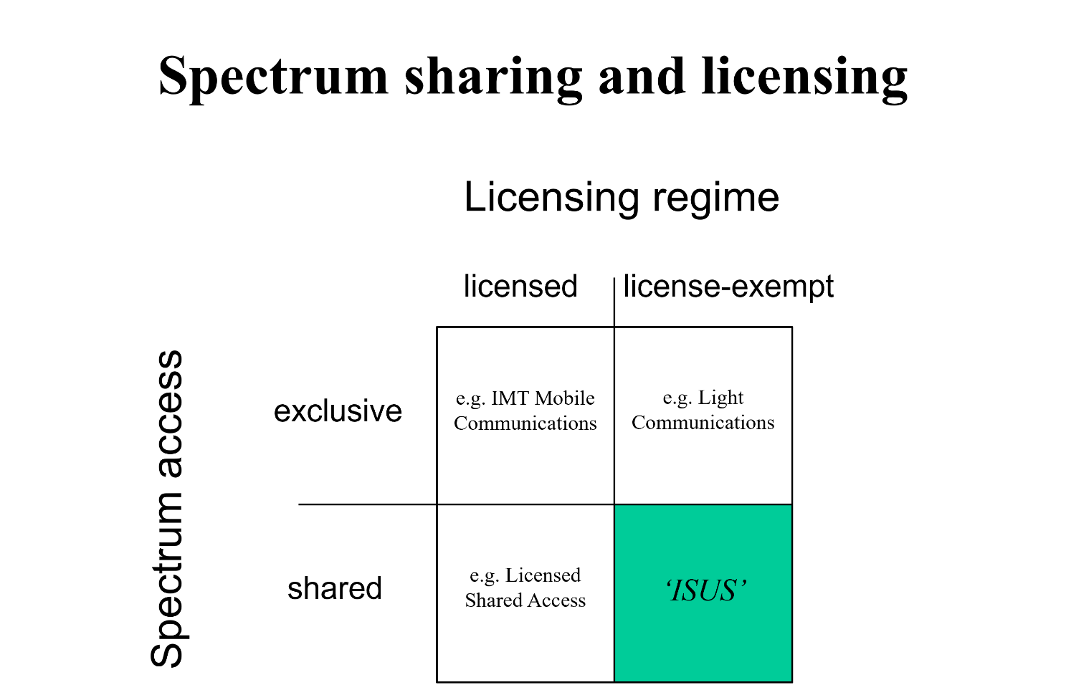

Proposal:

Use the term ‘licensed-exempt shared spectrum’ to denote the demanded allocation of additional spectrum for use by IEEE 802 technologies.

- Issues to mention in section 2 of Recommendations
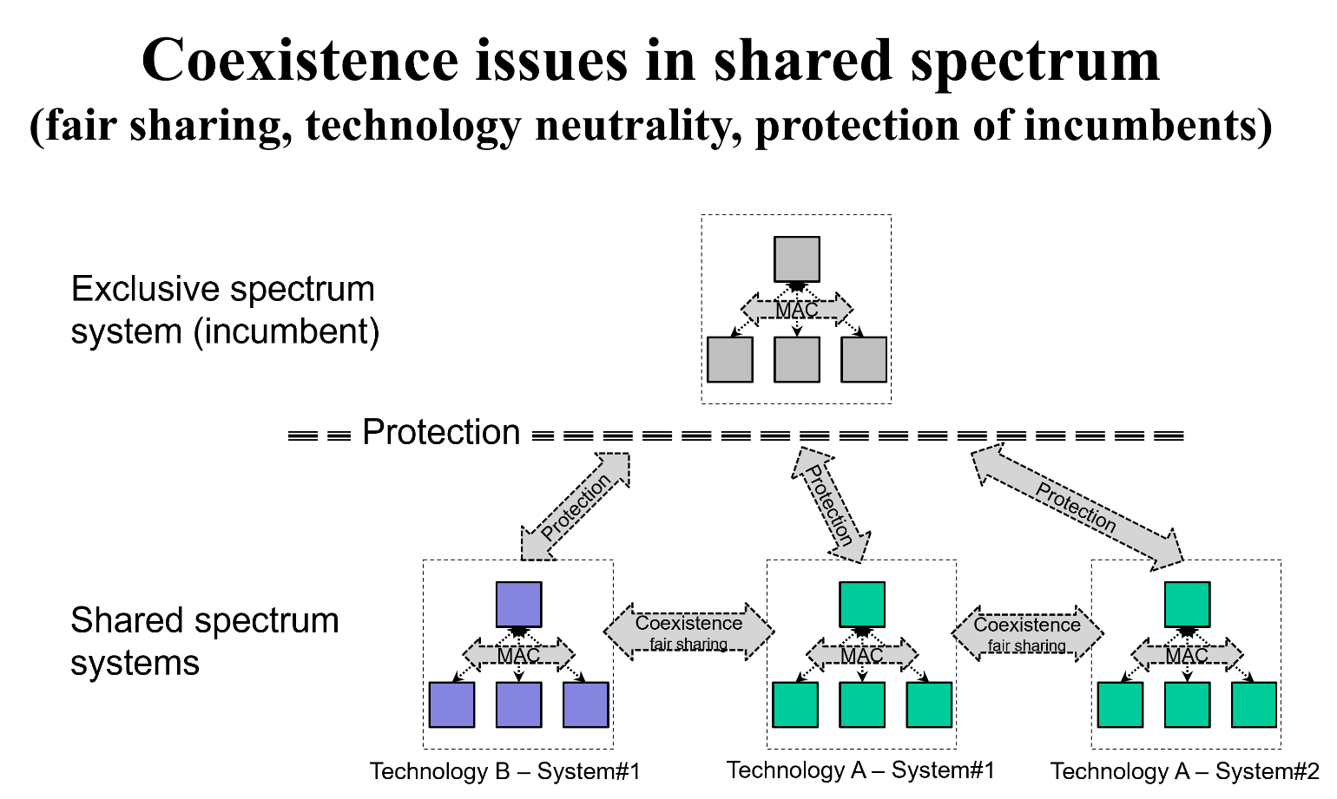

Proposal:
Consider proposed changes to section 2 of Recommendation below.

IEEE Standards Association Position Statement

Intelligent Spectrum Allocation and Management

<Introductory paragraph>
The IEEE Standards Association (IEEE-SA) is home to several of the key global technologies using license-exempt spectrum globally. The IEEE-SA, through its participants, is a major contributor to the standardization of leading wireless technologies. It supports position that spectrum allocation and management is needed for both licensed and license-exempt technologies to meet the explosive growth in wireless data demand.
<The IEEE 802 family of technologies for license-exempt shared spectrum>
IEEE-SA participants develop wireless standards for license-exempt shared spectrum such as the IEEE 802.11 Wireless LAN (WLAN) and IEEE Standard 802.15 Wireless Speciality Networks (WSN), including Ultra-Wide Band (UWB). While the former has reached wide fame under the brand-name Wi-Fi, the latter is used by numerous consortiums supporting applications ranging from sensing, to agriculture, to car keys.
<Recommendations>
1. Spectrum management, at both local, regional and global levels, should permit a multiplicity of uses and users, in so far as possible. Allocation and management strategies should be oriented towards shared spectrum, where many users are encouraged to co-exist and provide socially and economically beneficial services to communities.
2. License-exempt shared spectrum technologies are an important part of both industrial and citizen-oriented networking ecosystems world-wide today. To further increase social and economic benefits already being realized through license-exempt shared spectrum technologies, more spectrum resources should be considered for allocation to this kind of usage.
To protect fair sharing of scarce spectrum resources, technology neutrality principles, and potentially the exclusive access rights of incumbent spectrum owners, three levels of coexistence management are necessary in licensed-exempt shared spectrum allocations:

- To allow for multiple use of the same spectrum at a given location, spectrum resources are shared by same technology or even cross technology user devices in a fair fashion enabled by channel access mechanisms such as contention-based protocols.
- To enable various technologies to coexist in the same spectrum and to enable future evolution through new developments, the license-exempt shared spectrum is shared through appropriate means by different technologies such as those based on IEEE 802.11 and 802.15 and technologies developed by other organizations, like 3GPP.
- If spectrum owned by an incumbent user is underutilized, it should be made available for secondary license-exempt shared use under regulatory conditions designed in a way to safely protect the incumbent services from any harmful interference. This provides an excellent foundation for efficient spectrum utilization as it does not require re-farming of the spectrum and migration of incumbent services to other bands as spectrum is already scares.

3. In terms of global spectrum management, we want to specifically highlight that availability of the full 6 GHz band (i.e., 5925-7125 MHz) for license-exempt shared use enables deployment of new applications and services in the coming years, further increasing the societal benefits.
4. We also wish to highlight the changing conditions in the sub-1GHz bands. As previous incumbents in these bands are developing ever more effective ways of utilizing pre-existing allocations, license-exempt operation in these bands will enable a dynamic space for social and economic utility.

<History>
add more stuff? delete above?
<Current applications, increasing future applications>
Significant economic value is provided by IEEE 802 based systems today. Wi-Fi, based on the IEEE 802.11 standard, has an estimated 18 billion devices deployed world-wide, with 4,4 billion device shipments annually. The increasing use of IEEE 802.15 devices in the smartphone and consumer automotive spaces, puts forecasts at more than 1 billion UWB-enabled devices will be shipped annually worldwide by 2025. IEEE 802 technologies are found around the world, benefiting billions of people every day.
Wi-Fi networks are part of the essential human connectivity: it enables sharing of video, pictures or text messages with family and loved ones, and it enables communication inside enterprises and governments. Technologies developed under the auspices of IEEE SA's standardization activities also enable connectivity in underserved communities by efficiently using spectrum made available through advancements in other technology fields, such as digital television.
Ultra-wide band (UWB) technologies and IoT sensor networks are embedded in an increasing number of devices, from cars, to industrial equipment to body implants, all improving humanity's capacity to deal with challenges ranging from manufacturing and safety to human health. These technologies all use license-exempt spectrum to co-exist not just within our own ecosystem but also pre-existing spectrum users.
The IEEE SA, given its history of being a neutral and collaborative standards development organization, has long facilitated the development spectrum sharing technologies that are standardized across industry.
Since 2021, the IEEE Std 802.11ax-2021 standard supports operation in the 6425-7025 MHz and 7025-7125 MHz bands, and products based on this standard are seeing significant adoption where regulations permit deployment. A new generation of IEEE 802.11 technologies, currently under development in the IEEE P802.11be amendment, will continue to enhance and improve spectrum co-existence capacities. Prior research from the ECC indicates that access to larger, contiguous bandwidths in the 6 GHz band reduces the potential for harmful interference.
Meanwhile, the IEEE Std 802.15.4-2020 standard supports operation in the 6425-7025 MHz and 7025-7125 MHz bands and is expanding the use of radio determination, position tracking and tracking and data collection. With recent regulatory developments, UWB has come to be widely deployed in consumer devices such as smartphones and laptops, and increasingly in other consumer devices such as cars. IEEE Std 802.15.6-2012, a standard for short range, wireless communication in the vicinity of, or inside, a human body (but not limited to humans) uses the same bands and channels and is approved by national medical and/or regulatory authorities for applications including medical wireless body area network (BAN).
add more stuff? delete above?
<Spectrum sharing, co-existence, .19>
IEEE 802 technologies are designed not to cause interference with other users in bands where they operate. While continued improvement of interference mitigation remains a priority, technologies such as Wi-Fi and UWB sensors currently provide among the best co-existence guarantees for pre-existing incumbents and simultaneously opening up economic and social opportunities across sectors.
NOTE TO SELF: REDRAFT actively working on better co-existence mechanisms
New proposal: IEEE 802 technologies are designed not to cause interference with other users in bands where they operate. Our standards development process takes aim not just at regulatory minimum requirements for interference mitigation, but to be actively working on better co-existence mechanisms. Indeed, IEEE 802 is at the forefront of ensuring that a ubiquitous, wireless technological infrastructure can be shared by many technologies and actors. The technologies developed in the IEEE 802 group have not just implemented existing regulations, but enabled regulations to change in ways that opened up more opportunities for social and economic welfare.
IEEE 802.19 Wireless Coexistence Working Group (WG) has previously completed work in sub-1GHz and for automotive use scenarios, as well as for individual standards amendments developed in the IEEE 802.11 and .15 Working Groups. Additional work is undertaken within the Working Groups, such as the Co-existence Standing Committee of IEEE 802.11 which follows co-existence studies at the ISO and ETSI levels.
UWB operates with very low risk of causing interference to other services, due to the extremely low transmit power levels, low activity factors, and other technical characteristics, which support high spectral reuse factors and effective sharing on the spectrum. IEEE 802.11 technologies make use of back-off mechanisms to ensure that a channel is clear before attempting transmission.
Left from previous statement: The increasing demands for wireless spectrum should also be met by introducing flexibility into the use of lightly used spectrum. This includes spectrum that is being used sparsely on a geographic basis (i.e., only used in certain specific locations) or temporally.
<Optimistic end-note>
License-exempt wireless technologies are and will continue to benefit humanity profoundly in the years to come. In heavily regulated environments such as spectrum management, these benefits can only be realized with a solid vision from regulators and governments to include as many users and entities as possible in a technical environment that provides a maximum amount of flexibility for those users and entities.
add more stuff? delete above?

The IEEE-SA has an important role to play in the development of intelligent spectrum allocation and management based upon transparent, standardized rules that also account for incumbent users.

This statement was developed by the IEEE Standards Association and represents the considered judgement of a group of IEEE standards participants with expertise in the subject field. The position taken by the IEEE Standards Association does not necessarily reflect the views of IEEE or its other Organizational Units.

ABOUT IEEE

The IEEE is the world’s largest professional association advancing innovation and technological excellence for the benefit of humanity. IEEE and its members inspire a global community to innovate for a better tomorrow through its highly-cited publications, conferences, technology standards, and professional and educational activities. IEEE is the trusted “voice” for engineering, computing, and technology information around the globe.

There are more than 420,000 IEEE members in more than 160 countries. IEEE publishes a third of the world’s technical literature in electrical engineering, computer science, and electronics, and is a leading developer of international standards that underpin many of today’s telecommunications, information technology, and power generation products and services.

ABOUT THE IEEE STANDARDS ASSOCIATION

The IEEE Standards Association, a globally recognized standards-setting body within IEEE, develops consensus standards through an open process that engages industry and brings together a broad stakeholder community. IEEE standards set specifications and best practices based on current scientific and technological knowledge. The IEEE-SA has a portfolio of over 1,250 active standards and over 650 tandards under development. For more information visit http://standards.ieee.org.

Wi-Fi Alliance: Value of Wi-Fi. Available online [accessed: 12 December 2022]
FiRa Consortium: Unleashing the Potential of UWB: Regulatory considerations, August 2022. Available online [accessed: 12 December 2022]
“IEEE Standard for Information Technology - Telecommunications and Information Exchange between Systems Local and Metropolitan Area Networks - Specific Requirements Part 11: Wireless LAN Medium Access Control (MAC) and Physical Layer (PHY) Specifications Amendment 1: Enhancements for High-Efficiency WLAN,” in IEEE Std 802.11ax-2021 (Amendment to IEEE Std 802.11-2020), vol., no., pp.1-767, 19 May 2021, doi: 10.1109/IEEESTD.2021.9442429.
CEPT: Section 6.2.6, ECC Report 302 - Sharing and compatibility studies related to Wireless Access Systems including Radio Local Area Networks (WAS/RLAN) in the frequency band 5925-6425 MHz, May 2019. Available online [accessed: 12 December 2022]
“IEEE Standard for Low-Rate Wireless Networks--Amendment 1: Enhanced Ultra Wideband (UWB) Physical Layers (PHYs) and Associated Ranging Techniques,” in IEEE Std 802.15.4z-2020 (Amendment to IEEE Std 802.15.4-2020), vol., no., pp.1-174, 25 Aug. 2020, doi: 10.1109/IEEESTD.2020.9179124.
“IEEE Standard for Local and metropolitan area networks - Part 15.6: Wireless Body Area Networks,” in IEEE Std 802.15.6-2012, vol., no., pp.1-271, 29 Feb. 2012, doi:10.1109/IEEESTD.2012.6161600.
"IEEE Recommended Practice for Local and Metropolitan Area Networks--Part 19: Coexistence Methods for IEEE 802.11 and IEEE 802.15.4 Based Systems Operating in the Sub-1 GHz Frequency Bands," in IEEE Std 802.19.3-2021 , vol., no., pp.1-79, 26 April 2021, doi: 10.1109/IEEESTD.2021.9416944.
Proceedings from Automotive Study Group in IEEE 802.19. Available online [accessed: 2022-12-16]

