IEEE P802.11
Radio Regulatory Technical Advisory Group (RR-TAG)
ISUS Document Draft
Date: 2023-01-17
Author(s):
Name | Affiliation | Address | email
Amelia Andersdotter | Sky Group/Comcast | Belgium | amelia.ieee@andersdotter.cc
Abstract
This document contains a less skeletal draft for the IEEE Standards Association (SA) position statement “Intelligent Spectrum Allocation and Management” for review.

It is based on the Scope discussions outline on slide #12 in document 18-22-0084r2.'
r1: new text added from https://mentor.ieee.org/802.18/dcn/22/18-22-0120-07-0000-contribution-for-nkom-consultation.pdf and https://mentor.ieee.org/802.18/dcn/22/18-22-0152-07-0000-2022-dec-802-lmsc-response-to-japan-mic.pdf with some modifications (changing sentences to make better flows). footnotes are still messy. pieces kept from old statement are still marked with yellow highlight, but they've been reduced compared with previous version. new section with recommendations added just before history-headline.
r2: replaced "unlicensed" with "license-exempt"
r3: organised footnotes.
r4: with notes from 16 December 2022 meeting.
r5: with formatted version of new recommendation 2.
r6: annex with industry consortiums
r7: changes in current and future applications section courtesy of Hassan Yaghoobi.
r8: changes in the annex (add .11ah and WBA). replace mock titles of headings with real headings
r9: changes in the introduction (marked as accepted after no objections were made in the .18 session on 17 Jan 2023), "real" headings marked as accepted, changes in text of recommendation 2 marked as accepted to avoid further clutter, yellow highlights in introduction and co-existence sections removed, other changes not marked as accepted, recommendation 4 proposed to be removed,

IEEE Standards Association Position Statement

Spectrum Allocation and Management

Introduction
The IEEE Standards Association (IEEE-SA) supports the position that spectrum allocation and management is needed for both licensed and license-exempt technologies to meet the explosive growth in the demand for wireless communication and applications such as positioning, sensing and ranging. IEEE-SA technical standards volunteer participants are major contributors to the published standards incorporating industry leading wireless technologies. Participation in the development of IEEE standards is open to any interested party without restriction.
The IEEE-SA, through its volunteer participants, is a major contributor to the standardization of leading wireless technologies. Participation is open to any interested party, without restrictions. The IEEE 802 committee develops wireless standards such as the IEEE 802.11¹ Wireless LAN family of standards (in many cases marketed as Wi-Fi²) and IEEE 802.154 Wireless Speciality Networks (WSN) (occurring mostly in embedded systems). These standards are primarily designed for use of shared and license-exempt frequencies, and enable a dynamic and flexible ecosystem of networked technologies where many entities can contribute to a larger whole.
By providing accessible building blocks, IEEE 802 wireless standards have become among the most widely adopted standards globally, and are used in every market segment where there is a need for connectivity and communication, whether it is between humans and humans, humans and devices or devices and devices.
Main priorities for IEEE 802 wireless technologies in spectrum policy
1. Spectrum policies, at both local, regional and global levels, should permit a multiplicity of uses and users, in so far as possible. Policies should be oriented towards shared spectrum, where many users are encouraged to co-exist and provide socially and economically beneficial services to communities. As more spectrum becomes increasingly used, policies towards flexible sharing mechanisms and maximal efficient utilization of spectrum are not only critical but inevitable.
2. A core principle of IEEE 802 wireless standards is the specification of mechanisms for spectrum sharing that enable innovation and better use of the airwaves. To protect fair sharing of spectrum resources, technology neutrality, and, where necessary, priority access rights of incumbent spectrum owners, different levels of coexistence management are necessary in license-exempt shared spectrum allocations. For example:

- To allow for multiple use of the same spectrum at a given location, spectrum resources are shared by devices in a fair fashion enabled by channel access mechanisms such as contention-based protocols.
- To enable various technologies to coexist, devices based on IEEE 802.11, 802.15 or technologies developed by other organizations (such as 3GPP) share spectrum through appropriate means.
- License-exempt use may be allowed in bands allocated to an incumbent user. In these cases, license-exempt regulatory requirements are designed in a way to protect the incumbent services from harmful interference. This foundation for efficient spectrum utilization does not require re-farming of the spectrum or migration of incumbent services to other bands.

3. The increasing demands for wireless spectrum can be met by introducing flexibility into the use of lightly used spectrum. This includes spectrum that is being used sparsely on a geographic basis (for instance, when technologies needing spectrum are only used in certain specific locations) or temporally (when technologies only rarely need the spectrum).
4. In the near future, full global availability of the 6 GHz band (i.e., 5925-7250 MHz) for license-exempt shared use is critical to IEEE 802 technologies to expand existing applications and services and to enable development and deployment of new applications and services in the coming years. In response to ever increasing demand for IEEE 802-based wireless networks, this regulatory certainty is needed to further social and economical benefits enjoyed by users of IEEE 802 wireless technologies around the world.
5. In the longer term, global convergence on policies for the sub-1 GHz bands will enable the wider deployment of technologies already developed by IEEE 802 wireless participants, and enable us to continue to benefit societies and economies.

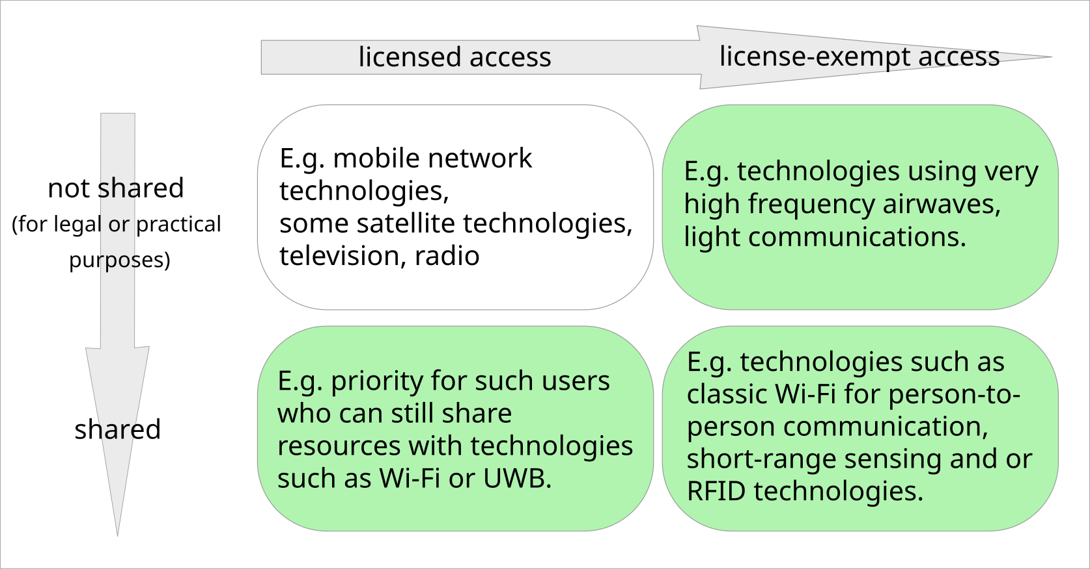The green fields indicate different spectrum policy strategies for which the IEEE 802 wireless community has already developed and deployed technical solutions.
Current and future state of IEEE 802 wireless technology development
Significant economic value is provided by IEEE 802 based systems today. Wi-Fi technology, based on the IEEE 802.11 standard, has an estimated 18 billion devices in use world-wide, with over 4 billion devices added annually. The current deployments of 802.15 devices in consumer, commercial and industrial IoT applications, such as utilities, smart cities and smart homes, counts in the hundreds of millions of devices. Additionally, the recent and rapid growth of IEEE 802.15 UWB-enabled devices in the smartphone and laptops for location discovery and device ranging, puts forecasts at more than 1 billion devices shipped annually worldwide by 2025. IEEE 802 wireless technologies are deployed around the world. Today, these technologies are integral part of human life and changed the way world operates, communicates and conducts business, benefiting billions of people every day.
Today, Wi-Fi networks are an essential part of the connectivity in residential, office, and industrial environments, in both public and private settings, and for both devices (such as printers or IoT) and people. Users in an array of industries including, health, education, transportation, leisure, and public services now rely on IEEE 802 and Wi-Fi technologies. Underserved communities benefit from IEEE 802 wireless technologies, and they are used in community networks to empower residents and provide an opportunity for education. IEEE 802 technologies are in the forefront as the cost-effective, energy-efficient enabler of state of the art applications such as augmented and virtual reality (AR/VR).
IoT networks based on 802.15 standards are embedded in an increasing number of devices, from consumer devices to industrial plants, automobiles to buildings and agriculture to space. For different applications, different industry consortia manage their respective industry segment, and for many specialised applications, such as body implants or medical devices, use of 802.15 standards falls within the remit of a single corporate entity. Whether our standards serve as the basis for other standards, or for individual companies' equipment, they improve user's capacity to deal with challenges ranging from manufacturing and safety to human health.
Since 2021, IEEE 802.11 supports operation in the 6 GHz (5925-7250 MHz) band, and thousands of products based on this standard (Wi-Fi 6E) are already in the market globally are seeing significant adoption where regulations permit deployment. Each new generation of IEEE 802.11 technologies continues to improve efficiency, reliability, latency, through-put and determinism. Contiguous bandwidths in the 6 GHz band accommodating multiple wide channel bandwidth are key for the success of next generation IEEE 802.11 technologies to achieve the promised performance.
Since 2007, the IEEE 802.15.4 standard supports operation in the upper 6 GHz (6425-7025 MHz and 7025-7125 MHz) bands and is expanding the use of data collection, location discovery and device ranging. Recent regulatory developments have accelerated the already wide adoption of UWB in consumer devices such as smartphones and laptops, and in other applications such as cars. IEEE 802.15.6, a standard for short range, wireless communication in the vicinity of, or inside, a human body. For high-speed, low-latency media transfers over short distances, IEEE 802.15.3 provides a speciality solution.
Many wireless speciality networks from the IEEE 802.15 family of standards, as well as IEEE 802.11 standards, also support operation on frequencies lower than 1 GHz. As technology developments in the broadcast industry has allowed more efficient use of their already assigned spectrum, the IEEE 802 wireless community has been able to provide solutions for underserved communities and IoT.
IEEE 802 wireless technologies are developed and designed for co-existence
IEEE 802 wireless technologies are designed not to cause any harmful interference with other incumbent users in bands where they operate. The standards development process considers both regulatory minimum requirements for interference mitigation and actively working on improved co-existence mechanisms.
The IEEE 802.19 Wireless Coexistence Working Group completed work in sub-1GHz and for automotive use scenarios, as well as for individual standards amendments developed in the IEEE 802.11 and .15 Working Groups. Additional work is undertaken within the Working Groups, such as the Co-existence Standing Committee of IEEE 802.11 which follows co-existence studies at the ISO and ETSI levels.

As additional spectrum and bands are identified for new and expanded uses, IEEE 802 will continue its efforts to enable robust coexistence and sharing with incumbent users.
A vision for social and economic development through flexible spectrum management
Technologies which are designed to use license-exempt or shared spectrum have made a tremendous positive impact on the world and will continue to benefit humanity profoundly in the years to come. In heavily regulated environment of spectrum management, these benefits can only be realized with a solid vision from regulators and governments to include as many users and entities as possible in a technical environment that provides a maximal amount of flexibility for those users and entities. The IEEE 802 wireless community provide the basic elements of one such ecosystem, and we welcome others to contribute to and use our results.
The IEEE-SA has an important role to play in the development of intelligent spectrum allocation and management based upon transparent, standardized rules that also account for incumbent users.

This statement was developed by the IEEE Standards Association and represents the considered judgement of a group of IEEE standards participants with expertise in the subject field. The position taken by the IEEE Standards Association does not necessarily reflect the views of IEEE or its other Organizational Units.

ABOUT IEEE

The IEEE is the world’s largest professional association advancing innovation and technological excellence for the benefit of humanity. IEEE and its members inspire a global community to innovate for a better tomorrow through its highly-cited publications, conferences, technology standards, and professional and educational activities. IEEE is the trusted “voice” for engineering, computing, and technology information around the globe.

There are more than 420,000 IEEE members in more than 160 countries. IEEE publishes a third of the world’s technical literature in electrical engineering, computer science, and electronics, and is a leading developer of international standards that underpin many of today’s telecommunications, information technology, and power generation products and services.

ABOUT THE IEEE STANDARDS ASSOCIATION

The IEEE Standards Association, a globally recognized standards-setting body within IEEE, develops consensus standards through an open process that engages industry and brings together a broad stakeholder community. IEEE standards set specifications and best practices based on current scientific and technological knowledge. The IEEE-SA has a portfolio of over 1,250 active standards and over 650 tandards under development. For more information visit http://standards.ieee.org.

Wi-Fi Alliance: Value of Wi-Fi. Available online [accessed: 12 December 2022]
FiRa Consortium: Unleashing the Potential of UWB: Regulatory considerations, August 2022. Available online [accessed: 12 December 2022]
Some examples of devices which implement IEEE 802.15.4 technologies are TV remote controls, lighting, windows, door locks, heating and air conditioning systems, alarm systems and remote medical monitoring.
“IEEE Standard for Low-Rate Wireless Networks--Amendment 1: Enhanced Ultra Wideband (UWB) Physical Layers (PHYs) and Associated Ranging Techniques,” in IEEE Std 802.15.4z-2020 (Amendment to IEEE Std 802.15.4-2020), vol., no., pp.1-174, 25 Aug. 2020, doi: 10.1109/IEEESTD.2020.9179124.
“IEEE Standard for Local and metropolitan area networks - Part 15.6: Wireless Body Area Networks,” in IEEE Std 802.15.6-2012, vol., no., pp.1-271, 29 Feb. 2012, doi:10.1109/IEEESTD.2012.6161600.
"IEEE Recommended Practice for Local and Metropolitan Area Networks--Part 19: Coexistence Methods for IEEE 802.11 and IEEE 802.15.4 Based Systems Operating in the Sub-1 GHz Frequency Bands," in IEEE Std 802.19.3-2021 , vol., no., pp.1-79, 26 April 2021, doi: 10.1109/IEEESTD.2021.9416944.
Proceedings from Automotive Study Group in IEEE 802.19. Available online [accessed: 2022-12-16]

