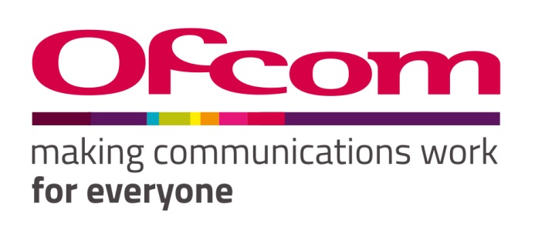

Consultation response form
Please complete this form in full and return to SharedAccess6GHz@ofcom.org.uk.
Consultation title | Enabling spectrum sharing in the upper 6 GHz band
Full name | Paul Nikolich, Chair of IEEE 802
Contact phone number
Representing (delete as appropriate) | Organisation
Organisation name | IEEE 802 LAN/MAN Standards Committee
Email address | IEEE802radioreg@ieee.org

Confidentiality
We ask for your contact details along with your response so that we can engage with you on this consultation. For further information about how Ofcom handles your personal information and your corresponding rights, see Ofcom’s General Privacy Statement.
Your details: We will keep your contact number and email address confidential. Is there anything else you want to keep confidential? Delete as appropriate. | Nothing
Your response: Please indicate how much of your response you want to keep confidential. Delete as appropriate. | None
For confidential responses, can Ofcom publish a reference to the contents of your response? | Yes

IEEE 802 LAN/MAN Standards Committee (LMSC) respectfully submits these responses to Ofcom.
IEEE 802 LMSC is a leading consensus-based industry standards body, producing standards for wireless networking devices, including wireless local area networks (“WLANs”), wireless specialty networks (“WSNs”), wireless metropolitan area networks (“Wireless MANs”), and wireless regional area networks (“WRANs”). We appreciate the opportunity to provide these comments to Ofcom.
IEEE 802 is a committee of the IEEE Standards Association and Technical Activities, two of the Major Organizational Units of the Institute of Electrical and Electronics Engineers (IEEE). IEEE has about 400,000 members in over 160 countries. IEEE’s core purpose is to foster technological innovation and excellence for the benefit of humanity. In submitting this document, IEEE 802 acknowledges and respects that other components of IEEE Organizational Units may have perspectives that differ from, or compete with, those of IEEE 802. Therefore, this submission should not be construed as representing the views of IEEE as a whole.

Your response

Question | Your response
Question 1: Do you agree with our proposals to add the 6425-7070 MHz band to the Shared Access framework? | Confidential? – Y / N  The shared access framework is already implemented for four other bands [1], but to our knowledge no assessment is available of the outcome. In general, wireless IEEE 802 technologies depend on unlicensed spectrum and have significantly driven innovation. However, we understand that this was not the objective of this consultation.  [1] https://www.ofcom.org.uk/__data/assets/pdf_file/0035/157886/shared-access-licence-guidance.pdf
Question 2: Do you have any comments on potential uses for this licence? | Confidential? – Y / N  This license will effectively block innovative uses of the upper 6GHz band in home networks. We believe Ofcom should assess whether its previous shared access framework was successful in bringing about the innovative environment foreseen before advancing this proposal. More specifically, from the perspective of IEEE 802.11 standards, we think it is important to have a feasibility assessment on co-existence with RLAN technologies, such as those specified by 802.11, in case such sharing is envisioned as an option in the future.
Question 3: Do you have any comments on our proposed licence conditions, licence fee or minimum separation distance? | Confidential? – Y / N  No comment
Question 4: Do you have any comments on our technical analysis? | Confidential? – Y / N  No comment

Please complete this form in full and return to SharedAccess6GHz@ofcom.org.uk.

This document solely represents the views of the IEEE 802 LAN/MAN Standards Committee and does not necessarily represent a position of either the IEEE, the IEEE Standards Association or IEEE Technical Activities.

