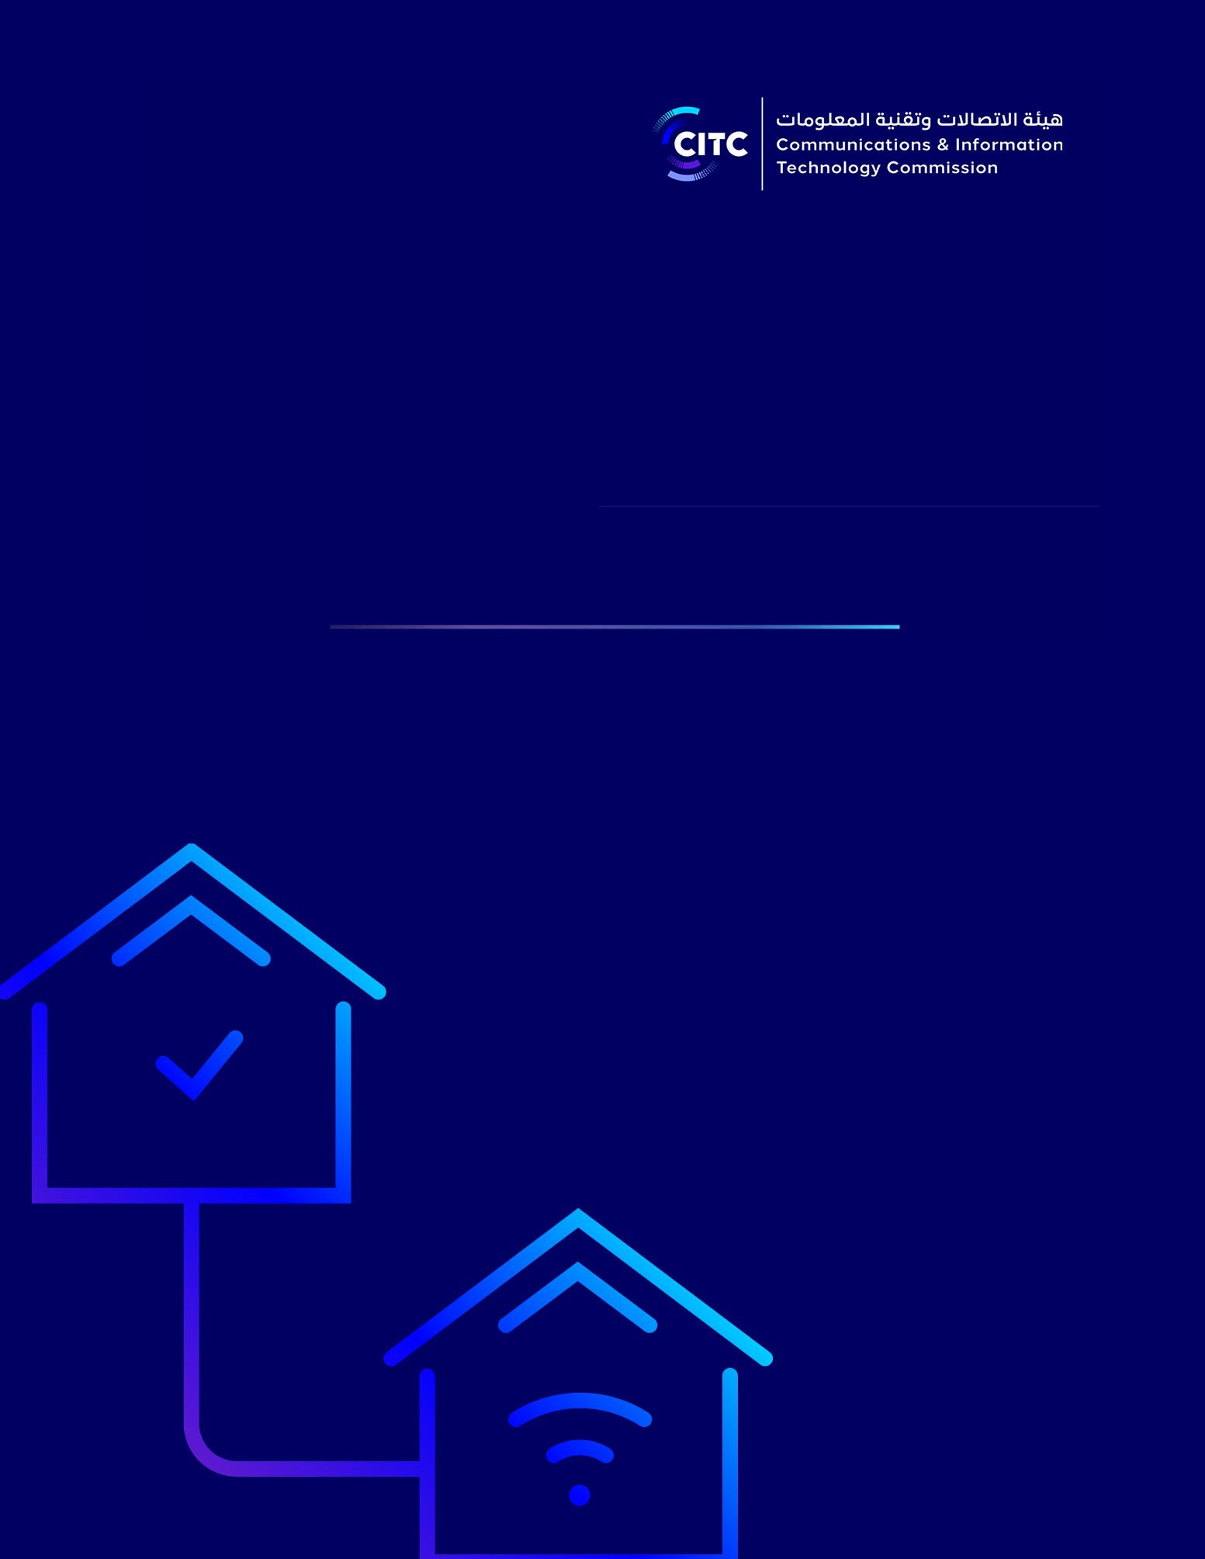

Radio Spectrum Allocation and Use Regulation for WLAN Applications

PUBLIC CONSULTATION
Publishing Date: 10 June 2021
Closing Date for Responses: 08 July 2021

Table of Contents

2

PREAMBLE - HOW TO RESPOND & NEXT STEPS 3
INTRODUCTION 3
SCOPE AND OBJECTIVE 3
SUBMITTING COMMENTS 3
- INTRODUCTION 5
- DEFINITIONS 6
- REGULATIONS 8
  - SPECTRUM ACCESS MECHNASIM 8
  - TECHNICAL CONDITIONS FOR LICENSE-EXEMPT ACCESS 8
  - LIGHTLY LINCESED ACCESS FOR WLAN BANDS 10
  - FIXED LINKS 10
  - TYPE APPROVAL 10
  - ELEGIBLITY 10
  - ENFORCEMENT 11
  - SPECTRUM FEES 11
- MAINTAINING THIS DOCUMENT 11

Preamble - How to Respond & Next Steps
Introduction
The Communications and Information Technology Commission (CITC) is responsible, in accordance with the Telecommunications Act1, Telecom Act Bylaw2 and CITC Ordinance; for managing radio spectrum for all users in the Kingdom of Saudi Arabia.
CITC continues to pursue its mission to protect consumers, promote investment and safeguard competition in order to ensure reliable communications services and innovative digital technologies, and is pleased to publish a Public Consultation document on its “Radio Spectrum Allocation and use Regulations for WLAN applications”. This regulatory document regulates the WLAN services and applications using WLAN license-exempt bands.
Scope and Objective
The purpose of this public consultation is to provide the relevant interested parties with an opportunity to submit their views and comments on the document titled “Radio Spectrum Allocation and use Regulations for WLAN applications”. This document was prepared to achieve the vision of CITC to unlock the potential of radiocommunication in Saudi Arabia, in order to secure a smarter and safer future by managing spectrum effectively and efficiently.
Submitting Comments
Participants who wish to submit their views/comments on this Public Consultation Document must submit them to CITC no later than Thursday 07/08/2021, corresponding

1 https://www.citc.gov.sa/ar/RulesandSystems/CITCSystem/Documents/LA_001_%20A_Telecom%20Act.pdf
2 https://www.citc.gov.sa/en/RulesandSystems/bylaws/Documents/LA_005_%20E_Telecom%20Act%20Bylaw.pdf

3

to 28/11/1442 H. To participate in this consultation process, stakeholders are requested to provide their views/comments in the format shown below.

Section # | Response & Comments

views/comments can be submitted to one or more of the following addresses:
- By email to (Spectrum.Strategy@citc.gov.sa).
- Hand-delivered (paper and electronic) at the CITC premises.
- By mail (paper copy and electronic) to the following postal address: Communications and Information Technology Commission, Al-Nakheel District- Prince Turki Bin Abdul Aziz I Street intersection with Imam Saud Bin Abdul Aziz Road, PO Box 75606, Riyadh 11588, Saudi Arabia.
CITC invites all interested parties nationally and internationally, including individuals, public organizations and commercial entities to engage in this process by submitting their views/comments. CITC encourages participants to provide detailed comments supported by relevant data, analysis, benchmarking studies and any other supporting information. CITC will take all views/comments into consideration during its deliberation process, but CITC is under no obligation to adopt the comments or proposals of any participant. Please note that all responses provided to CITC will be treated in confidence and will not be published.

4

Introduction
This document is issued by the Communications and information Technology Commission (CITC) in accordance with its responsibility established under the Telecommunications Act3 and the Bylaw to the Telecommunications Act4 to ensure the efficient management of the radio spectrum. It establishes the allocation and use regulations that apply to the use of the WLAN frequency bands in the Kingdom of Saudi Arabia to enable sharing with other non-WLAN services. The regulations set out in this document are designed to ensure that WLAN equipment, operated in accordance with these regulations, will not cause harmful interference to these other services. The objectives for this document are to:
  - Promote optimum utilization of the national spectrum resource
  - Promote innovative uses of spectrum
  - Ensure equitable access to spectrum by seeking a balance between complementary technologies and services
  - Enable more efficient use of spectrum through better approaches to sharing and more flexible access
  - Support introduction of new services and spectrum uses for the benefit of the Kingdom, including promotion of emerging radio technologies
  - Ensure effective usage of frequencies with an acceptable level of interference
  - Ensure clarity and transparency of procedures
  - Ensure principles of equality and non-discrimination

3 https://www.citc.gov.sa/ar/RulesandSystems/CITCSystem/Documents/LA_001_%20A_Telecom%20Act.pdf
4 https://www.citc.gov.sa/en/RulesandSystems/bylaws/Documents/LA_005_%20E_Telecom%20Act%20Bylaw.pdf

5

In order to meet these objectives, CITC is guided by the following principles:
  - Promoting release and utilization of spectrum for the wider benefit of The Kingdom.
  - Permitting the technology neutral use of spectrum where this is technically feasible.
  - Promote improved spectrum utilization, including the support of shared spectrum bands under appropriate technical conditions of use to ensure coexistence of services.

Definitions
The following definitions apply:
WLAN: Communication networks that are used to provide wireless communications in a limited area, denoted Wireless Local Area Networks. Such networks are built in accordance with the international standards, such as IEEE 802.11/HIPERLAN, and provide the user with the ability to remain connected whilst moving within a limited area. WLAN networks include those based on technologies such as Wi-Fi 4, Wi-Fi 5, Wi-Fi 6/6e, NR-U and WiGig technologies able to work in WLAN bands on a license exempt basis and are also designed to enable sharing and coexistence with other services. WLAN technology can also be used to establish communications between fixed locations (i.e. fixed links), or to control or monitor devices remotely.
WLAN License-Exempt Frequency Bands: The 2.4 GHz, 5 GHz, 6 GHz and 57-71 GHz frequency bands as set out in this document.
Indoor: locations within personal premises, where the radio waves of wireless networks have targeted coverage areas constrained by the walls of the structure (such as houses, offices, hotels, airports, etc).

6

Outdoor: locations outside of personal premises, where radio waves of wireless networks are able to propagate more widely subject to power limits (such as streets, seashores, parks, etc).
Harmful Interference: Interference which seriously degrades, obstructs or repeatedly interrupts a radio communication service operating in accordance with international radio regulations issued by International Telecommunication Union (ITU).
EIRP: The Effective Isotropic Radiated Power is the actual power emitted by the antenna.
TPC: Transmission Power Control is the feature of controlling transmission power in order to avoid harmful interference with frequencies specified for the usage of primary services.
DFS: Dynamic frequency selection is a technique for avoiding harmful interference with other systems operating in a specific frequency band.
LBT: Listen Before Talk is a technique for avoiding harmful interference with other systems operating in a specific frequency band.
License Exempt: Use of radio spectrum without the user being required to possess a frequency license issued by CITC, but required to operate under CITC terms and conditions.
Light licensing: An approach where spectrum is not exclusively assigned, but users need to register in order to have shared access to specified radio spectrum. Such approach includes:
  - Registration of location of usage.
  - Use of systems to reduce interference between registered users, for example, by preventing new registrations that might interfere with existing registrations
  - Use of systems that dynamically allow use, including on a time-sharing basis, to
enable band sharing between users in a band

7

Regulations
These regulations set out the framework under which WLAN equipment will be permitted to operate.
  - Spectrum Access Mechnasim
Users shall be permitted to operate WLAN equipment in WLAN License-Exempt Frequency Bands either on a license-exempt basis or under a Light Licensing regime.
  - Technical Conditions for License-Exempt Access
Equipment used for WLAN needs to conform with the technical conditions specified in table 1 below in addition to CITC’s technical specifications, which include RI1175 , RI054 6. Table 1 specifies WLAN license-exempt bands and access conditions for the environments (indoor or outdoor) where WLAN equipment may be used.

5 RI 117 Specification for Data Communication Equipment operating in License-Exempt Frequency Bands
6 RI054 Specification for Short Range Devices (SRD)

8

Table 1: Proposed technical conditions to be applied to WLAN allocations.
Frequency Band (MHz) | Appropriate Standard | Environment | Primary Restrictions | Maximum Radiated PSD (mW/ MHz) | Maximum EIRP (mW)
2400-2483.5 | EN 300 328 | Indoor and outdoor | LBT | 10 | 100
5150-5250 | EN 301 893 | Indoor | LBT | 10 | 200
5250-5350 | EN 301 893 | Indoor | DFS and TPC | 10 | 200
5470-5725 | EN 301 893 | Indoor and outdoor | DFS and TPC | 50 | 1000
5725-5825 | EN 301 893 | Indoor and outdoor | TPC | 50 | 1000
5825-5875 | EN 300 440  EN 301 489-3 | Indoor and outdoor | LBT | 1.25 | 25
5925-7125 | TBD | Indoor (Access point) | TPC | 3.125 | 1000
 |  | Indoor (Client device) | TPC | 3.125 | 150
 |  | outdoor | TPC | 0.3125 | 25
57-71 GHz | EN 302 567 | Indoor | DFS and TPC | 200 | 10000

9

  - Lightly Lincesed Access for WLAN bands
Aside from the license-exempt use, WLAN bands can also be used under the light licensing regime with more flexible use conditions (such as relaxed power restrictions).

NOTE: CITC will identify some WLAN bands for usage under Light Licensing and invites input on the most suitable license-exempt bands for light licensing usage and the technical parameters (power, access mechanisms, etc) for their use.
  - Fixed Links
WLAN bands can be used in fixed wireless links in a license-exempt manner for eligible users (see section 3.6) following the technical conditions in Table 1. Aside from the license- exempt use, WLAN bands can also be used in fixed wireless links under the light licensing regime with more flexible use conditions (such as relaxed power restrictions).

NOTE: CITC will specify the eligible users for license-exempt fixed wireless links and light licensing conditions. CITC invites input on license-exempt eligibility and light licensing conditions for fixed links in WLAN bands.
  - Type Approval
WLAN equipment shall be type approved by CITC prior to importation into The Kingdom. The radio interface performance shall comply with the regulations set out in this document in order to qualify for type approval and custom clearance. Also, WLAN equipment shall comply and meet the appropriate requirements specified in the technical specifications published on CITC’s website.
  - Elegiblity
WLAN License-Exempt Frequency Bands may be used by any person for License-Exempt WLAN applications as long as they are used in accordance with the relevant regulations, including the regulations set out in this document. As per article 19 of the

10

Telecommunications Act, networks which extend beyond the boundary of a user’s premises and public Wi-Fi services can only be operated by telecommunications service providers who holds an appropriate service providing license from CITC.
  - Enforcement
If CITC detects that frequency use falls outside the terms of any authorized use, CITC will serve an enforcement notice requiring either immediate cessation of transmissions in the case of a serious deviation that could lead to harmful interference, or a correction within a given timescale for less serious deviations. Note that CITC will impose a penalty in accordance with Chapter 10 of the Telecoms Act for any violations of these regulations that could lead to harmful interference.
  - Spectrum Fees
Spectrum users for WLAN applications operating on a license exempt basis will not pay any fee for using the spectrum in accordance with the regulations set out in this document as well as the regulations set out in relevant technical specifications.
Fees for using spectrum under the Light License regime will be subjected to the light licensing regulation issued by CITC.

Maintaining this document
CITC will review and update this document as appropriate to respond to emerging uses and demands for access to spectrum.
As part of this maintenance process, CITC will undertake consultations whenever needed in accordance with its most recent general spectrum strategy, as an important part of promoting transparent, fair and effective spectrum management to gather information and views so as to inform a wide range of spectrum policy decisions.

11

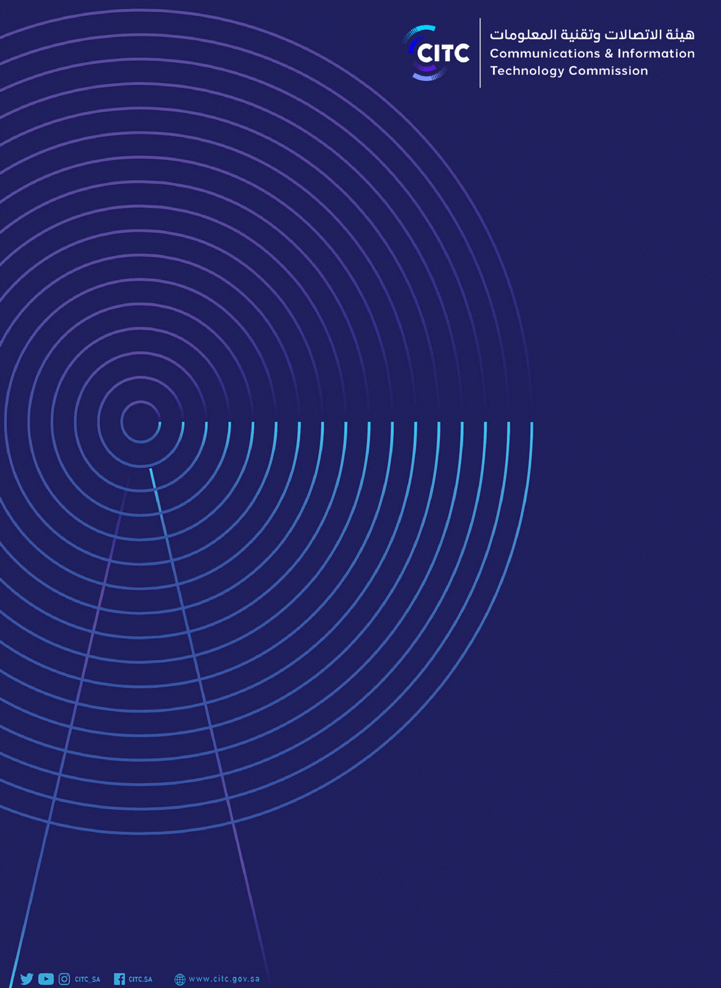

12

