Before the

FEDERAL COMMUNICATIONS COMMISSION

Washington, DC 20554

In the Matter of  Petition For Waiver to Allow Deployment of Intelligent Transportation System Cellular Vehicle to Everything (C-V2X) Technology | )  )  )  )  )  ) | ET Docket No.

5GAA PETITION FOR WAIVER

Sean T. Conway, Esq. Kelly A. Donohue, Esq. Mark A. Settle, P.E.

Wilkinson Barker Knauer, LLP 1800 M Street, NW
Suite 800N Washington, DC 20036

Counsel to the 5G Automotive Association

November 21, 2018

Introduction 1

The Current Rules Prohibit Use of C-V2X in the 5.9 GHz Band 2

C-V2X is a Modern, Standards-Based Technology Designed to Meet Today’s Transportation Challenges as Well as the Evolving Demands of Tomorrow’s 5G Connected Transportation Ecosystem 5

C-V2X Offers Capabilities Today that are Superior to Those of Other Technologies – Enabling Safety and Other Benefits 7

5GAA Testing Confirms the Significant Performance Advantages of C-V2X Peer-to-Peer Mode when Measured Against DSRC 7

The Performance Advantages of C-V2X Peer-to-Peer Mode, Which are Further Augmented by V2N Mode Capabilities, Can Help Unlock Safety and Other Benefits on America’s Roads 13

C-V2X’s Evolutionary Path to 5G and Subsequent Wireless Generations Will Help to Amplify and Expand Upon the Safety and Other Benefits Enabled by C-V2X Services 16

C-V2X’s Unique Cost Efficiency Supports an Accelerated Timeline for Deployment 18

The Commission Should Grant a Waiver of Its Rules to Expedite the Deployment of C-V2X 21

The Good Cause Standard 22

Good Cause Exists for the Grant of the Requested Waiver 23

A Grant of the Requested Waiver is in the Public Interest Because it Will Expedite the Availability of ITS Services 23

The Requested Waiver Would Advance, Rather than Undermine, the Underlying Policy Which the Rule in Question is Intended to Serve 26

Conclusion 31

Appendix A - Appendix B - Appendix C -
Appendix D -
5GAA Membership ................................................................................... A-1
5GAA C-V2X Test Results ....................................................................... B-1
C-V2X Test and Trials .............................................................................. C-1
Proposed Conditions Applicable to C-V2X Operations Pursuant to the

Waiver Request............................................................................................................ D-1

At the dawn of the 5G revolution, the 5G Automotive Association (“5GAA”) – a rapidly growing global association that brings together many of the world’s major automotive, technology and telecommunications companies – requests that the Commission grant a waiver, subject to the conditions proposed in Appendix D attached hereto, of footnote NG160 to Section
  - of the Commission’s rules to allow for the deployment of Cellular Vehicle-to-Everything technology, better known as C-V2X, in a 20 MHz channel located in the upper edge of the
5.850-5.925 GHz (“5.9 GHz”) band (5905-5925 MHz). As supported by the attached 5GAA test report, C-V2X represents a significant advancement in connected vehicle technology and is the first step towards leveraging 5G to increase road safety and to maximize the myriad other benefits of connected vehicles on America’s roads.
Built upon earlier efforts to develop Intelligent Transportation System (“ITS”) services and leveraging advancements in cellular technologies, first 4G and ultimately 5G, C-V2X is a modern, standards-based connected-vehicle communications technology. C-V2X enables direct, peer-to-peer mode communications between vehicles themselves (“V2V”), vehicles and vulnerable persons such as pedestrians and cyclists (“V2P”), and vehicles and transportation infrastructure (“V2I”), as well as communications between vehicles and mobile networks (“V2N”). These communications can help enable important improvements in safety, traffic efficiency, mobility, and energy efficiency on America’s roads.

Congress, the U.S. Department of Transportation (“DOT”), and the Commission have acknowledged for decades the life-saving and societal benefits enabled by ITS services. Today, the need for ITS services persists. Indeed, the DOT and the National Highway Traffic Safety Administration (“NHTSA”), the nation’s expert agency in traffic safety, repeatedly have stressed in recent years the importance of ITS services in the 5.9 GHz band for improving safety.

Unfortunately, widespread implementation of C-V2X technology in the United States is not feasible today. The Commission’s current rules for the 5.9 GHz band – adopted well before the development of C-V2X – restrict ITS operations to those that use the Dedicated Short Range Communications (“DSRC”) standard.

The consequences of this restriction are significant. Recent testing performed by 5GAA
members demonstrates that C-V2X peer-to-peer mode consistently outperforms DSRC in several key areas. These performance advantages, which include enhanced reliability over an extended communication range, better non-line-of-sight performance, and greater resiliency, can – both individually and as a complement to existing radar- and camera-based systems – provide vehicles and drivers with an earlier, more complete picture of the surrounding road environment.

C-V2X’s performance advantages over DSRC are particularly important in non-line-of- sight scenarios (e.g., around corners, through large trucks, etc.). Because current and near-term in-vehicle camera and sensor-based technologies experience limitations in non-line-of-sight scenarios, C-V2X’s performance advantage over DSRC thus may allow vehicles to perceive and provide earlier warnings of threats hidden from view. As NHTSA has acknowledged, such V2V warnings are particularly useful near intersections and in highway passing and braking scenarios.

The performance advantages of C-V2X peer-to-peer mode are further augmented by C- V2X’s V2N mode communications. V2N mode communications play an important complementary role to peer-to-peer mode communications by, among other things, providing the ability to offload less time-sensitive V2V, V2I, and V2P communications to a cellular network during times of peak congestion.

C-V2X is also designed with an upgrade path to 5G. Over the next several years, C-V2X will unlock the power of 5G technologies, driving further improvements in performance, introducing new capabilities to connected vehicles and infrastructure, and extending the number of use cases for C-V2X. For example, 5G C-V2X is expected to complement and augment advanced driving applications that enhance semi-automated or fully-automated driving features by coordinating the behaviors of vehicles.

To expedite the availability of C-V2X services, 5GAA is requesting a waiver of the Commission’s rules to deploy C-V2X in the 5.905-5.925 GHz portion of the ITS band. Good cause exists for the issuance of the requested waiver under the conditions proposed herein. First, grant of the requested waiver is in the public interest because it will expedite the widespread availability of ITS services in the 5.9 GHz band. Not only is C-V2X deployment expected to enable important safety benefits, but it also will enable other important public interest benefits, including improvements in traffic efficiency, productivity, mobility, and the conservation of fossil fuels. In addition, grant of the waiver will allow Americans to have access to the same modern safety technologies that are currently available or will soon be in other parts of the world. Finally, because C-V2X can be deployed in a cost-efficient manner, a waiver grant likely will enable consumers to benefit from ITS technology on an expedited timeframe.

Second, rather than undermine the underlying purpose of the rules, the waiver would advance the Commission’s objectives for allocating the 5.9 GHz band for short-range ITS services. The waiver grant will enable the deployment of C-V2X technology, which will help improve vehicular safety and travel. Moreover, a waiver is not expected to disturb existing commercial DSRC operations. Finally, other non-DSRC users of the band will not be negatively affected by a waiver grant, as the conditions proposed herein impose substantially similar technical and service requirements on C-V2X operations as those that are currently required by the Commission’s rules for DSRC operations.

ii

Before the

FEDERAL COMMUNICATIONS COMMISSION

Washington, DC 20554

In the Matter of  Petition For Waiver to Allow Deployment of Intelligent Transportation System Cellular Vehicle to Everything (C-V2X) Technology | )  )  )  )  )  ) | ET Docket No.

5GAA Petition For Waiver

    - Introduction

Pursuant to Section 1.3 of the Federal Communications Commission’s (“FCC” or “Commission”) rules, the 5G – Automobile Association (“5GAA”)1 respectfully requests that the Commission grant a blanket waiver, with conditions, of footnote NG160 to Section 2.106 of the Commission’s rules2 to allow for the deployment of Cellular Vehicle-to-Everything technology, better known as C-V2X, in the 5.905-5.925 GHz range of the 5.850-5.925 GHz (“5.9 GHz”)
1 5GAA is a global cross-industry organization of companies from the automotive, technology and telecommunications industries working together to develop end-to-end connectivity solutions for intelligent transportation, future mobility systems and smart cities. See 5GAA, www.5gaa.org (last visited Nov. 19, 2018). Created in 2016 by eight founding members, 5GAA’s membership has expanded rapidly and now includes over 100 companies. See Appendix A for a complete member list. In the past two years, 5GAA and its members have demonstrated the capabilities of C-V2X across the globe. See Press Release, 5GAA, 5GAA, BMW Group, Ford and Groupe PSA Exhibit First European Demonstration of C-V2X Direct Communication Interoperability Between Multiple Automakers (July 11, 2018), http://5gaa.org/news/5gaa-bmw-group-ford-and-groupe-psa-exhibit-first- european-demonstration-of-c-v2x-direct-communication-interoperability-between-multiple-automakers; Press Release, 5GAA, 5GAA, Audi, Ford and Qualcomm Showcase C-V2X Direct Communications Interoperability to Improve Road Safety (Apr. 26, 2018), http://5gaa.org/news/5gaa-audi-ford-and-qualcomm-showcase-c-v2x-direct- communications-interoperability-to-improve-road-safety-2; Press Release, 5GAA, 5GAA participates in Testbed Visit in Shanghai (Nov. 16, 2017), http://5gaa.org/news/5gaa-participates-in-testbed-visit-in-shanghai; Press Release, 5GAA, 5GAA joins 3GPP (Apr. 27, 2018), http://5gaa.org/news/5gaa-joins-3gpp; GSMA, Cellular Vehicle-to-Everything (C-V2X) Enabling Intelligent Transport (rel. Jan. 2, 2018 ), https://www.gsma.com/iot/wp- content/uploads/2017/12/C-2VX-Enabling-Intelligent-Transport_2.pdf.
2 47 C.F.R. § 2.106, NG160 (“In the 5850–5925 MHz band, the use of the non-Federal government mobile service is limited to Dedicated Short Range Communications operating in the Intelligent Transportation System radio service.”).

band. In addition to the instant petition for waiver (“Waiver Request”),3 5GAA plans to file a complementary petition for rulemaking in the near future requesting that the Commission initiate a proceeding to modify its rules for the 5.9 GHz band to provide stakeholders the flexibility to take the evolutionary leap forward in connected vehicle technologies. This Waiver Request is narrowly tailored to allow for the immediate deployment of C-V2X during the pendency of the Commission’s broader proceeding. As further discussed herein, a grant of the Waiver Request would serve the public interest by expediting the availability of C-V2X technology that holds the potential to improve safety, traffic efficiency, mobility, and energy efficiency on America’s roads and would further, rather than undermine, the underlying objectives for allocating the 5.9 GHz band for ITS services.
    - The Current Rules Prohibit Use of C-V2X in the 5.9 GHz Band

Built upon earlier Intelligent Transportation System (“ITS”) efforts and recent advancements in cellular technologies, C-V2X is a modern standards-based communications system that represents an evolution in connected vehicle technology and the first step towards leveraging 5G to increase safety and to maximize the myriad other benefits of connected vehicles on America’s roads. Already incorporated into standards set by the 3rd Generation Partnership Project (“3GPP”),4 C-V2X empowers direct communications between vehicles (“V2V”), between vehicles and pedestrians, cyclists and other vulnerable persons (“V2P”), and between vehicles and transportation infrastructure (“V2I”), as well as communications between vehicles and mobile networks (“V2N”).

3 This Waiver Request reflects the views of 5GAA, and does not necessarily reflect the views or positions of each of the individual members of 5GAA.
4 3GPP is the world’s preeminent standards body for cellular technologies.

C-V2X offers capabilities unrivaled by other ITS technologies. In extensive comparative benchmark testing conducted by members of 5GAA, C-V2X consistently outperformed radio operations based on the IEEE 802.11p standard, commonly referred to as Dedicated Short Range Communications (“DSRC”),5 in a number of key areas.6 These performance advantages, which include superior reliability over a much greater communications range, better non-line-of-sight
performance, and greater resiliency, can – both individually and as a complement to in-vehicle camera and sensor-based technologies – provide vehicles and drivers with an earlier, more complete picture of the surrounding road environment.
C-V2X also offers an evolution path to 5G. Chairman Pai has recognized the potential of 5G-enabled ITS:
Imagine a world where everything that can be connected will be connected – where driverless cars talk to smart transportation networks…. That’s a snapshot of what the 5G world will look like.7
C-V2X technology’s evolution path to 5G promises to bring this vision to ITS, addressing America’s road safety and connected mobility needs with applications such as connected and automated driving, ubiquitous access to services, and integration into smart city and intelligent transportation applications.

5 Over the course of the better part of the last two decades, the DSRC service has been conflated with the IEEE 802.11p standard, which in turn is based on the ASTM E2213-03 standard. The Commission’s rules define the DSRC service broadly, but limit operations within the DSRC service to radios compliant with the ASTM E2213-03 standard. Compare 47 C.F.R. § 90.371 (defining DSRC service) with 47 C.F.R. §§ 90.379, 95.3189 (limiting operations to radios compliant with the ASTM E2213-03 standard). This Petition uses the term “DSRC” to refer to technology based on the IEEE 802.11p standard or the ASTM E2213-03 standard.
6 See 5GAA Test Report at Appendix B.
7 Ajit Pai, Column: Florida is on the leading edge of 5G, Tampa Bay Times, May 14, 2018, https://www.tbo.com/- opinion/columns/Column-Florida-is-on-the-leading-edge-of-5G_168227409.

Unfortunately, widespread implementation of C-V2X technology in the United States is not feasible today. The Commission’s current rules for the 5.9 GHz band – adopted well before the development of C-V2X – restrict ITS operations to those that use the DSRC standard.
The negative repercussions of this restriction are considerable. Opening the 5.9 GHz to a newer technology, C-V2X, will bring great societal benefits. Congress, the U.S. Department of Transportation (“DOT”), and the Commission have acknowledged for decades the potential life- saving and societal benefits enabled by ITS. With respect to safety in particular, NHTSA – the
nation’s expert agency in traffic safety – has stated that ITS technologies in the 5.9 GHz band have the potential to “revolutionize motor vehicle safety.”8 This is due, among other reasons, to the fact that ITS technologies can address crashes that cannot be prevented by current vehicle- resident technologies.9 For example, ITS technologies offer non-line-of-sight capabilities (i.e., the ability to “see” around corners and “see” through other vehicles) that vehicle-resident sensors cannot match.10 In addition, NHTSA expects the fusion of ITS with vehicle-resident technologies to enhance the reliability and accuracy of sensor-based information in the short term and, in the longer term, advance the further development of vehicle automation systems.11 Consistent with the importance of ITS services in the 5.9 GHz band, the DOT recently issued guidance “encourage[ing] the automotive industry, wireless technology companies,

8 See, e.g., Federal Motor Vehicle Safety Standards; V2V Communications, 82 Fed. Reg. 3854, 3855 (Jan. 12, 2017) (“Federal Motor Vehicle Safety Standards”).
9 See id. Vehicle-resident technologies include in-vehicle camera and sensor-based technologies.
10 In addition to increased non-line-of-sight capabilities, ITS offers a number of additional benefits. For example, ITS basic safety messages contain additional information, such as path predictions and driver actions, not available from traditional sensors. Moreover, ITS offers an operational range that far exceeds that of vehicle-resident systems, and ITS technology is not subject to the same system limitations as vehicle-resident sensors, which may be affected by weather, sunlight, shadows, or cleanliness.
11 See Federal Motor Vehicle Safety Standards, 82 Fed. Reg. at 3855.

[infrastructure owners and operators], and other stakeholders to continue developing technologies that leverage the 5.9 GHz spectrum for transportation safety benefits.”12
To accelerate the realization of the expected benefits from C-V2X services, and consistent with the DOT’s guidance regarding the development of technologies that leverage the
5.9 GHz band, the Commission should grant this Waiver Request to allow for the near-term deployment of C-V2X technology. While this Waiver Request seeks permission to deploy C- V2X in the upper 20 MHz of 5.9 GHz band, this request should not be misconstrued as an indication that C-V2X requires only 20 MHz of spectrum. While 20 MHz is the ideal channel size for 4G LTE-based C-V2X, i.e., the initial version of C-V2X, the bandwidth requirements to support more intensive 5G-enabled road safety applications will be much higher. This should come as no surprise. It is a simple matter of physics that 5G technology requires access to large swaths of spectrum to meet the speed and latency requirements of 5G applications. 5G-based C- V2X is no different. 5GAA thus plans to file a complementary petition for rulemaking in the near future requesting that the Commission initiate a proceeding to modify its 5.9 GHz band ITS rules to provide stakeholders the flexibility to take the evolutionary leap forward in connected vehicle technologies enabled by 5G.
    - C-V2X is a Modern, Standards-Based Technology Designed to Meet Today’s Transportation Challenges as Well as the Evolving Demands of Tomorrow’s 5G Connected Transportation Ecosystem
Building upon decades of continuous evolution in cellular technologies, the standards development for C-V2X began in 2015 when 3GPP specified C-V2X features based on the 4G

12 See U.S. Department of Transportation, Automated Vehicles 3.0, Preparing For the Future of Transportation, at 16 (Oct. 4, 2018), https://www.transportation.gov/sites/dot.gov/files/docs/policy-initiatives/automated- vehicles/320711/preparing-future-transportation-automated-vehicle-30.pdf.

LTE-Pro system in 3GPP Release 14.13 The Release 14 version of LTE, which was finalized in 2017, was the first cellular standard to incorporate C-V2X technology, but it would not be the last.14 3GPP Release 15 also incorporated C-V2X,15 and work already is underway to develop 5G C-V2X in 3GPP Release 16, which is expected to be completed next year.16
C-V2X is comprised of two complementary communications modes for vehicular operations: peer-to-peer (called PC5 in 3GPP specifications) and network (called Uu in the specifications) communications. Peer-to-peer mode communications, which can operate independently of cellular networks and without a network subscription,17 include: (1) V2V communications, which are expected to be used to communicate safety information between
nearby vehicles to prevent collisions; (2) V2I communications (e.g., traffic signals, variable message signs, etc.), which are expected to communicate safety and traffic information to prevent accidents associated with roadway conditions and improve traffic efficiency, and (3) V2P communications, which are expected to be used to communicate safety information between vehicles and other road users such as pedestrians, bicyclists, motorcyclists, etc. to

13 Dino Flore, Initial Cellular V2X standard completed, 3GPP (Sept. 26, 2016), http://www.3gpp.org/news- events/3gpp-news/1798-v2x_r14ietf%20ipwave; NGMN Alliance, V2X White Paper v. 1.0, at 19 (June 17, 2018), https://www.ngmn.org/fileadmin/ngmn/content/downloads/Technical/2018/V2X_white_paper_v1_0.pdf.
14 3GPP, Release 14, http://www.3gpp.org/release-14 (last visited Nov. 19, 2018).
15 3GPP, Release 15, http://www.3gpp.org/release-15 (last visited Nov. 19, 2018).
16 See 3GPP, 3GPP Features and Study Items, http://www.3gpp.org/DynaReport/FeatureListFrameSet.htm (last visited Nov. 19, 2018) (identifying a study on NR Vehicle-to-Everything as part of the feature and study item list for Release 16).
17 As excitement grows about the potential for C-V2X to improve traffic safety, productivity, mobility, and energy efficiency, there inevitably also has developed a few inaccuracies regarding the nature of this service. One such inaccuracy is that the V2V, V2I, and V2P services that C-V2X enables will require a subscription. The peer-to-peer mode communications enabled by C-V2X do not require cellular network connectivity and thus do not require a subscription. See Tom Rebbeck et al., Socio-Economic Benefits of Cellular V2X, at 28, Analysys Mason (Dec.
2017), http://5gaa.org/wp-content/uploads/2017/12/Final-report-for-5GAA-on-cellular-V2X-socio-economic- benefits-051217_FINAL.pdf.

(V2N) mode capabilities allow vehicles to communicate with the rest of the world over the Uu interface and through cellular networks. These V2N mode communications enable key supporting functions for the peer-to-peer mode communications uses and expand the universe of applications enabled by C-V2X services.
Individually and in concert, these two communications modes of C-V2X make this technology uniquely suited to further the objectives of ITS in the 5.9 GHz band.
- C-V2X Offers Capabilities Today that are Superior to Those of Other Technologies – Enabling Safety and Other Benefits

The superior capabilities of C-V2X primarily are enabled by the radio performance of C- V2X peer-to-peer mode communications, which far exceeds the performance of DSRC radios in key areas. This performance advantage is augmented in turn by C-V2X’s V2N mode communications in a number of ways. In their totality, the resulting capabilities of C-V2X hold the potential to deliver a range of societal benefits.
  - 5GAA Testing Confirms the Significant Performance Advantages of C- V2X Peer-to-Peer Mode when Measured Against DSRC

A number of 5GAA members recently conducted extensive comparative benchmark testing to measure the radio performance of C-V2X peer-to-peer mode communications against DSRC. Using technology-agnostic test procedures documented and harmonized in 5GAA for global consistency and meticulous management of parameters affecting radio propagation to ensure fair comparison, the testing demonstrates that the radio performance of C-V2X peer-to-

18 See 5G Americas White Paper, Cellular V2X Communications Towards 5G, at 4 (Mar. 2018), http://www.5gamericas.org/files/9615/2096/4441/2018_5G_Americas_White_Paper_Cellular_V2X_Communicatio ns_Towards_5G Final_for_Distribution.pdf. Because C-V2X is part of the 3GPP standard, any vulnerable road user carrying a mobile device could potentially benefit from the protections offered by C-V2X. Id. at 29.

DSRC, C-V2X peer-to-peer mode delivers superior reliability over a much greater communications range, better non-line-of-sight performance, and greater resiliency to interference. Moreover, C-V2X implements congestion control mechanisms that meet the standards set by the Society of Automotive Engineers (“SAE”).20 While the complete 5GAA Test Report is attached in Appendix B, an overview of the highlights of this testing provides
valuable insight into the performance advantages of C-V2X.

C-V2X’s Superior Reliability Over a Much Greater Communications Range

5GAA’s line-of-sight field testing assessed the baseline range capability for V2V message exchanges using C-V2X peer-to-peer mode and DSRC. In one scenario, a stationary vehicle received communications from a vehicle in its line of sight.
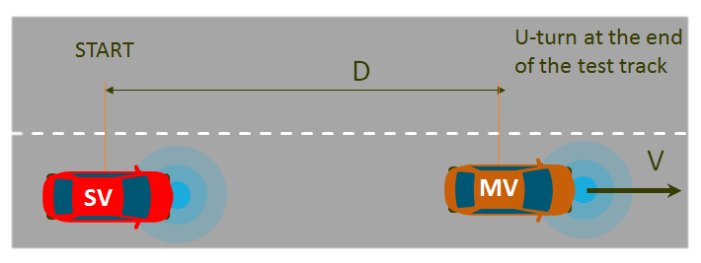
Figure 1: Depiction of 5GAA’s Line-of-Sight field test.

As demonstrated in Figure 2, and discussed in detail at pages 72-78 of the 5GAA Test Report, under 5GAA’s testing parameters, C-V2X reliably received messages at distances up to 1,175 meters, which amounts to an approximate line-of-sight range advantage of 500 meters

19 See 5GAA Test Report at Appendix B.
20 Moreover, this radio is designed with a consistently achieved, highly reliable latency regardless of channel congestion. See 5G Americas White Paper, supra note 18, at 22.

reliably deliver messages in a line-of-sight scenario was almost 75% greater than that of DSRC.
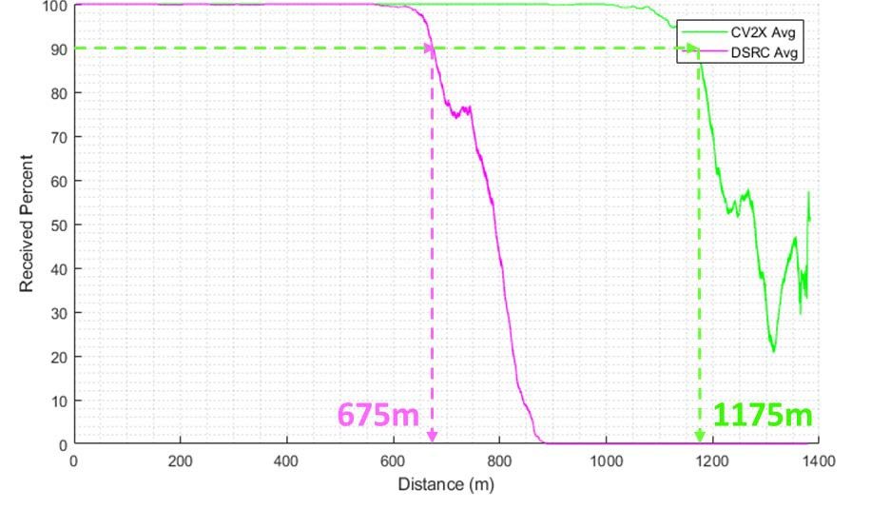
Figure 2: Line-of-sight field test results in a scenario in which a stationary vehicle received communications from an approaching vehicle that was transmitting communications.

C-V2X’s Better Non-Line of-Sight Performance

An examination of two specific tests helps to illustrate the better non-line-of-sight performance of C-V2X peer-to-peer mode compared to DSRC. These tests are (1) the intersection test with an obstructed view and (2) the shadowing test.
Intersection Test with an Obstructed View. 5GAA’s intersection test with an obstructed view assessed V2V communication capabilities in situations in which an obstruction is blocking the line of sight between a vehicle at an intersection and vehicles in lateral traffic crossing the intersection. An illustration of this test scenario is provided in Figure 3.

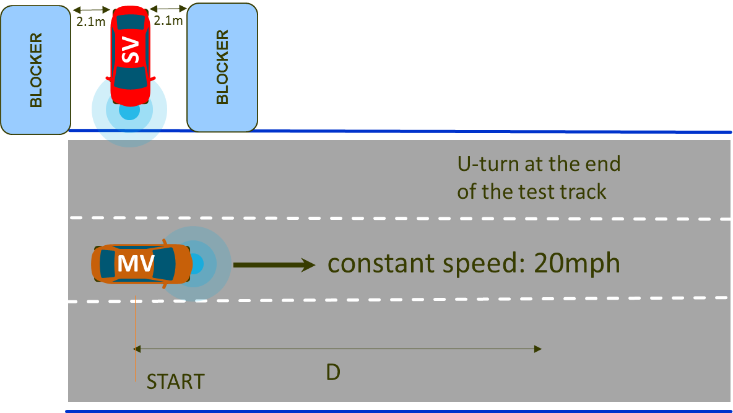
Figure 3: Depiction of 5GAA’s Intersection Test with Obstructed View.
In this scenario, the stationary vehicle (SV) is receiving communications and the vehicle moving lateral across the intersection (MV) is transmitting communications.

In this scenario, C-V2X peer-to-peer mode communications again outperformed DSRC by a wide margin. As illustrated in Figure 4 and discussed in detail at pages 84-87 of the 5GAA Test Report, C-V2X demonstrated a reliable range of approximately 875 meters in this scenario, outperforming DSRC’s reliable range of approximately 375 meters. In other words, the testing results indicate that C-V2X’s reliable range is more than twice that of DSRC in this scenario.

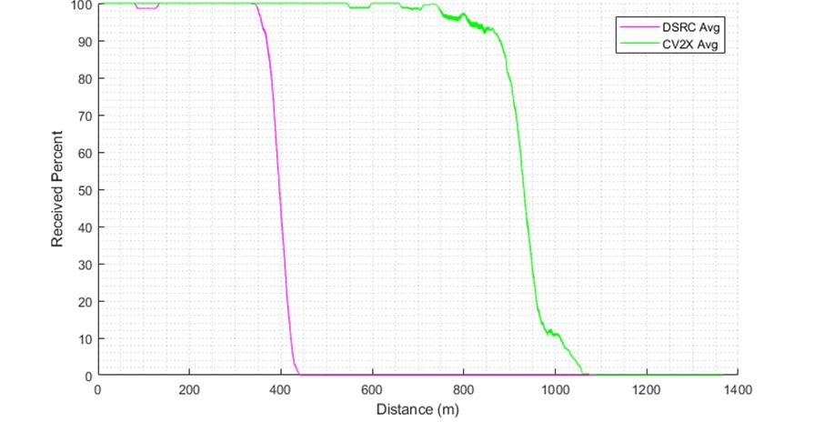
Figure 4: Intersection Test with Obstructed View in a scenario in which a stationary vehicle is receiving communications and the vehicle moving lateral across the intersection is transmitting communications.

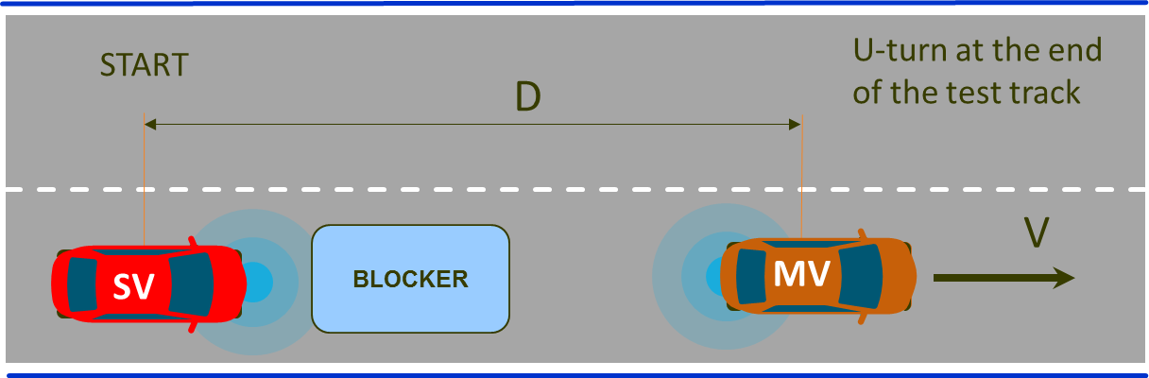
Shadowing Field Test. 5GAA’s shadowing test assessed the capability for V2V message exchange in non-line of sight scenarios in which there is a significant obstruction between the vehicles trying to communicate with one another. In this scenario, which is illustrated in Figure 5 below, the stationary vehicle and blocker remain motionless while the moving vehicle travels away from the blocker.
Figure 5: Shadowing Test in a scenario in which a stationary blocker is positioned in front of a stationary vehicle (SV) that is transmitting to a vehicle moving (MV) away from the SV and blocker. In this scenario, the blocker creates a significant line of sight obstruction between the vehicles.

In the shadowing test scenario, C-V2X peer-to-peer mode communications once again outperformed DSRC by a wide margin. As illustrated in Figure 6 and discussed in detail at pages 79-83 of the 5GAA Test Report, C-V2X achieved a reliable range of approximately 425 meters, compared to DSRC’s reliable range of only 125 meters. In other words, the testing

results indicate that C-V2X delivers superior transmission reliability at almost three times the range of DSRC in this scenario. As discussed in greater detail below, the results of the shadowing field testing, which are depicted in Figure 6, and the intersection test with an obstructed view are significant because they demonstrate the potential of C-V2X to provide vehicles with information about the surrounding environment that cannot be seen by the driver and that may not be detected by current in-vehicle camera and sensor-based technologies.
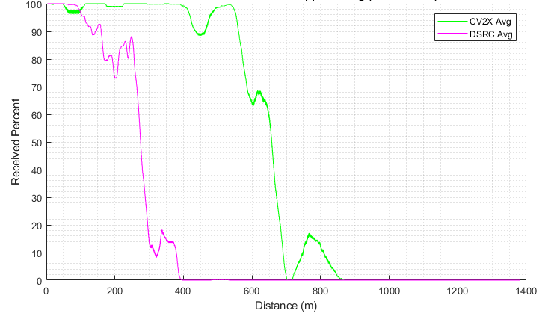
Figure 6: Shadowing Test results in a scenario in which a blocker is positioned in front of a stationary vehicle to create a significant line of sight obstruction.

C-V2X’s Superior Resiliency to Interference

5GAA’s testing also demonstrates a significant advantage for C-V2X in its resilience to out of band interference. In one scenario, line-of-sight range for C-V2X and DSRC was measured while a wireless hot spot operated in an adjacent channel. As demonstrated in Figure 7 and discussed in detail at pages 79-83 of the 5GAA Test Report, C-V2X once again demonstrated a significant advantage with a reliable range of more than seven times that of DSRC.

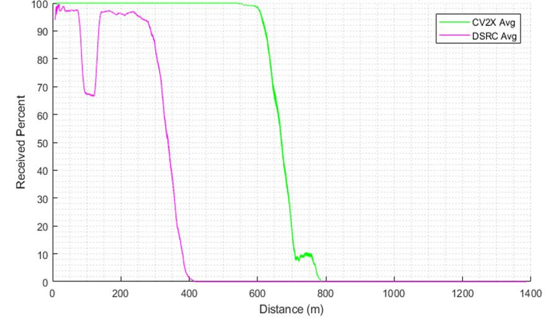
Figure 7: Line-of-sight range with out of band interference was measured in a scenario in which a moving, transmitting vehicle approached a stationary vehicle while a Wi-Fi hotspot using an 80 MHz channel operated with a 40 MHz separation to the C-V2X or DSRC operations.21

V2X’s Congestion Control

5GAA’s testing also confirms C-V2X’s ability to implement congestion control. As demonstrated more fully in the 5GAA Test Report, testing indicates that C-V2X can implement communications congestion control in accordance with the industry standard specified by the SAE, which was designed specifically for DSRC. By employing additional congestion
management techniques, C-V2X is likely to demonstrate performance that exceeds the SAE standards.22
  - The Performance Advantages of C-V2X Peer-to-Peer Mode, Which are Further Augmented by V2N Mode Capabilities, Can Help Unlock Safety and Other Benefits on America’s Roads

The performance advantages of C-V2X peer-to-peer mode can help unlock improvements in a variety of ITS applications and in a variety of different scenarios (e.g., varying road/traffic

21 The initial dip observed in DSRC performance is a consequence of out-of-band emissions, which effectively raise the floor of receiver sensitivity and amplify the effect of reflected-ray destructive interference. This is not observed in C-V2X results because of C-V2X’s higher link-budget. The importance of such resiliency in a world where Wi- Fi presence will be pervasive cannot be understated.
22 For example, C-V2X can manage radio resources at a more granular level as channel widths increase, which holds the promise to enable further improvements in C-V2X’s implementation of congestion control.

conditions and vehicle speeds). With C-V2X, drivers and vehicles will have access to a more complete and accurate picture of the surrounding road environment. For example:
  - C-V2X’s improved non-line-of-sight performance allows vehicles and drivers to “see” more clearly through obstructions and further around corners, providing an earlier, more expanded view of the surroundings;23

C-V2X’s enhanced reliability provides more certainty that critical safety messages reach their intended destination at a much greater communications range;24

  - C-V2X’s superior resiliency to out of band emissions provides a more dependable performance for vehicles and drivers;

C-V2X’s higher capacity to transmit data, a feature expected in future versions of C- V2X, will allow more and higher quality information to reach the driver and vehicle; and

  - C-V2X’s communications congestion control in traffic jams and other scenarios in which there is a high volume of vehicles in the same vicinity helps to ensure more consistent performance.25

These unique characteristics will translate into a variety of societal benefits. For example, the performance advantages of C-V2X peer-to-peer mode was a key factor contributing to a recent analysis published by 5GAA estimating that thousands more lives could be saved and tens of thousands – if not hundreds of thousands – of serious injuries avoided over a 22 year period if C- V2X were to be deployed in Europe.26
C-V2X’s performance advantages over DSRC are particularly important in non-line-of-

sight scenarios (e.g., around corners, around large trucks, etc.). Current and near-term in-vehicle camera and sensor-based technologies experience limitations in these scenarios. C-V2X’s non-
23 See 5G Americas White Paper, supra note 18, at 21-22.
24 See id.
25 See id. at 22.
26 See 5GAA, An assessment of LTE-V2X (PC5) and 802.11p direct communications technologies for improved road safety in the EU, at 22 (Dec. 5, 2017), http://5gaa.org/wp-content/uploads/2017/12/5GAA-Road-safety-FINAL2017- 12-05.pdf (“The modelling indicates that LTE-V2X (PC5) has a superior radio performance, particularly in dense urban settings with large numbers of competing vehicles, and in high speed roads. The superior reliability of LTE- V2X (PC5) results in a higher number of avoided fatalities and serious injuries compared to 802.11p….”).

line-of-sight performance advantage over DSRC thus may allow vehicles to perceive and provide earlier warnings of threats hidden from detection by current and near-term vehicle-resident technologies. Such warnings are particularly useful near intersections and in highway passing and braking scenarios. Indeed, as referenced in Section II, NHTSA repeatedly has endorsed the potential of V2V ITS technologies to help address crashes in scenarios such as these.27
The performance advantages of C-V2X peer-to-peer mode are further augmented by C-
V2X’s V2N mode communications. V2N mode communications play an important complementary role to peer-to-peer mode communications by, among other things, providing the ability to offload less time-sensitive V2V, V2I, and V2P communications to the cellular network during times of peak congestion.28 This offloading feature increases the reliability of C-V2X’s peer-to-peer mode communications, enhancing the effectiveness of critical time-sensitive services enabled by C-V2X. In addition, vehicles will be able to unlock a host of new applications by utilizing C-V2X’s V2N mode to communicate with almost anyone at any time.

This V2N mode functionality would allow, for example, integration with smart-city and other connected transportation initiatives that also use cellular technology.29
These capabilities allow C-V2X to support all of the V2V and V2I applications identified by NHTSA in its 2016 notice of proposed rulemaking on V2V communications.30 All told, the safety, efficiency, mobility, and environmental benefits resulting from these capabilities are

27 See supra pp. 4-5. See also, e.g., Federal Motor Vehicle Safety Standards, 82 Fed. Reg. at 3855 (“This ability to communicate certain information that cannot be acquired by vehicle-resident onboard sensors makes V2V particularly good at preventing impending intersection crashes, such as when a vehicle is attempting to make a left turn from one road to another.”).
28 Rebbeck, supra note 17, at 2.
29 Id.
30 See Federal Motor Vehicle Safety Standards, 82 Fed. Reg. 3854.

grant of the requested waiver, and ultimately changes to modernize the Commission’s rules, the benefits of C-V2X will only increase in a 5G world.
- C-V2X’s Evolutionary Path to 5G and Subsequent Wireless Generations Will Help to Amplify and Expand Upon the Safety and Other Benefits Enabled by C-V2X Services

Fifth-generation wireless technologies will enable transformative societal benefits in a wide range of areas. With data speeds of 100Mbit/s or more, ultra-low latency of a few milliseconds or less, extremely high reliability, and massive capacity, 5G will spur the development of myriad innovative applications that will revolutionize a broad range of industries, transforming the way we work, learn, and get around. The transportation industry – and specifically the automotive industry – is widely viewed as one of the key sectors that will benefit from 5G capabilities and services. For this reason, C-V2X is designed with a clear path to 5G, subsequent 5G advances, and subsequent wireless generations.
While the initial 3GPP standards specify a 4G LTE-based version of C-V2X peer-to-peer mode, work is already underway to develop 5G C-V2X peer-to-peer mode. The specifications for the first version of 5G-based C-V2X are expected to be finalized as soon as next year.
Because C-V2X peer-to-peer mode was developed with an evolution path to 5G,32 all future

versions of C-V2X are expected to be functionally backward compatible with earlier versions,

31 In addition, C-V2X peer-to-peer communications will benefit from established and developing security and transport layers and application protocols defined by the automotive standards communities, including the SAE, International Organization for Standardization, European Telecommunications Standards Institute, and Institute of Electrical and Electronics Engineers. C-V2X network communications will be able to reuse various security components that are already implemented in cellular networks. Working in concert, these security components will help to ensure robust security for C-V2X communications.
32 3GPP, Release 14, supra note 14; see also Rebbeck, supra note 17, at 1.

introduced, new vehicles will be able to communicate with older versions of C-V2X-enabled vehicles, infrastructure, and networks, effectively future-proofing the technology by ensuring seamless communications between all enabled devices.34 Thus, as the commercial wireless industry evolves to 5G, C-V2X peer-to-peer mode can and will evolve as well – adding 5G capabilities to C-V2X communications.35
This evolutionary path will allow C-V2X to unlock the power of 5G technologies, driving further improvements in performance, introducing new capabilities to connected vehicles and infrastructure, and extending the number of use cases for C-V2X. 5G C-V2X peer-to-peer mode communications, for example, will use advanced radio technologies such as massive MIMO and beamforming to achieve ultra-low latency and ultra-high capacity capabilities.36 With respect to
5G-enabled V2N and V2I, the combination of high-bandwidth operations and edge computing

capabilities will allow for the movement of larger amounts of data, over shorter distances, in smaller amounts of time, maximizing the safety benefits of C-V2X.37
While the applications for 5G C-V2X likely will expand in ways that are difficult to predict, 5GAA is aggressively exploring 5G C-V2X’s role in advanced driving applications. For example, C-V2X will complement and augment advanced driving applications that enhance semi-automated or fully-automated driving features (likely with the assistance of vehicle-

33 Rebbeck, supra note 17, at 21 (noting that 3GPP Release 16, which is expected in 2019, will consider the specifications for 5G C-V2X).
34 See id. at 30.
35 See id. at 13.
36 5G Americas White Paper, supra note 18, at 14.
37 5GAA White Paper, Toward fully connected vehicles: Edge computing for advanced automotive communications, at 6 (Dec. 2017), http://5gaa.org/wp-content/uploads/2017/12/5GAA_T-170219-whitepaper-EdgeComputing_- 5GAA.pdf.

mounted radar and other sensors) by coordinating the behaviors of vehicles. These applications allow a vehicle to share the trajectory data obtained from its local sensors with vehicles in its proximity. In addition, vehicles will be able to share their future intentions (i.e., lane changes, etc.) and engage in persistent information exchanges with vehicles in their proximity. Such exchanges will involve extended sensor data. Extended sensor applications allow vehicles to obtain information about objects around them located beyond the view of their own onboard sensors. These applications accomplish this by sharing sensor data (for example, data obtained from cameras, radar, and LIDAR) with nearby vehicles, providing a more complete picture of road and traffic conditions. Successful implementation of these extended sensors applications
will require the type of ultra-low latency and ultra-high data rate communications supported by 5G capabilities.38
To enable these types of advanced driving applications, initial research suggests that the communications requirements will include high bandwidth to support burst transmission of large quantities of data, 99.99 percent message reliability for highest degree of automation, and 10 ms latency for the highest degree of automation.39 These types of communications may only be possible with 5G C-V2X capabilities.
- C-V2X’s Unique Cost Efficiency Supports an Accelerated Timeline for Deployment

Of course, to maximize the safety and other societal benefits resulting from C-V2X services, the technology must be deployed commercially. C-V2X offers a unique cost efficiency that supports deployment on an accelerated timeline. This cost efficiency is based on a number of factors.

38 5G Americas White Paper, supra note 18, at 24-25.
39 Id. at 24.

First, C-V2X technology can be economically integrated into vehicles. In response to the overwhelming consumer demand for cellular-connected vehicles, virtually all new vehicles are or soon will be equipped with cellular modem chipsets.40 C-V2X can be added as an additional feature in these chipset products, lowering bill of materials costs, simplifying the supply chain and logistics, and reducing vehicle maintenance costs.41 These savings can be significant.
Second, C-V2X can leverage today’s cellular networks and tomorrow’s 5G networks to reduce infrastructure deployment costs. By re-using existing commercial mobile infrastructure in certain situations, C-V2X can offer enhanced functionality and increased reliability at reduced costs. The opportunities for cost-saving synergies will further increase with the deployment of
5G networks, which is expected to see an additional $275 billion of investment in the coming years.42
Third, C-V2X’s evolutionary path to 5G will help accelerate the development of a market for C-V2X, creating economies of scale and driving down costs. This path to 5G will ensure that future versions of C-V2X modules remain functionally backwards compatible with the current

40 See e.g., Press Release, Ford, Ford Readies North America’s Freshest Lineup By 2020 With Onslaught Of Connected New Trucks, SUVs And Hybrids (Mar. 15, 2018), https://media.ford.com/content/fordmedia/fna/us/en-
/news/2018/03/15/ford-readies-north-americas-freshest-lineup-by-2020.html (Ford announcing that all new Ford vehicles will have 4G LTE connectivity by the end of 2019); AT&T, Connected Car News, http://about.att.com-
/sites/internet-of-things/connected_car (last visited Nov. 19, 2018) (noting that AT&T has 21 million connected cars and 3.2 connected fleet vehicles on its network); Daimler, Daimler’s Perspective on Car-to-X Technologies (5GAA member), at 2 (June 2018), http://5gaa.org/wp-content/uploads/2018/06/5.-Daimler-view-on-V2X-5GAA-Policy- Debate.pdf (noting 90% of new Mercedes-Benz cars are already connected worldwide); Kristen Hall-Geisler, More cars than phones were connected to cell service in Q1, TechCrunch (June 20, 2016), https://techcrunch.com/2016/- 06/20/more-cars-than-phones-were-connected-to-cell-service-in-q1 (in the first quarter of 2016, connected cars accounted for a third of all new cellular devices); Press Release, Gartner, Gartner Says Connected Car Production to Grow Rapidly Over Next Five Years (Sept. 29, 2016), https://www.gartner.com/newsroom/id/3460018 (calculating how there will be approximately 120 million connected vehicles on the road globally by 2020).
41 NGMN Alliance, supra note 13, at 42-43.
42 Accenture Strategy, How 5G Can Help Municipalities Become Vibrant Smart Cities, at 1 (Jan. 2017), https://newsroom.accenture.com/content/1101/files/Accenture_5G-Municipalities-Become-Smart-Cities.pdf.

versions of this technology,43 providing consumers, automakers, roadway operators, infrastructure providers, and network operators with the assurance that C-V2X products purchased today will retain functionality in the future. In turn, C-V2X may even accelerate the deployment of 5G wireless networks. With the opportunity to connect with 5G C-V2X-equipped vehicles, mobile network operators and roadway operators may see incentives to speed the deployment of 5G networks, creating a self-reinforcing spiral of investment in both 5G networks and 5G C-V2X.
Fourth, the growing momentum towards the adoption of C-V2X internationally will further increase economies of scale, driving down the cost curve for this technology. As reflected in 5GAA’s rapidly growing membership, many of the world’s major automotive, technology and telecommunications companies are seriously exploring – if not committed to – the deployment of C-V2X.44 In addition, the Chinese Ministry of Industry and Information
Technology already has allocated spectrum for C-V2X, and regulators in other parts of the world

are contemplating similar action.45 This international momentum will grow as automobile manufacturers, technology companies, mobile network operators, and governments continue to demonstrate the superior performance capabilities of C-V2X in tests and trials around the globe.46

43 Rebbeck, supra note 17, at 2 (citing the certainty of C-V2X’s future evolution to 5G as facilitating earlier deployment and after-market deployment).
44 Similarly, the Next Generation Mobile Alliance, a forum founded by world-leading mobile network operators, recently created a C-V2X task force to, among other things, accelerate the global deployment of C-V2X technology. NGMN Alliance, supra note 13, at 8.
45 See Ministry of Industry and Information Technology of the People’s Republic of China, MIIT (2018) No. 203 regulation (Nov. 2018). See also TU Automotive, C-V2X’s Momentum in China May Drive Connected-Car Development (Nov. 7, 2018), https://www.tu-auto.com/c-v2xs-momentum-in-china-may-drive-connected-car- development/.
46 See Appendix C.

    - The Commission Should Grant a Waiver of Its Rules to Expedite the Deployment of C-V2X

In light of the transformational effect C-V2X is expected to have on motor vehicle travel, 5GAA requests that the Commission grant a blanket waiver, with conditions, of footnote NG160 to Section 2.106 of the Commission’s rules47 to allow for the near term deployment of C-V2X in 5905-5925 MHz.48 The proposed waiver conditions set forth in Appendix D are narrowly
constructed to allow for the introduction of C-V2X services in the near term during the pendency of the Commission’s broader rulemaking. To be clear, 5GAA is not seeking access to the full
  - GHz band under this waiver request. Rather, 5GAA is merely seeking access to the 5.905- 5.925 GHz frequency range to begin C-V2X operations as soon as possible.49 Significantly, as noted below, 5GAA has crafted this Waiver Request to ensure that C-V2X deployment under the requested relief should have no significant impact on any existing DSRC operations in the band.
The requested waiver will allow for basic C-V2X services, which will support V2V and V2I messages that enable many important safety applications, such as red light warnings, basic

47 47 C.F.R. § 2.106, NG160 (“In the 5850–5925 MHz band, the use of the non-Federal government mobile service is limited to Dedicated Short Range Communications operating in the Intelligent Transportation System radio service.”).
48 5GAA has structured this request as a waiver of footnote NG160 in part because, as noted previously, the Commission’s Dedicated Short Range Communications Service has been conflated with the IEEE 802.11p standard, which in turn is based on the ASTM E2213-03 standard. As a result, a waiver permitting C-V2X operations under the Dedicated Short Range Communications Service may cause confusion to the public. To the extent that the Commission finds that waiver of specific rules within Part 90 and 95 are more appropriate in this context, 5GAA requests waiver of Sections 90.375, 90.377, 90.379, 95.3159, 95.3163, 95.3167, 95.3189, and any others the
Commission views as barriers for the deployment of C-V2X. 47 C.F.R. §§ 90.375, 90.377, 90.379, 95.3159,
95.3163, 95.3167, 95.3189.
49 Granting C-V2X permission to operate on a 20 MHz channel will enhance C-V2X’s ability to implement congestion control, should help improve its resiliency to out of band interference, and will enable capacity to adjust dynamically between V2V and V2I applications in any given location, depending on usage. A 20 MHz channel allows for soft multiplexing of the various peer-to-peer mode communications supported by C-V2X. The communications system therefore will dynamically adjust to the capacity demands, ensuring a high reliability for message delivery. While the 5GAA Test Report reflects testing performed on a 10 MHz channel, 5GAA members have validated C-V2X operation in a 20 MHz channel in laboratory tests and are planning to conduct additional field tests using a 20 MHz channel in the very near future. Congestion control test results are expected to improve when utilizing a 20 MHz channel because a wider channel naturally accommodates more simultaneous users. In addition, resiliency test results using 20 MHz may similarly improve due to C-V2X’s channel sensing, which will choose less polluted parts of the channel for message transmission.

5GAA’s forthcoming petition for rulemaking will request that the Commission initiate a rulemaking to modernize the 5.9 GHz band to enable advanced C-V2X services, which will support the delivery of 5G C-V2X applications. To unleash these advanced features, 5G C-V2X will need to access much more spectrum in the 5.9 GHz band than the 20 MHz that are the subject of this Waiver Request.
    - The Good Cause Standard

The Commission is authorized to waive its rules where the petitioner demonstrates good cause for such action.51 Good cause may be found where “particular facts would make strict compliance inconsistent with the public interest.”52 In making this determination, the Commission may “take into account considerations of hardship, equity, or more effective implementation of overall policy.”53 To satisfy the public interest requirement, “the waiver cannot undermine the purposes of the rule, and there must be a stronger public interest benefit in granting the waiver than in applying the rule.”54 The Commission has also found that a waiver request satisfies its public interest requirement where it would serve some larger public interest

50 The requested waiver will enable basic C-V2X services, which will support V2V and V2I messages such as the Basic Safety Message, Signal Phase and Timing, Emergency Vehicle Alert, Probe Data Management, Probe Vehicle Data, Signal Request Message, Signal Status Message, Geometric Intersection Description, Traveler Information Message, & others encompassed by the Road Safety Message.
51 Northeast Cellular Telephone Co. v. FCC, 897 F.2d 1164 (D.C. Cir. 1990); WAIT Radio v. FCC, 418 F.2d 1153 (D.C. Cir. 1969).
52 Northeast Cellular, 897 F.2d at 1166; see also ICO Global Communications v. FCC, 428 F.3d 264, 269 (quoting Northeast Cellular); WAIT Radio, 418 F.2d at 1157-59; Deere & Company Request for Limited Waiver of Part 15 Rules for Fixed White Space Device, Order, 31 FCC Rcd 2131, 2134 ¶ 8 (OET 2016) (“Deere Order”) (quoting Northeast Cellular).
53 WAIT Radio, 418 F.2d at 1159.
54 Deere Order, 31 FCC Rcd at 2134 ¶ 8; see also WAIT Radio, 418 F.2d at 1157 (stating that even though the overall objectives of a general rule have been adjudged to be in the public interest, it is possible that application of the rule to a specific case may not serve the public interest if an applicant’s proposal does not undermine the public interest policy served by the rule); Kyma Medical Technologies Ltd., Order, 31 FCC Rcd 9705, 9707 ¶ 5 (OET 2016) (“Kyma Order”).

strict application of the rule in question.55

    - Good Cause Exists for the Grant of the Requested Waiver

      - A Grant of the Requested Waiver is in the Public Interest Because it Will Expedite the Availability of ITS Services

For decades, Congress, the DOT, and the Commission have acknowledged the life-saving and societal benefits of connected vehicle technologies. ITS traces its modern day origins to the mid-1980s, when the DOT, in partnership with state departments of transportation, academia, and industry, began evaluating how to incorporate communication technology into transportation infrastructure to improve safety, mobility, and emissions.56 Shortly thereafter, in the Intermodal Surface Transportation Efficiency Act of 1991 (“ISTEA”), Congress established a national program within the DOT for the development of ITS, which Congress identified as a means to improve traveler safety, decrease traffic congestion, facilitate the reduction of air pollution, and conserve vital fossil fuels by incorporating technology and advanced electronics into the nation’s transportation infrastructure.57 The passage of ISTEA represented the first in a sequence of

55 Kyma Order, 31 FCC Rcd at 9707 ¶ 5. See also Amendment of Part 15 of the Commission’s Rules To Establish Regulations for Tank Level Probing Radars in the Frequency Band 77-81 GHz, Notice of Proposed Rulemaking, 25 FCC Rcd 601, 612 ¶ 31 (2010) (“77-81 GHz NPRM”); Deere Order, 31 FCC Rcd at 2138 ¶¶ 15-16.
56 See Federal Motor Vehicle Safety Standards, 82 Fed. Reg. at 3867 (discussion of the history of V2V research).
57 Intelligent Vehicle-Highway Systems Act, Pub. L. No. 102-240 § 6052 (b), 105 Stat. 1914, 2189-90 (1991), https://www.gpo.gov/fdsys/pkg/STATUTE-105/pdf/STATUTE-105-Pg1914.pdf. The DOT embraced Congress’ approach:
Surface transportation systems – the networks of highways, local streets, bus routes, and rail lines – are the ties that bind communities and facilitate commerce, connecting businesses and residents to work, homes, schools, services, and each other. During the past 20 years, however, transportation systems have struggled to keep pace with Americans’ growing and changing travel needs …. Rather than continuing to rely simply upon quantitative additions to the existing transportation infrastructure, Congress has chosen to also emphasize the use of technology to improve the performance of that infrastructure.
Comments of the U.S. Department of Transportation, ET Docket No. 98-95, at 2 (filed July 28, 1997), https://ecfsapi.fcc.gov/file/1879770001.pdf.

Commission’s allocation of the 5.9 GHz band for ITS.60 In the Allocation Report and Order, the Commission found that the ITS allocation would “further the goals of the United States Congress and the Department of Transportation to improve the efficiency of the Nation’s transportation infrastructure and will facilitate the growth and development of the ITS industry.”61
Today, the need for ITS has only increased. Hundreds of Americans are losing their lives

every day on our nation’s roadways,62 with millions more being injured annually in motor vehicle accidents.63 More and more road use has contributed significantly to increased traffic congestion, higher energy consumption and worsening pollution.64 Furthermore, millions of

58 See, e.g., Transportation Equity Act for the 21st Century, Pub. L. No. 105-178, 112 Stat. 107 (1998), https://www.congress.gov/105/plaws/publ178/PLAW-105publ178.pdf.
59 For example, in 1994, the DOT officially sanctioned the term “ITS” as a replacement for “IVHS,” or “Intelligent Vehicle Highway System,” and established the ITS Joint Program Office to oversee and manage a national ITS program. See Ashley Auer, Shelley Feese, and Stephen Lockwood, History of Intelligent Transportation Systems, at 15, U.S. Department of Transportation, ITS Joint Program Office (May 2016), https://rosap.ntl.bts.gov/view/dot-
/30826. In 1998, the DOT’s Intelligent Vehicle Initiative Program was established to help develop driver assistance products and reduce the number and severity of vehicular collisions. Id. at 26. The following year, the DOT established a Commercial Vehicle Information Systems and Networks Grant Program to support states in the deployment of advanced technologies in safety information exchange, electronic credentialing, and electronic screening. Id. at 16.
60 See Amendment of Parts 2 and 90 of the Commission’s Rules to Allocate the 5.850-5.925 GHz Band to the Mobile Service for Dedicated Short Range Communications of Intelligent Transportation Services, Report and Order, 14 FCC Rcd 18221 (1999) (“Allocation Report and Order”).
61 Id. at 18221 ¶ 1.l.
62 Press Release, NHTSA, USDOT Releases 2016 Fatal Traffic Crash Data (Oct. 6, 2017), https://www.nhtsa.gov/- press-releases/usdot-releases-2016-fatal-traffic-crash-data.
63 NHTSA, Summary of Motor Vehicle Crashes (Sept. 2018), https://crashstats.nhtsa.dot.gov/Api/Public/ViewPublication/812580.
64 Martin Knopp, America’s Drivers Continue to Spend More Time Stuck in Traffic, 2016 Data Shows, Connections
– U.S. Department of Transportation Blog (June 12, 2017), https://www.transportation.gov/connections/america-
%E2%80%99s-drivers-continue-spend-more-time-stuck-traffic-2016-data-shows (“[D]rivers are spending more time stuck in rush-hour traffic than ever.… Congestion got worse [from 2016 to 2017] during peak hours in 2016, as represented by the Travel Time Index which compares peak hour or commuter travel times to free flow travel times. The index increased slightly to 1.35 in 2016 from 1.34 in 2015, meaning that a trip taking 10 minutes in free-flow traffic would now take 13.5 minutes during peak hours.”); U.S. Environmental Protection Agency, Inventory of U.S. Greenhouse Gas Emissions and Sinks (1990-2016), at 2-11 (April 12, 2018), https://www.epa.gov/sites/production-
/files/2018-01/documents/2018_complete_report.pdf (“Emissions from petroleum consumption for transportation have increased by 21.7 percent since 1990, which can be primarily attributed to a 48.0 percent increase in vehicle

elderly and disabled Americans continue to struggle to find reliable and affordable mobility options.65 In the face of these challenges, the DOT and NHTSA continue to stress the importance of deploying ITS technologies that leverage the 5.9 GHz band.66
Grant of the requested waiver would help to further the vision of ITS in the 5.9 GHz band and respond to the societal needs that Congress, the Commission, the DOT, and NHTSA repeatedly have identified over the better part of the past three decades. Most importantly, the waiver grant is expected to enable important safety benefits. As demonstrated in the 5GAA Test Report, C-V2X peer to-peer mode promises advantages that will help realize the benefits of ITS technology, advantages which are augmented by C-V2X’s V2N mode. Particularly important in non-line-of-sight scenarios (e.g., around corners and around large trucks, etc.), these advantages enable a host of applications that will help to provide drivers and vehicles access to a more complete and accurate picture of the surrounding road environment. These characteristics contributed to an estimate by 5GAA that thousands more lives could be saved and tens of thousands – if not hundreds of thousands – of serious injuries avoided over a 22 year period if C- V2X were to be deployed in Europe. Grant of the requested waiver will enable the deployment of C-V2X in the United States, allowing for the realization of similar projected safety benefits for American drivers, passengers, pedestrians, and cyclists.
The waiver will help to enable other important public interest benefits as well. Because C-V2X was designed to meet all of the V2X applications designed by the ITS community, C-

miles traveled (VMT) over the time series.… Total transportation sector CO2 emissions have increased by 5.2 percent since 2010.”).
65 National Aging and Disability Transportation Center, Travel Patterns of American Adults with Disabilities, (Nov. 8, 2018) https://www.nadtc.org/news/blog/travel-patterns-of-american-adults-with-disabilities/ (showing that there are over 25 million Americans who have self-reported travel-limiting disabilities).
66 See, e.g., U.S. Department of Transportation, Preparing for the Future of Transportation: Automated Vehicles 3.0 (AV 3.0), at 16 (Oct. 4, 2018), https://www.transportation.gov/sites/dot.gov/files/docs/policy-initiatives/-automated- vehicles/320711/preparing-future-transportation-automated-vehicle-30.pdf.

V2X can enable ITS applications that will improve traffic efficiency and productivity, facilitate the reduction of air pollution, and help to conserve vital fossil fuels. In addition, as other countries, including China, dedicate spectrum for the deployment of C-V2X, the waiver grant will both ensure that Americans have access to the same modern ITS technologies as are available in other parts of the world and help to facilitate the growth of the ITS industry in America. And, because C-V2X can be economically deployed, a waiver grant likely will enable consumers to benefit from ITS technology at lower societal costs and on an expedited timeframe.
Finally, a waiver grant prior to the adoption of final rules modernizing the 5.9 GHz band is supported by both Commission precedent and the instant facts.67 An expedited waiver will allow for the immediate deployment of new and improved safety and efficiency services enabled by C-V2X. Moreover, while there will be many near-term benefits during the early stage deployment of C-V2X-equipped vehicles, the benefits of V2V ITS technologies will grow as the
percentage of vehicles equipped with C-V2X increases. With C-V2X chipsets available commercially beginning in early 2019, a grant of the requested waiver can expedite C-V2X achieving critical mass in the vehicle fleet deployed on America’s roads.
      - The Requested Waiver Would Advance, Rather than Undermine, the Underlying Policy Which the Rule in Question is Intended to Serve

The requested waiver is expected to help further the underlying policy objectives of the ITS rules in the 5.9 GHz band. When the Commission adopted the ITS allocation and then service rules limiting operations in the 5.9 GHz band to the use of DSRC technology – the only short-range vehicular ITS technology available at the time – it did so for the primary purpose of
67 The Commission has granted waivers to expedite the deployment of new technologies prior to the adoption of final rules in numerous other instances. See, e.g., 77-81 GHz NPRM, 25 FCC Rcd at 610 ¶ 25 (granting a waiver to allow for the utilization of new radar technology during the pendency of a rulemaking in which the Commission proposed rules that would allow the use of such technology); iRobot Corporation Request for Waiver of Section
15.250 of the Commission’s Rules, Order, 30 FCC Rcd 8377 (OET 2015) (granting a waiver to enable the deployment of new technology with the potential of offering safety and environmental benefits).

improving vehicular safety and travel while preventing interference to other authorized users of the band.68 Grant of the requested waiver will advance, rather than frustrate, these policy objectives.
By granting the requested waiver, the Commission will further the objective of improving vehicular safety and travel by enabling the deployment and availability of ITS services. As previously explained, C-V2X technology offers capabilities that can enable new and improved ITS services,69 featuring a cost efficiency that supports an accelerated timeline for deployment,70 and presents a path to 5G that will greatly expand and enhance C-V2X services in the future.71
In short, C-V2X is poised for deployment, which will enable the safety, efficiency, and other societal benefits envisioned by the Commission when it adopted the ITS allocation and service rules for the band.
Moreover, a grant of the waiver request will enable robust ITS communications. Industry members from across the ITS ecosystem stand ready to deploy C-V2X technology. 72 The very creation of 5GAA, the exponential growth in membership over a relatively short time, and the investments made by members to date underscore this point. Grant of the instant request will provide the regulatory footing to unleash industry’s pent-up eagerness to deploy this

68 See Allocation Report and Order, supra 60, at 18221 ¶ 1.l (discussing the expectation that ITS services will “improve traveler safety” and “decrease traffic congestion”); Amendment of the Commission’s Rules Regarding Dedicated Short-Range Communication Services in the 5.850-5.925 GHz Band (5.9 GHz) Band et al., Report and Order, 19 FCC Rcd 2458, 2461 ¶ 3 (2004) (discussing the important safety functions of short-range ITS services), id. at 2461-62 ¶ 4 (discussing the potential of short-range ITS services to improve the efficiency of America’s surface transportation system) (2004); id at 2470 ¶ 18 (noting “that the record presents no alternative standard”).
69 See supra Section III.A. 70 See supra Section III.C. 71 See supra Section III. B. 72 See Appendix C.

technology.73 Further, under the proposed waiver conditions, C-V2X operations would occur only in the 5.905-5.925 GHz portion of the 5.9 GHz band.74 Because C-V2X and DSRC operations will occur on different channels, each technology will be protected from interference from the other.
In addition, because C-V2X operations will be subject to nearly identical operating parameters as those required of DSRC under the current rules, other non-ITS authorized users of the 5.9 GHz band will not be affected by a grant of the waiver. Specifically, in Appendix D,
5GAA proposes conditions that would impose substantially similar technical and service requirements on C-V2X operations under the waiver grant as those that are currently codified in the Commission’s rules for DSRC operations. As a result, any deployment of C-V2X under the requested waiver will not increase the potential for interference to these other users in the band. A brief analysis of these conditions follows.
Power limits. The proposed transmit power limits for all C-V2X devices permitted under

the waiver (i.e., Vehicular, Portable, and Roadside units) will be 20 dBm antenna input power as specified in § 8.10.1 of ASTM E2213 - 03. The EIRP for an OBU (vehicular and portable) will be limited to 23 dBm. The EIRP for an RSU will be limited to 33 dBm.

73 See, e.g., Qualcomm, 2019 will see commercial C-V2X rollouts throughout the world, OnQ Blog (Nov. 1, 2018), https://www.qualcomm.com/news/onq/2018/11/01/2019-will-see-commercial-c-v2x-rollouts-throughout-world (noting the availability and integration of the 9150 C-V2X chipset solution into infrastructure and vehicles; how Qualcomm partnered with Ford, Panasonic, and the Colorado Department of Transportation, to demonstrate the first production-grade C-V2X system in the U.S.; and how leading connected vehicle and V2X technologies companies in the U.S., such as Savari, Kaspch, and Ficose, plan to include C-V2X technology in their RSUs); 5GAA, Timeline for deployment of LTE-V2X, at 3 (Dec. 18, 2017), http://5gaa.org/wp-content/uploads/2018/02/5GAA_Timeline-for- deployment-of-LTE-V2X_FINAL.pdf (noting that nearly major chipset vendors, such as Intel, Qualcomm, and Samsung are committed to provide C-V2X chipsets).
74 5GAA is aware of pilots involving DSRC Roadside Units which use all or a portion of the 5.905-5.925 frequencies for support. 5GAA will engage in discussions with the parties involved with these pilots to ensure that any operations using any portion of 5905-5925 MHz can either transition to lower DSRC channels or use C-V2X technology.

Emission limits. All C-V2X devices must attenuate out-of-band emissions consistent

with the limits shown below, which may be measured at the antenna input. These are consistent with the existing FCC rules, but allow for the variable transmit power nature of C-V2X, and the planned 20 MHz bandwidth.

Offset from Band Edge | Out-of-Band Emission Limit
± 0 MHz | -29 dBm/100 kHz
± 1.0 MHz | -35 dBm/100 kHz
±10 MHz | -43 dBm/100 kHz
±20 MHz | -53 dBm/100 kHz

These limits are consistent with the current OOBE limits from Class C DSRC devices.

All C-V2X OBUs and RSUs also will limit emissions to -25 dBm/100 kHz EIRP or less outside the channel edges of 5905 MHz and 5925 MHz and below the band edge of 5855 MHz. The -25 dBm/100 kHz EIRP limit comes from § 8.10.2.2 of ASTM E2213 – 03.
RF Exposure. 5GAA proposes that C-V2X devices will be evaluated for RF Exposure

consistent with the current rules. Devices that would operate in mobile or portable configurations will be evaluated consistent with the procedures in § 2.1091 and § 2.1093, respectively, of the Commission’s rules. RSUs will be required to indicate compliance with the Maximum Permissible Exposure limits in § 1.1310 of the Commission’s rules.
Equipment Certification. 5GAA proposes that all equipment subject to the waiver must

be certified in accordance with Subpart J of Part 2 of the Commission’s rules.

Antenna Height for RSUs. 5GAA proposes that an RSU may employ an antenna with a

height not to exceed 8 meters, with the exception that the antenna height may be between 8 and 15 meters provided the EIRP is reduced by a factor of 20 log(Ht/8) in dB where Ht is the height of the radiation center of the antenna in meters above the roadway bed surface. The EIRP is

measured as the maximum EIRP toward the horizon or horizontal, whichever is greater, of the gain associated with the main or center of the transmission beam. The RSU antenna height shall not exceed 15 meters above the roadway bed surface. This proposal is consistent with
§ 90.377(b) of the rules for DSRC RSUs.

Permitted Uses. 5GAA proposes that communications permitted under this waiver will

include messages such as the Basic Safety Message, Signal Phase and Timing, Emergency Vehicle Alert, Probe Data Management, Probe Vehicle Data, Signal Request Message, Signal Status Message, Geometric Intersection Description, Traveler Information Message, and others encompassed by the Road Safety Message.
Licensing. The proposal that On-Board and Portable Units should be licensed by rule is

consistent with the approach used for DSRC On-Board Units. Individuals operating On-Board and Portable Units would not require a station license issued by the FCC.
5GAA proposes that parties desiring to operate RSUs should apply for non-exclusive nationwide licenses with individual site registration through the FCC’s Universal Licensing System (“ULS”). C-V2X RSU operators will comply with the process used by operators of DSRC RSUs detailed in § 9.375(b).
Eligibility to Operate RSUs. 5GAA proposes that any territory, possession, state, city,

county, town or similar governmental entity will be eligible to hold an authorization to operate RSUs. Any entity meeting the eligibility requirements of § 90.33 or § 90.35 would also be eligible to hold an authorization to operate RSUs.
Coordination of RSUs. 5GAA proposes that all RSUs shall not receive protection from

Government Radiolocation services in operation prior to the establishment of the RSU station. Operation of C-V2X RSU stations within 75 kilometers of the locations listed in the table in

§ 90.371 must be coordinated through the National Telecommunications and Information Administration.
RSUs near the U.S./Canada or U.S./Mexico Border. 5GAA proposes that RSUs will be

subject to the international coordination conditions identified in § 90.383 of the FCC Rules.

    - Conclusion

Permitting C-V2X operations in the upper 20 MHz portion of the 5.9 GHz band, subject to the conditions detailed herein, would have substantial, long term benefits without causing a material impact on any current DSRC operations or increasing any risk of interference to other authorized users of the band. Rather than undermine the underlying purpose of the rules, the requested waiver will help facilitate the deployment of robust ITS services to Americans and realize the benefits that Congress, the DOT and the FCC have envisioned for decades: improving traveler safety and mobility, decreasing traffic congestion, facilitating the reduction of air pollution, and conserving vital fossil fuels by incorporating technology and advanced electronics into the nation’s transportation infrastructure.

Based upon the foregoing, 5GAA respectfully requests a blanket waiver of footnote NG160 to Section 2.106 of the Commission’s rules,75 subject to the conditions described in Appendix D, to allow for the deployment of C-V2X technology in the 5.905-5.925 GHz range of
the 5.9 GHz band, and to facilitate the wide-spread deployment of C-V2X technology across America.

Respectfully submitted,

5G Automotive Association

/s/ Sean T. Conway, Esq. Sean T. Conway, Esq.
Kelly A. Donohue, Esq. Mark A. Settle, P.E.

Wilkinson Barker Knauer, LLP 1800 M Street, NW
Suite 800N Washington, DC 20036
(202) 783-4141

Its Counsel

November 21, 2018

75 47 C.F.R. § 2.106, NG160.

Appendix A - 5GAA Membership

Membership list as of October 5, 2018:

- Airgain, Inc.
- Alpine Electronics Inc.
- American Tower Corp
- Analog Devices Inc.
- Anritzu A/S
- AT&T Foundry
- Audi AG
- BAIC Group (Beijing Automotive Group Co., Ltd.)
- Baidu
- Beijing University of Technology
- Bell
- BlackBerry UK Limited
- BMW Group (Bayerische Motoren Werke AG)
- Bosch (Robert Bosch GmbH)
- CATT (China Academy of Telecommunication Technology)
- CETECOM GmbH
- China Mobile
- China Transinfo
- China Unicom (China United Network Communications Group Co.,Ltd)
- China Mobile Research Institute
- Cohda Wireless
- Commsignia Inc.
- Continental Teves AG & Co. oHG
- Daimler AG
- Danlaw Inc.
- Dekra
- DENSO AUTOMOTIVE Deutschland GmbH
- Deutsche Telekom AG
- Dt&C
- Ericsson AB
- Faradai Future
- FarEasTone
- FEV Group GmbH
- Ford
- Fraunhofer Institute
- Geely Auto
- Gemalto SA
- General Motors
- Hirschmann Car Communication GmbH
- Hitachi

- Honda
- Huawei
- Hyundai America Technical Center
- Infineon Technologies AG
- Intel
- InterDigital Communications, Inc.
- Jaguar Land Rover Ltd.
- Juniper Networks
- KDDI
- Keysight Technologies UK Limited
- KT R&D Center
- Laird Bochum GmbH
- Latvijas Mobilais Telefons
- Lear
- LG Electronics Inc.
- Mitsubishi
- Murata Manufacturing
- NavInfo
- Neusoft
- NIO China
- Nissan
- Nokia
- Noris Network AG
- NTT-DoCoMo
- OKI
- Orange SA
- P3 Group
- Panasonic
- Proximus B.V.
- PSA Groupe
- Qualcomm Incorporated
- Rohde & Schwarz GmbH & Co. KG
- Rohm Semiconductor
- SAIC Motor Corporation Limited
- Samsung Electronics Co., Ltd
- Savari Inc.
- SGS
- Shanghai Gotell Communication Technology Holdings Co., Ltd.
- SIAC (Shanghai Int. Automobile City)
- SK Telecom
- Skyworks
- Smart Mobile Labs
- Softbank Corp.
- Sumitomo Electric

- TELEFONICA DIGITAL ESPAÑA SL
- Telekom Austria Aktiengesellschaft
- Telstra
- TELUS
- Terranet, SE
- TÜV Rheinland AG
- Valeo (peiker acustic GmbH & Co.KG)
- Veniam Inc.
- Verizon
- Viavi
- Vodafone Group Services Ltd
- Volkswagen AG
- Volvocars
- VT Direct
- Wistron NeWeb Corp.
- ZF
- ZTE Corporation

Appendix B - 5GAA C-V2X Test Results

1 5GAA P-180106

5GAA

V2X Functional and Performance Test Report; Test Procedures and Results

B-2

Contents

Foreword 4
Introduction 4
      - Scope 4
      - References 5
        - Standards 5
      - Definitions and abbreviations 5
        - Definitions 5
3.3 Abbreviations 6
      - Executive Summary 7
        - Introduction 7
          - Reliability 7
          - End-to-End Latency 8
          - Channel Congestion 8
          - Resilience to Interference 8
          - Shadowing Scenarios 8
          - Near-Far Effect 8
      - Overview of the Test 9
        - KPIs Overview 9
          - Packet Error Rate (PER) 9
          - Packet Reception Rate (PRR) 10
          - Received Signal Strength Indicator (RSSI) 10
          - Inter-Packet Gap (IPG) (Sourced from 5GAA TR P-170142) 10
          - Latency (Sourced from 5GAA TR P-170142) 11
        - Data Post-Processing 11
          - KPI Calculations 12
          - Distance Calculations 12
          - Plotting vs Time 13
          - Plotting vs Distance 13
5.3 Test Classification 13
      - Test Equipment Description and Characterization 15
        - OBUs (Savari MW1000 and Qualcomm Roadrunner platforms) 15
        - In-vehicle setup 16
        - Lab equipment 17
        - Antenna characterization 18
      - Lab Test Procedures and Results 23
        - Introduction 23
          - Common Parameters and Setup 23
          - General guidance on C-V2X and DSRC device RF power management 24
  - AWGN Lab Tests 25
    - Cabled transmission and reception test with varying payload sizes 25
    - Clean channel cabled transmission and reception test across power levels 28
    - Cabled Transmission and Reception Test with added Channel Impairment 35
  - Interference Lab Tests 43
    - Hidden Node Scenario 43
    - Near-Far Effect 51
7.4 Congestion Tests 55
7.4.1 Congestion Control Lab Test 55
- Field Test Procedures and Results 68
  - Introduction 68
  - Hardware Setup 69
  - Field Test Parameters 71
  - Presentation of Results 71
  - Range tests 72
    - Line-of-Sight (LOS) Tests 72
    - Non-Line-of-Sight (NLOS) Range Tests 79
  - Interference tests 87
    - U-NII-3 802.11ac Interference Test and Results 87
    - Adjacent Channel Interference Test and Results 93
8.7 Key Takeaways 98
- Conclusion and Next Steps 100
Annex A: Supplemental Lab Interference Tests 101
  - Interference Lab Test 101
    - Cabled Transmission and Reception Test with Simulated External Interference: flat characteristics, constant in time, occupying part of ITS channel (e.g., channel 172) . 101
    - Cabled Transmission and Reception Test with Simulated External Interference: flat characteristics, constant in time, starting from guard band occupying part of given
ITS channel (e.g., channel 172) 110
Annex B: Supplemental Non-Line-of-Sight Field Tests 117
  - CAMP Shadowing Test 117
Annex C: Latency and IPG Summary Tables 119
Annex D: 5GAA V2X Test Procedures 120
Annex E: Change history 121

Copyright Notification

No part may be reproduced except as authorized by written permission. The copyright and the foregoing restriction extend to reproduction in all media.

Foreword
This Technical Report has been produced by 5GAA.
The contents of the present document are subject to continuing work within the Working Groups (WG) and may change following formal WG approval. Should the WG modify the contents of the present document, it will be re-released by the WG with an identifying change of the consistent numbering that all WG meeting documents and files should follow (according to 5GAA Rules of Procedure):
x-nnzzzz
    - This numbering system has six logical elements:
      - x: a single letter corresponding to the working group: where x =
T (Use cases and Technical Requirements)
A (System Architecture and Solution Development) P (Evaluation, Testbed and Pilots)
S (Standards and Spectrum)
B (Business Models and Go-To-Market Strategies)
      - nn: two digits to indicate the year. i.e. 16,17,18, etc
      - zzzz: unique number of the document

    - No provision is made for the use of revision numbers. Documents which are a revision of a previous version should indicate the document number of that previous version
    - The file name of documents shall be the document number. For example, document S-160357 will be contained in file S-160357.doc

Introduction
Ford and other automotive OEMs are interested in introducing V2V 5.9-GHz radio technology for safety and non-safety applications. Defining radio testing procedures is a prerequisite to comparing the candidate DSRC and C-V2X (PC5) radio technologies and performing validation. This document describes the test procedures and corresponding lab and field tests that were carried out from March through August 2018.

Scope
The present document describes tests and results comparing the two V2X radio technologies operating in the ITS band (5.850 GHz to 5.925 GHz) from the perspective of basic radio KPIs such as Packet Error Rate (PER) or Packet Reception Rate (PRR), latency or application end-to-end delay, Inter-Packet Gap (IPG), and Receive Signal Strength Indicator (RSSI). These tests are described in 5GAA test procedure documentation, but this document describes the test procedures specifically as they were executed in the lab and field environments.

References
The following documents contain provisions which, through reference in this text, constitute provisions of the present document.
  - (5GAA, March 2018) 5GAA TR P-180092, “5G Automotive Association; Working Group Evaluation, test beds and pilots; V2X Functional and Performance Test Procedures – Selected Assessment of Device to Device Communication Aspects”, March 2018.
  - (Parsons, 1994), The Mobile Radio Propagation Channel, Halsted Press: a division of John WILEY and SONS, New York-Toronto, 1994.
  - (USDOT NHTSA, CAMP, September 2011) Vehicle Safety Communications – Applications (VSC- A): Final Report: Appendix Volume 2 - Communications and Positioning, September 2011, DOT HS 811 492C.
  - (USDOT ITS JPO DNPW) Do Not Pass Warning Illustration

(https://www.its.dot.gov/infographs/DoNotPass.htm).
  - (USDOT ITS JPO IMA) I Intersection Movement Assist Illustration (https://www.its.dot.gov/infographs/intersection_movement.htm).
  - (SAE J2945) On-board Minimum Performance Requirements for V2V Safety Communications, Version 1, March 2016.

2.1 Standards

3GPP TS 36.213 Rel 14 | Evolved Universal Terrestrial Radio Access (E-UTRA); Physical layer procedures
3GPP TS 36.331 Rel 14 | Evolved Universal Terrestrial Radio Access (E-UTRA); radio Resource Control (RRC); protocol specification
3GPP TS 36.301 Rel 14 | Evolved Universal Terrestrial Radio Access (E-UTRA); User Equipment (UE) radio transmission and reception

Definitions and abbreviations

3.1 Definitions
For the purposes of the present document, the following definitions apply:
Approaching: Direction of movement of Moving Vehicle (MV) towards the Stationary Vehicle (SV).
MV: Moving Vehicle communicates with the Stationary Vehicle and performs loops on a typically straight stretch of road where the Stationary Vehicle is located.
Receding: Direction of movement of Moving Vehicle away from the Stationary Vehicle.
Sensitivity level of a signal: The lowest receive signal level that allows almost error-free reception. Below this level, the packet reception starts to deteriorate.
SV: Stationary vehicle is positioned on one end of the test track and communicates with the Moving Vehicle.

3.3 Abbreviations
For the purposes of the present document, the following symbols apply:
3GPP 3G Partnership Project (cellular standard organization) AWGN Additive White Gaussian Noise
BLER Block Error Rate
BSM Basic Safety Message
CAMP Crash Avoidance Metric Partnership CBP Channel Busy Period
CBR Channel Busy Ratio
CDF Cumulative Distribution Function
C-V2X Cellular Vehicle-to-Everything
DNPW Do Not Pass Warning
DSRC Dedicated Short-Range Communications (IEEE 802.11p) DUT Device Under Test
FPG Fowlerville Proving Ground HARQ Hybrid Automatic Repeat Request HV Home Vehicle
IEEE Institute of Electrical and Electronics Engineers IPG Inter-Packet Gap (s)
ITS Intelligent Transportation Systems
ITS Band Frequency band for ITS communications (5.850-5.925 GHz in the US) ITT Inter Transmission Time
KPI Key Performance Indicator
LOS Line of Sight
LTE Long Term Evolution (cellular standard organization) MCS Modulation Coding Scheme
MIMO Multiple Input Multiple Output
MV Moving Vehicle
NLOS No Line of Sight
OBE On-Board Equipment
OBU On-Board Unit
OS Operating System
PCS Radio interface between two UEs, also known as Sidelink PER Packet Error Rate (%)
PRB Physical Resource Block
PRR Packet Reception Ratio
PSCCH Physical Sidelink Control Channel (part of PC5) REF Reference Device
RBs Resource Blocks
RSS/RSSI Receive Signal Strength Indicator Rx Receiver
SA Spectrum Analyzer
SAE Society of Automotive Engineers
SG Signal Generator
SNR Signal-to-Noise Ratio
S-RSSI Sidelink RSSI
SPS Semi-Persistent Scheduling
SV Stationary Vehicle
TTI Transmission Time Interval in 3GPP
Tx Transmitter
UE User Equipment (device in 3GPP system)
U-NII Unlicensed-National Information Infrastructure V2I Vehicle-to-Infrastructure
V2N Vehicle-to-Network
V2V Vehicle-to-Vehicle
V2X Vehicle-to-Everything

Executive Summary

Introduction
This report describes the results of tests designed to objectively assess and compare DSRC and Cellular V2X (C-V2X) radio technologies for their suitability to deliver broadcast V2V safety messages. Many of the test results described in this report are traceable to the comprehensive test plan developed within 5GAA (5GAA, March 2018). Furthermore, several other tests were derived from that test plan to examine the effects of congestion control and interfering devices. In all instances, the test methodologies are either from the 5GAA test plan or are documented in this report. Therefore, between this document and the 5GAA test plan, the methodology is available to allow other parties to examine the procedures, understand their suitability, and to be able to reproduce and corroborate the results.
Reliable and timely radio performance is a crucial requirement that the transportation safety stakeholder community, including vehicle manufacturers, road infrastructure owner-operators, standardization bodies and regulators depend on to deliver critical safety applications. The test results reported here are intended to provide this community with an informed basis for making important decisions on the choice of the air interface to deliver standardized messages (e.g., Basic Safety Message or BSM). Therefore, great care was taken in the design, setup and execution of each experiment to ensure that environmental conditions (weather, time of day, temperature), RF parameters (antennas, power, cables), system integration details, and physical setup (track, obstructions, antenna placement) were consistent when comparing DSRC and C-V2X.
The V2V radio performance tests were conducted over a period spanning six months from March through September 2018. The tests included both laboratory and field components. During initial field testing on two automotive test tracks, significant interference was discovered in the ITS band (CH172) coming from devices transmitting in the U-NII-3 band (5.725-5.850 MHz). These tests were redone using the upper portion of the ITS band (CH184). The comparative results from CH184 were consistent with the initial CH172 tests.

Key Takeaways
We make the following observations based on the laboratory and field test results contained in this report.

Reliability
While test results confirm that in ideal conditions, i.e., line of sight RF propagation with no interference and strong received signal level, both V2X technologies reliably deliver BSM payload sizes of 193 bytes with the low end-to-end latencies necessary for vehicular safety applications, test results also reveal a significant reliability performance advantage of C-V2X over DSRC. The observed performance advantage is even more significant in non-ideal scenarios. Non-ideal scenarios that were systematically tested included non-line-of- sight (NLOS) conditions involving fixed and moving obstructions, adjacent and near adjacent channel interference and congestion. These non-ideal scenarios represent real-world vehicular traffic scenarios that must be included in the analysis to facilitate informed decision making. In short, test results indicate that in the presence of signal attenuation from real-world obstructions such as buildings, other vehicles or foliage, C-V2X is more reliable than DSRC in terms of vehicle-to-vehicle communication.
Specifically, in Section 7.2.2 the controlled lab test shows a significant reliability advantage for C-V2X over DSRC in the presence of signal attenuation. In Sections 8.5.1 and 8.5.2, carefully executed field tests show that such advantage translates to 1.7 to 3.4x range advantage in the field. These demonstrated advantages mean enhanced safety for drivers and pedestrians by providing reliable and early alerts even when there are coverage dead spots created by obstructions such as buildings, vehicles, and foliage.

End-to-End Latency
Both C-V2X and DSRC exhibited similar end-to-end application layer latencies under non-congested conditions, and both technologies met the latency requirements for the V2V safety applications defined in SAE J2945/1. Inter-packet gap performance was within 10 ms for both V2X technologies, typically increasing very quickly when the devices went out of range.
Only C-V2X technology was tested for a highly congested scenario in a laboratory setting. Even in the congested scenario, C-V2X latency remained bounded by the 100 ms latency budget configured for that scenario.

Channel Congestion
Robust operation of V2X in dense deployments is a key requirement of the technology. A laboratory test was conducted based on the high-density CAMP scenario [NHTSA-2015-0060] where 576 congesting devices were emulated with a total traffic load of about twice of what could fit into the channel.
The test data in Section 7.4 show that the SAE J2945/1-based congestion control algorithm works well for C- V2X technology. Congesting devices reduce their rate of transmission according to the SAE algorithm, while the devices under test continue to maintain the high packet reception rate.

The data showed that the PER performance of high-priority BSM is noticeably better than lower-priority messages when high attenuations are used, or reception signals are weak.
The reason is that high-priority safety messages can be protected more efficiently for channel-congested and collision scenarios by the C-V2X resource selection algorithm. For actual highly congested deployment scenarios, we expect this packet reception improvement of high-priority BSM to translate to noticeable and meaningful reliability improvement of critical safety messages.

Resilience to Interference
Interference is another major impairment for V2X communications. It arises as other devices in the environment emit RF energy into the V2X channel. These devices can be WiFi devices operating in the UNII-3 band. They can also be V2X devices in the neighbouring channels. The net effect is elevated channel noise level at the V2X receiver. With the interference in close proximity, the improvement in range with U-NII-3 interferer was 2.1x while the improvement with the adjacent DSRC interferer was 3x.

Shadowing Scenarios
A comparison test between DSRC and C-V2X for the shadowing scenarios was repeated for both C-V2X and DSRC. Although the same test was conducted and reported by CAMP in 2011 for DSRC, the test was reproduced for both radios to ensure that results are compared under similar parameters, environmental conditions, and physical setup. It was shown that the shadowing test specified by 5GAA is more demanding than that conducted by CAMP. More importantly, test results under similar conditions showed an approximately 3x range advantage of C-V2X over DSRC.

Near-Far Effect
One of the key features of C-V2X is frequency division multiplexing (FDM). However, because of the potential for transmissions on adjacent subchannels, FDM can lead to the near-far effect. The impact of the near-far effect though is limited by the minimum in-band emissions requirements defined in 3GPP specifications. The data from the near-far test showed that the average leakage of the device under test ~ -35 dB meets the minimum requirements specified in 3GPP Rel 14 TS 36.101 Section 6.5.2G.3.

Summary
Table 1 summarizes the relative performance of the two technologies for the laboratory and field tests defined in the 5GAA test plan.

Table 1: Relative performance of C-V2X and DSRC

Reliability | Lab Cabled Tx and Rx Tests | C-V2X better
 | Field Line-of-Sight (LOS) Range Tests | C-V2X better
 | Field Non-Line-of-Sight (LOS) Range Tests | C-V2X better
Interference | Lab Cabled Test with Simulated Co-Channel Interference | C-V2X better
 | Lab Cabled Near-Far Test | Pass
 | Field Co-existence with Wi-Fi 80 MHz Bandwidth in UNII-3 | C-V2X better
 | Field Co-existing of V2X with Adjacent DSRC Carrier | Pass
Congestion | Lab Cabled Congestion Control | Pass

In summary, the tests confirmed the suitability of C-V2X to deliver broadcast V2X safety messages in a variety of environments, both ideal and adversarial. The tests also showed that C-V2X significantly outperformed DSRC in range and reliability, especially in adversarial scenarios while satisfying the requirements for latency and IPG.

Overview of the Test
This chapter is an overview of the comparative tests and KPIs used in the test.

KPIs Overview
The KPIs used in testing included the Packet Error Rate (PER), Packet Reception Rate (PRR), Received Signal Strength Indicator (RSSI), Inter-Packet Gap (IPG), and Latency. This section defines these KPIs and clarifies the methods for post-processing collected data.

Packet Error Rate (PER)
The PER is the ratio, expressed as a percentage, of the number of missed packets at a receiver from a particular transmitter and the total number of packets queued at that transmitter.
A sliding window PER is used to smooth the sudden fluctuations and obtain an average PER. PER is calculated using the sequence number contained in each message between a receiving Host Vehicle (HV) and a transmitting Remote Vehicle(s) (RV). The PER is calculated and plotted versus time.
Let δ be the PER interval that is divided into sub-windows ω as shown in Figure 1. The width of ω is normally set to 100 ms, which is one BSM sample time. We are currently using 100 ms as this will provide a better resolution of the data results. In Figure 1, δ=n*ω, where n is normally set to a value such that PER interval is 5 seconds (i.e., n is 50). Assume that j is the index of the PER interval occurring at the center of this interval, the number of missed packets and the number of transmitted packets is calculated for that new PER interval
δj.

The PER is then calculated for that index j at the center of each δj, using the surrounding n sub-windows as follows,

𝑚𝑖𝑠𝑠𝑒𝑑 # 𝑜𝑓 𝐵𝑆𝑀𝑠 𝑓𝑟𝑜𝑚 𝑣𝑒ℎ𝑖𝑐𝑙𝑒 𝑖 𝑑𝑢𝑟𝑖𝑛𝑔 [𝜔(𝑗 𝑛)+1 , 𝜔(𝑗 𝑛)]  − +  𝑃𝐸𝑅𝑖(𝑗) = 2 2  𝑡𝑜𝑡𝑎𝑙 # 𝑜𝑓 𝐵𝑆𝑀𝑠 𝑓𝑟𝑜𝑚 𝑣𝑒ℎ𝑖𝑐𝑙𝑒 𝑖 𝑑𝑢𝑟𝑖𝑛𝑔 [𝜔(𝑗 𝑛)+1 , 𝜔(𝑗 𝑛)]  −2 +2 | (1)
Where j ≥ n.
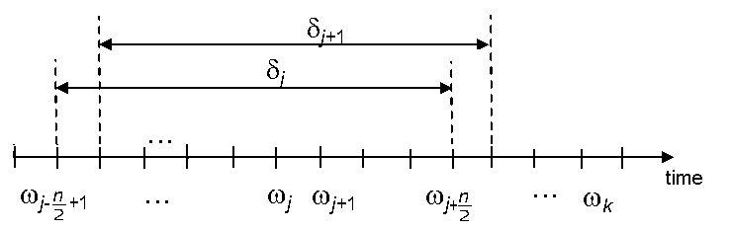

Figure 1: Sliding Window (SAE J2945)

Sliding window PER values are plotted against the duration of the test. In addition, all sliding window PER values are averaged and plotted on the same figure. Note that the PER metric in this case includes:
- Packet loss due to packets that were dropped from the transmit queue because a newer BSM arrived in the queue before the previous BSM could be transmitted due to the medium being busy (the DSRC radio’s clear channel assessment could not detect that the medium was clear for transmitting before the next packet arrived)
- Packets lost over the air due to collisions or insufficient signal strength

Packet Reception Rate (PRR)
The PRR is the ratio, expressed as a percentage, of the number of packets received from a particular transmitter and the total number of packets queued at the transmitter. The PRR is, therefore, the complement of the PER defined in section 5.1.1 and is defined as PRR = 1 – PER.

Received Signal Strength Indicator (RSSI)
For DSRC, RSSI is the Received Signal Strength Indicator. For Cellular, RSSI is the Reference Signal Received Power.
Note that the RSSI is a device self-reported quantity that is both noisy and biased. AGC outputs can differ from one type of radio to another due to (1) RF calibration per unit (2) amplifier noise floor. ADC will add quantization errors. At low received signal levels, thermal noise and other device noise floor start to color and even dominate the reported RSSI values. We have, therefore, observed RSSI reports to be a few dBs off expected signal levels. For these reasons, we view RSSI as a crude metric that is useful for making qualitative observations, but it is not accurate enough for quantitative conclusions.

Inter-Packet Gap (IPG) (Sourced from 5GAA TR P-170142)
The IPG is the time, calculated at the receiver and expressed in milliseconds, between successive successful packet receptions from a particular transmitter. IPG is calculated at the receiver and expressed in milliseconds.

Like the PER, the IPG is calculated between a receiving Host Vehicle (HV) and a transmitting Remote Vehicle(s) (RV) and represents the IPG seen over the entire test run.
Let 𝑟1 denote the Coordinated Universal Time (UTC time) at which the ith message from an RV is received by the HV, and r-1 denote the UTC time at which the (i-1)th message from the RV was received by the HV. Then the IPGi between the (i-1)th message and the ith message is:

𝐼𝑃𝐺𝑖 = 𝑟𝑖 − 𝑟𝑖−1 | (2)

Latency (Sourced from 5GAA TR P-170142)
Latency represents the time interval, expressed in milliseconds, between the time instant when the transmitter application delivers the application layer packet (e.g., BSM) to the lower layers, and the time instant when the application layer packet is received by the application layer at the receiver.
Latency is an important KPI for safety applications. C-V2X is designed for low-latency direct communications. The latency requirements, however, vary from application to application. For example, for today’s ITS applications such as EEBL/FCW/LTA/IMA/DNPW, an end-to-end application layer latency of 100 to 150 ms may be sufficient. For other future applications such as close-following platooning, an end-to-end application layer latency of about 40 ms or less may be needed.
Research is ongoing for latencies needed for platooning, and the latency configuration for C-V2X can be tailored to assure that future latency requirements are met. For the safety applications to be effective, the application-specific latency requirements need to be predictably met in ALL real-world scenarios (including highly congested scenarios). This is feasible with C-V2X, but not with DSRC. As the system load increases, C-V2X continues to meet the latency required by a particular safety application in a predictable manner, whereas with DSRC, the end-to-end latency can be unpredictable.

Differences between C-V2X and DSRC regarding latency
C-V2X is a synchronous system that relies on a distributed scheduling mechanism for packet transmission. This mechanism enables very efficient allocation of resources to C-V2X devices. The “Packet Delay Budget,” or PDB, is the window of time over which packets from an SPS flow are assigned resources when they are scheduled for the first time. PDB determines the latency experienced by packets from a specific Semi- Persistent Scheduling (SPS) flow. All subsequent messages from the same flow are transmitted exactly at the message periodicity interval (e.g., 100 ms gap between messages). The PDB for an SPS flow can be set based on the application requirement for latency, thereby allowing the device to stay below the required latency limit yet use an efficient scheduling mechanism. For example, EEBL/FCW/LTA/IMA/DNPW applications can use a PDB of 100 ms, while platooning could use a PDB of 40 ms. Average and maximum latency remains the same even as the system loading increases. The standard guarantees that the latency requirement is always met by allowing the devices to reselect SPS resources to meet the PDB. This can happen, for example, when there is variability in arrival at the application layer and an SPS opportunity is missed.
DSRC relies on CSMA/CA for channel access. There is no scheduling involved, and transmission is based on energy sensing on the channel. When the system is lightly loaded, messages can be transmitted with low latency. However, as the system becomes heavily loaded, latency experienced by messages will grow rapidly. This has been observed/confirmed and documented by several third parties. With high congestion, latency, as well as the interval between subsequent messages, increases significantly. Message reception reliability thus becomes unsuitable for safety applications.

Data Post-Processing
The data collected during tests was post-processed using methods that will be outlined in this section.

KPI Calculations
Figure 2 shows the high-level process flow for data processing and KPI generation. The details of each step follow the diagram.
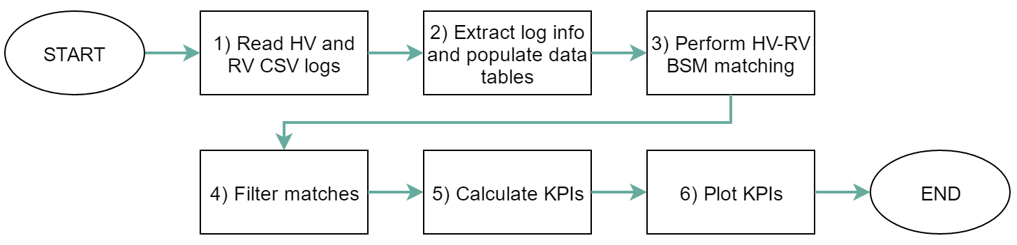

Figure 2: Data Processing Overview

The data files collected during tests were stored as comma separated value files. The content of the data files includes timestamp information, vehicle telemetry data, and the content of the transmitted and received BSM. These log files were read in and the data was labeled with the Vehicle from which it came, either “HV” or “RV”. The data from these files were concatenated, with HV followed by RV. In the case of multiple RVs, the data frame from each RV was separately merged with the HV data frame.
Next, the data was pre-processed. This involved filtering out blank RSSI values, and incorrect GNSS data. The data frames were then prepared using the following columns in the log files: Vehicle, LogRecType, TimeStamp, TimeStamp_ms, secMark, msgCnt, lat, long, and RSS. The KPI’s were calculated for two cases/perspectives:
      - RV is transmitting (Tx), HV is receiving (Rx).
      - HV is transmitting (Tx), RV is receiving (Rx).
For each of the two cases, the subset of Tx and Rx data was separated from the concatenated data, then matched together by the secMark and MsgCnt columns. Only the Tx-Rx matches per secMark and MsgCnt that have absolute minimum value of difference between the Tx and Rx timestamps were extracted. Any duplicate timestamps from the TimeStamp_ms field for the Tx data were removed. Due to the possibility of multiple matches per secMark and MsgCnt pairs, only matches with a timestamp difference or latency of less than 5000 ms were considered a match.
Data is then sorted by Rx TimeStamp_ms, which is used to determine the latency, IPG, and RSSI values. The calculation for each of the KPIs is done per the 5GAA definition as mentioned in the previous sections. Latency values were the previously calculated absolute time difference between the extracted Tx-Rx matches. The inter-packet gap, IPG, was determined by calculating the iterated differences over TimeStamp_ms for Rx. RSSI values are given from the source data via the Rx side respectively, ignoring any invalid values.
On generating packet-error and packet-reception rates (PER, PRR): the resulting data of Tx-Rx data was first sequenced by seconds - with all records outside of the lap timeframe removed - before beginning the PER and PRR calculations. The PRR was calculated as described in section 5.1.1, and the PER was calculated by simply subtracting each calculated PRR value from 100.
The tables of calculated values for PER, PRR, latency, IPG and RSSI are then fully joined pairwise by their timestamp.

Distance Calculations
To analyze the individual KPIs arranged by timestamp, the distance is calculated using the latitude and longitude recorded within the logfile and finding the closest matching timestamps for the Rx and Tx vehicles and the associated coordinates. For example, while targeting the RV Tx record with which an HV Rx is

matched, we look for the opposite HV Tx data to find the Tx record that occurred prior to the target RV Tx record to locate the starting coordinates. With the starting and final coordinates of the messages, these two sets of coordinates are calculated to distance using the haversine distance function, assuming an earth radius of 6,378,137 m.
For graphs using individual lines for approaching and receding runs, the local minima and maxima of distance are found within the data, before iterating through the data and marking individual entries as approaching or receding based on their position relative to the last extreme point.

Plotting vs Time
The KPIs described in the previous sections are all time-based so it is easy to plot those KPIs directly with respect to their associated time. For example, plotting each RSSI sample point directly with respect to the associated timestamp guarantees a reference in time to whether any BSM packet was received on the other end. Since the PER is a time window calculation, each value is plotted against the center or middle Tx timestamp value of that window.

Plotting vs Distance
The distance between the two vehicles is calculated as described in section 5.1.2. As we always use the transmitter for reference, we now have an associated distance value for each sample BSM value regardless of whether this BSM was received. Once we have this data, the KPIs are plotted as scatter plots. Each RSSI value is plotted against the associated distance for that sample. In addition, each PER value associated with a time window is plotted against the distance of the vehicle at the center of that window. Since the vehicle is moving at constant speed, the timestamps and distance values are linear; therefore, picking the center of the PER window for time and distance has the same effect as picking the linear average value of either distance and time. This is equivalent to results for PER vs distance if raw values were binned by distance first before doing the analysis.
For most tests, the vehicles were run in multiple loops to provide redundant and more robust data to perform KPI vs distance calculations. Clean, one-line average PER or RSSI vs distance values are provided by a procedure that averages results of the many loops by sorting the data with respect to distance first, then running a centered moving average on the data.

Test Classification
Planned tests are:
- Lab tests
- Field tests

Within the lab test category, we define these test areas:
- Clean (strong) signal reception tests
- Attenuation tests
- Strong signal reception tests in the presence of White-Gaussian noise
- Interference tests (resilience of the signal to jamming)
- Hidden-node tests
- Near-Far tests
Within the field test category, we define these test areas:
- Range tests
  - Line-of-Sight (LOS) tests with two vehicles
  - Non-Line-of-Sight (NLOS) tests with two vehicles and an obstruction
- Obstruction can be stationary or moving
  - Non-Line-of-Sight (NLOS) intersection tests with two vehicles and two obstructions
- Interference tests
  - Impact of UNII-3 802.11ac interferer
  - Impact of DSRC interferer in the adjacent channel

Test Equipment Description and Characterization
This chapter describes the test equipment and how it is characterized.

OBUs (Savari MW1000 and Qualcomm Roadrunner platforms)

Savari MW1000 (DSRC)

Component | Description
Processor | 1 GHZ iMX6 Dual Core
Memory | 1 GB DDR3 DRAM
Storage | Up to 16 GB Flash
Radio | Dual DSRC
GPS | U-Blox. Tracking Sensitivity: -160 dBm
Secure Flash / HSM | Infineon HSM SLE97
Operational Temperature | -40C to +85C
Antenna / GPS Connectors | Fakra type Z/C
Other Interfaces | CAN, 2 USB, MicroSD, Serial, Ethernet
Display | 16 x 2 LCD
Standards Compliance | 802.11p, IEEE 1609.x and SAE J2735 (2015), J2945
Security | 1609.2, IPSec & SSL
Enclosure | 140 x 133 x 42 (L x W x H)

Qualcomm Roadrunner (C-V2X)

Component | Description
Processor | Automotive Snapdragon820 (APQ8996) 1200 MHz ARM A7 (in MDM9150)+B2
Memory | 2 GB (APQ)
Storage | 64 GB + 2 GB, microSD slot
Radio | PC5 Mode 4
GNSS | Multi-constellation  Qualcomm QDR3 Dead Reckoning XTRA + Time injection
Secure Flash / HSM | Infineon HSM SLI97
Operational Temperature | -40C to +85C
Antenna / GPS Connectors | Quad Fakra
Other Interfaces | USB 3.0 OTG, USB Host, 3x 1 Mbps CAN,  1000BT Ethernet, RS232
Standards | 3GPP Rel 14, IEEE 1609.3 (not used), ETSI ITS G5 (not used), SAE J2735, SAE J3161  (draft)
Security | IEEE 1609.2 (Via Savari & On Board Security)
Other Radios | Automotive QCA6574AU  - Wi-Fi: 2.4 GHz, 802.11n, 2 x 2  - Bluetooth 4.2 + BLE

In-vehicle setup
This section outlines the devices within the retrofit trunk enclosures of each test vehicle. Figure 3 shows the layout of the system components in the test vehicle trunks.

ECOM6-5900

CAN Interface Panel

Netway

Ethernet Network Switch
Network Map per Vehicle
DSRC OBE | 192.168.0.X | - Where X is the vehicle number the unit is installed in (i.e. 1 – 6)  - The DNS and the Gateway address of the QC DP and the Dragon Board needs to be the same as the C-Card IP Address
QC DP | 192.168.0.1X
C-Card | 192.168.0.10
NAS | 192.168.0.20
Dragon Board | 192.168.0.30
Raspberry Pi | 192.168.0.35

Primary Antenna RF-195 10 ft
RF-195 10 ft

ECOM6-5900
Secondary Antenna

RG-175 10 ft

Taoglas Mama AA 170
GPS Antenna

12V GND ACC

To Vehicle CAN

SMA SMA

SMA SMA

Antennas shown connected to DSRC are connected to C-V2X when it is being tested

LMR100

Power Panel

Power Distribution
~8 inches

FAKRA FAKRA
LMR100
~8 inches

FAKRA FAKRA

DSRC OBE

FAKRA FAKRA

LMR100

QUAD
FAKRA

QUAD FAKRA

QUAD FAKRA

FAKRA FAKRA

Savari MobiWAVE
C-V2X DP Qualcomm

Modem
APQ
Savari
Qualcomm
Ethernet Switch
NAS
Netway
Dragon
Board
Box Lights

To Front Cabin
QC Dragon
Board

CCARD
Raspberry Pi

Network Storage

Figure 3: Ford Fusion test vehicle trunk enclosure contents

The vehicles used in testing are six 2017 Ford Fusion sedans outfitted with identical equipment.
- The trunk enclosure is made of 80/20 aluminum rail and is secured to the trunk floor.
- The enclosure is secured enough so vibration and movement outside of normal road disturbances do not influence the components.
- Each vehicle is outfitted with a magnet-mounted antenna with connections for 5.9 GHz (x2), Cellular, and GPS. The antenna is a MobileMark ECOM6 (manufacturer part number: ECOM6-5900-3C-BLK- 120).
  - Each antenna is placed on the apex of the vehicle roof and aligned 24” from the center of the dipole.
  - The river-side antenna cable is clocked at 225 degrees.
  - Two low-loss, 8--foot LMR240 cables are connected to the 5.9-GHz antenna connectors and routed through to the trunk. These and the GPS antenna connections are made to the appropriate device under test. Due to space limitations in Figure 3 only DSRC primary and secondary antenna ports are shown connected to the antennas. Both OBUs use the same antennas and cables, but only one OBU is connected to the antennas at any time.

  - Each of the vehicle CAN buses is routed through the Netway module into each of the on-board units. The Netway module translates the required Ford-specific CAN signals coming from the vehicle into the 6XX message set standard defined by CAMP.
  - The custom power distribution panel interfaces with the vehicle battery and ACC signal to manage power to the components. The panel keeps power to the system once the ACC signal is pulled and initiates proper shutdown sequences for the connected components.
  - Additional, optional components include a Qualcomm® DragonBoard, a Raspberry PI, Network Storage, and a Cradlepoint. The Cradlepoint provides internet access to the components that can use it, such as the DragonBoard or Raspberry PI. The Cradlepoint was not used during the comparison tests and was either powered off or removed from the instrumentation bay. The Raspberry PI works in conjunction with the Network Storage unit for data transfer.
  - Ethernet cables are routed throughout the vehicle from the trunk using the network switch to give operators access to the devices under test via the local area network. The hardwired Ethernet cables were used to collect the data from the devices under test once the tests were completed.

Lab equipment

Variable Attenuator
Model 4205 0.2 to 6 GHz Digital Attenuator TTL and USB Control, SMA Connectors
Attenuation varies up to 95.5 dB in 0.5-dB steps. Nominal impedance is 50 Ω, and the frequency range is 0.2 to 6.0 GHz

R&S SMBV100A Vector Signal Generator**
R&S®SMBV100A was equipped with an internal baseband generator to allow generation of a C-V2X signal.

R&S CMW 500 – Protocol Test**
R&S CMW 500 used for C-V2X & Wi-Fi signal generation. Combination of R&S SMBV100A & CMW 500 used for C-V2X Testing.

Spirent VR5 Channel Emulator
The Spirent spatial channel Emulator is an External RF BOX which is used to run AWGN and Fading scenarios. With this channel emulator we control MIMO configuration, DUT RSRP, AWGN power/SNR, Doppler, fading, timing/frequency offset and noise Bandwidth.

Keysight Technologies (formerly Agilent) N9010A EXA Signal Analyzer, 10 Hz to 26.5 GHz
EXA Signal Analyzer used to perform power measurements quickly at discrete frequency points with list-sweep mode

R&S SMJ100A Vector Signal Generator
The R&S®SMJ100A is used as signal generator to generate AWGN waveforms of given powers and bandwidths.

Splitter / Combiner:
Splitter – Combiners that support 6 GHz RF are used based on the testing needs.

Test Frequencies | 5850, 5860, 5870, 5880, 5890, 5900, 5910,  5920, 5930 MHz | Test Frequencies
Elevation | 10 deg to -6 deg by 2 deg (0 deg is defined as horizon) | Elevation
Azimuth | 0 deg to 355 (Zero is Front of Vehicle) | Azimuth

R&S®NRP2 Power Meter
Power meter used to accurate measure cable loss.

RF cables used
LMR-195, LMR-100A, & LMR-240
RF Shielded Test Enclosure: Model STE3300 was used to enclose devices (C-V2X and DSRC) during execution of test.

Antenna characterization
Antenna characterization was performed to determine the performance of the antenna installation on the vehicles. The identical antenna configuration was used to support both DSRC and C-V2X.

Test Setup:
The antenna performance was validated as passive components in the Oakland University Test using a gantry system. The method used was gain by comparison, and measurements were performed in the far field; no near-to-far field comparisons were performed. Table 2 shows the test parameters used for the antenna performance testing. These values are the standard test setup parameters used by OEMs for DSRC testing.
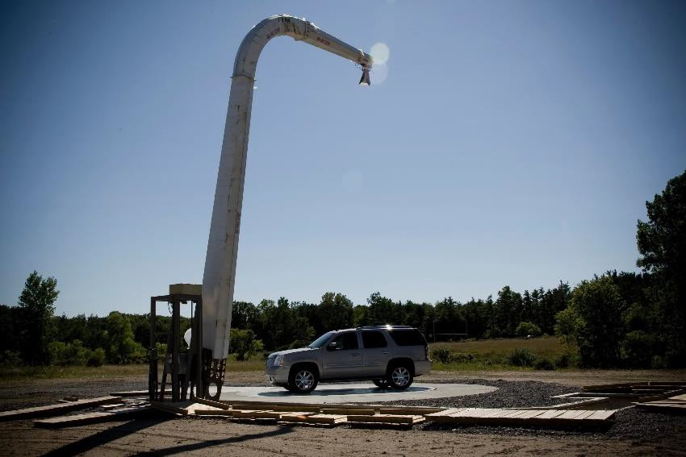
Elevation
Azimuth

Figure 4: Oakland University Antenna Test Range (NOTE: Vehicle shown is not actual test vehicle) Table 2: Antenna Test Parameters

Measurement Results:
Initial measurement was of the antenna (ECOM6-5500) on a 1-meter rolled edge ground plane. See Figure 5.
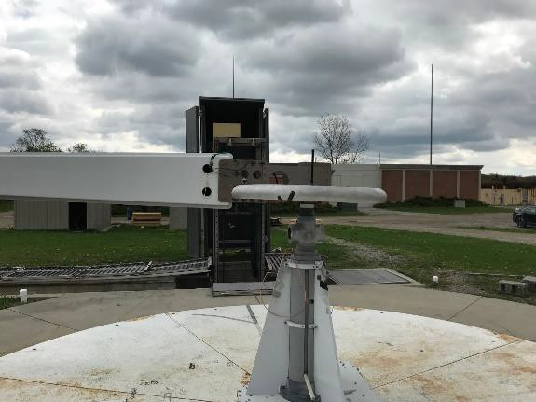

Figure 5: Single Antenna on 1 Meter Rolled Edge Groundplane

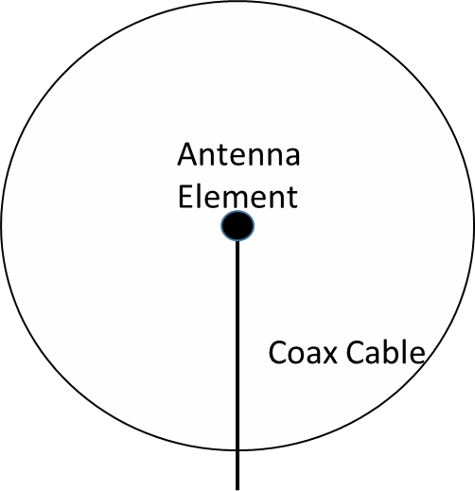

Figure 6: Test Setup

Figure 7 shows the resulting antenna pattern.

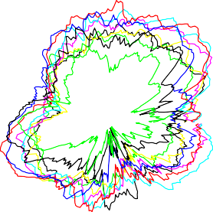

Figure 7: Single Antenna on Rolled Edge Groundplane Antenna Gain Pattern (Vertical Polarization)

Overall the antenna has adequate omnidirectional coverage but demonstrates some pattern degradation at 150 deg and 300 deg Azimuth. Therefore, the recommended placement on the vehicle is as shown in Figures 8 and 9. In Figure 9, the antenna cables are routed straight down the vehicle while on antenna range turntable. During the field tests the same cables are routed down the drip edge to the trunk of the vehicle.
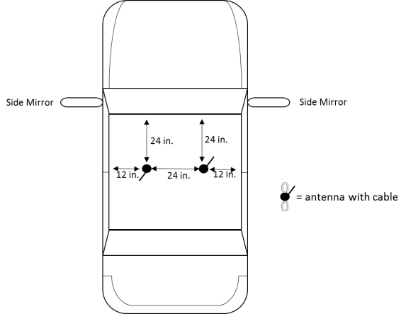

Figure 8: Antenna Configuration on Vehicle (top view)

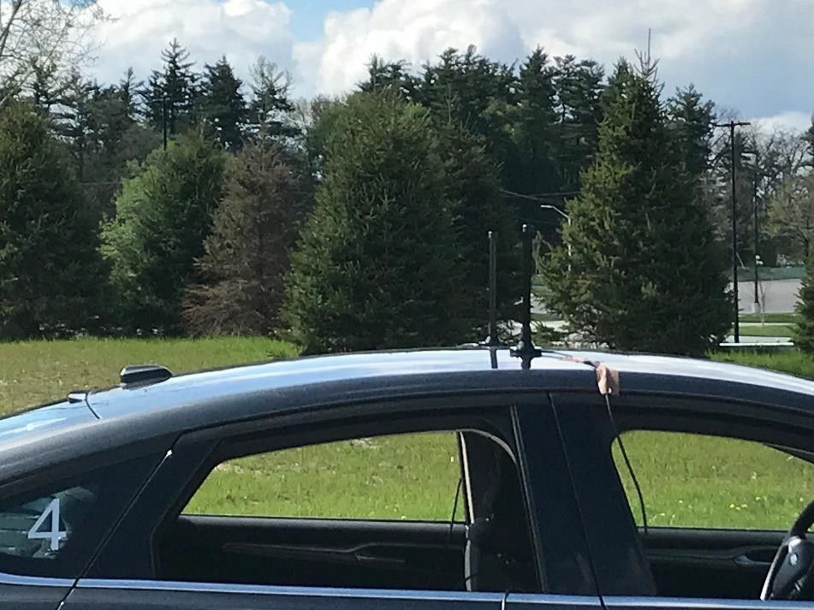

Figure 9: Antennas on Vehicle

This configuration optimizes the antenna gain to the front and rear of the vehicle. Figure 10 shows this in the antenna gain patterns.

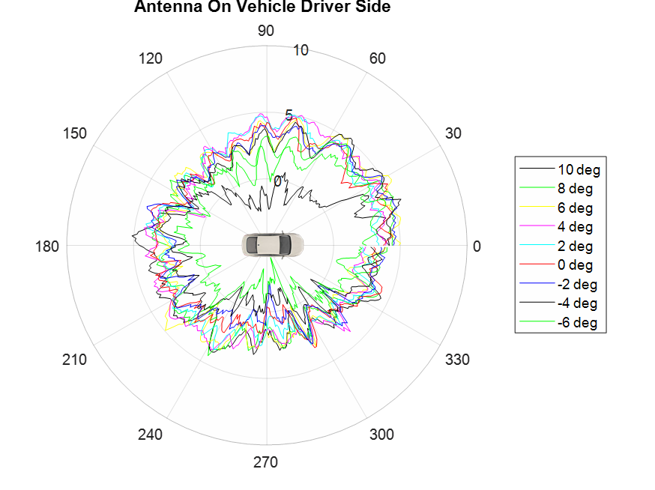
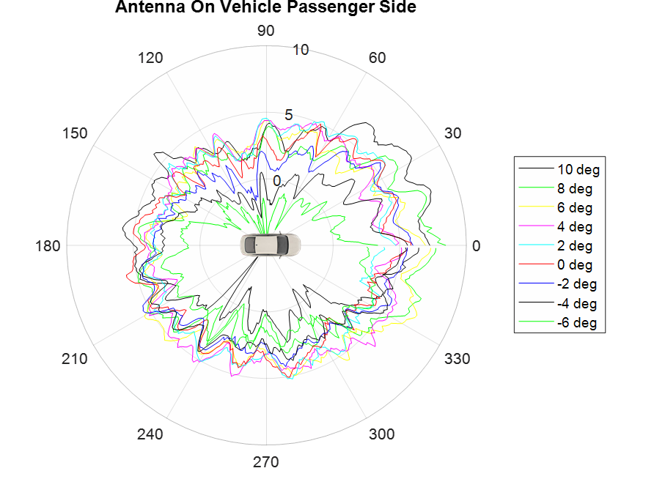

Figure 10: Antenna Performance on Vehicle (Vertical Antenna Gain)

Conclusion:
The antenna configuration has optimized the antenna patterns for the front and rear of the vehicle. Moreover, the side performance should be adequate for approaching the side that has the Tx/Rx antenna (which in our case is the driver side). However, the Tx section of the link approaching the passenger side will have a degraded range, and vehicle testing should account for this. In addition, the two antennae show a 3-dB difference in gain, which is probably caused by unit-to-unit variability. This difference does not invalidate the configuration recommendation. Crucially, the same antenna configuration was used for both radio technologies.

Lab Test Procedures and Results

Introduction

Test Cases - Device Characterization
The following sections focus on test cases that characterize the device’s Rx/Tx performance, end-to-end application layer latency, and processing performance in a laboratory environment. In particular, the tests described in this section focus on characterizing the Physical (PHY) and Medium Access Control (MAC) layers of radio technology, including interference scenarios and device performance in a high-density radio- congested environment. Evaluation measures shall reference industry standards, if available, for the given radio technology, such as IEEE 802.11p and SAE J2945/1 for the DSRC and 3GPP R14 / PC5-LTE for C- V2X.
Upon executing and collecting test log data from these test cases, analysis can help develop and validate simulation models for the given radio technology.
The overall guiding principle for each of these tests is maintaining applicability and repeatability for different radio technologies.

    - Common Parameters and Setup
Following are the common parameters used for lab testing. Any changes in test parameters are noted in respective sections.

Table 3: Common Parameters

Configuration | DSRC | C-V2X (PC5 Mode 4)
Channel | Channel 172 | 5860 MHz (Channel 172)
Bandwidth | 10 MHz | 10 MHz
Modulation | QPSK ½ (6 Mbps burst rate) | QPSK 0.46 (MCS 5)
Application Used | Savari | Savari
Tx/Rx Configuration | 1 Tx 2 Rx | 1 Tx 2 Rx
Device Details | Savari MW1000 | Qualcomm Roadrunner platform
HARQ | NA | Enabled
Tx Power | 21 dBm | 21 dBm
Packet Size | 193 Bytes | 193 Bytes (5 Sub-Channels)*
* Sub-Channel size = 5 RB
For GNSS, a signal drop from a rooftop antenna is used in all the lab tests.

General guidance on C-V2X and DSRC device RF power management

Equipment used:
      - Spectrum Analyzer (SA)
      - Power Sensor
      - Signal Generator (SG)

Measure Tx power of device
- For C-V2X and DSRC devices, enable transmission of BSM messages with specified payload required for the test case.
- Measure the cable loss (preferably of shorter length) of the cable connecting FAKRA output to SA input. Use SG (sending CW signal at 5.9 GHz) and Power sensor to measure the loss.
- Use SA to measure the Tx power. To reliably measure the burst of Tx power from the C-V2X signal, we used the Gate function and RF burst absolute trigger available in SA to exclude off-period. Please keep account of the cable loss in SA.
- Ensure that the expected power is close to the target power of the given test case.

Quad FAKRA cable (C-V2X)
Single FAKRA cable (DSRC)
C-V2X/DSRC
device
SA
Cable

Figure 11: Tx Power Measurement

Measure Rx power of device
- Once Tx power is measured, add longer cable and a digital attenuator (to increase dynamic range) between the device and SA to measure Rx power.
- For Rx measurement, the RF Burst Absolute Trigger value changes depending on the expected Rx power that can be controlled by changing the attenuation value in the digital attenuator.
- Turn on the internal preamp of SA when measuring low power.

C-V2X/DSRC
device
A
Attenuator
Cable
C-V2X/DSRC
device
SA
Quad FAKRA cable (C-V2X)
Single FAKRA cable (DSRC)

Figure 12: Rx Power Measurement

  - AWGN Lab Tests

Basic Bench Cabled RF Tests
In this section, we focus on test procedures performed in the lab in the cabled RF environment. Although the test procedures below refer mainly to C-V2X, the exact same tests were carried out for both C-V2X and DSRC. According to 5GAA test document TR P-180092, to keep the setup simple, devices are configured as transmit- only and receive-only.
The procedures are described as C-V2X test procedures; however, it is straightforward to convert them to another V2X point-to-point radio technology (e.g., IEEE 802.11p).

Cabled transmission and reception test with varying payload sizes

Background
This test verifies that C-V2X devices can transmit and receive varying C-V2X messages over a PC5 Interface.

Assumptions
Operating system (OS) time of the transmitter and receiver boxes is synchronized to the common clock (e.g., GPS) with an error of ≤ 1 ms.

Setup
This test uses a lab-cabled setup as Figure 13 shows. A C-V2X (receiver) is configured to receive data from C-V2X on ITS band (channel 172) with a bandwidth of 10 MHz. Each piece of On-Board Equipment (OBE) is placed in an RF-shielded box to account for possible RF leakage.

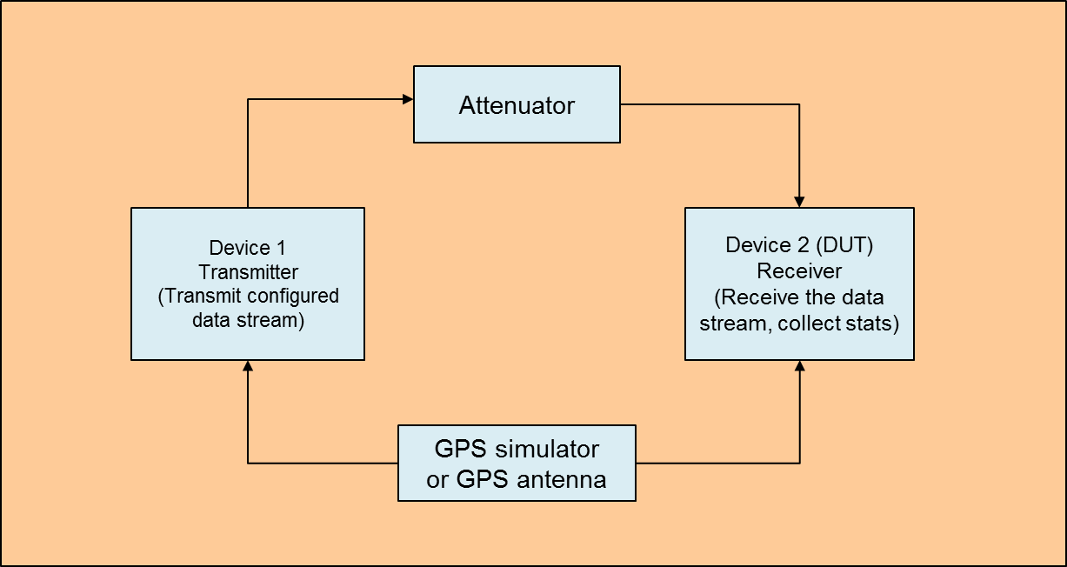

Figure 13: Test Setup – Cabled transmission and reception test with varying payload sizes

        - Settings on the C-V2X Device 1 [Transmit Radio]:
          - Application layer configured to generate messages and deliver to the lower layers with 100 ms periodicity.
          - Varying Packet lengths
            - Smaller packet size 193 bytes for four transmit occasions followed by larger 270 bytes for one occasion. This models the expected load with security certificate digests and security certificate transmissions.
            - Repeat the above data pattern for the duration of the test.
          - Transmit on ITS band Channel 172 with bandwidth of 10 MHz
          - Appropriate transmit power and attenuation added to ensure DUT input of -50 dBm (when signal is present)
        - Settings on the C-V2X Device 2 [Receive Radio]
          - Configured to receive on the same 10 MHz bandwidth channel.
          - Receive radio will listen on all occasions.
        - Data Collection at Tx
          - OS timestamp for each transmitted packet (ITS stack)
          - Sequence number of the transmitted packet (ITS stack)

        - Data Collection at Rx
          - OS timestamp for each received packet (ITS stack)
          - Sequence number of the received packet (ITS stack)
          - Receive signal power for each received packet
        - For this test, set Tx power at 20 dBm for C-V2X and DSRC.

Table 4: Test Configuration

Configuration | C-V2X | DSRC
Packet Size | 193 and 270 Bytes | 193 and 270 Bytes
Number of Samples | 1000 | 1000
Tx Power | 20 dBm | 20 dBm

      - Test Execution
- Configure the attenuator so that received power on the receiver entity is -50 dBm.
- Configure the transmit device with the data stream of interest.
  - Transmit power for the transmit device remains constant.
  - Data stream is a sample SPS-based transmit flow of varying payload sizes sent periodically every 100 ms (Note: equivalent to setting a periodic stream at 100 ms period for other technologies)
- Record this data collected by the Tx and Rx device in a log file.
  - OS timestamp for each Tx/Rx packet
  - Sequence number of the Tx/Rx packet
  - Receive signal power for each Rx packet

      - Unique Tests to Conduct
Run this test using:
Two (2) C-V2X devices for the test

Required Documentation
Tables 5 and 6 are based on the data we collected from the log files. PER is computed from the Tx and Rx data logs. The IPG statistic is computed from the Rx logs. In addition, the latency is computed from Tx and Rx logs. Note that the IPG and latency values are rounded off to the nearest integer.

Table 5: Results of the Basic Cabled Tests – C-V2X

No. of  Transmitted pkts/s reported | No. of  Received pkts/s reported | Calculated at Receiver | Calculated at Receiver | Calculated at Receiver | Calculated at Receiver | Calculated at Receiver
Transmit Device | Receive Device | PER % | 95  Percentile IPG (ms) | Mean IPG (ms) | 95  Percentile Latency (ms) | Mean Latency (ms)
1000 | 1000 | 0 | 106 | 100 | 23 | 14
1000 | 1000 | 0 | 105 | 100 | 23 | 15
1000 | 1000 | 0 | 106 | 100 | 22 | 14
1000 | 1000 | 0 | 106 | 100 | 22 | 14
1000 | 1000 | 0 | 105 | 100 | 23 | 14
1000 | 1000 | 0 | 105 | 100 | 22 | 14
1000 | 1000 | 0 | 106 | 100 | 21 | 13
1000 | 1000 | 0 | 105 | 100 | 21 | 14
1000 | 1000 | 0 | 106 | 100 | 23 | 14
1000 | 1000 | 0 | 107 | 100 | 23 | 14

Table 6: Results of the Basic Cabled Tests – DSRC

No. of  Transmitted pkts/s reported | No. of  Received pkts/s reported | Calculated at Receiver | Calculated at Receiver | Calculated at Receiver | Calculated at Receiver | Calculated at Receiver
Transmit Device | Receive Device | PER % | 95  Percentile IPG (ms) | Mean IPG (ms) | 95  Percentile Latency (ms) | Mean Latency (ms)
1000 | 1000 | 0 | 111 | 100.0 | 19 | 16
1000 | 1000 | 0 | 102 | 100.0 | 19 | 17
1000 | 1000 | 0 | 109 | 100.0 | 19 | 16
1000 | 1000 | 0 | 102 | 100.0 | 20 | 17
1000 | 1000 | 0 | 107 | 100.0 | 19 | 16
1000 | 1000 | 0 | 104 | 100.0 | 19 | 16
1000 | 1000 | 0 | 102 | 100.0 | 20 | 16
1000 | 1000 | 0 | 106 | 100.0 | 19 | 16
1000 | 1000 | 0 | 106 | 100.0 | 19 | 16
1000 | 1000 | 0 | 109 | 100.0 | 19 | 16
      - Evaluation Criteria
The evaluation criteria is a successful decode of all the payload lengths on the Rx entity.

Key Takeaway
Test results show that in excellent radio conditions (-50 dBm Receive power with no added noise), both V2X technologies can reliably carry BSM payload sizes. In unloaded conditions, C-V2X latency is generally within 1 to 4 ms of DSRC latency, which from the entire vehicle system perspective, is a negligible difference. IPG numbers for C•V2X in loaded conditions, C-V2X might provide lower latency than DSRC.

Clean channel cabled transmission and reception test across power levels

Background
This test verifies that C-V2X devices can transmit and receive C-V2X messages over a PC5 Interface at different received power levels and assess end-to-end statistics. This test determines the receiver sensitivity of a device (at a 10% PER level).

Assumptions
The operating system (OS) time of the transmitter and receiver boxes is synchronized to the common clock (e.g., GPS) with an error of no more than 1 ms.

Setup
This test used a lab-cabled setup as Figure 14 shows. A C-V2X (receiver) is configured to receive data from C-V2X on the ITS band (Channel 172) with a Bandwidth of 10 MHz. Each C-V2X OBE was placed in an RF- shielded box to account for possible RF leakage.

Figure 14: Test Setup – Clean channel cabled transmission and reception test across power levels
        - Settings on the C-V2X Device 1 [ Transmit Radio]:
          - Application layer configured to generate messages and deliver to the lower layers with 100 ms periodicity.
          - Packet length is constant and is set to 193 Bytes.
          - Transmit on ITS band with bandwidth of 10 MHz.
          - Appropriate transmit power and fixed attenuation added to ensure DUT input of -49 dBm.
        - Settings on the C-V2X Device 2 [ Receive Radio]
          - Configured to receive on ITS Band (e.g., center frequency 5.860 MHz) and bandwidth of 10 MHz.
          - Receive radio in C-V2X configured to always be in Rx mode.

        - Data Collection at Tx
          - OS timestamp for each transmitted packet.
          - Sequence number of the transmitted packet.
        - Data Collection at Rx
          - OS timestamp for each received packet.
          - Sequence number of the received packet.

          - Receive signal power for each received packet.
        - For this test Tx power is set at 20 dBm for both C-V2X and DSRC.

Table 7: Test Configuration

Configuration | C-V2X | DSRC
Number of Samples | 1000 | 1000
Tx Power | 20 dBm | 20 dBm

      - Test Execution
- Calibrate the insertion loss between the two devices by setting the attenuator to 0 dB and measure the loss with both cables connected to the attenuator. This measured value will be the fixed insertion loss of the cables and attenuator setup.
- Transmit power for the transmit device remains constant.
- Adjust overall path loss (insertion loss plus attenuator value) to be 69 dB
- Vary the attenuation in steps of 10 dB
  - Near sensitivity, reduce step size to 1 dB
  - Continue the test until observed PER is 100%
- Record these statistics on the devices for each path loss setting in a log file:
- OS timestamp for each Tx/Rx packet
- Sequence number of the Tx/Rx packet
- Receive signal power for each Rx packet
NOTE: Tests should be conducted at room temperature (21 deg Celsius +/- 5 deg).

Unique Tests to Conduct
Run this test using:
Two (2) C-V2X devices for the test

Required Documentation
Tables 8 through 11 are based on the data we collected from log files. PER is computed from the Tx and Rx data logs. The number of missing (not received) packets is divided by the number of total packets transmitted. The IPG statistic is computed from the Rx logs. The latency is computed from Tx and Rx logs. IPG and latency values are captured for runs in which PER reaches around 10%. Note that the IPG and latency values are rounded off to the nearest integer.

Table 8: C-V2X Results – PER

 | No. of  Transmitted pkts/s | No. of  Received pkts/s | Calculated at Receiver | Calculated at Receiver
Overall Path Loss (dB) | C-V2X  Transmit Device | C-V2X  Receive Device | PER % | CBR (%) for C-V2X
69 | 1000 | 1000 | 0 | < 1
79 | 1000 | 1000 | 0 | < 1
89 | 1000 | 1000 | 0 | < 1
99 | 1000 | 1000 | 0 | < 1
109 | 1000 | 1000 | 0 | < 1
114 | 1000 | 1000 | 0 | < 1
119 | 1000 | 1000 | 0 | < 1
122 | 1000 | 988 | 1.18 | < 1
123 | 1000 | 987 | 1.27 | < 1
124 | 1000 | 984 | 1.53 | < 1
125 | 1000 | 887 | 11.27 | < 1
126 | 1000 | 810 | 18.93 | < 1
127 | 1000 | 791 | 20.83 | < 1
128 | 1000 | 35 | 96.5 | < 1
129 | 1000 | 0 | 100 | < 1

Table 9: C-V2X Results – IPG and Latency

 | No. of  Transmitted pkts/s | No. of  Received pkts/s | Calculated at Receiver | Calculated at Receiver | Calculated at Receiver | Calculated at Receiver
Overall Path Loss (dB) | C-V2X  Transmit Device | C-V2X  Receive Device | 95th Percentile IPG (ms) | Mean IPG | 95th Percentile Latency (ms) | Mean Latency
69 | 1000 | 1000 | 107 | 100 | 21 | 13
79 | 1000 | 1000 | 107 | 100 | 21 | 13
89 | 1000 | 1000 | 105 | 100 | 21 | 14
99 | 1000 | 1000 | 106 | 100 | 21 | 13
109 | 1000 | 1000 | 106 | 100 | 22 | 13
114 | 1000 | 1000 | 105 | 100 | 22 | 14
119 | 1000 | 1000 | 105 | 100 | 22 | 14
122 | 1000 | 988 | 106 | 100 | 23 | 15
123 | 1000 | 987 | 106 | 101 | 22 | 14
124 | 1000 | 984 | 106 | 101 | 22 | 15
125 | 1000 | 887 | 113 | 113 | 26 | 19

Table 10: DSRC Results – PER

 | No. of  Transmitted pkts/s | No. of  Received pkts/s | Calculated at Receiver | Calculated at Receiver
Overall Path Loss (dB) | DSRC  Transmit Device | DSRC  Receive Device | PER % | CBR (%) for DSRC
69 | 1000 | 1000 | 0 | < 1
79 | 1000 | 1000 | 0 | < 1
89 | 1000 | 1000 | 0 | < 1
99 | 1000 | 1000 | 0 | < 1
109 | 1000 | 995 | 0.5 | < 1
110 | 1000 | 946 | 5.4 | < 1
111 | 1000 | 561 | 43.9 | < 1
112 | 1000 | 26 | 97.4 | < 1
113 | 1000 | 0 | 100 | < 1

Table 11: DSRC Results – IPG and Latency
PER VS Overall Path Loss
120
100
80
60
40
20
0
60
70
80
90
100
110
120
130
Overall Path Loss (dB)
CV2X PER %
DSRC PER %

 | No. of  Transmitted pkts/s | No. of  Received pkts/s | Calculated at Receiver | Calculated at Receiver | Calculated at Receiver | Calculated at Receiver
Overall Path Loss (dB) | DSRC  Transmit Device | DSRC  Receive Device | 95th Percentile IPG (ms) | Mean IPG | 95th Percentile Latency (ms) | Mean Latency
69 | 1000 | 1000 | 106 | 100 | 20 | 16
79 | 1000 | 1000 | 107 | 100 | 19 | 16
89 | 1000 | 1000 | 107 | 100 | 20 | 17
99 | 1000 | 1000 | 104 | 100 | 20 | 17
109 | 1000 | 995 | 109 | 101 | 18 | 17
110 | 1000 | 946 | 193 | 106 | 18 | 16

Figure 15: 7.2.2 – PER vs Overall Path Loss
PER %age

IPG(ms)

Figure 16: 7.2.2 – 95th Percentile IPG
C-V2X vs DSRC 95th Percentile IPG
1000
100
10
69
79
89
99
Overall Path Loss (dB)
109
119
129
CV2X
DSRC
C-V2X vs DSRC Mean IPG
1000
100
10
69
79
89
99
Overall Path Loss (dB)
109
119
129
CV2X
DSRC
IPG (ms)

Figure 17: 7.2.2 – Mean IPG

Latency (ms)

Figure 18: 7.2.2 – 95th Percentile Latency
C-V2X vs DSRC 95th Percentile Latency
100
10
69
79
89
99
Overall Path Loss (dB)
109
119
129
CV2X
DSRC
C-V2X vs DSRC Mean Latency
100
10
69
79
89
99
Overall Path Loss (dB)
109
119
129
CV2X
DSRC
Latency (ms)

Figure 19: 7.2.2 – Mean Latency

Evaluation Criteria
Evaluation criteria is a successful decode of all the payload lengths on Rx entity.

Key Takeaway
The purpose of this controlled lab test was to examine and compare the communication reliability of V2X technologies at varying levels of received signal strength. This test emulates field scenarios where the received signal power diminishes because of the distance between the transmitter and the receiver, or because of obstructions between the two. This test has no added background interference in the channel.
The results show significant reliability advantage of C-V2X over DSRC, which translates into a longer communication range for C-V2X in the real world. Field results in Chapter 8 show these gains. This advantage implies enhanced safety for drivers and pedestrians by providing reliable and early alerts even with coverage dead spots created by obstructions such as buildings, vehicles, and foliage.
Even at reasonable distances, the RSSI can be low due to obstructions such as buildings or blocking vehicles. In DNPW scenarios for example, a few vehicles in front of the receiver severely degrade the received signal strength. Similarly, a line of vehicles waiting in turn lanes from the opposite direction can severely degrade the RSSI in the left-turn-assist scenario. Obstructions create areas of very low RSSI in the environment, i.e., dead spots. With superior link performance, C-V2X can eliminate or alleviate the dead spots experienced by DSRC.

Cabled Transmission and Reception Test with added Channel Impairment

Background
This test verifies that C-V2X devices can transmit and receive messages over the PC5 Interface with an AWGN channel impairment model applied between the transmit and receive devices.

Assumptions
The operating system time of the transmitter and receiver boxes is synchronized to a common clock (e.g., GNSS) with an error of no more than 1 ms.

Setup
This test uses a lab-cabled setup as Figure 20 shows. A Fader Box is used to generate AWGN in the frequency range of the channel, and Device 2 (receiver) is configured to receive data from Device 1 on this same impaired channel.

AWGN/
Fader Box
Attenuator

Device 1 Transmitter (Transmit configured data stream)

Device 2 (DUT) Receiver (Receive the data
stream, collect stats)
GPS simulator or GPS antenna

Figure 20: 7.2.2 – Test Setup - Cabled Transmission and Reception Test with added Channel Impairment

- Channel Impairment settings on the Fader Box Generator
  - Configured to generate AWGN across the entire 10 MHz channel 172.
- Settings on Device 1 (Transmit Radio):
  - SPS-based transmit flow with a periodicity of 100 ms (Note: equivalent to setting a periodic stream at 100 ms period for other technologies)
  - Packet length of 193 bytes
  - Transmit at Channel 172 with bandwidth of 10 MHz.
  - Appropriate fixed attenuation added (“Attenuator” shown in figure) to ensure that Device 1 Rx power at DUT input is 50 dBm
- Settings on Device 2 (Receive Radio):
  - Configured to receive on Channel 172 with bandwidth of 10 MHz
  - All measurements of receiving side performance are done on this device
- Data Collection at Tx (Device 1):
  - OS timestamp for each transmitted packet
  - Sequence number of each transmitted packet
- Data Collection at Rx (Device 2):
  - OS timestamp for each received packet
  - Sequence number of each received packet
- 10000 samples are run for each setting on AWGN/Fader box to assess performance

Table 12: Test Configuration

Configuration | C-V2X | DSRC
AWGN | AWGN/Fader Box | AWGN/Fader Box
Number of Samples | 10000 | 10000
HARQ | Enabled/Disabled | NA

      - Test Execution
NOTE: Conduct tests at room temperature (21 deg Celsius +/- 5 deg).
        - Configure the AWGN/Fader Box to generate AWGN across the entire 10-MHz channel 172.
        - Configure the Transmit Device (Device 1) with the data stream of interest:
          - Transmit power remains constant.
          - Send application layer message (e.g., BSM) periodically every 100 ms. Packet length shall be such that there is a one-to-one correspondence between packet and message; the packet size should remain constant throughout the test.
        - Set the Signal Generator to produce zero AWGN power in the channel.
        - Set the Attenuator to an attenuation value such that the receive signal power measured at DUT input is 50 dBm per Antenna.
        - Adjust the power of the noise produced by the Signal Generator to exercise performance across different levels of channel impairment as follows:
          - Set the AWGN/Fader Box to produce 70 dBm of AWGN power in the channel.
          - Measure/calculate PER at Device 2.
          - Adjust the Signal Generator to increase the AWGN power in the channel (suggested step size 10 dBm until BLER appears).
          - Once BLER appears, increase AWGN power with 0.1 dBm.
          - Measure/calculate PER at Device 2 (should be greater than before).
          - Repeat steps d and e until PER reaches 100%.
        - Record to a log file these statistics on the Receive Device (Device 2) at every noise power value:
- OS timestamp for each Tx/Rx packet.
- Sequence number for each Tx/Rx packet

      - Unique Tests to Conduct
Run this test using:
Two (2) C-V2X devices for the test

Required Documentation
Tables 13 through 18 show the data we collected from log files. IPG and latency values are captured for runs in which PER is < 10%. Note that the IPG and latency values are rounded off to the nearest integer. Noise Power Spectral Density (PSD) is calculated from actual Noise power or from the knowledge of Signal power and SNR. PSD is calculated per Hz in terms of dBm and hence we also need to convert into a Logarithmic scale. For example, total noise power of -60 dBm for 10 MHz BW (~ 70 dB) is equivalent to -130 dBm PSD.

Table 13: C-V2X Harq Enabled Results – PER

Signal Generator Setting | No. of Transmitted pkts | No. of Received pkts | Calculated at Receiver
Noise PSD dBm/Hz | Tx Device | Rx Device | PER %
-139.54 | 10000 | 10000 | 0
-129.54 | 10000 | 10000 | 0
-119.54 | 10000 | 10000 | 0
-111.54 | 10000 | 9922 | 0.78
-111.44 | 10000 | 9700 | 3
-111.34 | 10000 | 9383 | 6.17
-111.24 | 10000 | 9295 | 7.05
-111.14 | 10000 | 7983 | 20.17
-111.04 | 10000 | 7624 | 23.76
-110.94 | 10000 | 5597 | 44.03
-110.84 | 10000 | 1566 | 84.34
-110.44 | 10000 | 0 | 100

Table 14: C-V2X HARQ Enabled Results – IPG and Latency

Signal Generator Setting | No. of  Transmitted pkts | No. of  Received pkts | Calculated at Receiver | Calculated at Receiver | Calculated at Receiver | Calculated at Receiver
Noise PSD dBm/Hz | Tx Device | Rx Device | 95th Percentile IPG (ms) | Mean IPG | 95th Percentile Latency (ms) | Mean Latency
-139.54 | 10000 | 10000 | 106 | 100 | 22 | 13
-129.54 | 10000 | 10000 | 106 | 100 | 22 | 14
-119.54 | 10000 | 10000 | 106 | 100 | 22 | 14
-111.54 | 10000 | 9922 | 106 | 101 | 25 | 19
-111.44 | 10000 | 9700 | 110 | 103 | 26 | 21
-111.34 | 10000 | 9383 | 113 | 106 | 27 | 23

Table 15: C-V2X Harq Disabled Results – PER

Signal Generator Setting | No. of Transmitted pkts | No. of Received pkts | Calculated at Receiver
Noise PSD dBm/Hz | Tx Device | Rx Device | PER %
-139.54 | 10000 | 9999 | 0.01
-129.54 | 10000 | 10000 | 0
-119.54 | 10000 | 9998 | 0.02
-114.44 | 10000 | 9954 | 0.46
-114.34 | 10000 | 9475 | 5.25
-114.24 | 10000 | 9266 | 7.34
-114.14 | 10000 | 8308 | 16.92
-114.04 | 10000 | 7421 | 25.79
-113.94 | 10000 | 5054 | 49.46
-113.84 | 10000 | 1365 | 86.35
-113.34 | 10000 | 0 | 100

Table 16: C-V2X HARQ Disabled Results – IPG and Latency

Signal Generator Setting | No. of  Transmitted pkts | No. of  Received pkts | Calculated at Receiver | Calculated at Receiver | Calculated at Receiver | Calculated at Receiver
Noise PSD dBm/Hz | Tx Device | Rx Device | 95th Percentile IPG (ms) | Mean IPG | 95th Percentile Latency (ms) | Mean Latency
-139.54 | 10000 | 9999 | 105 | 100 | 24 | 15
-129.54 | 10000 | 10000 | 105 | 100 | 24 | 15
-119.54 | 10000 | 9998 | 105 | 100 | 24 | 15
-114.44 | 10000 | 9954 | 106 | 100 | 24 | 15
-114.34 | 10000 | 9475 | 117 | 105 | 28 | 20

Table 17: DSRC Results – PER

Signal Generator Setting | No. of Transmitted pkts | No. of Received pkts | Calculated at Receiver
Noise PSD dBm/Hz | Tx Device | Rx Device | PER %
-140 | 10000 | 9983 | 0.17
-135 | 10000 | 9981 | 0.19
-130 | 10000 | 9952 | 0.48
-127 | 10000 | 9955 | 0.45
-126 | 10000 | 9852 | 1.48
-125.5 | 10000 | 9520 | 4.8
-125 | 10000 | 8674 | 13.26
-124.5 | 10000 | 7810 | 21.9
-124 | 10000 | 4693 | 53.07
-123.5 | 10000 | 2284 | 77.16
-123 | 10000 | 399 | 96.01
-122 | 10000 | 0 | 100

Table 18: DSRC Results – IPG and Latency

Signal Generator Setting | No. of  Transmitted pkts | No. of  Received pkts | Calculated at Receiver | Calculated at Receiver | Calculated at Receiver | Calculated at Receiver
Noise PSD dBm/Hz | Tx Device | Rx Device | 95th Percentile IPG (ms) | Mean IPG | 95th Percentile Latency (ms) | Mean Latency
-140 | 10000 | 9983 | 108 | 100 | 18 | 16
-135 | 10000 | 9981 | 108 | 100 | 18 | 16
-130 | 10000 | 9952 | 107 | 100 | 18 | 16
-127 | 10000 | 9955 | 108 | 100 | 19 | 16
-126 | 10000 | 9852 | 108 | 101 | 19 | 16
-125.5 | 10000 | 9520 | 109 | 105 | 19 | 17

PER

Figure 21: 7-11 – PER vs Noise PSD (dBm/Hz)
PER Vs Noise PSD (dBm/Hz)
100
10
CV2X_With_HARQ
DSRC CV2X_No_HARQ
1
0,1
-127 -126 -125 -124 -123 -122 -121 -120 -119 -118 -117 -116 -115 -114 -113 -112 -111 -110
Noise_PSD (dBm/Hz)

C-V2X vs DSRC 95 Percentile IPG

10000
DSRC
CV2X_With_HARQ CV2X_No_HARQ

1000

100

10
-127 -126 -125 -124 -123 -122 -121 -120 -119 -118 -117 -116 -115 -114 -113 -112 -111 -110
Noise_PSD (dBm/Hz)
IPG (ms)

Figure 22: 7.2.3 – 95th Percentile IPG

Latency (ms)

Figure 23: 7.2.3 – 95th Percentile Latency

C-V2X vs DSRC 95 Percentile Latency
100
DSRC
CV2X_With_HARQ CV2X_No_HARQ

10
-127 -126 -125 -124 -123 -122 -121 -120 -119 -118 -117 -116 -115 -114 -113 -112 -111 -110
Noise_PSD (dBm/Hz)
C-V2X vs DSRC Mean IPG
DSRC
1000
CV2X_With_HARQ
CV2X_No_HARQ
100
10
-127 -126 -125 -124 -123 -122 -121 -120 -119 -118 -117 -116 -115 -114 -113 -112 -111 -110
Noise_PSD (dBm/Hz)
Mean IPG (ms)

Figure 24: 7.2.3 – Mean IPG

Mean Latency (ms)

 |  |  |  |  |  |  |  |  |  |  |  |  |  |  |  |  |  |  |  |  |  |  |  |  |  | D | SRC
 |  |  |  |  |  |  |  |  |  |  |  |  |  |  |  |  |  |  |  |  |  |  |  |  |  | CV | 2X | _W | ith | _H | AR | Q
 |  |  |  |  |  |  |  |  |  |  |  |  |  |  |  |  |  |  |  |  |  |  |  |  |  | CV | 2X | _N | o_ | HA | RQ

Figure 25: 7.2.3 – Mean Latency
C-V2X vs DSRC Mean Latency
100
10
1
-127 -126 -125 -124 -123 -122 -121 -120 -119 -118 -117 -116 -115 -114 -113 -112 -111 -110
Noise_PSD (dBm/Hz)

Evaluation Criteria
Evaluation criteria assess the performance across the noise power range.

Key Takeaway
This test examined and compared the communication reliability of V2X technologies at varying levels of added channel noise. The test emulates deployments with other users in the environment, either within communication range or outside of it, that produce the over-the-air noise background. This configuration complements section 7.2.2 where path loss is modelled without added channel noise.
The results show a significant (about 14 dB) reliability advantage of C-V2X over DSRC. The performance advantage in this experiment is consistent with the performance in section 7.2.2.
Because the experiments in this section are conducted far above the thermal noise floor, the noise figures of the radio devices do not play a role. Confirming the observations in section 7.2.2, therefore, establishes that the performance difference presented there cannot be attributed to any possible device noise figure differences.
Together with section 7.2.2, this section establishes that C-V2X has superior performance over DSRC in the presence of path loss and channel noise.

Again, we expect this performance advantage to translate into meaningful improvements for V2X safety applications. Communication range will be improved. More importantly, coverage dead spots created by obstructions such as buildings, other vehicles, foliage, etc. can be significantly mitigated with C-V2X. Note that non-line-of-sight (NLOS) conditions created by obstructions are the most relevant scenarios for V2X technologies as existing sensing techniques such as LiDAR or radar do not work well under NLOS conditions.

Interference Lab Tests

Adjacent/Non-Adjacent Channel Interference Lab Test
The following test cases were performed.
    - Intra-System Interference Testing
      - Hidden Node Scenario (section 7.3.1)
      - Interference caused by Near-Far Effect (section 7.3.2)
The procedures are described as C-V2X test procedures; however, it is straightforward to convert them to another V2X point-to-point radio technology (e.g., IEEE 802.11p).

    - Hidden Node Scenario

Background
This test assesses the performance of a V2X device during a resource collision scenario (hidden node phenomenon). The hidden node scenario is reproducible in a highly congested environment, for example, OBUs located at opposite edges of one OBU’s communication range. Those transmitter devices cannot sense each other and can transmit on the same subframe to the OBU in the middle which produces a collision at the latter device.

Assumptions
Lab setup with cabled or over-the-air RF environment: The test case is specified with a cabled environment in section 7.3.1.3, but it can also be adapted to an RF laboratory environment.
The operating system time of all the transmitter and receiver boxes is synchronized to a common clock (e.g., GPS) with an error of no more than 1 ms.
All devices operate in the same channel (e.g., 172).

Setup
Two different configurations run the hidden node test scenario.

Configuration1 – Without congesting devices
We consider three devices (DUT1, DUT2, DUT3) in the setup in Figure 26.
- Settings on Device 1 (DUT1):
  - SPS-based transmit flow with a periodicity of 100 ms
  - Transmit with bandwidth of 10 MHz.

- Settings on Device 2 (DUT2):
  - SPS-based transmit flow with a periodicity of 100 ms (Note: equivalent to setting a periodic stream at 100 ms period for other technologies).
  - Transmit with bandwidth of 10 MHz.
DUT1 and DUT2 are isolated from each other such that both the transmit devices (DUT1 and DUT2) are unable to decode each other’s transmissions.
- Settings on Device 3 (DUT3):
  - Configured to receive on ITS band of 10 MHz
  - All measurements of receiving side performance are done on this device.
- Variable attenuators VA1, VA2 are set to 50 dB attenuation.
- Data Collection at DUT1:
  - OS timestamp for each transmitted packet
  - Sequence number of each transmitted packet
- Data Collection at DUT2:
  - OS timestamp for each transmitted packet
  - Sequence number of each transmitted packet
- Data Collection at DUT3:
  - OS timestamp for each received packet
  - Sequence number of each received packet

1x2
1x2
2x1
DUT1 (Tx)
DUT2 (Tx)
1x2
DUT3 (Rx)
GPS
Source
VA 1
VA 2

*1x2 and 2x1 above are splitter/combiners and VA is the variable attenuator
Figure 26: Hidden Node Scenario Test Setup (Configuration1- Without Congesting devices)

Table 19: Test Configuration

Configuration | C-V2X | DSRC
Number of Samples | 6000 | 6000
HARQ | Enabled | NA

Configuration 2 – With Congesting devices
We consider five devices (DUT1, DUT2, DUT3, two Congesting Devices) in the setup in Figure 17.
- Settings on Device 1 (DUT1):
  - SPS-based transmit flow with a periodicity of 100 ms.
  - Transmit on Channel 172 with bandwidth of 10 Mhz.
- Settings on Device 2 (DUT2):
  - SPS-based transmit flow with a periodicity of 100 ms (Note: equivalent to setting a periodic stream at 100 ms period for other technologies).
  - Transmit on Channel 172 with bandwidth of 10 Mhz.
- DUT1 and DUT2 are isolated from each other such that both the transmit devices (DUT1 and DUT2) are unable to decode each other’s transmissions.
- Settings on Device 3 (DUT3):
  - Configured to receive transmissions on Channel 172.
  - All measurements of receiving side performance are done on this device.
- Settings on Device: Congesting Device 1, Congesting Device 2:
  - C-V2X configuration:
    - Configured to continuously transmit on Channel 172 with bandwidth of 10 MHz to achieve desired CBR.
    - Each device is configured to achieve ~ 80% CBR.
  - DSRC configuration:
    - Configured to continuously transmit on Channel 172, a fixed-packet size to achieve the desired congestion level.
    - Each device is configured to create ~ 80% CBR.
- On C-V2X Transmit devices DUT1 and DUT2, HARQ is disabled (because DUT1 and DUT2 will observe congestion).
- Variable attenuators VA1, VA2, VA3 and VA4 are set to 50 dB attenuation.
- Data Collection at DUT1:
  - OS timestamp for each transmitted packet
  - Sequence number of each transmitted packet
- Data Collection at DUT2:
  - OS timestamp for each transmitted packet
  - Sequence number of each transmitted packet
- Data Collection at DUT3:
  - OS timestamp for each received packet
  - Sequence number of each received packet

Congesting Device 2
GPS
Source
VA 2
VA 3
VA 4
2x1
2x1
1x2
1x2
2x1
DUT1 (Tx)
1x2
DUT2 (Tx)
DUT3 (Rx)
Congesting Device 1
2x1
2x1
VA 1

*1x2 and 2x1 above are splitter/combiners and VA is the variable attenuator

Figure 27: Hidden Node Scenario Test Setup (Configuration2 – With Congesting devices)

Table 20: Test Configuration

Configuration | C-V2X | DSRC
Number of Samples | 6000 | 6000
HARQ | Disabled | NA

      - Test Execution
        - Transmit power of Device 1 and Device 2 remains constant at 21 dBm throughout the test.
        - Set the attenuator value to 50 dB between Device 1 (DUT1) and Device 3 (DUT3) and 50 dB between Device 2 (DUT2) and Device 3 (DUT3).
        - Calculate the insertion loss between Device 2 (DUT2) and Device 3 (DUT3) and Device 1 (DUT1) and Device 3 (DUT3). This value is the fixed insertion loss of the cables/attenuator/combiner setup for these devices.
        - After setting the attenuator to these values, ensure that transmissions from Device 1(DUT1) and Device 2 (DUT2) are isolated such that they cannot decode each other’s transmissions.
        - For Configuration2 (with congesting devices), turn on congesting devices and check the average CBR/CBP at Tx devices.
        - Turn on Device 3.
        - Record these statistics on all the C-V2X devices for a period of 10 minutes:
          - Device 1 and Device 2:
            - OS timestamp for each Tx packet
            - Sequence number of each Tx packet
          - Device 3:
            - OS timestamp for each Rx packet
            - Sequence number of each Rx packet
            - Receive signal power for each Rx packet
        - Repeat step 7 for a total of 10 executions.

Required Documentation

Table 21: C-V2X Results with configuration 1 (no congesting device)

Execution  # | No. of Transmitted pkts |  | No. of Received pkts |  | PER % Calculated at Receiver (Device 3)
 | (total for the 10 min test) |  | (total for the 10-min test)
 | Transmit Device 1 | Transmit Device 2 | Received at Device 3 from  Device 1 | Received at Device 3 from  Device 2 | For Packets from Device 1 | For Packets from Device 2
1 | 6000 | 6000 | 5992 | 5966 | 0.13 | 0.57
2 | 6000 | 6000 | 6000 | 5999 | 0.00 | 0.02
3 | 6000 | 6000 | 5999 | 5989 | 0.02 | 0.18
4 | 6000 | 6000 | 6000 | 6000 | 0.00 | 0.00
5 | 6000 | 6000 | 5993 | 5992 | 0.12 | 0.13
6 | 6000 | 6000 | 5998 | 5978 | 0.03 | 0.37
7 | 6000 | 6000 | 6000 | 6000 | 0.00 | 0.00
8 | 6000 | 6000 | 6000 | 5998 | 0.00 | 0.03
9 | 6000 | 6000 | 5999 | 5999 | 0.02 | 0.02
10 | 6000 | 6000 | 5998 | 5991 | 0.03 | 0.15
Measured Insertion Loss, Device 1 to Device 3 (dB) |  | 37 |  | Attenuator 1 Value (dB) | 50
Measured Insertion Loss, Device 2 to Device 3 (dB) |  | 37 |  | Attenuator 2 Value (dB) | 50

Table 22: DSRC Results with configuration 1 (no congesting device)

Execution  # | No. of Transmitted pkts |  | No. of Received pkts |  | PER % Calculated at Receiver (Device 3)
 | (total for the 10 min test) |  | (total for the 10-min test)
 | Transmit Device 1 | Transmit Device 2 | Received at Device 3 from  Device 1 | Received at Device 3 from  Device 2 | For Packets from Device 1 | For Packets from Device 2
1 | 6000 | 6000 | 5999 | 5998 | 0.02 | 0.03
2 | 6000 | 6000 | 5995 | 5994 | 0.08 | 0.10
3 | 6000 | 6000 | 6000 | 6000 | 0.00 | 0.00
4 | 6000 | 6000 | 5998 | 5999 | 0.03 | 0.02
5 | 6000 | 6000 | 6000 | 5999 | 0.00 | 0.02
6 | 6000 | 6000 | 5998 | 5999 | 0.03 | 0.02
7 | 6000 | 6000 | 5996 | 5997 | 0.07 | 0.05
8 | 6000 | 6000 | 6000 | 6000 | 0.00 | 0.00
9 | 6000 | 6000 | 5999 | 6000 | 0.02 | 0.00
10 | 6000 | 6000 | 6000 | 6000 | 0.00 | 0.00
Measured Insertion Loss, Device 1 to Device 3 (dB) |  | 37 |  | Attenuator 1 Value (dB) | 50
Measured Insertion Loss, Device 2 to Device 3 (dB) |  | 37 |  | Attenuator 2 Value (dB) | 50

Table 23: C-V2X Results with configuration 2 (with congesting devices)

Execution  # | No. of Transmitted pkts |  | No. of Received pkts |  | PER % Calculated at Receiver (Device 3)
 | (total for the 10 min test) |  | (total for the 10-min test)
 | Transmit Device 1 | Transmit Device 2 | Received at Device 3 from  Device 1 | Received at Device 3 from  Device 2 | For Packets from Device 1 | For Packets from Device 2
1 | 6000 | 6000 | 6000 | 6000 | 0 | 0
2 | 6000 | 6000 | 6000 | 6000 | 0 | 0
3 | 6000 | 6000 | 5971 | 5994 | 0.48 | 0.1
4 | 6000 | 6000 | 5848 | 5871 | 2.53 | 2.15
5 | 6000 | 6000 | 5995 | 5992 | 0.08 | 0.13
6 | 6000 | 6000 | 5994 | 6000 | 0.1 | 0
7 | 6000 | 6000 | 5981 | 5966 | 0.32 | 0.57
8 | 6000 | 6000 | 6000 | 6000 | 0 | 0
9 | 6000 | 6000 | 5937 | 5955 | 1.05 | 0.75
10 | 6000 | 6000 | 5848 | 5911 | 2.53 | 1.48
Measured Insertion Loss, Device 1 to Device 3 (dB) |  | 37 |  | Attenuator 1 Value (dB) | 50
Measured Insertion Loss, Device 2 to Device 3 (dB) |  | 37 |  | Attenuator 2 Value (dB) | 50

Table 24: DSRC Results with configuration 2 (with congesting devices)

Execution  # | No. of Transmitted pkts |  | No. of Received pkts |  | PER % Calculated at Receiver (Device 3)
 | (total for the 10 min test) |  | (total for the 10-min test)
 | Transmit Device 1 | Transmit Device 2 | Received at Device 3 from  Device 1 | Received at Device 3 from  Device 2 | For Packets from Device 1 | For Packets from Device 2
1 | 6000 | 6000 | 5996 | 5997 | 0.07 | 0.05
2 | 6000 | 6000 | 6000 | 6000 | 0.00 | 0.00
3 | 6000 | 6000 | 5542 | 5552 | 7.63 | 7.47
4 | 6000 | 6000 | 5894 | 5897 | 1.77 | 1.72
5 | 6000 | 6000 | 6000 | 6000 | 0.00 | 0.00
6 | 6000 | 6000 | 5996 | 5995 | 0.07 | 0.08
7 | 6000 | 6000 | 6000 | 6000 | 0.00 | 0.00
8 | 6000 | 6000 | 5939 | 5941 | 1.02 | 0.98
9 | 6000 | 6000 | 5999 | 6000 | 0.02 | 0.00
10 | 6000 | 6000 | 5999 | 6000 | 0.02 | 0.00
Measured Insertion Loss, Device 1 to Device 3 (dB) |  | 37 |  | Attenuator 1 Value (dB) | 50
Measured Insertion Loss, Device 2 to Device 3 (dB) |  | 37 |  | Attenuator 2 Value (dB) | 50

Evaluation Criteria
Evaluation criteria assesses the performance in a collision-challenged environment through assessment of colliding TTIs and RBs.

Key Takeaways
This section examines and compares the robustness of V2X technologies for the hidden node scenario. In this scenario, two transmitters target the same receiver, but are out of communication range of each other. Because the two transmitters are unaware of each other, the scheduling algorithm cannot effectively avoid mutual collision.
We tested two scenarios. The scenario with no congesting devices models a lightly loaded deployment with no other users around. In this case, we observed that C-V2X and DSRC communications stayed robust with lower than 1% PER.
In the scenario with congesting devices, congestion is added to the system to reduce the number of available resources and to increase the probability of collision. This is achieved by connecting separate congesting device to each of the two transmitters. The emulated scenario calls for each transmitter being congested by its own cluster of local users.
In the scenario with congesting devices, we observe that the link stayed relatively reliable for both technologies. The PER is less than 10% across runs for both technologies. The C-V2X performance was better, as its observed PER is lower than the DSRC observed PER.
Because communication is independent between the two transmitters, there is inherent variability in the test results from one run to another. Depending on how the timing of traffic processes align for a particular run, the transmissions can be more or less prone to collisions. In the second scenario, independent traffic processes from the two congesting devices also contribute to run-to-run variability. Indeed, inspection of the 7% PER for DSRC from Table 24 confirms that for this run, the timing of the two transmissions happens to align more than for other runs.

Near-Far Effect

Background
This test assesses the performance of C-V2X devices in the scenario where a device receives a signal from two or more transmitters with different power levels in adjacent subchannels. The power difference can occur even for two nearby transmitters, when one of them is obstructed.
This test applies only for C-V2X technology as DSRC transmissions occupy all the frequency resources within allocated bandwidth.

Assumptions
Lab setup with cabled or over-the-air RF environment: The test case is specified with a cabled environment in section 7.3.2.3, but it can also be adapted to an RF laboratory environment.
The operating system time of all the transmitter and receiver boxes is synchronized to a common clock (e.g., GPS) with an error of no more than 1 ms.
All devices operate in the same channel (e.g., 172).

Setup
Three C-V2X devices (DUT1, DUT2, DUT3) are included in the setup in Figure 28.

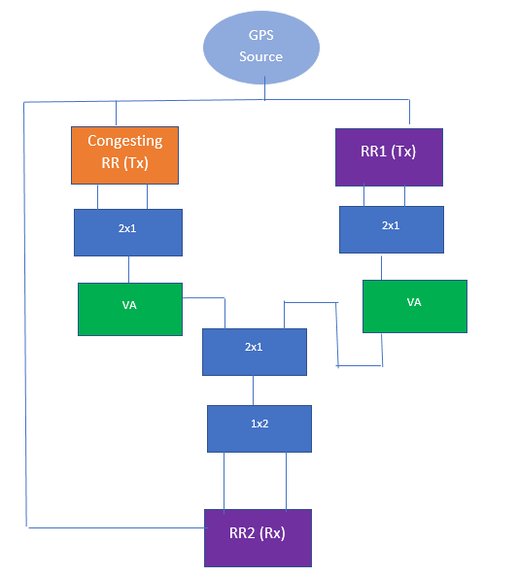

*1x2 and 2x1 above are splitter/combiners and VA is the variable attenuator
Figure 28: Near-Far Effect Test Setup

- Settings on DUT1:
  - Transmit on ITS band with bandwidth of 10 MHz.
  - Configured to transmit packets almost every 1 ms occupying 5 Sub-channels (Sub-Channel 0 to Sub- Channel 4), i.e., first half of the frequency resources in 10 Mhz channel bandwidth.
  - Packet length of standard BSM
- Settings on DUT2:
  - Transmit on ITS band with bandwidth of 10 MHz
  - SPS-based transmit flow with a periodicity of 100 ms (Note: equivalent to setting a periodic stream at 100 ms period for other technologies) occupying 5 Sub-channels (Sub-Channel 5 to Sub-Channel
9) i.e., second half of the frequency resources in 10 Mhz channel bandwidth.

  - Packet length of standard BSM
- Settings on DUT3:
  - Configured to receive on ITS band (e.g., center frequency 5,860 MHz) with bandwidth of 10 MHz
  - All measurements of receiving side performance are done on this device.
- Data Collection at DUT1
  - OS timestamp for each transmitted packet
  - Sequence number of each transmitted packet
- Data Collection at DUT2
  - OS timestamp for each transmitted packet
  - Sequence number of each transmitted packet
- Data Collection at DUT3
  - OS timestamp for each received packet
  - Sequence number of each received packet
  - Receive signal power for each received packet

Table 25: Test Configuration

Configuration | C-V2X
HARQ | Disabled
Number of Samples | 6000

NOTE: For an equivalent test for 3GPP for near-far effect, please see 3GPP Rel 14 TS 36.101, chapter 14.4.

      - Test Execution
        - Turn off Device 2 (DUT2).
        - Adjust the attenuator between Device 1 (DUT1) and Device 3 (DUT3) such that received power is -50 dBm at DUT3. Record this attenuator setting.
        - Turn off Device 1 (DUT1).
        - Turn on Device 2 (DUT2) and set the attenuation at Device 2 (DUT2) such that the input power at Device 3 (DUT3) is -50 dBm.
        - Turn on Device 1 (DUT1) and set the attenuator to the value determined in Step 2. This attenuator value is set constant throughout the test.
        - Record the data as mentioned below on all the devices:

- Device  - OS | 1 | (DUT1)  timestamp | for | and |  | Device each | 2  Tx | (DUT2):  packet
- Sequence number of each Tx packet
- Device  - OS | timestamp |  | for |  | 3 | each | Rx | (DUT3):  packet
- Sequence | number |  |  | of |  | each | Rx | packet
- Receive signal power for each Rx packet

        - At Device 3 (DUT3), calculate the PER for packets sent by Device 1 (DUT1), as well as the PER for packets sent by Device 2 (DUT2).

Increase the attenuation on the Variable Attenuator between DUT2 and DUT3 by a certain increment.
          - In the first few iterations, use 10 dB as the increment.
          - In later iterations, as the PER approaches 100%, use one dB as the increment.
        - Repeat step 8 until the PER for packets sent by Device 2 reaches 100%

Required Documentation
Table 26 is based on the data collected from log files.

Table 26: C-V2X Near-Far Effect Results

Attenuator Value (dB) | Rx power delta* at Device 3 (dB) | No. of Transmitted pkts |  | No. of Received pkts |  | PER % Calculated at Receiver (Device 3)
 |  | (total for the 10 min test) |  | (total for the 10-min test)
 |  | Transmit Device 1 | Transmit Device 2 | Received at Device 3 from  Device 1 | Received at Device 3 from Device 2 | For Packets from Device 1 | For Packets from Device 2
39 | 0 | 6000 | 6000 | 6000 | 6000 | 0 | 0
49 | 10 | 6000 | 6000 | 6000 | 6000 | 0 | 0
59 | 20 | 6000 | 6000 | 6000 | 6000 | 0 | 0
69 | 30 | 6000 | 6000 | 6000 | 6000 | 0 | 0
71 | 32 | 6000 | 6000 | 6000 | 6000 | 0 | 0
72 | 33 | 6000 | 6000 | 6000 | 5996 | 0 | 0.07
73 | 34 | 6000 | 6000 | 6000 | 5918 | 0 | 1.37
74 | 35 | 6000 | 6000 | 6000 | 5675 | 0 | 5.42
75 | 36 | 6000 | 6000 | 6000 | 4475 | 0 | 25.42
76 | 37 | 6000 | 6000 | 6000 | 2501 | 0 | 58.32
77 | 38 | 6000 | 6000 | 6000 | 699 | 0 | 88.35
78 | 39 | 6000 | 6000 | 6000 | 16 | 0 | 99.73
Device 1 Tx Power (dBm) |  |  |  | 21 dBm
Device 2 Tx Power (dBm) |  |  |  | 21 dBm

* Rx power difference at Device 3 (Receiving Device), between transmissions received from Device 1 and Device 2 (which are transmitting devices).
Note that Table 26 captures Tx packets from DUT1 and DUT2 that are sent in the same subframe. Measured insertion loss from DUT1 to DUT 3, and DUT2 to DUT3 is 32 dB. Total Pathloss = Attenuation + Insertion loss

Evaluation Criteria
Evaluation criteria assesses the performance in terms of PER during near-far scenario through assessment of colliding TTIs and adjacent RBs.

Key Takeaways
One of the key features of C-V2X is frequency division multiplexing (FDM). However, because of the potential for transmissions on adjacent subchannels, FDM can lead to the near-far effect. The impact of the near-far effect though is limited by the minimum in-band emissions requirements defined in 3GPP specifications. The data from the near-far test showed that the average leakage of device under test ~ -35 dB meets the minimum requirements specified in 3GPP Rel 14 TS 36.101 Section 6.5.2G.3.

Congestion Tests

Congestion Control Lab Test
The following lab tests are conducted to assess performance of the V2X systems in a radio-congested environment (all cases listed here are V2V without network infrastructure coverage):
      - Section 7.4.1: V2V congestion control in lab environment: regular BSM broadcast
      - Section 7.4.2: V2V congestion control in lab environment: critical BSM broadcast
Carefully designed, cabled-up lab testbeds produce repeatable and reproducible results. As a result, they provide a controlled and stable platform for comparing technologies and algorithms. Unlike an over-the-air testbed that produces results that vary over time, performance comparisons obtained from cabled-up testbeds are precise.
CBR is a metric that tracks the Channel Utilization in C-V2X. It is defined as mentioned in 3GPP specification TS 36.214 section 5.1.30.

Definition | Channel busy ratio (CBR) measured in subframe n is defined as follows:  - For PSSCH, the portion of sub-channels in the resource pool whose S-RSSI measured by the UE exceed a (pre-)configured threshold sensed over subframes [n-100, n-1];  - For PSCCH, in a pool (pre)configured such that PSCCH may be transmitted with its corresponding PSSCH in non-adjacent resource blocks, the portion of the resources of the PSCCH pool whose S-RSSI measured by the UE exceed a (pre-)configured threshold sensed over subframes [n-100, n-1], assuming that the PSCCH pool is composed of resources with a size of two consecutive PRB pairs in the frequency domain.

The congestion control lab setup evaluates the performance of speeding cars in the carpool lane of a traffic- jammed highway.

V2V Congestion Control in lab environment – Regular BSM broadcast

Background
This test verifies that V2V (LTE C-V2X Mode 4) devices can transmit and receive BSM messages in a congestion-challenged channel. C-V2X devices communicate over the PC5 interface without cellular network assistance (out-of-coverage, Mode 4). The devices implement the congestion control algorithm inspired by SAE J2945/1. 3GPP congestion control was turned off for this test. This is a standalone C-V2X test and only C-V2X results are presented.

Goals
          - Execute a BSM transmission and reception test between DUT1 and DUT2 in a congestion- challenged environment.
          - Measure KPIs including PER, Latency, and IPG for transmission and reception between DUT 1 and DUT 2.
          - Compare the CDF of PER and CBR generated from the lab Setup with the System-Level Simulation and verify a match.

To achieve these goals, we consider the challenging scenario of speeding cars on the carpool lane of a traffic- jammed highway. This test is based on the CAMP scenario described in [NHTSA-2015-0060] where the devices under test move on a 1200-meter stretch of highway in the carpool lanes, while the devices creating the congestion are stationary on both sides of the carpool lanes. In the CAMP setup and with 5x emulation by the test devices, the congesting test devices emulate columns of 10 cars on each side of the carpool lanes where the columns are separated by 12.5 meters and the lane width is 3.6 meters. This scenario repeats the setup for the congesting devices.
Compared to the original CAMP setup, the following changes were made to adapt the test to the lab environment:
- Two stationary DUT devices: The two devices under test are stationary in the middle of the 1200-meter stretch of highway, but they still transmit periodically every 100 ms as in the original scenario. The stationarity assumption simplifies the lab setup emulating this scenario while placing the devices under test in the location where maximum interference is occurring.
- AWGN channel: The main source of error is interference from the congesting devices and thus modeling AWGN is not necessary.
- Reduced set of emulated congesting devices: The main contributors to interference are the closest 576 cars that are traffic-jammed on the highway. This number was determined by conducting simulations of a larger number of interfering devices spread over the full 1200-meter stretch of highway (1940 cars) and then repeating the simulations with an increasingly smaller number of interfering cars to determine the smallest number of congesting devices for which the performance of the DUTs remains unchanged. Figure 29 shows the congestion scenario:
  - DUT 1, shown in red, is the host vehicle. It is stationary in the test environment but transmits at the maximum frequency of once every 100 ms due to its higher speed in the emulated scenario.
  - DUT 2, shown in grey on the central lanes, is the remote vehicle. Similarly to DUT1, it transmits at the maximum frequency of once every 100 ms.
  - The 576 interfering cars are also stationary in columns that are spaced 12.5 meters from each other. Within a column, 10 cars are spaced by the lane width of 3.6 meters on each of the upper and the lower sides of the carpool lanes.
Main Contributors
Small Contributors

Figure 29: Emulated Congestion Scenario

- 12-to-1 emulation ratio was produced for the lab reference devices: the 576 interfering devices are emulated in the lab environment using 48 lab reference devices. The next section explains how the 12- to-1 ratio is achieved.
- Path loss model from 3GPP TR 36.885: The path loss model is the freeway scenario mentioned in 3GPP TR 36.885 Section A.1.4. It specifies the model of LOS in WINNER+B1. Pathloss at 3m is used if distance is less than 3m.
Note that this test exercises the congestion control feature on the devices in the lab setup. Without congestion control, all devices would transmit a BSM every 100 ms. Each of the 48 reference devices generates two SPS transmissions occupying four subframes every 100 ms (one transmission and one retransmission per SPS, each using 50 out of 50 RBs per subframe). Given that all the devices are within communication range, this setup would produce a load of (48*4)/100 = 192%, almost twice what the channel bandwidth can support. Without congestion control, the system would fail to support every user in the system and result in large packet drops due to the high load.

Assumptions
For C-V2X, the devices should be pre-configured as mentioned in section 7.4.1.1.3.
The operating system time of all devices is synchronized to a common clock (e.g., GPS) with an error of no more than 1 ms. This requirement ensures that end-to-end latency between the transmitter and receiver can be measured with an accuracy of 2 ms. (This requirement does not relate to the requirement of the PHY layer synchronization.)

Setup
Fully cabled setup, using RF cables and arrays of splitters and combiners to connect all required devices, is used to construct this setup. A cabled environment is more controlled and repeatable.

Configuration | C-V2X
Channel | 5890 MHz (Channel 178)

NOTE: The following describes the cabled lab setup:
In this setup, multiple reference devices are used (sometimes referred to as “REF”), and their purpose is to generate the traffic that will provide the congested environment. In addition, two devices under test (DUT) are used, referred to as DUT1 and DUT2.
In this setup:
- All devices will be cabled up and connected via splitters and combiners.
- Adequate insulation is required to prevent leakages.
- The setup needs to use splitters/combiners that satisfy the requirements in the frequency range of C- V2X operation.
To control the experiment, use either or both of these:
- External PC/laptop units
- Connection of the modules/devices by wired LAN or 2.4 GHz Wi-Fi to centrally controlled equipment Figure 30 is a diagrammatic description of the setup. Notes for reading the diagram:
- The devices labelled “UE” are reference devices [Congesting Devices].
- “VA” stands for “variable attenuator.”

- DUT1 and DUT2 are shown as “HV” and “RV,” respectively.
- N=2, so every two REF devices are grouped in terms of the path loss toward the DUT1 and DUT2.
- The diagram is a representative illustration of the lab setup.
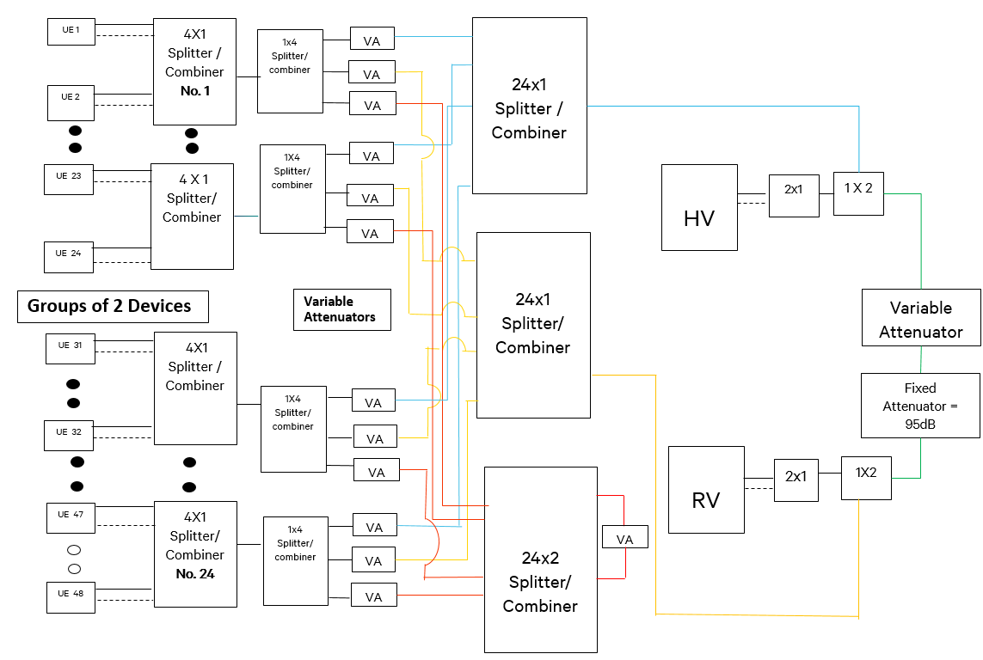

Figure 30: Representative Lab Setup (HV is DUT1 and RV is DUT2)

Detailed Diagram Description
- The Test setup is constructed keeping in mind that each device needs to hear the others, while offering pathloss control for specific device groups with other device groups.
- The Reference Devices are shown on the left, grouped in pairs.
- HV-RV are on the right talking to each other via a separate path connected via a fixed and a variable attenuator.
- The Blue Line Connector connects all the reference devices to HV, and path losses between them are tuned (via variable attenuator) per the simulation.
- The Yellow Line Connector connects all the reference devices to RV, and path losses between them are tuned (via variable attenuator) per the simulation.
- The two separate paths are required because path losses between HV-Reference Devices and RV- Reference Devices are different.
- The Reference Devices are connected to each other with the Red Connector path. The Variable attenuator for that link is set to ‘0’ as pathloss between reference devices does not impact the result of metrics collected at DUT1(HV) and DUT2(RV).

- HV-RV are connected with the Green Connector path and have a fixed attenuator of 95 dB and a variable attenuator that applies values per the test requirement.
This setup can be extended to accommodate a larger number of devices following similar logic, using and cascading more splitters/combiners and attenuators and connecting to the overall grid.
- Settings on Device 1 (DUT1) and Device 2 (DUT2):
  - Periodic packet transmit flow with a periodicity of 100 ms (in LTE C-V2X an SPS flow shall be configured with a periodicity of 100 ms)
  - Transmit on ITS band (e.g., center frequency 5,860 MHz) with a bandwidth of 10 MHz; transmitting regular BSM messages
  - Transmit power is kept constant at 21 dBm.
  - Both devices use Modulation Coding Scheme (MCS) 8 and 14 RBs for transmission
(LTE C-V2X allows for a choice of different parameters in the presence of congestion. The parameters were chosen to accommodate more users during congestion.)
  - C-V2X Rx and Tx pool bitmap is set to an all 1 bitmap with a bitmap length of 20.
- sl-Subframe bs20 : '11111111 11111111 1111'B
  - Rx and Tx pools have a number of sub-channels set to 10, and the size of each sub-channel is 5.
  - The frequency resources for both Tx and Rx pools have the start RB set to 0.
  - CBR RSSI threshold is set to a value of 9.
    - threshS-RSSI-CBR 9
  - HARQ is disabled.
  - Vehicle Density Co-efficient is set to 4.
  - Maximum Inter Transmit Time [Max_ITT] for packets is configured to 400 ms.
  - Add a default attenuation of 95 dB between DUT1 and DUT2 as a reference starting point for this test.
  - All attenuations added in the duration of the test are on top of the above default attenuation already present.
  - Configured to receive on ITS band (e.g., center frequency 5,860 MHz) with a bandwidth of 10 MHz
  - Packet length of standard BSM message
  - Using static GPS
- Adjustable attenuator (“Variable Attenuator” at far-right side of diagram) is used to simulate different distances between DUT1 and DUT2.
- Settings on the reference devices:
  - Transmit power is kept constant at 21 dBm.
  - Periodic transmit packet flow with a periodicity and load specified in such a way as to emulate multiple devices using the channel. This has been done in these ways:
  - Increasing the number of Resource blocks (RBs) in use to 50 per transmission by using a packet size of 1736 bytes (vs. 14 RBs for the DUTs).

  - Enabling HARQ retransmissions (vs. none for the DUTs).
  - Using 2 SPS flows on the device (vs. 1 on DUTs).
- With the above changes, a reference UE emulates about 12 interfering devices.
  - C-V2X Rx and Tx pool bitmap is set to an all 1 bitmap with a bitmap length of 20.
- sl-Subframe bs20 : '11111111 11111111 1111'B
  - Rx and Tx Pools have number of Sub-Channels set to 10, with size of each sub-channel being 5.
  - The Frequency resources for both Tx and Rx Pools have the start RB set to 0.
  - CBR RSSI threshold is set to a value of 15.
    - thresS-RSSI-CBR 15
  - Given the above 12-to-1 emulation ratio, the position of the REF devices is shown in Figure 31:
    - Simulated devices are shown as light blue stars.
    - REF devices are shown as red stars. These devices are labeled from 1 to 24 and then 1’ to 24’. Devices x and x’ have the same path loss toward the DUT1 and DUT2 in the lab setup due to the grouping highlighted above (N=2).
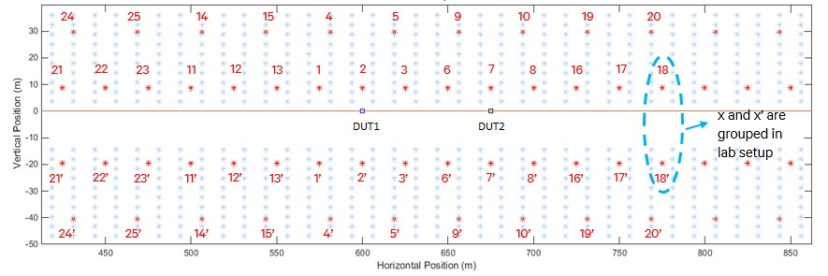

Figure 31: REF Device Locations

- The variable attenuators (in cabled RF setup) are set depending on the following:
  - The number of “real” devices each REF device emulates; (since a reference device emulates three equivalent “real” devices within each transmission, the attenuation from this device to each DUT should be divided by 3 to account for the reduced power per resource block in the lab scenario).
  - The real-world “distance” to be emulated between the specific REF device and the DUTs.
  - The attenuation between the REF devices is set to a fixed value corresponding to the average distance between the REF devices. In the default setup, the path loss between any two REF devices is 103 dB.
NOTE: The set of attenuators discussed here excludes the “Variable Attenuator” shown at the far-right side of diagram.
  - This table lists the positions and attenuations used in the default test setup:

Device | X-Pos | Y-Pos | Pathloss to DUT2 | Pathloss to DUT1
DUT2 | 675 | 0 | N/A | 95.1
DUT1 | 600 | 0 | 95.1 | N/A
1 | 575 | 8.7 | 95.15 | 72.01
1' | 575 | 8.7 | 95.15 | 72.01
2 | 600 | 8.7 | 90.19 | 58.89
2' | 600 | 8.7 | 90.19 | 58.89
3 | 625 | 8.7 | 83.31 | 72.01
3' | 625 | 8.7 | 83.31 | 72.01
4 | 581.25 | 29.7 | 94.78 | 76.89
4' | 581.25 | 29.7 | 94.78 | 76.89
5 | 618.75 | 29.7 | 87.21 | 76.89
5' | 618.75 | 29.7 | 87.21 | 76.89
6 | 650 | 8.7 | 72.01 | 83.31
6' | 650 | 8.7 | 72.01 | 83.31
7 | 675 | 8.7 | 58.89 | 90.19
7' | 675 | 8.7 | 58.89 | 90.19
8 | 700 | 8.7 | 72.01 | 95.15
8' | 700 | 8.7 | 72.01 | 95.15
9 | 656.25 | 29.7 | 76.89 | 87.21
9' | 656.25 | 29.7 | 76.89 | 87.21
10 | 693.75 | 29.7 | 76.89 | 94.78
10' | 693.75 | 29.7 | 76.89 | 94.78
11 | 550 | 8.7 | 98.99 | 83.31
11' | 550 | 8.7 | 98.99 | 83.31
12 | 525 | 8.7 | 102.16 | 90.19
12' | 525 | 8.7 | 102.16 | 90.19
13 | 500 | 8.7 | 104.82 | 95.15
13' | 500 | 8.7 | 104.82 | 95.15
14 | 543.75 | 29.7 | 100.24 | 87.21
14' | 543.75 | 29.7 | 100.24 | 87.21
15 | 506.25 | 29.7 | 104.43 | 94.78
15' | 506.25 | 29.7 | 104.43 | 94.78
16 | 725 | 8.7 | 83.31 | 98.99
16' | 725 | 8.7 | 83.31 | 98.99
17 | 750 | 8.7 | 90.19 | 102.16
17' | 750 | 8.7 | 90.19 | 102.16
18 | 775 | 8.7 | 95.15 | 104.82
18' | 775 | 8.7 | 95.15 | 104.82
19 | 731.25 | 29.7 | 87.21 | 100.24
19' | 731.25 | 29.7 | 87.21 | 100.24
20 | 768.75 | 29.7 | 94.78 | 104.43
20' | 768.75 | 29.7 | 94.78 | 104.43
21 | 475 | 8.7 | 107.14 | 98.99
21' | 475 | 8.7 | 107.14 | 98.99
22 | 450 | 8.7 | 109.18 | 102.16
22' | 450 | 8.7 | 109.18 | 102.16
23 | 425 | 8.7 | 111.01 | 104.82
23' | 425 | 8.7 | 111.01 | 104.82
24 | 468.75 | 29.7 | 107.83 | 100.24
24' | 468.75 | 29.7 | 107.83 | 100.24

  - Transmit on ITS band (e.g., center frequency 5,860 MHz) with bandwidth of 10 MHz; transmitting regular BSM messages
  - Generation of BSM content shall not be synchronized, i.e., each reference device generates its content at a different (random) point in time to avoid synchronization of transmission behavior
  - Transmit power is kept constant at 21 dBm.

  - Configured to receive on ITS band (e.g., center frequency 5,860 MHz) with a bandwidth of 10 MHz
  - Packet length of standard BSM message (unless the choice is made to vary the packet size as described in earlier bullet)
  - Using static GPS
- SAE congestion control settings:
  - Max_ITT of 400 ms. The max_ITT was pushed lower, from the default of 600 ms, to ensure a higher load in the system.
  - DensityCoefficient, B, is set to 25/6 ~= 4. Reason: each device transmits two BSMs and emulates 12 devices. Thus, every received BSM emulates six BSMs in the original scenario and the congestion control density coefficient, which has a default value of 25 per specification, should be adjusted accordingly.
- Data Collection at DUT1 and DUT2:
  - Timestamp for each transmitted packet
  - Timestamp for each received packet
  - Receive signal power for each received packet
  - All KPIs as listed further in this section
- Data Collection at each reference device:
  - Timestamp for each transmitted packet
  - All KPIs as listed further in this section

Test Execution
Overview: With the reference devices creating a congested environment, the PER between the DUTs (DUT1 and DUT2) is observed as the “distance” between them is gradually increased by adjusting the attenuation.
Set up the test bed as explained above, where the total number of reference devices is 48 which effectively simulates 576 devices.
- Add a default attenuation of 95 dB, between DUT1 and DUT2 as a reference starting point for this test
- The default attenuation of 95 dB was chosen to emulate ~75 m according to simulations as mentioned in section 7.4.1.1.3.
- Set “Variable Attenuator” at the far-right side of the diagram to 0 dB to simulate a short distance between the DUTs.
- Start transmission at all reference devices (regular BSM broadcast).
- Start transmission at DUT1 and DUT2 (regular BSM broadcast).
- Record to a log file the statistics and KPIs as defined in this section for DUT1, DUT2, and the reference devices.
NOTE: Logging/saving of all KPIs shall be done for at least one reference device. Logging/saving is recommended for all reference devices as far as practical for additional analysis.

- Calculate the PER between the two DUTs at both DUT1 and DUT2.
- Increase the attenuation at “Variable Attenuator” by 5 dB to simulate an increased distance between the DUTs.
- Repeat steps 5 through 7 until the overall attenuation reaches 115 dB (near sensitivity level).
- Set “Variable Attenuator” at the far-right side of the diagram to 0 dB to simulate a short distance between the DUTs.

Unique Tests to be Conducted
Run this test as described in section 7.4.1.1.4 using two C-V2X DUTs and up to 48 reference devices as explained in section 7.4.1.1.3. All devices (DUT1, DUT2, reference devices) have congestion control turned on.

Required Documentation
Table 27 summarizes the results based on the data collected from log files.

Table 26: Required Documentation Congestion Control
Attenuati on value between DUTs (dB) | Numbe r of  referen ce devices | No. of  Transmitted pkts |  | No. of Received pkts |  | Calculated at Receiver
 |  | DUT1 | DUT2 | DUT1 | DUT2 | PER %  at DUT1 | PER %  at DUT2 | 95%ile IPG  Value at DUT1 | 95%Tile IPG  value at DUT2 | 95%ile Latency Value at DUT1 | 95%Tile Latency value at DUT2
 | 48
95 |  | 2071 | 2076 | 2043 | 2029 | 1.6 | 2.0 | 105 | 104 | 97 | 102
100 |  | 2068 | 2055 | 1952 | 1964 | 5.0 | 5.0 | 108 | 105 | 104 | 101
105 |  | 2068 | 2072 | 1850 | 1967 | 10.7 | 4.8 | 105 | 105 | 99 | 97
110 |  | 2065 | 2067 | 1847 | 1846 | 10.6 | 10.6 | 212 | 104 | 100 | 90
115 |  | 2067 | 2066 | 1720 | 1681 | 16.7 | 18.6 | 214 | 215 | 92 | 102

CDF

Figure 32: CDF of CBR
CDF of CBR
1
0,9
0,8
0,7
Lab with CC
0,6
0,5
Sims - 600 Users -
AWGN
0,4
Simulation - 1940
UEs
0,3
0,2
0,1
0
0
10
20
30
CBR
40
50
60
RV PER CDF
100,00%
90,00%
80,00%
70,00%
60,00%
50,00%
40,00%
30,00%
Lab PER CDF
Simulation 600 UEs
Simulation 1940 UEs
20,00%
10,00%
0,00%
0
0,05 0,1 0,15
0,2
PER
0,25 0,3 0,35 0,4
CDF

Figure 33: CDF of PER

Evaluation Criteria
Evaluation criteria assesses the performance of V2X in a highly congested environment, including the performance of the distributed congestion control mechanism implemented on the device under test under different values of CBR. For CBR implementation details see: J2945-1.
Verify that lab data at the 75-m distance point (95 dB Attenuation) matches the SIM data for the CDF of CBR and the CDF of PER. A satisfactory match for both these metrics implies that channel utilization was commensurate to the load on the system and that Packet Loss under the observed congestion environment is as per expectation.

Key Takeaway
As can be observed, both CBR metrics and PER metrics observed in the lab and the SIM closely resemble each other. SAE congestion control is working as expected for C-V2X. All the devices in the system back off to an ITT of 400 ms as soon as congestion is detected per the parameters set in the test. The devices in the setup choose their transmission resources while avoiding transmissions chosen by other devices, which helps improve overall PER as measured on DUT1 and DUT2.
This confirms the channel utilization under operating load is an efficient use of the channel while also maintaining a low packet error rate to improve overall PER performance in a congested environment.

      - V2V Congestion Control in lab – Critical BSM broadcast
Most of the test setup and test steps for this 7.4.1.2 test case are the same as for the 7.4.1.1 test case. Therefore, the following subsections describe only key differences.

Background
Same as Section 7.4.1.1.1 except for the following:
The purpose of this test is to verify that C-V2X devices can transmit and receive BSM messages, with critical priority, over the PC5 interface in a congestion-challenged channel. This corresponds to a critical event condition, as defined in SAE J2945/1, and corresponding messages are transmitted with a higher 3GPP priority.
In the following lab tests, we have an equivalent load of 578 devices like the earlier test with 48 special configured devices and two DUTs.

Assumptions
Same as section 7.4.1.1.2.

Setup
Same as section 7.4.1.1.3 except for the following:
The two devices under test, DUT1 and DUT2, send BSM messages as in section 7.4.1.1.3. While most of the messages are regular BSM messages, a subset of the sent BSM messages is critical, as detailed below. (As in section 7.4.1.1.3, the REF devices provide the congested environment, and they send only regular, not critical BSM messages.)
          - Settings on Device 1 (DUT1) and Device 2 (DUT2):
            - Same as in Section 7.4.1.1.3 except as described below:
            - BSM messages are sent according to the same cadence in Section 7.4.1.1.3. The only difference is that critical BSM messages (i.e., priority 0) are sent at random occasions (in place of regular BSM messages) to simulate the event or incident. More specifically:
              - At a random time, the device starts sending BSM messages with critical priority in place of regular priority BSM. Critical BSMs are transmitted with highest priority at the occurrence of an event.

After the first transmission of a critical BSM, a periodicity of 10 Hz is maintained until the event is over. The duration of an event has been set to 5 seconds for the test.
              - At the end of the event the device reverts to sending the BSM messages with regular priority.
          - Adjustable attenuator (“Variable Attenuator” at far-right side of Figure 30):
            - Same as specified in Section 7.4.1.1.3
          - Settings on the reference devices:
            - Same as specified in Section 7.4.1.1.3. This includes the fact that the reference devices will send only regular BSM messages (no critical ones).
          - Data Collection at DUT1 and DUT2:
            - Same as specified in Section 7.4.1.1.3 with the additions listed below
            - Priority (critical or regular) for each transmitted packet
            - Priority (critical or regular) for each received packet
  - Data Collection at each reference device:
- Same as specified in Section 7.4.1.1.3

Test Execution
The overall idea of the testing is the same as in section 7.4.1.1.4. The “Overview” from section 7.4.1.1.4 is repeated here:
With the reference devices creating a congested environment, the PER between the DUTs (DUT1 and DUT2) is observed as the “distance” between them is gradually increased by adjusting the attenuation.
Following is the complete set of test execution steps.
- Set up the test bed as explained in section 7.4.1.1.3, where the total quantity of reference devices is 48.
- The default attenuation of 95 dB was chosen to emulate ~75 m according to Simulations.
- Set “Variable Attenuator” (at the far-right side of diagram in Figure 7 20) to 0 dB to simulate a short distance between the DUTs.
- Start transmission at all reference devices (regular BSM broadcast).
- Start transmission at DUT1 and DUT2 (BSM broadcast). Normally the BSM messages of a given DUT shall be sent with regular priority, but at times they shall instead be sent with critical priority, according to the following:
  - At a random time, the device starts sending BSM messages with critical priority in place of regular priority BSM. Critical BSMs are transmitted with highest priority at the occurrence of an event. After the first transmission of a critical BSM, a periodicity of 10 Hz is maintained until the event is over. The duration of an event has been set to 5 seconds for the test
  - At the end of the event the device reverts to sending the BSM messages with regular priority. The event repeats for five to 10 times in the overall test duration.
- Record to a log file the data and KPIs as defined in this section for DUT1, DUT2, and the reference devices.
NOTE: Logging/saving of all KPIs shall be done for at least one reference device. Logging/saving is recommended for all reference devices as far as practical, for additional analysis.

- Calculate the PER between the two DUTs at both DUT1 and DUT2.
NOTE: Perform these calculations separately for critical and regular BSM messages.
- Increase the attenuation at “Variable Attenuator” (at far-right side of Figure 30) by 10 dB to simulate an increase in distance between the DUTs.
- Repeat steps 5 through 7 until the overall attenuation between DUT1 and DUT2 reaches 115 dB. PER shall be considered separately for critical and regular BSM messages.

Unique Tests to be Conducted
Run this test as described in section 7.4.1.2.3 using two C-V2X DUTs and up to 48 reference devices with special configuration as explained above. Run the test in section 7.4.1.2.4 as follows:
  - All devices (DUT1, DUT2, reference devices) have congestions control switched on

Required Documentation
Table 27 uses the data collected from log files or observed from any OBU user interface.

Table 27: Required Documentation

Attenuation value between DUTs (dB) | No. of Transmitted pkts |  |  |  | No. of Received pkts |  |  |  | Calculated at Receiver
 | DUT1 |  | DUT2 |  | DUT1 |  | DUT2 |  | PER % at DUT1 |  | PER % at DUT2 |  | 95th Percentile IPG  (ms) |  | 95th Percentile Latency  (ms)
 | Crit. BSM | Reg. BSM | Crit. BSM | Reg. BSM | Crit. BSM | Reg. BSM | Crit. BSM | Reg. BSM | Crit. BSM | Reg. BSM | Crit. BSM | Reg. BSM | DUT1 | DUT2 | DUT1 | DUT2
95 | 350 | 1448 | 399 | 1669 | 394 | 1667 | 347 | 1426 | 1.2 | 1.9 | 0.8 | 1.5 | 105 | 105 | 98 | 101
100 | 350 | 1449 | 400 | 1660 | 388 | 1542 | 340 | 1320 | 2.9 | 7.1 | 2.8 | 8.8 | 105 | 105 | 101 | 103
105 | 350 | 1451 | 395 | 1658 | 383 | 1511 | 330 | 1291 | 3.1 | 8.8 | 5.6 | 11.0 | 105 | 105 | 103 | 102
110 | 350 | 1449 | 400 | 1662 | 367 | 1408 | 323 | 1279 | 8.2 | 15.3 | 7.5 | 11.4 | 215 | 105 | 102 | 101
115 | 350 | 1450 | 400 | 1665 | 351 | 1281 | 322 | 1201 | 12.3 | 23.1 | 8 | 17.2 | 219 | 105 | 100 | 100

Evaluation Criteria
Evaluation criteria assesses the performance of high-priority BSM messages in a highly congested lab environment and multi-priority BSM usages.
The evaluation criteria is satisfactory performance of lab tests with congestion control where the PER performance of high-priority BSM messages is better than, or at least, equal to the low-priority messages.

Key Takeaway
The results showed that the PER performance of high-priority BSM messages is noticeably better than lower- priority messages when high attenuations are used, or reception signals are weak.
Under poor communication environments, high-priority BSM messages showed more reliable performance compared to lower priority messages. The reason is that high-priority safety messages can be protected more efficiently for congested and collision scenarios by the C-V2X resource selection algorithm.

Under low attenuation or strong reception signal environments, the PER improvement of high-priority BSM messages is marginal, which is expected because the PER performance of low- priority BSM messages is already satisfactory.
For the actual deployment, we expect that this PER improvement of high-priority BSM messages can be translated into noticeable and meaningful reliability improvement of critical safety messages under highly congested scenarios.

Field Test Procedures and Results

Introduction
These field tests provided a realistic, but controlled, open-sky setting for comparative testing of the V2V technologies. Each test is executed exactly the same for both technologies, and the results are compared. For comparative tests, the following must be the same when testing the two technologies:
    - Test procedure
    - Test conditions
Under test conditions we ensured that the following are the same:
    - Antenna characteristics and placement
    - Vehicle geometry and cabling
    - Track topology and arrangement
    - Sample size and repeatability
    - Environmental conditions and interference
    - Power and other radio settings
In our tests, our main goal is to collect data for an apples-to-apples comparison between DSRC and C-V2X technologies. The performance metrics or KPIs used for the comparison are:
    - Packet reception rate (PRR)
    - Inter-packet gap (IPG)
Receive Signal Strength Indicator (RSSI) is collected and presented for DSRC only. While this performance measure has issues with accuracy, as discussed in section 5.1.3, it can be used for relative comparisons of the two technologies.
Field tests were performed on several test tracks and in more realistic road conditions for benchmarking. Range tests determine the distance at which PRR or the reliability of the BSM message reception drops below an acceptable level. The PRR threshold for range determination is 90%. The range tests were performed on the following test tracks:
    - Road A – Straightaway (Fowlerville Proving Ground - FPG, Michigan)
    - Perryman test track (Aberdeen Proving Grounds, Maryland)
    - Straightaway (Ford Michigan Proving Grounds, Michigan)
The most comprehensive tests were performed at FPG, and this section discusses those test results. Test results from other test tracks were consistent with the results from FPG in terms of comparative testing. We note that different test tracks produced different range results, emphasizing that the uniformity of conditions is key for comparison testing.
It is commonly accepted that range is reached when the PRR drops below 90%.

In realistic conditions, the signal sometimes drops and then quickly recovers, resulting in packet loss over a short period of time and, since the vehicle is moving, over a short distance. There is no industry agreement on how to treat these short outages. The goal of this document is to make a wider industry audience aware of this effect and promote discussion leading to a consensus. In this section, we report both the first time the PRR crosses 90% and the last time before the PRR deteriorates beyond recovery.
The rest of this section presents test procedures and results for the following tests:
    - Range
      - Line-of-Sight (LOS)
      - Non-Line-of-Sight (NLOS)
        - Shadowing
        - Intersection
    - LOS interference from U-NII-3 band
    - LOS interference from adjacent channel

Hardware Setup
Figure 34 shows the setup of the transmitter and receiver. The connector on the DSRC OBU was FAKRA Type Z with a 6’’ SMA cable. The connector on the C-V2X OBU was Quad FAKRA with a 2’’ SMA cable. One antenna was used for transmission and two antennas for reception (1Tx 2Rx configuration). The effective transmit power was varied by changing both attenuators simultaneously at the primary and the secondary ports. The sum of the attenuator values at the transmit and receive sides represents the effective transmit power reduction (10 dB and 16 dB total path loss increase for 5 dB and 8 dB attenuator values, respectively).
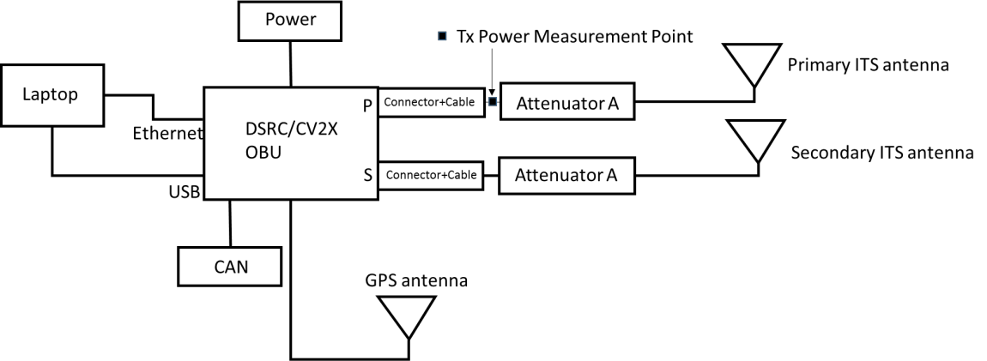

Figure 34: Transmitter and receiver setup

In the field tests both OBUs were transmitting and receiving at the same time. As discussed, all three antennas: primary (Tx and Rx), secondary (Rx only) and GPS, were placed on the roof. The OBUs are connected to a power supply, CAN connector, and a laptop for test control and data logging.
Each OBU has a primary antenna port to transmit the RF signal out of the unit. The antenna port connectors are different for each technology and are shown in Table 28. In Figure 35, we show the link power budget for both technologies for the field test. Assuming the same antenna cabling and gain used for both technologies (same car), the only variable component is the antenna connector with a short SMA-terminated cable. We measured transmit power at the output of each connector/cable as shown in the table in Figure 35. section
7.1.2 described the measurement technique. Based on the connector loss values and the requirement to guarantee the same end-to-end loss conditions for comparative testing, we set the transmit power of the DSRC OBU to 23 dBm. This gives a 0.8 dB to DSRC units at the receive antenna ports. We believe that this small difference is within measurement error of the test and should not affect the conclusions of the test.

Table 28: Antenna connectors and cables with illustrations

Technology | Connector | Loss
C-V2X | Quad FAKRA | 0.4 dB | 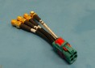
DSRC | FAKRA Type Z | 1.0 dB | 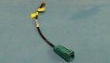

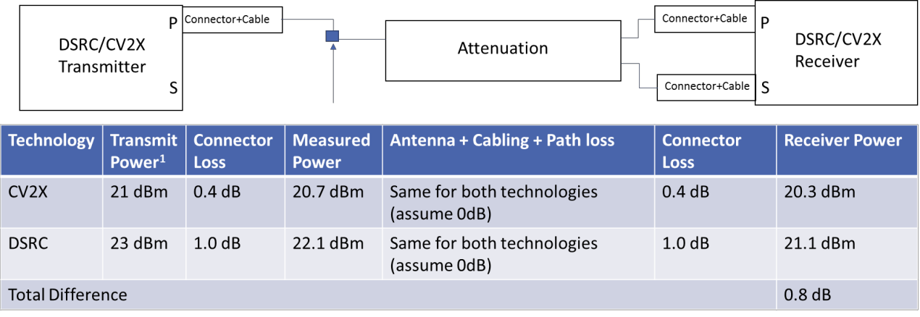

Figure 35: Link budget for the two technologies

Field Test Parameters
As Section 6.1 describes, the OBUs used in the tests are:
    - Savari MW1000 (DSRC)
    - Qualcomm Roadrunner (C-V2X)
Table 29 shows the main parameters used in the field tests. Due to high activity of the U-NII-3 devices on most test tracks including FPG, we decided to move the test frequency as far as possible from the U-NII-3 band but keep it in the ITS band, i.e., to CH184 (center frequency 5,920 MHz). Based on free-space and plane-earth propagation models (see (Parsons, 1994)) the change in operating frequency should have less than 0.1 dB effect on propagation loss, ensuring that the conclusions from CH172 and CH184 testing are the same. This equivalence is ensured under the interference-free conditions required for the range tests. Additionally, while the C-V2X has the same channel bandwidth as DSRC, the actual transmission bandwidth of C-V2X can be a fraction of 10 MHz (in our case it is ~4.5 MHz) due to the frequency division multiplexing feature of C-V2X.

Table 29: OBU and system parameters used in the field tests

Parameter11 | DSRC | C-V2X
Vehicle | Fusion (w/o moon roof) | Fusion (w/o moon roof)
Modulation and coding2 | QPSK, 0.5 | MCS5 (QPSK, 0.46)
HARQ | Not available | Yes
Channel3 | CH184 (5,920 MHz) | CH184 (5,920 MHz)
Bandwidth (message) | 10 MHz | 10 MHz
Packet size | 193B | 193B
Message frequency | 10 Hz | 10 Hz
Antenna4 | ECOM6-5500 (6 dBi) | ECOM6-5500 (6 dBi)
Diversity | 1Tx, 2Rx | 1Tx, 2Rx
Equivalent Tx Power (with attenuation)5 | 5 dBm, 11 dBm | 5 dBm, 11 dBm

  - Presentation of Results
The main performance metrics used in this section include: Packet Reception Ratio (PRR), Inter-Packet Gap (IPG), and Receive Signal Strength Indicator (RSSI). All metrics are defined in section 5.1. Average PRR is plotted as a function of the distance between stationary vehicle (SV) and the moving vehicle (MV). PRR is computed using the sliding window approach explained in section 5.1. PRR from multiple loops is combined in a single plot. We are typically showing the plots of PRR at the SV receiving BSM when MV is approaching. In cases where MV’s environment is different, e.g., interference scenarios, we show PRR at the MV when it is approaching SV and when SV is transmitting. IPG is plotted as a function of distance as an average over all loops. The distance at which average IPG increases sharply beyond 100 ms is closely correlated with the distance at which PRR drops below 90%. Small drops in PRR are also visible on the average IPG plot; however, they are of smaller magnitude. Cumulative distribution function (CDF) of IPG is used to illustrate the ratio of “good” IPG points (values close to 100 ms) to the total number of IPG data points collected. RSSI was collected at the DSRC OBU. It represents the estimate of the receive signal power as a function of distance for both technologies. Average RSSI over all loops is plotted as a function of the distance between the SV and MV. It provides an insight into the path loss characteristics of a particular test track.

- Selected parameters include standard options. Proprietary options were not considered.
- Code rates of 0.5 and 0.46 for DSRC and C-V2X, respectively.
- We used CH184 to avoid any impact of the existing U-NII-3 devices operating near the test track that we do not have control over.
- Antennas were mounted 24 inches apart in the middle of the roof (driver side Primary, passenger side Secondary – Primary used for Tx).
- Equivalent Tx power is the OBU total Tx power out minus attenuation on each RF antenna cable. Tx power was 21 dBm and the total attenuation was 10 dB (on both Rx ends combined) resulting in 11 dBm equivalent Tx power. Note that for DSRC OBU the matching Tx power was 23 dBm. To simplify, we will refer to Tx powers of both OBUs as 21 dBm. We have also done tests with 5 dBm equivalent transmit power by introducing 16 dB of total attenuation. This was done to fit the C-V2X range into the test track as well as match the same setting in previous tests by the industry (USDOT NHTSA, CAMP, September 2011).

Range tests
Range tests verify the distance at which a V2V technology achieves communication in various scenarios. Range or reliability tests also verify the reliability of basic safety packet communication as a function of distance between the vehicles. Range test scenarios are categorized as follows:
  - Line-of-Sight (LOS) tests
  - Non-Line-of-Sight (NLOS) tests

The results for LOS and NLOS scenarios follow.

Line-of-Sight (LOS) Tests
LOS range tests are described in Section 9.1.1 of (5GAA, March 2018). The procedure tests the performance characteristics of the radio technology in a realistic, yet controlled, environment of a test track. The conditions are open sky with no obstructions and minimal disturbance in the RF environment.
The objectives of the test are:
      - Compare communication range (packet reception rate vs. distance) and reliability of safety message exchange under LOS conditions for C-V2X and DSRC.
      - Compare inter-packet gap (IPG) for both technologies.
The scenario includes the following for both RF technologies tested:
- One stationary and one moving vehicle (SV, MV) broadcasting BSM messages (packets) without security.
- Packets are fixed at 193 bytes.
- Fixed attenuators are used so that the tests can be scaled to the test track maximum length.
- Transmit power fixed at the same equivalent value to guarantee the same link budget. Typically, two levels are tested: 5 dBm and 11 dBm equivalent transmit power.
- RF cabling including attenuation identical for both technologies.
- Same vehicles, instrumentation and antenna placements are used during the comparison tests for both technologies.
- Same vehicle models are used, so that the vehicle antenna characteristics are identical between SV and MV.
- MV is performing loops by moving away and returning towards the SV (see Figure 36). The two directions are referred to as receding and approaching. Each test consists of 10 loops.
- MV uses cruise control to maintain a constant speed of 20 mph or approximately 32 kph (except in the turns) per lap to be consistent for both technologies.

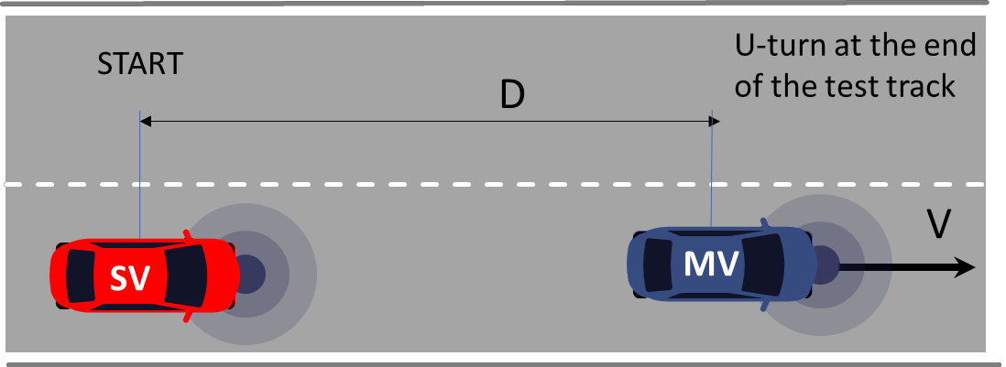

Figure 36: LOS Ranging Setup. D is the length of the test track (1.35 km)

Table 29 shows parameters used in the LOS test. The test track was not long enough to observe packet errors with a transmit power of 21 dBm. For that reason, the tests were performed with the reduced equivalent transmit power of 5 dBm and 11 dBm. The equivalent transmit power was achieved by placing the same fixed attenuators on both RF antenna cables (primary and secondary) between the OBU connector and the antenna cable (see Figure 34.). The fixed attenuators were measured in the lab using a VNA (Vector Network Analyzer).
The test was performed on Road A at the Fowlerville Proving Grounds (FPG), Fowlerville, Michigan. Road A is a 1.35-km long straightaway shown in Figure 37. Figure 38 shows a more detailed aerial view of the Stationary Vehicle setup and the U-turn performed by the Moving Vehicle i.
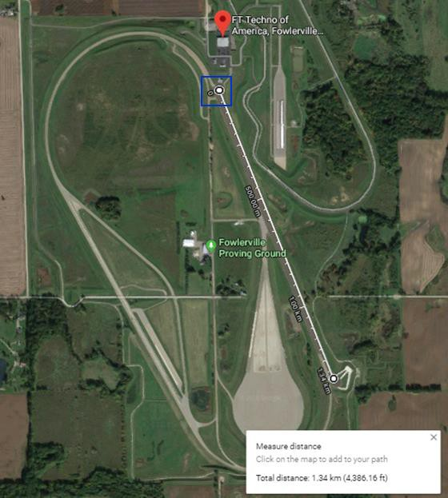

Figure 37: Map of FPG Road A

NOTE: The blue square on the map above represents the north circle where the SV was located (see Figure 38).
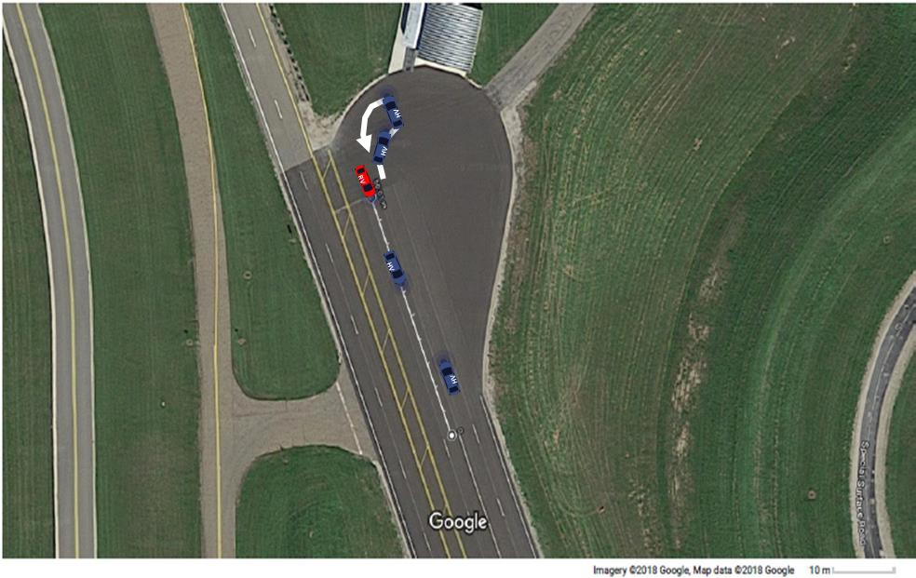

Figure 39: Map of the north circle at FPG Road A

NOTE: The red vehicle is the SV, and the blue vehicle is the MV with its trajectory labeled with the white arrow.

8.5.1.1 LOS Test Results
The first test was done to assess range of the devices on the track and collect the RSSI with no additional attenuation. Figure 40 shows the RSSI of a two-loop test. The RSSI KPI logs were collected by the DSRC OBUs. We observed that the equivalent path loss OBU-to-OBU at 1200 m (~85% of the test track) is approximately 113 dB (=23 dBm-(-90 dBm)). This path loss includes connector and cable losses, antenna gains, as well as propagation loss.
In Figure 40, we also show DSRC sensitivity based on Lab tests in section 7.2.2. Below this level the packet reception starts to deteriorate rapidly. The intersection of the sensitivity levels with the RSSI plot indicates roughly the range for DSRC. Since the accuracy of the RSSI measurements from the DSRC OBU is unknown, the range estimate is only approximate. From the Lab tests we know that C-V2X can sustain an additional 11 to 14 dB signal loss before the PRR starts to degrade. Therefore, we expect that at 21 dBm transmit power the test track is not long enough for C-V2X to experience packet loss. For that reason, as we discussed, we introduced additional loss into the system by adding 5 dB or 8 dB attenuators on each RF cable (two per OBU) increasing the path loss by a total of 10 dB or 16dB, respectively. This is equivalent to reducing the transmit power from 21 dBm down to 11 dBm or 5 dBm, respectively. Note that because of power adjustment for the DSRC system (23 dBm transmit power), the equivalent transmit power for the DSRC tests will be 13 dBm and 7 dBm, respectively. To avoid confusion, we refer to this power level for comparison testing as 21 dBm. With additional 10 dB/16 dB attenuation, we expect that DSRC PRR will start deteriorating at approximately 700 m/500 m, respectively (see Figure 40).
We note that the RSSI plot in Figure 40 exhibits a classic example of the constructive and destructive superposition of direct and reflective paths. The sharp drops of RSSI at 50 m and 100 m distances are predicted by the plane-earth propagation equation; see (Parsons, 1994), which also predicts the slope of the RSSI curve at larger distance (~1/(distance) 4 or approximately 12 dB for each doubling of the distance).

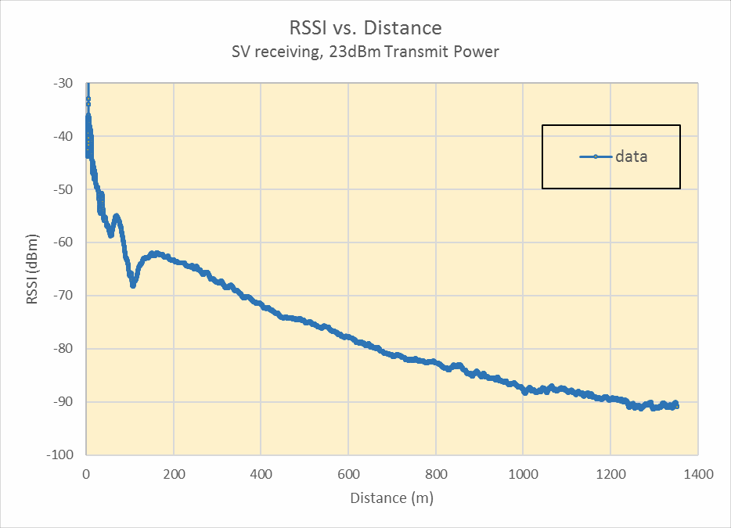

Figure 40: Receive Signal Strength measured by the stationary vehicle DSRC OBU with 23 dBm transmit power

In Figure 41, we show average Packet Reception Ratio as a function of distance between the stationary vehicle (SV) and the moving vehicle (MV) which MV is approaching averaged over all the loops. Assuming 90% PRR as the threshold, DSRC range for 5 dBm and 11 dBm is 475 m and 675 m, respectively. Similarly, C-V2X range is 780 m and 1175 m for effective transmit power of 5 dBm and 11 dBm, respectively. Note that PRR of C-V2X at 5 dBm effective transmit power has a higher range than PRR for DSRC at 11 dBm. It is interesting to note that the RSSI plot in Figure 40 provided a reasonable sanity check for the DSRC range performance on this test track.
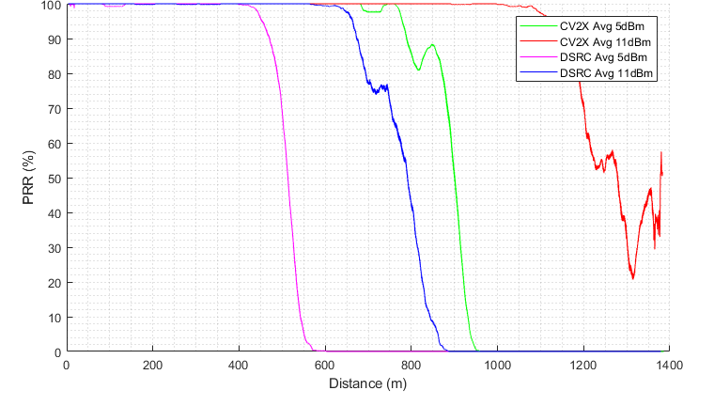

Figure 41: LOS average Packet Reception Ratio at the SV as a function of distance between the SV and MV

In Figure 42 we show the average Inter-Packet Gap (IPG) as a function of distance between SV and MV observed by SV for both technologies at 5 dBm effective power. We observe that average IPG is a fixed value (100 ms) for distances below PRR range for each technology. This is expected when no packets are lost. Small variations around the average are due to radio access and protocol stack processing variability. When N packets are lost the next received packet will record IPG which is approximately (N+1) inter-packet gaps or (N+1) x 100 ms. With a larger number of packets lost, the IPG increases rapidly, meaning that consecutive packets are being dropped. It can be observed that the rapid increase in the average IPG is closely correlated with range (see corresponding curves in Figure 41).
In Figure 43 we show the Cumulative Distribution Function (CDF) of the IPG data from Figure 42. We observe that for both DSRC and C-V2X ~82 to 83% of all BSMs received during the test recorded a regular inter-packet gap of 100 ms. The other ~17% of BSM messages were received after at least one of the preceding packets was lost. It can also be observed that ~2% of all BSMs collected had a gap of 20 missing packets preceding it. This clearly occurs beyond the range for both technologies. Similar observation from Figure 42 and Figure 43 apply to Figure 44 and Figure 45, respectively.
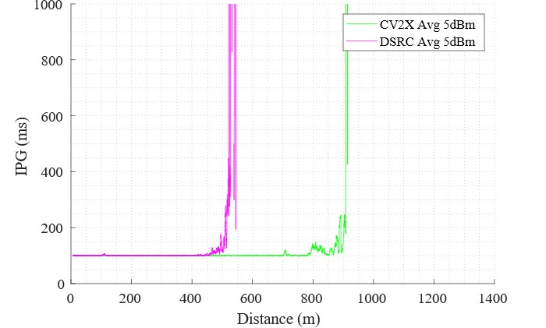

Figure 42: LOS average Inter-Packet Gap at the SV as a function of distance between the SV and MV (5 dBm).

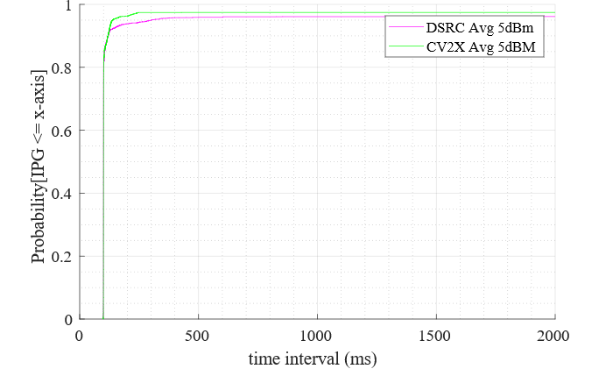

Figure 43: LOS Inter-Packet Gap CDF (5 dBm)

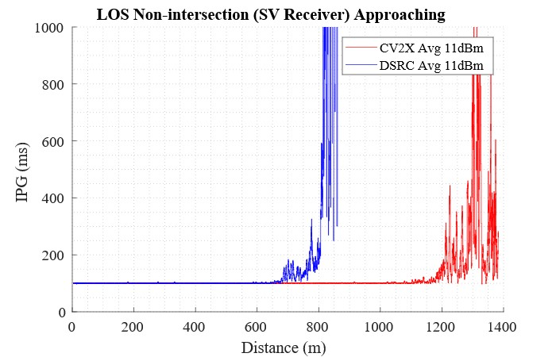
Figure 44: LOS average Inter-Packet Gap at the SV as a function of distance between the SV and MV (11 dBm)

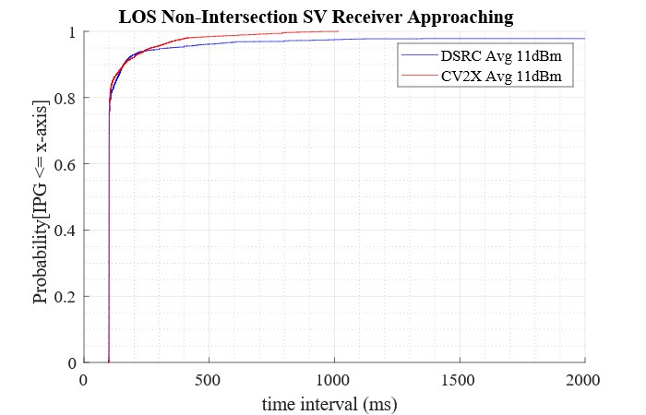

Figure 45: LOS Inter-Packet Gap CDF (11 dBm)

Figure 46 illustrates RSSI measured by the SV DSRC OBU for the 5dBm and 11 dBm effective power levels. DSRC OBU reports RSSI approximately -92 dBm at range. Beyond range average RSSI drops only slightly even though the signal level has dropped on average due to increased path loss. It should be noted that the 11 dBm curve in Figure 46 is 10 dB shifted version of the RSSI measurement in the initial test illustrated in Figure 46. The difference between RSSI curves in Figure 46 is approximately 6 dB which is expected based on the difference in the effective transmit powers.

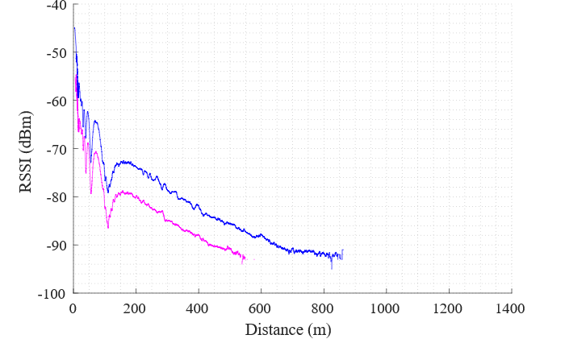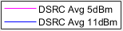

Figure 46: LOS DSRC RSSI as a function of distance between the SV and MV

Non-Line-of-Sight (NLOS) Range Tests
In this section we describe the test procedure and present results for two NLOS tests. The two NLOS tests that were performed are:
      - NLOS shadowing test, which assumes that the obstruction is in front of the SV and that the MV performs the maneuver in front of the blocker. This test is closely related to Do Not Pass Warning safety use case (e.g., (USDOT ITS JPO DNPW)).
      - NLOS intersection obstructed view test, which assumes that SV is positioned between two blockers obstructing the view of the road perpendicular to the SV position where the MV performs the maneuver. This test is closely related to Intersection Movement Assist (IMA) safety use case (e.g., (USDOT ITS JPO IMA)).
NLOS range tests are described in Section 9.1.1 of (5GAA, March 2018). As in the LOS test, the NLOS procedures test performance characteristics of the radio technology in a dynamic outdoor environment over the full range communications. The conditions are open sky with precisely defined obstructions and minimal disturbance in the RF environment.
The objectives of the test are to
- Compare communication range and reliability of safety message exchange under NLOS conditions (non-intersection and intersection) for C-V2X and DSRC.
- Compare inter-packet gap (IPG) for both technologies.
The test and system parameters used in these tests are the same as in Section 8.3. The 26-ft U-Haul trucks were used as blockers in all NLOS tests.

NLOS Shadowing Test and Results
The NLOS non-intersection test setup is shown in Figure 47. The distance between the front of the SV and the back of the blocker truck was set at 5.3 m. MV starts close to SV and moves away in the same lane as the SV at speed V=20 mph until out-of-range. Blocker stays stationary in front of SV. MV performs a U-turn and approaches SV in the neighboring lane. Testing was performed with 5 and 11 dBm equivalent transmit power.
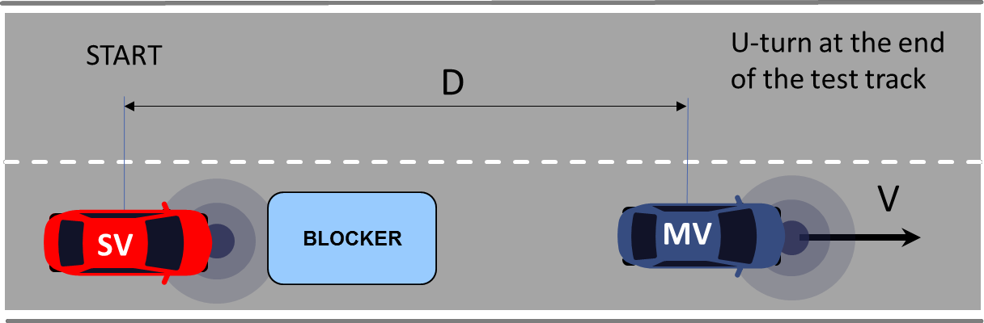
Figure 47: NLOS non-intersection test setup

The test was performed on the same test track as the LOS test, namely Road A at the Fowlerville Proving Grounds (FPG), Fowlerville, Michigan. The layout is shown below in Figure 48. The red vehicle is the Stationary vehicle (SV) and the blue vehicle is the moving vehicle (MV) with its trajectory labeled by white arrows. The grey blocker (U-Haul truck) is shown in front of the SV.

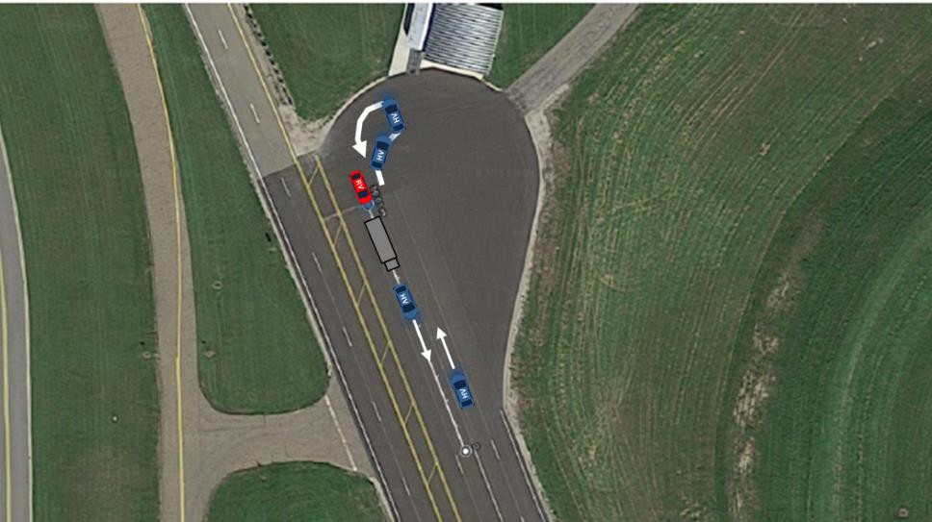

Figure 48: Map of the north circle at FPG Road A showing NLOS non-intersection test setup

In Figure 49, we show average Packet Reception Ratio at the stationary vehicle (SV) while the moving vehicle (MV) is approaching as a function of distance between the vehicles averaged over all the loops. Using 90% PRR threshold, DSRC range for 5 dBm and 11 dBm is 60 m and 125 m, respectively. Similarly, C-V2X range is 290 m and 425 m for effective transmit power of 5dBm and 11 dBm, respectively. Note that PRR of C-V2X at 5 dBm effective transmit power is better than PRR for DSRC at 11 dBm consistent with the observations in the LOS test. In Figure 50, we show average Inter-Packet Gap (IPG) as a function of distance between SV and MV observed by SV for both technologies. We observe that average IPG increases at the distances where there is a decrease in PRR. A spike in IPG for C-V2X at 425m is closely correlated with a drop in PRR below 90% at the same distance. Note also the sharp increase in PRR at 700 m and a brief recovery at around 800m. We should point out that, while PRR and IPG behavior beyond range is interesting, small variations in the RF environment can cause significant variability since the systems are operating close to the receiver sensitivity.

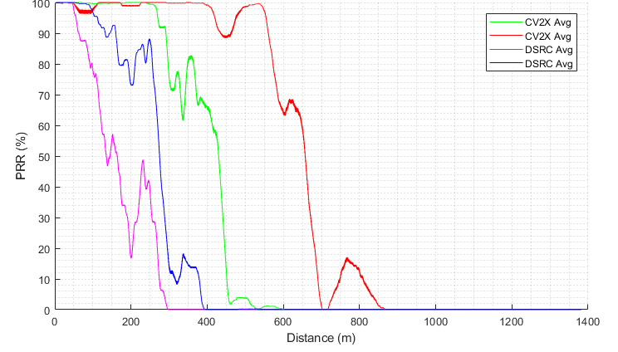

Figure 49: NLOS shadowing average Packet Reception Ratio at the SV as a function of distance between the SV and MV

In Figure 50 we show the average Inter-Packet Gap (IPG) as a function of distance between SV and MV observed by SV for both technologies at 5 dBm effective power. We observe that average IPG is approximately flat (100 ms) for distances below PRR range for each technology. In Figure 51 we show the Cumulative Distribution Function (CDF) of the IPG data from Figure 50. We observe that for DSRC and C-V2X ~60% and
~75% of all BSMs received during the test had a regular inter-packet gap of 100ms, respectively. This is different from the observations in the case of LOS where a higher percentage of all received BSMs were received after a regular 100ms interval from the preceding packet. Similar observation from Figure 50 and Figure 51 apply in Figure 52 and Figure 53, respectively.

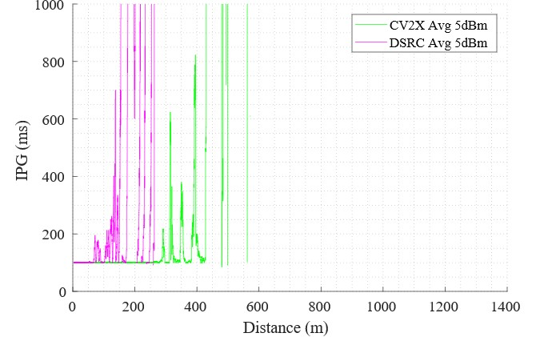

Figure 50: NLOS shadowing average Inter-Packet Gap at the SV as a function of distance between the SV and MV

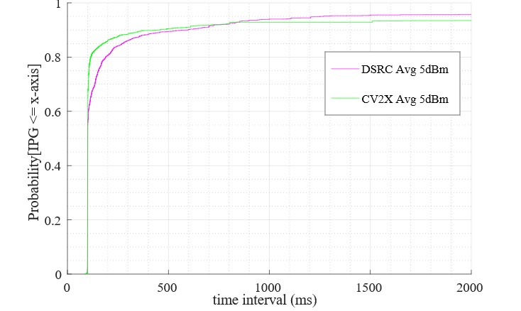
Figure 51: NLOS shadowing Inter-Packet Gap CDF

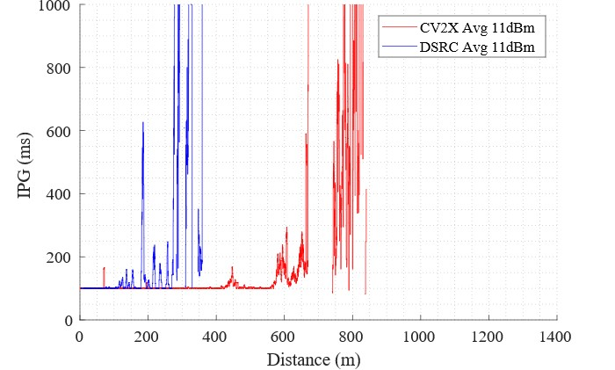

Figure 52: NLOS shadowing average Inter-Packet Gap at the SV as a function of distance between the SV and MV

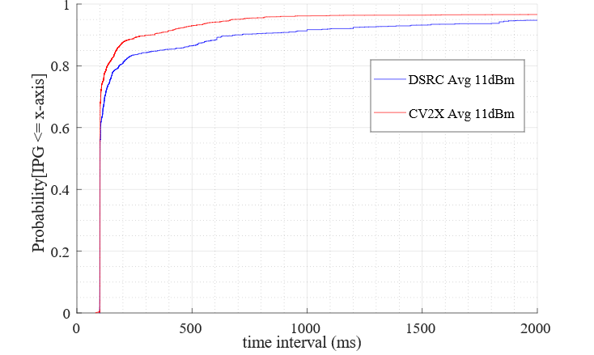
Figure 53: NLOS shadowing Inter-Packet Gap CDF

Figure 54 illustrates RSSI measured by the SV DSRC OBU for the 5 dBm and 11 dBm effective power levels for the NLOS shadowing test. The two curves are consistent with the corresponding DSRC PRR plots in Figure 49 showing approximately 100 m extended reception for the higher power level.

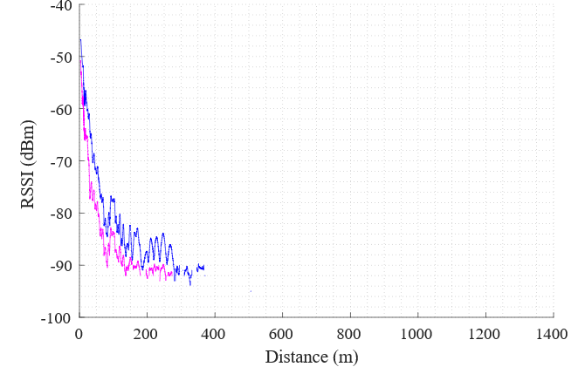

Figure 54: NLOS shadowing DSRC RSSI at the SV as a function of distance between the SV and MV

NLOS Intersection Test and Results
Figure 55 shows the NLOS intersection test setup. The test was performed with the full distance of Road A test track (D=1.35 km). SV is placed between two large blocking objects (trucks). Two 26-ft U-Haul trucks were used for the intersection tests. In the approach from the left, the MV starts in front of the SV and moves away in the lane perpendicular to the SV at a constant speed of 20 mph, simulating an intersection scenario. At the end of the test track it performs a U-turn and moves back in the neighboring lane. After passing by SV in the opposite direction it performs a U-turn and gets into the initial position without stopping. The blockers are placed 2.1 m from either side of the SV.
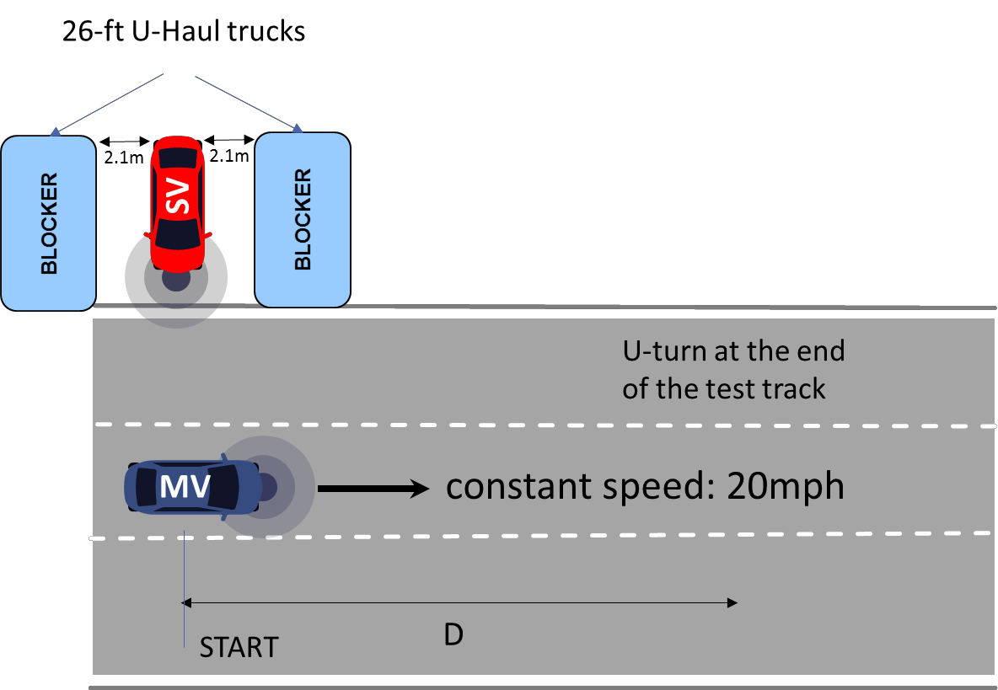

Figure 55: NLOS test setup for the approach from the left.

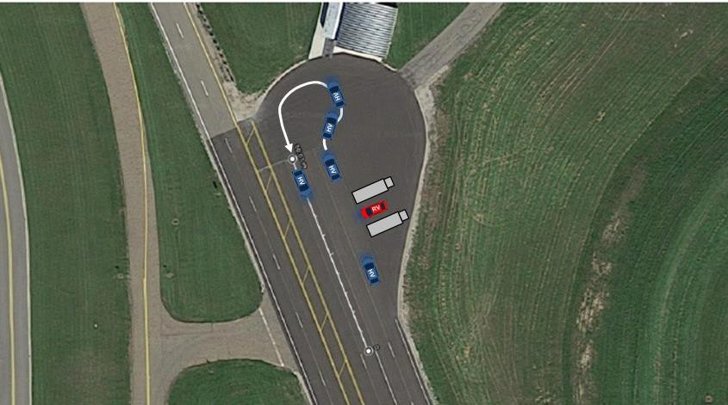

Figure 56: Map of the north circle at FPG Road A showing NLOS intersection test setup

NOTE: The red vehicle is the SV, the blue vehicle is the MV and the grey blockers are U-Haul trucks.
In Figure 57, we show average Packet Reception Ratio at the stationary vehicle (SV) while the moving vehicle (MV) is approaching as a function of distance between the vehicles averaged over all the loops. Using 90% PRR threshold, DSRC and C-V2X ranges are 375 m and 875 m, respectively. In Figure 58 we show average Inter-Packet Gap (IPG) as a function of distance between SV and MV observed by SV for both technologies. Small spikes in average IPG indicate isolated packet error which is consistent with the 1 to 2% temporary dips in PRR in Figure 57. Note that the NLOS intersection test was less demanding than the NLOS shadowing test and that the range in this test is significantly higher than in the previous NLOS test.

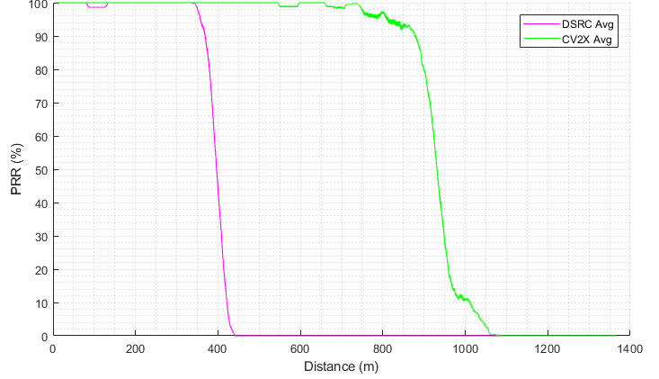

Figure 57: NLOS intersection average Packet Reception Ratio at the SV as a function of distance between the SV and MV

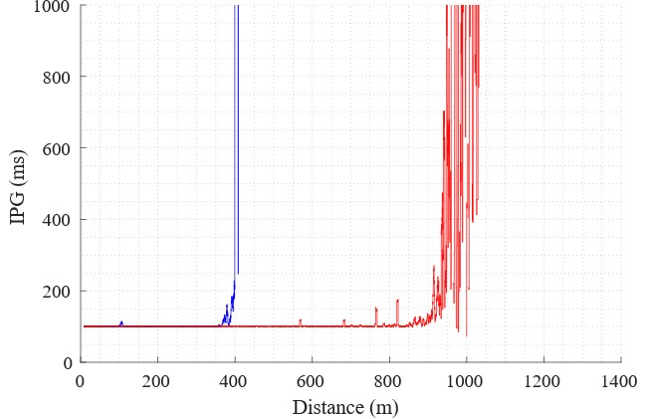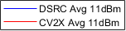

Figure 58: NLOS intersection average Inter-Packet Gap at the SV as a function of distance between the SV and MV

Figure 59 illustrates RSSI measured by the SV DSRC OBU for 11 dBm effective power level in the NLOS intersection test. The RSSI is consistent with the corresponding DSRC PRR and IPG plots in Figures 57 and 58 showing the loss of signal at approximately 400 m. The range was reached 25 m earlier at 375 m.

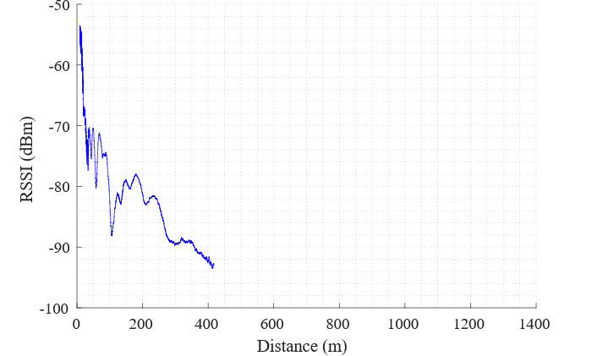

Figure 59: NLOS intersection DSRC RSSI at the SV as a function of distance between the SV and MV

  - Interference tests
The purpose of the interference tests was to assess resilience of V2X technologies from two types of out-of- band interference:
    - Interference originating in U-NII-3 Band (5,725-5,850 MHz)
    - Interference originating in the channel adjacent to the operating (safety) channel (CH172)
As in the range tests, both DSRC and C-V2X OBUs are tested under the same conditions. This implies that both technologies are tested using the same interferer. In the case of the U-NII-3 test, both V2X technologies are subjected to the same IEEE 802.11ac 80 MHz synthetically created interference in CH155. Similarly, in the case of the adjacent channel interference tests, the interference for both DSRC and CXV2X is the same synthetically created IEEE 802.11p 10MHz interference in the adjacent channel.
Since the operating channel was moved to CH184, to create equivalent interference conditions the interference had to be moved accordingly. Center frequency of CH184 (5,920 MHz) is 60 MHz above the center frequency of CH172 (5,860 MHz). To ensure the same interference effect by the U-NII-3 interference on the safety, the center frequency of the interfering signal was shifted up by 60 MHz to maintain the same 40 MHz separation. Similarly, adjacent channel interference was configured for center frequency 5,910 MHz (CH182) to ensure operation in the adjacent channel. Both tests are following test procedures described in Sections 9.1.3 and
9.1.4 of (5GAA, March 2018).

U-NII-3 802.11ac Interference Test and Results
This test compares the effects of U-NII-3 band interference on both V2X technologies in terms of range, reliability, and IPG. Since this is a LOS test, the range with interference present should be compared to the LOS range results. We expect that the range of both technologies will decrease when the interference is in close proximity. This is a realistic situation when a vehicle is for example at an intersection and a Wi-Fi hotspot antenna is close by as in Figure 60.

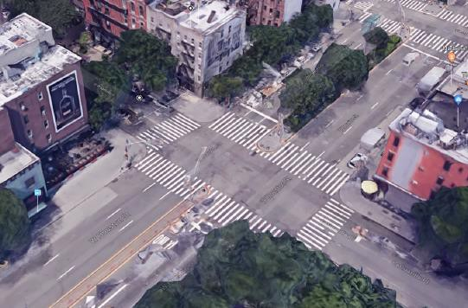

Figure 60: Downtown Manhattan intersection with a possible Wi-Fi hotspot at the corner café

This test closely follows the test procedure described in Section 9.1.3 of (5GAA, March 2018). This scenario tests the impact of a fixed Wi-Fi 802.11ac 80 MHz interferer in U-NII-3 CH155 on Basic Safety Message (BSM) reception in CH172. The interferer is the widest IEEE 802.11ac signal that fits in U-NII-3 (80 MHz). Since the OBUs are operating in CH184, the interferer was shifted from the center frequency 5,775 MHz to the center frequency 5,835 MHz. The modified center frequency ensures that the tests in CH184 will produce results equivalent to the tests in CH172 with Wi-Fi signal in CH155. This is shown in Figure 61.
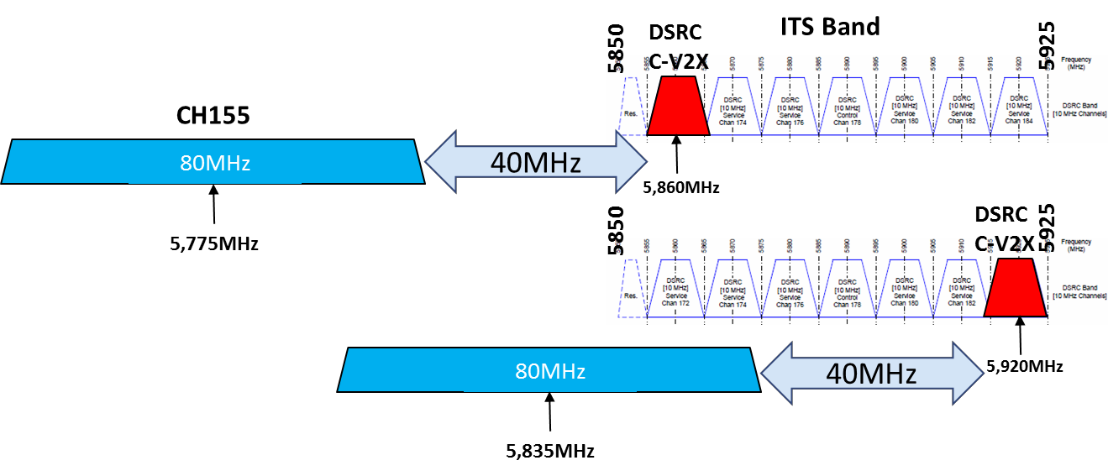

Figure 61: Frequency layout of the U-NII-3 LOS Interference Test

Figure 62 shows the test setup. This setup is identical to the LOS test setup in section 8.5.1 except that the interferer is placed in the same line as the SV 13 m away as Figure 62 shows. The same test track (Road A at FPG) was used in this test. The moving vehicle (MV) starts in front of the stationary vehicle (SV) and moves away in the same lane at a constant speed of 20 mph. At the end of the test track it performs a U-turn and moves back in the neighboring lane. After passing SV in the opposite direction, it performs a U-turn and gets into the initial position without stopping. As in the LOS test case, D is the length of the test track (1.35 km).
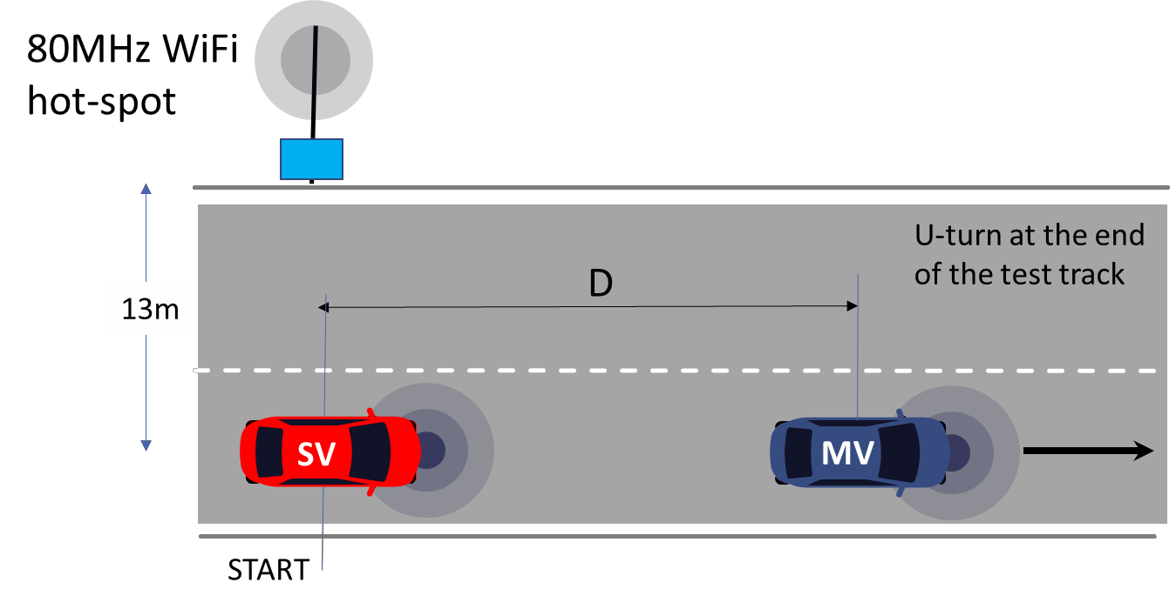

Figure 62: LOS U-NII-3 interference test setup. D is the length of the test track

Interference is generated by the signal generator. We used a Rohde and Schwartz SMBV100A signal generator with the configuration listed in Table 30.

Table 30 U-NII-3 interference test signal generator configuration parameters

Configuration parameter | Value
Frequency | 5.835 GHz
Frame Block Configuration (Std) | 11ac
Frame Block Configuration (Type) | Data
Frame Block Configuration (Physical Mode) | Mixed
Frame Block Configuration (Tx Mode) | VHT-80MHz
Frame Block Configuration (Frames) | 1
Frame Block Configuration (Idle time/ms) | 0.081
Frame Block Configuration (Data) | A-MPDU
Frame Block Configuration (A-MPDU length) | 1484 bytes
Frame Block Configuration (DRate/Mbps) | 58.50
Frame Block Configuration (State) | On
Clipping setting (State) | On
Clipping setting (Level) | 100%
Clipping setting (Mode) | Vector |i+jQ|
Level (power) | Adjustable (target 23 dBm at the antenna input)
Traffic source duty cycle | 76%

Output of the signal generator is connected to an RF cable to the power amplifier (Minicircuits ZVE-3W-83+) as shown in Figure 63. Output of the power amplifier is connected to a Wi-Fi base station antenna (HG2458- 06U-PRO) mounted on a tripod with the height of 7 ft 10 in (top). The loss of the two RF cables in Figure 63 was 2.1 and 2.4 dB. The measured average power at the input to the AP antenna was 23 dBm. The transmit power was measured with a power meter with the Idle Time in Table 30 set to 0.001 ms. The power spectrum of the signal measured at the input to the antenna is shown in Figure 64.

The combination of packet length, data rate, and idle time duration results in 252 ON periods followed by
81 OFF or idle periods. The application data rate is approximately 35 Mbps while the utilization of the channel is 76%. This traffic profile models high-volume data download or high data-rate video streaming.
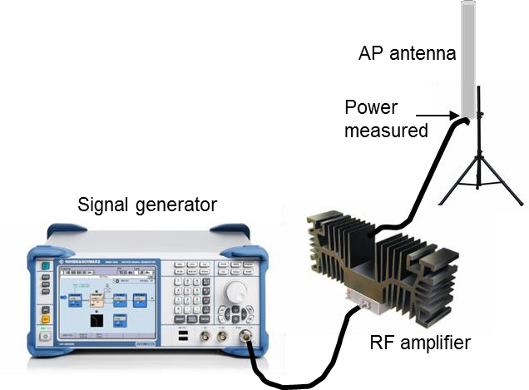

Figure 63: U-NII-3 Interferer Setup

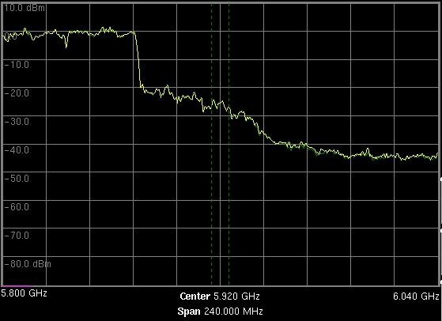

Figure 64: Power spectrum of the U-NII-3 interferer

In this test we compare the range of DSRC and C-V2X OBUs in the presence of 80-MHz wide U-NII-3 interference assuming 11 dBm equivalent transmit power of the OBUs. In Figure 65, we show PRR as a function of distance for the SV receiver. Compared to the LOS results in Section 8.5.1.1, we observe a decrease in range for both technologies, with DSRC PRR affected by the destructive superposition of the direct and reflected paths. The range for DSRC and C-V2X with U-NII-3 interference present is 300 m and 625 m, respectively. Note that DSRC PRR drops below 90% at 125 m but recovers at 75 m as the MV approaches the SV. In Figure 66 we show PRR at the MV when MV approaches the SV. PRR at the MV for the LOS case is also shown for comparison. We observe that there is a small negative impact on both technologies from the presence of the UNII-3 interference. However, this degradation is significantly smaller compared to the negative impact on the reception of the SV. This is explained by the close proximity of the AP antenna to the SV. The new range is 575 m and 850 m for DSRC and C-V2X, respectively.

We note that the DSRC reception at the SV is negatively impacted even for distances below range. We have observed a steady loss of packet at roughly 2 to 3%. Small PER for distance below range is also observed at the MV (Figure 66).
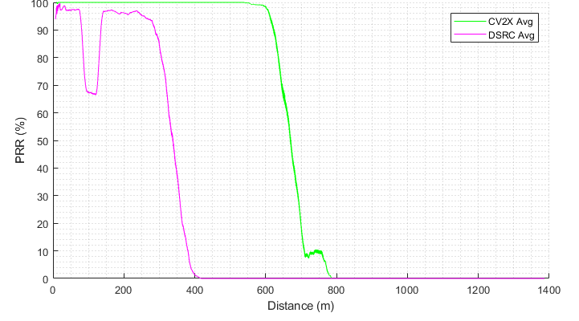

Figure 65: U-NII-3 interference average Packet Reception Ratio at the SV as a function of distance between the SV and MV. LOS PRR results shown on the right

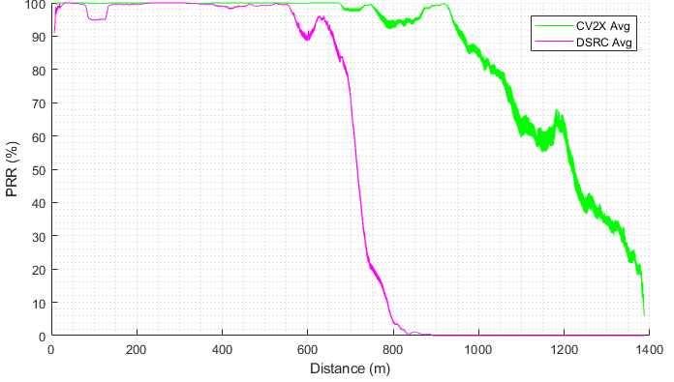
Figure 66: U-NII-3 interference average Packet Reception Ratio at the MV as a function of distance between the SV and MV. LOS PRR results shown on the left

In Figures 67 and 68 we show average Inter-Packet Gap (IPG) as a function of distance between SV and MV for both technologies observed by SV and MV, respectively. Small constant spikes in average IPG for DSRC indicate a constant small packet error rate which is consistent with the PRR plot in Figure 65 and Figure 66. Both IPG plots are consistent with the corresponding PRR plots indicating a sharp increase in IPG when the range is reached.

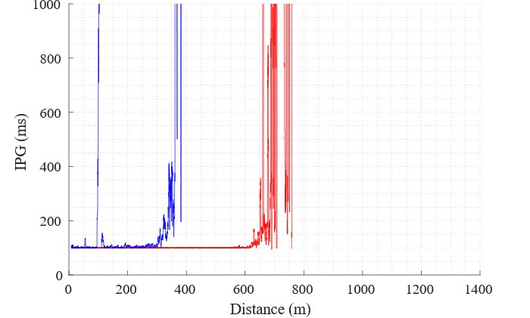

Figure 67: U-NII-3 interference average Inter-Packet Gap vs. distance at the SV as a function of distance between the SV and MV

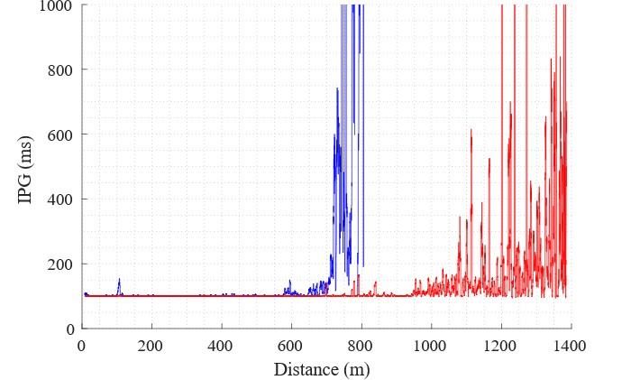
Figure 68: U-NII-3 interference average Inter-Packet Gap vs. distance at the MV as a function of distance between the SV and MV

Figure 69 illustrates RSSI measured by the SV DSRC OBU U-NII-3 interference test. The RSSI plot is approximately the same, just a truncated version of the DSRC RSSI in the LOS test which is to be expected since the setup is the same. Since the signal is lost at -80 dBm in Figure 69 it indicates that there is approximately 12 dB loss in range for DSRC due to the presence of the interferer. This is consistent with the range loss for C-V2X based on the difference in range between the LOS test and U-NII-3 interference tests. We emphasize that this is a rough calculation and used here only as a sanity check of the results.
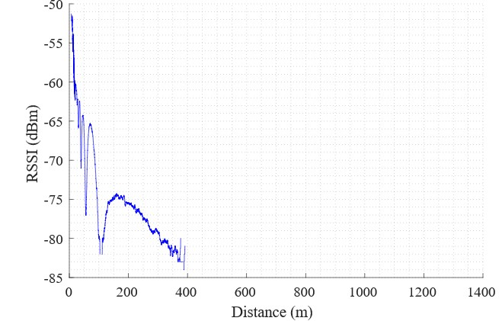

Figure 69: U-NII-3 interference DSRC RSSI at the SV as a function of distance between the SV and MV

    - Adjacent Channel Interference Test and Results
This test compares the effects of the adjacent ITS Band channel interference at close range on both V2X technologies in terms of range, reliability, and IPG. Both V2X technologies are interfered by the same signal emulating IEEE 802.11p at high utilization.
This test follows the test procedure described in section 9.1.4 of (5GAA, March 2018). The original test procedure called for testing only C-V2X in the presence of the adjacent DSRC carrier. To make this a comparative test, we have extended it to test DSRC in the presence of the same interference. Clearly, other extensions are possible. This scenario tests the impact of a fixed DSRC interferer in the adjacent ITS band channel on Basic Safety Message (BSM) reception in CH172. The interferer is using CH174. Since the OBUs are operating in CH184, the interferer was shifted from center frequency CH174 to CH182 to remain in the ITS band and be adjacent to the safety channel which in the test was CH184. This new position ensures that the tests in CH184 will produce the equivalent results as the tests in CH172 with V2X interfering signal in CH174.
Figure 70 shows the test setup together with a frequency plan for the safety and the interference channel in red and green, respectively. This setup is identical to the one in Section 8.6.1 except that the interferer is a vehicle (IV) lined up with SV at a 13 m distance. The same test track (Road A at FPG) was used in this test. The interfering vehicle has an antenna that is identical to the SV and MV but uses only a single one mounted in the center of the roof.

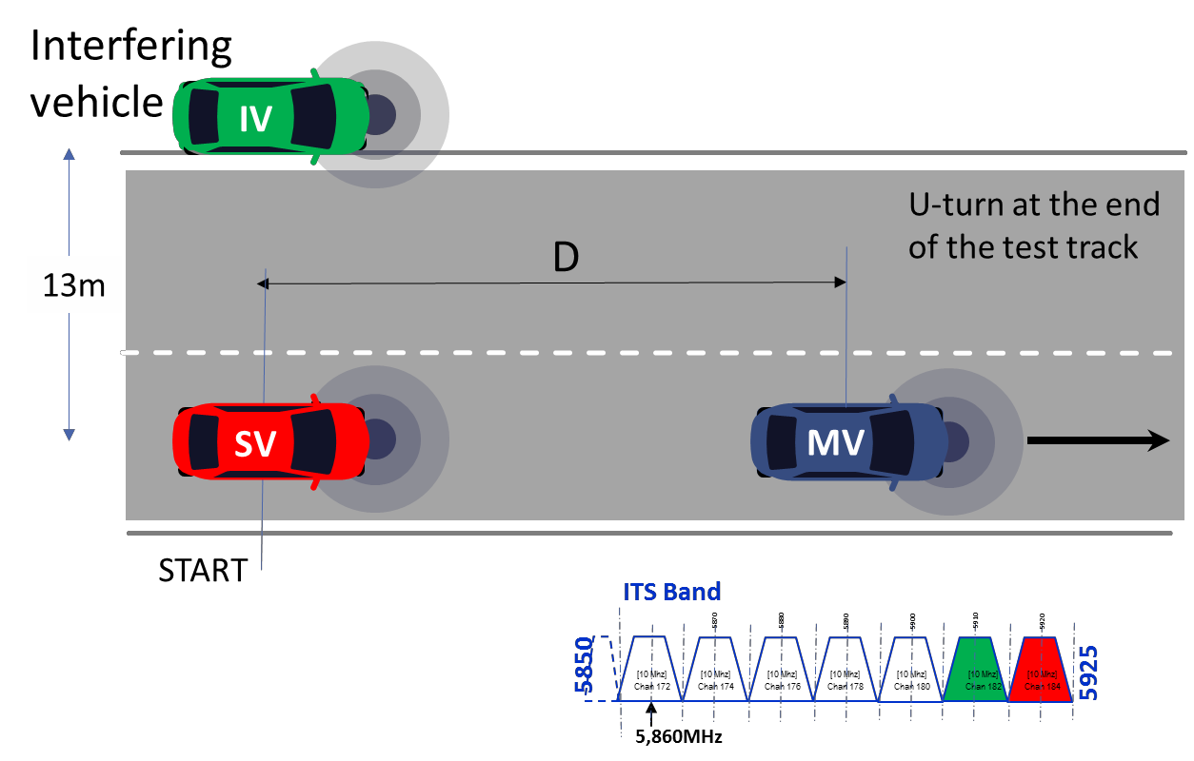

Figure 70: Adjacent channel interference test setup

The frequency diagram illustrates the position of the safety channel (CH184) and the interference channel (CH182) used in this test.
Figure 71 shows the interferer setup. This setup is placed in the interference vehicle (IV). The interference is generated by the signal generator. As in section 8.6.1, we used a Rohde and Schwartz SMBV100A signal generator configured with parameters shown in Table 31.

Table 31 Adjacent channel interference test signal generator configuration parameters

Configuration parameter | Value
Frequency | 5.910 GHz
Frame Block Configuration (Std) | 11p/j
Frame Block Configuration (Type) | Data
Frame Block Configuration (Physical Mode) | Legacy
Frame Block Configuration (Tx Mode) | L-10MHz
Frame Block Configuration (Frames) | 1
Frame Block Configuration (Idle time/ms) | 0.081
Frame Block Configuration (Data) | PN 9
Frame Block Configuration (PPDU(Packet length)) | 1460 bytes
Frame Block Configuration (DRate/Mbps) | 6.00
Frame Block Configuration (State) | On
Filter/Clipping setting (Filter) | Cosine
Filter/Clipping setting (Roll Off Factor) | 0.70
Filter/Clipping setting (Cut Off Frequency Shift) | 0.00
Filter/Clipping setting (Sample Rate Variation) | 20 MHz
Filter/Clipping setting (Clipping) | On
Filter/Clipping setting (Clipping(Level)) | 60%
Filter/Clipping setting (Clipping(Mode)) | Vector |i+jq|
Level (power) | Adjustable (target 18 dBm at the antenna cable input)
Traffic source duty cycle | 96%

Output of the signal generator connects to an RF cable to the power amplifier (Minicircuits ZVE-3W-83+) as Figure 71 shows. Output of the power amplifier is connected to the vehicle antenna (COM6-5500) which comes with a 10-ft cable and is mounted on the roof of the Interfering Vehicle (IV). In our tests the IV was the same vehicle type as the SV and MV (Ford Fusion w/o moon roof). The measured average power at the input to the AP antenna was 18.7 dBm. The transmit power was measured with a power meter with the Idle Time in Table 31 set to 0.001 ms. The power spectrum of the signal measured at the input to the antenna is shown in Figure 72.The combination of packet length, data rate, and idle time duration results in 1,946 s ON periods followed by 81 s OFF or idle periods. The application data rate is approximately 6 Mbps while the utilization of the channel is 96%. This traffic profile models V2V/V2I data download.
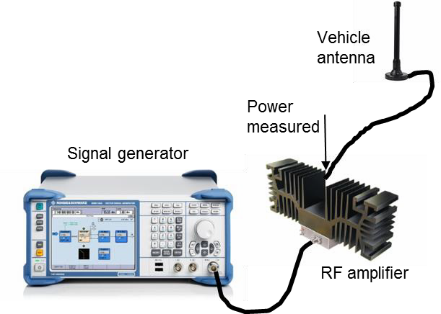

Figure 71: Adjacent channel interferer setup. This equipment was placed in the interfering vehicle (IV)

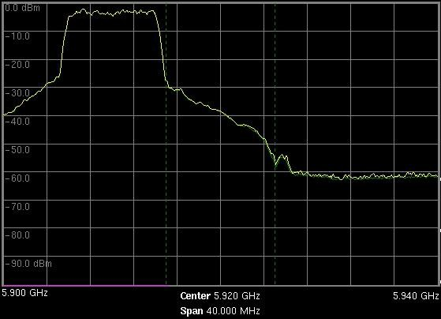
Figure 72: Power spectrum of the adjacent channel DSRC interferer

This test compares the range of DSRC and C-V2X OBUs in the presence of 10-MHz-wide DSRC interference in the adjacent channel (CH182) assuming 11 dBm equivalent transmit power of the OBUs. The transmit power of the IV measured at the output of the power amplifier is approximately 19 dBm. In Figure 73 we show PRR at the SV as a function of distance for the MV and SV. The DSRC and CV2x range is 400 m and 1050 m, respectively. This represents a smaller negative impact than the U-NII-3 interference which is expected given that power of the U-NII-3 interferer is higher. Note that DSRC PRR drops below 90% briefly at the distance of 100 m but quickly recovers. We also note that the DSRC reception at the SV is negatively impacted even for distances below range. We have observed a steady loss of packets at roughly approximately 1%.

Similar to U-NII-3 results, in Figure 74 we observe that reception at the MV is only slightly affected by the presence of the interferer. The range for DSRC and C-V2X is 700 m and 1025 m, respectively. Compared to LOS results MV range for DSRC is unchanged while MV range for C-V2X dropped by 125 m.

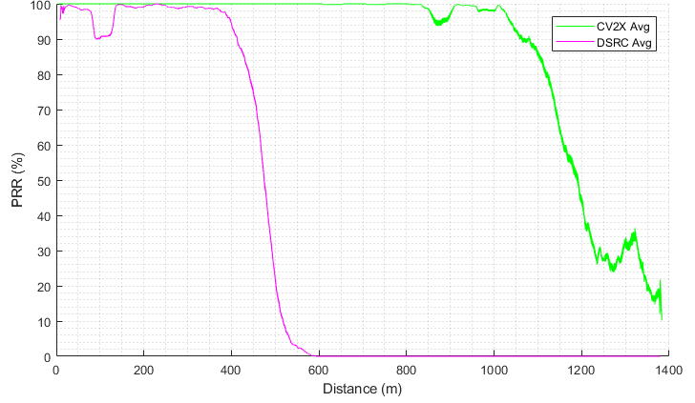

Figure 73: Adjacent channel interference average Packet Reception Ratio at the SV as a function of distance between the SV and MV

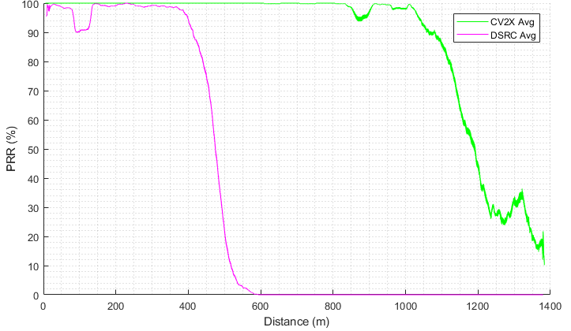
Figure 74: Adjacent channel interference average Packet Reception Ratio at the MV as a function of distance between the SV and MV

In Figures 75 and 76 we show average Inter-Packet Gap (IPG) as a function of distance between SV and MV for both technologies, observed by SV and MV, respectively. Small constant spikes in average IPG for DSRC indicate constant small packet error rate which is consistent with the PRR plot in Figure 65. Both IPG plots are consistent with the corresponding PRR plots indicating a sharp increase in IPG when the range is reached.
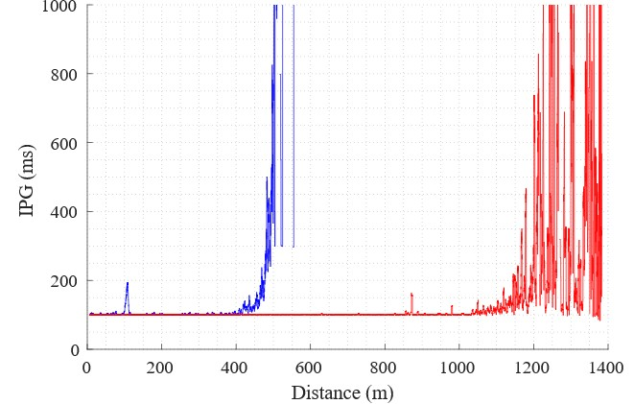

Figure 75: Adjacent channel interference average Inter-Packet Gap vs. distance at the SV as a function of distance between the SV and MV

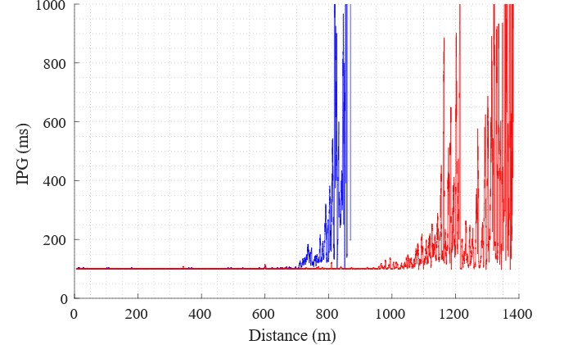
Figure 76: Adjacent channel interference average Inter-Packet Gap vs. distance at the MV as a function of distance between the SV and MV

Figure 77 illustrates RSSI measured by the SV DSRC OBU for the adjacent channel interference test. Similar to the U•NII-3 interference test, the RSSI plot is approximately the same, just a truncated version of the DSRC RSSI in the LOS test which is to be expected since the setup is the same.
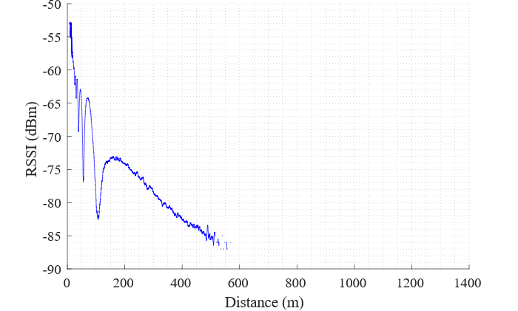

Figure 77: Adjacent channel interference DSRC RSSI at the SV as a function of distance between the SV and MV

  - Key Takeaways
The field tests compared DSRC and C-V2X under the tight control of the factors that influence RF propagation:
- Antenna characteristics and placement
- Vehicle geometry and cabling
- Location and environmental conditions
- Power, interference, and other settings The field test addressed the following questions:
- Range of the system and reliability of communication as a function of distance for the following vehicle scenarios:
  - Line-of-Sight (LOS)
  - Non-Line-of-Sight (NLOS)
    - Shadowing
    - Intersection
- Impact of out-of-band interference for the following cases
  - LOS interference from the U-NII-3 band
  - LOS interference from the adjacent DSRC channel

We compared the two V2X technologies using range, reliability, and IPG as KPIs. In all tests C-V2X OBUs outperformed DSRC OBUs by a significant margin. The test results indicate gains in terms of RF range for Cellular-V2X compared to DSRC. Under varying radio environment conditions (LOS, NLOS, and interference) the field tests have shown that Cellular-V2X has 1.7 to 3.4x times the range advantage over DSRC. The LOS advantage was 1.7x the range, however, the improvements rose to 3.4 times the advantage in more realistic NLOS conditions involving signal obstruction. With the interference in close proximity, the improvement in range with the U-NII-3 interferer was 2.1 times while the improvement with the adjacent DSRC interferer was 3 times. Table 32 and Table 33 summarize the range comparison of the two technologies.

Table 32: Range comparison between DSRC and C-V2X for at 5 dBm effective transmit power

Test Procedure | Range in (m) at 90% reliability
 | DSRC | C-V2X
Line-of-Sight (LOS) Range | 475 | 675
Non-Line-of Sight (NLOS) Blocker (5GAA) | 60 | 425

Table 33: Range comparison between DSRC and C-V2X for at 11 dBm effective transmit power

Test Procedure | Range in (m) at 90% reliability
 | DSRC | C-V2X
Line-of-Sight (LOS) Range | 675 | 1175
Non-Line-of Sight (NLOS) Blocker (5GAA) | 125 | 425
Non-Line-of-Sight (NLOS) Blocker (CAMP) | 200 | >1350 (625)*
Non-Line-of-Sight (NLOS) Intersection | 375 | 875
Co-existence with Wi-Fi 80 MHz Bandwidth in UNII-3 | 300 (75)* | 625
Co-existing of V2X with Adjacent DSRC Carrier | 400 (100)* | 1050

* First drop below 90% PRR

Conclusion and Next Steps
Ford and Qualcomm performed a series of V2V RF tests from March - September 2018, with the goal of comparing two V2X RF technologies, namely DSRC and C-V2X, under the same RF conditions and using the same in-vehicle integration setup. The tests were performed in both laboratory and field environments and follow closely 5GAA test procedure methodology.
The test results indicate gains in terms of RF range for C-V2X compared to DSRC. The lab tests have shown significant link budget gain for C-V2X compared to DSRC. Under varying radio environment conditions (LOS, NLOS, and interference) the field tests have shown that C-V2X has a 1.7x-3.4x range advantage over DSRC. The LOS advantage was 1.7x, however, the improvements rose to 3.4x in more realistic NLOS conditions involving signal obstruction. With the interference in close proximity the improvement in range with U-NII-3 interferer was 2.1x while the improvement with the adjacent DSRC interferer was 3x.
Both C-V2X and DSRC exhibited similar end-to-end application layer latencies under non-congested conditions, and both technologies met the latency requirements for the V2V safety applications defined in SAE J2945/1. Inter-packet gap performance was within 10 ms for both V2X technologies, typically increasing very quickly when the devices went out of range. Only C-V2X technology was tested for a highly congested scenario in a laboratory setting. Even in the congested scenario, C-V2X latency remained bounded by the 100ms latency budget configured for that scenario.
While performing the field testing, we have observed that each test track has its own characteristics, emphasizing the importance of technology comparison under the same conditions. We have also observed significant interference activity from the U-NII-3 band (5,725-5,850MHz) on two automotive test tracks causing re-planning and moving of the test operating frequency to the upper portion of the ITS band (CH184). Results and conclusions from CH184 were consistent with the initial CH172 tests.
As a follow-up to the testing and results presented in this report we are preparing for the next phase. The planning is under way for the following testing activities:
- Testing C-V2X operation in 20MHz channel, specifically in CH183 (center frequency 5,915 MHz)
- Testing C-V2X congestion control functionality in the field
More specifically, 3GPP Rel-14 standard allows operation in 20 MHz channel which makes it attractive for the combined V2V and V2I safety applications. While the radio propagation and reception in 20 MHz are expected to be similar to 10 MHz, we plan to confirm this and also test various coexistence scenarios appropriate for the 20 MHz channel operation. We intend to continue to build on the work we began in the first phase of congestion testing. Additionally, we anticipate testing advanced C-V2X use cases and applications (i.e., non-BSM transmission), which may make use of a larger portion of the Intelligent Transportation Systems band.

Annex A:
Supplemental Lab Interference Tests

Interference Lab Test

Cabled Transmission and Reception Test with Simulated External Interference: flat characteristics, constant in time, occupying part of ITS channel (e.g., channel 172)

Background
This test analyzes robustness to external interference which has flat spectrum density, varying bandwidths, and is constant in time.
The goal is to verify that C-V2X devices can transmit and receive C-V2X messages over the PC5 interface with an interference model being applied between the transmit and receive C-V2X devices to simulate potential external interference in the system with pre-defined characteristics.

Assumptions
The operating system time of the transmitter and receiver boxes is synchronized to a common clock (e.g., GPS) with an error of no more than 1 ms.
The testing environment is isolated from other external interference sources.
Tests should be conducted at room temperature (21 degrees Celsius +/- 5 degrees).

Setup
This test uses a lab cabled setup as Figure 77 shows. Signal generators (1, 2, and 3) model different characteristics of potential interference in a 10-MHz channel bandwidth. Device 2 (receiver, Rx), also known as DUT, is configured to receive data from Device 1 (Tx) on the same impaired channel.
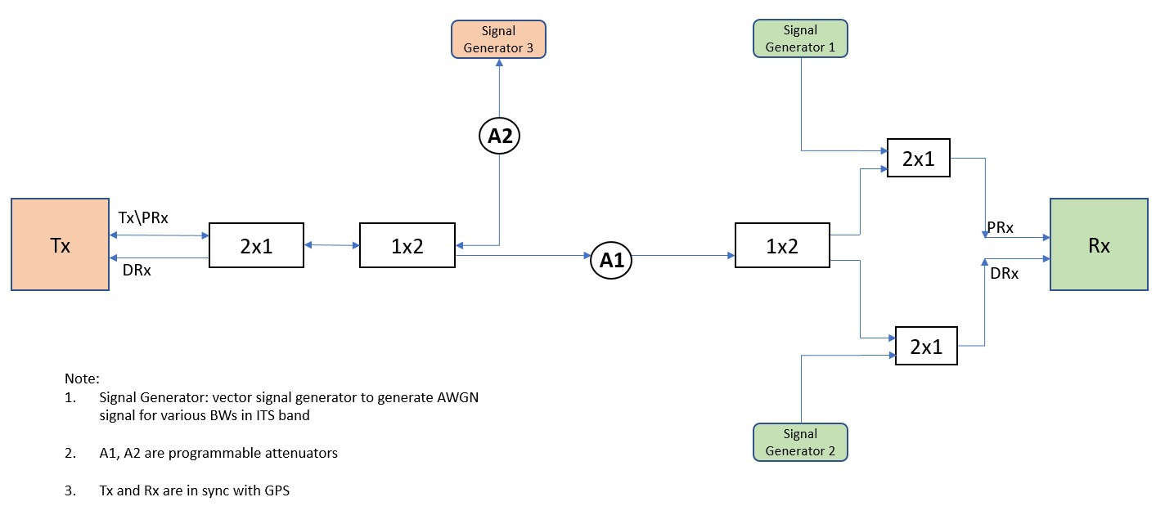
Figure 77: A.1.1 - Test Setup

        - Channel impairment settings on the Signal Generators (1-3) are configured to emulate pre-defined interference with the following characteristics:
          - Flat characteristic, constant power spectral density within the predefined bandwidth
          - Bandwidth of the interference signal defined in Table 10 2 with the center frequency of the signal defined in Figure 78.
          - Signal Generators 1 & 2 are set to ensure that power at DUT input is 40 dBm.
          - Signal Generator 3 is set to ensure that power at Tx input is 40 dBm.
        - Testing is done by switching on/off signal generator 3 and/or signal generators 1&2 so that the interference source is located at two different positions11:
          - Interference source at the Rx side only (Device 2).
          - Interference source midway between Tx side (Device 1) and Rx side (Device 2), so that both devices are affected 2.
        - Settings on Device 1 (Transmit Radio):
          - SPS-based transmit flow with a periodicity of 100 ms (Note: equivalent to setting a periodic stream at 100ms period for other technologies)
          - Packet length of 193 bytes
          - Transmit on ITS band (e.g., center frequency 5,860 MHz) with bandwidth of 10 MHz
          - Appropriate transmit power and fixed attenuation added Attenuator 1 (A1) to ensure that Device 1 Rx power at DUT input is -50 dBm

5855
MHz
fc = 5857.5 MHz
Position 2
fc = 5860 MHz fc = 5862.5 MHz
Position 1 Position 3
5865
MHz

Figure 78: Interference definition in the Channel 172 (PSD not drawn to scale)

        - Settings on the Device 2 (Receive Radio):
          - Configured to receive on ITS band (e.g., center frequency 5,860 MHz) with bandwidth of 10 MHz
          - All measurements of receiving side performance are done on this device.

- Signal Generators will not be physically moved. Rather, the varying positions of Signal Generators will be simulated by adjusting each signal generator 1-3.
- Although Device 1 (Tx side) does not receive the data stream, its behavior as a transmitter is affected by the signal received from Signal Generator 3.

  - Data Collection at Tx (Device 1):
    - OS timestamp for each transmitted packet
    - Sequence number of each transmitted packet
  - Data Collection at Rx (Device 2):
    - OS timestamp for each received packet
    - Sequence number of each received packet
    - Receive signal power for each received packet

Table 34: Configuration of devices

Configuration | C-V2X | DSRC
Number of samples | 1000, 10000 | 1000, 10000
Interference signal | External AWGN source | External AWGN source

Table 35: Interference characterization definition

Signal Generator Setting
Interference Bandwidth (MHz) | Position Numbers | Number of Iterations
0.2 | 1, 2, 3 | 1
0.5 | 1, 2, 3 | 1
1 | 1, 2, 3 | 1
2 | 1, 2, 3 | 1
5 | 1, 2, 3 | 1

      - Test Execution
NOTE: Tests should be conducted at room temperature (21 degrees Celsius +/- 5 degrees).
- Configure the Transmit Device (Device 1) with the data stream of interest: Application layer message (e.g., BSM) to be sent periodically every 100 ms. Packet length shall reflect a one-to-one correspondence between packet and message; the packet size should remain constant throughout the test.
- Set the Signal Generator to produce zero power.
- Set Attenuator 1 (A1) to an attenuation value such that the receive signal power measured at DUT input is 50 dBm.
- Set the transmit power for the Transmit device (Device 1) to zero (e.g., by turning the device off).
- Configure the Signal Generators 1, 2, and 3 to generate a pre-defined interference of 200-kHz bandwidth with center frequency defined in Table 35 as position 1.
- Adjust levels of Signal Generators 1, 2 and 3 according to the first row of Table 36.

Table 36: Interference source position settings

Interference source position settings
Interference Source | Signal Generator 1 & 2 | Signal Generator 3
Interference source is close to Rx device (Device 2). Tx device (Device 1) is minimally impacted by interference source. | Setting to achieve that interference power at DUT input is 10dB above Device 1 power at DUT input. | Interference source is close to Rx device (Device 2). Tx device (Device 1) is minimally impacted by interference source.
I.e. receive signal power (of Signal Generators) measured at DUT input is 40 dBm. | Off | I.e. receive signal power (of Signal Generators) measured at DUT input is 40 dBm.

- Enable transmission of the Transmit device (Device 1).
- For each test run, record a log file of the following statistics:
  - For Device 1: OS timestamp for each Tx packet, sequence number of each Tx packet.
  - For DUT: OS timestamp for each Rx packet, sequence number of each Rx packet, receive signal power for each Rx packet.
- Repeat step 8 for a total of “n” iterations, according to column “Number of Iterations” of Table 35. 10.Repeat steps 5 through 9 for interference on position 2 from Figure 78, (i.e., in step 6 use the center
frequency defined in Figure 78 as position 2.)
- Repeat steps 5 through 10 for interference on position 3 from Figure 78, (i.e., in step 6 use the center frequency defined in Figure 78 as position 3.)
- Repeat steps 5 through 11 for all bandwidth sizes from Table 35, (i.e., in step 6 use the bandwidth from column “Interference Bandwidth” from the next row of Table 35).
- Repeat steps 5 through 12 for the second set of interference source position settings, (i.e., in step 7 set the attenuation values on Attenuator 1 and Attenuator 2 according to the second row of Table 35.)

      - Unique Tests to be Conducted
Run this test using:
Two (2) C-V2X devices for the test

Required Documentation
Using the data collected from log files, or observed from any OBU user interface, fill in Table 37.

Table 37: C-V2X Results

Signal Generator Setting – Interference Bandwidth (MHz) | Signal Generator Setting – Position (i.e. Interference Center Frequency (1, 2, or 3) | SigGen Location (“Rx” =  close to Rx device; “Mid” = halfway between Tx and Rx Devices) | No. of  Transmitted pkts (summed across all 60- second iterations) | No. of  Received pkts (summed across all 60-second iterations) | PER % | 95th Percentile IPG (ms) | 95th Percentile Latency (ms)
 |  |  | Measured at Tx Device | Measured at Rx  Device | Calculated at Rx  Device | Calculated at Rx Device | Calculated at Rx Device
0.2 | 1 | Rx | 1000 | 999 | 0.1 | 106 | 32
0.2 | 2 | Rx | 10000 | 2855 | 71.45 | n\a* | n\a*
0.2 | 3 | Rx | 1000 | 1000 | 0 | 108 | 26
0.5 | 1 | Rx | 1000 | 1000 | 0 | 108.5 | 24
0.5 | 2 | Rx | 10000 | 2875 | 71.25 | n\a* | n\a*
0.5 | 3 | Rx | 1000 | 1000 | 0 | 106 | 22
1 | 1 | Rx | 1000 | 999 | 0.1 | 107 | 24
1 | 2 | Rx | 10000 | 2443 | 75.57 | n\a* | n\a*
1 | 3 | Rx | 1000 | 998 | 0.2 | 106 | 23
2 | 1 | Rx | 10000 | 8197 | 18.03 | n\a* | n\a*
2 | 2 | Rx | 10000 | 47 | 99.53 | n\a* | n\a*
2 | 3 | Rx | 1000 | 999 | 0.1 | 108 | 24
5 | 1 | Rx | 1000 | 0 | 100 | n\a* | n\a*
5 | 2 | Rx | 10000 | 0 | 100 | n\a* | n\a*
5 | 3 | Rx | 1000 | 996 | 0.4 | 108 | 24
0.2 | 1 | Mid | 1000 | 995 | 0.5 | 108 | 23
0.2 | 2 | Mid | 1000 | 1000 | 0 | 106 | 23
0.2 | 3 | Mid | 1000 | 999 | 0.1 | 105 | 22
0.5 | 1 | Mid | 1000 | 1000 | 0 | 107 | 22
0.5 | 2 | Mid | 1000 | 1000 | 0 | 107 | 22
0.5 | 3 | Mid | 1000 | 1000 | 0 | 105 | 23
1 | 1 | Mid | 1000 | 0 | 0 | 107 | 23
1 | 2 | Mid | 1000 | 1000 | 0 | 107 | 23
1 | 3 | Mid | 1000 | 1000 | 0 | 105 | 23
2 | 1 | Mid | 1000 | 7444 | 25.56 | n\a* | n\a*
2 | 2 | Mid | 1000 | 1000 | 0 | 107 | 27
2 | 3 | Mid | 1000 | 1000 | 0 | 107 | 22
5 | 1 | Mid | 1000 | 0 | 100 | n\a* | n\a*
5 | 2 | Mid | 1000 | 997 | 0.3 | 108 | 25
5 | 3 | Mid | 1000 | 1000 | 0 | 107 | 22
n\a* - Latency and IPG are shown only in scenarios where PER is < 10%

Table 38: DSRC results

Signal Generator Setting – Interference Bandwidth (MHz) | Signal Generator Setting – Position (i.e. Interference Center Frequency (1, 2, or 3) | SigGen Location (“Rx” =  close to Rx device; “Mid” = halfway between Tx and Rx Devices) | No. of  Transmitted pkts (summed across all 60- second iterations) | No. of  Received pkts (summed across all 60-second iterations) | PER % | 95th Percentile IPG (ms) | 95th Percentile Latency (ms)
 |  |  | Measured at Tx Device | Measured at Rx  Device | Calculated at Rx  Device | Calculated at Rx Device | Calculated at Rx Device
0.2 | 1 | Rx | 1000 | 0 | 100 | n\a | n\a
0.2 | 2 | Rx | 1000 | 0 | 100 | n\a | n\a
1 | 1 | Rx | 1000 | 0 | 100 | n\a | n\a
1 | 2 | Rx | 1000 | 0 | 100 | n\a | n\a
5 | 1 | Rx | 1000 | 0 | 100 | n\a | n\a
5 | 2 | Rx | 1000 | 0 | 100 | n\a | n\a
0.2 | 1 | Mid | 1000 | 0 | 100 | n\a | n\a
0.2 | 2 | Mid | 1000 | 0 | 100 | n\a | n\a
1 | 1 | Mid | 1000 | 0 | 100 | n\a | n\a
1 | 2 | Mid | 1000 | 0 | 100 | n\a | n\a
5 | 1 | Mid | 1000 | 0 | 100 | n\a | n\a
5 | 2 | Mid | 1000 | 0 | 100 | n\a | n\a

The DSRC system did not receive any data packages while the interfering signal was present. For that reason, latency and IPG time calculation is not possible at receiving side. This is marked “n\a” in Table 38.
When the disturbing signal is injected closer at the Rx device (case “Rx”), poor SNR ratio is the main root cause for failing. If injected halfway between Tx and Rx and therefore also disturbing Tx is noticeable (case “Mid”), Clear Channel Assessment (CCA) of Wi-fi technology can make the transmitter hold off sending data packages or send them with a delay (after the interferer is gone).

C-V2X vs DSRC Comparison
Interferer
5855 fc = 5857.5 MHz fc = 5860 MHz fc = 5862.5 MHz 5865
MHz Position 2 Position 1 Position 3 MHz
C-V2X 10MHz band (PSD not drawn to scale)

Figure 79: When Interferer is at Position 1

PER (%)

Figure 80: C-V2X vs DSRC Comparison plot when Interferer is at Position 1
Interferer at Position 1
C-V2X PER %(Interferer at Rx)
DSRC PER %(Interferer at Rx)
C-V2X PER %(Interferer at Tx and Rx)
DSRC PER %(Interferer at Tx and Rx)
100
90
80
70
60
50
40
30
20
10
0
0.2 MHz
0.5 MHz
1 MHz
Interferer Bandwidth
2 MHz
5 MHz

Interferer
5855
MHz
fc = 5857.5 MHz fc = 5860 MHz fc = 5862.5 MHz
Position 2 Position 1 Position 3
5865
MHz

C-V2X 10MHz band (PSD not drawn to scale)

Figure 81: When Interferer is at Position 2

PER (%)

Figure 82: C-V2X vs DSRC Comparison plot when Interferer is at Position 2
Interferer at Position 2
C-V2X PER % (Interferer at Rx)
DSRC PER % (Interferer at Rx)
C-V2X PER %(Interferer at Tx and Rx)
DSRC PER %(Interferer at Tx and Rx)
100
90
80
70
60
50
40
30
20
10
0
0.2 MHz
0.5 MHz
1 MHz
Interferer Bandwidth
2 MHz
5 MHz

Interferer
5855
MHz
fc = 5857.5 MHz fc = 5860 MHz
Position 2 Position 1
fc = 5862.5 MHz
Position 3
5865
MHz

Figure 83: When Interferer is at Position 3

C-V2X 10MHz band (PSD not drawn to scale)

PER (%)

Figure 84: C-V2X vs DSRC Comparison plot when Interferer is at Position 3
Interferer at Position 3
C-V2X PER % (Interferer at Rx)
DSRC PER % (Interferer at Rx)
C-V2X PER %(Interferer at Tx and Rx)
DSRC PER %(Interferer at Tx and Rx)
100
90
80
70
60
50
40
30
20
10
0
0.2 MHz
0.5 MHz
1 MHz
Jammer Bandwith
2 MHz
5 MHz

NOTE: The difference in Interferer at Rx plots between Figure 82 and Figure 84 for C-V2X can be explained by the unevenness in noise level. Since the noise level of a given test environment cannot be perfectly flat, it plays a role in the C-V2X device’s scheduling decisions for choosing a part of the spectrum with lower energy for transmission.

Evaluation Criteria
Evaluation criteria assesses and compare Tx and Rx activity of the Tx and Rx devices, respectively, across the various interference scenarios. In addition, the purpose is to measure reported PER values for the Rx device with the injected interference stream.

Key Takeaway
This test examines and compares the robustness of V2X technologies to narrow band Interferer. The jamming signal is placed at various frequency locations within the channel. Two scenarios are modelled. In the first scenario, the jamming signal is heard only by the receiving device. This emulates a situation where the location of the Interferer hides it from the transmitter’s perspective. In the second scenario, the jamming signal is heard by the receiving and transmitting devices.
The results show that C-V2X is much more robust than DSRC in both scenarios. The DSRC link does not work in either scenario. This is due either to corruption of the received signal, or CSMA/CA starvation. For C-V2X, when the Interferer can be heard at the transmitter, the transmitter tries to avoid the jammed frequencies. This results in uncompromised communication in most configurations except when the Interferer bandwidth becomes so wide that the location of it makes complete avoidance impossible (i.e., location 1 with Interferer bandwidth wider than 2 MHz). When the Interferer is configured to be hidden from the transmitter, transmissions cannot avoid the jammed frequency. Even in this case, we observe that in many configurations the communication link remains reliable.

Cabled Transmission and Reception Test with Simulated External Interference: flat characteristics, constant in time, starting from guard band occupying part of given ITS channel (e.g., channel 172)

Background
This test analyzes robustness to external interference which has flat spectrum density, varying bandwidths, and is constant in time, where the external interference is starting from the guard band of channel 172.
The goal is to verify that C-V2X devices can transmit and receive C-V2X messages over the PC5 interface with an interference model being applied between the transmit and receive C-V2X devices to simulate potential external interference in the system with pre-defined characteristics.

Assumptions
The operating system time of both the transmitter and receiver boxes is synchronized to a common clock (e.g., GPS) with an error of no more than 1ms.
The testing environment is isolated from other external interference sources.
Tests should be conducted at room temperature (21 degrees Celsius +/- 5 degrees).

Setup
This test uses a lab cabled setup as shown in Figure 85. Signal generators (1, 2 and 3) are used to model different characteristics of potential interface in a 10-MHz channel bandwidth. Device 2 (receiver, Rx), also known as DUT, is configured to receive data from Device 1 (Tx) on the same impaired channel.
        - Channel impairment settings on the Signal Generator (Signal Generators 1-3) are configured to emulate pre-defined interference characterization:
          - Flat characteristic, constant power spectral density within the predefined bandwidth
          - Bandwidth of the interference signal defined in Figure 85 with the center frequency of the signal such that it starts from the edge of the spectrum as shown in Figure 86.
          - Signal Generators 1&2 are set to ensure that power at DUT input is 40 dBm.
          - Signal Generator 3 is set to ensure that power at Tx input is 40 dBm.
        - Testing is done by switching on/off signal generator 3 an/or signal generators 1&2 so that the interference source is located at two different positions 3:
          - Interference source at the Rx side only (Device 2)
          - Interference source midway between Tx side (Device 1) and Rx side (Device 2), so that both devices are affected4

- Signal Generators will not be physically moved. Rather, the varying positions of Signal Generators will be simulated by adjusting each signal generator 1-3.
- Although Device 1 (Tx side) does not receive the data stream, its behavior as a transmitter is affected by the signal received from Signal Generator 3.

Figure 85: A.1.2.3 - Test Setup

  - Settings on Device 1 (Transmit Radio):
    - SPS (Semi-Persistent Scheduling) based transmit flow with a periodicity of 100 ms (Note: equivalent to setting a periodic stream at 100 ms period for other technologies)
    - Packet length of 193 bytes
    - Transmit on ITS band (e.g., center frequency 5,860 MHz) with bandwidth of 10 MHz
    - Appropriate transmit power and fixed attenuation added Attenuator 1 (A1) to ensure that Device 1 Rx power at DUT input is 50 dBm

5855
5865

Figure 86: Interference position in Channel 172 (PSD not drawn to scale)

  - Settings on the Device 2 (Receive Radio, Rx):
    - Configured to receive on ITS band (e.g., center frequency 5,860 MHz) with bandwidth of 10 MHz
    - All measurements of receiving side performance are done on this device.
  - Data Collection at Tx (Device 1):
    - OS timestamp for each transmitted packet

    - Sequence number of each transmitted packet
  - Data Collection at Rx (Device 2):
    - OS timestamp for each received packet
    - Sequence number of each received packet
    - Receive signal power for each received packet

Table 39: Test configuration

Configuration | C-V2X | DSRC
Number of Samples | 1000 | 1000
Interference Signal | External AWGN source | External AWGN source

Table 40: Interference characterization definition

Signal Generator Setting
Interference Bandwidth [MHz] | Number of Iterations
0.05 | 1
0.1 | 1
0.2 | 1
0.3 | 1
0.4 | 1
0.5 | 1
0.6 | 1
0.7 | 1
0.8 | 1
0.9 | 1
1 | 1
      - Test Execution
NOTE: Tests should be conducted at room temperature (21 degrees Celsius +/- 5 degrees)
- Configure the Signal Generator 1-3 to generate a pre-defined interference of 50 kHz bandwidth (subsequently referred to as “Interference_Bandwidth") with a center frequency of (5855 MHz + Interference_Bandwidth/2).
- Adjust levels of Signal Generators 1, 2, and 3 according to the first row of Table 41.

Table 41: Interference source position setting

Interference source position settings
Interference source | Signal Generator 1 & 2 | Signal Generator 3
Interference source is close to Rx device (Device 2. Tx device (Device 1) is minimally impacted by  interference source. | Setting to achieve that interference power at DUT input is 10dB above Device 1 power at DUT input.  I.e. receive signal power (of SigGen) measured at DUT input is -40 dBm. | Off
Both devices are affected by interference source. | Setting to achieve that interference power at DUT input is 10 dB above Device 1 power at DUT input.  I.e. receive signal power (of SigGen) measured at DUT input is -40 dBm. | Setting to achieve that interference power at Device 1 input is same as interference power at DUT input,  i.e., receive signal power (of SigGen) measured at Device 1 input is -40 dBm.

- Adjust the attenuators to fulfill requirements stated in Table 41.

- Configure the Transmit Device (Device 1) with the data stream of interest: Application layer message (e.g. BSM) to be sent periodically every 100ms. Packet length shall be such that there is a one-to-one correspondence between packet and message; the packet size should remain constant throughout the test.
- For each test run, record a log file with the following statistics:
  - For Device 1: OS timestamp for each Tx packet, sequence number of each Tx packet.
  - For DUT: OS timestamp for each Rx packet, sequence number of each Rx packet, receive signal power for each Rx packet.
- Repeat step 5 for a total of “n” iterations, according to column “Number of Iterations” in Table 40.
- Repeat steps 5 through 6 for all bandwidth sizes from Table 40, (i.e., in step 6 use Interference Bandwidth from column “Interference Bandwidth” from the next row of Table 40)
- Repeat steps 5 through 7 for the second set of interference source position settings, (i.e., in step 7 set the attenuation values on Attenuator 1 and Attenuator 2 according to the second row of Table 41).

      - Unique Tests to be Conducted
Run this test using:
Two (2) C-V2X devices for the test

Required Documentation
Using the data collected from log files, or observed from any OBU user interface, fill in the Table 42.

Table 42: C-V2X Results

Signal Generator Setting – Interference Bandwidth (MHz) | Signal Generator Setting – Interference Center Frequency (MHz) | SigGen Location (“Rx” =  close to Rx device; “Mid” = halfway between Tx and Rx Devices) | No. of  Transmitted pkts (summed across all 60-second iterations) | No. of Received pkts (summed across all 60-second iterations) | PER % | 95th Percentile IPG (ms) | 95th Percentile Latency (ms)
 |  |  | Measured at Tx Device | Measured at Rx  Device | Calculated at Rx  Device | Calculated at Rx  Device | Calculated at Rx  Device
0.05 | 5.855025 | Rx | 1000 | 1000 | 0 | 107.5 | 21
0.1 | 5.85505 | Rx | 1000 | 1000 | 0 | 108 | 23
0.2 | 5.8551 | Rx | 1000 | 1000 | 0 | 107 | 29
0.3 | 5.85515 | Rx | 1000 | 1000 | 0 | 107 | 22
0.4 | 5.8552 | Rx | 1000 | 1000 | 0 | 109 | 25

Signal Generator Setting – Interference Bandwidth (MHz) | Signal Generator Setting – Interference Center Frequency (MHz) | SigGen Location (“Rx” =  close to Rx device; “Mid” = halfway between Tx and Rx Devices) | No. of  Transmitted pkts (summed across all 60-second iterations) | No. of Received pkts (summed across all 60-second iterations) | PER % | 95th Percentile IPG (ms) | 95th Percentile Latency (ms)
 |  |  | Measured at Tx Device | Measured at Rx  Device | Calculated at Rx  Device | Calculated at Rx  Device | Calculated at Rx  Device
0.5 | 5.85525 | Rx | 1000 | 1000 | 0 | 107 | 23
0.6 | 5.8553 | Rx | 1000 | 111 | 88.9 | n\a* | n\a*
0.7 | 5.85535 | Rx | 1000 | 159 | 84.1 | n\a* | n\a*
0.8 | 5.8554 | Rx | 1000 | 284 | 71.6 | n\a* | n\a*
0.9 | 5.85545 | Rx | 1000 | 174 | 85.3 | n\a* | n\a*
1 | 5.8555 | Rx | 1000 | 122 | 87.8 | n\a* | n\a*
0.05 | 5.855025 | Mid | 1000 | 943 | 5.7 | 108 | 24
0.1 | 5.85505 | Mid | 1000 | 970 | 3 | 106 | 24
0.2 | 5.8551 | Mid | 1000 | 980 | 2 | 107 | 23
0.3 | 5.85515 | Mid | 1000 | 1000 | 0 | 106 | 25
0.4 | 5.8552 | Mid | 1000 | 1000 | 0 | 107 | 22
0.5 | 5.85525 | Mid | 1000 | 1000 | 0 | 106 | 24
0.6 | 5.8553 | Mid | 1000 | 971 | 2.9 | 107 | 23
0.7 | 5.85535 | Mid | 1000 | 1000 | 0 | 106.5 | 41
0.8 | 5.8554 | Mid | 1000 | 1000 | 0 | 107 | 22
0.9 | 5.85545 | Mid | 1000 | 1000 | 0 | 108 | 27
1 | 5.8555 | Mid | 1000 | 1000 | 0 | 107 | 24

n\a* - Latency and IPG are shown only in scenarios where PER is < 10%

Table 43: DSRC Results

Signal Generator Setting – Interference Bandwidth (MHz) | Signal Generator Setting – Interference Center Frequency (MHz) | SigGen Location (“Rx” =  close to Rx device; “Mid” = halfway between Tx and Rx Devices) | No. of  Transmitted pkts (summed across all 60-second iterations) | No. of Received pkts (summed across all 60-second iterations) | PER % | 95th Percentile IPG (ms) | 95th Percentile Latency (ms)
 |  |  | Measured at Tx Device | Measured at Rx  Device | Calculated at Rx  Device | Calculated at Rx  Device | Calculated at Rx  Device
0.05 | 5855.025 | Rx | 1000 | 183 | 81.7 | n\a | n\a
0.1 | 5855.05 | Rx | 1000 | 269 | 73.1 | n\a | n\a
0.2 | 5855.1 | Rx | 1000 | 437 | 56.3 | n\a | n\a
0.3 | 5855.15 | Rx | 1000 | 397 | 60.3 | n\a | n\a
0.4 | 5855.2 | Rx | 1000 | 370 | 63 | n\a | n\a
0.5 | 5855.25 | Rx | 1000 | 362 | 63.8 | n\a | n\a
0.6 | 5855.3 | Rx | 1000 | 376 | 62.4 | n\a | n\a
0.7 | 5855.35 | Rx | 1000 | 372 | 62.8 | n\a | n\a
0.8 | 5855.4 | Rx | 1000 | 336 | 66.4 | n\a | n\a
0.9 | 5855.45 | Rx | 1000 | 204 | 79.6 | n\a | n\a
1 | 5855.5 | Rx | 1000 | 9 | 99.1 | n\a | n\a
0.05 | 5855.025 | Mid | 1000 | 0 | 100 | n\a | n\a
0.1 | 5855.05 | Mid | 1000 | 0 | 100 | n\a | n\a
0.2 | 5855.1 | Mid | 1000 | 0 | 100 | n\a | n\a
0.3 | 5855.15 | Mid | 1000 | 0 | 100 | n\a | n\a
0.4 | 5855.2 | Mid | 1000 | 0 | 100 | n\a | n\a
0.5 | 5855.25 | Mid | 1000 | 0 | 100 | n\a | n\a
0.6 | 5855.3 | Mid | 1000 | 0 | 100 | n\a | n\a
0.7 | 5855.35 | Mid | 1000 | 0 | 100 | n\a | n\a
0.8 | 5855.4 | Mid | 1000 | 0 | 100 | n\a | n\a
0.9 | 5855.45 | Mid | 1000 | 0 | 100 | n\a | n\a
1 | 5855.5 | Mid | 1000 | 0 | 100 | n\a | n\a

The DSRC system did not receive any data packages while the interfering signal was present halfway between Tx and Rx (case “Mid”). For that reason, latency and IPG time calculation is not possible at the receiving side. This is marked in Table 43 with “n\a”. Latency and IPG are also marked “n/a” in scenarios where PER is greater than 10%.
When the disturbing signal is inserted closer to the Rx device (case “Rx”), poor SNR ratio is the main root cause for failing. If inserted halfway between Tx and Rx and therefore also noticeably disturbing Tx (case “Mid”), Clear Channel Assessment (CCA) of Wi-fi technology can also make the transmitter hold off sending data packages or send them with a delay (after interferer is gone).

C-V2X vs DSRC Comparison Data

Interferer
5855
MHz
C-V2X 10MHz band (PSD not drawn to scale)
5865
MHz

Figure 87: When Interferer is at Guard Band
INTERFERER AT GUARD BAND
C-V2X PER % (Interferer at Rx)
DSRC PER % (Interferer at Rx)
C-V2X PER %(Interferer at Tx and Rx)
DSRC PER %(Interferer at Tx and Rx)
100

90

80

70

60

50

40

30

20

10

0
0
0 , 1
0 , 2
0 , 3
0 , 4
0 , 5
0 , 6
0 , 7
0 , 8
0 , 9
1
Jammer Bandwidth (MHz)

Figure 88: C-V2X vs DSRC Comparison Data when Interferer is at Guard Band
PER (%)

NOTE: In the case of C-V2X, where Interferer only at Rx, the PER increases when Interferer BW goes beyond the guard band (500 KHz) as Interferer starts to corrupt the control channel of C-V2X.

Evaluation Criteria
Evaluation criteria assess and compare Tx and Rx activity of the Tx and Rx devices, respectively, across the various interference scenarios. In addition, the purpose is to measure reported PER values for the Rx device with the added interference stream.

Key Takeaway
This test examines and compares the robustness of V2X technologies against Interferers located in the guard band of the channel. This is an extension of Section 10.1.1 with the Interferer moved from within the channel to the guard band.
Like Section A.1.1, we observe that C-V2X is much more robust than DSRC. DSRC link reliability is severely impacted across the board. For C-V2X, if the Interferer can be heard by the transmitter, the communication is uncompromised. Even when the Interferer is not recognized by the transmitter, the link remains reliable until the Interferer bandwidth exceeds 500 kHz.

Annex B:
Supplemental Non-Line-of-Sight Field Tests

B.1 CAMP Shadowing Test
CAMP shadowing tests are described in (USDOT NHTSA, CAMP, September 2011). The test is illustrated in Figure 89. The test is significantly different from the NLOS shadowing test described in Section 4.1.5 that it was important to perform the test for both V2X technologies. The purpose of the test is to assess V2V message exchange capability through obstruction in a highway queue-forming scenario. The same blocker used in the NLOS shadowing test is positioned in the middle of the test track while the MV initial position is at the opposite end of the track from the SV. The MV and the truck move towards the SV at the constant speed of 20 mph and 10 mph, respectively, ensuring that the truck is half the distance between SV and MV at all times.
The objectives of the test are the same as in NLOS tests:
- Compare communication range and reliability of safety message exchange for C-V2X and DSRC under NLOS conditions with the blocker moving.
- Compare Inter-Packet Gap (IPG) for both technologies.
The test and system parameters used in these tests are the same as in the Section 8.5.1. The 26-ft U-Haul trucks were used as blockers in all NLOS tests. The test was performed on the same test track as the LOS test, namely Road A at the Fowlerville Proving Grounds (FPG), Fowlerville, Michigan.
Since the blocker is at a large distance from both vehicles its blocking impact is reduced compared to the NLOS shadowing test in Section 8.5.2. We expect that this will be less demanding and will result in a higher range than the NLOS shadowing test with the blocker stationary and in close proximity to the SV.
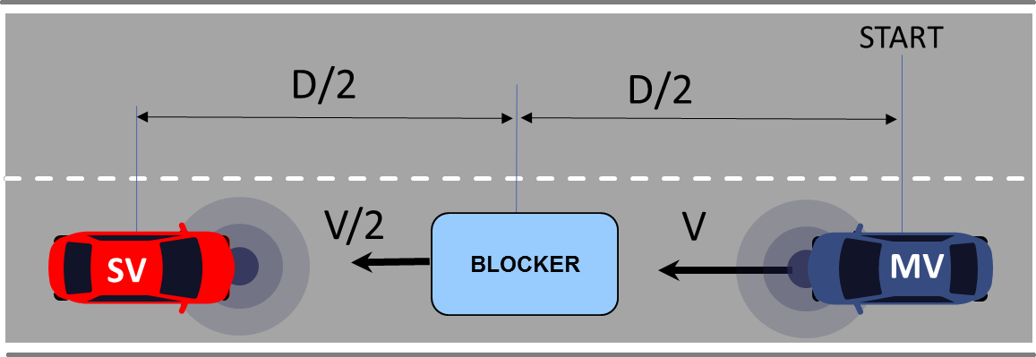

Figure 89: CAMP shadowing test setup

In Figure 90 and Figure 91, we show average Packet Reception Ratio at the stationary vehicle (SV) while the moving vehicle (MV) is approaching as a function of distance between the vehicles averaged over all the loops for the effective transmit power of 11 dBm and 21 dBm, respectively. Using 90% PRR threshold, DSRC range is 200 m and > 1350 m, for 11 dBm and 21 dBm, respectively. For C-V2X, the range is 625 m and > 1350 m for 11 dBm and 21 dBm, respectively. DSRC PRR is briefly below 90% at the distance of 525 m. This is due to a combined characteristic of the test track and the occlusion because both technologies experience the same dip in PRR (C-V2X at 11 dBm and DSRC at 21 dBm) and can be observed in Figure 92.
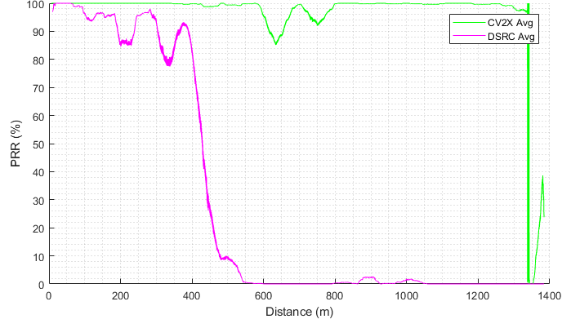

Figure 90: CAMP shadowing test PRR at the SV as a function of distance between SV and MV (11 dBm)
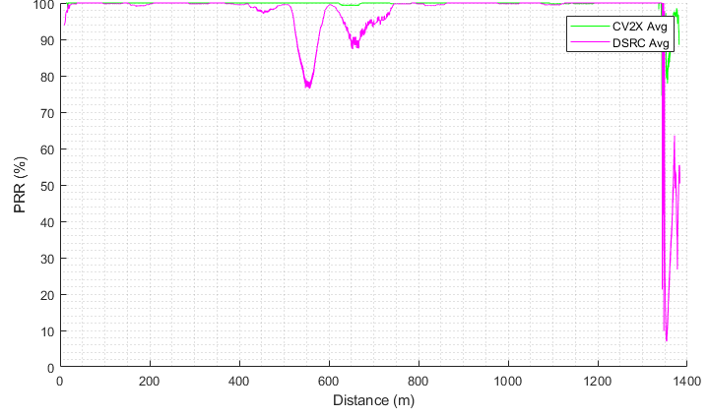

Figure 91: CAMP shadowing test PRR at the SV as a function of distance between SV and MV (21 dBm)

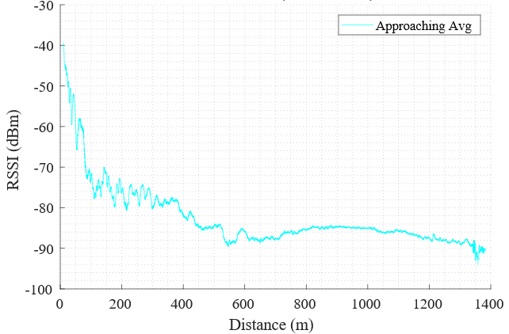

Figure 92: CAMP shadowing test DSRC RSSI as a function of distance (21 dBm effective transmit power)

Annex C:
Latency and IPG Summary Tables

The summaries of the latency and IPG results from Chapter 7 are included below.

Table 44: Summary of 95th percentile latency results

Test | 95th Percentile Latency (ms)
 | C-V2X | DSRC
7.2.1 Cabled transmission and reception test with varying payload sizes | 23 | 20
7.2.2 Clean channel cabled transmission and reception test across power levels | 23 | 20
7.2.3 Cabled Transmission and Reception Test with added Channel Impairment | 27(with HARQ), 28(without HARQ) | 19

Table 45: Summary of average latency results

Test | Average Latency (ms)
 | C-V2X | DSRC
7.2.1 Cabled transmission and reception test with varying payload sizes | 14 | 16.2
7.2.2 Clean channel cabled transmission and reception test across power levels | 13.8 | 16.5
7.2.3 Cabled Transmission and Reception Test with added Channel Impairment | 17.3 (with HARQ), 16 (without HARQ) | 16.2

Table 46: Summary of 95th percentile IPG results

Test | 95th Percentile IPG (ms)
 | C-V2X | DSRC
7.2.1 Cabled transmission and reception test with varying payload sizes | 107 | 111
7.2.2 Clean channel cabled transmission and reception test across power levels | 113 | 109
7.2.3 Cabled Transmission and Reception Test with added Channel Impairment | 113 (with HARQ),  117 (without HARQ) | 109

Table 47: Summary of average IPG results

Test | Average IPG (ms)
 | C-V2X | DSRC
7.2.1 Cabled transmission and reception test with varying payload sizes | 100 | 100
7.2.2 Clean channel cabled transmission and reception test across power levels | 101.4 | 101.2
7.2.3 Cabled Transmission and Reception Test with added Channel Impairment | 101.7 (with HARQ), 101 (without HARQ) | 101

Annex D:
5GAA V2X Test Procedures

The detailed test procedures are documented in TR P-180092 Double-Click icon to open the document.

Annex E:
Change history

Date | Meeting | TDoc | Subject/Comment
24 October 2018 | F2F | P-180106 | Approved by WG
26 October 2018 | F2F | P-180106 | Approved by Board

Appendix C - C-V2X Test and Trials

A growing number of road tests across the globe are demonstrating C-V2X for V2V safety applications. Below is a description of those tests in which 5GAA members are participating.

Fowlerville, Michigan | Qualcomm, Ford
Denver, Colorado | Panasonic, Ford, Qualcomm, CO DoT
Paris, France | 5GAA, BMW Group, Ford and Groupe PSA, Qualcomm, Savari
Ingolstadt, Germany | Audi, Ducati, Qualcomm
Shanghai, China | Ford and Datang
Japan | Continental, Ericsson, Nissan, NTT DOCOMO, OKI and Qualcomm
Shanghai, China | Continental and Huawei
San Diego, California | AT&T, McCain, Ford, Nokia, Qualcomm
Columbia, Maryland | Rohde & Schwarz, Qualcomm
Towards 5G, France | Ericsson, Orange, Qualcomm, PSA Group
Mobilifunk (A9), Germany | Vodafone, Bosch and Huawei
RACC track, MWC 2017 | Audi, Vodafone, Huawei @ MWC
ConVeX (A9), Germany | Audi, Ericsson, Qualcomm, Swarco, Kaiserslautern Univ.
Car2X in Wuzhen, China | CMCC, Continental, Nokia, Fraunhofer
DT (A9), Germany | Audi, Deutsche Telekom, Huawei, Toyota
UK | Jaguar Land Rover, Vodafone, et al
MEC pilot project, Germany | Bosch, DT/T-Systems, Nokia
Car2X at A9, Germany | Continental, DT/T-Systems, Nokia, Fraunhofer

Ford, Qualcomm (Fowlerville, Michigan): Qualcomm and Ford have partnered up to test C- V2X radio capabilities such as the Line-of-Sight range / reliability.76

Panasonic, Ford, Qualcomm, and the Colorado Department of Transportation (August 2018, Denver, Colorado): Panasonic, Ford, Qualcomm, and the Colorado Department of Transportation demonstrated the “first real-world application of C-V2X technology connecting the vehicle, the roadways and a regional traffic management center” and showcased the technology’s ability to detect oncoming traffic, data from Road Side Units, and aggregate traffic data to allow real-time monitoring of roadways connected with C-V2X.77 Testing on C-V2X

76 Jovan Zagajac, The C-V2X Proposition, 5GAA (Apr. 26, 2018), http://5gaa.org/wp-content/uploads/2018/05/3.- The-C-V2X-Proposition-Ford.pdf.
77 Press Release, Panasonic, Panasonic, Qualcomm and Ford Demo the First Real-World Application of C-V2X in Colorado (Aug. 15, 2018), https://www.prnewswire.com/news-releases/panasonic-qualcomm-and-ford-demo-the- first-real-world-application-of-c-v2x-in-colorado-300697513.html.

capabilities will continue on select roadways throughout Panasonic’s CityNOW headquarters in Denver and will be followed by deployment in select areas along the I-70 Mountain Corridor in the back half of 2018.78

5GAA, BMW Group, Ford and Groupe PSA, Qualcomm, Savari (July 2018, Paris, France): Conducted first live demonstration of C-V2X direct communication technology operating across vehicles from multiple auto manufacturers. The demonstration also featured a live showcase of C-V2X direct communication technology operating between passenger cars, motorcycles, and roadside infrastructure.79 Six demonstrations were shown including: Emergency Electronic Brake Light, Intersection Collision Warning, Across Traffic Turn
Collision Risk Warning, Slow Vehicle Warning and Stationary Vehicle Warning, Signal Phase and Timing / Signal Violation Warning and Vulnerable Road User (pedestrian) Warning. The vehicles involved included two-wheel e-scooters provided by BMW Group, and automotive passenger vehicles provided by Ford, Groupe PSA, and BMW Group, all of which were equipped with C-V2X direct communication technology using the Qualcomm® 9150 C-V2X chipset solution. V2X software stack and application software, along with roadside infrastructure, were provided by industry leader, Savari.80

Audi, Ducati, Qualcomm (July, 2018, Ingolstadt, Germany): ConVex (Connected Vehicle to Everything of Tomorrow) trial in Ingolstadt, Germany, featured Audi Q7 and A4 cars and a Ducati Multistrada 1200 Enduro motorbike fitted with the Qualcomm 9150 C-V2X chipset solution, and showed how C-V2X can aid road safety in common scenarios involving motorcycles and cars.81

Ford and Datang (March, 2018, Shanghai, China): Ford and Datang have partnered to trial

V2X “at the National Intelligent Vehicle Pilot Zone in Shanghai, the first intelligent connected car demonstration area in China. The tests built on Datang’s extensive work in creating LTE- V2X technology, which is the first phase of C-V2X technology and Ford’s key role in the area of intelligent connected vehicles (ICV) in China. The evaluations were carried out according to industry harmonized test procedures from 5G Automobile Association.”82

78 Press Release, Qualcomm, Panasonic, Qualcomm and Ford Join Forces on First U.S. Deployment for C-V2X Vehicle Communications in Colorado (June 1, 2018), https://www.qualcomm.com/news/releases/2018/06/01/- panasonic-qualcomm-and-ford-join-forces-first-us-deployment-c-v2x-vehicle.
79 Press Release, Ford, 5GAA, BMW Group, Ford And Groupe PSA Exhibit First European C-V2x Direct Communication Interoperability Between Multiple Automakers (July 11, 2018), https://media.ford.com/- content/fordmedia/feu/en/news/2018/07/11/-5gaa--bmw-group--ford-and-groupe-psa--exhibit-first-european-c-
.html.
80 Id.
81 Farah Alkhalisi, C-V2X demos incorporate motorcycles, vehicles and infrastructure, communications between carmakers, automotiveIT International (July 11, 2018), http://www.automotiveit.com/news/c-v2x-demos- incorporate-motorcycles-vehicles-and-infrastructure-communications-between-carmakers.
82 Press Release, Ford, Ford And Datang Trial C-V2X Connected Car Technology In Shanghai To Support Global Connectivity Initiative (Mar. 29, 2018), https://media.ford.com/content/fordmedia/fap/cn/en/news/2018/03/29-
/Ford_and_Datang_Trial_C-V2X_Connected_Car_Technology_in_Shanghai_to_Support_Global_Connectivity_- Initiative.html.

Continental, Ericsson, Nissan, NTT DOCOMO, OKI and Qualcomm (January, 2018, Japan): Continental, Ericsson, Nissan, NTT DOCOMO, OKI and Qualcomm have partnered to trial C-V2X capabilities where “Continental will utilize the Qualcomm C-V2X Reference Design, which features the Qualcomm 9150 C-V2X chipset with integrated Global Navigation Satellite System (GNSS) capability to build connected car systems and integrate the systems into Nissan vehicles. Nissan will perform V2X use case selection and develop test scenarios with key performance indicators (KPIs) for C-V2X technology validation. OKI, one of the leading companies in ITS, will bring their expertise in roadside unit (RSU) infrastructure and applications to demonstrate V2I as a viable technology for advanced traffic applications by integrating the Qualcomm® 9150 C-V2X chipset into their RSU. Ericsson, as one of the leading companies in the technology and service for telecommunications, will join to the V2N use case discussion, considering a combination of direct communication and LTE-A network technologies. NTT DOCOMO will provide an LTE-A network and V2N applications to demonstrate the benefits of complementary use of network-based communications for a variety
of advanced automotive informational safety use cases.”83

Continental and Huawei (December 2017, Shanghai, China): Continental and Huawei have conducted field trials on C-V2X performance, including reliability and latency. “To test in realistic conditions, Continental conducted its driving tests in China’s National Intelligent Connected Vehicle Pilot Zone in Shanghai named ‘A Nice City’. The joint tests leveraged Huawei’s prototype C-V2X module and infrastructure for use cases such as Emergency Brake Light and Stationary Vehicle Warning. While the average latency was 11 ms, single event message latencies as low as 8 ms were achieved, and throughout the tests the packet reception rate was nearly 100 percent.”84

AT&T, McCain, Ford, Nokia, and Qualcomm (October, 2017, San Diego, California): AT&T, McCain, Ford, Nokia, and Qualcomm, are cooperating with local government bodies to conduct C-V2X trials at the San Diego Regional Proving Ground. Ford vehicles will be using C- V2X technology and the Qualcomm 9150 C-V2X solution to facilitate direct communications, and will be complemented by AT&T’s 4G LTE network communications and ITS platform that takes advantage of wireless base stations and multi-access edge computing technology from Nokia. McCain will help facilitate the effective integration with existing and emerging traffic signal control infrastructure. Testing will support direct C-V2X communications operating in the 5.9 GHz ITS spectrum to explore the safety enhancements of V2V use cases, including do not pass warning, intersection movement assist, and left turn assist, among others. The trials will also support advanced vehicle communication capabilities for improved traffic efficiencies, such as real-time mapping updates and event notifications relayed using AT&T’s cellular network and Nokia Cloud Infrastructure.85

83 Press Release, Qualcomm, Leading Automotive, Telecom and ITS Companies Unveil First Announced Cellular V2X Trials in Japan (Jan. 11, 2018), https://www.qualcomm.com/news/releases/2018/01/11/leading-automotive- telecom-and-its-companies-unveil-first-announced.
84 Press Release, Continental, Cellular V2X: Continental Successfully Conducts Field Trials in China (Dec. 18, 2017), https://www.continental-corporation.com/en/press/press-releases/2017-12-18-cellular-v2x-116994.
85 Press Release, Qualcomm, AT&T, Ford, Nokia and Qualcomm Launch Cellular-V2X Connected Car Technology Trials Planned for the San Diego Regional Proving Ground with Support From McCain (Oct. 31, 2017), https://-

Rohde & Schwarz and Qualcomm (October 2017, Columbia, Maryland): The R&S CMW500 Wideband Radio Communication Tester Was Used to Successfully Test a Pre- Commercial Qualcomm® 9150 C-V2X Chipset.86

Ericsson, Orange, Qualcomm, PSA Group (February, 2017, Towards 5G, France): The initial phase of testing demonstrated Cellular V2X capabilities on the evolution towards 5G in a real environment over two use cases dedicated to connected vehicles: “see through” between two connected vehicles on a road, and “emergency vehicle approaching,” aimed at notifying drivers when an emergency vehicle is nearby in real-time. These two use cases have taken advantage of improved latency, and high throughput performance, using the network-based capabilities of Cellular V2X to deliver a high-resolution video stream between two vehicles, and demonstrating reactivity to show real time event notification.

Vodafone, Bosch and Huawei (February, 2017, Mobilifunk (A9), Germany): Trial underway in the stretch of the A9 between Nuremberg and Munich in Germany. During the trial, the consortium demonstrated the viability of direct V2V communications and the ability to exhibit very low latency. In addition, the tests were intended to investigate how Cellular V2X differs from the IEEE 802.11p technology.

Audi, Vodafone and Huawei (February 2017, Barcelona): On the Circuit de Barcelona- Catalunya race track at the Mobile World Congress 2017, Audi, Huawei and Vodafone demonstrated the use of 4G cellular to enhance safety by enabling rapid exchange of information between vehicles (V2V), other road users and infrastructure (V2I). They demonstrated “see through” (connected cars can see a video feed from a vehicle in front of them in situations where it will help them to have visibility of other traffic, upcoming entry roads or other issues to negotiate); a traffic light warning (traffic light is about to change alerting the driver to slow down), pedestrian in the roadway warning; and emergency braking warning (other connected vehicles suddenly braking or changing lanes).

Audi, Ericsson, Qualcomm, Swarco, Kaiserslautern Univ (January, 2017, ConVeX (A9), Germany): The goal of the trial was to demonstrate the benefits of a Cellular V2X connectivity platform, as defined by 3GPP Release 14, to showcase range, reliability and latency advantage for real-time V2V communications. Additionally, the trial aimed to highlight new use cases that help support traffic flow optimization and improve safety. The goals of ConVeX were to use the results of the trial to inform regulators, provide important inputs to ongoing global standardization work and shape a path for further development and future evolution of Cellular V2X technology.

www.qualcomm.com/news/releases/2017/10/31/att-ford-nokia-and-qualcomm-launch-cellular-v2x-connected-car- technology.
86 Press Release, Rohde & Schwarz, Rohde & Schwarz Supports 3GPP Cellular V2X Device Testing for Vehicle-to- Vehicle Connectivity, ACCESSWIRE (Oct. 19, 2017), https://www.accesswire.com/478295/Rohde--Schwarz- Supports-3GPP-Cellular-V2X-Device-Testing-for-Vehicle-to-Vehicle-Connectivity.

CMCC, Continental, Nokia, Fraunhofer (November 2016, Car2X in Wuzhen, China): At the 2016 World Internet Conference in Wuzhen, China, the partners demonstrated Cellular V2V applications such as Emergency Brake Light that lets you know when traffic in front of you slows down and Cooperative Passing Assistant, that determines whether it is safe to change lanes, advising oncoming traffic to slow down and warning vehicles in front not to change lanes.

Audi, Deutsche Telekom, Huawei, Toyota (July, 2016, DT (A9), Germany): The companies conducted trials of Cellular V2V technology on a section of the “digital A9 motorway test bed” near Ingolstadt, Germany. Audi AG and Toyota Motor Europe research cars, and Deutsche Telekom infrastructure were specially equipped with V2V hardware from Huawei to support the trial scenarios.

Jaguar Land Rover, Vodafone et al (June, 2016, UK): Connected Intelligent Transport Environment (UKCITE) is a project to create the most advanced environment for testing connected and autonomous vehicles. It involved equipping over 40 miles of urban roads, dual- carriageways and motorways with various V2V technologies including Cellular V2X. The project established how this technology can improve journeys; reduce traffic congestion; and provide entertainment and safety services through better connectivity.

Bosch, DT/T-Systems, Nokia (June 2016, MEC pilot project, Germany): The development partnership demonstrated the application of Cellular V2X utilizing local clouds for fast vehicle- to-vehicle communication for hazard warnings and for cooperative and coordinated driving maneuvers. The work included implementing driver assistance functions such as intersection assistance and electronic brake lights.

Continental, DT/T-Systems, Nokia, Fraunhofer (November 2015, Car2X at A9, Germany): The trial demonstrated how vehicles on the motorway can share hazard information using the LTE network of Deutsche Telekom. As extremely short transmission times are vital for this purpose, a section of the Deutsche Telekom network was equipped with innovative Mobile Edge Computing technology from Nokia Networks, and upgraded with position-locating technology developed by Fraunhofer ESK. This combination permitted signal transport times between two vehicles of less than 20 milliseconds.

Appendix D -
Proposed Conditions Applicable to C-V2X Operations Pursuant to the
Waiver Request

The following conditions are proposed for all operations under the requested waiver.

These conditions are largely consistent with the technical rules for DSRC, to ensure that C-V2X will not have any larger potential for interference than DSRC operations currently permitted under the FCC Rules.
Conditions Applicable to All C-V2X Equipment:

  - C-V2X operations will be limited to the 5905-5925 MHz band. DSRC operations will be prohibited from operating in these frequencies.
  - The transmit power limits for all C-V2X devices permitted under the waiver (i.e., Vehicular, Portable, and Roadside units) will be 20 dBm antenna input power as specified in § 8.10.1 of ASTM E2213 - 03. The EIRP for an OBU (vehicular and portable) will be limited to 23 dBm. The EIRP for an RSU will be limited to 33 dBm.
  - All C-V2X devices must attenuate out-of-band emissions consistent with the limits shown below, which may be measured at the antenna input. These are consistent with the existing FCC rules, but allow for the variable transmit power nature of C-V2X, and the planned 20 MHz bandwidth.

Offset from Band Edge | Out-of-Band Emission Limit
± 0 MHz | -29 dBm/100 kHz
± 1.0 MHz | -35 dBm/100 kHz
±10 MHz | -43 dBm/100 kHz
±20 MHz | -53 dBm/100 kHz

  - All C-V2X OBUs and RSUs also will limit emissions to -25 dBm/100 kHz EIRP or less outside the channel edges of 5905 MHz and 5925 MHz and below the band edge of 5855 MHz. The -25 dBm/100 kHz EIRP limit comes from § 8.10.2.2 of ASTM E2213 – 03.
  - C-V2X devices will be evaluated for RF Exposure consistent with the current FCC rules. Devices that would operate in mobile or portable configurations will be evaluated consistent with the procedures in § 2.1091 and § 2.1093 of the FCC Rules respectively. RSUs will be required to indicate compliance with the Maximum Permissible Exposure (MPE) limits in § 1.1310 of the FCC Rules.
  - All equipment subject to the waiver must be certified in accordance with Subpart J of Part 2 of the Commission’s rules.

Conditions Applicable to Roadside Units:

  - A Roadside Unit may employ an antenna with a height not to exceed 8 meters, with the exception that the antenna height may be between 8 and 15 meters provided the EIRP is reduced by a factor of 20 log(Ht/8) in dB where Ht is the height of the radiation center of the antenna in meters above the roadway bed surface. The EIRP is measured as the maximum EIRP toward the horizon or horizontal, whichever is greater, of the gain associated with the main or center of the transmission beam. The RSU antenna height shall not exceed 15 meters above the roadway bed surface.

Conditions on C-V2X Operations:

  - Communications permitted under this waiver will include Vehicle to Vehicle and Vehicle to Infrastructure messages such as the Basic Safety Message, Signal Phase and Timing, Emergency Vehicle Alert, Probe Data Management, Probe Vehicle Data, Signal Request Message, Signal Status Message, Geometric Intersection Description, Traveler Information Message, & others encompassed by the Road Safety Message.
  - Operation under this waiver will be limited to the use of cellular technology to enable vehicles to communicate with everything—including other vehicles, infrastructure, etc.— as standardized by the 3rd Generational Partnership.
  - On-Board and Portable Units should be licensed by rule, consistent with the approach used for DSRC OBUs. Individuals operating On-Board and Portable Units would not require a station license issued by the FCC.
  - Parties desiring to operate Roadside Units must apply for non-exclusive nationwide licenses with individual site registration through the FCC’s Universal Licensing System (ULS). C-V2X Roadside Unit operators will comply with the registration process used by operators of DSRC RSUs detailed in § 9.375(b).
  - All Roadside Units shall not receive protection from Government Radiolocation services in operation prior to the establishment of the Roadside Unit station. Operation of C-V2X Roadside Unit stations within 75 kilometers of the locations listed in the table in § 90.371 must be coordinated through the National Telecommunications and Information Administration.
  - Roadside Units will be subject to the international coordination conditions identified in
§ 90.383 of the FCC Rules.

