Future use of the 3.6 GHz band
Options paper
june 2017

Canberra
Red Building
Benjamin Offices
Chan Street
Belconnen ACT
PO Box 78
Belconnen ACT 2616
T +61 2 6219 5555
F +61 2 6219 5353
Melbourne
Level 32
Melbourne Central Tower
360 Elizabeth Street
Melbourne VIC
PO Box 13112
Law Courts
Melbourne VIC 8010
T +61 3 9963 6800
F +61 3 9963 6899
Sydney
Level 5
The Bay Centre
65 Pirrama Road
Pyrmont NSW
PO Box Q500
Queen Victoria Building
NSW 1230
T +61 2 9334 7700 or 1800 226 667
F +61 2 9334 7799
Copyright notice
http://creativecommons.org/licenses/by/3.0/au/
With the exception of coats of arms, logos, emblems, images, other third-party material or devices protected by a trademark, this content is licensed under the Creative Commons Australia Attribution 3.0 Licence.
We request attribution as © Commonwealth of Australia (Australian Communications and Media Authority) 2017.
All other rights are reserved.
The Australian Communications and Media Authority has undertaken reasonable enquiries to identify material owned by third parties and secure permission for its reproduction. Permission may need to be obtained from third parties to re-use their material.
Written enquiries may be sent to:
Manager, Editorial and Design
PO Box 13112
Law Courts
Melbourne VIC 8010
Email: info@acma.gov.au

Executive summary 1
Issues for comment 7
1 Introduction 9
Legislative and policy environment 9
Purpose 10
Issues not within the scope of this paper 10
Next steps 11
Structure 12
2 Update and outcomes of previous consultation 14
Summary of issues raised 14
Outcomes of previous consultation 14
3 Case for action 16
Highest value use 16
Optimum arrangements to facilitate the highest value use 17
4 Discussion of issues 19
Assessment of areas with high demand for spectrum 19
Process and effect of re-allocating spectrum for the issue of
spectrum licences 23
Geographical boundary issues associated with area-wide licences 26
Options for incumbent services 29
Sharing arrangements 34
5 Replanning options 39
Assessment of options 41
The ACMA’s preferred option 51
6 Invitation to comment 54
Glossary 56
Appendix 1: Current use of the 3.6 GHz band 60
Current planning arrangements and use 60
Appendix 2: Detailed assessment of replanning options 65
Principles of Spectrum Management 65
Option 1—no change 65
Option 2—expand existing apparatus licence arrangements into Area 1 66
Option 3—spectrum licence-specific areas 68
Option 4—hybrid apparatus and spectrum licence approach 71
Appendix 3: 5.6 GHz band considerations 76
Current BoM use of the band 77
RLAN/Wi-Fi use of the band 79
Options for future use of the 5.6 GHz band 79
Appendix 4: FSS earth station sharing study 83
Study parameters 83
Results 86
Appendix 5: Earth station protection zones 95
Proposed criteria for establishing an earth station protection zone 96
Example assessment of sites 97
Appendix 6: Geographical area descriptions 102

Executive summary
This paper represents the next steps in the ACMA’s consideration of the future use of the 3575–3700 MHz band (the 3.6 GHz band) in Australia. The discussion and options outlined in this paper (referred throughout as the Options paper) follow on from the discussion paper Future use of the 1.5 GHz and 3.6 GHz bands released by the ACMA in October 2016 (the October 2016 discussion paper).
The October 2016 discussion paper and resulting feedback have established the case for the ACMA to further investigate possible regulatory action in the 3.6 GHz band. Completing this work, and thus providing clarity to all stakeholders, is an ACMA priority. While timely resolution of this issue is important, the ACMA is committed to making its decisions in an open, transparent and evidence-informed manner.
This Options paper and the associated documents released simultaneously, collectively outline the outcomes of ACMA consideration of responses to the October 2016 discussion paper and identify options, along with an ACMA-preferred option, on next steps for the 3.6 GHz band. This includes the implications for services currently using that band. The associated documents are:
- Future use of the 3.6 GHz band—Highest value use assessment: Quantitative Analysis (HVU paper)
- Future use of the 1.5 GHz and 3.6 GHz bands—Summary of and response to 3.6 GHz submissions (Summary of submissions paper).
Later in 2017, following consideration of any submissions in response, the ACMA aims to form a view on the optimal future use or uses of the 3.6 GHz band. If the ACMA chooses to proceed towards reallocation of spectrum in the band, the formal regulatory steps set out in legislation would entail further consultation.
Stakeholder views
The October 2016 discussion paper sought industry feedback on the ACMA’s medium and longer term planning approaches in the 1.5 GHz and 3.6 GHz bands, in the context of emerging international and domestic interest in mobile broadband (MBB) use of the bands. The extensive feedback received to the October 2016 discussion paper (72 submission were received—almost all commenting on the 3.6 GHz band) demonstrated the importance of this band to many stakeholders and the sensitivity associated with any possible regulatory change in the band.
Stakeholder views on the future of the 3.6 GHz band were strong and highly polarised. This is unsurprising given the importance of spectrum in delivering current services, such as satellite earth stations and point-to-multipoint use, as well as the continuing strong interest of telecommunications carriers in future wide-area mobile or fixed broadband networks.
The ACMA acknowledges the major impact reallocation could have on current incumbents’ use of the spectrum. Major satellite earth stations in metropolitan areas represent substantial long-term investments by a number of operators. Point-to-multipoint users, including wireless internet service providers (WISPs), have collectively made substantial use of the band in regional Australia, although each individual deployment is on a smaller scale. Arrangements in regional areas for point-to-multipoint use of the 3.6 GHz band were only relatively recently established, in 2009. Those utilising these arrangements have identified a need to recover the costs of their investment in the band and, in terms of future growth, have also argued that the 3.6 GHz spectrum is one of a few bands where a small business can obtain affordable apparatus-licensed access to spectrum harmonised internationally for wireless broadband. Some WISPs have called for extension of the current apparatus licensing arrangements into metropolitan areas.
From the perspective of potential new entrants to the band, submissions have only confirmed the previous strong indications that the 3.6 GHz band is of increasing interest for wide-area mobile and fixed broadband networks. While clearly of interest from a purely network capacity perspective, the band has also been flagged as a potential option for early 5G use, bringing with it the possibility of new types of fixed or mobile broadband services. The nature of the band means that it has at times been referred to as a potential ‘coverage layer’, meaning its relatively robust propagation characteristics would complement those of the millimetre wave spectrum that has been the other focus of early interest for 5G services. Hence a reallocated 3.6 GHz band may become an important part of providing 5G services to both urban and regional areas.
Highest value use considerations and the case for action
As part of its MBB strategy, the ACMA committed to undertaking a comprehensive assessment of the highest value use of a band during the preliminary replanning stage of the process for consideration of additional spectrum for mobile broadband services. Following on from the preliminary assessment of highest value use included in the October 2016 discussion paper, and using feedback obtained from stakeholders as part of that process, the ACMA has undertaken a comprehensive highest value use assessment of the 3.6 GHz band.
This analysis indicates that the highest value use of the band has (or will soon) move to wide-area broadband deployments (notably fixed/mobile broadband) in metro and regional areas. As always, this analysis and its conclusions depend on a number of assumptions. Broadly speaking, the conclusion holds if the value placed on the band by new users is above the minimum valuation in the ACMA’s valuation range, and incumbents can continue to deliver their services via other means, such as alternative spectrum options (different bands or geographic locations) or different platforms (for example, fibre).
A key consideration for the ACMA has therefore been to determine whether the assumption is valid that, in general, incumbents could continue to deliver their services. This has led the ACMA to identify a series of potential mitigations for incumbents, including possibly making alternative spectrum in the 5.6 GHz band available as a new band for point-to-multipoint services, and to identify geographic location(s) for the eventual relocation and long-term protection of earth stations.
Considering the issues outlined above, the ACMA has considered what, if any, regulatory barriers exist to the spectrum moving to its highest value use.
The ACMA acknowledges that arrangements suitable for fixed and mobile broadband use already exist in regional and remote areas of Australia in the 3.6 GHz band. Specifically, these are the arrangements in place for site-based point-to-multipoint apparatus licences. The ACMA further notes that no arrangements currently exist in metropolitan areas to support the deployment of fixed or mobile broadband services.
The existing site-based apparatus licence arrangements in the 3.6 GHz band support use of the band by a number of different applications and licensees. However, site-based apparatus licence arrangements are not considered optimal for situations where demand for spectrum exceeds its supply or where there is strong interest in deploying dense, wide-area networks. There are a number of reasons for this.
First, the certainty of access to a large geographic area facilitates the rollout over time of a wide-coverage and, where necessary, dense network. In these cases, it may not be necessary or possible to have extensive geographic coverage from day one but rather have it grow over time. In addition, capacity growth is facilitated as additional sites can be deployed over time as network needs change. In both of these cases, confidence of long-term, wide-area access to the spectrum is, however, important in committing to network deployments.
Second, technical efficiency can be improved by an operator intending wide-area coverage having access to common spectrum in all areas where they wish to deploy services. This allows optimised interference management and network planning.
The ACMA therefore considers that, in some areas, existing planning and licensing arrangements are not optimised for the expected highest value use of the band and there is a case for considering alternative arrangements.
ACMA decisions
A key question asked in the October 2016 discussion paper was whether the 1.5 GHz and/or the 3.6 GHz bands should progress from the initial investigation to the preliminary replanning stage of the ACMA’s process for considering additional spectrum for MBB services. While divergent views on this question were expressed, taking all factors into consideration a strong case was identified for progressing both of these bands. The ACMA is therefore of the view there is a strong and clear case for both of these bands progressing to the preliminary replanning stage and has decided to do so.
The October 2016 discussion paper also sought input on the relative priority of the 1.5 and 3.6 GHz bands. Again, while divergent views on this question were expressed, on balance, the ACMA believes there is a strong case to prioritise the review of the 3.6 GHz band, which it has decided to do.
This recognises the significant investment uncertainty the review has created for incumbent spectrum users, including the effect of the November 2016 spectrum embargo decision on point-to-multipoint users, including WISPs and their customers in regional Australia. Submissions and representations have expressed frustration at the lack of clear long-term licensing options for future point-to-multipoint deployments. The decision to prioritise the 3.6 GHz band also takes into account submissions from several carriers supporting the urgent reallocation of spectrum in the band for wide-area broadband deployments (fixed and mobile), including likely early 5G deployments. Prioritising the review of this band is intended to provide greater clarity and investment certainty for incumbents and potential new band entrants alike.
Options and ACMA preferred option
In this paper, the ACMA has identified a range of possible replanning options to facilitate the spectrum moving to its expected highest value use. These options are based on different spectrum bandwidths and geographic areas. Various mitigation measures to reduce the effects of any change on incumbents have been identified and are a feature that can be integrated with the various spectrum/area options identified.
The ACMA has also identified a preferred option on the way forward, taking into account:
- input from stakeholders to the October 2016 discussion paper
- the outcome of the highest value use assessment
- the shortcomings of the existing regulatory arrangements in light of the changing highest value use of the band
possible mitigations for incumbents.
The primary purpose of this paper is to seek views on the options identified and the ACMA’s preferred option.
The ACMA’s preferred option is to establish arrangements optimised for wide-area broadband deployments (be they mobile or fixed) over the entire 125 MHz of the 3.6 GHz band available in metro and regional areas. The expected licensing regime under this approach would be spectrum licences allocated via auction.
Mitigation opportunities for incumbents under the preferred ACMA option include:
- An extended re-allocation period (transition period) of seven (7) years for all incumbents. While spectrum licences would commence well before the end of this period, existing apparatus-licensed users could, at their discretion, continue to operate (and be protected) throughout this period, though no new assignments would be issued. Spectrum licensees would be required to afford protection to incumbent apparatus licences during the re-allocation period. At the end of the re-allocation period, all apparatus licences would be cancelled. Apparatus licensees would also be free to negotiate with any spectrum licensees in the area to continue operating their services after the end of the re-allocation period. This could be facilitated under third-party access arrangements and requires no intervention by the ACMA.
- Establishment of site-based, coordinated apparatus licensing arrangements for point-to-multipoint services in the 5610–5650 MHz band initially in regional and remote areas, with future consideration for release in metropolitan areas. Existing 3.6 GHz licensees would initially be invited to apply for and obtain ‘like-for-like’ licences in the band. An ACMA policy commitment would be made stating its intention not to vary these arrangements to the detriment of licensees prior to the end of 2028.
- Establishment of long-term planning arrangements supporting the relocation of satellite earth stations from metropolitan areas. Specifically, this would see the establishment of a specified area (or areas) on the east coast of Australia to complement existing arrangements on the west coast at Mingenew, Western Australia. Depending on the location of the area(s) selected, it may need to be excised from a spectrum licence allocation in regional Australia to facilitate the creation of the east coast earth station protection zone(s).
- Excluding the area immediately surrounding the earth station facility at Uralla, New South Wales (represented by the HCIS identifier NU7K4) from being re-allocated for the issue of spectrum licences. This would enable the facility to continue operating under existing apparatus licence arrangements. Suitable coordination criteria would also be developed so spectrum licensees can manage interference into the earth station receivers operated at the site. However, it is important to note that the long-term viability of this site for earth station use cannot be guaranteed. This is due to the increasing interest in using the broader 3400–3800 MHz band for the delivery of mobile broadband services and the earth station facility being located reasonably close to significant population centres (Armidale and Tamworth). As such, this facility may be required to relocate to another location, such as one of the identified earth station protection zones, in the future.
ACMA reasons for supporting this preferred option include:
- The consistent, strong and clear indications that current planning arrangements are not conducive to the 3.6 GHz band moving to its highest value use in metro and regional areas, which is expected to be for dense, wide-area deployment of broadband services—be they for fixed or mobile applications.
- Site-based apparatus licensing arrangements are not optimal for efficiently and effectively managing access to spectrum in areas of high demand. However, they are appropriate in areas of low to medium demand for spectrum. Implementing spectrum licensing arrangements in metro and regional areas, while retaining site-based apparatus licensing arrangements in remote areas, strikes a balance between capturing all likely areas of high demand while minimising the areas of low to medium demand re-allocated for spectrum licensing. To that end, the re-allocation of metro and regional areas for the issue of spectrum licences maximises the increase in economic benefit while minimising overall costs. This option addresses the case for action outlined above.
- Existing apparatus licence-holders in the band provide a range of services using either relatively recently installed infrastructure of modest cost (for example, point-to-multipoint services) or expensive, long-standing infrastructure that requires extended periods to relocate (for example, earth stations). In both cases, in order to facilitate the continued delivery of these services and/or allow for a reasonable opportunity to recoup investments, extended re-allocation periods are proposed. This minimises the overall costs associated with regulatory change, thus maximising the net benefit derived from the change in arrangements.
- An extended re-allocation period of seven years will allow market mechanisms to be used if new 3.6 GHz band spectrum licence-holders seek to use spectrum in an area occupied by an incumbent apparatus-licensed spectrum user. For example, a spectrum licensee could pursue a commercial arrangement with an incumbent apparatus licensee to cease operation prior to the end of the seven year re-allocation period. Similarly, an incumbent apparatus licensee could reach a commercial agreement with a spectrum licensee to continue operating beyond the re-allocation period.
- The exact duration of such an extended re-allocation period is a matter of judgement. The proposed seven years is suggested as an adequate period for earth station operators to relocate (periods up to six years have been suggested by industry) and would allow incumbent point-to-multipoint operators a minimum of around eight years to recoup investment on installed infrastructure. This estimate of an eight-year minimum is derived by adding the proposed seven-year reallocation period (notionally starting in quarter one of 2018) to the approximately 12 months that will have passed since the ACMA’s embargo on new point-multipoint apparatus licenses was extended to regional areas. Prior to the extension of the embargo, point-to-multipoint licences would have been issued where the licensee may not have been aware of the risk of possible planning changes in the band.
- The ACMA’s assessment of highest value use indicates that the public benefit derived from the 3.6 GHz band is maximised by re-allocating the entire 3.6 GHz band in metropolitan and regional areas for the issue of spectrum licences rather than a hybrid approach where a segment is retained for site-based apparatus licensing. It also indicates that greater benefit will be derived through minimising fragmentation in spectrum arrangements across frequency ranges and different geographic areas. The mitigation approaches described previously for incumbent services go some way to minimising the increase in costs for incumbent users between the hybrid approach and the ACMA preferred option.
- While most satellite services in this band are currently operated from metropolitan areas for reasons of history and convenience, there is no overwhelming argument as to why they must remain in these areas long term. The existence of a west coast earth station protection zone and the proposed establishment of an east coast earth station protection zone will provide an option for earth station licensees to move to if they wish to continue delivering and even expanding their existing services. These zones will provide operators with long-term protection and access to spectrum used by satellite services.
- Identifying alternative spectrum for point-to-multipoint services is particularly challenging as spectrum suitable for these services is also often of interest for wide-area dense network deployments. The ACMA has considered other bands of interest to point-to-multipoint users but believes that any apparatus licensing arrangements developed for the 5.6 GHz band could be implemented for the longest period of time before coming under review.
Site based apparatus licensing arrangements for wireless broadband services in the 5610–5650 MHz band are intended to provide a long-term alternative for point-to-multipoint licensees that currently provide services in the 3.6 GHz band. The development and implementation of coordination arrangements should help to protect incumbent BoM radars in the 5600–5650 MHz band from interference while also supporting the deployment of carrier grade wireless broadband services by small operators.
In identifying this preferred option, the ACMA has given thought to the possibility of using some form of ongoing spectrum-sharing in the band (including the use of dynamic spectrum access approaches). Some incumbents have suggested various sharing arrangements as a potential way to allow wide-area fixed and mobile broadband deployments in the 3.6 GHz band by new users, while simultaneously allowing incumbent site-based point-to-multipoint users to continue to operate. A key concept advocated by proponents is that of allowing point-to-multipoint users to continue to operate (and expand services) in areas until the ‘main’ spectrum user wishes to deploy in that area.
The ACMA has carefully considered whether practical sharing models could be implemented within the existing legislative framework, which would meet the requirements of both aspirant wide-area broadband network users and incumbent (and aspirant) point-to-multipoint users alike. Its view is that in areas where demand for 3.6 GHz spectrum is likely to exceed supply, practical sharing models will not provide the required certainty of long-term access to wide-area broadband users while simultaneously offering the desired certainty to current and new point-to-multipoint users that they state is required. This is because in practice the sharing models contemplated are based on hierarchical access rights—with lower tiers of users having to ‘give way’ to higher tier users (which could be incumbent or new licensees). The approach currently proposed of providing an extended re-allocation period (during which incumbents retain ‘primary’ rights), along with identifying alternative spectrum for future deployments, is likely to be the better approach.

Issues for comment
The ACMA invites comments on the issues set out in this paper.
Specific questions are featured in the relevant sections of this paper and collated below. Details on making a submission can be found in the Invitation to comment section at the end of this document.
- Should the 3.6 GHz band be progressed from the preliminary replanning stage to the re-farming stage in the ACMA’s process for considering additional spectrum for MBB services? Why/Why not?
- Do the areas identified in this analysis cover the likely areas of high demand for access to the 3.6 GHz band? Would smaller or larger areas be more appropriate? Why?
- If any part of the 3.6 GHz band is re-allocated for the issue of spectrum licences is seven years a suitable re-allocation period? If not, what period of time would be appropriate?
- Should different re-allocation periods be considered for different areas? For example, should a longer period be considered for services outside Area 1?
- Are these guidelines appropriate? Why?
- Are there any other issues that affect the usability of an area-wide licence that should be taken into account when defining the licence area?
- If point-to-point licences are affected by replanning activities in the 3.6 GHz band, are the options identified for point-to-point licences suitable? Are there any alternative options that should be considered?
- Is the 5.6 GHz band a viable option for wireless broadband systems?
- Under what circumstances should apparatus- and class-licensed arrangements be considered for the 5.6 GHz band?
- If apparatus licensing arrangements are developed for wireless broadband systems in the 5.6 GHz band, are the notional arrangements proposed in Appendix 3 suitable?
- If point-to-multipoint licences are affected by replanning activities in the 3.6 GHz band, are the alternative options identified suitable? Are there any alternative options that should be considered?
- The ACMA seeks comment on the suitability of the current west coast earth station protection zone located near Mingenew, WA, for long-term satellite service use. Are the current regulatory arrangements effective?
- In the event FSS earth stations are affected by replanning activities in the 3.6 GHz band, the ACMA seeks comment on:
- Any issues surrounding the development and establishment of an east coast earth station protection zone; particularly on what factors would be necessary to make it an attractive option for earth station operations.
- Whether there are any views on potential candidate locations to consider.
- Whether there should there be more than one earth station protection zone on the east and west coasts of Australia.
- If the identification of a central Australia earth station zone should be considered.
- Are the approaches for amateurs, radiolocation services, class licensed devices and TVRO systems suitable?
- Are there any other options for incumbent services, not identified in this paper, which should be considered?
- Should any of the sharing arrangements discussed in this section be considered for implementation in the 3.6 GHz band? Why or why not?
- Are there any other sharing arrangements that should be considered?
- Are there any other replanning options that should be considered?
- Which replanning option should be implemented in the band? Why?
- In the event an area-wide licensing option is implemented, in which of the defined areas (that is, Area 1, 2, 3 and Australia-wide as defined in Appendix 6) should these arrangements be implemented? Are the current area definitions appropriate? If not, what area should be defined?
- If Option 4a is implemented, what frequencies and areas should be re-allocated for the issue of spectrum licences? How much spectrum should remain subject to site-based apparatus licensing arrangements? Should different amounts be considered in different areas?
- If Option 4b is implemented, what frequencies and areas (that is, incumbent apparatus licence services) should remain subject to site-based apparatus licensing arrangements?
- Comment is sought on the ACMA’s preferred option (Option 3c) for the 3.6 GHz band.

1 Introduction
The Australian Communications and Media Authority (the ACMA) released the discussion paper Future use of the 1.5 GHz and 3.6 GHz bands (the October 2016 discussion paper) on 20 October 2016. The paper considered the current and possible future use of the 1427–1518 MHz band (the 1.5 GHz band) and the 3575–3700 MHz band (the 3.6 GHz band) both domestically and internationally. Preliminary assessments of the highest value use of the 1.5 GHz and 3.6 GHz bands were also presented.
We received seventy-two submissions to the October 2016 discussion paper. The paper Future use of the 1.5 GHz and 3.6 GHz bands—Summary of and response to 3.6 GHz submissions (Summary of submissions paper) has been released in parallel with this paper.
One of the main outcomes of the October 2016 discussion paper was that the review of arrangements in the 3.6 GHz band has been progressed from the initial investigation stage to the preliminary replanning stage of the process for considering additional spectrum for mobile broadband services. The purpose of this discussion paper is to determine whether or not to further progress consideration of the 3.6 GHz band from the preliminary replanning to the re-farming stage of the process.
For simplicity in this paper, the term ‘mobile broadband’ (MBB) is used to refer to a variety of different technologies including terms such as 3G, 4G and 5G. The term should also be taken to include fixed broadband systems.

Legislative and policy environment

Spectrum Review
On 18 May 2017, the government released a consultation package on reforms to modernise and simplify Australia’s spectrum management framework. The comprehensive consultation package includes an Exposure Draft of the Radiocommunications Bill and related consultation papers, including broadcasting spectrum and transitional arrangements. Consultation papers on government spectrum holdings and spectrum pricing were also released.
These reforms will simplify the regulatory framework and support new and innovative technologies and services. The proposed reforms follow the recommendations of the government’s 2015 Spectrum Review report to:
- Replace the current legislative arrangements with new legislation that removes prescriptive processes and streamlines licensing for a simpler and more flexible framework.
- Better integrate the management of public sector and broadcasting spectrum to improve the consistency and integrity of the framework.
- Review spectrum pricing to ensure consistent and transparent arrangements to support the efficient use of spectrum and secondary markets.
At this stage, the Exposure Draft of the Bill is incomplete and the government is yet to release draft transitional and consequential legislation. The Department of Communications and the Arts (DoCA) is currently seeking stakeholder views on preferred approaches to transition, and has noted that the full transition to a new framework would take place over a number of years.
Given the timeframes associated with the 3.6 GHz band review, the ACMA is proposing to develop new arrangements in this band on the assumption that the existing regulatory regime will apply. Depending on when new legislations begins, it is acknowledged that any new arrangements for the 3.6 GHz band may need to be accommodated under the new legislative framework. Subject to the transitional and consequential legislative arrangements, the ACMA will take into account relevant opportunities offered by the implementation of the new legislative framework.

Mobile broadband strategy and work program
The ACMA has developed a set of strategies to address the growth in demand for mobile broadband capacity. A key part of these strategies is a spectrum management process to release additional spectrum for mobile broadband in bands where there is evidence of a change in highest value use.
The review of the 3.6 GHz band was flagged in the ACMA’s Five-year spectrum outlook 2016–20 (FYSO), including in the Mobile broadband work program—September 2016 update, released in October 2016. It is intended that updates to this work program will be made in each subsequent edition of the FYSO.
The stages of the process for consideration of additional spectrum for MBB services are outlined in the ACMA’s mobile broadband strategy.

Purpose
As discussed previously, the 3.6 GHz band is currently in the preliminary replanning stage of the process for considering additional spectrum for MBB services. This stage involves identifying replanning/re-farming proposals (including mechanisms to address the interests of incumbent licensees), informed by detailed technical sharing studies and analysis of ongoing incumbent spectrum needs. A comprehensive assessment of the highest value use or uses of the band is undertaken. Outlining this analysis and garnering feedback from interested stakeholders is the primary purpose of this paper.
This paper provides an opportunity for stakeholders to inform ACMA thinking and comment on different options for future arrangements in the 3.6 GHz band, to ensure the costs and benefits are accurately gauged and taken into consideration.
The main outcome sought from this paper is to determine if the 3.6 GHz band should be progressed from the preliminary replanning stage to the re-farming stage and, if so, what replanning option is most appropriate.
- Should the 3.6 GHz band be progressed from the preliminary replanning stage to the re-farming stage in the ACMA’s process for considering additional spectrum for MBB services? Why/Why not?

Issues not within the scope of this paper
The purpose and scope of this paper is outlined above. The following notes a number of issues that are not within the scope of this paper.

Detailed licensing and allocation options
Detailed licensing and allocation options (such as auction methods and lot configuration) will be considered as part of any possible re-farming process after the most suitable planning direction is determined.

Arrangements in 3400–3575 MHz
Spectrum adjacent to the 3.6 GHz band in 3400–3575 MHz is subject to a combination of apparatus and spectrum licensing in metropolitan and regional areas. Any planning arrangements developed for the 3.6 GHz band will, as a matter of course, take this into account. However, consideration of possible changes (including reconfiguration) of planning and licensing arrangements in the 3400–3575 MHz band is outside the scope of this paper.

Engagement in international activities
Various international developments and activities are relevant to domestic considerations. However, the ACMA’s actual international engagement process into these matters is not considered in this paper. The ACMA will continue to monitor and engage with stakeholders via the usual international preparatory process, to develop Australian positions on issues regarding the 3.6 GHz bands in the ITU-R and APT. Those interested in participating in these activities can obtain more information from the ACMA website or can email the International Radiocommunications Section of the ACMA at IRS@acma.gov.au.

1427–1518 MHz band
The October 2016 discussion paper discussed both the 1427–1518 MHz band (the 1.5 GHz band) and the 3575–3700 MHz band (the 3.6 GHz band). This discussion paper deals solely with the 3.6 GHz band. The 1.5 GHz band will be considered separately in a future paper. Further details are outlined in the Summary of submissions paper released in parallel with this paper.

Next steps
Should the 3.6 GHz band progress to the re-farming stage, Table 1 provides a notional timeline for its progression.
Importantly, whether the notional timeline is achievable and/or appropriate is contingent on a variety of factors. A critical one is the feedback from discussion papers that contributes to the ACMA’s evidence-informed decision-making processes.
- Indicative timeline for progressing the 3.6 GHz band through the process for considering additional spectrum for MBB services
Stage | Milestone | Date
Stage 2—  Preliminary replanning | Release: second discussion paper focused on the 3.6 GHz band providing comprehensive highest value use assessment and planning options | June 2017
 | Submissions due to second discussion paper | 4th August 2017
 | Release: decision paper on whether or not band will move to stage 3—re-farming | No earlier than late Q3 2017
Stage 3—  Re-farming | Commencement of re-farming stage, if applicable | Q4 2017

As illustrated in Table 1, a decision on whether or not the 3.6 GHz band will be progressed to the re-farming stage of the process for considering additional spectrum for MBB services is expected in Q3–Q4 this year. Should the decision be taken to progress the 3.6 GHz band to the re-farming stage, this would commence in Q4 2017.
The exact actions taken in the re-farming stage depend on the final re-farming option chosen. In the event the ACMA believes the best re-farming option involves re-allocating spectrum for the issue of spectrum licences, the following steps would be undertaken:
- The ACMA would consult on giving the Minister for Communications a written recommendation to make a spectrum re-allocation declaration (section 153F) for the relevant frequencies and areas identified in the final option chosen. This would also include consultation on the recommended re-allocation period.
- After receiving a written recommendation from the ACMA, the minister would make a decision on whether or not to make a re-allocation declaration (section 153B).
- If the minister makes the re-allocation declaration, the ACMA would then start developing a technical framework and relevant allocation instruments for the re-allocated spectrum.
Once this work is finalised, the spectrum will be released to the market. The ACMA normally uses a price-based allocation (an auction) when re-farming spectrum in cases where demand is expected to be greater than supply.
In the event the ACMA believes the best re-farming option does not involve re-allocating spectrum for the issue of spectrum licences, it could immediately start developing any necessary technical frameworks or allocation instruments before releasing the spectrum.

Structure
The rest of this document is structured as follows:
- Chapter 2—Update and outcomes of previous consultation describes the outcomes of the ACMA’s previous consultation on this issue in the October 2016 discussion paper. More detail on these outcomes are available in the Summary of submissions paper.
- Chapter 3—Case for action details the basis for possible replanning action by the ACMA. This is informed by a comprehensive assessment of the highest value use of the band, along with an analysis as to whether existing arrangements in the band are conducive to the spectrum moving to its highest value.
Chapter 4—Discussion of issues considers a number of issues that any options for replanning the band will need to address or take into account.
Chapter 5—Replanning options for the 3.6 GHz band details the four broad options the ACMA has identified for replanning the 3.6 GHz band. A description of each option and sub-options as well as an assessment of the options is undertaken, and a preferred option identified.
There are also a number of appendixes to this paper:
- Appendix 1—Current use of the 3.6 GHz band describes current arrangements and use of the 3.6 GHz band.
- Appendix 2—Detailed assessment of replanning options provides a comprehensive assessment of the options outlined and summarised in Chapter 3.
- Appendix 3—5.6 GHz band considerations outlines the current use of the 5600–5650 MHz band (the 5.6 GHz band) and discusses the potential future use of the band for point-to-multipoint services.
- Appendix 4—FSS Earth station sharing study provides a summary of sharing studies between Fixed Satellite Service (FSS) earth station receivers and potential MBB services in the 3.6 GHz which have been conducted by the ACMA.
- Appendix 5—Earth station protection zones investigates the concept of earth station protection zones to provide long-term planning certainty.
Appendix 6—Geographical area descriptions defines four geographical area options that could be considered for replanning in the 3.6 GHz band.
In parallel to the release of this Options paper, the ACMA has also released two other documents as part of its considerations:
- Future use of the 1.5 GHz and 3.6 GHz bands—Summary of and response to 3.6 GHz submissions (Summary of submissions paper)
Future use of the 3.6 GHz band—Highest value use assessment: Quantitative analysis (HVU paper).
These documents should be read and considered together as they collectively form the basis of the ACMA’s current thinking in the 3.6 GHz band.

2 Update and outcomes of previous consultation
The ACMA released the discussion paper Future use of the 1.5 GHz and 3.6 GHz bands (the October 2016 discussion paper) on 20 October 2016. The paper considered the current use of the 1427–1518 MHz band (the 1.5 GHz band) and the 3575–3700 MHz band (the 3.6 GHz band) both domestically and internationally.
We received seventy-two submissions to the October 2016 discussion paper. The Summary of submissions paper has been released in parallel with this paper. This chapter provides a summary of the issues raised in submissions and the outcomes of the consultation. More detail on these outcomes is available in the Summary of submissions paper.

Summary of issues raised
The October 2016 discussion paper was the first step in the review of the 3.6 GHz band. It allowed all stakeholders to provide their views on whether the review should progress further and opinions on the timing and priorities associated with any further work.
From the responses provided, it appears the October 2016 discussion paper provided an accurate account of the current status of the 3.6 GHz band in Australia, as well as identifying the issues surrounding potential future use of the 3.6 GHz band for MBB services. This confirms there is a broad understanding of the 3.6 GHz band, the drivers for the review and those that would be affected by any changes to arrangements have been identified.
Further, incumbent services, namely fixed satellite service (FSS) earth station and point-to-multipoint users, outlined the potential effects on their operations if the 3.6 GHz band was to be re-farmed for MBB services. Prospective MBB advocates described the importance of the 3.6 GHz band for their future operations, particularly for the introduction of 5G or fixed broadband services. This feedback has allowed the ACMA to investigate the costs and benefits associated with the options in this paper.

Outcomes of previous consultation
The outcomes of the October 2016 discussion paper are outlined in the Summary of submissions paper. The key outcomes that led to the development of this Options paper are:
- The ACMA has decided to progress both the 1.5 GHz and 3.6 GHz bands to the preliminary replanning stage of its process for considering additional spectrum for MBB services.
- Given international developments and strong domestic interest, the ACMA has decided to prioritise consideration of the 3.6 GHz band over the 1.5 GHz band. A more timely resolution of what, if any, replanning would occur in the 3.6 GHz band will also provide certainty to incumbent services about long-term arrangements in the band and any alternative options available to them (if applicable).
- Submissions largely supported the proposal to adopt time-division duplex (TDD) arrangements should the 3.6 GHz band be re-farmed. The ACMA will continue to assess replanning options based on the use of TDD technologies in the band.
To facilitate timely consideration of the 3.6 GHz band, any ACMA process for optimising the broader 3400–3700 MHz band will be deferred until the outcomes of this process are known.
This Options paper has been developed to pursue these outcomes. As outlined in the Purpose section, one of the aims of this Options paper is to progress consideration of the 3.6 GHz band within the preliminary replanning stage of the ACMA’s process for considering additional spectrum for MBB services.

3 Case for action
This chapter details the basis for possible replanning action by the ACMA. This is informed by a comprehensive assessment of the highest value use of the band, along with an analysis whether existing arrangements in the band are conducive to the spectrum moving to its highest value use.

Highest value use
The October 2016 discussion paper contained a preliminary assessment of the highest value use of the 3.6 GHz band, with the conclusion that the highest value use of the band may be changing in some areas. As outlined in Chapter 2, the ACMA has subsequently decided to progress consideration of this band to the preliminary replanning phase of the process for considering additional spectrum for MBB services.
As part of the ACMA’s process for considering bands at the preliminary replanning phase, a comprehensive assessment of the highest value use of a band is undertaken. The HVU paper has been developed and released in parallel with this Options paper. It paper focuses on the quantitative aspects of the HVU analysis but also notes a range of qualitative factors.
The ACMA’s broad conclusion from the HVU paper is that a quantitative analysis of re-farming benefits and incremental costs indicates that replanning the 3.6 GHz band in a manner suitable for wide-area fixed/mobile broadband services will be net beneficial and increase overall economic welfare in metro and regional areas of Australia.
The HVU paper also notes a number of qualitative factors that may influence this conclusion. These include that some incumbent licensees may discontinue their services. In these cases, the incremental costs will be the difference in economic welfare between the existing and substitute service, if any is available.
A number of measures discussed in the HVU paper would decrease the incremental costs to incumbent services should the 3.6 GHz band be re-farmed. These options allow for ongoing provision of services, though at an increased cost, which is quantifiable. This essentially means that a greater number of displaced services can be considered constant output cases and the unquantifiable effect of the change in end output is minimised.
Another aspect considered for FSS earth receive licensees is that a single facility may have multiple services (or licences) operating across C-band—that is, not just the 3.6 GHz band portion. Indications from incumbent licensees are that, in this case, it is not cost-effective to relocate just the services operating in the 3.6 GHz band. Consequently, if there is a need to move, the options for licensees are whether to cease services in the 3.6 GHz band and stay where they are or relocate all C-band services to a new location. This is particularly relevant in identifying the incremental costs attributable to FSS earth receive licences. Specifically, it is unclear how this cost should be attributed. For example, should the relocation costs be apportioned to the 3.6 GHz band in their entirety or on a proportional basis? In the ACMA’s analysis, the entire costs of a C-band geographic relocation are attributed to the 3.6 GHz band. However, it is acknowledged that this represents the worst-case scenario.
There are also further qualitative aspects of the benefits of re-farming—unmeasurable consumer surplus increases and positive externalities (that is, broader social net benefits) that have not necessarily been factored into valuations. Many of these were raised in the Preliminary assessment of HVU contained in the October 2016 discussion paper as well as in submissions to that paper. They include:
- Identifying spectrum for MBB that is both internationally harmonised and aligns with technology standards is important to the ultimate success of services in a frequency band. International spectrum harmonisation and technology standardisation generate economies of scale, reducing the price of equipment for both network operators and consumers. They also provide greater global roaming opportunities for consumers, allowing the same handset to be operated on networks in many different countries.
- The potential benefits realised in MBB operators gaining access to more spectrum are reduced costs to provide greater MBB capacity. This could facilitate mobile operators deploying higher quality services, and provide higher peak and average data rates at a similar price.
- This potential to improve competition in the MBB market by providing incumbent and/or new operators with access to more spectrum in key market areas.
There are potential social effects as well as effects on local business associated with a change in availability of broadband services, particularly in rural areas where options for such services are limited.
The effect any change in arrangements may have on incumbent licensees, and any communities or businesses they provide services to, is also an important factor. As such, this paper outlines options to allow for the ongoing provision of services as far as possible.
Overall, the ACMA does not consider that qualitative factors substantially change the conclusion derived from the quantitative analysis, and the conclusion from its comprehensive assessment of the highest value use of the 3.6 GHz band (as detailed in the HVU paper) remains. That is, use of the 3.6 GHz band in metropolitan and regional areas for wide-area fixed/mobile networks will be net beneficial and increase overall economic welfare.
While considering qualitative factors has not changed the ACMA’s overall HVU conclusion, they are relevant to how arrangements in the band should be varied in order to allow for highest value use. In particular, strategies to mitigate the potential adverse effects of re-farming on current uses of the band, including the proposal for an extended reallocation period, are discussed elsewhere in the paper.

Optimum arrangements to facilitate the highest value use
Based on the ACMA’s findings, discussed above, that the highest value use of the band has or is changing, it is important to identify what, if any, regulatory barriers exist to the spectrum moving to its highest value use. (If it was determined that arrangements were already adequately optimised for the projected highest value use, then regulatory action may not be warranted.)
The ACMA acknowledges that arrangements suitable for fixed and mobile broadband use already exist in regional and remote areas of Australia in the 3.6 GHz band—those in place for point-to-multipoint licences. These are site-based licences with low-density deployments, typically providing services over a small area or multiple small areas. There are no arrangements in metropolitan areas to deploy broadband services.
The existing site-based apparatus licence arrangements in the 3.6 GHz band support use of the band by a number of different services and licensees. Such arrangements are optimal when demand for access to spectrum does not exceed its supply. They allow any prospective operator to apply for licences in specific areas where spectrum is available. This allows spectrum to be assigned as required rather than as part of an area-based licence where services may not be deployed across the whole area or where there are no plans to roll out services in certain areas for some time.
Site-based apparatus licence arrangements are not considered optimal if demand for access to spectrum exceeds its supply and there is strong interest in deploying dense wide-area networks. There are a number of reasons for this.
First, giving a single operator access to the same spectrum across a large geographic area better facilitates the rollout, over time, of wide-coverage and, where necessary, appropriately dense, networks. It provides much greater certainty to the licensee than site-based arrangements, as the operator is not constrained to seek an additional, site-based apparatus licence each time it wishes to roll out to a new area or add network density in an area that is already covered. In planning a wide-area network, it may not be necessary or possible to achieve its ultimate geographic coverage from the commencement of services; rather, there should be provision for growth over time, with additional sites added as network needs change.
Second, technical efficiency can be improved when an operator intending wide-area coverage has access to the same range of frequencies across a wide area. This allows optimised interference management and network planning.
Given area-wide licensing arrangements will often be optimal in circumstances where demand is expected to exceed supply, market mechanisms, such as price-based allocations, are usually the preferred allocation method in these cases. This allows those who value the spectrum the most to gain access, ensuring spectrum moves to its highest value use. It also helps to avoid potential situations where one or more entities ‘hoard’ spectrum in relevant areas to secure future access and/or block competitors, or speculatively take out licences in key locations with a view to on selling them to the highest bidder.
Area-wide licences can be issued as either spectrum or apparatus licences, but a higher utility is usually placed on the issue of spectrum licences. This is due to the greater investor certainty provided by longer licence tenure (up to 15 years for spectrum licences versus a maximum of five years for apparatus licences), technical flexibility and full tradability (including aggregation and disaggregation of licences).
The ACMA therefore concludes that existing planning and licensing arrangements are not optimised for the expected highest value use of the band in areas where demand is expected to exceed supply, and there is a case to consider alternative arrangements.

4 Discussion of issues
In concluding that existing arrangements in the 3.6 GHz band should be reviewed to facilitate the expected highest value use of the band, the ACMA has identified a number of overarching issues that influence potential options for change. This section provides a discussion of those common issues prior to describing and assessing each option in detail in Chapter 5.
To provide clarity in the proceeding discussion, the definition of Area 1, Area 2 and Area 3 referred to in this section are provided at Appendix 6.

Assessment of areas with high demand for spectrum
Based on submissions to the October 2016 discussion paper, discussions with operators and analysis of existing MBB deployments, it is clear there is increasing interest in using the 3.6 GHz band for MBB services. Two operators have indicated they would ideally seek up to 100 MHz of spectrum to deploy wide-area MBB services in the 3.6 GHz band. Given there is 125 MHz of spectrum available in the 3.6 GHz band, this would have a significant impact on the availability of spectrum.
Although interest will initially be in deploying wide-area MBB services in major cities, it is expected that expansion into regional areas will occur over time (as it has in numerous other bands). This will be facilitated by advanced technologies such as massive multiple input, multiple output (mMIMO) and beamforming, which are expected to improve coverage and capacity of cells deployed in the 3.6 GHz band. This will make it more attractive and cost-effective for operators to deploy wide-area services in the 3.6 GHz band in regional and remote areas.
In order to gauge the likely areas of interest for deploying wide-area mobile services in the 3.6 GHz band, a comparison has been made to current deployments in the following bands:
- 1710–1785/1805–1880 MHz (1800 MHz)
- 1920–1980/2110–2170 MHz (2 GHz)
- 2302–2400 MHz (2.3 GHz)
2500–2570/2620–2690 MHz (2.5 GHz) bands.
These bands were chosen as they are currently used to deploy wide-area 4G (LTE) and 3G (HSPA) MBB services. It is also likely operators would use existing infrastructure to deploy services in the 3.6 GHz band. There is evidence to suggest there will also be improvements in cell coverage available in the 3.6 GHz band, due to advanced antenna techniques. This would result in cell sizes that approach existing 1800 MHz, 2 GHz, 2.3 GHz and 2.5 GHz deployments. Figure 1 to Figure 5 provide a visual comparison of current deployment by wide-area mobile services in the 1800 MHz, 2 GHz, 2.3 GHz and 2.5 GHz bands, respectively. This has been overlaid with current point-to-multipoint licence deployments in the 3.6 GHz band.
Analysis of Figure 1 to Figure 4 show the following:
- Deployment of extensive wide-area mobile services is concentrated mainly in regional and metropolitan areas. These areas are best defined by the current metropolitan and regional spectrum licence areas for the 1800 MHz and 2 GHz bands.
- Typically, deployments of wide-area mobile services become more sparse, though not insignificant, in remote and some regional areas
Deployments by 3.6 GHz wireless broadband operators using existing site-based apparatus licences and MBB operators in regional areas (1800 MHz, 2 GHz, 2.3 GHz and 2.5 GHz spectrum licence areas) extensively overlap, although not necessarily at identical sites or covering the same areas. As such, if the same band was shared between these operators, there is likely to be an increase in demand and contention for spectrum in and around these areas.
Based on this assessment, the most likely areas of high demand and contention for access to spectrum would be in major metropolitan and major regional population centres. Submissions to the October 2016 discussion paper further indicated that interest will initially be in deploying wide-area mobile services in major cities. Expansion into regional areas will likely occur over a longer period of time (as it has in numerous other bands). The timeframes associated with the rollout of services would depend on factors such as the availability of equipment, existing or forecasted capacity constraints on the network, and the ability to provide new and improved services.
- Do the areas identified in this analysis cover the likely areas of high demand for access to the 3.6 GHz band? Would smaller or larger areas be more appropriate? Why?
- Comparison of base station locations in the 1800 MHz (wide-area networks only) and 3.6 GHz bands (RRL extract, 1 May 2017)
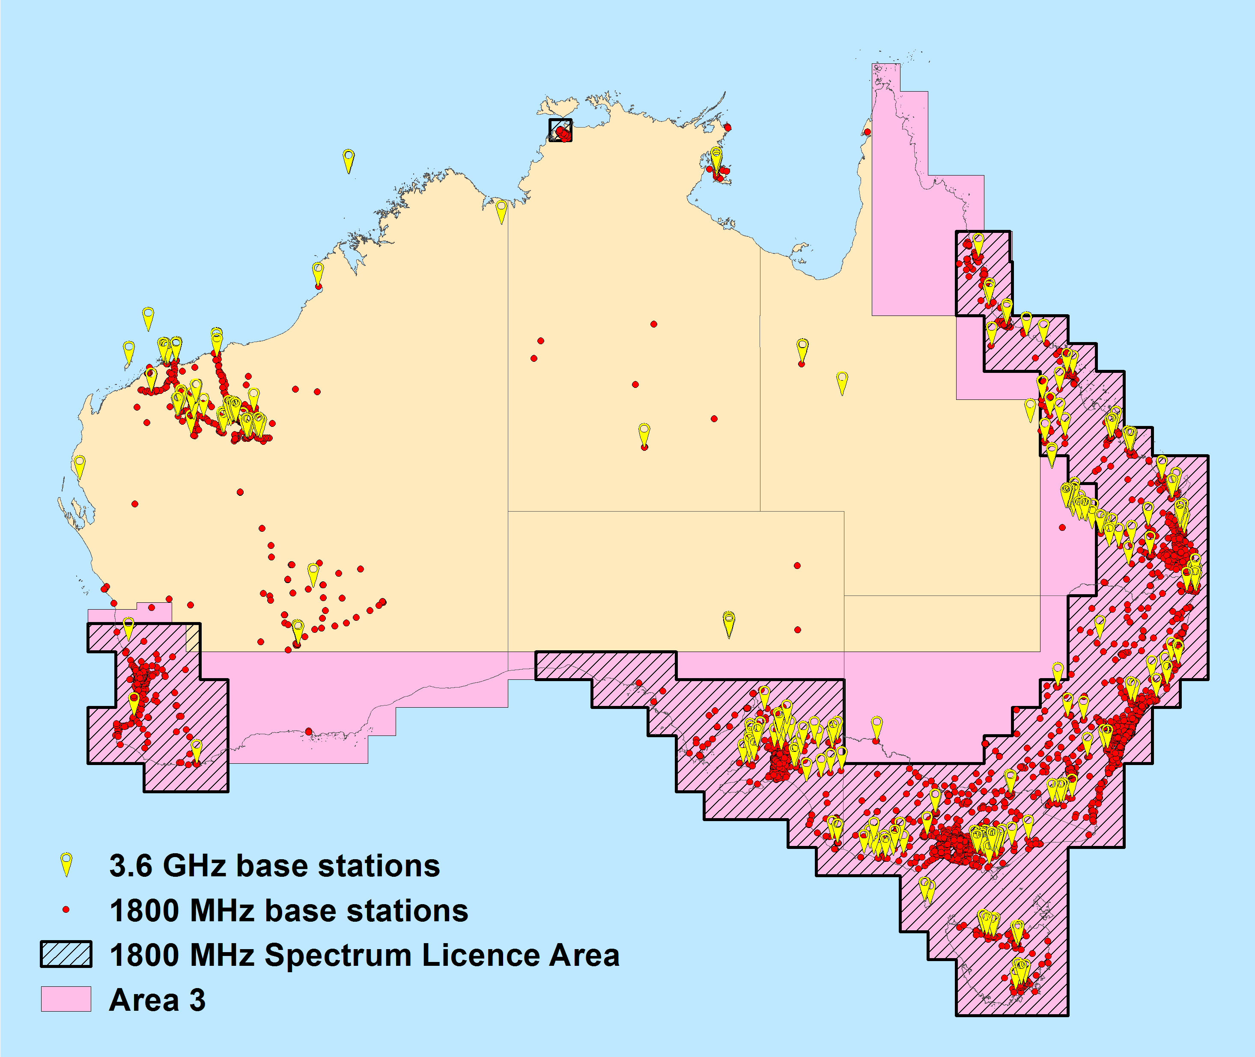
- Comparison of base station locations in the 2 GHz (wide-area networks only) and 3.6 GHz bands (RRL extract, 1 May 2017)
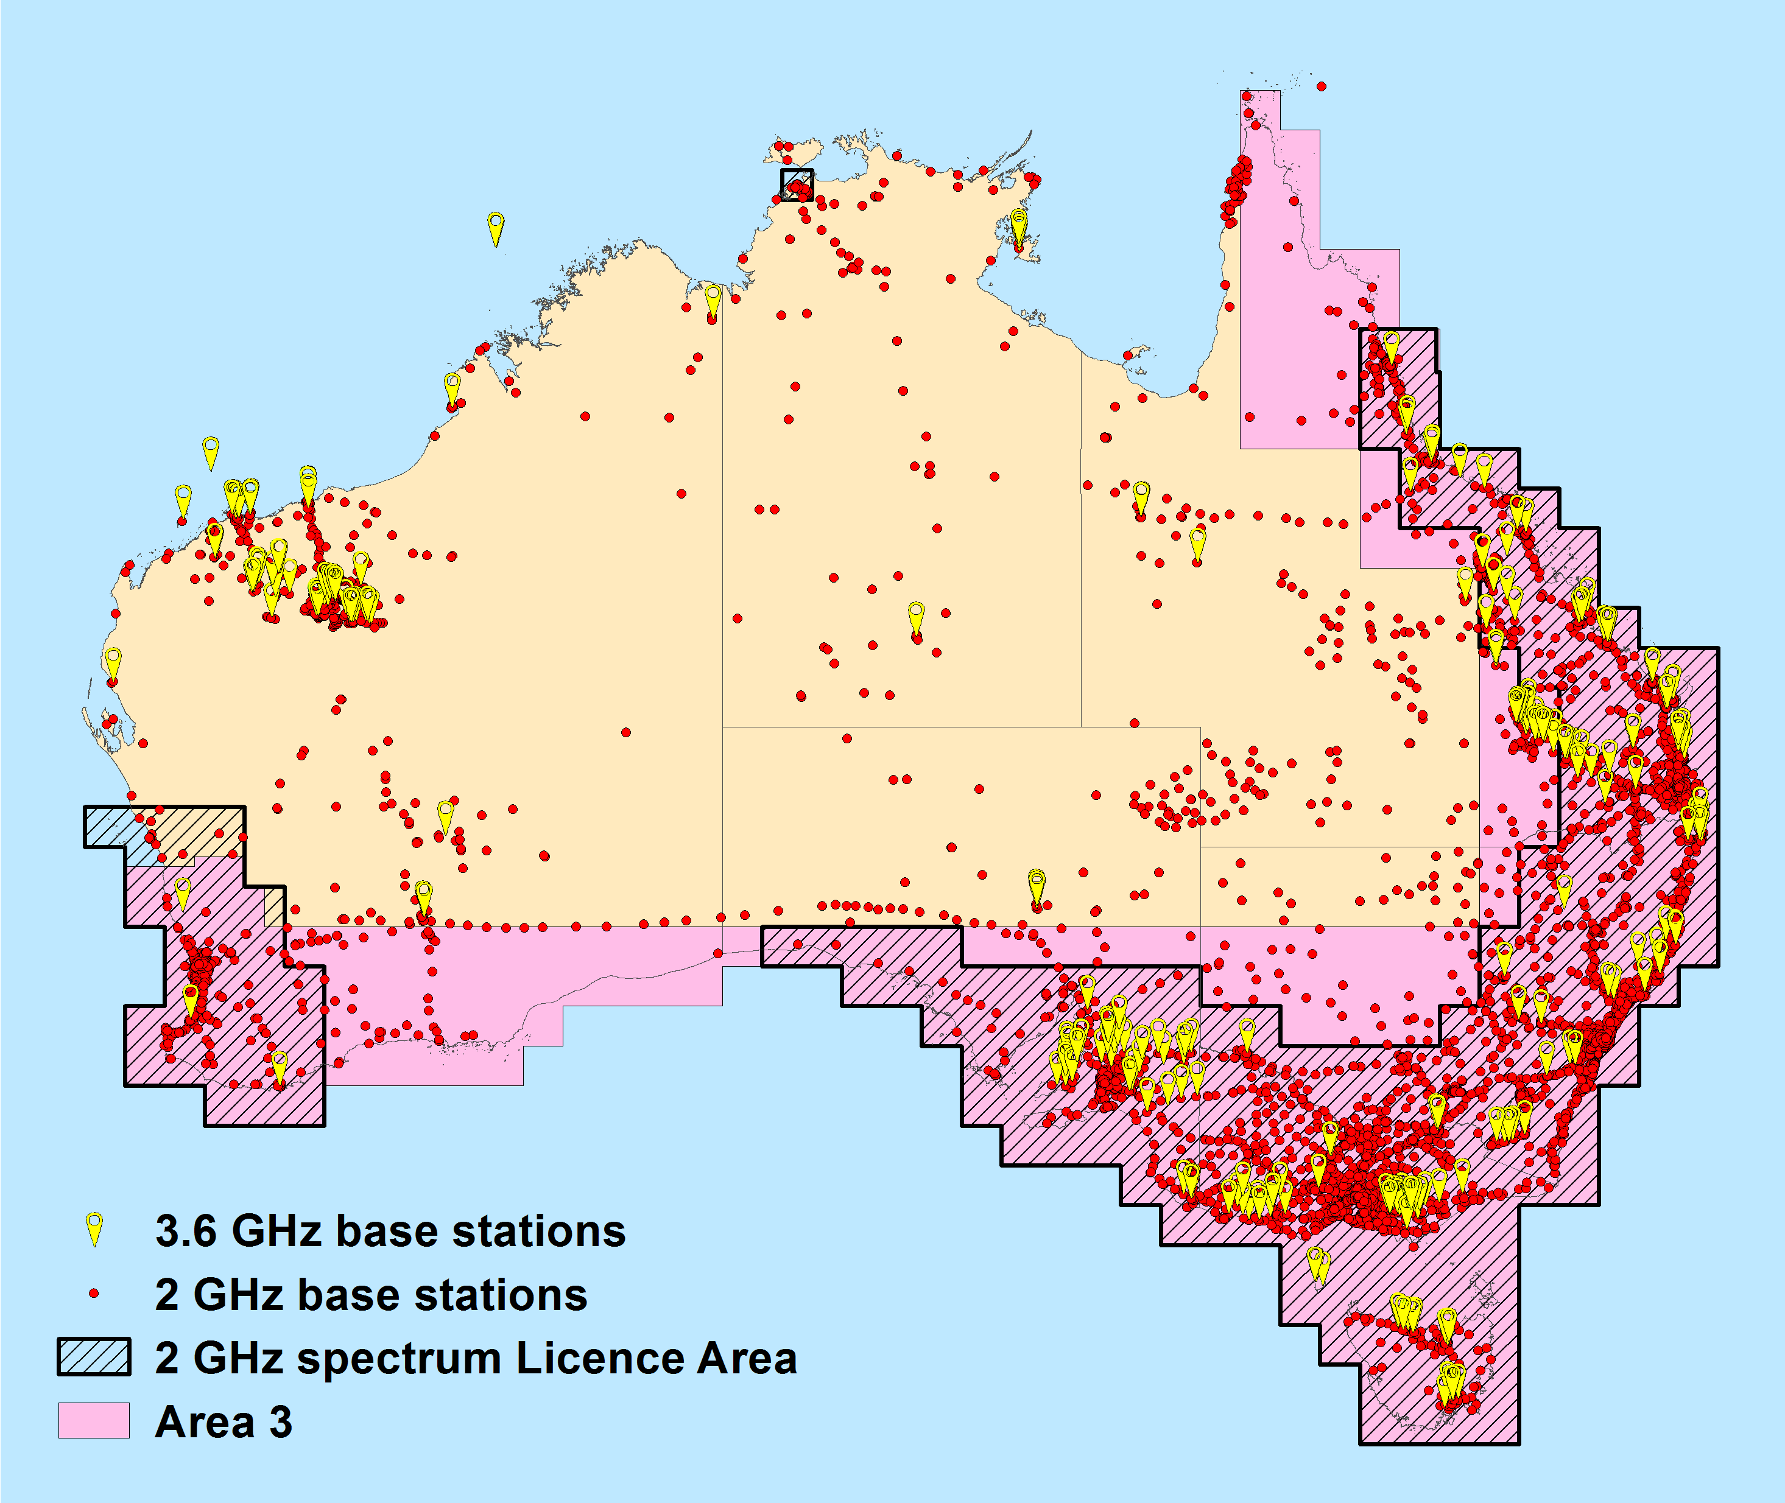
- Comparison of base station locations in the 2.3 GHz (subject to spectrum licensing Australia-wide) and 3.6 GHz bands (RRL extract, 1 May 2017)
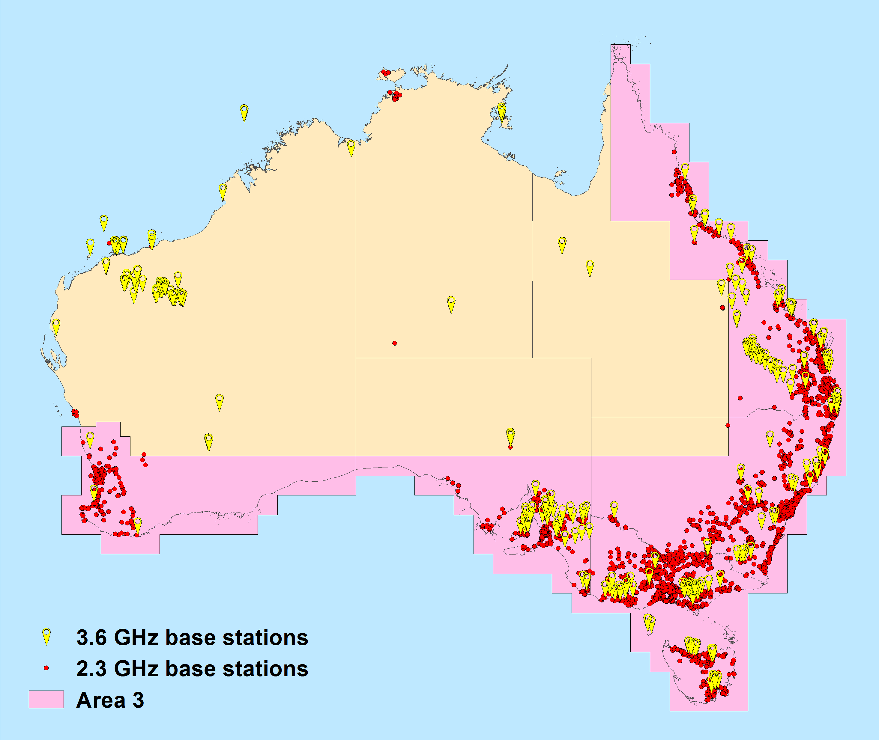
- Comparison of base station locations in the 2.5 GHz (subject to spectrum licensing Australia-wide) and 3.6 GHz bands as (RRL extract, 1 May 2017)
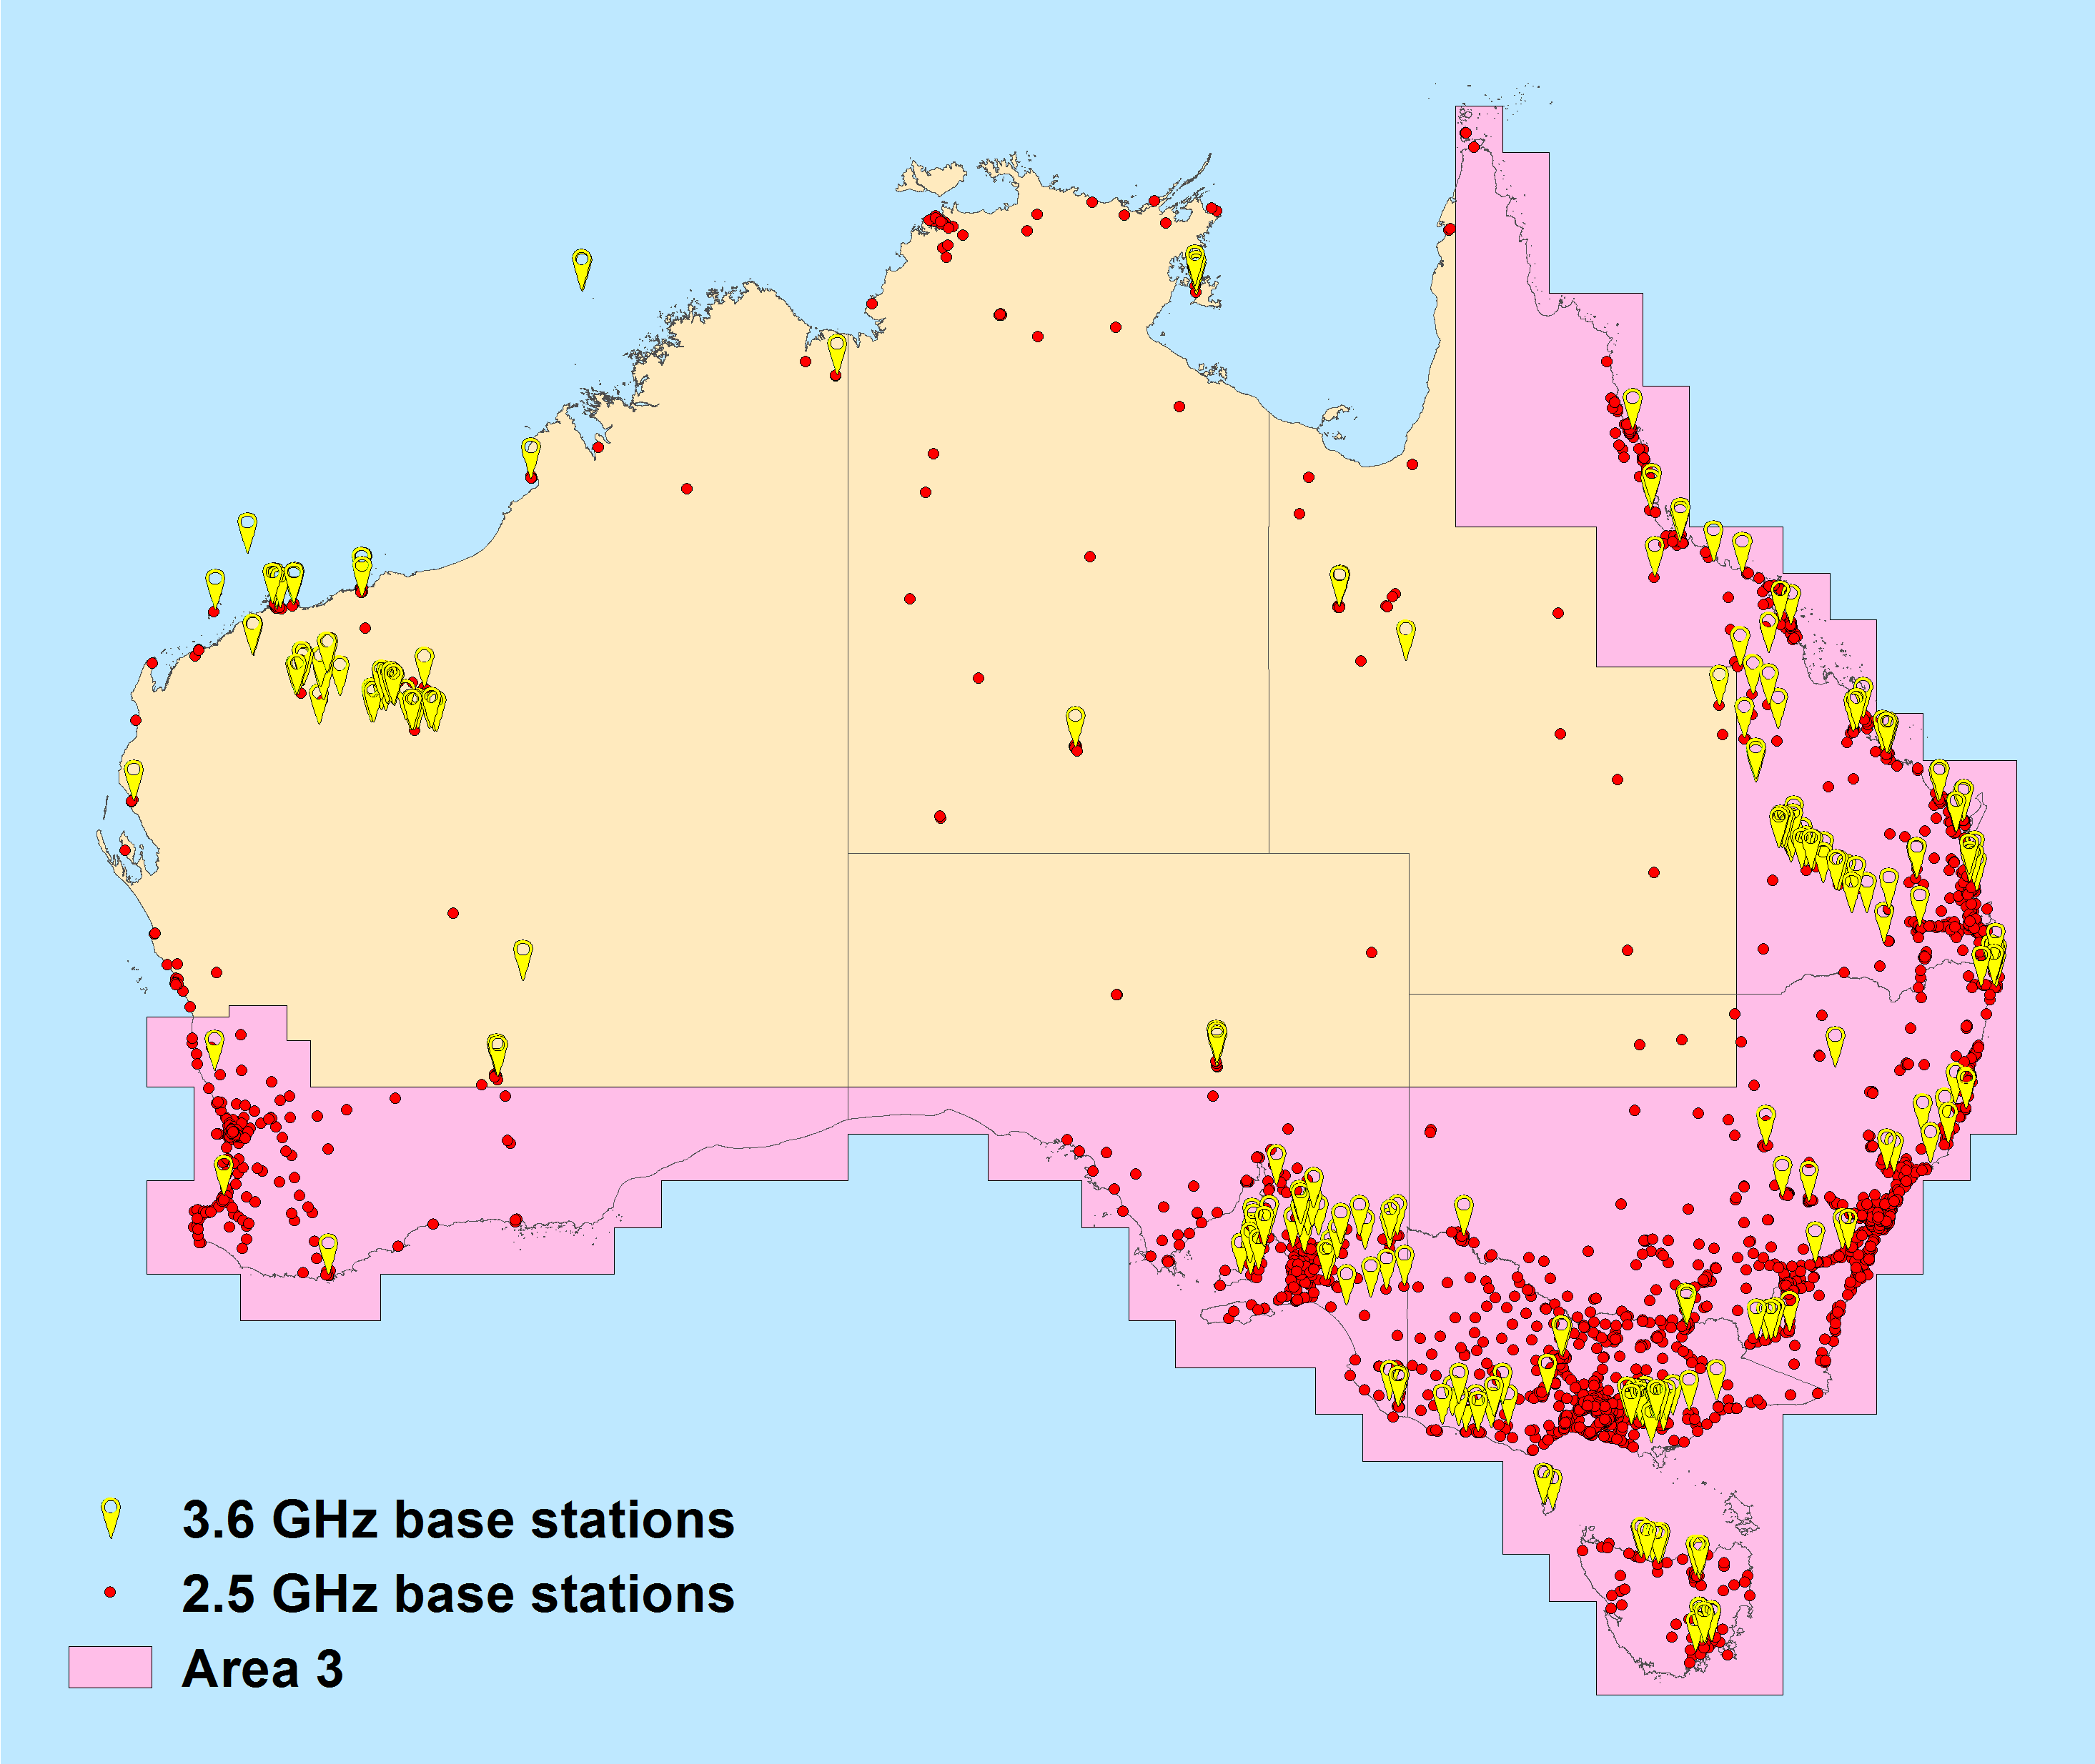

Process and effect of re-allocating spectrum for the issue of spectrum licences
If the ACMA decides the most appropriate re-farming option to implement in the 3.6 GHz band involves the issue of spectrum licences then, under section 153P of the Radiocommunications Act 1992, such a recommendation could be made to the minister after consulting with potentially affected apparatus licensees. After receiving the recommendation, the minister may, under section 153B of the Act make a written declaration that one or more specified parts of the spectrum be subject to re-allocation for the issue of spectrum licences. When this occurs, incumbent apparatus-licensed services that fall within the frequencies and areas to be re-allocated are given a specified period of time to relocate either in frequency or location and cease operation in the band. This is referred to as the ‘re-allocation period’. At the end of the re-allocation period, the incumbent apparatus licences are automatically cancelled (subsection 153H). Subsection 153B(4) of the Act specifies this period must start within 28 days after the declaration is made and run for a minimum of two years, though longer periods can (and have in the past) be defined.

Re-allocation period considerations for incumbents
If any part of the 3.6 GHz band is re-allocated for the issue of spectrum licences, a suitable re-allocation period would need to be determined for any affected apparatus licences. If desired, different periods can be defined for different frequency and geographical area combinations of the band.
Ideally, the re-allocation period should provide time for incumbent licensees to plan for and implement the relocation of their services or alternatively to cease their service altogether. The re-allocation period should also preferably provide time for incumbent apparatus licensees to either recoup investment costs and/or for equipment to naturally reach its end-of-service life, though this may not be achievable in all cases.
In addition, to assist and facilitate the change in arrangements in a band, the ACMA will typically identify or develop alternative options for the relocation/continuation of services for incumbent apparatus licensees where possible. Alternative options for affected services in the 3.6 GHz band are discussed in the Options for incumbent services section of this paper.
Some specific issues influence the ideal re-allocation period for different incumbent services in the 3.6 GHz band:
- FSS earth receive licences—advice from incumbent FSS earth receive licensees is that it would not be economical to relocate only those services in the 3.6 GHz band to another geographical area. Operationally, if geographical relocation of services in the 3.6 GHz band is required, it is likely that the relocation of all services operating in C-band (3400–7250 MHz) would be required. Suitable locations would also need to be identified for such a move. Submissions to the October 2016 discussion paper and subsequent discussions with licensees has indicated a timeframe of four to six years would be required to plan and implement such a move.
- Point-to-multipoint licences—arrangements for point-to-multipoint apparatus licensing in the 3.6 GHz band were put in place in 2009. A number of services in this band have only been operational for a relatively short period of time. Based on discussions with a few licensees, it is understood a minimum of two to three years is required to recoup investment costs. It is also desirable to run services past this point to make a profit. Considering this, a minimum of at least three years would be an appropriate re-allocation period for point-to-multipoint licences.
- Point-to-point licences—the ACMA has conducted numerous processes that have required point-to-point licences to relocate from bands. Typically, a two-year timeframe is all that has been required for this to occur. However, in the recent regional 1800 MHz band release, some links were identified as requiring up to three years, due to factors such as the large number of links being relocated and delays in obtaining access to sites. Given the small number of licences, it is expected that a reallocation period of two to three years would be sufficient for the relocation of any affected point-to-point licences.
Amateur licences—there are two amateur repeater licences on the register of radiocommunications licences (RRL). These services operate on a ‘no-interference and no-protection’ basis with primary services in the 3.6 GHz band. This ensures they would not hinder the rollout of new services under a spectrum licence during a re-allocation period. Given the small number of licences and their secondary nature in the band, it is considered sufficient to allow amateur services to continue to be licensed up to the end of any relocation period defined for the band.

Re-allocation period considerations for new users
Another important factor that needs to be considered when determining the length of the re-allocation period is any delay this period may cause in the spectrum reaching the highest value use in an area. This may be mitigated to a degree by the new spectrum licensee(s) negotiating with incumbent licensees, on a case-by-case basis, for a faster relocation from the band. The availability of alternative options for incumbent licensees may also assist with any such negotiations. Alternative options for incumbent licensees in the 3.6 GHz band are discussed in the Options for incumbent services section of this paper.
As described in the Assessment of areas with high demand for spectrum section, it is expected that interest will initially be in deploying wide-area mobile services in major cities. Analysis of the location of incumbent services in the 3.6 GHz band indicate the main incumbency issues that could affect the rollout of new services in metropolitan areas are:
- FSS earth receive licences located in Sydney and Perth
- Point-to-point licences in Brisbane
- Point-to-multipoint licences located nearby to metropolitan areas.
While these services may restrict the deployment of MBB services in some locations, new licensees could still commence planning and rolling out services in unaffected portions of the main metropolitan areas, when desired. If required, various mitigation techniques (such as lower radiated powers and antenna heights) may also be considered to support deploying services closer to incumbent services during the re-allocation period.
The main incumbency issues affecting the rollout of services outside metropolitan areas are existing point-to-point and point-to-multipoint licences, as well as a single FSS earth receive licence operated near Uralla.

Proposed length of a re-allocation period
A minimum re-allocation period of two years is specified under the Act. However, based on the preceding discussion, this length of time is unlikely to be appropriate in the event a decision is made to re-allocate the 3.6 GHz band for the issue of spectrum licences.
An extended re-allocation period (for example, one which matches the 15-year duration of the spectrum licence) is similarly considered unviable. This is because it would unreasonably limit the utility of the licence over most or all of its duration, as well as delay or prevent the provision of services in some areas. Further, an extended re-allocation period may limit any incentive for negotiations between incumbent services and new licensees for early migration to alternative arrangements or cessation of services.
Considering the relevant issues associated with incumbent and new services in the 3.6 GHz band, if part or all of the 3.6 GHz band is re-allocated for the issue of spectrum licences, the ACMA’s preliminary view is that a seven year re-allocation period for all affected services would be appropriate. This period is slightly longer than the minimum time deemed appropriate for the re-location of affected FSS earth receive licences, to provide additional margin for planning and unexpected delays.
A seven year re-allocation period also provides extra time in addition to the minimum migration timeframes indicated for affected point-to-point and point-to-multipoint licensees to run their services and either plan and implement a migration to another band or cease operation. Since point-to-point and point-to-multipoint licences are mostly located in regional and remote areas, the additional time to relocate is not expected to have a significant effect on the ability of a spectrum licensee to roll out services. This is because the initial focus for spectrum licensees is expected to be metropolitan areas.
- If any part of the 3.6 GHz band is re-allocated for the issue of spectrum licences is seven years a suitable re-allocation period? If not, what period of time would be appropriate?
- Should different re-allocation periods be considered for different areas? For example, should a longer period be considered for services outside Area 1?

Geographical boundary issues associated with area-wide licences
Numerous technical conditions are placed on area-wide licence products (including spectrum and area-wide apparatus licences) in order to define the licences, manage interference and provide certainty to licensees. This includes defining limits on the strength of emissions that can cross the geographical boundary of the licence. These limits provide a baseline for the level of interference an area-wide licensee can expect to encounter, which assists in planning network deployments. The exact emission level defined is a compromise between providing absolute certainty of protection from co-channel interference, which restricts deployments close to the licence boundary, and maximising the utility of the entire licence area (that is, increased flexibility of deployment), which requires greater planning, coordination and negotiation with adjacent-area licensees when deploying services.
A limit is typically defined somewhere in between these extremes, and there is a tendency to lean towards the certainty of providing protection to systems deployed by licensees. An effect of this limit is that it restricts the deployment of services on both sides of the geographical boundary. This occurs irrespective of whether apparatus and/or spectrum licensing applies. The areas where deployments are restricted are referred to as ‘dead zones’. Figure 5 shows the relative lack of mobile base station deployments in the ‘dead zone’ surrounding Melbourne’s 2.3 GHz spectrum licences.
The effect of dead zones can be mitigated via agreements between adjacent licensees to accept higher levels of emissions. However, the outcome of such negotiations cannot be guaranteed at the time of purchasing licences and can depend on numerous commercial and technical factors. For this reason, the preferred approach is to define appropriate geographical lots to minimise the effect of dead zones, as far as possible, from the outset. This is done, for example, by setting licence boundaries so that ‘dead zones’ do not fall across areas of significant population.
The location and extent of dead zones can also vary depending on the technology deployed. Dead zones are typically larger in size for TDD wide-beamwidth systems (the internationally harmonised system of choice for MBB in the 3.6 GHz band) than for FDD wide-beamwidth systems. This is due to the greater potential for high-site-to-high-site interference in TDD systems, as opposed to FDD systems, which typically result in a high-site-to-low-site interference scenario.
As an example of the effect of technology choice on dead zones, anecdotal evidence suggests that the current sizes of metropolitan areas in the 2.3 GHz and 3.4 GHz spectrum licence bands are not ideal to deploy dense wide-area TDD MBB services. These areas are comparable in size and location to the current definition of Area 1 (which only covers major metropolitan areas). The original metropolitan areas defined for these bands were optimised for a different type of use. However, over time the highest value use of the band has changed and the metropolitan areas defined, while still usable, are arguably too small for the TDD MBB services that are now prevalent.
Figure 5 shows devices registered under two spectrum licences in the 2.3 GHz band that are geographically adjacent and owned by different licensees. It also provides an indication of where significant population centres are via the inclusion of 2011 Urban Centre Localities (UCL). The figure shows the deployment of services becomes sparser within 20–30 km of either side of the licence’s geographical boundary even where there are significant population centres. To deploy close to the boundary, licensees must either negotiate access, or consider the use of techniques such as lowering antenna heights, lowering EIRPs, increasing antenna down tilt, making use of terrain shielding and only deploying sectors that face away from the boundary. However, these techniques are not always practical, typically increase deployment costs, reduce cell coverage area and may still not be enough to allow a proposed deployment to meet the relevant boundary emission limits. This suggests the metropolitan licence area boundary is in the wrong place, and the metropolitan licences themselves are too small to deal optimally with their current highest value use. (In the case of 2.3 GHz, the problem of the small size of the Melbourne spectrum licences was exacerbated by trading of licences that had occurred not long after the original licences were issued in the band—but before the change in highest value use—which resulted in some metropolitan licence areas becoming even smaller in size than when they were originally allocated.)
The problem of dead zones is relevant to the design of wide-area spectrum licences (fewer and larger licences mean fewer dead zones). Where nationwide lots are not appropriate, the effect of dead zones can be minimised by defining geographical areas that have boundaries, to the extent possible, in areas of low demand for access to spectrum. Based on the analysis in the Assessment of areas with high demand for spectrum section of this paper, these areas are most likely to occur in remote and some specific regional areas.
The problem of dead zones is also relevant to the valuation bidders assign to geographically adjacent spectrum licences, as the common owner of adjoining licences can merge their licences to remove the issue of dead zones. It may be harder to achieve commercial agreement where lots are not commonly owned, and the problem can be exacerbated if spectrum licences adjoin site-based apparatus licences. While commercial agreement may still be possible, the potential involvement of multiple separate apparatus licensees makes a negotiated outcome harder. These factors make it important that, from the outset, the entire area that is deemed to be optimal for spectrum licensing (or area-wide apparatus licensing) is identified and made available at the initial allocation of a band. This allows bidders to place a valuation on the acquisition of the same spectrum in adjacent areas. This last consideration suggests, for example, that it may be desirable to allocate spectrum licences simultaneously in metropolitan and adjacent regional markets, even if it is expected that introduction of wide-area services will occur first in the major cities.
- Base station locations of two licensees in the 2.3 GHz in and around Melbourne (RRL extract, 1 May 2017)
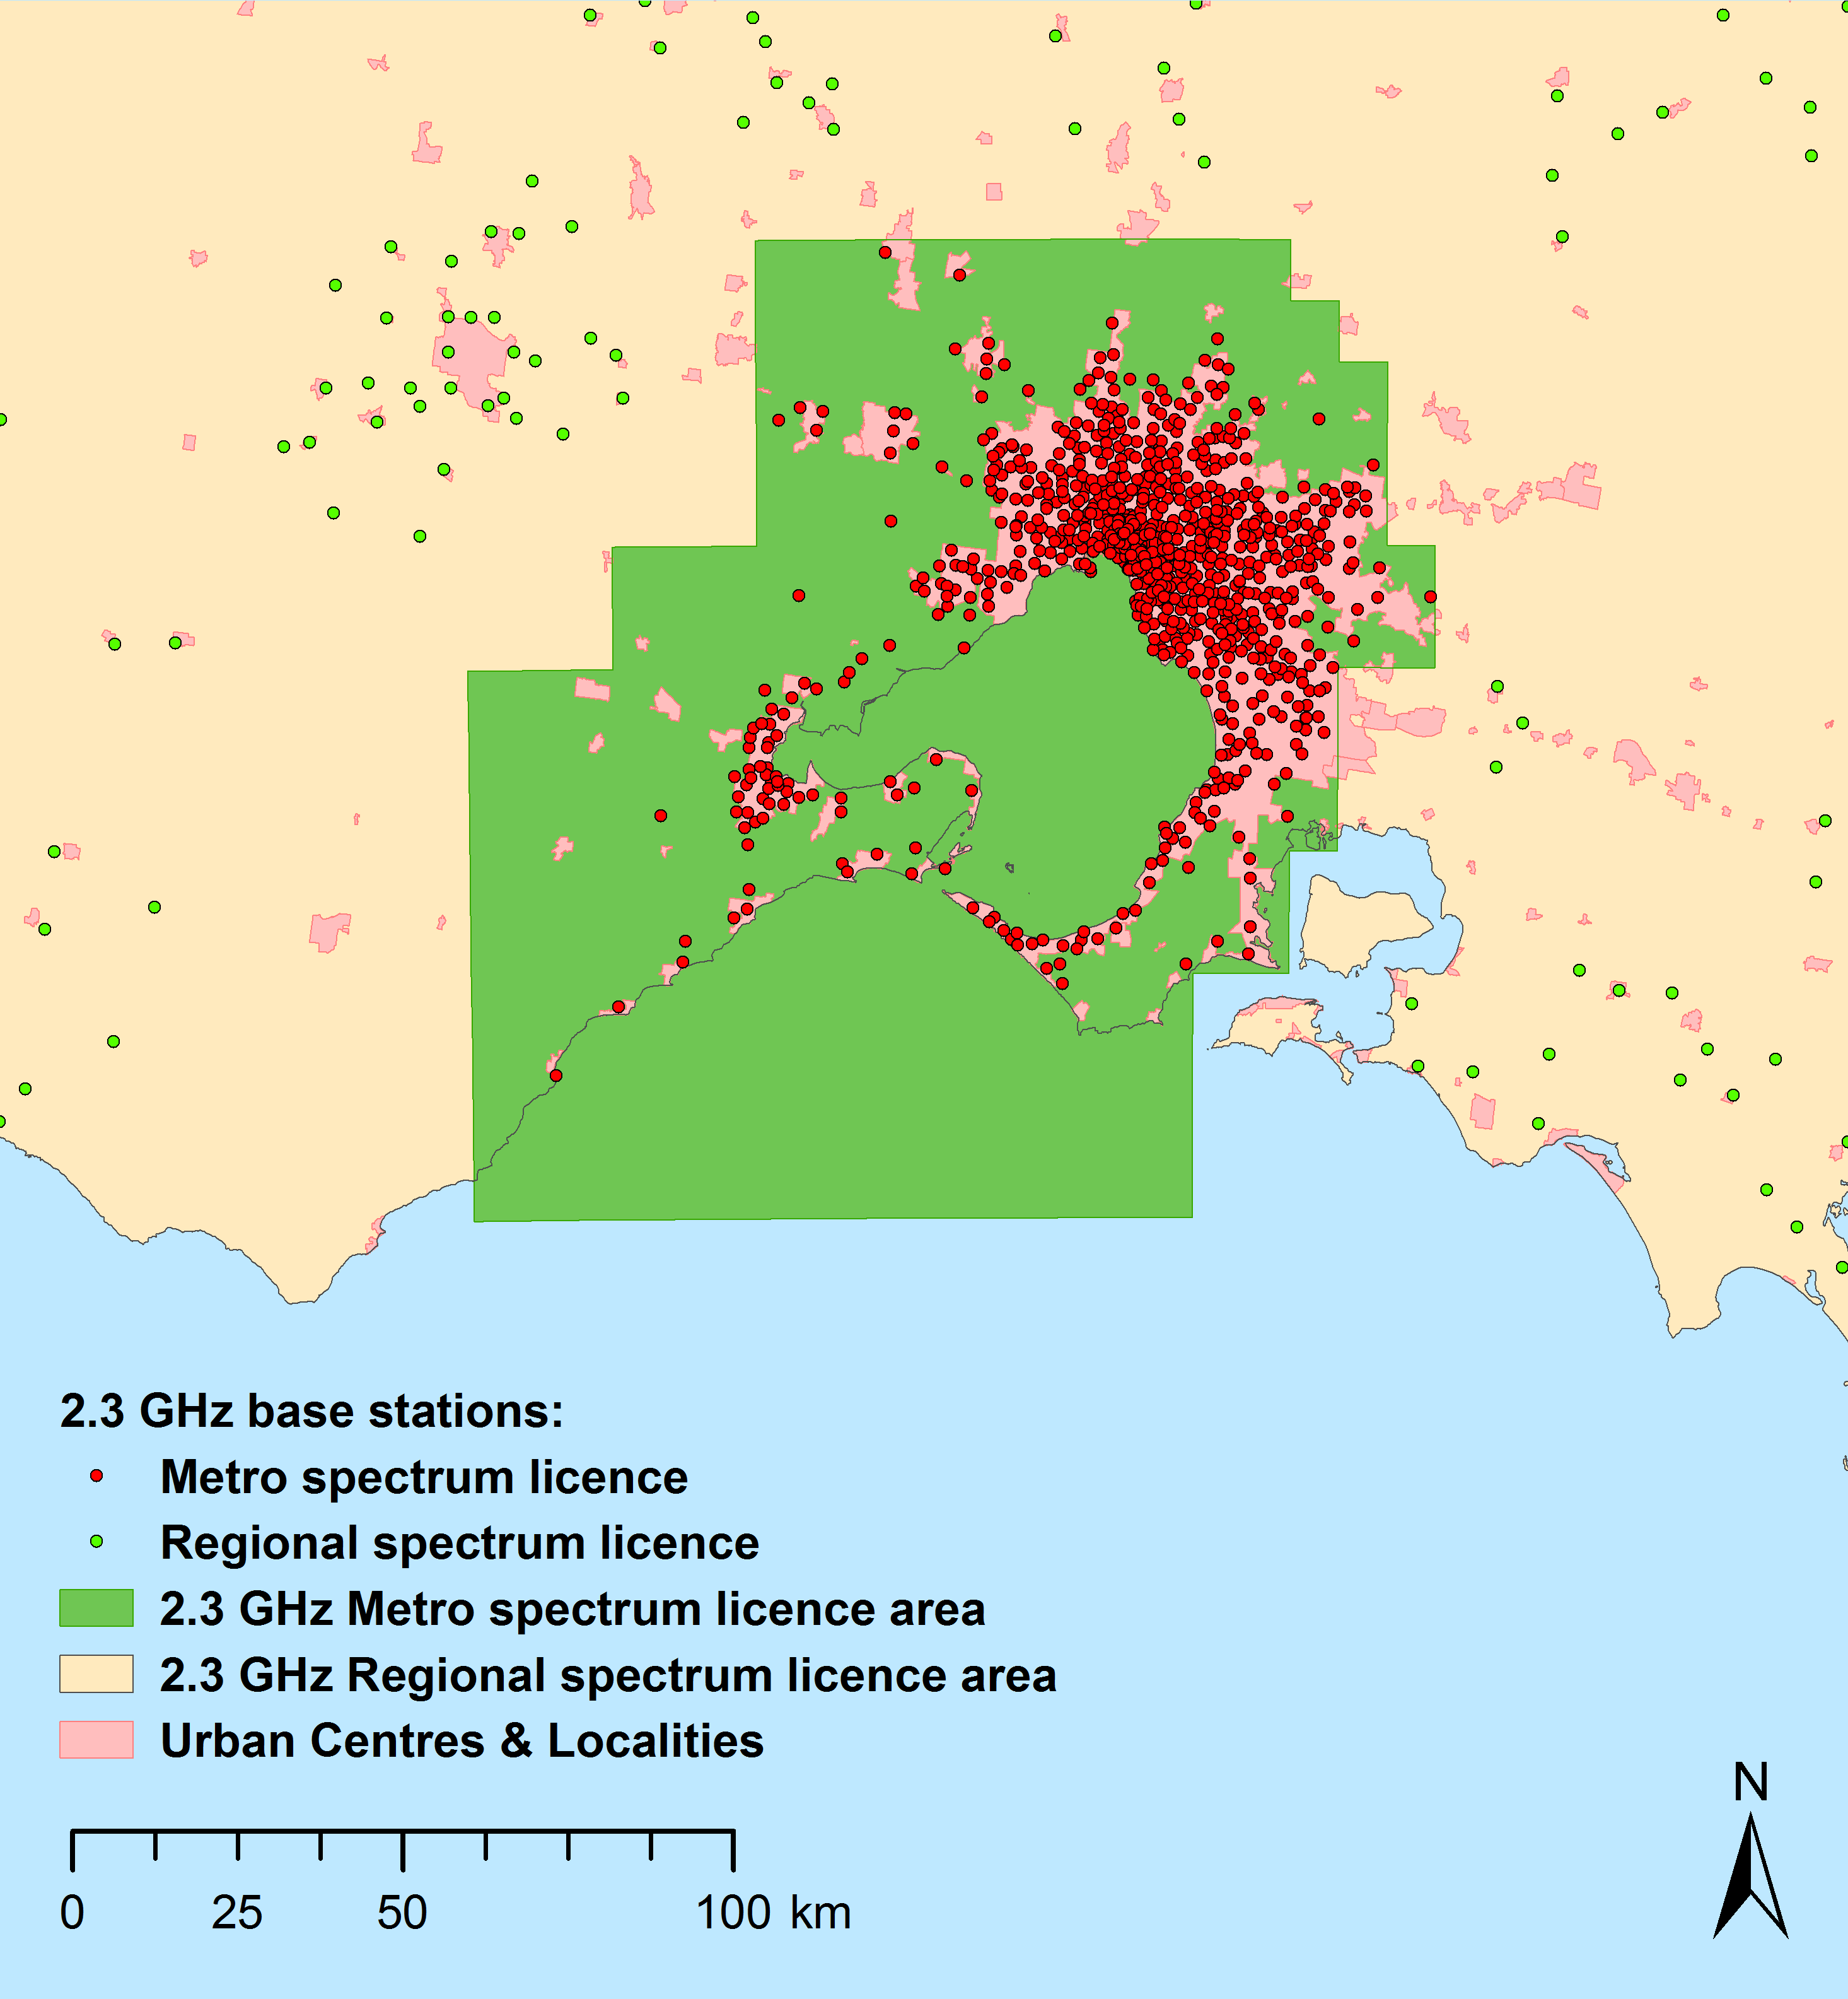
A further issue is that any geographical emission limit restriction would not apply to adjacent-area incumbent apparatus licences issued before any area-wide licensing arrangements are put in place. This means that there will be significant parts on either side of the geographical boundary of area-wide licences where the deployment of services will be restricted or not possible. Depending on the size and location of geographical boundaries, this could affect the ability of prospective licensees to use their licence area.
As an example, previous work by the ACMA to implement the October 2014 Ministerial Direction indicated that in order to minimise the potential for co-channel interference to services deployed in metro and metro fringe areas (Area 1), an area as large as Area 2 is required. This ensures a large-enough buffer to adjacent-area services to manage most co-channel interference issues. This suggests that the eventual clearance of some existing apparatus licences for a wide perimeter around areas of high demand will be necessary for the full exploitation by TDD MBB services within these areas.
As a result of the preceding discussion, the ACMA has taken into account the following three guidelines when assessing potential areas for replanning in the 3.6 GHz band:
- To the extent possible, define geographical borders in areas of low demand.
- To the extent possible, define geographical areas that are large enough to minimise potential co-channel interference issues when deploying services in areas of high demand.
Consider allocating spectrum licences simultaneously across the entire area in which spectrum licensing is considered the most appropriate longer term outcome, even if the rollout of services is likely to commence in some areas first.
- Are these guidelines appropriate? Why?
- Are there any other issues that affect the usability of an area-wide licence that should be taken into account when defining the licence area?

Options for incumbent services
There are a number of incumbent services operating in the 3.6 GHz band. Depending on the frequency range and geographical area considered, a varying number of incumbent licences may be affected by a decision to revise planning arrangements in the band. This number depends on the type of replanning arrangements implemented.
Under the options outlined in Chapter 5, the only time an incumbent service would be required to consider alternative options would be if they fall within the frequencies and areas re-allocated for the issue of spectrum licences (as defined in Options 3a–d). In this case, incumbent services would be required to either negotiate ongoing access to the spectrum or relocate in frequency or location within the defined ‘reallocation period’ as discussed in the Process and effect of re-allocating spectrum for the issue of spectrum licences section of this paper. If this is not possible, the service must cease operation by the end of the re-allocation period.
The October 2016 discussion paper provided information on existing arrangements and use of the 3.6 GHz band. For convenience, this has been updated and reproduced in Appendix 1 and is shown in Table 2 below. In summary, the existing allocations and use of the 3.6 GHz band are as follows:
- fixed services, including point-to-point and point-to-multipoint licences
- fixed-satellite service (FSS) earth receive licences
- amateur services
- radiolocation services
- low interference potential devices operating under a class licence
television receive-only (TVRO) systems.
- Number of incumbent licences in different areas across the 3.6 GHz band (RRL extract, 1 May 2017)
Licence type | Number of incumbent licences
 | Area 1 | Area 2 | Area 3 | Australia-wide
Point-to-multipoint | 0 | 122 | 293 | 413
Point-to-point | 2 | 14 | 47 | 47
Earth station | 15 | 15 | 17 | 19
Amateur repeater | 2 | 2 | 2 | 2
Total | 19 | 153 | 359 | 481

Alternative options for each of these services are discussed below. Consideration of the timeframes to implement any changes and the costs involved are provided in the Process and effect of re-allocating spectrum for the issue of spectrum licences section of this paper and the HVU paper, respectively.

Fixed service—point-to-point licences
There are only a small number of point-to-point licences in the 3.6 GHz band. Most of these are located in regional areas of Australia. There are a number of alternative delivery options available for this service. These include retuning to a different channel in the 3.8 GHz fixed-link band, relocating to another fixed-link band (as defined in RALI FX3), or investigating fixed-line options.
- If point-to-point licences are affected by replanning activities in the 3.6 GHz band, are the options identified for point-to-point licences suitable? Are there any alternative options that should be considered?

Fixed service—point-to-multipoint licences
Submissions to the October 2016 discussion paper confirmed there are a range of point-to-multipoint licensees currently using the 3.6 GHz band to provide wireless broadband services to various businesses and communities. Some respondents considered these services to be particularly important in areas where other broadband options are limited or unsuitable. There was also strong interest in the further growth of business by expanding the delivery of services into new areas.
Alternative options currently available for incumbent point-to-multipoint licensees include:
- Consider alternative bands, such as:
- 1800 MHz band—Frequency assignment arrangements are in place for Public Telecommunication Service (PTS) apparatus licences in remote areas. 2 x 10 MHz spectrum limits apply and proposed new services must coordinate with existing licences.
- 2 GHz band—Frequency assignment arrangements are in place for PTS apparatus licences in regional and remote areas. 2 x 10 MHz spectrum limits apply and proposed new services must coordinate with existing licences. The band is currently heavily used in regional areas.
- 2.4 GHz and 5 GHz bands—Radiocommunications (Low Interference Potential Devices) Class Licence 2015 (LIPD class licence) defines arrangements for wireless broadband services Australia-wide. Some restrictions on use apply; for example, radiated power limits. Operation is on a no-interference and no-protection basis.
- Negotiate access to spectrum held by spectrum licensees in the area the service is to operate.
Consider moving to fixed-line options (for example, fibre) where viable.
Submissions from WISPs to the October 2016 discussion paper acknowledged the availability and value of class-licensed spectrum as an option to deploy wireless broadband services like Wi-Fi. However, this is increasingly becoming an unviable option to deploy carrier-grade services in many locations. This is due to increasing use of the spectrum and the lack of protection from interference for services that operate under the LIPD class licence. Given there are no ongoing licence fees for use of class-licensed bands, they are likely to be used where they are a viable option. However, where they are not considered suitable, apparatus licence options are expected to be preferred.
The current apparatus licence options available for wireless broadband operators, particularly in regional areas, are limited. In cases where class-licensed bands are not appropriate and apparatus licences are not available, the only remaining spectrum option is to negotiate access to any spectrum licence space in the area. In addition, while fixed-line options are theoretically available, they may not be practical in many cases due to cost factors or if communication is required with mobile or nomadic devices.
In order to enable affected point-to-multipoint licences to continue operating, additional spectrum options would need to be identified. A number of bands have been identified internationally for both fixed and mobile wireless broadband services that could be considered. However, given international interest and developments within these bands (particularly for the deployment of wide-area mobile networks), there is a strong likelihood that they, too, will be subject to a change in highest value use in the near future. The question then is whether a band can be identified where a review of arrangements for the band is unlikely to occur for as long a timeframe as possible.
A significant factor determining the suitability of, and relative interest in, a band is the level of international harmonisation and resulting economies of scale for equipment. Wireless broadband operators currently have the choice to take advantage of global markets for fixed or mobile equipment.
For those wireless broadband operators deploying equipment optimised for mobile use, the overlap in bands of interest with other mobile operators is clear.
For those wireless broadband operators deploying equipment optimised for fixed use, submissions to the October 2016 discussion paper indicated that the main bands of interest below 6 GHz where equipment is available are the 3300–3900 MHz and 5 GHz (class-licensed) bands. While it is acknowledged that the 5 GHz class-licensed bands are always an option available to operators, it is clear they are not suitable for the delivery of a carrier-grade service in many cases. This leaves the 3300–3900 MHz as the next viable band. However, as discussed in the October 2016 discussion paper and as evident by the current review of arrangements for the 3.6 GHz band, this broader frequency range is being targeted internationally as a pioneer band for 5G. So there is an increased likelihood that the highest value use of the broader 3300–3900 MHz range may change in the medium term. This would require the ACMA to undertake a detailed investigation of the band, including an assessment of its highest value use along with potentially reviewing planning arrangements.
The ACMA’s analysis of bands below 6 GHz indicates that spectrum in the 5600–5650 MHz (5.6 GHz) band appears to be the best candidate in Australia for the implementation of site-based apparatus licence arrangements. The background and reasoning for this are discussed further below and in Appendix 3. It is acknowledged that any apparatus licence arrangements developed for the 5.6 GHz band may also come under review at some future point. This is because of the rate of change and innovation in global spectrum use generally, and the uncertainties inherent in predicting future changes in highest value use of bands. But based on its current knowledge, the ACMA expects that the greatest certainty and longest timeframe before this occurs can be provided in the 5.6 GHz band as compared to other candidate bands.
Use of the 5.6 GHz band for wireless broadband services
The 5600–5650 MHz (5.6 GHz) band has been made available in most countries for use by wireless broadband services, including Wi-Fi, on an opportunistic basis involving sharing with metrological radiodetermination services (that is, weather radars). This means there are internationally harmonised technology standards in place and a viable equipment ecosystem for the band. In Australia, the Bureau of Meteorology (BoM) is licensed to operate radars in the band, but no arrangements have been put in place for wireless broadband services and the band is not currently included in the LIPD Class Licence. Details on international and domestic use of the 5.6 GHz band are provided in Appendix 3 considerations.
The ACMA has identified an opportunity to use the 5.6 GHz band to support the deployment of wireless broadband services while continuing to provide for use of the band by radars. Any such arrangements could be used to provide additional options for new wireless broadband services as well as any point-to-multipoint licences affected by replanning of the 3.6 GHz band. There are two ways this could be realised:
- Existing class licence arrangements could be extended to cover the 5.6 GHz band. This would enable anyone to access the band and take advantage of the additional capacity and larger operational bandwidths with no annual licence fees payable. However, while access to additional class-licensed spectrum would help to improve services provided, devices operated under a class licence would still need to accept interference from other radiocommunications devices operating in accordance with their licence. As discussed previously, such arrangements may not always provide sufficient certainty for a wireless broadband operator to provide a carrier-grade service.
Site-based apparatus licensing arrangements could be developed for access to the band. These would be similar to what is currently in place for point-to-multipoint licences in the 3.6 GHz band. Such arrangements would ensure protection of licenced BoM radars as well as provide sufficient protection to wireless broadband services to enable them to deliver a carrier-grade service.
In the event that replanning options are adopted that remove availability of the 3.6 GHz band for apparatus-licensed point-to-multipoint use, the ACMA proposes that suitable arrangements be developed in the 5.6 GHz band to make it available for site-based point-to-multipoint apparatus licensing. This would provide spectrum for new licensees as well as an alternative for licensees displaced by any replanning options that reduce the amount of spectrum available for point-to-multipoint licensees in the 3.6 GHz band.
This idea is discussed further in Appendix 3.
- Is the 5.6 GHz band a viable option for wireless broadband systems?
- Under what circumstances should apparatus- and class-licensed arrangements be considered for the 5.6 GHz band?
- If apparatus licensing arrangements are developed for wireless broadband systems in the 5.6 GHz band, are the notional arrangements proposed in Appendix 3 suitable?
- If point-to-multipoint licences are affected by replanning activities in the 3.6 GHz band, are the alternative options identified suitable? Are there any alternative options that should be considered?
FSS Gateway earth stations
The Australian Radiofrequency Spectrum Plan 2017 (ARSP) specifies that the FSS is a primary service in the 3600–4200 MHz band and is a secondary service in the 3400–3600 MHz band. This means in the 3400–3600 MHz band, the FSS operates on a ‘no-interference and no-protection’ basis with primary fixed, mobile and radiolocation services.
Traditionally, a majority of FSS use has been in the 3700–4200 MHz portion of the broader 3400–4200 MHz band, commonly referred to as the ‘Earth receive’ segment of C-band. In combination with the embargo in metropolitan areas that has been in place since 2006, this has resulted in relatively few licensed FSS earth stations in the 3.6 GHz band. Of particular note are the services located in the Belrose/Oxford Falls area in Sydney, as well as Landsdale and Lockridge in Perth. There is also a facility near Uralla in regional New South Wales.
The frequency on which an FSS earth station operates is dictated by the satellite it communicates with. This is determined by a combination of the intended use of the satellite system and international coordination processes. Re-tuning to different frequencies is unlikely to be a practical option in most instances. As such, in the event FSS earth stations are affected by replanning in the 3.6 GHz band, the only alternative option available for ongoing access to the band would be geographical relocation. A suitable period of time would be required to facilitate planning and implementing such a move. This is considered in the Process and effect of re-allocating spectrum for the issue of spectrum licences section of this paper.
For services on the west coast of Australia, it is proposed that affected FSS earth stations relocate to the general area around Mingenew. This area is defined in Embargo 49. It was created as an earth station protection zone and was chosen to provide long-term certainty for space and satellite operations, while minimising the probability of spectrum denial to terrestrial services in populated areas.
For services on the east coast of Australia, there is currently no equivalent earth station protection zone. In the event FSS earth stations are affected by replanning activities in the 3.6 GHz band, it is proposed that such an area be defined for the east coast. The identification of any such area would use similar criteria as that used for the west coast zone. The ACMA most recently considered this issue in the 2011 Earth Station Siting discussion paper.
While it is not the intention of this paper to propose a specific area, the ACMA is interested in pursuing this concept in partnership with industry. If required, more detailed work on the issue would occur following a decision on which replanning option will be implemented in the 3.6 GHz band. Details on the preliminary criteria the ACMA propose to consider for the identification of an east coast protection zone and example application of some of these criteria against specific locations is provided Appendix 5.
- The ACMA seeks comment on the suitability of the current west coast earth station protection zone located near Mingenew, WA, for long-term satellite service use. Are the current regulatory arrangements effective?
- In the event FSS earth stations are affected by replanning activities in the 3.6 GHz band, the ACMA seeks comment on:
  - Any issues surrounding the development and establishment of an east coast earth station protection zone; particularly on what factors would be necessary to make it an attractive option for earth station operations.
  - Whether there are any views on potential candidate locations to consider.
  - Whether there should there be more than one earth station protection zone on the east and west coasts of Australia.
  - If the identification of a central Australia earth station zone should be considered.
Amateur service
The ARSP specifies that amateur services are a secondary service in the 3300–3600 MHz band and operate on a secondary basis. This means amateur services in the band operate on a ‘no-interference and no-protection’ basis with primary fixed, mobile and radiolocation services.
There are two licensed amateur repeater services operating in the 3575–3600 MHz band. These are located in Sydney and Adelaide. The Australian Amateur Band Plan (the amateur band plan) indicates that the 3580–3600 MHz band is identified for wideband amateur television (ATV) operations. The amateur band plan also indicates alternative ATV frequency options are available in the 3300–3320 MHz and 3360–3380 MHz bands. These frequencies could be used to support the relocation of amateur services if required.
Radiolocation service
The ARSP specifies radiolocation services are a primary service in the 3400–3600 MHz band and operate on a primary basis. This service is subject to footnote AUS101A, which states the service is to be used principally for the purposes of defence and national security. There are currently no radiolocation licences issued in the 3575–3600 MHz band. The ACMA will continue to liaise with the Department of Defence on any future requirements in the 3575–3600 MHz band.
Class-licensed devices
The LIPD Class Licence defines arrangements for building material analysis and ultra-wideband transmitters to operate within (and beyond) the 3.6 GHz band. Radiocommunications devices operating under this class licence must not cause interference to or claim protection from interference caused by other radiocommunications devices. The ACMA believes that no change would be required to these arrangements in the event the 3.6 GHz band is replanned.
TVRO systems
Television receive-only (TVRO) systems operate in the broader 3400–4200 MHz band on an opportunistic basis. They are not afforded protection from interference in Australia. In the event interference occurs, the owner of the TVRO system would need to consider mitigation techniques such as RF filtering and/or site shielding where viable.
- Are the approaches for amateurs, radiolocation services, class-licensed devices and TVRO systems suitable?
- Are there any other options for incumbent services, not identified in this paper, which should be considered?

Sharing arrangements
One option to support the ongoing use of the 3.6 GHz band by new and incumbent services is to develop sharing arrangements. Sharing arrangements can take many different forms. At their most basic level, such arrangements could support all services or just allow some specified services or licences to continue operating and even expand operations in the 3.6 GHz band after a change in arrangements has occurred. Sharing can be on a primary, secondary or best-efforts basis, or a multi-tiered access sharing arrangement could be developed. These approaches can be summarised as follows:
- If service types or specified licence(s) continue to operate on a primary basis, any new services would need to ensure they do not cause unacceptable interference. This would allow incumbent licensees to continue operating in the 3.6 GHz band unaffected by any re-farming activities.
- If service types or specified licence(s) continue to operate on a secondary basis, they must not cause unacceptable interference to primary services. This would allow incumbent licensees to continue operating in the band, but only until a primary user deployed services in the same or nearby area.
If services operate on a best-efforts interference management approach, all users of the spectrum would be required to take reasonable measures to manage interference where practical. However, no guarantee of interference-free operation would be made. This is similar to how class licence arrangements work.
In a multi-tiered approach, primary, secondary, tertiary and potentially more levels are defined for different services types or specified licences. This approach supports the opportunistic use of spectrum by services operating in lower tiers. However, such use would be on a ‘no interference and no protection’ basis.
Other alternatives for sharing include providing adequate geographical separation between services. For example, this could allow an incumbent service to continue operating in the 3.6 GHz band by ensuring sufficient geographical separation with new services, or by moving it to a different location. The latter may not be a practical solution in many cases, particularly for those services that are area/location-specific. Geographical relocation of services is discussed as a potential option for FSS earth stations in the Options for incumbent services section of this paper.

International implementation
In considering sharing arrangements that may be available, the ACMA has investigated what has been implemented, or proposed for implementation, in the United States and Europe.
In the US, the Federal Communications Commission (FCC) has developed arrangements for wireless broadband services in the 3550–3700 MHz band. The rules governing what is termed the ‘Citizens Broadband Radio Service’ (CBRS) in the 3550–3700 MHz band are found in Part 96 of the Commission’s rules. These arrangements define a three-tiered spectrum authorisation framework to support shared access to the 3550–3700 MHz band by a variety of services, including radiolocation, FSS and wireless broadband systems:
- Tier 1—Incumbent Users—this includes registered earth stations (in both the 3600–3700 MHz and 3700–4200 MHz bands), Government users (Government exclusion zone details) and grandfathered wireless broadband services. Incumbent users are to be protected from harmful interference from systems operating in tiers 2 and 3.
- Tier 2—Priority Access Licences (PAL)—area-wide licences are auctioned covering a single census tract and 10 MHz of spectrum in the 3550–3650 MHz band. Licences can be issued for two three-year periods (three years with an option for another three). Up to seven PALs may be assigned in any given census tract, with a maximum four 10 MHz channels going to any single applicant. PALs are provided protection from systems operating in tier 3.
- Tier 3—General Authorised Access (GAA)—GAA provides access to the 3550–3700 MHz band on a shared basis, provided operators register and coordinate spectrum use with a Spectrum Access System (SAS). GAA systems can opportunistically access spectrum in the 3550–3700 MHz band that is not being used by tier 1 or 2 licensees. However, such operation is on a ‘no-interference and no-protection’ basis.
The pros and cons of these arrangements are provided in Table 3below.
- Summary of pros and cons of US sharing arrangements developed for the 3550–3700 MHz band
Pros | Cons
- Incumbent FSS and radiolocation and grandfathered wireless broadband services can continue operating in the 3550–3700 MHz band.  - Grandfathered wireless broadband services can continue operating in the 3550–3700 MHz band and receive protection from CBRS users until 17 April 2020.  - New wireless broadband services can use the spectrum in those areas and during those times it is not being used by tier 1 and, where relevant, tier 2 users. | - There are significant areas either not available or with limited availability for use by new services due to incumbent licensees.  - A six-year licence tenure for tier 2 users is not optimal for investment in and deployment of wide-area MBB networks.  - Given the uncertainty associated with tier 3 use, GAA licensees may not be able to guarantee the delivery of carrier-grade services. This would also apply to tier 2 users operating within ‘Government Exclusion Zones’.

The Electronic Communications Committee (ECC) in Europe has also been investigating the implementation of what it refers to as Licensed Share Access (LSA). LSA is defined by the Radio Spectrum Policy Group (RSPG) as:
A regulatory approach aiming to facilitate the introduction of radiocommunication systems operated by a limited number of licensees under an individual licensing regime in a frequency band already assigned or expected to be assigned to one or more incumbent users. Under the Licensed Shared Access (LSA) approach, the additional users are authorised to use the spectrum (or part of the spectrum) in accordance with sharing rules included in their rights of use of spectrum, thereby allowing all the authorized users, including incumbents, to provide a certain Quality of Service (QoS).
ECC Report 205 provides a detailed description of the LSA concept. For the most part, LSA focuses on defining arrangements that ensure incumbent services can continue operating in a band after the introduction of a new services (for example, wireless broadband services). Much of the practical implementation work to date in Europe has focused on the 2.3–2.4 GHz band and sharing with incumbent government, television outside broadcast (TOB) and amateur spectrum users. ECC Decision 14(02) defines the European harmonised arrangements for the 2.3–2.4 GHz band.

Domestic consideration
Sharing arrangements developed in the US for the 3550–3700 MHz band and the LSA arrangements developed in Europe have been designed to support the ongoing use of the band by incumbent services. The effects of implementing such arrangements could include restrictions on the deployment of new services, a devaluing of the band by operators wishing to deploy area-wide networks and, in some cases, uncertainty about how long a service could opportunistically access the spectrum before it is required to cease operation.
The replanning options outlined in Chapter 5 consider various opportunities to support the ongoing operation of some or all incumbent services in the 3.6 GHz band, including requiring new services to manage interference with incumbent services, opportunistic access to spectrum by specific service types, as well as options for the geographical relocation of incumbent FSS earth stations to areas of low demand. Ultimately, the need for developing sharing arrangements depends on a number of issues including the frequencies and areas any replanning occurs in and the alternative options available for incumbent services.
Based on submissions to the October 2016 discussion paper, key issues for incumbent and prospective new licensees are certainty regarding licence tenure, interference management (to ensure quality-of-service targets can be achieved) and the ability to expand and/or deploy new services in specific areas when required. Different sharing arrangements address these issues to varying degrees (or not at all).
Incumbent 3.6 GHz band licensees have suggested various sharing arrangements as a potential way to allow wide-area fixed and mobile broadband deployments in the 3.6 GHz band, while simultaneously allowing incumbent site-based point-to-multipoint users to continue to operate and new users to gain access to the band. These options include:
- A use-it-or-share-it approach, where incumbent operators can continue to operate (and expand services) until the ‘main’ spectrum user wishes to deploy in that area. The risk with this option is there is no guarantee on how long an operator could make use of the spectrum before they are required to cease operation. This could affect whether or not operators invest in and take advantage of any such arrangements. This approach is considered in the discussion for Option 2b at Appendix 2.
Setting aside 25 MHz of spectrum for continued site-based apparatus use. This approach is considered in the discussion for Option 4aat Appendix 2.
Given the key issues raised in response to the October 2016 discussion paper, a best-efforts interference management approach (that is, class licensing arrangements) in the 3.6 GHz band is not considered further in this paper. This is because this approach is not conducive to the deployment of carrier-grade services. In addition, there are already such arrangements in place for wireless broadband services in the 2.4 GHz and 5 GHz bands if operators considered such arrangements as suitable for their means.
The other sharing options described above are considered for implementation under the different replanning options proposed in this paper. These are discussed on a case-by-case basis in the Assessment of options section of this paper.
- Should any of the sharing arrangements discussed in this section be considered for implementation in the 3.6 GHz band? Why or why not?
- Are there any other sharing arrangements that should be considered?

5 Replanning options
When developing potential replanning options for the 3.6 GHz band, the ACMA has considered the following issues:
- How much, if any, of the 3.6 GHz band should be considered for replanning? Should different amounts of spectrum be considered for replanning in different geographical areas?
- What, if any, geographic areas should be considered for replanning?
- What alternative options exist for incumbent services? Are there viable sharing options for new services with incumbent services?
These issues were presented for comment in the October 2016 discussion paper along with a number of preliminary options.
After reviewing the information provided in submissions to the October 2016 discussion paper, the ACMA has identified the following potential replanning options for the 3.6 GHz band. Various mitigations for incumbent licensees affected by these options can be implemented as part of these options.
To provide clarity in the proceeding discussion, the proposed definitions of Area 1, Area 2 and Area 3 referred to in this section are provided at Appendix 6 and depicted in Figure 6. The exact definition of these areas is open for discussion as part of this paper.
- Pictorial depictions of Area 1, Area 2 and Area 3 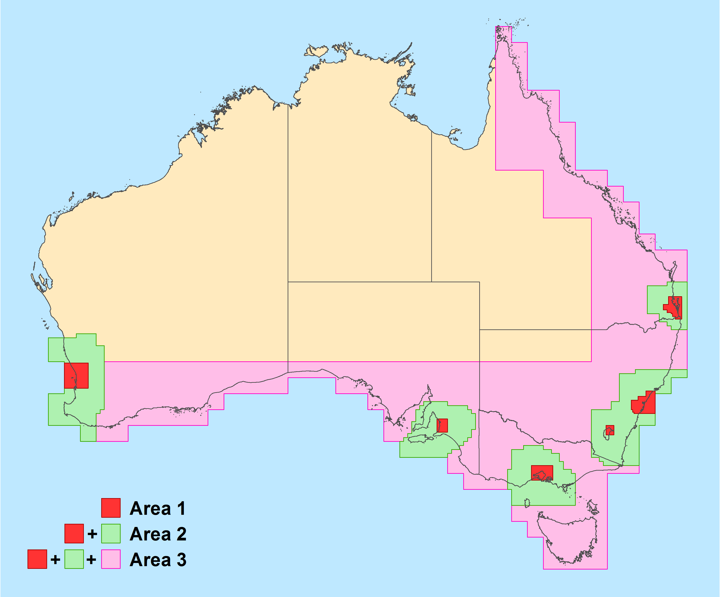
The options for replanning the 3.6 GHz band are as follows:
- Option 1—No change—no change to the current allocation or licensing arrangements in the band. Site-based point-to-multipoint licensing arrangements in the 3.6 GHz band currently in place for regional and remote areas would be retained. The issue of new apparatus licences in Area 1 (metropolitan areas) would continue to be restricted.
- Option 2—Expand apparatus licence arrangements into Area 1 (metropolitan areas):
- Option 2a—Site-based apparatus licensing in Area 1—site-based point-to-multipoint apparatus licensing arrangements would be implemented in the 3.6 GHz band in Area 1. Existing site-based point-to-multipoint apparatus licensing arrangements would remain in regional and remote areas. Incumbent services could continue operating in the band under this option.
- Option 2b: Area-wide apparatus licensing in Area 1—area-wide point-to-multipoint apparatus licensing arrangements would be implemented in the 3.6 GHz band for Area 1. Existing site-based apparatus licensing arrangements would remain in regional and remote areas. Incumbent services could continue operating in the band under this option.
- Option 3—Spectrum licensing:
- Option 3a: Spectrum licence metro areas—the 3.6 GHz band in Area 1 would be re-allocated for the issue of spectrum licences. Existing site-based point-to-multipoint apparatus licensing arrangements would remain outside of Area 1.
- Option 3b: Spectrum licence metropolitan areas and some surrounding areas—the 3.6 GHz band in Area 2 would be re-allocated for the issue of spectrum licences. Existing site-based point-to-multipoint apparatus licensing arrangements would remain outside of Area 2.
- Option 3c: Spectrum licence metropolitan areas and regional areas—the 3.6 GHz band in Area 3 would be re-allocated for the issue of spectrum licences. Existing site-based point-to-multipoint apparatus licensing arrangements would remain outside of Area 3.
- Option 3d: Australia-wide spectrum licence—the 3.6 GHz band for all of Australia would be re-allocated for the issue of spectrum licences. Existing site-based point-to-multipoint apparatus licensing arrangements would remain in Australian external territories.
- Option 4—Hybrid apparatus and spectrum licence approach:
- Option 4a: Re-allocate part of the band for spectrum licensing (restack and carve out approach)—a segment of the 3.6 GHz band would be re-allocated for spectrum licensing for one of the areas identified in options 3a–d. Site-based point-to-multipoint apparatus licensing arrangements would apply in all other frequencies and areas not subject to spectrum licensing.
- Option 4b: Define frequencies and areas around incumbent apparatus licences that will not be re-allocated for spectrum licensing (‘Swiss cheese’ carve-out approach)—spectrum licensing would be implemented as per one of the areas defined in options 3a–d. Specific frequencies and areas around all or some incumbent apparatus-licensed services would not be re-allocated for spectrum licensing.
- Are there any other replanning options that should be considered?
An assessment of each of these options is undertaken in this chapter. It concludes with the ACMA’s preferred option, along with associated reasoning.
The government is currently in the process of reforming Australia’s spectrum management framework (refer to the Spectrum Review). Given the timeframes associated with the 3.6 GHz band review, arrangements are being developed on the assumption that the existing regulatory regime will apply. However, depending on when any new legislation begins, any new arrangements for the 3.6 GHz band may need to be accommodated under the new legislative framework. The ACMA will take into account relevant opportunities offered by the implementation of the new legislative framework.

Assessment of options
A detailed assessment of each of the identified options for replanning is provided in Appendix 2. This analysis is informed by a range of factors including the:
- Principles of Spectrum Management
- case for regulatory change discussed earlier; in particular, the HVU assessment for the band
feedback received from the October 2016 discussion paper.
The results of the detailed assessment are summarised in Table 4.

- Summary of analysis of options
Option | Summary of analysis | Effect on incumbents
1. No change | - New site-based apparatus licences could be applied for outside of Area 1.  - No arrangements for any new services would be put in place in Area 1. This aspect of the option does not address the case for action outlined in Chapter 3 and is not in line with the ACMA’s assessment of HVU.  - Existing site-based apparatus licensing arrangements are not optimal for efficiently and effectively managing access to spectrum in areas of high demand. Such areas are expected to include and extend beyond Area 1. This aspect of the option does not address the case for action outlined in Chapter 3 and is not in line with the ACMA’s assessment of HVU.  - Existing site-based apparatus licensing arrangements are appropriate for managing access to spectrum in areas of low to medium demand for spectrum. Such areas occur outside of Area 1, in remote and some regional areas. This aspect of the option is consistent with the case for action outlined in Chapter 3 and is in line with the ACMA’s assessment of HVU. | - Incumbent licensed services would continue operating unaffected by this review process.  - Incumbents seeking to deploy new services into Area 1 would be unable to do so.
2a. Site-based apparatus licensing in Area 1 | - New site-based apparatus licences could be applied for outside of Area 1.  - Arrangements would be made for a controlled (e.g., via auction) release of the 3.6 GHz band in Area 1 for site-based point-to-multipoint apparatus licences. Deployment of new services in areas of high demand would be restricted in a number of locations by incumbent apparatus licensed services such as earth stations, point-to-point links and other point-to-multipoint licences.  - Existing site-based apparatus licensing arrangements are not optimal for efficiently and effectively managing access to spectrum in areas of high demand. Such areas are expected to include and extend beyond Area 1. This aspect of the option does not address the case for action outlined in Chapter 3 and is not in line with the ACMA’s assessment of HVU.  - Site-based apparatus licences in areas of high demand are likely to affect how much existing and prospective licensees value the spectrum as well as how much is invested in service deployments. This is because they can only be issued for a maximum of five years at a time and the licensee would have limited certainty on the ability to expand their network.  - Existing site-based apparatus licensing arrangements are appropriate for managing access to spectrum in areas of low to medium demand for spectrum. Such areas occur outside of Area 1 in remote and some regional areas. This aspect of the option is consistent with the case for action outlined in Chapter 3 and is in line with the ACMA’s assessment of HVU.  - Apparatus licence arrangements can be more conducive to sharing between a number of different services and spectrum users. | - Incumbent licensed services would continue operating unaffected by this review process.
2b. Area-wide apparatus licensing in Area 1 | - New site-based apparatus licences could be applied for outside of Area 1.  - Area-wide apparatus licence arrangements would be put in place for Area 1. This would facilitate the deployment of dense wide-area MBB networks. Deployment would be restricted in a number of locations due to ‘dead zones’ and incumbent apparatus licensed services such as earth stations, point-to-point links and other point-to-multipoint licences. This would likely affect the utility of any licences issued.  - The issue of apparatus licences in areas of high demand (as opposed to spectrum licences) may affect how much prospective licensees value the spectrum as well as how much they invest in service deployments—particularly wide-area networks. This is because they can only be issued for a maximum of five years at a time and are not as flexible in how they can be used.  - Existing site-based apparatus licensing arrangements are not optimal for managing fair and spectrally efficient access to spectrum in areas of high demand. Such areas are expected to include and extend beyond Area 1. Therefore, this aspect of the option does not address the case for action outlined in Chapter 3 and is not in line with the ACMA’s assessment of HVU.  - Existing site-based apparatus licensing arrangements are appropriate for managing access to spectrum in areas of low to medium demand for spectrum. Such areas are most likely to occur outside Area 1 in remote and some regional areas of Australia. This aspect of the option is consistent with the case for action outlined in Chapter 3 and is in line with the ACMA’s assessment of HVU.  - Apparatus licence arrangements are more conducive to sharing between a number of different services and spectrum users. This includes creating arrangements to support incumbents, as well as allowing other users to access spectrum in those areas that an area-wide apparatus licensee is not using the spectrum or in the period before they roll out a service. However, there is no guarantee how long an operator could make use of the spectrum before they are required to cease operation. | - Incumbent licensed services would continue operating unaffected by this review process.
3a. Spectrum licence metropolitan areas | - New site-based point-to-multipoint apparatus licences could be applied for outside of Area 1.  - Spectrum licence arrangements would be put in place in Area 1. This would facilitate the deployment of dense wide-area MBB networks in that area. Deployments would be restricted in a number of locations due to ‘dead zones’ and coordination requirements with adjacent-area incumbent apparatus-licensed services. This would likely affect the value prospective licensees would place on licences issued as it would affect deployment of services in likely areas of high demand.  - Greater value is usually placed on spectrum licences (issued for a maximum 15 years) as compared to apparatus licences due to their greater long-term utility and flexibility in use. Spectrum licence arrangements are also generally more conducive to greater investment in and deployment of dense wide-area MBB networks.  - Existing site-based apparatus licensing arrangements for wireless broadband including MBB services are not optimal for managing fair, spectrally efficient and equitable access to spectrum in areas of high demand. Such areas are most likely to occur in various regional and metropolitan areas. Area 1 does not encompass all likely areas of high demand for access to spectrum. Therefore, this aspect of the option does not address the case for action outlined in Chapter 3 and is not in line with the ACMA’s assessment of HVU.  - Existing site-based apparatus licensing arrangements for wireless broadband including MBB services are appropriate for managing access to spectrum in areas of low-medium demand for spectrum. Such areas are most likely to occur outside Area 1 in remote and some regional areas of Australia. This aspect of the option is consistent with the case for action outlined in Chapter 3 and is in line with the ACMA’s assessment of HVU. | - Incumbent licensed services outside Area 1 would continue operating unaffected by this review process.  - Incumbent apparatus licence services inside Area 1 would be required to relocate by the end of the re-allocation period.  - Long-term geographical relocation options in regional/remote areas would need to be identified for earth receive stations displaced from Area 1 so they could continue operating in the 3.6 GHz band.
3b. Spectrum licence metropolitan areas and some surrounding areas | - New site-based point-to-multipoint apparatus licences could be applied for outside of Area 2.  - Spectrum licence arrangements would be put in place in Area 2. This would facilitate the deployment of dense wide-area MBB networks in that area. Deployments would be restricted in a number of locations due to ‘dead zones’ and coordination requirements with adjacent-area incumbent apparatus-licensed services. This would likely affect the value that prospective licensees would place on licences issued as it would affect deployment of services in some likely areas of high demand.  - Greater value is usually placed on spectrum licences (issued for a maximum 15 years) when compared with apparatus licences due to their greater long-term utility and flexibility in use. Spectrum licence arrangements are also generally more conducive to greater investment in and deployment of dense wide-area MBB networks.  - Existing site-based apparatus licensing arrangements for wireless broadband including MBB services are not optimal for managing fair, spectrally efficient and equitable access to spectrum in areas of high demand. Such areas are most likely to occur in metropolitan areas and various regional areas. Area 2 encompass most but not all likely areas of high demand for access to spectrum. Therefore, for any areas of high demand outside of Area 2, these arrangements are not optimal. In areas of high demand outside of Area 2, this option does not address the case for action outlined in Chapter 3 and is not in line with the ACMA’s assessment of HVU  - Existing site-based apparatus licensing arrangements for wireless broadband including MBB services are appropriate for managing access to spectrum in areas of low to medium demand for spectrum. Such areas are most likely to occur outside Area 2 in remote and some regional areas of Australia. Therefore, for areas of low to medium demand outside of Area 2, this option is consistent with the case for action outlined in Chapter 3 and in line with the ACMA’s assessment of HVU. | - Incumbent licensed services outside Area 2 would continue operating unaffected by this review process.  - Incumbent apparatus licence services inside Area 2 would be required to relocate by the end of the re-allocation period.  - Long-term geographical relocation options in regional/remote areas would need to be identified for earth receive stations displaced from Area 2 so they could continue operating in the 3.6 GHz band.  - Apparatus licence options for wireless broadband services in the 5.6 GHz band would be developed.
3c. Spectrum licence metropolitan areas and regional areas | - New site-based point-to-multipoint apparatus licences could be applied for outside of Area 3.  - Spectrum licence arrangements would be put in place in Area 3. This would facilitate the deployment of dense wide-area MBB networks in that area. Deployments would be restricted in a number of locations due to ‘dead zones’ and coordination requirements with incumbent apparatus licences in adjacent areas. This is unlikely to affect the value prospective licensees place on licences issued as it would mainly affect areas of low demand. This aspect of the option is therefore consistent with the case for action outlined in Chapter 3 and in line with the ACMA’s assessment of HVU outside Area 3.  - Area 3 encompasses all likely areas of high demand and some areas of low to medium demand towards the edges. Spectrum licensing arrangements in areas of high demand are in line with the ACMA’s assessment of highest value use for the areas of high demand. Such arrangements are not optimal for areas of low to medium demand.  - Greater value is usually placed on spectrum licences (issued for a maximum 15 years) when compared with apparatus licences due to their greater long-term utility and flexibility in use. Spectrum licence arrangements are also generally more conducive to greater investment in and deployment of dense wide-area MBB networks.  - Existing site-based apparatus licensing arrangements for wireless broadband, including MBB services, are appropriate for managing access to spectrum in areas of low to medium demand for spectrum. Such areas are most likely to occur outside Area 3; however, there some areas of low to medium demand that are located inside Area 3. This aspect of the option is therefore consistent with the case for action outlined in Chapter 3 and in line with the ACMA’s assessment of HVU outside Area 3. However, this aspect is not in line with the ACMA’s assessment of HVU in specific areas of low to medium demand inside Area 3. | - Incumbent licensed services outside Area 3 would continue operating unaffected by this review process.  - Incumbent apparatus licence services inside Area 3 would be required to relocate by the end of the re-allocation period.  - Long-term geographical relocation options in regional/remote areas would need to be identified for earth receive stations displaced from Area 3 so they could continue operating in the 3.6 GHz band.  - Apparatus licence options for wireless broadband services in the 5.6 GHz band would be developed.
3d. Australia-wide spectrum licence | - Spectrum licence arrangements would be put in place across Australia. This would enable the deployment of wide-area MBB networks anywhere in Australia. Once the re-allocation period ends, new deployments would not be restricted by incumbent services or dead zones.  - New apparatus-licensed MBB services could be deployed in Australian external territories provided they coordinate with existing services.  - Australia-wide encompasses all likely areas of high demand and all areas of low to medium demand. Spectrum licensing arrangements in areas of high demand are consistent with the case for action outlined in Chapter 3 and in line with the ACMA’s assessment of HVU for the areas of high demand. However, this is not the case for the significant areas of low to medium demand covered by this option.  - Greater value is usually placed on spectrum licences (issued for a maximum 15 years) when compared with apparatus licences due to their greater long-term utility and flexibility in use. Spectrum licence arrangements are also generally more conducive to greater investment in and deployment of dense wide-area MBB networks. | - Incumbent licensed services located in Australian external territories would continue operating unaffected by this review process.  - Incumbent apparatus licence services on mainland Australia would be required to relocate by the end of the re-allocation period.  - Long-term geographical relocation options in regional/remote areas would need to be identified for earth receive stations so they could continue operating in the 3.6 GHz band.  - Apparatus licence options for wireless broadband services in the 5.6 GHz band would be developed.
4a. Hybrid approach—re-allocate part of the 3.6 GHz band for spectrum licensing (restack and carve-out approach) | - Spectrum licence arrangements would be put in place in one of the areas defined in options  3a–d. A portion of the band in each of these areas, or subset of the area, would remain subject to site-based apparatus licensing arrangements.  - To support defragmentation of licence holdings in the broader 3400–3700 MHz band, any area to remain subject to apparatus licensing arrangements would best be placed at the upper end of the 3.6 GHz band.  - The discussion on the appropriateness of the area to be re-allocated for spectrum licensing described for each of options 3a–d apply in this case.  - Site-based apparatus licensing arrangements for wireless broadband including MBB services are not optimal for managing fair, spectrally efficient and equitable access to spectrum in areas of high demand. Therefore, in areas of high demand, this option does not address the case for action outlined in Chapter 3 and is not in line with the ACMA’s assessment of HVU. This effect can be minimised by considering the minimum amount of spectrum to remain subject to apparatus licensing arrangements. The minimum amount of spectrum required to make this option viable is considered to be 25 MHz. | - Incumbent apparatus-licensed services that operate outside those frequencies and areas that are re-allocated for spectrum licensing would continue operating unaffected by this review process.  - Incumbent apparatus-licensed services that operate inside those frequencies and areas that are re-allocated for spectrum licensing would be required to relocate by the end of the re-allocation period.  - Some incumbent apparatus-licensed services may be able to relocate into those portions of spectrum that remain subject to apparatus licensing.  - This option is considered appropriate to implement in situations where ongoing use of the 3.6 GHz band by incumbent point-to-multipoint licences is desired.  - New site-based apparatus licences for wireless broadband services could be deployed in areas not re-allocated for the issue of spectrum licences.  - Long-term geographical relocation options in regional/remote areas would need to be identified for earth receive stations so they could continue operating in the 3.6 GHz band.  - Apparatus licence options for wireless broadband services in the 5.6 GHz band would be developed.
4b. Hybrid approach—define frequencies and areas around incumbent apparatus licences that will not be re-allocated for spectrum licensing (‘Swiss cheese’ carve-out approach) | - Spectrum licence arrangements would be put in place in one of the areas defined in options  3a–d. Specific frequency and area combinations around some or all existing incumbent apparatus licences would remain subject to site-based apparatus licensing arrangements.  - The discussion on the appropriateness of the area to be re-allocated for spectrum licensing described for each of options 3a–d apply in this case.  - Site-based apparatus licensing arrangements for wireless broadband, including MBB services, are not optimal for managing fair, spectrally efficient and equitable access to spectrum in areas of high demand. Therefore, in areas of high demand, this option does not address the case for action outlined in Chapter 3 and is not in line with the ACMA’s assessment of HVU.  - Carving out areas that will remain subject to apparatus licensing has the potential to complicate and restrict the deployment of services as well as introduce ‘dead zones’ near apparatus-spectrum licence geographical boundaries. It also has the potential to affect a future defragmenting of licence holdings across the broader 3400–3700 MHz band. Both these effects are best managed by limiting the number of areas carved out for apparatus licensing and as far as possible restricting them to areas of low demand. | - Incumbent apparatus-licensed services that operate outside those frequencies and areas that are re-allocated for spectrum licensing would continue operating unaffected by this review process.  - Incumbent apparatus-licensed services that operate inside those frequencies and areas that are re-allocated for spectrum licensing would be required to relocate by the end of the re-allocation period.  - This option is considered appropriate to implement in situations where ongoing support for earth stations operating under an apparatus licence is desired.  - Consideration could be given to allow new site-based apparatus licences for wireless broadband services to be deployed in areas not reallocated for the issue of spectrum licences.  - Long-term geographical relocation options in regional/remote areas would need to be identified for any earth receive stations required to relocate so they could continue operating in the 3.6 GHz band.  - Apparatus licence options for wireless broadband services in the 5.6 GHz band would be developed.

- Which replanning option should be implemented in the band? Why?
- In the event an area-wide licensing option is implemented, in which of the defined areas (that is, Area 1, 2, 3 and Australia-wide as defined in Appendix 6) should these arrangements be implemented? Are the current area definitions appropriate? If not, what area should be defined?
- If Option 4a is implemented, what frequencies and areas should be re-allocated for the issue of spectrum licences? How much spectrum should remain subject to site-based apparatus licensing arrangements? Should different amounts be considered in different areas?
- If Option 4b is implemented, what frequencies and areas (that is, incumbent apparatus licence services) should remain subject to site-based apparatus licensing arrangements?

The ACMA’s preferred option
Based on the assessments of options provided in the previous section and in Appendix 2: Detailed assessment of replanning options, the ACMA’s preferred replanning option is Option 3c: Spectrum licence metropolitan areas and regional areas.
Under this option, Area 3 would be re-allocated for the issue of spectrum licences. Existing site-based point-to-multipoint apparatus licensing arrangements would remain available outside of Area 3.
Mitigation approaches for incumbents in Area 3 under this option would include:
- An extended re-allocation period (transition period) of seven years for all incumbents. While spectrum licences would commence well before the end of this period, existing apparatus-licensed users could, at their discretion, continue to operate (and be protected) throughout this period, though no new assignments would be issued. Spectrum licensees would be required to afford protection to incumbent apparatus licences during the re-allocation period. At the end of the re-allocation period, all apparatus licences would be cancelled. Apparatus licensees would also be free to negotiate with any spectrum licensees in the area to continue operating their services after the end of the re-allocation period. This could be facilitated under third-party access arrangements and requires no intervention by the ACMA.
- Establishment of site-based, coordinated apparatus licensing arrangements for point-to-multipoint services in the 5610–5650 MHz band initially in regional and remote areas, with future consideration for release in metropolitan areas. Existing 3.6 GHz licensees would initially be invited to apply for and obtain ‘like-for-like’ licences in the band. An ACMA policy commitment would be made stating its intention not to vary these arrangements to the detriment of licensees prior to the end of 2028.
- Establishment of long-term planning arrangements supporting the relocation of satellite earth stations from metropolitan areas. Specifically, this would see the establishment of a specified area (or areas) on the east coast of Australia to complement existing arrangements on the west coast at Mingenew. Depending on the location of the area(s) selected, it may need to be excised from a spectrum licence allocation in regional Australia to facilitate the creation of the east coast earth station protection zone(s).
- Excluding the area immediately surrounding the earth station facility at Uralla, New South Wales (represented by the HCIS identifier NU7K4) from being re-allocated for the issue of spectrum licences. This would enable the facility to continue operating under existing apparatus licence arrangements. Suitable coordination criteria would also be developed so spectrum licensees could manage interference into the earth station receivers operated at the site. However, the long-term viability of this site for earth station use cannot be guaranteed, due to the increasing interest in using the broader 3400–3800 MHz band to deliver mobile broadband services and the facility being located reasonably close to significant population centres (Armidale and Tamworth). As such, this facility may be required to relocate to another location, such as one of the identified earth station protection zones, in the future.
ACMA reasons for supporting this preferred option include:
- The consistent, strong and clear indications that current planning arrangements are not conducive to the 3.6 GHz band moving to its highest value use in metro and regional areas, which is expected to be for dense, wide-area deployment of broadband services—be they for fixed or mobile applications.
- Site-based apparatus licensing arrangements are not optimal for efficiently and effectively managing access to spectrum in areas of high demand. However, they are appropriate in areas of low to medium demand for spectrum. Implementing spectrum licensing arrangements in Area 3, while retaining site-based apparatus licensing arrangements in remote areas, strikes a balance between capturing all likely areas of high demand while minimising the areas of low to medium demand re-allocated for spectrum licensing. To that end, the re-allocation of metro and regional areas for the issue of spectrum licences maximises the increase in economic benefit while minimising overall costs. This option addresses the case for action outlined above.
- Existing apparatus licence-holders in the band provide a range of services using either relatively recently installed infrastructure of modest cost (for example, point-to-multipoint services) or expensive, long-standing infrastructure that requires extended periods to relocate (for example, earth stations). In both cases, in order to facilitate the continued delivery of these services and/or allow for a reasonable opportunity to recoup investments, extended re-allocation periods are proposed. This minimises the overall costs associated with regulatory change, thus maximising the net benefit derived from the change in arrangements.
- An extended re-allocation period of seven years will allow market mechanisms to be used if new 3.6 GHz band spectrum licence-holders seek to use spectrum in an area occupied by an incumbent apparatus-licensed spectrum user. For example, a spectrum licensee could pursue a commercial arrangement with an incumbent apparatus licensee to cease operation prior to the end of the seven year re-allocation period. Similarly, an incumbent apparatus licensee could reach a commercial agreement with a spectrum licensee to continue operating beyond the re-allocation period.
- The exact duration of such an extended re-allocation period is a matter of judgement. The proposed seven years is suggested as an adequate period for earth station operators to relocate (periods up to six years have been suggested by industry) and would allow incumbent point-to-multipoint operators a minimum of around eight years to recoup investment on installed infrastructure. This estimate of an eight-year minimum is derived by adding the proposed seven-year reallocation period (notionally starting in quarter one of 2018) to the approximately 12 months that will have passed since the ACMA’s embargo on new point-multipoint apparatus licenses was extended to regional areas. Prior to the extension of the embargo, point-to-multipoint licences would have been issued where the licensee may not have been aware of the risk of possible planning changes in the band.
- The ACMA’s assessment of HVU indicates that the public benefit derived from the 3.6 GHz band is maximised by re-allocating the entire 3.6 GHz band in metropolitan and regional areas for the issue of spectrum licences, rather than a hybrid approach where a segment is retained for site-based apparatus licensing. It also indicates that greater benefit will be derived through minimising fragmentation in spectrum arrangements across frequency ranges and different geographic areas. The mitigation approaches described previously for incumbent services go some way to minimising the increase in costs for incumbent users between the hybrid approach and the ACMA’s preferred option.
- While most satellite services in this band are currently operated from metropolitan areas for reasons of history and convenience, there is no overwhelming argument why they must remain in these areas long term. The existence of a west coast earth station protection zone and the proposed establishment of an east coast earth station protection zone will provide an option for earth station licensees to move to if they wish to continue delivering and even expanding their existing services. These zones will provide operators with long-term protection and access to spectrum used by satellite services.
- Identifying alternative spectrum for point-to-multipoint services is particularly challenging as spectrum suitable for these services is also often of interest for wide-area dense network deployments. The ACMA has considered other bands of interest to point-to-multipoint users but believes that any apparatus licensing arrangements developed for the 5.6 GHz band could be implemented for the longest period of time before coming under review.
Site-based apparatus licensing arrangements for wireless broadband services in the 5610–5650 MHz band are intended to provide a long-term alternative for point-to-multipoint licensees that currently provide services in the 3.6 GHz band. The development and implementation of coordination arrangements should help to protect incumbent BoM radars in the 5600–5650 MHz band from interference while also supporting the deployment of carrier-grade wireless broadband services by small operators.
- Comment is sought on the ACMA’s preferred option (Option 3c) for the 3.6 GHz band.

6 Invitation to comment
The ACMA invites comments on the issues set out in this discussion paper or any other relevant issues.
Making a submission
- Online submissions—submissions can be made via the comment function or by uploading a document. The online consultation page provides details.
- Submissions by post—can be sent to:
The Manager, Spectrum Planning Section
Spectrum Planning and Engineering Branch
Communications Infrastructure Division
PO Box 78, Belconnen, ACT 2616
The closing date for submissions is COB, Friday 4 August 2017.
Electronic submissions in Microsoft Word or Rich Text Format are preferred.
Enquiries
Media enquiries can be directed to Emma Rossi on 02 9334 7719 or by email to media@acma.gov.au.
Effective consultation
The ACMA is working to enhance the effectiveness of its stakeholder consultation processes, which are an important source of evidence for its regulatory development activities. To assist stakeholders in formulating submissions to its formal, written consultation processes, it has developed Effective consultation—a guide to making a submission. This guide provides information about the ACMA’s formal written public consultation processes and practical guidance on how to make a submission.
Publication of submissions
In general, the ACMA publishes all submissions it receives. The ACMA prefers to receive submissions that are not claimed to be confidential. However, the ACMA accepts that a submitter may sometimes wish to provide information in confidence. In these circumstances, submitters are asked to identify the material over which confidentiality is claimed and provide a written explanation for the claim.
The ACMA will consider each confidentiality claim on a case-by-case basis. If the ACMA accepts a claim, it will not publish the confidential information unless authorised or required by law to do so.
Release of submissions where authorised or required by law
Any submissions provided to the ACMA may be released under the Freedom of Information Act 1982 (unless an exemption applies) or shared with various other government agencies and certain other parties under Part 7A of the Australian Communications and Media Authority Act 2005. The ACMA may also be required to release submissions for other reasons including for the purpose of parliamentary processes or where otherwise required by law (for example, under a court subpoena). While the ACMA seeks to consult submitters of confidential information before that information is provided to another party, the ACMA cannot guarantee that confidential information will not be released through these or other legal means.
Privacy
The Privacy Act 1988 imposes obligations on the ACMA in relation to the collection, security, quality, access, use and disclosure of personal information. These obligations are detailed in the Australian Privacy Principles.
The ACMA may only collect personal information if it is reasonably necessary for, or directly related to, one or more of its functions or activities.
The purposes for which personal information is being collected (such as the names and contact details of submitters) are to:
- contribute to the transparency of the consultation process by clarifying, where appropriate, whose views are represented by a submission
enable the ACMA to contact submitters where follow-up is required or to notify them of related matters (except where submitters indicate they do not wish to be notified of such matters).
The ACMA will not use the personal information collected for any other purpose, unless the submitter has provided their consent or the ACMA is otherwise permitted to do so under the Privacy Act.
Submissions in response to this paper are voluntary. As mentioned above, the ACMA generally publishes all submissions it receives, including any personal information in the submissions. If a submitter has made a confidentiality claim over personal information that the ACMA has accepted, the submission will be published without that information. The ACMA will not release the personal information unless authorised or required by law to do so.
If a submitter wishes to make a submission anonymously or use a pseudonym, they are asked to contact the ACMA to see whether it is practicable to do so in light of the subject matter of the consultation. If it is practicable, the ACMA will notify the submitter of any procedures that need to be followed and whether there are any other consequences of making a submission in that way.
Further information on the Privacy Act and the ACMA’s privacy policy is available at www.acma.gov.au/privacypolicy. The privacy policy contains details about how an individual may access personal information about them that is held by the ACMA, and seek the correction of such information. It also explains how an individual may complain about a breach of the Privacy Act and how the ACMA will deal with such a complaint.

Glossary
Term | Definition
1800 MHz band | Refers to the 1710–1785/1805–1880 MHz frequency range
2 GHz band | Refers to the 1920–1980/2110–2170 MHz frequency range
2.3 GHz band | Refers to the 2302–2400 MHz frequency range
2.5 GHz band | Refers to the 2500–2570/2620–2690 MHz frequency range
3.4 GHz spectrum licence band | Refers to the frequency ranges 3425–3492.5 MHz and 3542.5–3575 MHz frequency ranges
3.5 GHz band | Refers to the frequency ranges 3400–3425 MHz and 3492.5–3542.5 MHz frequency ranges
3.6 GHz band | Refers to the 3575–3700 MHz frequency range
3GPP | 3rd Generation Partnership Project  An international body responsible for the standardisation of (cellular) mobile (including broadband) telecommunications, including the 2G, 3G, 4G and (soon) 5G technology standards.
5.6 GHz band | Refers to the 5600–5650 MHz frequency range
(Spectrum or Service) Allocation | For the purposes of radiofrequency spectrum planning, an allocation is a specific range of frequencies allocated to use by one or more radiocommunications services within a band plan or spectrum plan.
Apparatus licence | An apparatus licence authorises, under the Radiocommunications Act 1992, the use of a radiocommunications device under a particular service type, in a particular frequency range and at a particular geographic location for a period of up to five years.
ASMG | Australian Spectrum Map Grid  Used to define geographical areas over which spectrum licences are issued. The HCIS is used to define the cells that make up the ASMG. The ASMG is described in detail in the document The Australian spectrum map grid 2012.  See also HCIS.
Australian external territories | Consist of the Australian Antarctic Territory, Christmas Island, Cocos (Keeling) Islands, Norfolk Island, the Territory of the Hear and McDonald Islands, the Coral Sea Islands, and the Ashmore and Cartier Islands.
Cellular network | A network of radiocommunications services distributed over land areas called cells. Each cell is serviced by a base station, each of which is interconnected via a core network. User devices connected to cellular networks can be seamlessly passed between cells.  2G, 3G and 4G mobile networks are examples of cellular networks.
Coordination | The process of assessing the interference potential existing licensed services and a proposed new service will have on each other. Coordination is deemed to fail if the level of interference exceeds the specified protection criteria for the services involved.
Dead zone | An area where an operator is restricted from deploying a service. This is usually a result of emission limits leaving or entering a specified adjacent area or the need to manage interference with other services.  For spectrum licences, dead zones relate to the area near the geographical boundary of the licence where limits on emissions leaving the area can restrict the deployment of services.
Embargo | A spectrum embargo is a policy notice of intent by the ACMA to restrict the allocation of new licences in a particular frequency range to support replanning of that frequency range. Spectrum may still be able to be accessed on an exceptions basis through an application for an exemption to the embargo.
FDD | Frequency Division Duplex  A technique where downlink and uplink communications can operate at the same time but are separated by the allocation of different frequency blocks. The frequency separation between these blocks is known as the FDD ‘split’ (e.g. the FDD split between mobile services operating in the 803–960 MHz band is 45 MHz).
Guard band | A frequency band that is either deliberately vacant or has specific operating conditions to minimise intra-band interference between the two bands on either side (analogous to a ‘buffer’).
HCIS | Hierarchical Cell Identification Scheme  A naming convention developed by the ACMA that applies unique ‘names’ to each of the cells of the ASMG. Each five-minute of arc square cell in the ASMG is assigned a unique identifier, derived from the cell’s position in a hierarchically arranged grouping of cells. The hierarchy has four levels. A detailed description of the HCIS is available on the ACMA website.  See also ASMG.
HVU | Highest value use  Ehen applied to spectrum, is the use for which spectrum can provide the greatest incremental value to economic welfare. The value provided to the economy by spectrum is typically due to reduced costs for spectrum users to provide services, or the ability to provide new services that would not be possible without the use of particular spectrum.
International spectrum harmonisation | The generally desirable outcome where radiocommunications services operate throughout the world in similar spectrum bands. Among other benefits, harmonisation facilitates lower-cost equipment through economies of scale.
International Telecommunication Union (ITU) | A specialised agency of the United Nations that is responsible for issues that concern information and communication technologies. The ITU coordinates the shared global use of radio spectrum and assists in the development of spectrum harmonisation arrangements.
LTE | Long Term Evolution  A 4th Generation 3GPP technology standard for wireless communications including high-speed data for mobile devices.
Mobile broadband | The variety of ways an internet service is delivered via a mobile network, typically comprising mobile wireless internet services provided via a dongle, USB modem or data card service, or mobile phone handset internet services.
MBB strategy | The ACMA has developed a set of strategies to address the growth in demand for mobile broadband capacity. A key part of these strategies is the articulation of a spectrum management process for the release of additional spectrum for mobile broadband.
Principles for Spectrum Management | Developed by the ACMA to guide its approach to spectrum management. The key theme of the principles is that maximising the overall public benefit from use of the radiofrequency spectrum requires balanced application of both regulatory and market mechanisms. Details of the principles are available on the ACMA website.
RALI | Radiocommunications Assignment and Licensing Instruction  A technical document made by the ACMA that outlines frequency assignment and information pertaining to coordination and interference management.
Re-allocation of spectrum | Under section 153B of the Radiocommunications Act 1992, the minster can re-allocate specific frequencies and areas for the issue of spectrum (or apparatus) licences. A result of this process is the cancellation of incumbent apparatus licences in the identified areas at the end of a defined timeframe known as the re-allocation period.
Re-allocation period | The period of time before incumbent apparatus licenses that fall wholly or partially within the frequencies and areas to be re-allocated under section 153B of the Radiocommunications Act 1992 will be cancelled. The re-allocation period is required to be a minimum of two years.
Spectrum licence | Issued under the Radiocommunications Act 1992 and authorises the use of a particular frequency band within a particular geographic area for a period of up to 15 years. The geographic area can vary in size, up to and including the entire country.
TDD | Time Division Duplex  A technique where downlink and uplink communications use the same frequency but are separated by the allocation of different slots. This means uplink and downlink communications cannot occur at the same time.
TVRO | Television receive-only systems  Used to obtain satellite television services. The antennas for these systems are usually attached to the walls or roofs of homes and businesses.
WISP | Wireless Internet Service Provider

Appendix 1:
Current use of the 3.6 GHz band

Current planning arrangements and use
Historically, the 3.6 GHz band has been used by the FSS and point-to-point links. However, in 2005 as part of the ACMA’s Strategies for Wireless Access Services consultation process, Embargo 42 was placed across the band. The band remains embargoed in metropolitan and regional areas for point-to-multipoint services and Australia-wide for all other services.
Figure 7 provides the current arrangements in the 3.6 GHz band (shown by the shaded area) and adjacent bands. Table 5 and Figure 8 provide information on the number and location of existing apparatus-licensed services in the 3.6 GHz band.
- 3.6 GHz band arrangements
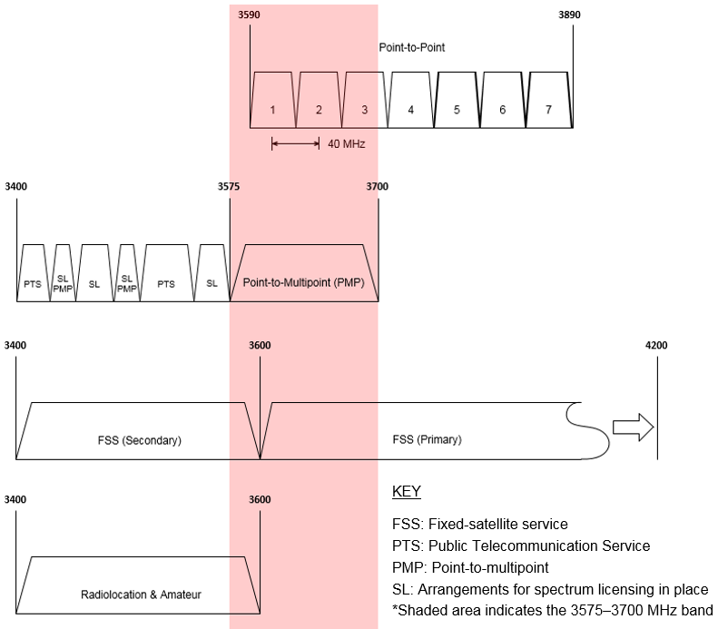
- Breakdown of licences in the 3.6 GHz band (RRL extract, 1 May 2017)
Licence type | No. of licences | No. of licensees | Major licensees (number of licences)
Earth receive | 19 | 5 | Telstra (9), Inmarsat (4), Lockheed Martin (2), Optus (2)
Point-to-multipoint | 413 | 57 | Pilbara Iron Company (62), Aus Pacific LNG (44), Aussie Broadband (29), QEStel (29), Agile (25), Connectivity I.T. Pty Ltd (22), Dep Transport Qld (19)
Point-to-point | 47 | 5 | Digital Distributions Australia (37), Telstra (7)
Amateur repeater | 2 | 2 | Elizabeth Amateur Radio Club (1), Central Coast Amateur Radio Club (1)

Fixed service
There is currently an embargo in the 3.6 GHz band that has been in place since 2005. While the embargo does not restrict existing licences from being renewed, it does restrict any new point-to-point apparatus licences being issued in the band on an Australia-wide basis. Due to the embargo, point-to-point link use has steadily declined since 2005.
Until November 2016, the embargo did not restrict new point-to-multipoint licences being issued in regional areas, and new services continue to be allowed in remote areas. As a result, point-to-multipoint use of the 3.6 GHz band, which can be considered to be a form of MBB service, has steadily increased over time. Access to capital cities (except Hobart) was embargoed for point-to-multipoint services until November 2016, at which point the embargo was expanded to include all capital cities and regional areas in support of this review. The embargo does not restrict existing licences from being renewed.
The ACMA has developed the following frequency assignment instructions for fixed services operating in the 3.6 GHz band:
- RALI FX3 Microwave fixed services frequency coordination
RALI FX19 Frequency Coordination and Licensing Procedures for apparatus licensed Broadband Wireless Access Services in the 1900–1920 and 3575–3700 MHz bands.

Fixed-satellite service (FSS)
In Australia, FSS is a primary service in the 3600–4200 MHz band and a secondary service in the 3400–3600 MHz band.
Traditionally, a majority of FSS use has been in the 3700–4200 MHz band (also known as the standard C-band). This, in combination with the embargo in the band, means there are relatively few licensed FSS earth stations in the 3.6 GHz band. Of particular note are the services located in the Belrose/Oxford Falls area in Sydney, and Landsdale and Lockridge in Perth.

Amateur
Amateur use of the band is comparatively lower than other services. It is currently limited to two locations, one in Adelaide and one in Sydney. Amateur services have a secondary service allocation in the 3300–3600 MHz band under the ARSP. Use of the 3300–3600 MHz band by amateur services is in accordance with the Australian Amateur Band Plan.

Radiolocation
There is a primary service allocation to the radiolocation service in Australia under the ARSP, which is in the 3400–3600 MHz band. Currently there are no licences in the 3.6 GHz portion of the band.

Low interference potential devices
The Radiocommunications (Low Interference Potential Devices) Class Licence 2015 defines arrangements for the following devices to operate across the 3.6 GHz band:
- building material analysis transmitters operating in the 2200–8500 MHz band
ultra-wideband transmitters operating in the 3400–4800 MHz band.

C-band television receive-only (TVRO) systems
In previous ACMA consultation processes, it was identified that there are unlicensed TVRO systems operating in the 3400–4200 MHz band in Australia. These are typically used to obtain satellite television services meant for other countries. In response to previous consultations, satellite industry representatives have suggested there may be in the order of 200,000 TVRO systems operating in Australia. TVRO systems operating in the 3400–4200 MHz band are unlicensed and, as such, are not afforded protection from interference in Australia.

Embargoes
There are four embargoes currently in place that cover all or part of the 3.6 GHz band in specified areas:
- Embargo 41—covers the 70 MHz–25.25 GHz band. It was established to create a radio quiet zone near Boolardy Station in Western Australia to facilitate the development and use of new radio astronomy technologies.
- Embargo 42—covers the 3575–3710 MHz band. It was put in place in September 2005 while future planning options for the band were being considered under the ACMA’s Strategies for Wireless Access Services consultation process. In 2009, the ACMA made the 3575–3700 MHz band available for MBB services in regional and remote areas of Australia. The embargo was subsequently modified to support this outcome. Embargo 42 was revised in November 2016 to restrict access to the 3575–3710 MHz band for point-to-multipoint services in metropolitan and regional areas in support of the current review of the band. Restrictions still apply Australia-wide to the issue of new licences for point-to-point links and FSS earth stations.
- Embargo 49—covers numerous bands used by satellite, space research and radio astronomy services. This includes the 3400–4200 MHz band. The embargo limits the deployment of services other than satellite, space research and radio astronomy services operating in the 3400–4200 MHz band, within 150 kilometres of a location near Mingenew in Western Australia.
Embargo 52—covers the 3400–3575 MHz and 3600–3700 MHz bands within the Woomera Prohibited Area (WPA). It was created to facilitate the ongoing use of the WPA by the Department of Defence.

Details of licences in the 3.6 GHz band
In the event that the 3.6 GHz band is re-farmed for MBB, the ACMA has performed work to determine the number and type of licences that may be affected under the different geographical area options defined in Appendix 6. The results of the analysis are displayed in Table 6 and Figure 8.
- Location of embargoed areas and licensed services in the 3.6 GHz band (RRL extract, 1 May 2017)
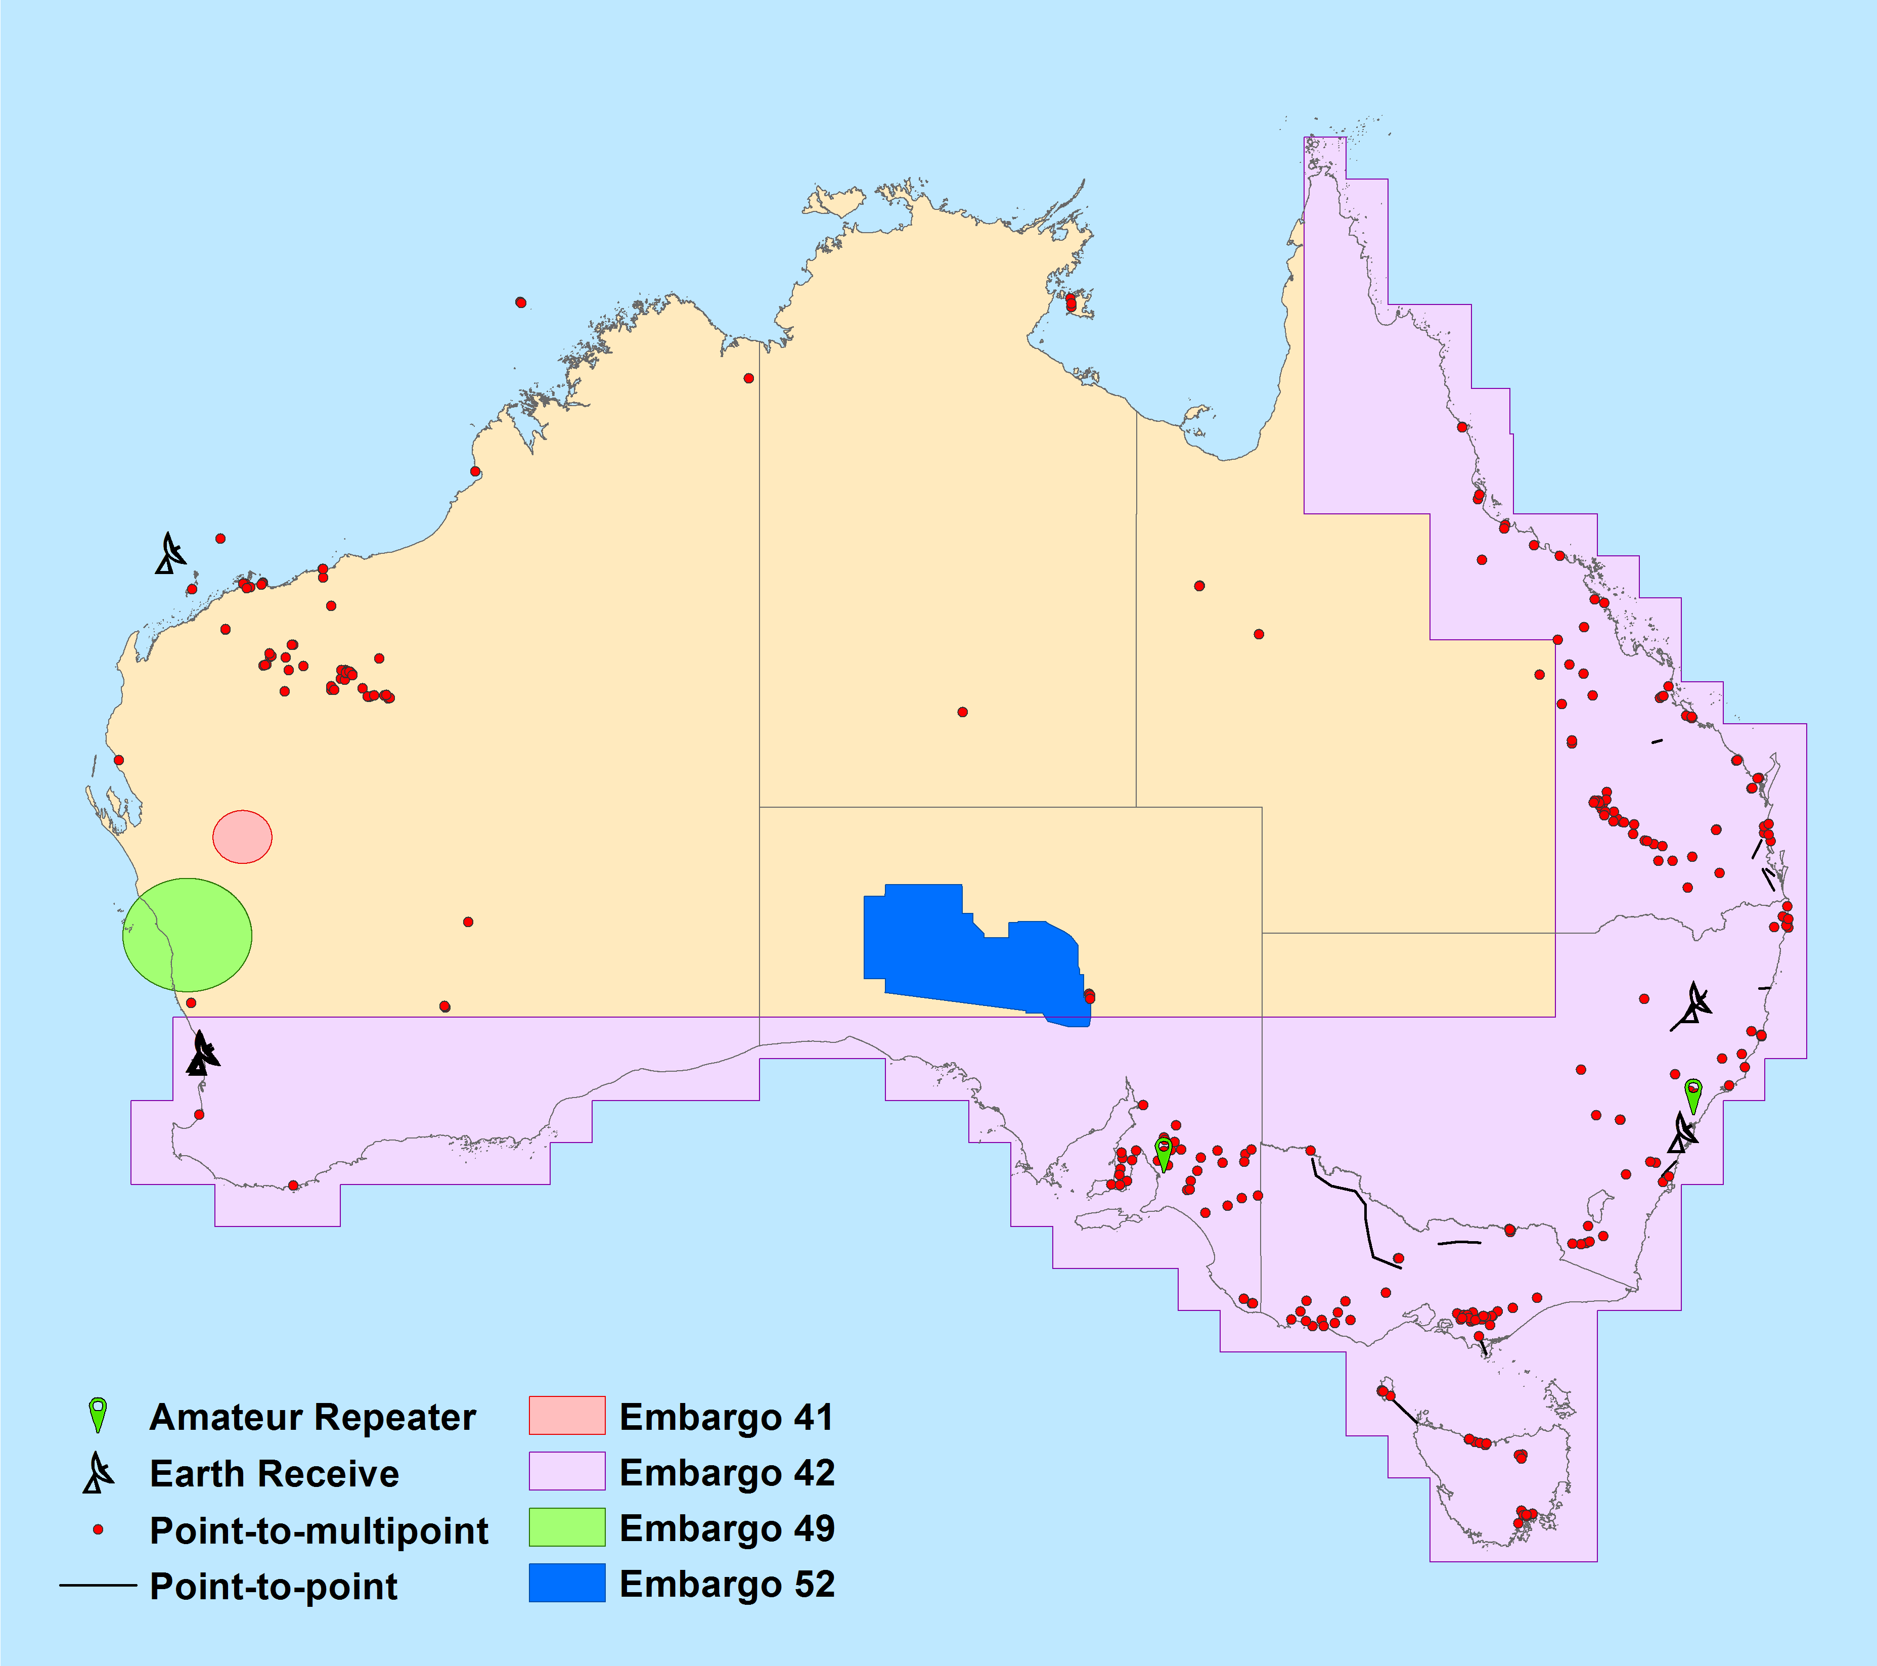
- Breakdown of licences in the 3.6 GHz band by Area (RRL extract, 1 May 2017)
Area |  | All licences | Point-to-multipoint | Point-to-point | Amateur repeater | Earth receive
Area 1 | Adelaide | 1 | 0 | 0 | 1 | 0
 | Brisbane | 2 | 0 | 2 | 0 | 0
 | Canberra | 0 | 0 | 0 | 0 | 0
 | Melbourne | 0 | 0 | 0 | 0 | 0
 | Perth | 11 | 0 | 0 | 0 | 11
 | Sydney | 5 | 0 | 0 | 1 | 4
 | Total | 19 | 0 | 2 | 2 | 15
Area 2 | Adelaide + Buffer | 34 | 33 | 0 | 1 | 0
 | Brisbane + Buffer | 24 | 21 | 3 | 0 | 0
 | Canberra/Sydney + Buffer | 31 | 20 | 6 | 1 | 4
 | Melbourne + Buffer | 51 | 46 | 5 | 0 | 0
 | Perth/WA + Buffer | 13 | 2 | 0 | 0 | 11
 | Total | 153 | 122 | 14 | 2 | 15
Area 3 | Regional (minus Area 2) | 206 | 171 | 33 | 0 | 2
 | Regional (including Area 2) | 359 | 293 | 47 | 2 | 17
Area 4 | Remote (minus Area 3) | 122 | 120 | 0 | 0 | 2
 | Australia-wide | 481 | 413 | 47 | 2 | 19

Appendix 2:
Detailed assessment of replanning options
This appendix contains a detailed analysis of each of the potential replanning options for the 3.6 GHz band. The examination draws on issues raised in Chapter 4, Discussion of issues, and the consideration in Chapter 3, Case for action (in particular regarding the expected HVU of the band), and uses the Principles of Spectrum Management as a guide. A summary of the analysis is provided in Table 4 of Chapter 5, Replanning options.
To provide clarity in the proceeding discussion, the definition of Area 1, Area 2 and Area 3 referred to in this section are provided at Appendix 6.

Principles of Spectrum Management
The ACMA has developed a set of principles that guides its approach to spectrum management. The key theme of the principles is that maximising the overall public benefit from use of the radiofrequency spectrum requires balanced application of both regulatory and market mechanisms.
The Principles for Spectrum Management are consistent with the principles of good regulatory practice. They provide directions that will generally result in welfare being maximised and, together with use of a total welfare standard, articulate the ACMA’s approach to spectrum regulation.
The principles are:
- Allocate spectrum to the highest value use or uses.
- Enable and encourage spectrum to move to its highest value use or uses.
- Use the least cost and least restrictive approach to achieving policy objectives.
- To the extent possible, promote both certainty and flexibility.
Balance the cost of interference and the benefits of greater spectrum utilisation.
More information about each of the spectrum management principles is available from the ACMA website.

Option 1—no change
Under this option, arrangements in the 3.6 GHz band would revert back to those in place prior to the release of the October 2016 discussion paper. Site-based apparatus licence arrangements for wireless broadband services in regional and remote areas would remain in place and incumbent licensed services could continue operating unaffected by this review process. This would provide certainty for existing apparatus licensees while allowing aspirant apparatus licensees to gain access to the band where spectrum is available. The ACMA would also look to review the existing site-based frequency assignment criteria for point-to-multipoint apparatus licences as proposed by numerous respondents to the October 2016 discussion paper.
The ‘no-change’ option would mean that no arrangements would be put in place to support any new services for deployment in the currently underutilised Area 1. This is not in line with principles 1 and 2, nor the case-for-change assessment outlined earlier in this paper, particularly regarding the expected HVU of the band. Historically, the highest demand for access to spectrum has occurred in large population centres, such as those encompassed by Area 1.
This option would also leave existing site-based apparatus licensing arrangements in place in other areas of high demand that are outside Area 1.

Option 2—expand existing apparatus licence arrangements into Area 1
Under this option, existing point-to-multipoint apparatus licensing arrangements would remain in regional and remote areas. Point-to-multipoint apparatus licensing arrangements would be implemented in Area 1 coordinating with existing FSS earth station facilities. The ACMA would also look to review the existing site-based frequency assignment criteria for point-to-multipoint apparatus licences, as proposed by a number of respondents to the October 2016 discussion paper.
The extension of the point-to-multipoint apparatus licence arrangements into Area 1 is more in line with the ACMA’s assessment of highest value use for the 3.6 GHz band than Option 1. There are two sub-options for how this could be implemented:
- Option 2a—implement site-based apparatus licence arrangements in Area 1. This mirrors what is currently implemented in regional and remote areas.
Option 2b—implement area-wide apparatus licence arrangements in Area 1. Under this option, the ACMA does not propose the spectrum be re-allocated via section 153B of the Act; as a result, incumbent services could continue operating in the band. Services deployed under an area-wide apparatus licence would be required to manage interference to incumbent services.
Incumbent services could continue operating in the band unaffected by this review process under both of these options. Existing FSS earth station sites in metropolitan areas would be afforded sufficient protection for existing and prospective new services pointing across a defined range of the geostationary arc. This means any new services would be required to coordinate with them. This will have an effect on the availability of spectrum for point-to-multipoint services in Area 1. Specifically, there will be difficulty deploying services in various parts of Area 1 caused by incumbent fixed links, earth stations and adjacent area point-to-multipoint licences. In particular, the MBB and earth station compatibility study at Appendix 4 suggests there would be significant restrictions in where MBB services could be deployed in Perth and Sydney.
Another likely issue associated with both these options is the shorter licence tenure and perceived lack of certainty associated with apparatus licences. This could affect the value that prospective licensees place on access to the band as well as investment in infrastructure, particularly in areas of high demand. Area-wide apparatus licensing also limits the types of services that can be deployed (for example, point-to-point, point-to-multipoint) and is not as flexible in use as spectrum licensing. As such, an apparatus-licensing approach in such areas is not considered the optimal approach with respect to Principle 4, which aims to balance certainty and flexibility to the extent possible.
Area 1 does not encompass all likely areas of high demand, as determined in the Assessment of areas with high demand for spectrum section of this paper. Site-based apparatus licensing arrangements are not considered to be optimal in such areas. However, they are considered appropriate in areas where demand does not exceed supply.
Options 2a and 2b are analysed further below.

Option 2a—site-based apparatus licensing in Area 1
Under this option, the site-based point-to-multipoint licensing arrangements in the 3.6 GHz band currently in place in regional and remote areas would be extended to cover metropolitan areas.
Area 1 is considered extremely likely to be an area of high demand for 3.6 GHz spectrum. In order to manage the initial release of site-based apparatus licences in Area 1, an appropriate mechanism would need to be developed. This would ensure orderly access to the band in a ‘gold rush’ situation. Market-based mechanisms, such as auctions, are usually most suitable in these situations. However, this could be highly complicated to implement (due to the high number of apparatus licence sites and prospective bidders) while also managing interference between prospective operators.
Given there is strong interest from large MBB operators in deploying dense wide-area networks in Area 1, it is likely that the effective outcome of this approach would be similar to that of options 2b and 3a (area-wide licences in Area 1). However, when compared with options 2b and 3a, Option 2a poses a greater risk of fragmentation of spectrum holdings and other inefficiencies that would reduce the overall utility of the spectrum. In areas of high demand, site-based apparatus licensing may also limit the ability of licensees to expand coverage of an area-wide network over time. This increases the risk of licensees pre-emptively hoarding spectrum in relevant areas to secure future access and/or block competitors, or speculatively taking out licences in key locations to then sell to the highest bidder.
A benefit of site-based apparatus licensing is that it is conducive to sharing between a number of different services and spectrum users on a first-in-time coordinated basis. Operators interested in deploying dense wide-area networks could negotiate with incumbent services either to manage interference and/or trade licences to secure access to spectrum in areas of interest. Potential issues with this approach, such as the increased risk of licence fragmentation and inefficiencies in the use of spectrum, are outlined in Chapter 4, Discussion of issues.

Option 2b—area-wide apparatus licensing in Area 1
Under this sub-option, area-wide apparatus licensing arrangements would be implemented in Area 1. Existing site-based apparatus licence arrangements would be maintained outside Area 1.
Area 1 is considered extremely likely to be an area of high demand in the 3.6 GHz band. Implementing area-wide apparatus licensing arrangements would address a number of the issues associated with site-based apparatus licensing in such areas. This includes providing greater certainty for access to spectrum to support the progressive rollout of and investment in area-wide services in Area 1. It also removes the ability for competitors to block each other or speculators from taking out licences in key locations to then sell to the highest bidder.
Area-wide apparatus licensing is also conducive to the development of sharing arrangements with other services and spectrum users. This includes allowing incumbent services to continue operating, as well as creating arrangements to allow other users to access spectrum in those areas that an area-wide apparatus licensee is not using or in the period before they roll out a service. The risk with this option is that there is no guarantee on how long an operator could make use of the spectrum before it is required to cease operation. This could affect whether or not operators invest in and take advantage of any such arrangements.
Outside Area 1, operators interested in deploying dense wide-area networks could negotiate with incumbent services either to manage interference and/or trade licences to secure access to spectrum in areas of interest. Potential issues with this approach, such as the increased risk of licence fragmentation and inefficiencies in the use of spectrum, are outlined in Chapter 4, Discussion of issues.
A downside of this option is the effect of deployment restrictions and dead zones on either side of the geographical boundary of the licence. This is because the areas affected include likely areas of high demand. In addition to these effects, incumbent services have the potential to further restrict deployments in outer-metro areas. These issues combined would be likely to reduce the utility of the spectrum arrangements in these areas—the less-than-optimal arrangements would restrict the spectrum being used for or moving to its highest value use.

Option 3—spectrum licence-specific areas
Under this option, specific areas would be re-allocated for the issue of spectrum licences and any remaining areas would be subject to the current apparatus licensing arrangements. Those incumbent services that fall outside re-allocated areas would not be affected by this process. Those that fall within re-allocated areas will be required to relocate within a designated re-allocation period. For those areas that are not re-allocated, the ACMA would look to review the existing site-based frequency assignment criteria for point-to-multipoint apparatus licences, as proposed by numerous respondents to the October 2016 discussion paper.
In the October 2016 discussion paper, the ACMA presented some possible areas that could be re-allocated for spectrum licensing. Factors that need to be considered include identifying areas likely to be of high demand, the effect on incumbent services and ensuring areas are large enough to be of practical use. It is also assumed that any geographical areas re-allocated for spectrum licensing would be optimised for the deployment of dense wide-area TDD MBB networks. Under such arrangements, the management and effect of co-channel interference from existing apparatus-licensed TDD MBB services to and from any re-allocated areas also needs to be considered. This is done to maximise the ability of adjacent-area spectrum and apparatus licensees to deploy services close to the delineating geographical boundary.
In identifying areas of high demand, the ACMA’s starting assumption is that this would include, at a minimum, the metropolitan areas originally embargoed for point-to-multipoint licences in the 3.6 GHz band from 2009 to 2016. This is referred to in this paper as Area 1.
With the above issues in mind, the ACMA has defined four geographical area options that could be considered for re-allocation in the 3.6 GHz band:
- Option 3a—re-allocate Area 1 for the issue of spectrum licences. This area covers major capital cities (except Darwin and Hobart).
- Option 3b—re-allocate Area 2 for the issue of spectrum licences. This mirrors the areas developed by the ACMA in implementing the October 2014 Ministerial Direction. The areas were defined large enough to support the deployment of services in outer-metro and metro fringe areas, while reducing adjacent area interference concerns. Refer to Annex D of RALI MS39 for area descriptions.
- Option 3c—re-allocate Area 3 for the issue of spectrum licences. This mirrors the metro and regional areas subject to spectrum licensing in the 3.4 GHz band. Refer to Schedule 2 of the Radiocommunications (Spectrum Re-allocation) Declaration 2000 for a description of the area.
Option 3d—re-allocate all of Australia for the issue of spectrum licences.
As stated in numerous RALIs developed by the ACMA, additional considerations apply to any proposal for an apparatus licence in the 3.6 GHz band that is within 150 km of latitude 12.449722° south and longitude 130.833333° east (GDA94 Datum) in Darwin (NT). The RALI states that any request for assignments within this zone must be referred to the ACMA for assessment. As this affects the availability of the 3.6 GHz band in and around Darwin, it would likely affect the viability of the area for use by dense wide-area MBB networks. Consequently, it is proposed that the Darwin area not be considered for spectrum licensing under the Area 1, Area 2 or Area 3 options. Instead, it is recommended it remain under the existing site-based apparatus licensing arrangements.
The areas for each sub-option are further defined and displayed in Appendix 6. The exact definition of each of these areas is open for discussion in this paper. For example, the excision of other areas may also be considered in order to implement earth station protection zones, as discussed in Appendix 5. In order for the ACMA to evaluate any alternative proposals, it is requested that sufficient reasoning be provided.
As discussed previously, a benefit of re-allocating spectrum for the issue of spectrum licences is that it avoids some of the issues associated with apparatus licensing—as discussed in Optimum arrangements to facilitate the highest value use(Chapter 3) and Option 2: Expand existing apparatus licence arrangements into Area 1 (Appendix 2, above).
In addition to this, greater value is usually placed on the issue of spectrum licences when compared with apparatus licences. This is largely due to the advantages of longer licence duration, flexibility in use and certainty typically associated with spectrum licences compared to apparatus licences. Historically, such arrangements have been more conducive to greater investment in and deployment of dense wide-area MBB networks.
In the event an operator wishes to deploy a service in an area where the spectrum is unused by a particular spectrum licensee, this can only be done by either obtaining the spectrum via trade or seeking third-party access to it.
Options 3a–d are analysed further below.

Option 3a: Spectrum licence metro areas
Under this option, Area 1 would be re-allocated for the issue of spectrum licences. The point-to-multipoint licensing arrangements in the 3.6 GHz band currently in place for regional and remote areas would be retained outside Area 1.
Area 1 is considered likely to encompass much but not all areas of high demand in the 3.6 GHz band. Area-wide licensing arrangements such as spectrum licensing are considered optimal in this case. This is consistent with the case for action outlined in Chapter 3 and is in line with the ACMA’s assessment of HVU.
However, analysis of MBB deployments in the 1800 MHz, 2 GHz, 2.3 GHz and 2.5 GHz bands suggests that Area 1 would not encompass all likely areas of high demand. This means site-based apparatus licensing arrangements would apply in such areas. These arrangements are not considered optimal for areas of high demand. Therefore, it does not address the case for action outlined in Chapter 3 and is not in line with the ACMA’s assessment of HVU.
A downside of this option is that the effect of deployment restrictions and dead zones (see Chapter 4, Discussion of issues) on either side of the geographical boundary of any spectrum licences issued would be high. This is because the areas affected include likely areas of high demand. Incumbent services would have the potential to restrict deployments in outer metro areas and spectrum licence coordination requirements would also restrict deployment of new apparatus licences services in these areas. These issues combined would be likely to reduce the utility of the spectrum arrangements in these areas. Such areas would therefore be restricted from being used for or moving to its highest value use.

Option 3b: Spectrum licence metro and some surrounding areas
Under this option, Area 2 would be re-allocated for the issue of spectrum licences. The point-to-multipoint licensing arrangements in the 3.6 GHz band currently in place for regional and remote areas would be retained outside Area 2.
Area 2 is considered likely to encompass many but not all areas of high demand in the 3.6 GHz band. Area-wide licensing arrangements such as spectrum licensing are considered optimal for areas of high demand. Therefore, while implementing spectrum licensing in Area 2 would meet principles 1 and 2 in that area, maintaining site-based apparatus licence arrangements in areas outside of Area 2 where demand exceeds supply is not considered optimal.
The area was developed by the ACMA as part of the implementation of the October 2014 Ministerial Direction. The areas within Area 2 were specifically made large enough to support the deployment of TDD wireless broadband services in outer metro areas of the five largest cities in Australia. Area 2 would also support the deployment of services in some regional areas.
However, analysis of MBB deployments in the 1800 MHz, 2 GHz, 2.3 GHz and 2.5 GHz bands suggests that Area 2 would not encompass all likely areas of high demand. This means site-based apparatus licensing arrangements would apply in such areas. These arrangements are not considered optimal for areas of high demand. This is not in line with the considerations identified in Chapter 3, Case for action.
A downside of this option is that the effect of deployment restrictions and dead zones (See Chapter 4, Discussion of issues) on either side of the geographical boundary of any spectrum licences issued would be reasonably high. This is because the areas affected include likely areas of high demand. The effect of this is not considered as severe as for Option 3a as outer metro areas are not affected. However, the combined effect of these issues would still likely reduce the utility of spectrum arrangements in these areas.

Option 3c—spectrum licence metro and regional areas
Under this option, Area 3 would be re-allocated for the issue of spectrum licences. The point-to-multipoint licensing arrangements in the 3.6 GHz band currently in place for regional and remote areas would be retained outside Area 3.
Area 3 is considered likely to encompass almost all areas of high demand in the 3.6 GHz band. Area-wide licensing arrangements such as spectrum licensing are considered optimal in this case. This is consistent with the case for action outlined in Chapter 3 and is in line with the ACMA’s assessment of HVU.
An apparent area of high demand north of Perth in Western Australia is not included. This is due to the desire to avoid the issue of spectrum licences around the earth station protection zone created by the ACMA near Mingenew (refer to Embargo 49).
Analysis of MBB deployments in the 1800 MHz, 2 GHz, 2.3 GHz and 2.5 GHz bands suggests that Area 3 would also encompass some likely areas of low to medium demand. In one sense, this may not appear to be an optimal outcome. However, the benefit of defining Area 3 in its current form is that it provides an additional buffer for the management of co-channel interference in areas of high demand and reduces the effect of dead zones (see Geographical boundary issues associated with area-wide licences section for more information). Area 3 also closely matches the current definition of metro and regional areas for 3.4 GHz spectrum licences. The latter point has the potential to be beneficial in any future efforts to defragment spectrum holdings in the broader 3400–3700 MHz band as it could facilitate the trading of licences to resolve the issue.
A significant benefit of this option is that the effect of deployment restrictions and dead zones (see Chapter 4, Discussion of issues) on either side of the geographical boundary of any spectrum licences issued is considerably lower when compared to options 3a and 3b. This is because the areas affected are likely areas of low to medium demand.

Option 3d—Australia-wide spectrum licence
Under this option, all of Australia (within the boundaries of The Australian spectrum map grid 2012) would be re-allocated for the issue of spectrum licences. The point-to-multipoint licensing arrangements in the 3.6 GHz band currently in place for regional and remote areas would be retained only in Australian external territories.
The Australia-wide spectrum licence option would encompass all likely areas of high demand. However, this option also covers a vast amount of area where there is considered to be low to medium demand. This includes most of remote and some of regional Australia. This is not considered an optimal outcome. It also does not address the case for action outlined in Chapter 3 and is not in line with the ACMA’s assessment of HVU.

Option 4—hybrid apparatus and spectrum licence approach
Under this option, there would be a mixture of the apparatus and spectrum licence options discussed under options 2 and 3. Implementation of Option 4 has the potential for the benefits and/or disadvantages of both apparatus and spectrum licensing to be realised, depending on how it is implemented.
Two broad sub-options have been identified for the hybrid approach:
- Option 4a—re-allocate part of the 3.6 GHz band for the issue of spectrum licences under each of options 3a–d.
Option 4b—define suitable frequencies and areas around incumbent apparatus licences that will not be re-allocated for spectrum licensing under each of options 3a–d. This would allow existing incumbent licensees to continue operating in the band.
Options 4a and 4b are analysed further below. While both of these options could be implemented at the same time, to simplify discussion they are defined and analysed separately.

Option 4a—re-allocate part of the 3.6 GHz band for spectrum licensing
Under this option, only part of the 3.6 GHz band would be re-allocated for the issue of spectrum licences under one of options 3a–d. The remaining part would stay subject to site-based apparatus licensing arrangements. For example, under Option 3b, 100 MHz of the 3.6 GHz band could be re-allocated for spectrum licensing in Area 2 and the remaining 25 MHz retained for apparatus licensing. Site-based apparatus licensing arrangements would remain in place outside Area 2. One possible implementation of this example is displayed in Figure 9.
- Hybrid approach with Area 2 re-allocated for spectrum licensing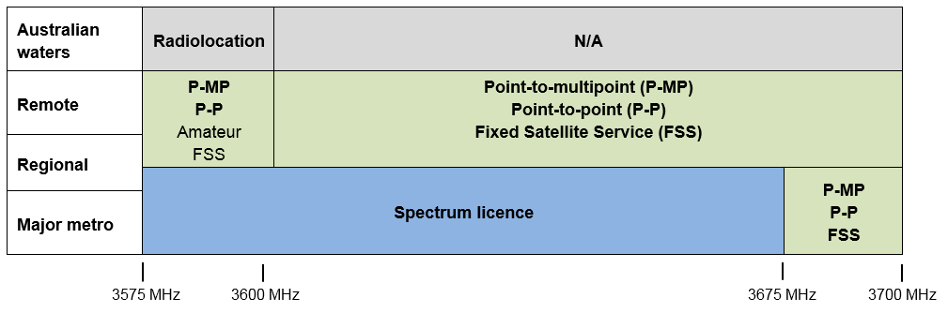
Areas and frequencies subject to apparatus licensing are shown in green and grey; primary services are in bold.

This option has been previously implemented in the 1800 MHz, 2 GHz and 3.4 GHz bands. In these cases, the entire band was re-allocated in major cities, but only part of the band was re-allocated in regional areas. No spectrum was re-allocated for spectrum licensing in remote areas in any of these bands.
This approach allowed incumbent apparatus-licensed services to continue operating in the bands in regional areas. In the case of the 1800 MHz band, these services continued operating for 19 years before the HVU changed to include mobile broadband services. The remaining regional apparatus licence portion of the 1800 MHz band have subsequently been re-allocated for the issue of spectrum licences. Apparatus licence arrangements still apply to some regional areas in the 2 GHz and 3.4 GHz bands. However, the intermingling of apparatus and spectrum licence arrangements in the 3400–3575 MHz band has resulted in fragmented licence holdings that may be considered less than optimal and would likely require regulatory intervention to improve. A similar issue in the 3.6 GHz band could be avoided by ensuring any apparatus licence arrangements are placed at the upper end of the band, as shown in Figure 9.
A significant benefit of Option 4a is the outcome for incumbent apparatus licensees. However, the same issues with apparatus licensing as described under Option 2 still remain. This includes the appropriateness of apparatus licence arrangements in areas of high demand. However, the effect of these issues would be reduced given the smaller size of the apparatus licensing segment.
Based on discussions with industry and some submissions to the October 2016 discussion paper, the ACMA considers that 20 MHz of spectrum is the minimum bandwidth required to deploy a viable wireless broadband service in most instances. A further 5 MHz guard band would also be reasonable to help manage a majority of adjacent channel interference issues between TDD services, if and when required. This suggests a minimum 25 MHz of spectrum would need to be made available for either spectrum or apparatus licensing under Option 4a. In response to the October 2016 discussion paper, numerous Wireless Internet Service Providers proposed the same amount of spectrum remain subject to apparatus licensing. While 25 MHz is sufficient for point-to-multipoint services, larger bandwidths would typically be required to support the continued operation of point-to-point links and satellite services.
As noted to avoid fragmentation, if any apparatus licence portion is provided, it would be best placed at the upper end of the 3.6 GHz band. This approach would also best support a future defragmentation of licence holdings in the broader 3400–3700 MHz band. A potential disadvantage of this approach is that, historically, the segmentation of spectrum to support different licensing arrangements in the same area has either restricted or complicated the ability of licensees to use mechanisms such as trading and commercial arrangements to optimise spectrum holdings and/or facilitate a change in use of the band.

Option 4b—define frequencies and areas around incumbent apparatus licences that will not be re-allocated for spectrum licensing
Under this option, specific frequencies and areas around incumbent apparatus-licensed services would not be re-allocated for spectrum licensing. Any apparatus licences in these specified areas would not need to relocate and could continue operating in the 3.6 GHz band unaffected by this review process. Apparatus licences within those frequencies and areas re-allocated for the issue of spectrum licences would still need to relocate within the specified time period. This approach has been used previously by the ACMA to support the ongoing operation of a small number of apparatus-licensed services in both the 2 GHz and 2.5 GHz bands. The approach has also been used to assist in the use and protection of the Australian Radio Quiet Zone in Western Australia.
As an example of how this option would work, consider the apparatus-licensed earth stations currently operating at Belrose in Sydney. First, the HCIS level 1 identifier encompassing these sites is identified and removed from the area to be re-allocated. The end result of this when applied to Option 3a is shown in Figure 10. Second, the frequency range over which the earth stations operate is identified. The resulting combination of area and frequency identified is not re-allocated for the issue of spectrum licensing and remains subject to apparatus licensing arrangements.
This approach could equally be used for existing point-to-point and point-to-multipoint licenses in the 3.6 GHz band, though in the case of point-to-multipoint licences, the service area of the system would also need to be identified.
Given amateur licences operate on a ‘no-interference and no-protection’ basis, they have no guarantee of interference-free or ongoing operation in the band, and have not been considered under this option. As such, amateur licences would still cease at the end of any re-allocation period put in place.
- Option 4b applied to Area 1
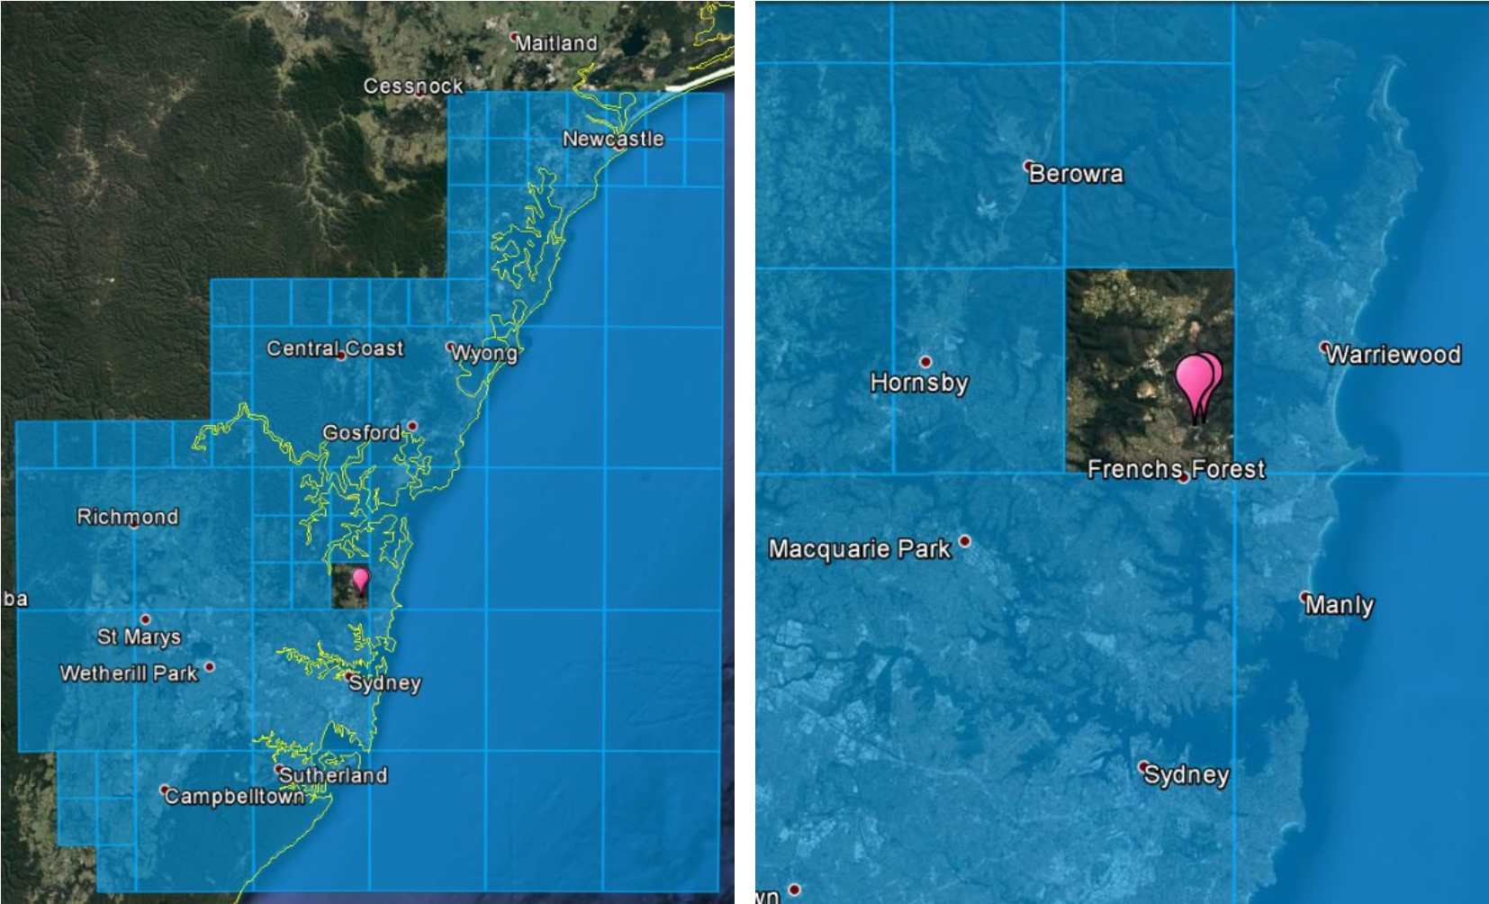
The area surrounding the earth stations at Belrose in Sydney (shown by the pink balloons) is removed from the spectrum-licensed area.

The same key outcomes as discussed in Option 3 apply to the portion of the band that is re-allocated for spectrum licensing under this option. The additional key outcomes below also apply to those frequencies and areas that are retained for apparatus licensing:
- There would be no effect on incumbent licensed services with a licensed bandwidth that falls entirely within the portion of spectrum that remains available for apparatus licensing.
- Within the portion of spectrum that remains available for apparatus licensing, consideration would be given as to whether existing and prospective new apparatus licensees would be issued new site-based point-to-multipoint apparatus licences. However, any such licences would be limited by the size of the apparatus licence area and the amount of spectrum available.
- A greater number of spectrum and apparatus licence geographical boundaries would further complicate and restrict the ability of licensees to deploy services under a spectrum (and apparatus) licence. This is due to interference management requirements with incumbent apparatus-licensed services and the ‘dead zone’ issue (see the Geographical boundary issues associated with area-wide licences section). In particular, the MBB and earth station compatibility study at Appendix 4 suggests there would be significant restrictions on where any mobile broadband services could deploy in Perth and Sydney. This would likely affect the utility of the spectrum in these areas in the 3.6 GHz band.
The intermingling of spectrum and apparatus licence types as proposed by this option, particularly in likely areas of high demand, is likely to lead to further fragmentation of licence holdings in the band. This would further complicate any attempts to defragment licence holdings across the broader 3400–3700 MHz band. Additionally, the excising of areas to support different licensing arrangements would restrict or complicate the ability of licensees to undertake any possible future trading or come to other commercial arrangements to facilitate expansion of services or a change in use of the band.
Based on the issues outlined above, Option 4b would be best implemented when a small number of area-frequency combinations are identified to remain under apparatus licensing arrangements. However, as the number of areas that need to be excised increases, this would make this option unviable.
A significant benefit of Option 4b is that incumbent apparatus licensees can continue operating unaffected by this review process in the areas retained for apparatus licensing. However, issues around the appropriateness of site-based apparatus licence arrangements in areas of high demand still remain.

Appendix 3:
5.6 GHz band considerations
The 5.6 GHz band (5600–5650 MHz) is currently subject to an apparatus licensing regime for radiodetermination (radar) use. Surrounding spectrum is included in the Radiocommunications (Low Interference Potential Devices) Class Licence 2015 (the LIPD). However, the 5.6 GHz band is currently excised from the LIPD as a means of protecting radar use in the band. As the band is not included in the LIPD, it cannot be used by Wi-Fi devices as is the case in adjacent spectrum. Figure 11 provides an overview of the Wi-Fi channel raster including 5.6 GHz band exclusion used by weather radars.
- Wi-Fi channel raster, including 5.6 GHz band exclusion used by weather radar
Most countries (including Europe and the US) utilise the 5.6 GHz band in their general authorisation regimes for uses such as Wi-Fi, on the condition that dynamic frequency selection (DFS) is used to protect weather radars sharing the band. While considered in Australia in the past, most recently in 2007, the ACMA has so far chosen not to include the 5.6 GHz band in the LIPD. This is due to concerns from the Bureau of Meteorology (BoM) that DFS does not provide the required level of certainty in protecting its weather radars operating across the band, coupled with the difficulty in locating sources of interference that operate under a class licence.
The ACMA has maintained a close watch on international developments in use of DFS in this band and flagged in the most recent Five-year spectrum outlook a review of arrangements for 5 GHz radio local area networks (RLANs) such as Wi-Fi. The progress of DFS use internationally, and in particular changes to DFS approaches since it was first implemented, have been of particular interest. The ACMA has followed regulatory actions and discussions in other countries and maintained dialogue directly with other regulators on their experiences.
The ACMA is aware of concerns with the use of DFS in a class-licensed environment in the 5.6 GHz band. Concerns include the efficacy of DFS to detect and protect radars, and the difficulties in identifying and addressing interference sources in a class-licensed environment. It is understood that these concerns, from BoM as the major user of the 5.6 GHz band, are informed by learnings from the experience of weather radar operators in countries that have adopted use of DFS for RLAN/Wi-Fi-type devices. The ACMA observes that a coordinated apparatus-licensed regime in the band would largely address these concerns, while also helping to identify interference sources if issues did arise.
Overall, the ACMA is of the view that it is timely to review arrangements in the 5.6 GHz band, particularly given the possibility that the band could help to mitigate the impact on point-to-multipoint users from possible changes in the 3.6 GHz band. Broad options include no change, adopting DFS in a class-licensed regime or establishing a site-based, coordinated apparatus licence regime for point-to-multipoint services. In each case, the intent is to retain protected use, though not necessarily exclusive use, of the band for BoM weather radars.

Current BoM use of the band
Current use of the 5.6 GHz band is primarily limited to BoM weather radars, with Defence also utilising this band in one location (Exmouth). Information on the location of existing radars in the band is shown in Figure 12.
Figure 13 shows the assignments of the 5.6 GHz radars are spread across the band, with a majority (43 of 53) located in the centre of the band (see Table 7).
Figure 14 shows the frequency of new radar assignments in the 5.6 GHz band over the last 27 years.
The ACMA understands that from time to time these radars are replaced, which may have a limited effect on the number or bandwidth characteristics of the BoM radars, or result in a small change in location of the radar.
- Location of C-band (5.6 GHz) weather radar used in Australia
(RRL extract, 1 May 2017)
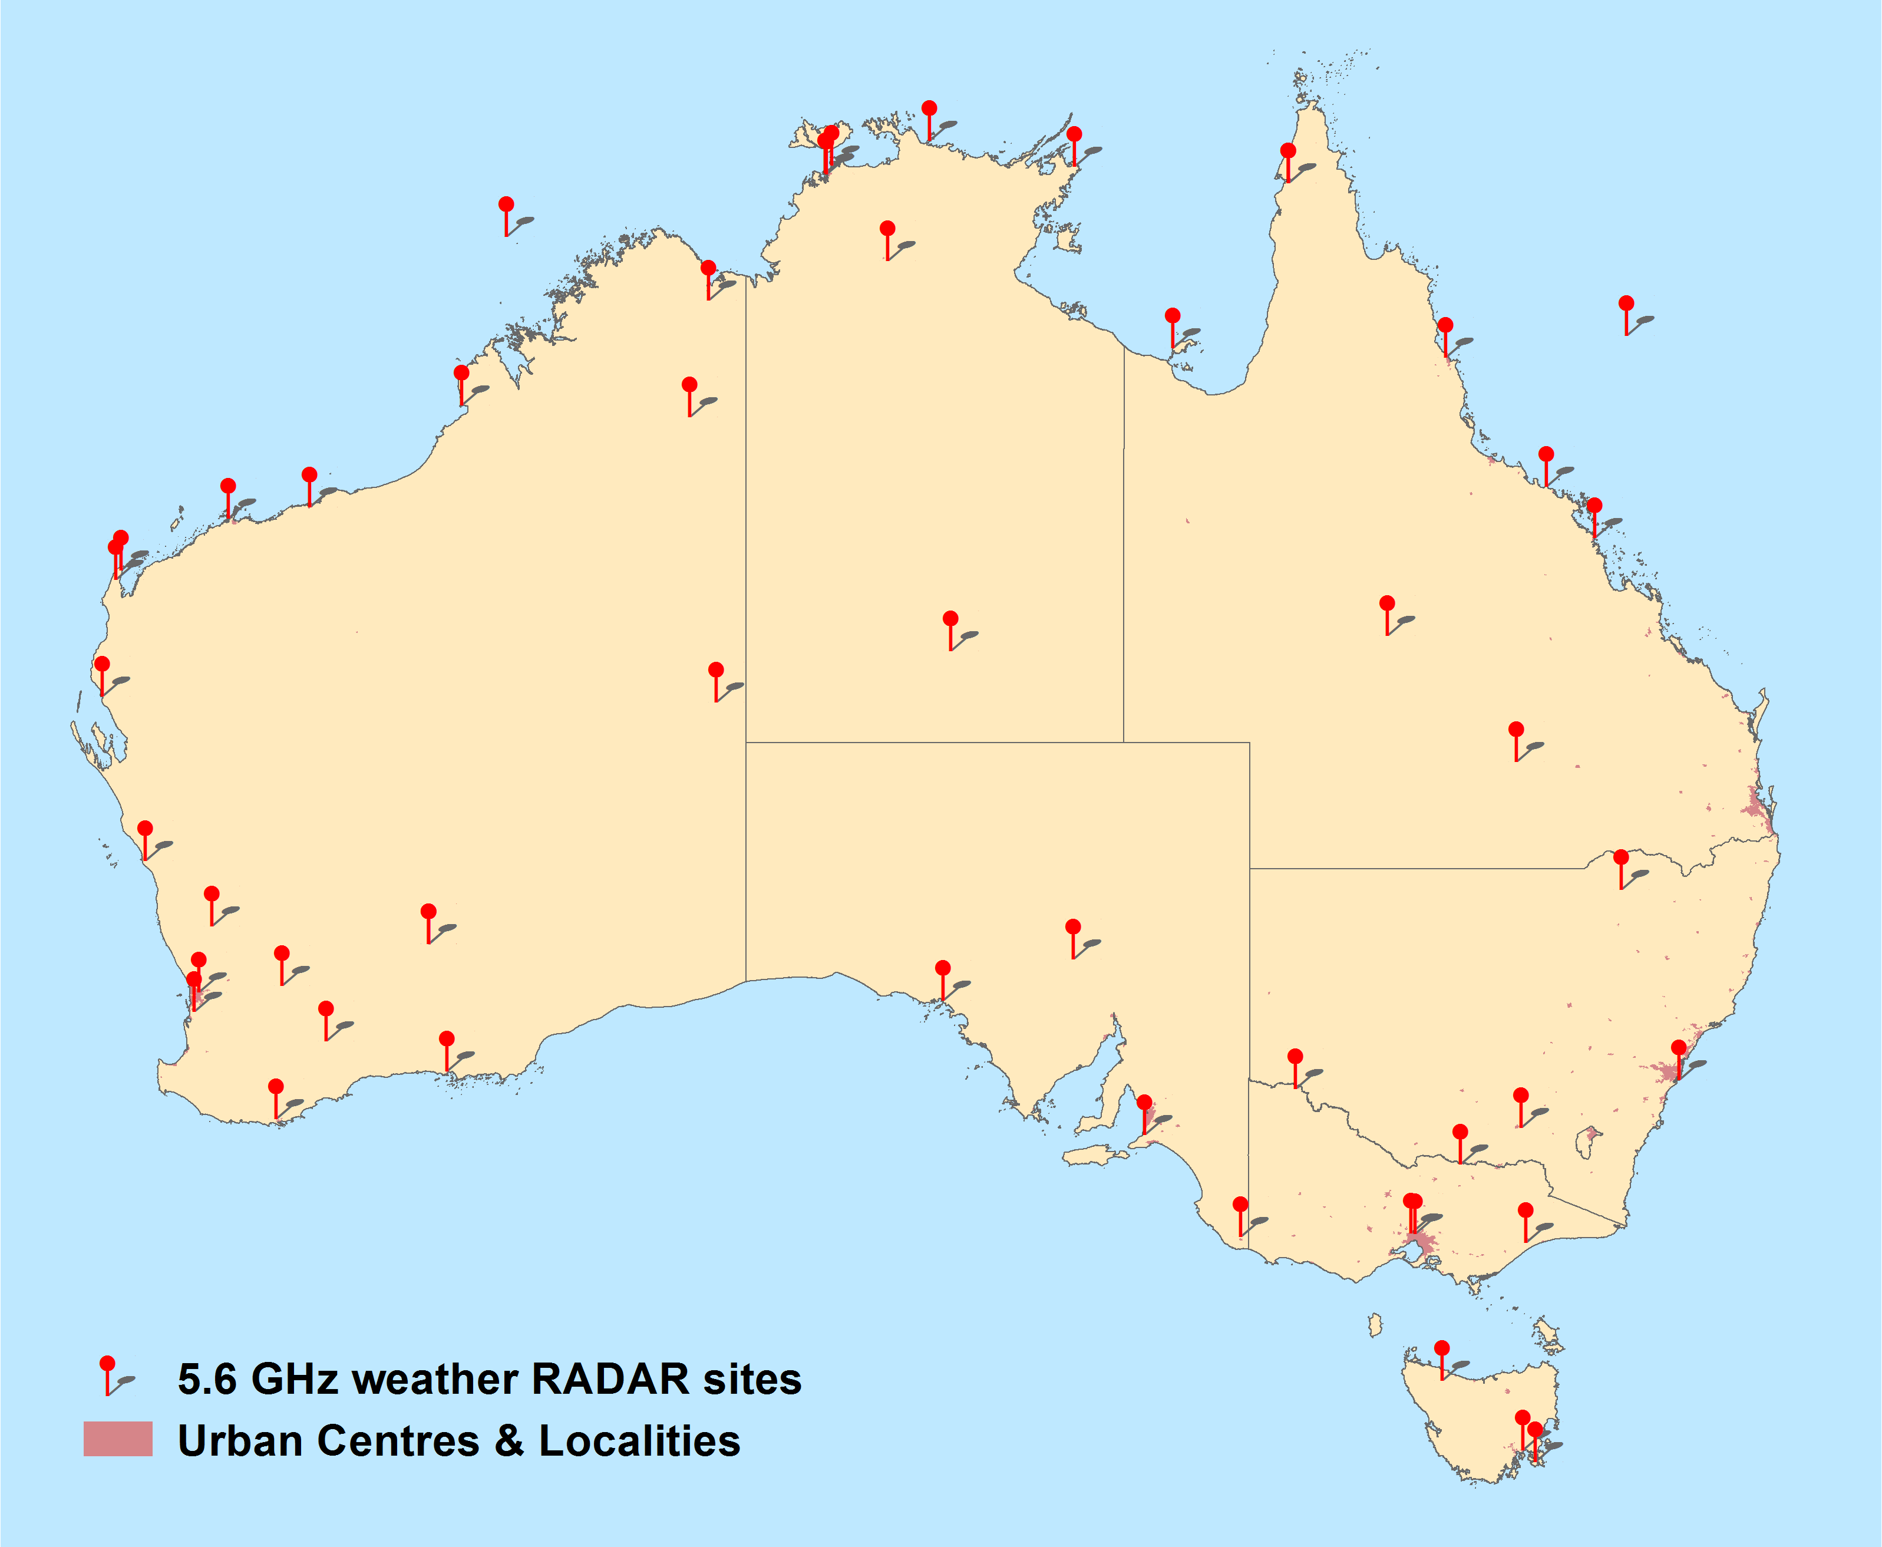

- Frequency view of current assignments of BoM Radars in the 5.6 GHz band
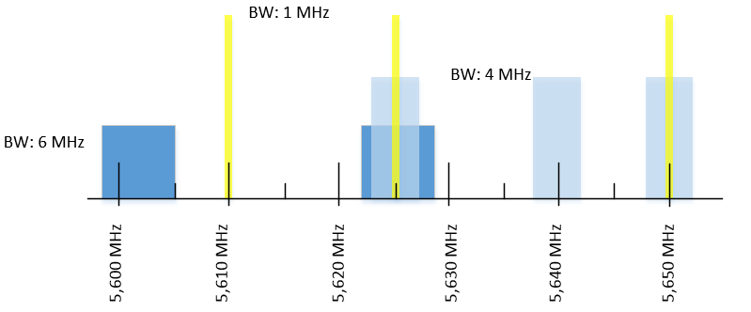

- Number of BoM frequency assignments across Australia in the 5.6 GHz band, including breakdown by bandwidth
(RRL extract, 1 May 2017)
Frequency (MHz) | Bandwidth (MHz) |  |  |  |  | Total
 | 1.0 | 1.1 | 4.0 | 6.0 | 504
5602 |  |  |  | 1 |  | 1
5610 | 1 |  |  |  |  | 1
5625 | 17 | 1 | 13 | 12 |  | 43
5640 |  |  | 3 |  |  | 3
5650 | 3 |  | 1 |  | 1 (Defence Exmouth Radar) | 5
Total | 21 | 1 | 17 | 13 | 1 | 53

- Annual number of new frequency assignments in the 5.6 GHz band, as of 1 May, 2017
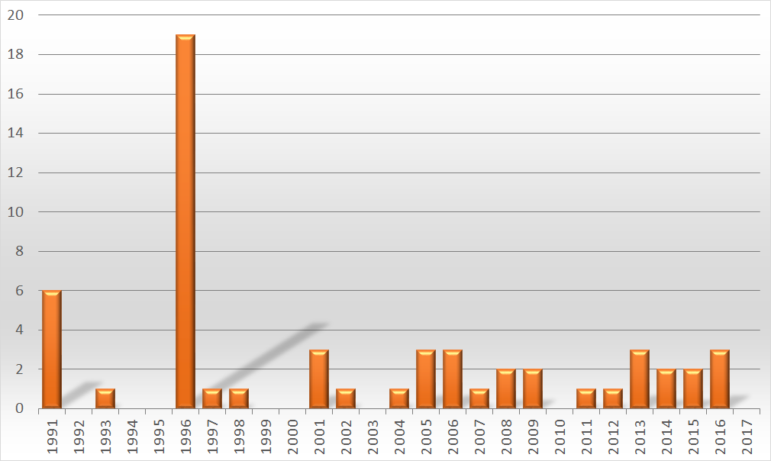

RLAN/Wi-Fi use of the band
There is currently a substantial amount of spectrum included in the LIPD for radio local area network (RLAN) (for example, Wi-Fi use; 460 MHz) across the 5 GHz band. On face value, the lack of an additional 50 MHz in the 5.6 GHz band may seem minor. While in the absolute of spectrum availability this may be true, the unavailability of this 50 MHz has an impact on the availability of not only more 20 MHz and 40 MHz channels, but also wider instantaneous channel bandwidths (80 MHz and 160 MHz) for users.
The channel raster for Wi-Fi standards 802.11a/n and ac (the main current RLAN use of the band) are shown in Figure 11. A number of channels that overlap the 5.6 GHz band are currently unavailable for use in Australia. Specifically, there are three 20 MHz, two 40 MHz, one 80 MHz and one 160 MHz channel. This is equivalent to 12 per cent of 20 MHz channels, 17 per cent of 40 MHz channels, 17 per cent of 80 MHz channels and 50 per cent of 160 MHz channels unavailable for use in Australia.
A study released by the Wi-Fi Alliance to determine future Wi-Fi needs suggests the current amount of spectrum available for Wi-Fi is inadequate to meet emerging demand. It was further estimated that between 2020 and 2025 the world will experience a Wi-Fi spectrum shortfall. Making the 5.6 GHz band available for general Wi-Fi use could help result in a (variable) improvement in Wi-Fi utility in many areas, particularly with the availability of wider channel bandwidths, which are of increasing interest to new services and applications that use the 5 GHz band.
3GPP has also developed technology standards for LTE Unlicensed (LTE-U) and Licensed Assisted Access (LAA). These standards seek to utilise the ‘unlicensed’ 5 GHz band as a complement to traditional carrier networks in licensed spectrum. LTE-U and LAA use fundamentally different technology (common with LTE) than that used by Wi-Fi. This has resulted in questions over their compatibility with the existing dominant Wi-Fi use of the spectrum. The ACMA is not aware of particular interest in Australia for the implementation of LTE-U or LAA in the 5 GHz band at this time. However, it is likely, as LTE-U or LAA deployments grow internationally, that domestic carriers may show increased interest in these technologies.

Options for future use of the 5.6 GHz band
There are two broad options for the future use of the 5.6 GHz band—class licensing option and apparatus licensing option—which are described and discussed below.

Class licensing option
The class licensing option would see the inclusion of the 5.6 GHz band (along with the DFS obligations for co-existence with radar) into the LIPD. Existing apparatus licensing of radars would remain. If this option was pursued, further engagement with industry would be required on the specific nature of DFS arrangements included in the LIPD. It is likely that arrangements implemented internationally (such as in Europe and/or the US) would form the basis for Australian regulation. Implementation in Australia would take advantage of advances in DFS technology and associated regulation that have occurred since DFS was originally used in the band.
Inclusion of the 5.6 GHz band in the LIPD would have the advantage of making additional spectrum available for general use. This would not only increase the overall quantity of spectrum available but also increase the number of wider bandwidth channels available for use. Both advantages would increase the overall utility of the 5 GHz band for Wi-Fi (and potentially LTE-U or LAA). This increased utility would benefit both general users such as individuals with home 5 GHz Wi-Fi access points and enterprise users of the band. The actual scale of these benefits would depend in part on the specifics of the deployment and the associated degree of contention for spectrum.
This approach would not, however, address BoM’s ongoing concerns with the use of DFS in a class-licensed environment, as outlined above. These include concerns about the efficacy with which DFS is able to detect and protect radars, and the difficulties in identifying and addressing interference sources in a class-licensed environment.

Apparatus licence option
An apparatus licensing option would involve the ACMA establishing, over time, a nationwide framework for the site-based apparatus licensing of point-to-multipoint systems alongside the current apparatus licensing of radars. In this scenario, frequency assignment rules similar to those in the 3.6 GHz band would be established. Additional coordination rules would also need to be established for point-to-multipoint/radar coordination. While existing radars would be protected from new point-to-multipoint assignments through the coordination process, it would be expected that subsequent radars would need to coordinate with existing point-to-multipoint services.
As a contingency to provide increased certainty that new radar assignments could be accommodated, these point-to-multipoint arrangements would be limited to the upper 40 MHz of the 5.6 GHz band (5610–5650 MHz). This would result in the bottom 10 MHz being retained under current arrangements, with no non-radar services being permitted.
The ACMA does not intend to develop the exact details of these arrangements until a final decision on the way forward in the 3.6 GHz band is made. However, the following key points would inform the development of any such arrangements:
- Bandwidth—as outlined above, preliminary thinking is that only the top 40 MHz of the 5.6 GHz band (5610–5650 MHz) would be made available for site-based point-to-multipoint apparatus licensing. This provides options for new radar assignments to be made in the 5600–5610 MHz band in the event the 5610–5650 MHz band is unavailable. In addition, the top 40 MHz provides for two distinct 20 MHz channels (or a single 40 MHz channel) for point-to-multipoint, consistent with the defined Wi-Fi channelisation for the band.
- Areas—site-based apparatus licensing for point-to-multipoint services would initially be established in regional and remote areas. Given there will likely be strong interest in accessing the band in metro areas, further consideration would be required on the most appropriate way to make the band available in these areas. This would ensure orderly and fair access to the band in the event of a ‘gold rush’ situation.
- Power—current LIPD arrangements for RLANs in the adjacent band is 1 W for a 20 MHz channel. Acknowledging the desirability of higher powers for point-to-multipoint purposes, the ACMA has considered the possibility of permitting higher powers under an apparatus licensing regime.
On balance, the ACMA is of the preliminary view that permitting a power of 4 W would be reasonable for point-to-multipoint deployments (considering the expected use of external antennas at a modest height for point-to-multipoint outstations) while managing adjacent channel compatibility with radar and existing class-licensed RLAN use.
- Coordination—coordination between radars and point-to-multipoint assignments would occur on a first-come, first-served basis. This means existing radars would be afforded protection from any new point-to-multipoint assignments in the band. However, any subsequent proposed radar and point-to-multipoint assignments would be required to coordinate with any licensed services that exist at the time of licence application. In other words, point-to-multipoint and radar would enjoy equal status in the band based on defined first-in-time coordination rules.
The ACMA’s preliminary view is that the rules based on RALI FX19 would be appropriate for point-to-multipoint coordination. New frequency assignment rules for point-to-multipoint assignments and new radar assignments would also be developed. For the most part, it is expected coexistence with radars will be managed via a detailed site-by-site coordination processes. However, it may also be appropriate to define an exclusion zone around radar sites where coordination is not expected to be feasible. If any such exclusion zones were to be established, they are likely to be modest in size.
It may be beneficial for radar assignment rules to be established to maximise the utility of the band for both radar and point-to-multipoint uses. For example, current assignment data indicates that radar use of the band appears to be broadly centred around three parts of the band. Codifying such existing practices along with identifying any other assignment practices may be prudent.
- Pricing—the current pricing arrangements for point-to-multipoint licences in the 5.6 GHz are defined in Division 3 of the Apparatus Licence Fee Schedule. While licence charges are the same, the annual licence tax payable is lower than those for point-to-multipoint licences in the 3.6 GHz band. For example, the annual licence tax for a point-to-multipoint licence in low-density areas in the 3.6 GHz band is $0.0733/kHz and in the 5.6 GHz bands is $0.0389/kHz.
While the ACMA currently has no plans to change the relevant parts of the Apparatus Licence Fee Schedule, implementation of the Spectrum Review, which is expected to include the replacement of apparatus and spectrum licences with a new type of licence, may necessitate changes both in the nature and price of existing apparatus licence types
- 3.6 GHz band point-to-multipoint priority—to help mitigate any impact of possible re-farming of the 3.6 GHz band, some form of priority access for licensees displaced from the 3.6 GHz band could be developed. Under this approach, access to point-to-multipoint apparatus licence arrangement in the band would be limited to assignments affected by any re-farming in the 3.6 GHz band for a period of time—notionally six months. Following any initial preferential access for those displaced from the 3.6 GHz band, access would be administratively allocated in accordance with the Act.
Consideration would also need to be given to the possibility of contention in priority access arising from demand exceeding supply in a specific location. One approach would be to limit assignments to a single 20 MHz channel in the first instance, which would allow the accommodation of up to two displaced 3.6 GHz licensees.
- Certainty—the ACMA recognises that certainty of spectrum access is a key consideration in whether new arrangements in the 5.6 GHz band would be useful to mitigate those displaced from the 3.6 GHz band, as well as promote investment in new services. While under current legislation there are limitations to the certainty that can be applied to apparatus licences, the ACMA can make in-principle policy commitments to giving licensees assurances about when and under what circumstances arrangements in the 5.6 GHz band would be changed.
The preliminary view is that, in the event site-based apparatus licence arrangements are developed for the 5.6 GHz band, the ACMA could make a policy commitment that it does not intend to vary these arrangements to the detriment of licensees prior to the end of 2028 (as a minimum). If made, this commitment would be included in the subsequent decision paper announcing the way forward for the 3.6 GHz band. While such an approach is not and cannot be legally binding on the ACMA, it would form a clear statement of intent and offer a degree of increased predictability to spectrum users.
The ACMA recognises that an apparatus licence approach offers a range of both opportunities and risks/disadvantages. These include:
- The 5.6 GHz band apparatus licensing arrangements would offer less spectrum than currently available for point-to-multipoint licensing in the 3.6 GHz band. It might not be possible to accommodate every user in the 3.6 GHz band who might seek reassignment of existing 3.6 GHz assignments in the 5.6 GHz band, although some submissions to the October 2016 discussion paper flagged that retaining 25 MHz in the 3.6 GHz band might be a reasonable outcome for point-to-multipoint users.
- Apparatus licensing arrangements in the 5.6 GHz band would offer access to more geographic areas than current 3.6 GHz band arrangements—specifically, access to metropolitan areas.
- Any apparatus licensing arrangements developed for the 5.6 GHz band could be implemented for a longer period of time than alternative bands before coming under review.
- Given compatibility of the proposed arrangements with the Wi-Fi channel raster, it is expected there will be equipment available in the band suitable for point-to-multipoint use.
- Apparatus licensing arrangements in the 5.6 GHz band will provide coordinated interference protection for both radar and point-to-multipoint use of the band. This will enable licensed services to provide higher quality-of-service commitments than if class licensing were implemented in the band.
- The 5600–5610 MHz portion of the band will be set aside for exclusive use by radars. This will provide additional options for the deployment and future growth of radar services in areas where the 5610–5650 MHz portion of the band is unavailable.
Supporting shared use of the band, rather than retaining it exclusively for BoM radar, would improve the utility of the band and the overall public benefit derived from use of the spectrum.

Appendix 4:
FSS earth station sharing study
This appendix provides a summary on sharing studies conducted by the ACMA between MBB services and FSS earth station receivers operating in the 3.6 GHz band. Since FSS earth station receivers do not transmit in the 3.6 GHz band, interference is only considered from MBB transmitters into FSS earth station receivers.
The aim of this study is to gauge the areas where it is likely there will be restrictions on deployments or access to spectrum is denied altogether for MBB services, due to the protection requirements of existing licensed FSS earth station receivers. This study could be considered to model the case where coexistence arrangements are developed between FSS earth station receivers at their current locations and MBB systems operating in the 3.6 GHz band.
The study considers co-channel single-entry interference only; the effect of aggregate interference from multiple MBB systems was not modelled. The study was further limited to licensed gateway earth station facilities located in Sydney and Perth, as they are located in areas of high population density.
Importantly, the results of this study should be viewed as indicative only. It utilises interference models and input assumptions that, if varied, will affect the outputs generated. Importantly, the parameters and approaches used here (such as the level of protection provided) may vary from those used in any regulatory arrangements implemented.

Study parameters

Mobile broadband parameters
The choice in MBB technology considered was limited to TDD systems, which have been identified as the most likely to be deployed in the band (refer to the Summary of submissions paper for details). Based on this, four interference scenarios were identified for modelling:
- macro base station (BS) transmitter into FSS earth station receiver
- small-cell BS transmitter into FSS earth station receiver
- mobile user equipment (UE) transmitter into FSS earth station receiver
fixed UE transmitter into FSS earth station receiver (this can equally be viewed as modelling interference from a micro base station).
The BS scenarios identified are considered to represent the two bookend cases for outdoor BS deployments. It is acknowledged that a range of other in-between cases exist, and there may be different mitigation techniques (such as antenna down-tilt, reducing power and reducing antenna height) that can be employed to facilitate coexistence. However, in most cases it is expected that the resulting areas where deployment of services are restricted will fall somewhere within the range identified for the macro and small-cell cases identified.
The two UE cases are indicative of the case where typical mobile and fixed UEs are operating at maximum EIRP. This is considered a worst-case scenario for both UE cases.
While the 3.6 GHz band is being considered for the early deployment of 5G services, there is still no clear definition of what 5G actually is, or what the appropriate deployment models and associated parameters for use in studies are. However, Report ITU-R M.2292 (M.2292) does contain information on parameters to use in sharing studies involving 4G systems. For the purposes of this study, 4G system characteristics and parameters in the 3–6 GHz range of M.2292 were assumed for the first three interference scenarios identified.
Similarly, details on fixed UEs were also included. For this scenario, parameters were based on those previously developed in the 3.4 GHz Technical Liaison Group (TLG), which was tasked with revising the technical framework for 3.4 GHz band spectrum licences. For the purposes of this study, the fixed UE case could also be considered to be representative of a micro-cell BS deployment.
Interference was modelled on a per MHz basis. This was done because it removes the need to adjust the level of received interference based on the amount of frequency overlap between the systems being studied (which can vary depending on the case). It also ensures the same level of protection is provided from a single-entry interferer for every MHz over which the receiver operates. This effectively means the study assumes that a single (or, alternatively, multiple-adjacent) MBB transmitter occupies the entire operational bandwidth of the FSS earth station receiver.
The full list of MBB parameters used in the study are provided in Table 8.
- Mobile broadband study parameters
 |  | Transmitting MBB system
 |  | From Rep. ITU-R M.2292 |  |  | From 3.4 GHz TLG
Parameter | Unit | Macro-BS | Small-cell BS | Mobile UE | Micro-BS/  Fixed UE
Antenna height | m | 25 | 6 | 1.5 | 5*
Tx Power | dBm | 43 | 24 | 23 | 26
Tx Power | dBW | 13 | –6 | –7 | –4
Tx Power reference bandwidth | MHz | 5 | 5 | 5 | 5
Tx Power in 1 MHz | dBW | 9.01 | –12.99 | –13.99 | –10.99
Losses (feeder/body) | dB | 0** | 0 | 4 | -
Maximum antenna gain | dBi | 18 | 5 | –4 | 18***
EIRP | dBW/MHz | 24.01 | –7.99 | –21.99 | 7.01
*Fixed UEs are typically wall- or roof-mounted to provide line-of-sight with the serving BS.
**While M.2292 specifies 3 dB of feeder losses, 0 dB has been assumed in studies as this better reflects new systems employing remote radio heads (losses in the order of 0.5–0.7 dB) or integrated radio-antenna systems (closer to 0 dB).
***Includes losses.

FSS earth station parameters
The site-specific FSS earth station parameters used in the study are provided in Table 9. Studies were performed using the location of the licensed gateway earth station facilities located in Perth and Sydney. Due to closeness of facilities at Belrose in Sydney, only one site was modelled. While there may be numerous antennas at each facility, only one was modelled. The parameters of the dish with the highest gain at each facility were used in the study. This is considered to have a negligible effect on results because, according to Recommendation ITU-R S.465, for the antenna sizes considered, the off-axis antenna pattern beyond a degree of bore-sight is the same for all dishes. Additionally, based on the deployment scenarios modelled, interference from MBB transmitters are received at angles greater than one degree of an earth station’s bore-sight.
The generic parameters in Table 10 apply to all earth station receivers in the study. In this case, the study aims to identify areas that MBB services cannot operate, in order to provide protection to a notional earth station looking at any point on the geostationary arc down to a specified minimum elevation. This was deemed appropriate in order to support the long-term viability of each of the sites to allow the repointing of dishes and provide new services. The minimum elevation angle of five degrees was chosen as it mirrors that previously agreed with industry when developing coordination criteria for earth stations in the 3.6 GHz band.
It is acknowledged that FSS earth station operators may prefer protection from interference across the entire transponder bandwidth on which they are receiving. This is commonly (though not limited to) 36 MHz in C-band satellites. The consequence of this is that protection may be desired for a wider bandwidth than is actually licensed. It could also result in FSS earth station receivers, licensed for operation in spectrum adjacent to the 3.6 GHz band, effectively seeking protection from co-channel interference because the relevant satellite transponder overlaps with the 3.6 GHz band. While this issue is not the focus of this study, a per MHz approach to sharing studies does provide an indication of the potential areas where spectrum denial may result from such cases for the three sites modelled.
- FSS earth station study site parameters
Location | Latitude | Longitude | Maximum gain (dBi) | Antenna diameter  (m) | Antenna height (m)
620 Gnangara Road LANDSDALE | –31.804891° | 115.88777° | 56.8 | 20 | 11
Lot 1 Altone Road LOCKRIDGE | –31.880355° | 115.94124° | 54.1 | 16 | 9
Oxford Falls Road BELROSE | –33.729263° | 151.23077° | 61.5 | 32 | 17

- FSS earth station study generic parameters
Parameter | Value | Reference
Feeder loss | 0 dB | Report ITU-R S.2199
Minimum elevation angle | 5° | Assumption
Antenna pattern | * | Recommendation ITU-R S.465
Receiver noise temperature | 100 K | Recommendation ITU-R SF.1006
Long-term protection criteria (p₀=20%) | –130.15 dBm/MHz | Recommendation ITU-R SF.1006
Short-term protection criteria (p₀=0.005%) | –121.48 dBm/MHz | Recommendation ITU-R SF.1006
*A 3D pattern was developed by determining the elevation of the antenna along each azimuth (resolution of one degree) and then using Recommendation ITU-R S.465 to define the vertical pattern at each slice.

Propagation model and terrain
The studies were completed using:
- Visualyse Professional v7.9.3.7 with three-second DEM from the Shuttle Radar Topography Mission (SRTM)
propagation model ITU-R P.452-16 for both long- (p₀=20%) and short- (p₀=0.005%) term protection criteria.
While the use of detailed clutter information may also help to improve sharing between MBB and FSS earth station receivers, the ACMA does not have access to reliable information to accurately model this. For this reason, additional losses due to clutter have not been directly modelled in the studies. However, the effect of clutter can be considered to a degree, through the sensitivity analyses performed that shows the effect an additional ±10 dB gain/loss would have on results.
The ITU has various sources of information that provide advice on clutter loss. Specifically, Recommendation ITU-R P.452-16 suggests a maximum of 20 dB clutter loss could be taken into account in some urban scenarios, while Recommendation ITU-R P.833-9 suggests additional losses due to vegetation could be as high as 40 degrees. However, without reliable field measurements to back up assumptions, it cannot be said with certainty whether, and to what degree, these specific scenarios apply to the FSS earth station sites being considered in this study.

Results
The results of studies performed are displayed in:
- Figure 15 and Figure 16 for the BS and UE transmitter cases, respectively, at Landsdale
- Figure 17 and Figure 18 for the BS and UE transmitter cases, respectively, at Lockridge
Figure 19 and Figure 20 for the BS and UE transmitter cases, respectively, at Belrose.
A sensitivity analysis was also performed for each of the scenarios considered. This analysis varied results by ±10 dB and the resulting contours have been included in the relevant figures below. The sensitivity analysis could be considered to show results that take into account either an increase or decrease in parameter values, as well as additional losses along the propagation path.
An indication of the population encompassed by the contours in each of these figures is provided in Table 11. Population figures were determined using 2011 Geocoded National Address File (G-NAF) and 2011 Australian Bureau of Statistics census data. In determining the figures for Perth, the population within the combined contours for Landsdale and Lockridge studies was determined. This was done to avoid any double-counting.
This population count does not take into account factors such as the bulk movement of people into places like business districts, tourist locations and shopping centres, or the ability of a MBB operator to deploy a BS outside the contour and still provide coverage to users located inside the contour.
- Population (based on 2011 GNAF data) encompassed within contours in figures 15–20
 |  | Variation from standard parameters (Sensitivity analysis)
Earth station | Scenario | –10 dB | +0 dB | +10 dB
Perth  (Combined Landsdale/  Lockridge) | Macro BS long-term | 1 549 728 | 1 654 121 | 1 739 659
 | Macro BS short-term | 1 861 107 | 1 890 729 | 1 926 764
 | Small-cell BS long-term | 310 550 | 570 137 | 1 073 402
 | Small-cell BS short-term | 279 926 | 789 741 | 1 368 716
 | Mobile UE long-term | 95 213 | 207 494 | 413 118
 | Mobile UE short-term | 75 920 | 166 457 | 538 497
 | Fixed UE long-term | 803 545 | 1 208 244 | 1 448 291
 | Fixed UE short-term | 1 332 202 | 1 707 641 | 1 853 604
Sydney  (Belrose) | Macro BS long-term | 591 902 | 1 976 423 | 4 058 293
 | Macro BS short-term | 415 221 | 1 547 864 | 4 063 149
 | Small Cell BS long-term | 24 464 | 54 218 | 116 451
 | Small Cell BS short-term | 17 292 | 36 515 | 81 296
 | Mobile UE long-term | 5 995 | 18 647 | 49 357
 | Mobile UE short-term | 3 459 | 9 046 | 26 953
 | Fixed UE long-term | 86 449 | 179 936 | 425 872
 | Fixed UE short-term | 58 560 | 120 122 | 287 989

Discussion of BS results
As expected, results show that the macro-cell BS has the largest area of potential spectrum denial. Additionally, the size of the spectrum denial contours associated with the studies for both short- and long-term protection criteria in Perth are larger than those in Sydney; even more so if the results of both the Landsdale and Lockridge sites (Perth sites) are combined. The reason for this is likely due to the flat terrain in and around the Perth sites, which provides little shielding. In contrast, Belrose appears to have significant terrain features around it that help to shield the site from interference.
The contours also appear to extend further along azimuths slightly north of pure east and west directions. This represents the azimuths that the minimum elevation angle of five degrees is achieved. Consequently, there is less off-axis antenna discrimination in the direction of an interference source, resulting in larger areas of potential denial in those directions. It is acknowledged that one option to reduce the size of the contours in these directions would be to define a larger minimum elevation angle. However, this would require discussion with relevant stakeholders to determine an appropriate value to ensure the long-term viability in use of gateway earth station sites.
Due to a combination of lower EIRP and antenna height, the micro-cell BS and small-cell BS results have far smaller spectrum denial contours than the macro-cell BS case. These results show that, in areas where macro-cell deployments are restricted, there may still be options to make use of the spectrum by deploying micro-cells (as indicated by the fixed UE results), small cells and/or employing other mitigation techniques such as increasing antenna down-tilt or not deploying sectors that face towards earth station sites. However, these typically come at a greater cost to achieve similar coverage and may result in an operator not providing the same level of coverage as would be achieved if there were no restrictions on how they deployed their networks. This is a particularly important point, given the spectrum denial contours encompass significant portions of suburban and outer-metro areas. Typically, coverage in such areas is most economically achieved via the deployment of macro-cells.
This study only considered a single BS transmitter. In a real-world scenario, interference from multiple transmitters may need to be considered, particularly for macro-cell deployments. This will ensure that the cumulative effect of interference does not exceed the protection criteria defined for a receiver. Logically, taking account of multiple transmitters is expected to result in larger spectrum denial contours than the single-entry case results provided in this study.

Discussion of UE results
Both the mobile and fixed UE results show a similar pattern as the BS ones. That is, short-term interference studies resulted in larger contours than long-term studies. The contours in Perth were larger than the contours in Sydney, and there was an elongation of the contours along azimuths slightly north of pure east and west directions. The same reasoning for these outcomes in the BS case apply in the UE case.
The UE results assume devices are operating at their maximum EIRP. In the general case, the use of power control would result in a lower average EIRP for UEs. However, the worst-case scenario was modelled in this paper to gauge the extent of the areas UEs could cause interference to an FSS earth station receiver. Ultimately, it is expected that this type of interference could largely be managed through network design and placement of BSs. However, this may still result in areas where a MBB service could not be deployed.
- Potential areas where a MBB BS can cause interference into an earth receive station at Landsdale
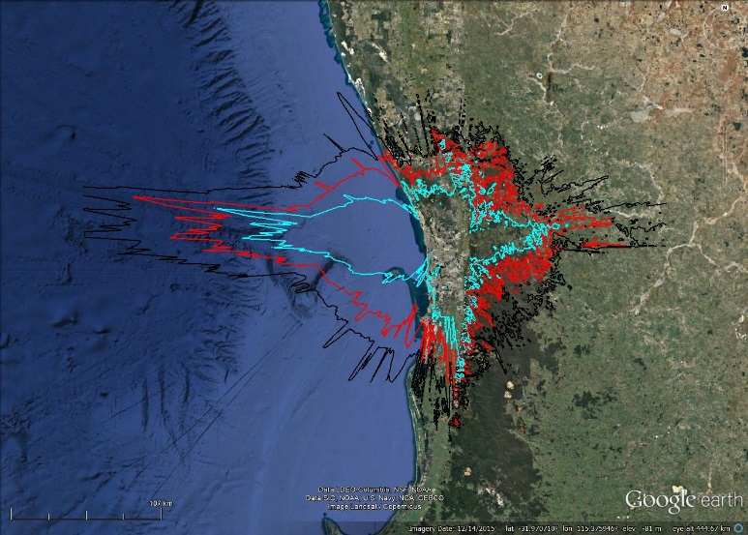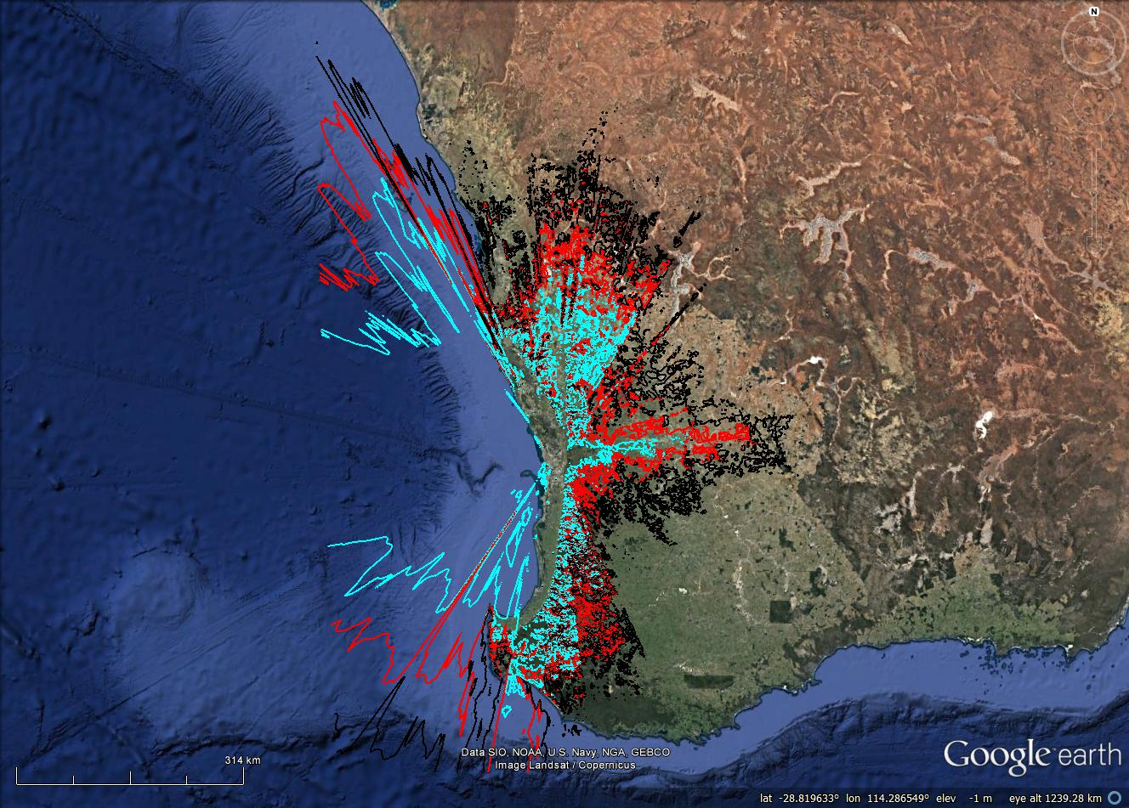

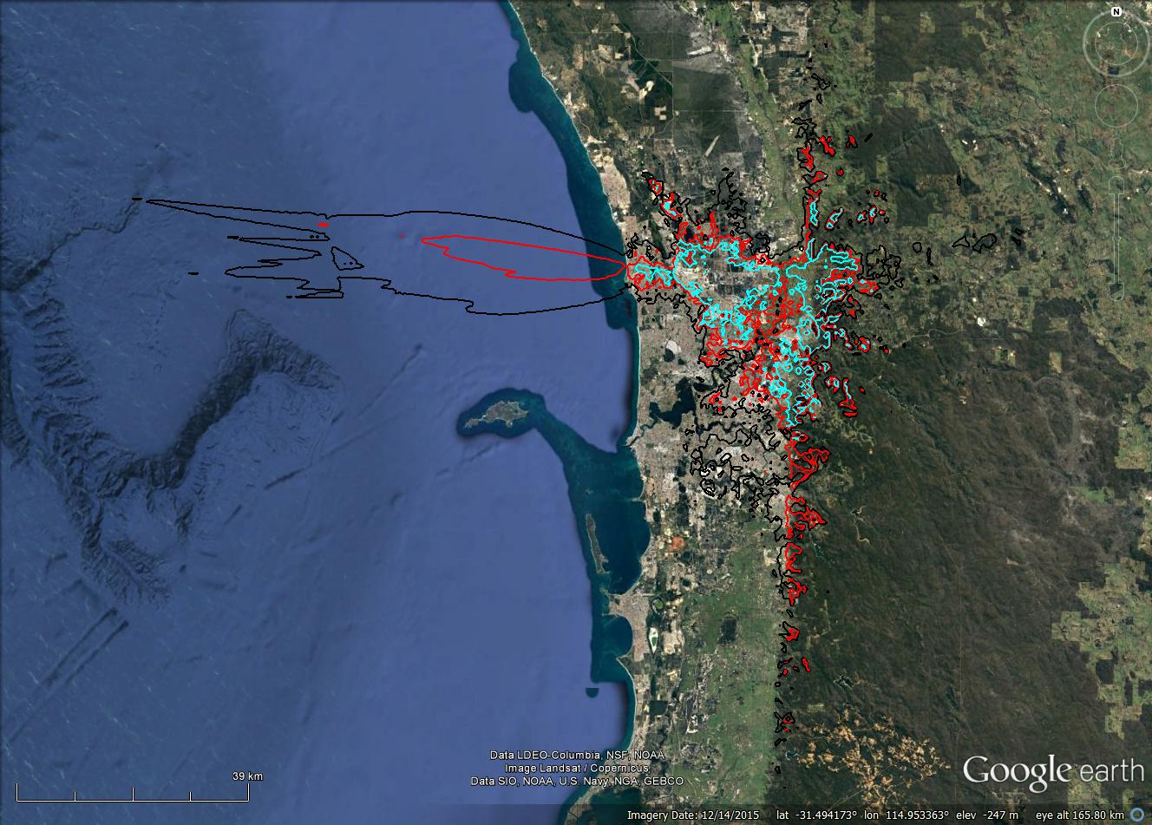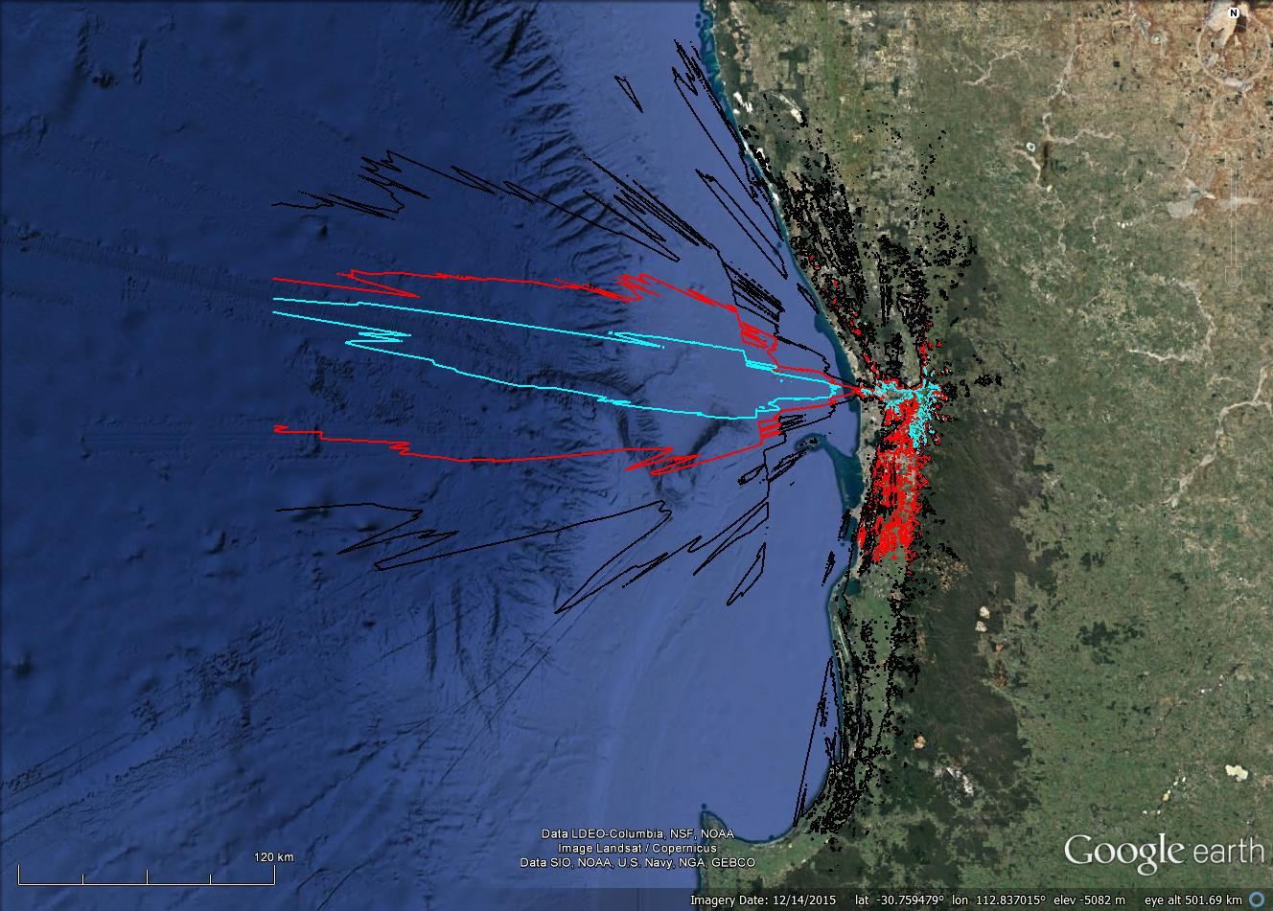
Top left: Macro BS, long-term protection. Top right: Macro BS, short-term protection. Bottom left: Small-cell BS, long-term protection. Bottom right: Small-cell BS, short-term protection.
Red contour represents results for standard parameters; black and blue represent a ±10 dB sensitivity analysis, respectively.

- Potential areas where a MBB UE can cause interference into an earth receive station at Landsdale
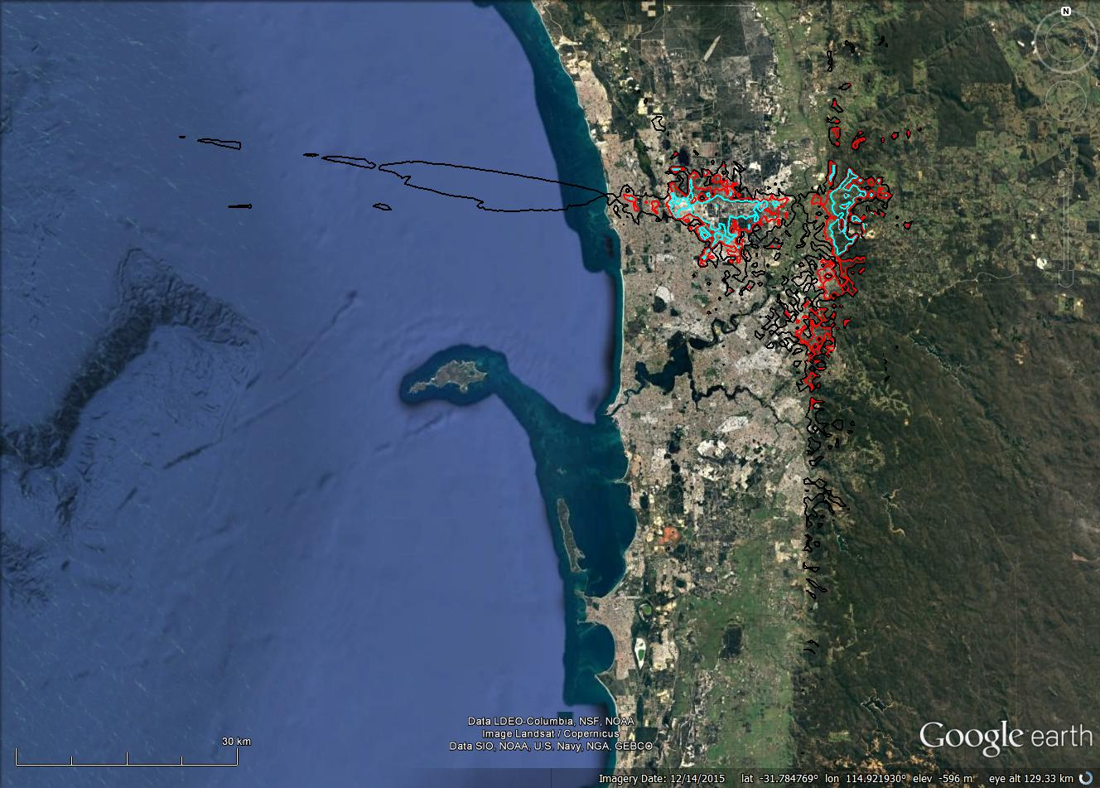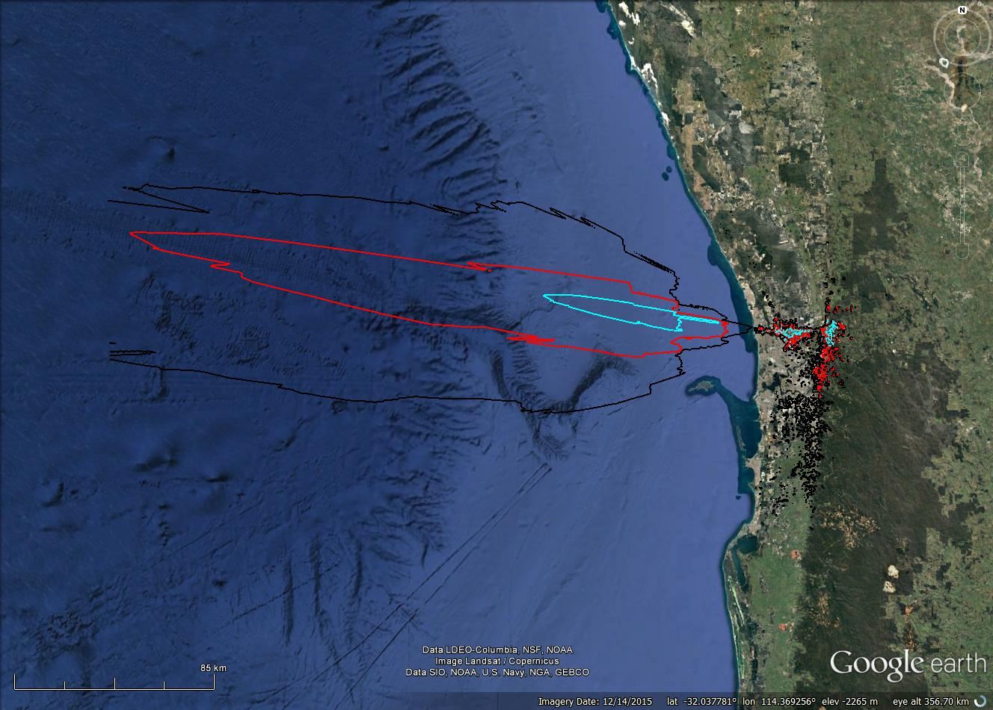

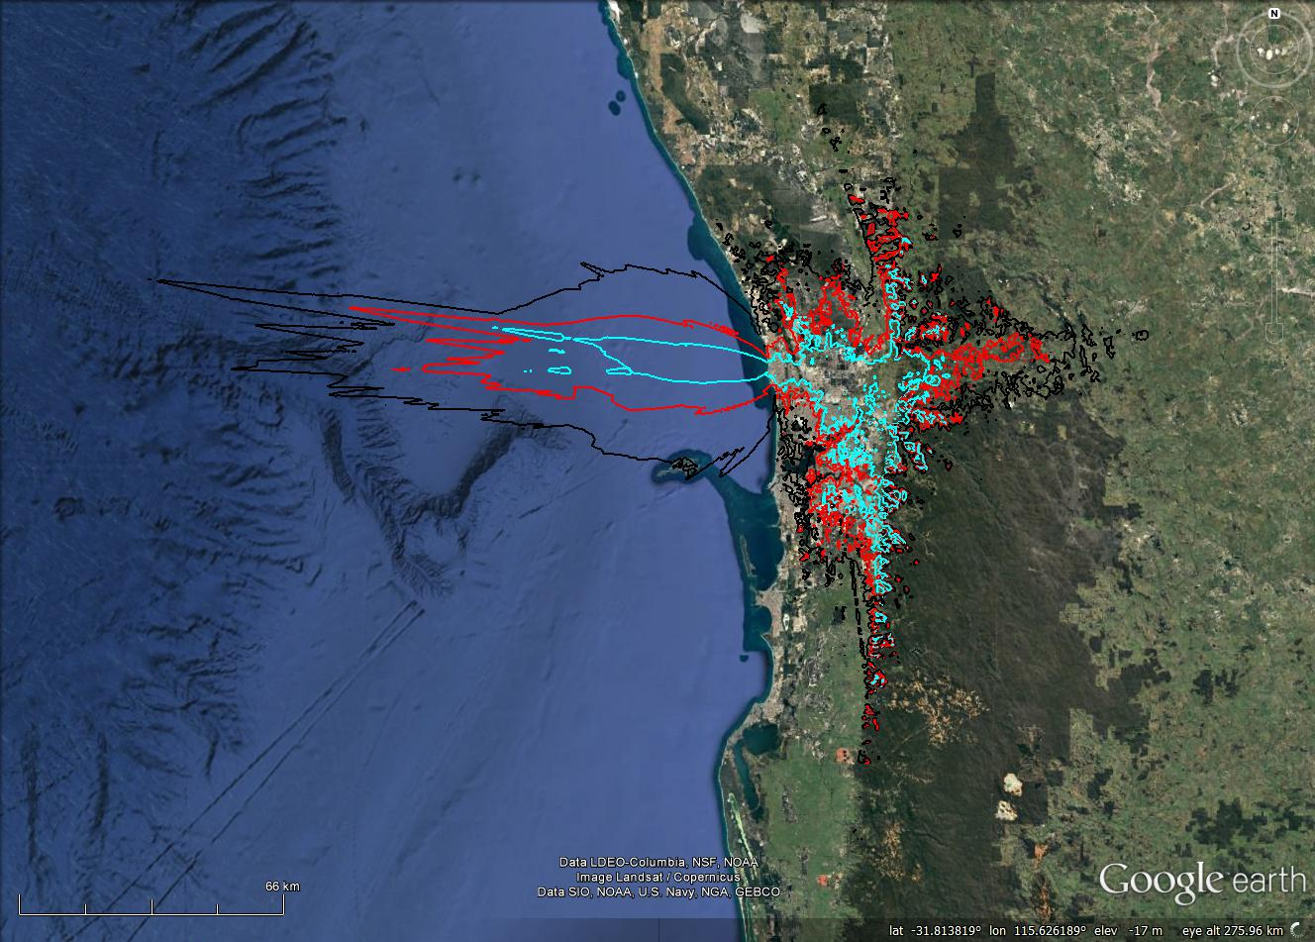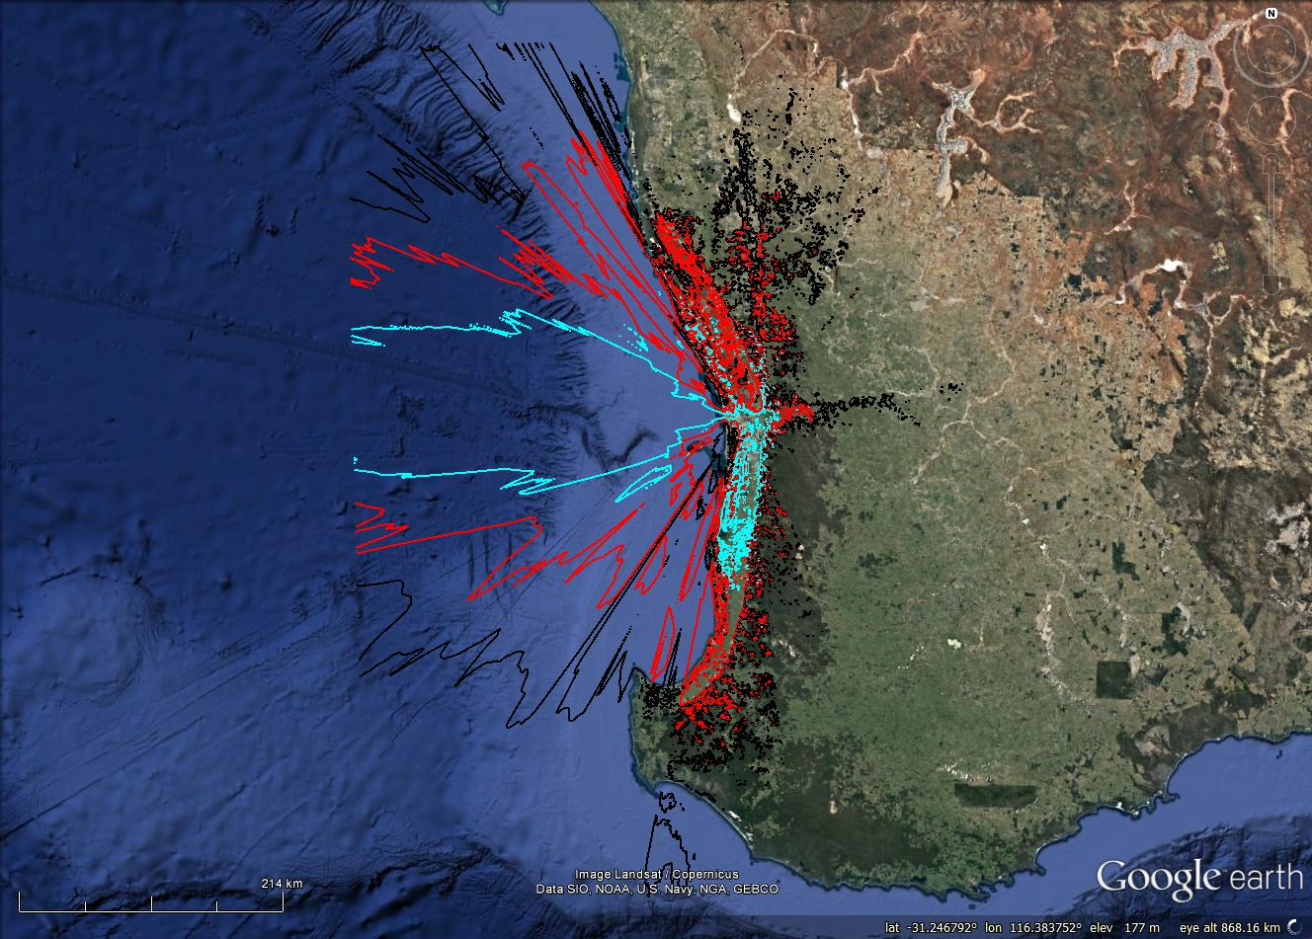
Top left: mobile UE, long-term protection. Top right: mobile UE, short-term protection. Bottom left: fixed UE, long-term protection. Bottom right: fixed UE, short-term protection.
Red contour represents results for standard parameters; black and blue represent a ±10 dB sensitivity analysis, respectively.

- Potential areas where a MBB BS can cause interference into an earth receive station at Lockridge
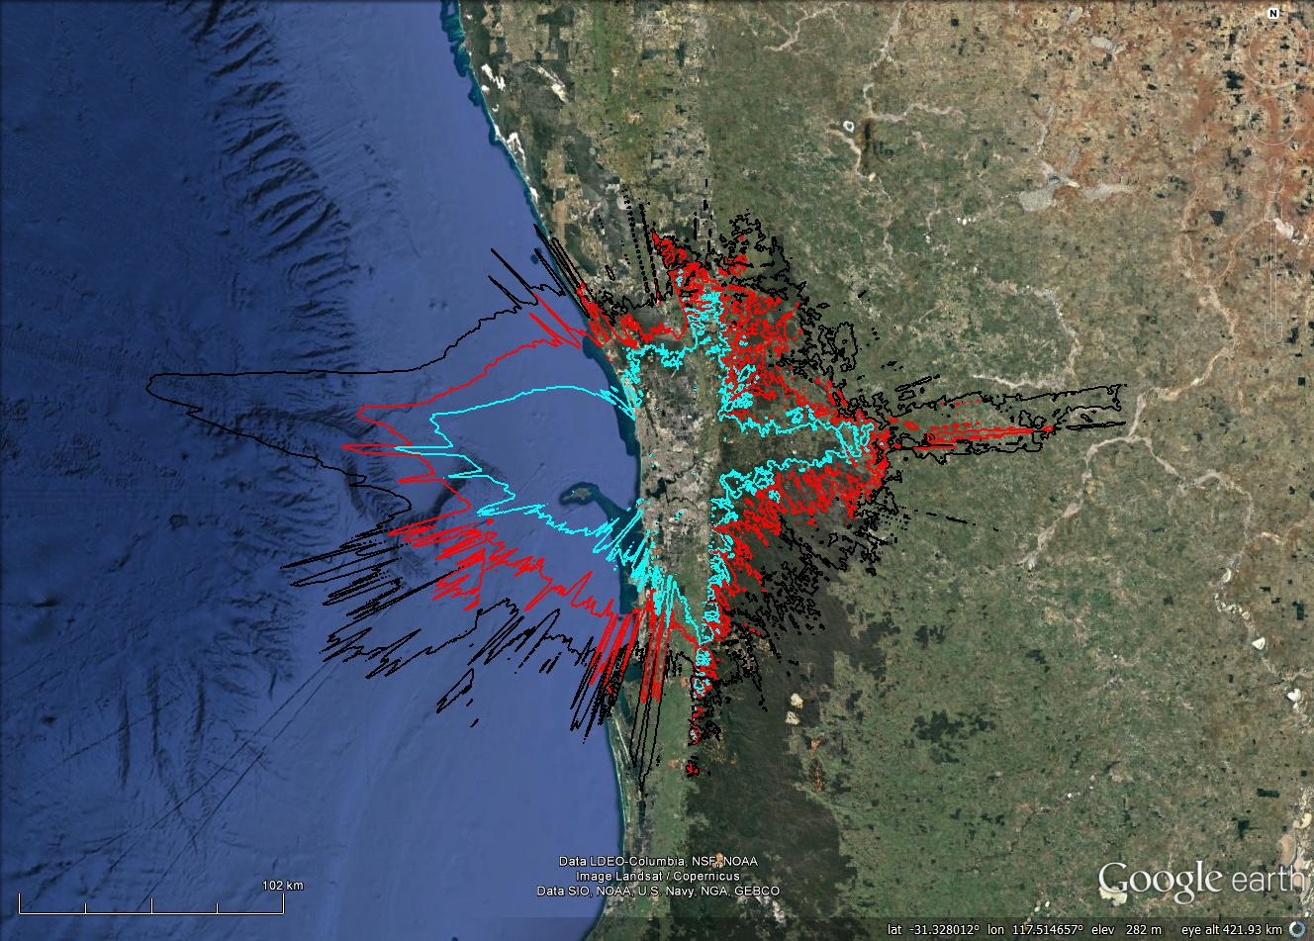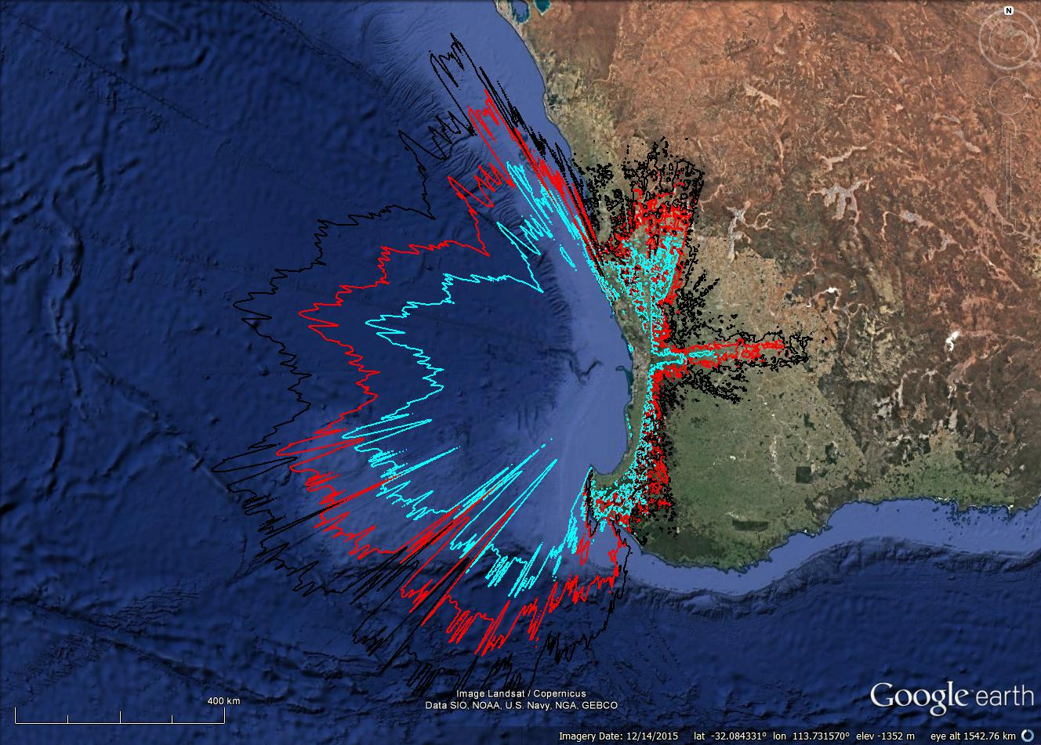

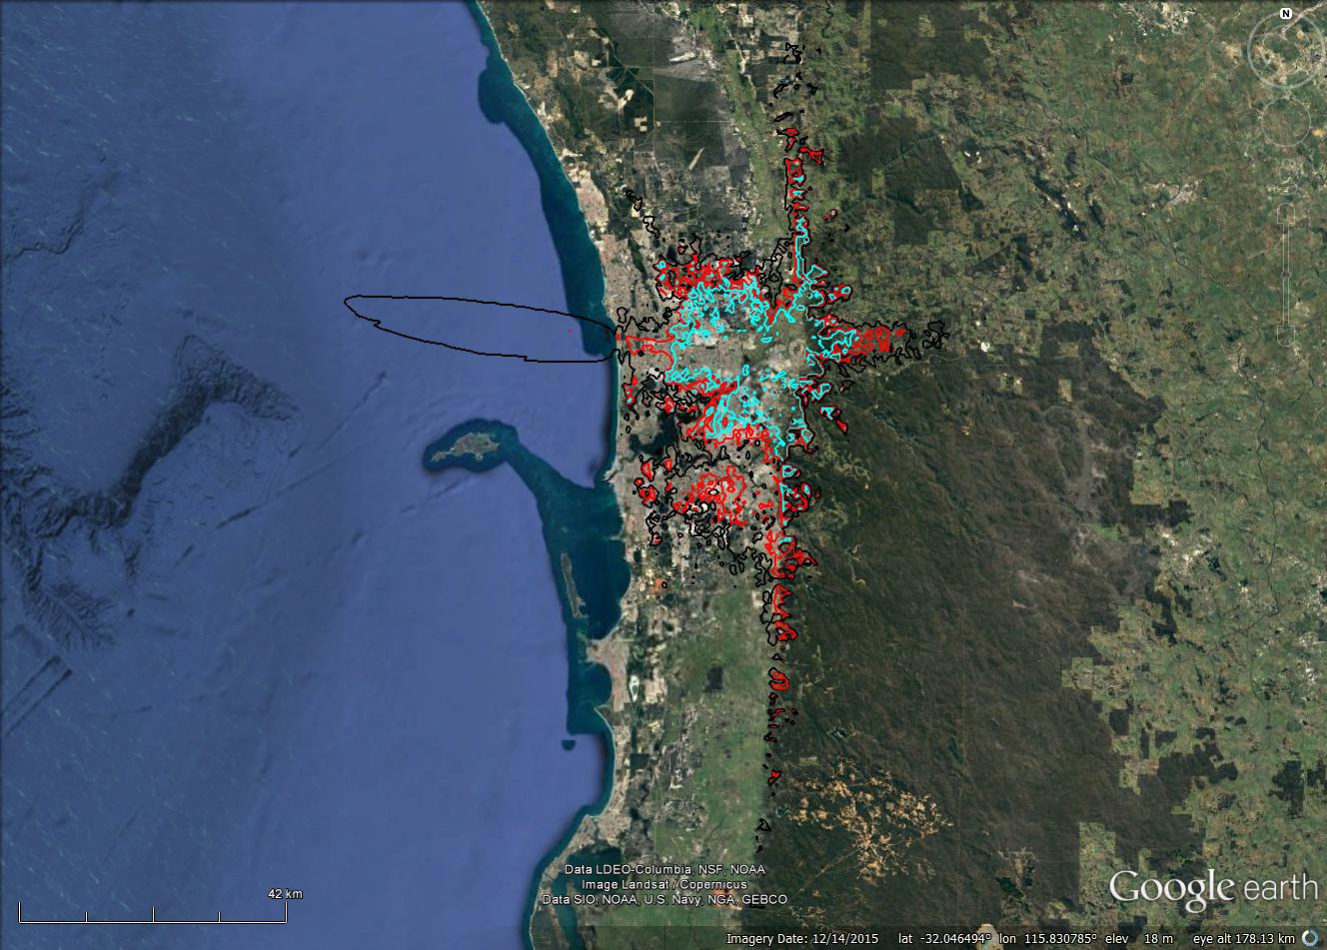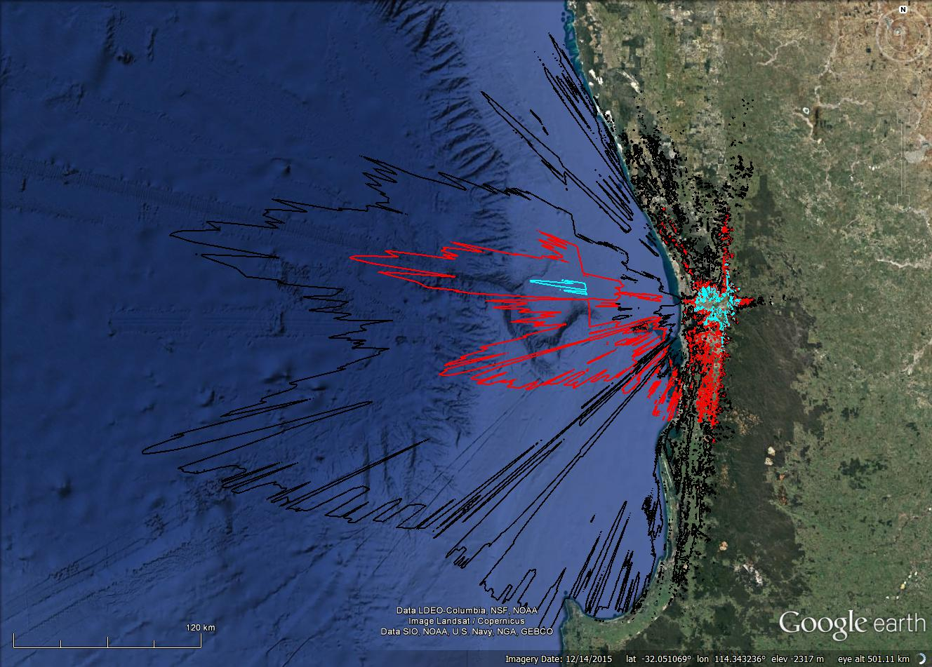
Top left: Macro BS, long-term protection. Top right: Macro BS, short-term protection. Bottom left: Small-cell BS, long-term protection. Bottom right: Small-cell BS, short-term protection.
Red contour represents results for standard parameters; black and blue represent a ±10 dB sensitivity analysis, respectively.

- Potential areas where a MBB UE can cause interference into an earth receive station at Lockridge
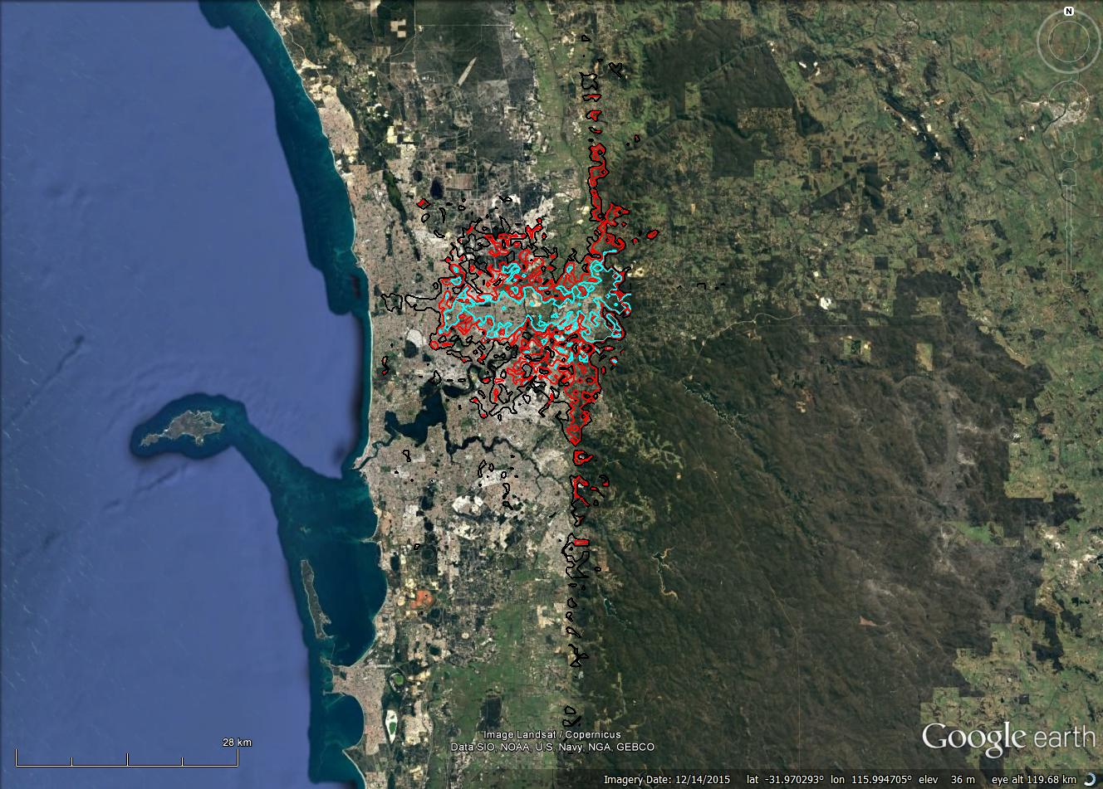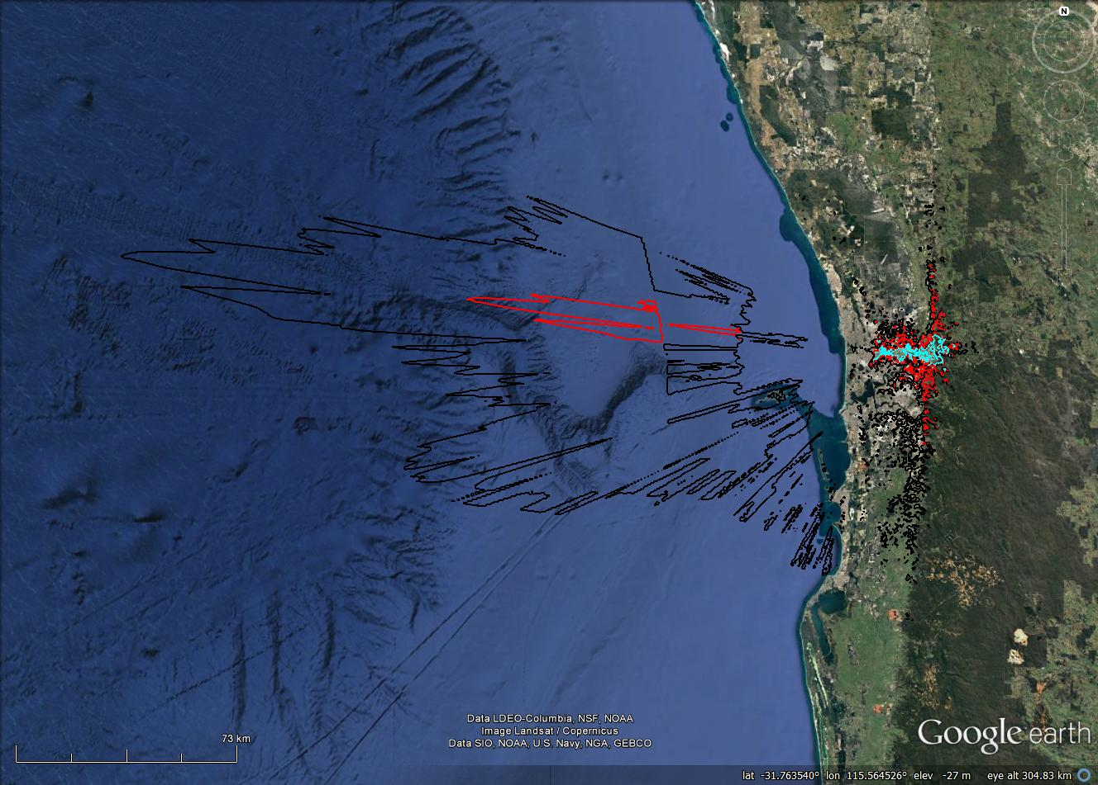

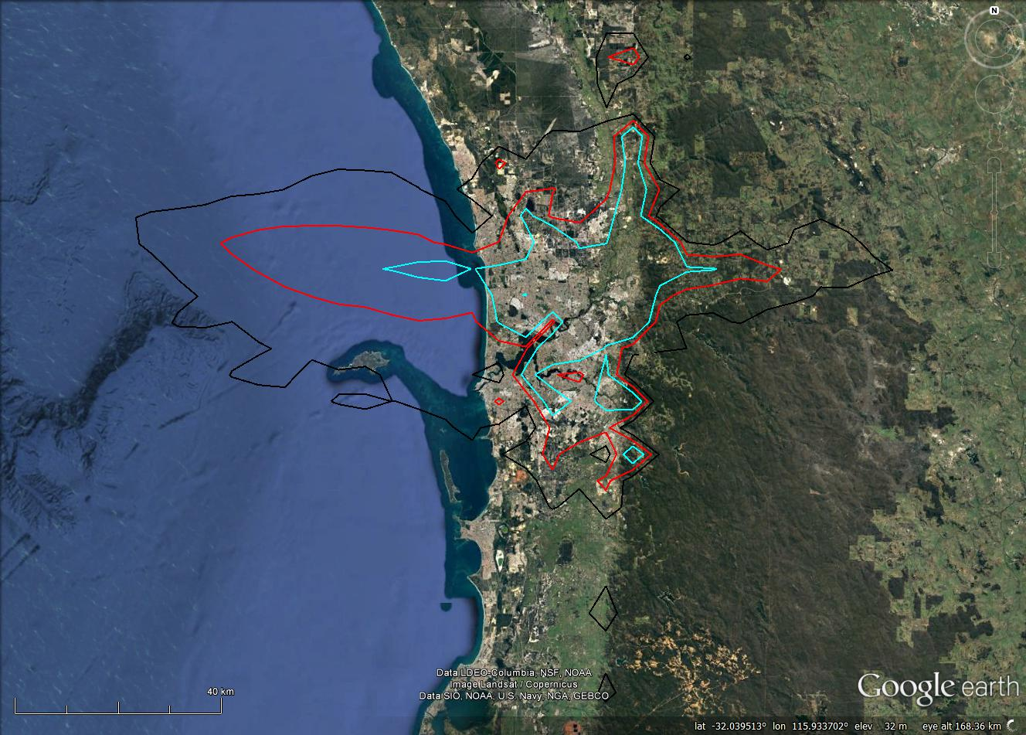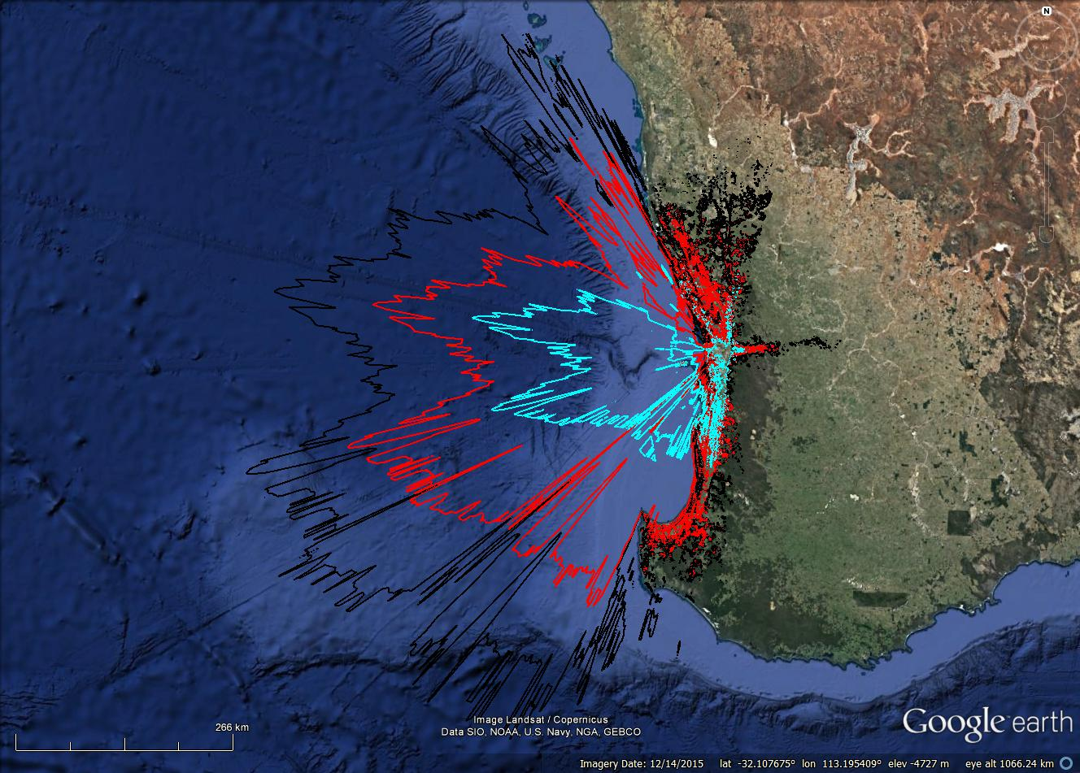
Top left: mobile UE, long-term protection. Top right: mobile UE, short-term protection. Bottom left: fixed UE, long-term protection. Bottom right: fixed UE, short-term protection.
Red contour represents results for standard parameters; black and blue represent a ±10 dB sensitivity analysis, respectively.

- Potential areas where a MBB BS can cause interference into an earth receive station at Belrose
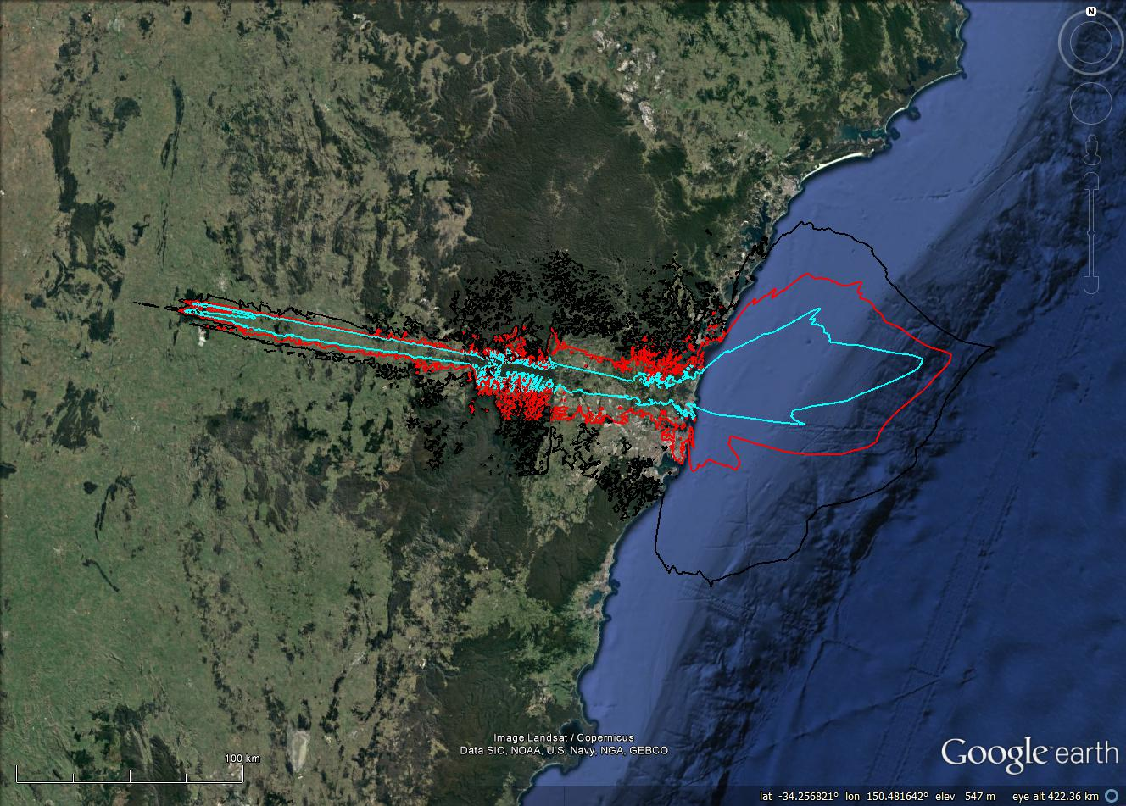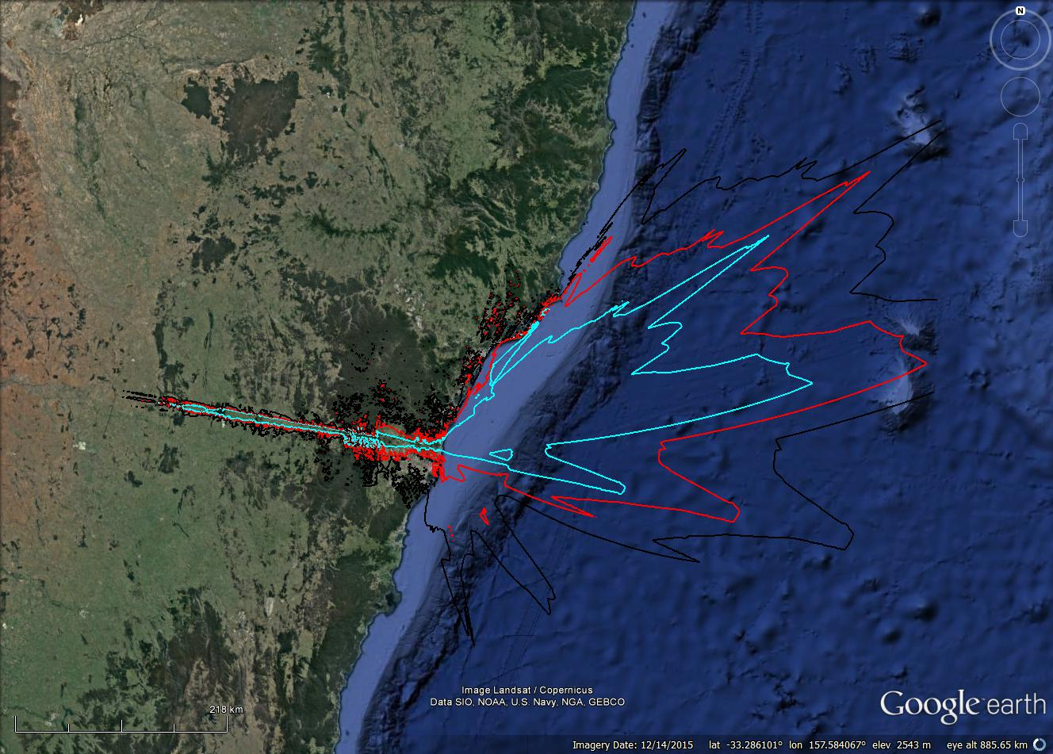

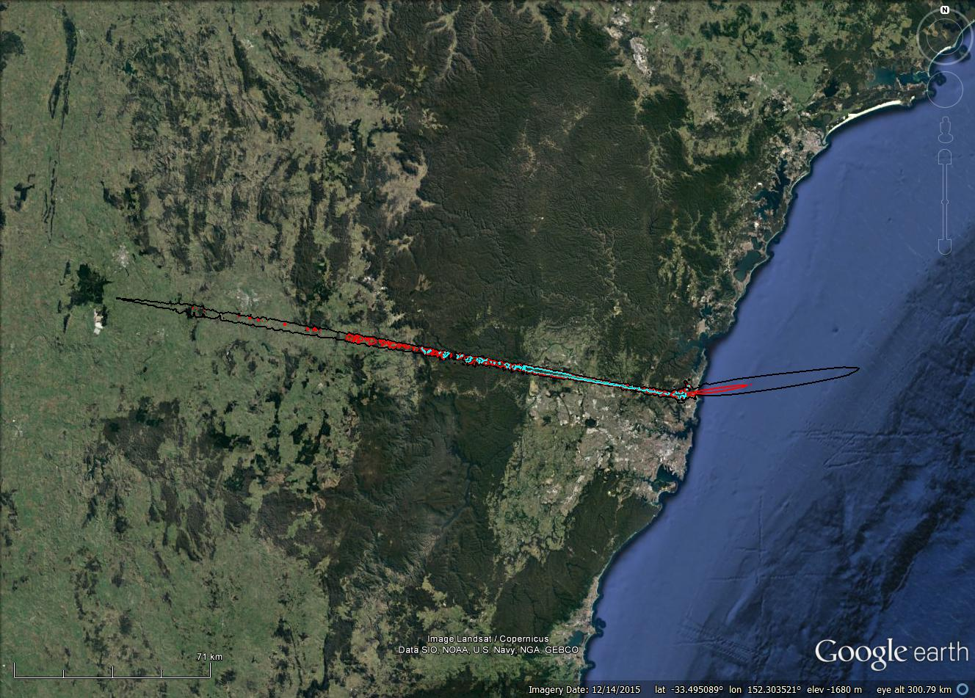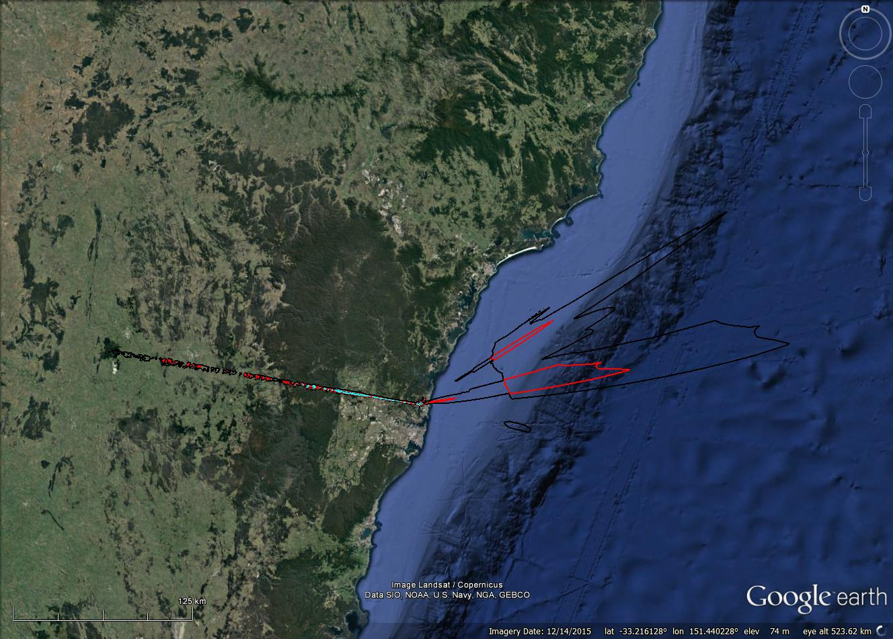
Top left: Macro BS, long-term protection. Top right: Macro BS, short-term protection. Bottom left: Small-cell BS, long-term protection. Bottom right: Small-cell BS, short-term protection.
Red contour represents results for standard parameters; black and blue represent a ±10 dB sensitivity analysis, respectively.

- Potential areas where a MBB UE can cause interference into an earth receive station at Belrose
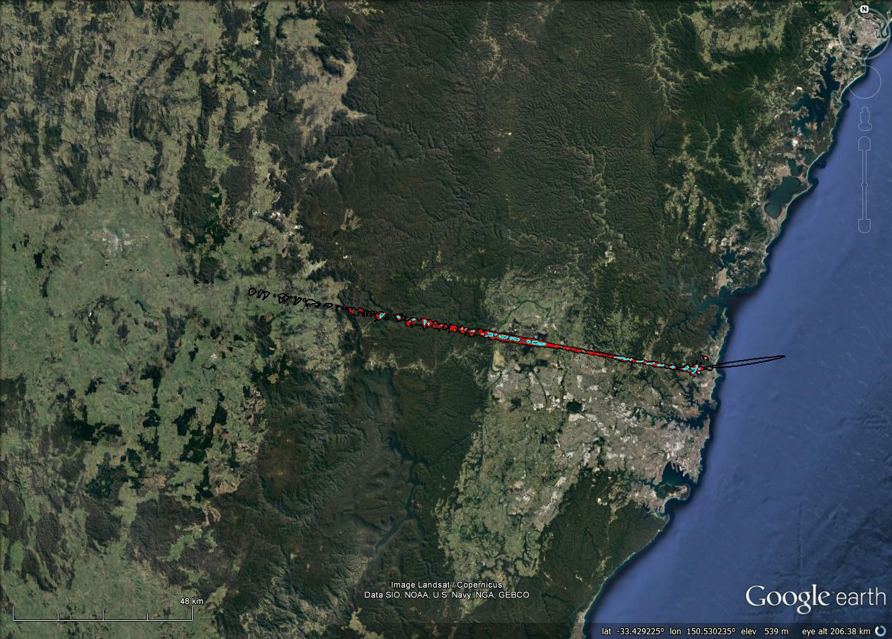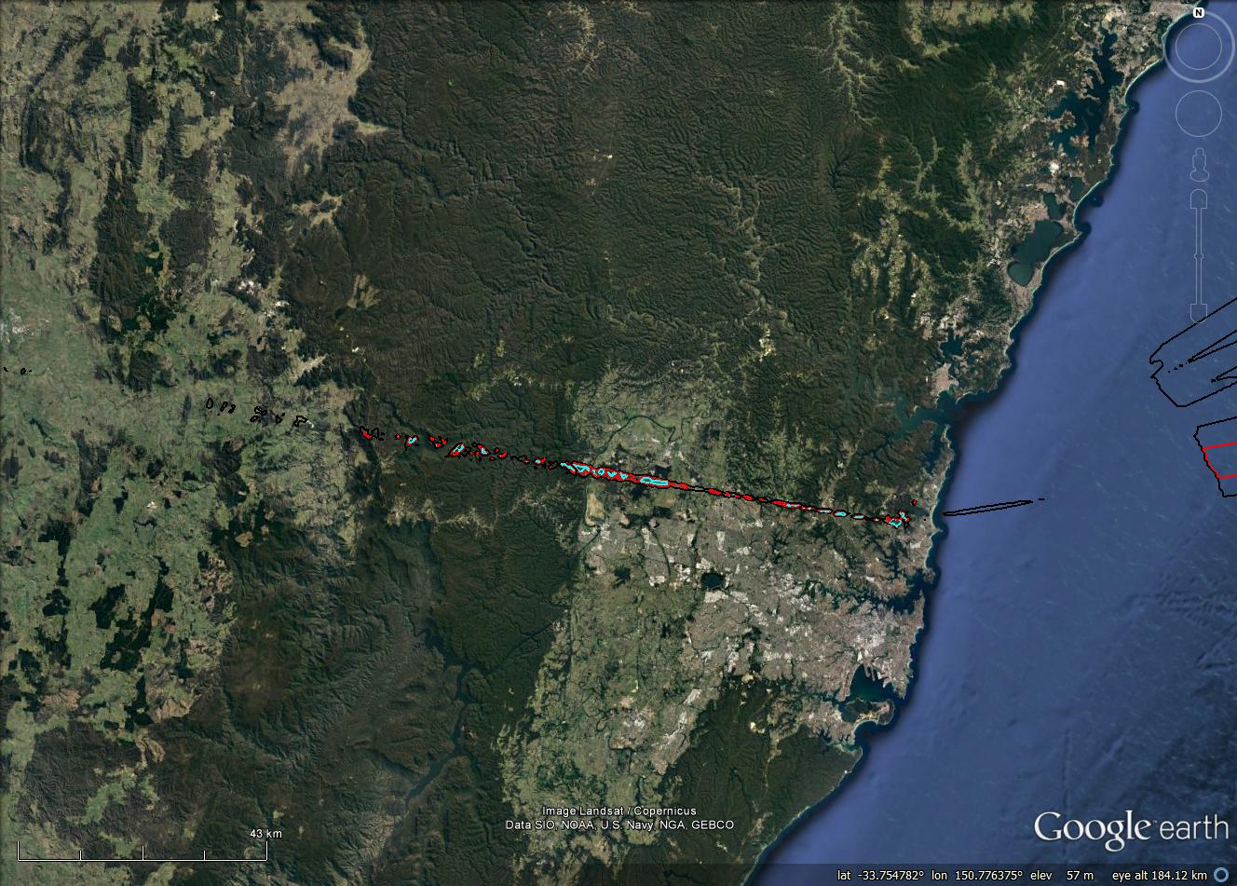

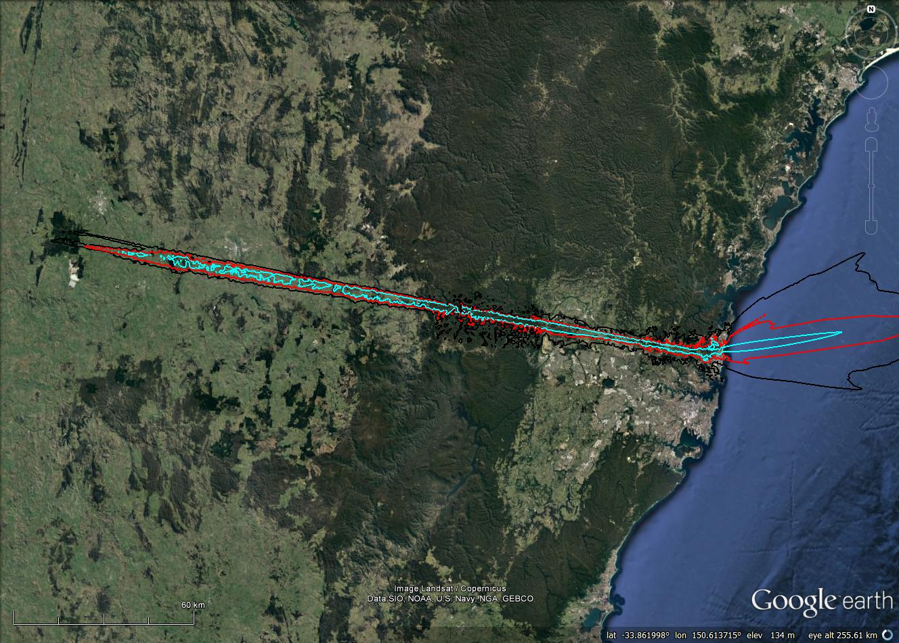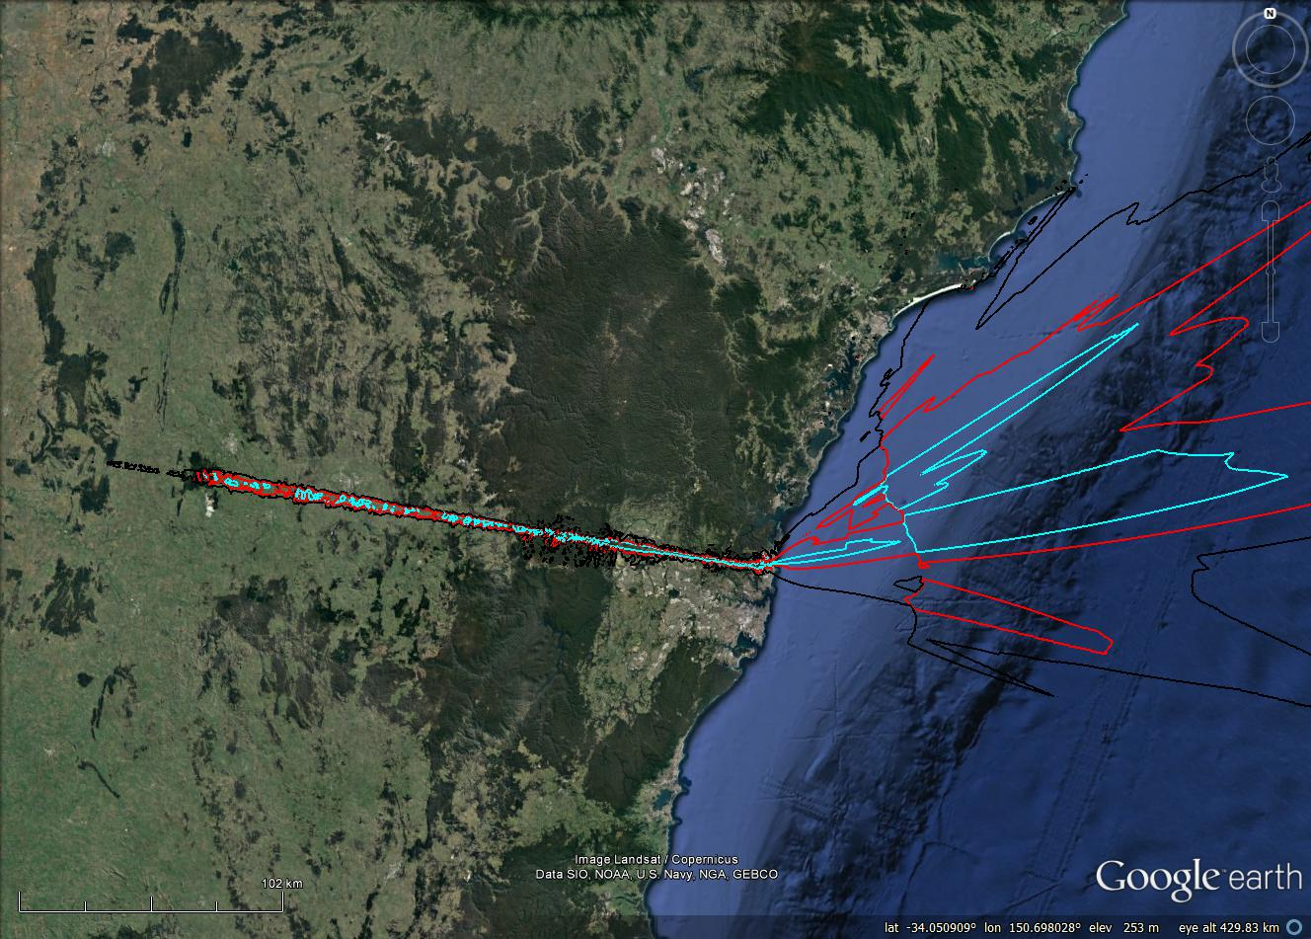
Top left: mobile UE, long-term protection. Top right: mobile UE, short-term protection. Bottom left: fixed UE, long-term protection. Bottom right: fixed UE, short-term protection.
Red contour represents results for standard parameters; black and blue represent a ±10 dB sensitivity analysis, respectively.

Appendix 5:
Earth station protection zones
The ACMA encourages the sustainable siting of earth stations and other space communications facilities. It aims to provide options for satellite earth stations and other space communications facilities while meeting the needs of these facilities into the future and providing long-term planning certainty. One option proposed to meet this aim is to create earth station protection zones.
Earth station protection zones are a tool the ACMA and industry can jointly use to provide long-term security to the satellite industry while enabling spectrum in more populous areas to reach its highest value use. This approach involves identifying an area where regulatory measures can be implemented to protect the operation of the satellite and space sectors. The framework defining these zones would include mechanisms to provide assurance of spectrum availability and use into the future.
Locating earth stations away from capital cities in areas of low population density enables the ACMA to protect an area around these sites, while freeing up spectrum in highly populated areas for use by terrestrial services where this is determined to be the highest value use. Developments such as the expansion of optical fibre networks throughout Australia mean there is no longer an overwhelming requirement to maintain or establish all earth stations within capital cities.
The ACMA previously recognised the value of locating earth stations in areas of low population density and has already established an earth station protection zone around Mingenew in Western Australia. This zone was established in order to preserve options for the future deployment of space communications facilities and is protected in all space bands by Embargo 49.
Over the past few years, the west coast earth station protection zone has increasingly been used by the space and satellite industries. The ACMA will continue to support this use into the future. Previously, the ACMA has also sought advice from industry about the identification of an east coast earth station protection zone. However, to date industry has not engaged in detail on this issue.
With the current review of arrangements in the 3.6 GHz band potentially affecting incumbent FSS earth station licences, it is timely to revisit the concept. This is because, depending on the final replanning option implemented, one or more C-Band earth station facilities may be required to geographically relocate. In the event this occurs, suitable location(s) will need to be identified.
In identifying an appropriate location for an earth station protection zone, the ACMA proposes to consider the criteria identified in the next section. It may not be possible to optimise the outcome for all these criteria. Specifically optimising one or more of them can have the opposite effect on other criteria. Therefore, an appropriate balance may need to be found when assessing the merits of one site over another.

Proposed criteria for establishing an earth station protection zone
The following criteria are proposed to guide consideration in identifying appropriate location(s) for earth station protection zone(s):
- Maximise the amount of the geostationary satellite orbit (GSO) visible from a single location—the amount of the GSO visible to an earth station is a function of its latitude—the further south (of the equator) the location is, the less is visible. This criteria only relates to earth stations communicating with satellites in the GSO.
- Maximise the amount of the GSO visible from the east and west coast earth station protection zones combined—the further apart in longitude east and west coast earth station protection zones are, the greater the combined portion of the GSO that is visible. This criteria only relates to earth stations communicating with satellites in the GSO.
- Minimise the population encompassed within an earth station protection zone—the area and frequency ranges (that is, those used by satellite services) encompassed by an earth station protection zone will be subject to a spectrum embargo or other tool that restricts access by new non-satellite services. This is done to ensure protection to earth station receivers and maximise the availability of, and access to, the spectrum by satellite services in these zones. However, it can affect the ability to provide new services to those people and business located within the zone. It is expected that the smaller the total population affected by the protection zone, the greater the chance that alternative spectrum or delivery options would be able to provide a similar result. In the ACMA’s 2011 Earth station siting paper, a population of 25,000 or fewer was considered a trigger for when wireless broadband needs (for example) could be met in other bands. When determining the population a service could be denied to, the effect of local terrain (for example) could be taken into account.
- Provide long-term protection and access to as many satellite service bands as possible—it is expected that the viability of an earth station protection zone will depend on the bands available for use and certainty about their long-term availability. Embargo 49 provides an indication of the bands that could be considered for inclusion in any earth station protection zone created. A similar embargo or other instrument would be put in place to ensure protection of any new earth station protection zone(s).
- Minimise the number of incumbent services affected by the creation of an earth station protection zone—a location should be chosen that minimises the number of incumbent services that could affect the availability of spectrum to satellite services within the protection zone. In order to make an area a viable earth station protection zone, there may be some locations where incumbent services would be required to consider alternative options or cease operation.
- The cost and availability of infrastructure should not be prohibitive—general considerations such as planning, power supply, land availability and staffing requirements will need to be taken into account.
Local conditions should be conducive to the operation of earth stations—factors such as the local rainfall rate (practically important for higher frequency band operations), likelihood of flooding, risk of bushfires, risk of earthquakes or cyclones could be considered.

Example assessment of sites
An assessment of four potential sites for an east-coast earth station protection zone is provided below. The aim is to provide a worked example of how different sites can be assessed against the criteria identified above and also provide a starting point for discussion with industry on this matter. The four sites identified for assessment—Quirindi, Uralla, Dubbo and Moree—are all in New South Wales.

Site near Quirindi
In the 2011 Earth station siting paper, a simple assessment for a prospective earth station protection zone was made for a site near Quirindi. The assessment only considered the size of restricted areas for C-band operations. However, it provides an indication of the analysis the ACMA would undertake on the viability of a particular location.
- C-band restricted areas around the site near Quirindi
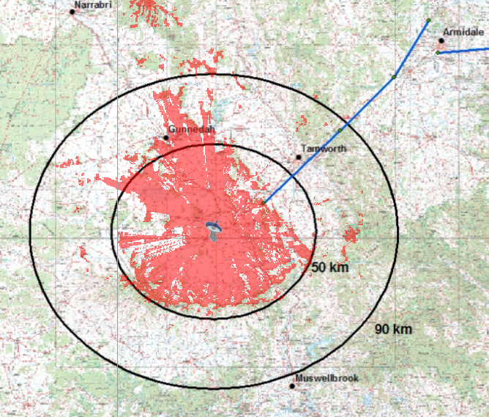

The red area of Figure 21 portrays the size a restriction area would need to be in order to protect the site from terrestrial services operating in the C-band. Higher frequencies would require a smaller restriction area, whereas lower frequencies would require a greater restriction area.
The base of the zone is constrained by a semi-circular ridge at about 50 km, which shields the site in the direction of Sydney and Newcastle. There is also shielding in the direction of Tamworth. Thus, the spectral denial of the area is low.
The blue lines represent existing incumbent fixed links operating in C-band. For this particular site, it is likely that these links could remain as they do not appear to threaten the viability of the site.
This site is within an hour of a number of population centres where amenities for workers could be found and is also within two hours of Newcastle.
On face value, the site meets many of the criteria defined for identifying an earth station protection zone. However, the ACMA understands there may be a number of issues about control of the land in the area, which may affect availability and long-term access. This may make the area unsuitable for the level of investment and long-term certainty required to make a site viable.

Site near Uralla
A high-level analysis was performed for a potential earth station protection zone near Uralla, on the Northern Tablelands of New South Wales. The town is located at the intersection of the New England Highway and Thunderbolts Way, 360 km north of Sydney. 2011 census data states that the Uralla Urban Centre and Locality (UCL) contains 2,388 people.
The initial reason for considering this site is the existing earth station facility operated by Lockheed Martin, which is located around six kilometres east of Uralla. Identification of this site would minimise relocation costs and other issues. Another benefit of this site is that it is located close to a number of population centres with amenities for workers.
Unfortunately, the existing earth station site does not make good use of the local terrain to shield itself (or equivalently reduce the size of any potential protection zones).
Table 12 shows UCLs within 100 km of the Uralla UCL. This table only shows population associated with UCLs—the actual population in the area is likely to be greater.
- Details of UCLs within 100 km of Uralla UCL
UCL name | 2011 population | Distance (km) | Bearing (°)
Uralla | 2,388 | 0 | 0
Armidale | 19,818 | 17 | 230
Walcha | 1,482 | 36 | 346.8
Guyra | 1,947 | 45 | 200.6
Moonbi (L) | 324 | 55 | 43.7
Kootingal | 1,599 | 59 | 42.1
Bundarra (L) | 404 | 61 | 143.3
Attunga (L) | 339 | 68 | 61.7
Tamworth | 36,131 | 69 | 46.6
Nemingha (L) | 232 | 70 | 41.8
Manilla | 2,107 | 71 | 80.9
Kingswood (L) | 906 | 77 | 44.5
Tingha (L) | 527 | 78 | 161.4
Barraba | 1,150 | 86 | 108.8
Gilgai (L) | 393 | 90 | 158.5
Nundle (L) | 270 | 94 | 21.1
Inverell | 9,347 | 97 | 160.2

Table 13 shows there are 1,314 services operating within 100 km of the Uralla UCL in satellite bands identified in Embargo 49.
- Licensed services operating within 100 km of the Uralla UCL in satellite bands identified in Embargo 49 (RRL 1 May 2017)
Service subtype | Devices
Point-to-point | 901
Device registration (spectrum licences) | 298
PMTS Class B | 57
Earth receive | 27
Fixed earth | 25
Point-to-multipoint | 6
Total | 1,314

More analysis of the location would be required to definitively determine if this is an appropriate location for an earth station protection zone. This would include modelling of the interference environment similar to the site near Quirindi. However, given the high population potentially affected (particularly at Armidale and Tamworth) and the high number of existing services in the area, it is unlikely to be considered a suitable long-term option.

Site near Dubbo
A high-level analysis was performed for a potential earth station protection zone near Dubbo, which is the largest city in the Orana region of New South Wales, about 300 km northwest of Sydney. The 2011 census data states that the Dubbo UCL contains 32,327 people.
The site is located close to a number of population centres with amenities for workers.
Table 14 shows UCLs within 100 km of the Dubbo UCL. This table only shows the population associated with UCLs—the actual population in the area is likely to be greater.
- Details of UCLs within 100 km of Dubbo UCL
UCL name | 2011 population | Distance (km) | Bearing (°)
Dubbo | 32,327 | 0 | 0
Firgrove (L) | 597 | 3 | 278.8
Wongarbon (L) | 525 | 9 | 288.4
Geurie (L) | 454 | 18 | 307.2
Narromine | 3,789 | 25 | 80.1
Wellington | 4,540 | 37 | 317.1
Yeoval (L) | 292 | 48 | 355.6
Gilgandra | 2,664 | 51 | 181.8
Trangie (L) | 849 | 55 | 109.1
Peak Hill (L) | 755 | 58 | 36
Mendooran (L) | 302 | 59 | 225.5
Cumnock (L) | 275 | 70 | 348.4
Dunedoo (L) | 802 | 70 | 253.8
Gulgong | 1,866 | 81 | 277.3
Warren | 1,523 | 86 | 129.7
Mudgee | 9,830 | 87 | 290.1
Molong | 1,629 | 89 | 344.5
Putta Bucca - Bombira (L) | 493 | 91 | 289.9
Gulargambone (L) | 367 | 93 | 172
Manildra (L) | 464 | 96 | 355.5
Parkes | 10,026 | 98 | 21.1
Binnaway (L) | 457 | 98 | 223.1
Tullamore (L) | 210 | 99 | 68

Table 15 shows there are 959 services operating within 100 km of the Dubbo UCL in satellite bands identified in Embargo 49.
- Licensed services operating within 100 km of the Dubbo UCL in satellite bands identified in Embargo 49 (RRL 1 May 2017)
Service subtype | Devices
Point-to-point | 759
Device registration (spectrum licences) | 158
PMTS Class B | 32
Point-to-multipoint | 4
Earth receive | 4
Fixed earth | 2
Total | 959

More analysis of the location would be required to definitively determine if this is an appropriate location for an earth station protection zone. This would include modelling of the interference environment, similar to the site near Quirindi. This would occur before a decision is made on whether or not to evaluate the other criteria defined for establishment of an earth station protection zone. However, given the high population potentially affected (particularly at Dubbo) and the high number of existing services in the area, it is unlikely to be considered a suitable long-term option.

Site near Moree
A high-level analysis was performed for a potential earth station protection zone near Moree, which is located on the banks of the Mehi River, 500 km north-northwest of Sydney and 380 km southwest of Brisbane. The 2011 census data states that the Moree UCL contains 7,720 people.
The site is located close to a number of population centres with amenities for workers.
Table 16 shows UCLs within 100 km of the Moree UCL. This table only shows the population associated with UCLs—the actual population in the area is likely to be greater. Analysis of the UCL populations in the table suggest a far smaller population would potentially be affected than with the Uralla or Dubbo sites.
- Details of UCLs within 100km of Moree UCL
UCL name | 2011 population | Distance (km) | Bearing (°)
Moree | 7,720 | 0 | 0
Ashley (L) | 339 | 14 | 168.8
Pallamallawa (L) | 253 | 26 | 269.7
Warialda | 1,120 | 68 | 275.5
Bingara | 1,093 | 78 | 299.8
Wee Waa | 1,653 | 87 | 25.7
Narrabri | 5,890 | 88 | 3.1
Mungindi (NSW Part) (L) | 485 | 95 | 124.2
Delungra (L) | 291 | 95 | 281.4

Table 17 shows there are 289 services operating within 100 km of the Moree UCL in satellite bands identified in Embargo 49.
- Licensed services operating within 100 km of the Moree UCL in satellite bands identified in Embargo 49 (RRL 1 May 2017)
Service subtype | Devices
Point-to-point | 253
PMTS Class B | 29
Device registration (spectrum licences) | 6
Earth receive | 1
Total | 289

More analysis of the location would be required to definitively determine if this is an appropriate location for an earth station protection zone. This would include modelling of the interference environment, similar to the site near Quirindi. This would occur before a decision is made on whether or not to evaluate the other criteria defined for establishment of an earth station protection zone. However, given the low population potentially affected and the low number of existing services in the area, this site may be a suitable long-term option.

Appendix 6:
Geographical area descriptions
The ACMA has defined four geographical area options that could be considered for replanning in the 3.6 GHz band. These areas are displayed in Figure 22. A brief description of each follows:
- Area 1—covers all capital cities (except Darwin and Hobart). It largely mirrors the metro areas originally covered by the 2009 modification to Embargo 42.
- Area 2—mirrors the areas developed by the ACMA in implementing the October 2014 Ministerial Direction. The areas were defined large enough to support the deployment of services in outer-metro and metro-fringe areas, while reducing adjacent area interference concerns. Refer to Annex D of RALI MS39 for area descriptions.
- Area 3—mirrors the metro and regional areas subject to spectrum licensing in the 3.4 GHz band. Refer to Schedule 2 of the Radiocommunications (Spectrum Re-allocation) Declaration 2000 for a description of the area.
Australia-wide—covers all of Australia, but excludes Australian external territories.
As stated in numerous RALIs developed by the ACMA, additional considerations apply to any proposed apparatus licence in the 3.6 GHz band that is within 150 km of latitude 12.449722° south and longitude 130.833333° east (GDA94 Datum) in Darwin (NT). The RALI states that any request for assignments within this zone must be referred to the ACMA for assessment. As this affects the availability of the 3.6 GHz band in and around Darwin, it would likely devalue the area for use by dense wide-area MBB networks. Consequently, it is proposed that the Darwin area not be considered for area-wide licensing under the Area 1, Area 2 or Area 3 options. Instead, it is recommended that existing site-based apparatus licensing arrangements remain in place.
The Australian Spectrum Map Grid (ASMG) is used to define geographical areas over which spectrum licences are issued. The Hierarchical Cell Identification Scheme (HCIS) is a naming convention developed by the ACMA that applies unique ‘names’ to each of the cells that make up the ASMG. The ASMG and HCIS are described in detail in the document The Australian spectrum map grid 2012.
The HCIS coordinates in Table 15 can be converted into a Placemark file (viewable in Google Earth) through a facility on the ACMA website: www.acma.gov.au/theACMA/convert-hcis-area-description-to-a-placemark
- 3.6 GHz band geographical area re-farming options

- HCIS description of areas
Area | Sub-area name | HCIS
Area 1 | Adelaide A | IW3O, IW3P, IW6C, IW6D, IW3J5, IW3J6, IW3J8, IW3J9, IW3K4, IW3K5, IW3K6, IW3K7, IW3K8, IW3K9, IW3L4, IW3L5, IW3L6, IW3L7, IW3L8, IW3L9, IW3N2, IW3N3, IW3N5, IW3N6, IW3N8, IW3N9, IW6B2, IW6B3, IW6B5, IW6B6, IW6B8, IW6B9, IW6F2, IW6F3, IW6F5, IW6F6, IW6G1, IW6G2, IW6G3, IW6G4, IW6G5, IW6G6, IW6H1, IW6H2, IW6H3, IW6H4, IW6H5, IW6H6
 | Brisbane A | NT8K, NT8L, NT9A, NT9B, NT9E, NT9F, NT9I, NT9J, NT9M, NT9N, NU3B, NT5P8, NT5P9, NT6M7, NT6M8, NT6M9, NT6N7, NT6N8, NT6N9, NT6O7, NT6O8, NT8D2, NT8D3, NT8D5, NT8D6, NT8D8, NT8D9, NT8G7, NT8G8, NT8G9, NT8H2, NT8H3, NT8H5, NT8H6, NT8H7, NT8H8, NT8H9, NT8P1, NT8P2, NT8P3, NT8P4, NT8P5, NT8P6, NT9C1, NT9C2, NT9C4, NT9C5, NT9C7, NT9C8, NT9G1, NT9G2, NT9G4, NT9G5, NT9G7, NT9G8, NT9K1, NT9K2, NT9K4, NT9K5, NT9K7, NT9K8, NT9O1, NT9O2, NT9O4, NT9O5, NT9O7, NT9O8, NU3A2, NU3A3, NU3A5, NU3A6, NU3C1, NU3C2, NU3C4, NU3C5, NU3C7, NU3C8, NU3F1, NU3F2, NU3F3, NU3G1, NU3G2
 | Canberra A | MW4D3, MW4D6, MW4D9, MW4H3, MW4H6, MW4H9, MW4L3, MW5A, MW5B1, MW5B2, MW5B4, MW5B5, MW5B7, MW5B8, MW5E, MW5F1, MW5F2, MW5F4, MW5F5, MW5F7, MW5F8, MW5I1, MW5I2, MW5I3, MW5J1, MW5J2
 | Melbourne A | KX3J, KX3K, KX3L, KX3N, KX3O, KX3P, KX6B, KX6C, KX6D, KX6F1, KX6F2, KX6F3, KX6F4, KX6F5, KX6F6, KX6G1, KX6G2, KX6G3, KX6G4, KX6G5, KX6G6, KX6H1, KX6H2, KX6H3, KX6H4, KX6H5, KX6H6, LX1I, LX1J, LX1K1, LX1K4, LX1K7, LX1M, LX1N, LX1O1, LX1O4, LX1O7, LX4A, LX4B, LX4C1, LX4C4, LX4C7, LX4E1, LX4E2, LX4E3, LX4E4, LX4E5, LX4E6, LX4F1, LX4F2, LX4F3, LX4F4, LX4F5, LX4F6, LX4G1, LX4G4
 | Perth A | BV1A4, BV1A5, BV1A5, BV1A6, BV1A7, BV1A8, BV1A9, BV1B4, BV1B5, BV1B6, BV1B7, BV1B8, BV1B9, BV1C4, BV1C5, BV1C6, BV1C7, BV1C8, BV1C9, BV1D4, BV1D5, BV1D6, BV1D7, BV1D8, BV1D9, BV1E, BV1F, BV1G, BV1H, BV1I, BV1J, BV1K, BV1L, BV1M, BV1N, BV1O, BV1P, BV2A4, BV2A5, BV2A6, BV2A7, BV2A8, BV2A9, BV2B4, BV2B5, BV2B6, BV2B7, BV2B8, BV2B9, BV2E, BV2F, BV2I, BV2J, BV2M, BV2N, BV4A, BV4B, BV4C, BV4D, BV4E, BV4F, BV4G, BV4H, BV4I1, BV4I2, BV4I3, BV4I4, BV4I5, BV4I6, BV4J1, BV4J2, BV4J3, BV4J4, BV4J5, BV4J6, BV4K1, BV4K2, BV4K3, BV4K4, BV4K5, BV4K6, BV4L1, BV4L2, BV4L3, BV4L4, BV4L5, BV4L6, BV5A, BV5B, BV5E, BV5F, BV5I1, BV5I2, BV5I3, BV5I4, BV5I5, BV5I6, BV5J1, BV5J2, BV5J3, BV5J4, BV5J5, BV5J6
 | Sydney A | MV9D9, MV9G7, MV9G8, MV9G9, MV9H3, MV9H6, MV9H7, MV9H8, MV9H9, MV9K, MV9L, MV9O, MV9P, MW3C2, MW3C3, MW3C5, MW3C6, MW3C9, MW3D, NV4N6, NV4N9, NV4O4, NV4O5, NV4O6, NV4O7, NV4O8, NV4O9, NV4P4, NV4P5, NV4P6, NV4P7, NV4P8, NV4P9, NV7A7, NV7A8, NV7A9, NV7B3, NV7B6, NV7B7, NV7B8, NV7B9, NV7C, NV7D, NV7E, NV7F, NV7G, NV7H, NV7I, NV7J, NV7K, NV7L, NV7M, NV7N, NV7O, NV7P, NW1A, NW1B, NW1C, NW1D
Area 2 | Adelaide B | IV8K, IV8L, IV8N, IV8O, IV8P, IV9I, IV9J, IV9K, IV9L, IV9M, IV9N, IV9O, IV9P, IW1P, IW2, IW3, IW4D, IW4H, IW4K, IW4L, IW4N, IW4O, IW4P, IW5, IW6, IW7, IW8, IW9, JV7M, JV7N, JV7O, JV7P, JV8M, JW1, JW2A, JW2B, JW2E, JW2F, JW2G, JW2I, JW2J, JW2K, JW2M, JW2N, JW2O, JW4, JW5A, JW5B, JW5C, JW5E, JW5F, JW5I, JW5J, JW5M, JW7A, JW7B, JW7C, JW7D, JW7E, JW7F, JW7G, JW7I
 | Brisbane B | NT4G, NT4H, NT4K, NT4L, NT4O, NT4P, NT5D, NT5E, NT5F, NT5G, NT5H, NT5I, NT5J, NT5K, NT5L, NT5M, NT5N, NT5O, NT5P, NT6, NT7C, NT7D, NT7G, NT7H, NT7K, NT7L, NT7O, NT7P, NT8, NT9, NU2B, NU2C, NU2D, NU2F, NU2G, NU2H, NU2L, NU3
 | Canberra/ Sydney B | MV2P, MV3L, MV3M, MV3N, MV3O, MV3P, MV5D, MV5H, MV5L, MV5P, MV6, MV8D, MV8H, MV8J, MV8K, MV8L, MV8N, MV8O, MV8P, MV9, MW, MX1C, MX1D, MX1H, MX2A, MX2B, MX2C, MX2D, MX2E, MX2F, MX2G, MX2H, MX3A, MX3B, MX3C, MX3D, MX3E, MX3F, MX3G, MX3H, NV1I, NV1J, NV1K, NV1L, NV1M, NV1N, NV1O, NV1P, NV2I, NV2J, NV2K, NV2L, NV2M, NV2N, NV2O, NV2P, NV3I, NV3J, NV3K, NV3L, NV3M, NV3N, NV3O, NV3P, NV4, NV5, NV7, NW1
 | Melbourne B | KW8H, KW8I, KW8J, KW8K, KW8L, KW8M, KW8N, KW8O, KW8P, KW9E, KW9F, KW9G, KW9H, KW9I, KW9J, KW9K, KW9L, KW9M, KW9N, KW9O, KW9P, KX1P, KX2, KX3, KX4D, KX4H, KX4L, KX4P, KX5, KX6, KX8, KX9, LW7I, LW7J, LW7M, LW7N, LW7O, LW7P, LX1, LX2E, LX2I, LX2M, LX2N, LX2O, LX4, LX5A, LX5B, LX5C, LX5D, LX5E, LX5F, LX5G, LX5H, LX5I, LX5J, LX5K, LX5L, LX5M, LX5N, LX5O, LX5P, LX7, LX8
 | Perth/WA B | AU6I, AU6J, AU6K, AU6L, AU6M, AU6N, AU6O, AU6P, AU9, AV9, AW3, BU4H, BU4I, BU4J, BU4K, BU4L, BU4M, BU4N, BU4O, BU4P, BU5E, BU5F, BU5G, BU5H, BU5I, BU5J, BU5K, BU5L, BU5M, BU5N, BU5O, BU5P, BU7, BU8, BU9A, BU9B, BU9E, BU9F, BU9I, BU9J, BU9M, BU9N, BV1, BV2, BV3A, BV3B, BV3E, BV3F, BV3I, BV3J, BV3M, BV3N, BV4, BV5, BV6A, BV6B, BV6E, BV6F, BV6I, BV6J, BV6M, BV6N, BV7, BV8, BV9A, BV9B, BV9E, BV9F, BV9I, BV9J, BV9M, BV9N, BW1, BW2, BW3A, BW5
Area 3 | Metro and regional | AU6I, AU6J, AU6K, AU6L, AU6M, AU6N, AU6O, AU6P, AU9, AV9, AV9, AW3, AW3, BU4H, BU4I, BU4J, BU4K, BU4L, BU4M, BU4N, BU4O, BU4P, BU5E, BU5F, BU5G, BU5H, BU5I, BU5J, BU5K, BU5L, BU5M, BU5N, BU5O, BU5P, BU7, BU8, BU9A, BU9B, BU9E, BU9F, BU9I, BU9J, BU9M, BU9N, BV, BV1, BV2, BV4, BV5, BV7, BV8, BW1, BW1, BW2, BW2, BW3, BW3A, BW5, BW5, BW6, CV, CW1, CW2, CW3, CW4, DV, DW1, DW2, DW3, EV1, EV2, EV3, EV4, EV5, EV6, EV7, FV1, FV2, FV3, FV4, FV5, GV1, GV2, GV3, GV6, HV1, HV2, HV3, HV4, HV5, HV6, HV8, HV9, HW3, HW6, IV, IW, JV, JW, JX1, JX2, JX3, JX5, JX6, KO1, KO4, KO5, KO7, KO8, KP1, KP2, KP4, KP5, KP6, KP7, KP8, KP9, KQ, KV, KW, KX1, KX2, KX3, KX4, KX5, KX6, KX8, KX9, KY2, KY3, KY6, LP4, LP7, LQ1, LQ2, LQ4, LQ5, LQ7, LQ8, LR, LV, LW, LX, LY, LZ1, LZ2, LZ3, MR1, MR4, MR5, MR7, MR8, MR9, MS, MT, MU, MV, MW, MX1, MX2, MX3, MX4, MX7, MY1, MY4, MY7, MZ1, NS4, NS7, NS8, NS9, NT, NU, NV1, NV2, NV3, NV4, NV5, NV7, NW1
Australia-wide | – | AR8, AR9, AS2, AS3, AS5, AS6, AS8, AS9, AT1, AT2, AT3, AT5, AT6, AT8, AT9, AU2, AU3, AU6, AU9, AV9, AW3, BR, BS, BT, BU, BV, BW1, BW2, BW3, BW5, BW6, CR, CS, CT, CU, CV, CW1, CW2, CW3, CW4, DQ, DR, DS, DT, DU, DV, DW1, DW2, DW3, EP, EQ, ER, ES, ET, EU, EV1, EV2, EV3, EV4, EV5, EV6, EV7, FP, FQ, FR, FS, FT, FU, FV1, FV2, FV3, FV4, FV5, GO3, GO4, GO5, GO6, GO7, GO8, GO9, GP, GQ, GR, GS, GT, GU, GV1, GV2, GV3, GV6, HO, HP, HQ, HR, HS, HT, HU, HV1, HV2, HV3, HV4, HV5, HV6, HV8, HV9, HW3, HW6, IO, IP, IQ, IR, IS, IT, IU, IV, IW, JO, JP, JQ, JR, JS, JT, JU, JV, JW, JX1, JX2, JX3, JX5, JX6, KO1, KO4, KO5, KO7, KO8, KP1, KP2, KP4, KP5, KP6, KP7, KP8, KP9, KQ, KR, KS, KT, KU, KV, KW, KX1, KX2, KX3, KX4, KX5, KX6, KX8, KX9, KY2, KY3, KY6, LP4, LP7, LQ1, LQ2, LQ4, LQ5, LQ7, LQ8, LR, LS, LT, LU, LV, LW, LX, LY, LZ1, LZ2, LZ3, MR1, MR4, MR5, MR7, MR8, MR9, MS, MT, MU, MV, MW, MX1, MX2, MX3, MX4, MX7, MY1, MY4, MY7, MZ1, NS4, NS7, NS8, NS9, NT, NU, NV1, NV2, NV3, NV4, NV5, NV7, NW1

The re-allocation period specified in the re-allocation declaration sets the period of time that apparatus licences in spectrum flagged for re-allocation by way of spectrum licensing will continue to be re-issued and protected. It is possible for both spectrum and apparatus licences to be in effect concurrently during a re-allocation period. This occurs if the issue and commencement of a spectrum licence is not deferred until the end of the re-allocation period. In that case, during any re-allocation period, spectrum licensees can negotiate with incumbent apparatus licensees for them to cease operation earlier. Alternatively, incumbent apparatus licensees could negotiate with spectrum licensees for ongoing access to the spectrum. Otherwise, at the end of the re-allocation period, any existing apparatus licences are cancelled.
Ericsson, Massive beamforming in 5G radio access, Ericsson Research Blog.
Qualcomm, Making 5G NR a reality: Leading the technology inventions for a unified, more capable 5G air interface, December 2016.
Arrangements for MBB licensing in the 1800 MHz band in remote areas (outside of the spectrum licence area) were only made available in late 2015. New regional 1800 MHz spectrum licences (which encompass the 1735–1785/1820–1880 MHz band) commenced on 30 May 2017. Although early access arrangements were developed, deployments may have been restricted by incumbent services. Additionally, apparatus licensing arrangements apply for MBB in the 1920–1960/2110–2150 MHz portion of the 2 GHz regional spectrum licence area. Apparatus-licensed MBB services in the 2 GHz band are required to share the band with incumbent fixed-link services. This may limit access to spectrum in a number of locations.
The definition of a UCL is provided on the ABS website.
The disaggregation of geographic areas issued under a spectrum licence would still be likely to result in spectrum being allocated to its highest value use. For example, if two separate licensees secure spectrum on either side of a geographic boundary, the spectrum will still be considered to have been allocated to its highest value use. In this case, it is implied that the spectrum is more valuable with separate users accessing it in different areas—with limited use at the boundary—than it is with one user accessing the spectrum across the combined area with full use at the boundary.
Refer to Rulemaking 12-354.
Grandfathered wireless broadband services operate in the 3650–3700 MHz band. They are authorised to operate under different rules to CBR services.
A census tract is the statistical subdivisions of a county or equivalent entity that are updated prior to each decennial census as part of the Census Bureau’s Participant Statistical Areas Program. Census tracts are defined by the United States Census Bureau and census tract maps can be found at http://www.census.gov.
Australia is defined by the Area encompassed by the Australian Spectrum Map Grid 2012.
TVRO refers to the reception of satellite television from the fixed-satellite service.
HCIS level 1 is the smallest area into which a spectrum licence can be divided. It is approximately 9 x 9 km in size. Details on HCIS can be found on the ACMA website.
Wi-Fi Alliance submission to the ACMA’s consultation on the Five-year spectrum outlook 2016–20.
A micro-cell is defined as having a cell size (and associated EIRP and antenna heights) in between that of a macro and small cell.
2017 International Satellite Directory: The Satellite Industry, Satnews Publishers, www.satnews.com.
The use of this recommendation is not mandatory for coordination between services within a country. The associated protection criteria is used here as a basis for this initial analysis and does not indicate the ACMA would necessarily support its use for further consideration of this issue.
The definition of a UCL is provided on the ABS website.
Excision of other areas may also be considered in order to implement earth station protection zones, as discussed in Appendix 5.

