|  |  |  |  |
| --- | --- | --- | --- |
|  | **Radiocommunication Study Groups** | |  |
| **INTERNATIONAL TELECOMMUNICATION UNION** | |  | |
|  | |  | |
| Received: 26 May 2016  Subject: LED lighting interference to  broadcasting services | | **Document 1A/55-E** | |
| **27 May 2016** | |
| **English only** | |
| European Broadcasting Union | | | |
| LED lighting interference to broadcasting services | | | |
|  | | | |

# 1 Introduction

LED lighting has the potential to be a major source of electromagnetic interference, as it can affect the operation of many radio services, both directly through radiated emissions and indirectly though conducted emissions over electrical supplies. In particular, it can affect all broadcasting bands from LF to UHF. It can also cause significant interference to mains signaling (e.g. Smart Metering) and telecommunications (e.g. xDSL).

The issue is partly due to performance of the individual lights and partly as a result of the way these lights operate together. Resolving this issue will require further development of the related EMC emission standards, together with active enforcement action and education of installers and consumers.

This contribution aims to raise this issue in ITU-R WP 1A with its role related to protection of Radiocommunication services from various sources of interference.

# 2 Proposal

It is proposed that a Liaison Statement be sent from WP 1A to the relevant CISPR groups asking them to keep WP 1A informed about the status of standardization and possible codes of practice to help avoid possible interference from LED lighting to broadcasting services. It is also proposed to copy this Liaison Statement to WP 6A in its role related to the protection of broadcasting services.

The proposed draft Liaison Statement is attached for consideration by WP 1A.

Draft

Liaison Statement to CISPR/F and CISPR/H on LED lighting interference to broadcasting services

(Copy to ITU-R WP 6A)

# 1 Introduction

LED lighting has the potential to be a major source of electromagnetic interference, as it can affect the operation of many radio services, both directly through radiated emissions and indirectly though conducted emissions over electrical supplies. In particular, it can affect all broadcasting bands from LF to UHF. It can also cause significant interference to mains signaling (e.g. Smart Metering) and telecommunications (e.g. xDSL).

The issue is partly due to performance of the individual lights and partly as a result of the way these lights operate together. Resolving this issue will require further development of the related EMC emission standards, together with active enforcement action and education of installers and consumers.

A description of developments to date, technical issues and issues to address is attached.

WP 1A would like to be informed about the status of development of the CISPR standards on LED lights and related publications (e.g. codes of practice).

The contact person is: TBD

Attachment

LED lighting interference to broadcasting services

# 1 Developments to date

1.1 A [market survey](http://ec.europa.eu/DocsRoom/documents/9868/attachments/1/translations/en/renditions/native)[1] carried out by the European Commission showed that only 61.5% of LED lamps complied with emission standards.

1.2 The Consumers Association (UK) also reported interference [issues](http://conversation.which.co.uk/energy-home/led-bulb-radio-interference-dab-test/?cmp=W0413_convo_lightnoise)[2].

1.3 The CENELEC mains communications committee (SC205a) has done an [extensive report](http://standardsproposals.bsigroup.com/Home/getPDF/2326)[3] into interference between electrical equipment /systems in the frequency range below 150 kHz, where LED lamps are identified as one of the problem areas.

1.4 The Australian Regulator ([ACMA](http://www.acma.gov.au)) has issued an EMC report which classifies LED lighting together with Switch Mode Power Supplies as medium risk interference [devices](http://www.acma.gov.au/theACMA/engage-blogs/engage-blogs/Interference/LED-light-globes-and-your-TV)[4].

1.5 The EMC Industries Association ([EMCIA](http://www.emcia.org)) is also concerned, and reports its experience that only 20% of LED products tested comply with EN55015 (CISPR 15).

1.6 Radio Amateurs now see [LED interference](http://www.ukqrm.org.uk/lighting.php)[5] to be a greater problem than PLC.

1.7 CISPR is aware of the issues and is dealing with the standards aspect, but this may not be sufficient to resolve the problems. The CISPR position is stated in CIS/1324/inf. However the standard currently only has emission limits up to 300 MHz, with at least one case of interference in the 1.5GHz band.

1.8 Whilst the lighting industry has concerns that products are on the market which are not compliant with standards, their main concern is that many are not compliant with safety legislation.

1.9 The [EBU](http://tech.ebu.ch) has issued an [advice document](https://tech.ebu.ch/docs/factsheets/ebu_tech_fs_ledinterference.pdf)[6] on LED lighting interference. It has produced a [video](https://tech.ebu.ch/LEDinterference)[7] (click on the picture below) showing real situations where such interference can occur.

Figure

Interference to radio reception from a LED lighting installation

[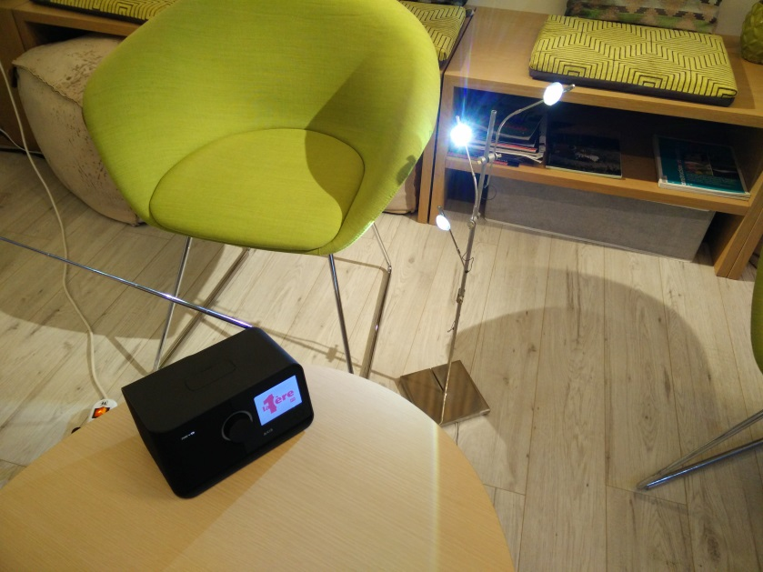](https://tech.ebu.ch/LEDinterference)

# 2 Technical Issues

2.1 LED lighting is an attractive low energy source of illumination. However where ELV (12 volt) LEDs are used to replace existing lamps, it will significantly reduce the loads on existing transformers[8]. Transformers have to comply with EMC limits at full load, but often have much higher emission levels with lower loads. Consequently the only remedy is to replace the transformer. This issue is not widely known outside EMC circles, and having a higher rated unit would normally be seen as a good thing. It should be noted that replacing the transformer is normally a job requiring an electrician.  
See the Annex for examples of noise levels generated by LED lighting devices and installations.

2.2 The transformer is a switched mode power supply (SMPS), typically switching in the range 20-60 kHz. As fast switching speeds are needed to improve energy efficiency (reduce heat), harmonics of the switching frequency can occur across the spectrum; with one case of interference in the 1.5 GHz band.

2.3 Whilst good design and installation should prevent problems, there are also issues with the aging of the suppression components. It is known that the capacitance of some types of capacitor can significantly reduce after a few years, thereby reducing their effectiveness. Standards only require products to comply at the time of manufacture as no lifetime testing is required. It should be noted that this is an issue for all SMPSs, and hence applies to a wide range of electrical products.

# 3 Issues to Address

3.1 The lack of effective market surveillance allows sub-standard products onto the market. This not only impacts broadcasting, but is also potentially damaging to broadband and Smart Metering. Pressure needs to be applied to market surveillance authorities.

3.2 Where products comply, the resulting installations may still be a source of interference due to incompatibility between the various components. This is difficult to cover in standards and may require codes of practice for installers and system designers – see 1.9 above.

3.3 Consumers are being encouraged to replace existing lighting with LEDs for environmental impact reasons. As with the installation situation above there is a need for a code of practice, but directed toward the consumer.

3.4 There is a need for standards to address the issue of component aging – see 2.3 above.

3.5 CISPR 15, the lighting emissions standard, may need its limits to be extended to beyond the present 300 MHz. The standard is complex as it deals with all types of lighting.   
The clarity of the standard needs improving. It is noted that other CISPR standards have flow diagrams to resolve this type of problem.

3.6 CISPR/H is working on ELV LED installations together with Grid Connected Power Supplies. In case this work takes some time, it may be useful to consider interim solutions.

3.7 Encouraging the use of mains voltage LED lighting would avoid many of the problems associated with ELV lighting.

Annex

Measured levels of noise generated in the DAB frequency band by LED lighting devices and installations in real situations

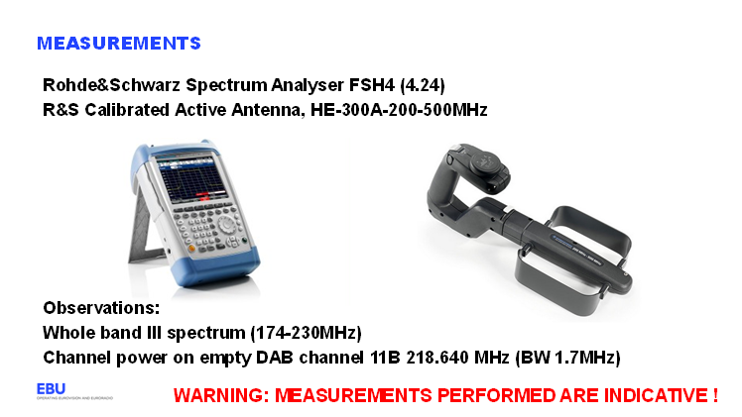

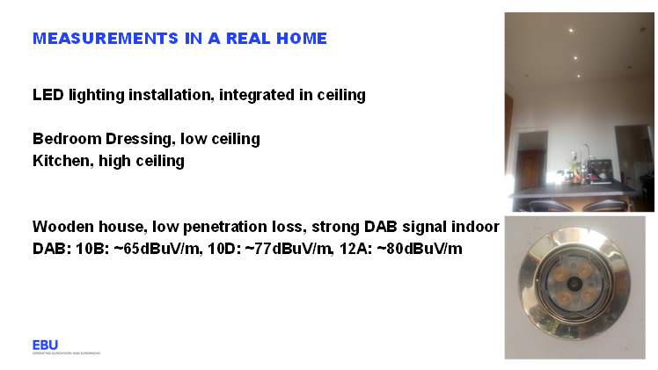

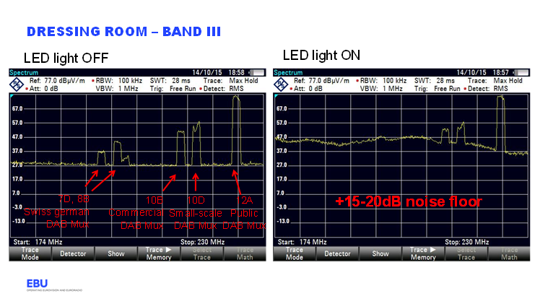

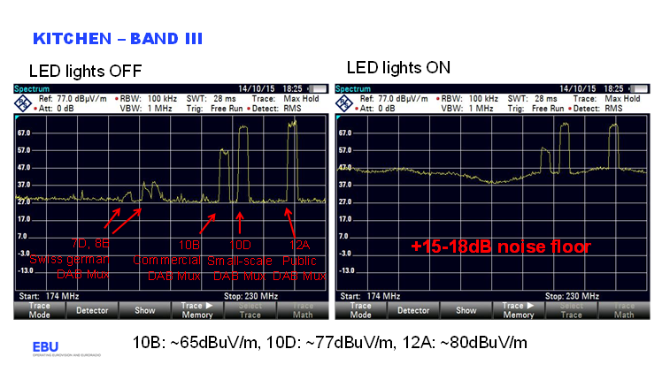

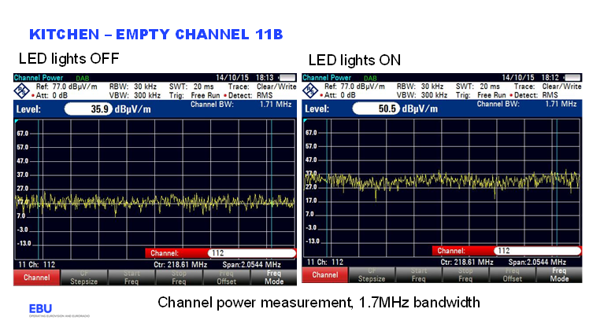

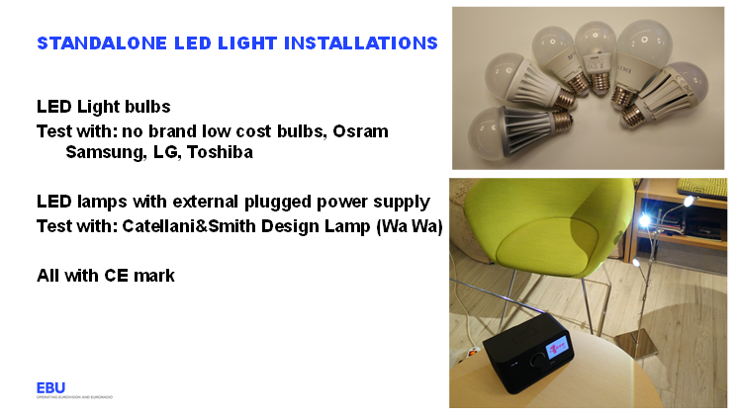

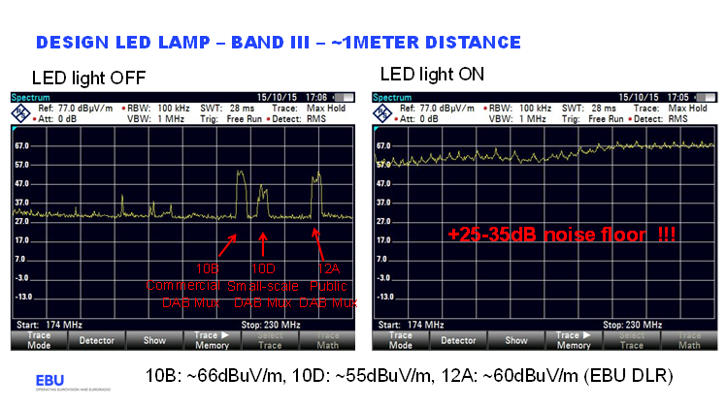

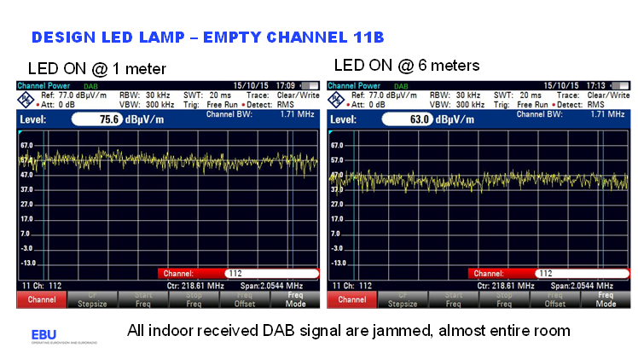

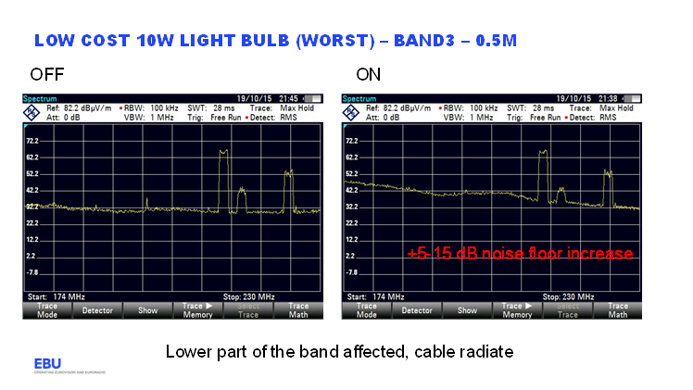

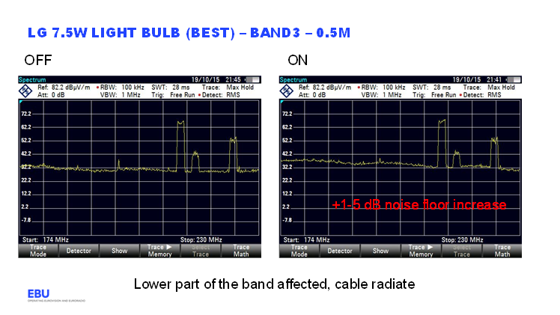

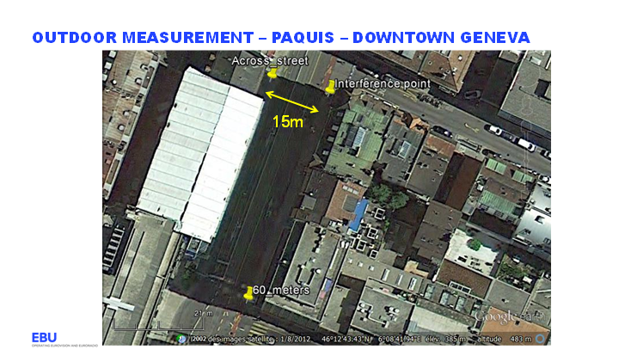

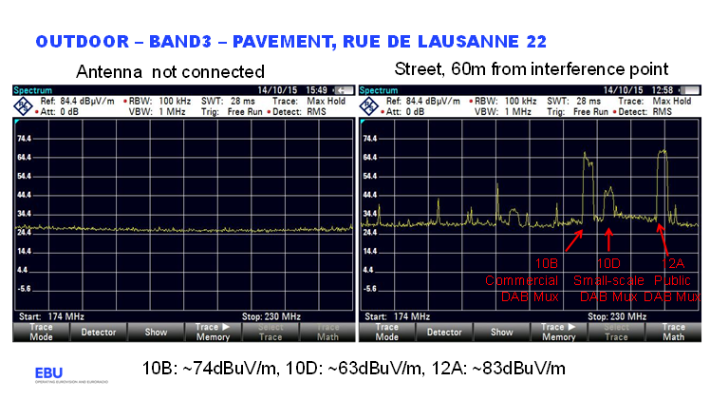

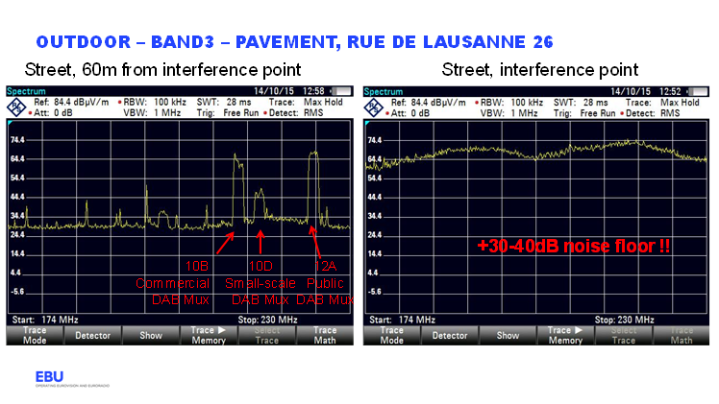

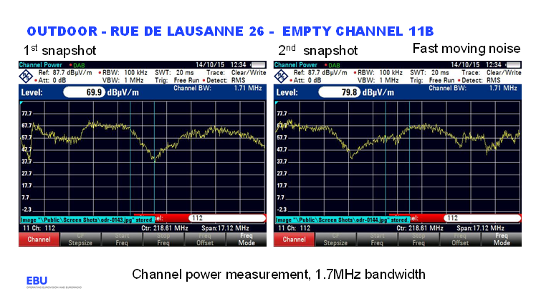

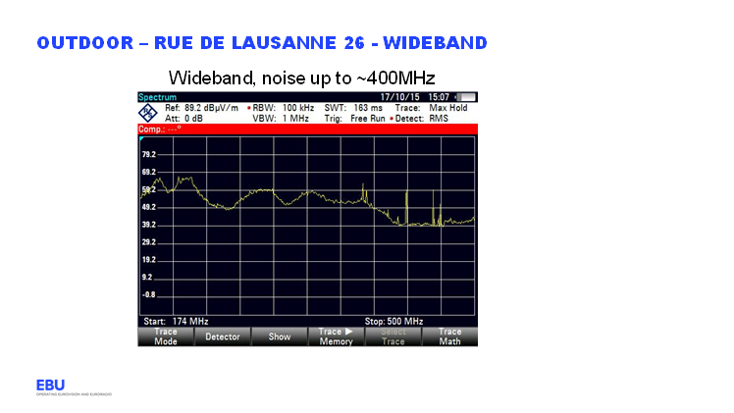

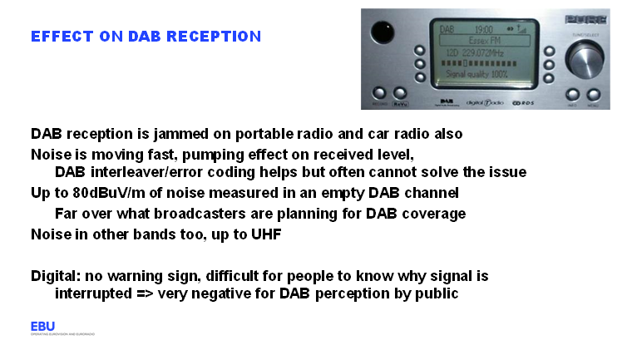

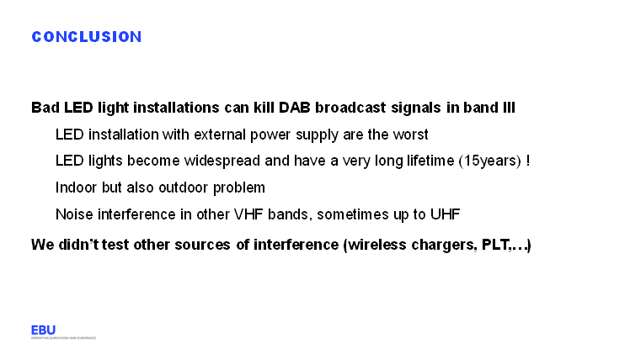

______________

1. <http://ec.europa.eu/DocsRoom/documents/9868/attachments/1/translations/en/renditions/native>
2. <http://conversation.which.co.uk/energy-home/led-bulb-radio-interference-dab-test/?cmp=W0413_convo_lightnoise>
3. <http://standardsproposals.bsigroup.com/Home/getPDF/2326>
4. <http://www.acma.gov.au/theACMA/engage-blogs/engage-blogs/Interference/LED-light-globes-and-your-TV>
5. <http://www.ukqrm.org.uk/lighting.php>
6. <https://tech.ebu.ch/docs/factsheets/ebu_tech_fs_ledinterference.pdf>
7. <https://tech.ebu.ch/LEDinterference>
8. Transformers are actually Switch Mode Power Supplies (SMPSs), but commonly referred   
   to as ‘transformers’ in the lighting and electrical industries.