IEEE 802.18
Radio Regulatory Technical Advisory Group
Operations Manual
www.ieee802.org/18
Date:
2014-05-13
Author:
Michael Lynch
Chair, IEEE 802.18 Radio Regulatory TAG
MJ Lynch & Associates LLC
Email: MJLynch@mjlallc.com

Rich Kennedy,
Vice Chair, IEEE 802.18 Radio Regulatory TAG
MediaTek Inc.
Email: rkennedy1000@gmail.com

IEEE Project 802 Radio Regulatory Technical Advisory Group 802.18
Copyright (c) 2000-2014 by the Institute of Electrical and Electronic Engineers, Inc.
345 East 47th Street
New York, NY 10017, USA
All rights reserved.
Revision History:
Item | Document | Revision Date | Notes
1 | 18-14/0031r0 | 13 May 2014 | Opman created
2 | 18-14/0031r1 | 5 November 2014 | Edits incorporated; ready for final review

Contents
Contents 3
Table of Figures 4
References 5
Acronyms 6
1 Hierarchy 7
2 Maintenance of Operations Manual 7
3 802.18 Technical Advisory Group 7
3.1 Overview 7
3.2 Function 8
3.3 Technical Advisory Group Officers’ Responsibilities 9
3.3.1 Technical Advisory Group Chair 9
3.3.2 Technical Advisory Group Vice-Chair(s) 9
3.3.3 Technical Advisory Group Secretary 10
3.3.4 Liaisons 10
3.3.4.1 Liaison Roles and Responsibilities: 10
3.4 Technical Advisory Group Officer Election Process 11
3.5 Technical Advisory Group Sessions 11
3.5.1 Plenary Session 11
3.5.2 Interim Sessions 12
3.5.3 Session Meeting Schedule 13
3.5.4 Session Logistics 13
3.5.4.1 Attendance 13
3.5.4.2 Meeting Etiquette 13
3.6 Documentation 14
3.6.1 Types 14
3.6.2 Format 14
3.6.3 Submissions 14
3.6.4 File naming conventions 14
3.6.5 Agendas 15
3.7 Summary of Types of Balloting / Voting used in 802.18 15
4 Radio Regulatory Technical Advisory Group Functions 16
5 Voting Rights 16
5.1 Earning and Losing Voting Rights 17
5.1.1 Voter 17
5.2 Voting Tokens 17
6 Access to: Email lists, Telecons and Document server 17
6.1 Email lists 17
6.2 Teleconferences 18
6.3 Public Document Server 18
7 Guidelines for 802.18 secretaries 18

Table of Figures
Figure 3-1 – Project 802 Organizational Structure 8
Figure 3.5.1 – Typical 802.18 TAG meetings during 802 Plenary Session 12
Figure 3.5.2 – Typical 802.18 TAG Meetings during Interim session 13
Figure 3.6.4 – File Naming Convention 15

References
Policies and Procedures
- IEEE Standards Board Bylaws
http://standards.ieee.org/guides/bylaws/
- IEEE-SA® Standards Board Operations Manual
http://standards.ieee.org/guides/opman/
- IEEE Project 802 LAN/MAN Standards Committee (LMSC) Sponsor Policies and Procedures (LMSC P&P)
- IEEE 802 LAN/MAN Standards Committee (LMSC) Operations Manual -- Approved Nov 2013
- IEEE Project 802 LAN/MAN Standards Committee (LMSC) Working Group Policies and Procedures (WG P&P) - Approved March 2014
- Robert's Rules of Order Newly Revised (Latest Published Edition), by Henry M. Robert III (Editor), Sarah Corbin Robert, and William J. Evans (Editor), Perseus Publishing

Other References
- IEEE Standards Companion
http://standards.ieee.org/guides/companion/
- Overview & guide to IEEE 802 LMSC
http://grouper.ieee.org/groups/802/802 overview.pdf
- Adobe Acrobat Reader for viewing PDF files
http://www.adobe.com/support/downloads/main.html
- ISO/IEC JTC1: International Standards Organization / International Engineering Consortium Joint Technical Committee 1
http://www.jtc1.org
- IEEE Standards Style Manual
http://standards.ieee.org/guides/style/

Acronyms
802 EC 802 LMSC executive committee
802 LMSC Project 802, LAN/MAN standards committee
AHC Ad-hoc committee
ANA Assigned Numbers Authority
CAC chair advisory committee
IEC International Engineering Consortium
IEEE International Electrical and Electronics Engineers, Inc.
IEEE-SA IEEE Standards Association
IPR intellectual property rights
ISO International Standards Organization
LAN local area network
PAR project authorization request
PDF portable document format (Adobe Acrobat file format)
SC standing committee
SG study group
TAG technical advisory group
WG working group
WLAN wireless local area network (802.11)
WMAN wireless metropolitan area network (802.16)
WPAN wireless personal area network (802.15)
WRAN wireless regional area network (802.22)
.

Hierarchy
The following documents take precedence over the procedures described in this document in the following order (highest precedence shown first, in case of revisions, the latest approved revision applies):

New York State Not-for-Profit Corporation Law
IEEE Certificate of Incorporation
IEEE Constitution
IEEE Bylaws
IEEE Policies
IEEE Board of Directors Resolutions
IEEE Standards Association Operations Manual
IEEE-SA Board of Governors Resolutions
IEEE-SA Standards Board Bylaws
IEEE-SA Standards Board Operations Manual
IEEE-SA Standards Board Resolutions
IEEE Computer Society (CS) Constitution and Bylaws
IEEE CS Policies and Procedures, Section 10
IEEE CS Board of Governors Resolutions
IEEE CS Standards Activities Board Policies and Procedures (SAB P&P)
IEEE Project 802 LAN/MAN Standards Committee (LMSC) Sponsor Policies and Procedures (LMSC P&P)
IEEE Project 802 LAN/MAN Standards Committee (LMSC) Operations Manual (LMSC OM)
IEEE Project 802 LAN/MAN Standards Committee (LMSC) Working Group (WG) Policies and Procedures (WG P&P)

Robert’s Rules of Order Newly Revised (latest edition) is the recommended guide on questions of parliamentary procedure not addressed in these procedures.

Maintenance of Operations Manual
The Operations Manual is adopted as stated in 9.3 802 WG P&P ([rules5]). It is maintained as directed by the TAG Chair.

802.18 Technical Advisory Group

Overview
The 802.18™ Technical Advisory Group (TAG) is responsible for supporting Wireless Local Area Network (WLAN) standards under the authority of the IEEE® Project 802 LAN/MAN Standards Committee (802 LMSC).

The 802 LMSC is directed by the 802 Executive Committee (802 EC). The 802 EC is the sponsor for both sponsor ballot groups as well as the Standards Development Groups. The 802 LMSC includes WGs, Technical Advisory Groups (TAG) and, on a temporary basis, Executive Committee Study Groups (ESG) to standardize technologies applicable to local and metropolitan area networks as shown in Figure 3.1.

P802 LMSC
Executive Committee
Working Groups
Technical Advisory
Groups
Executive
Committee Study
Groups
We are here

Figure 3-1 – Project 802 Organizational Structure

See references [other1] and [other2] for some relevant background information on the IEEE standards development process, and an introduction to the 802 LMSC.

Function

The 802.18 TAG is chartered:

- To encourage collaborative participation in the radio regulatory process by members of the RR-TAG including official representatives from the wireless Working Groups

- To monitor the regulatory environment as it may apply to or affect existing IEEE 802 wireless standards or standards in process and advise the relevant Working Groups and the IEEE 802 SEC of issues of interest at their opening plenaries

- To prepare, review, and submit approved radio regulatory documents on behalf of the RR-TAG, the wireless Working Groups, and/or the IEEE 802 SEC that fairly reflect all points of view

- To serve as the official communications channel between the 802 Wireless WGs, any relevant TAGs, and the IEEE 802 SEC, and other standards and industry bodies on radio regulatory matters

- To liaise and seek cooperative relationships on radio and other regulatory matters of mutual interest with other standards and industry bodies

- To serve as the official communications channel between the 802 Wireless and other WGs, any relevant TAGs, and the IEEE 802 SEC and regulatory agencies and spectrum management bodies on radio regulatory matters

- To establish and maintain contacts within, and understand the processes for interaction with, radio regulatory and spectrum management bodies

- To liaise on radio regulatory matters with such co-existence groups as may exist in the 802 domain

Technical Advisory Group Officers’ Responsibilities

Technical Advisory Group Chair
As stated in 802 WG Policies and Procedures, the Chair of the TAG is responsible for presiding over TAG Plenary sessions.

Responsibilities of the chair include:

Before session tasks:
- Submit agenda items for the opening Executive Committee meeting (a week before the meeting). All members of the leadership team, and TAG attendees are to work with the chair in developing items for the agenda.
- Attend the opening Executive Committee Plenary meeting.
- Submit unballoted documents developed between the meetings for inclusion on the EC opening plenary consent agenda
- Report the status of the TAG to the 802 EC opening plenary meeting.

During session tasks:
- Conduct full TAG meetings.
- Keep Executive Committee members informed as early as possible about 802.18 matters requiring approval at the closing 802 EC Plenary meeting
- Attend the closing 802 EC Plenary meeting; representing and leading 802.18 items of business.
- Maintain a voters list.

After session tasks:
- Prepare a TAG status report to the 802 EC Recording Secretary within one week after the conclusion of the closing 802 EC meeting. This status report shall include a description of the progress made during the week, as well as plans for further work and future meetings.
- Prepare the agenda for the next meeting; publish the agenda and meeting venue information on the TAG web site, and email notice of same to the 802.18 TAG Email list.
- Manage the preparation of the meeting place as well as the venue for the next interim meeting. [Note: the venue preparation is a function not performed by the TAG Chair. The chair merely inputs the requirements for the TAG’s meeting room.]
- Respond to inquiries regarding the 802.18 TAG.

Technical Advisory Group Vice-Chair(s)

Responsibilities of the Vice-Chair(s) are assigned by the Chair and may include the following.

Before session tasks, including but not limited to, preparation of:
- Voters list
- Updated Electronic Records of participant status as required by the meeting planner and the IEEE-SA systems according the required schedule.
- Populate the Electronic Attendance system with plan of meetings.
  - Update any changes during the session.
- Arbitrate any attendee record discrepancies.
- PAR reviews

During session tasks, including but not limited to:
- Be prepared to take over the duties of the Chair in the event of temporary or permanent absence.
- Be prepared to assume or assign secretary duties when required.
- Between meetings, be prepared to respond to inquiries regarding the TAG and keep the Chair informed.
- Oversee the document process.
- Attend to any business that might otherwise prevent the Chair from orderly conduct of the meetings, such as attending to emergency messages, and inquiries from the meeting planner or facility staff.
- Assist the Chair in obtaining accurate and fair vote counts.
- Assist the Chair during IEEE 802 Executive Committee meetings held on initial and final days.

After session tasks, but not limited to:
- Update partipants status based on attendance, and inform paraticipants of any change in status
- Post a list of active (i.e., Aspirant, Potential-Voter or Voter) participants on the 802.18 website
- Update web site : meeting arrangements, ballot status
- Update 802.18 Draft documents on the 802.18 Mentor web site
- Update 802.18 email list servers

Technical Advisory Group Secretary
See Section 7 of this document, Guidelines for 802.18 secretaries and IEEE Standards Companion (ref. [other1]) for details on content and form of minutes.

Liaisons
Liaison relationships are established with other groups within 802 LMSC, other relevant standards setting bodies, industry promotional bodies, Special Interest Groups (SIGs), and radio spectrum regulatory bodies (liaison groups). Liaisons shall be recommended by the TAG Chair and confirmed by the vote of the TAG. Liaisons shall be reconfirmed each year at the July 802 plenary. Liaisons will be granted voting rights upon confirmation of their liaison status in 802.18 and will seek to be granted voting rights in their respective liaison groups.

Liaison Roles and Responsibilities:
- Liaisons are responsible for providing updates and status reports to the TAG at plenary and interim sessions. If a liaison does not provide this in two consecutive sessions, then the TAG Chair may withdraw the liaison responsibility from the concerned individual. The TAG Chair recommends a replacement as necessary.
- Liaisons cannot pass on responsibilities, nor have other individuals represent their post without having TAG or TAG Chair approval.
- Liaisons have the same voting rights, privileges and obligations as 802.18 Voters. Liaisons are given 802.18 TAG attendance credit for attending liaison group meetings that are concurrent with 802.18 TAG sessions.
- Liaisons shall be empowered to report status of the TAG developments to their respective liaison groups, and shall report back to the TAG the status of the liaison group at interim and plenary sessions.
- Liaisons shall report back to the TAG Chair items of concern to their WGs or TAGs

Technical Advisory Group Officer Election Process
The election of the IEEE 802.18 TAG Officers (Chair and Vice-Chairs) is held in March of each even-numbered year. The nominations for the election shall be made at the TAG Opening Plenary meeting. The TAG Chair shall designate one of the TAG Vice-Chairs as an Acting Chair Pro Tem if the TAG Chair is running for re-election. If not running for re-election, the TAG Chair shall conduct the election process. This election process shall be used for each TAG officer election.

- The Acting Chair shall open the floor for nominations.
- The Acting Chair shall close nominations after the nominations have been made.
- Each candidate shall be given a short time (nominally, 5-10 minutes) for an introductory statement of acceptance that should nominally contain the candidate’s:
  - Summary of qualifications
  - Commitment to participate and accept duties and responsibilities
  - Vision for the TAG.

- The floor shall be opened for discussion (nominally for five-ten minutes total).

  - The Acting Chair should limit the duration of comments and promote open participation, both pros and cons. If only one candidate is nominated, the Acting Chair may choose to sharply limit the debate.

- The discussion shall be repeated, with the TAG Chair leading the process for the nomination(s) of the TAG Vice-Chair(s).
- The TAG Officers shall conduct the election, count the votes, and notify the TAG of the results.

  - Voting tokens shall be used to cast valid votes during the session.
  - In order to be elected, any candidate must receive a simple majority (over 50%) of the votes cast in the election for the respective position.
  - Should no candidate receive a majority in the election, a runoff election shall be held. The process shall be similar to the initial election, except that:

    - New nominations shall not be permitted.
    - In the runoff election, the nominated candidate having received the fewest votes in the previous election round shall not be an eligible candidate (in case a tie prevents this possibility, all the nominated candidates shall remain eligible).

  - If the process is inconclusive, another runoff shall be held, as in the point above.

Technical Advisory Group Sessions

Plenary Session
The 802.18 TAG plenary session is conducted three times a year as part of the 802 LMSC plenary sessions (see ref. [other2]). Typically the 802.18 TAG Opening and Closing plenary meetings are held at each 802 LMSC plenary session (see Figure 3.5.1).

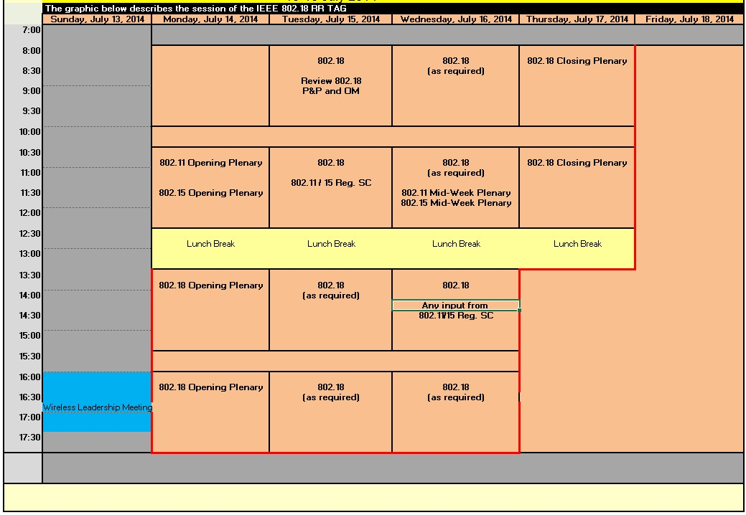
Figure 3.5.1 – Typical 802.18 TAG meetings during 802 Plenary Session

Interim Sessions
Interim sessions of the TAG are scheduled no later than the end of the prior plenary session. A TAG interim session is held between 802 plenary sessions. Additional sessions may be scheduled as needed to conduct business of the TAG. The date, time, and place of the session(s) must be approved by the TAG and announced at the TAG Closing Plenary meeting and entered in the minutes of the TAG meeting.

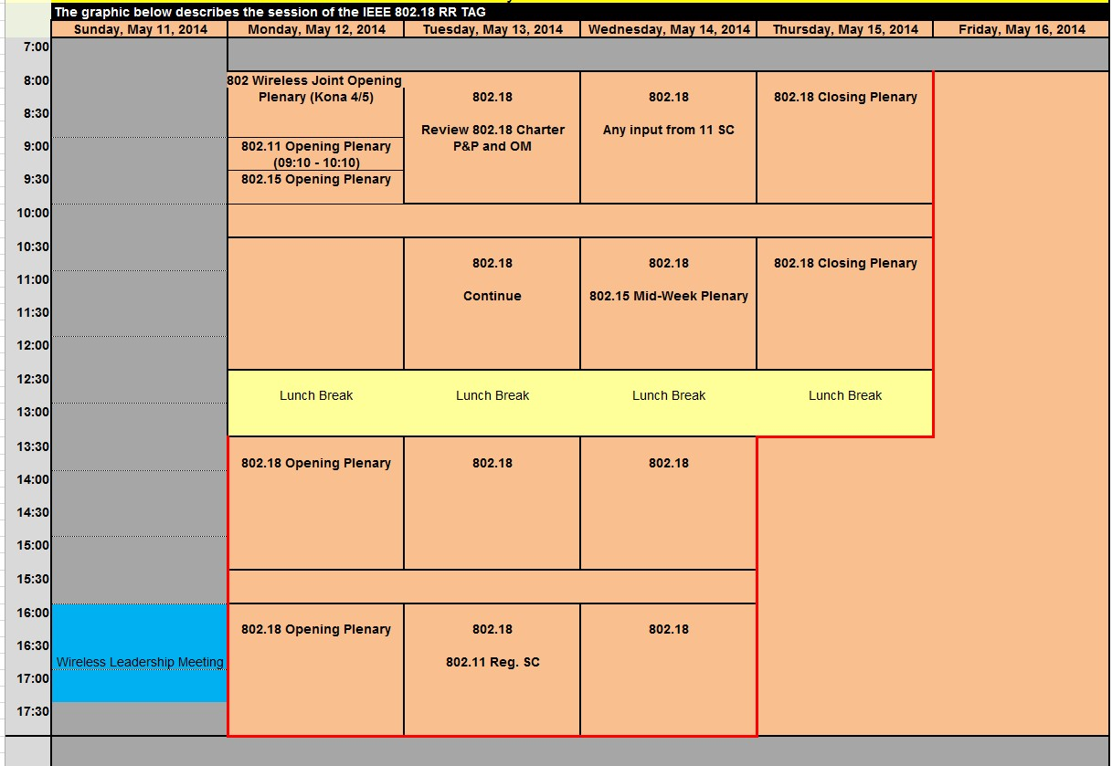
Figure 3.5.2 – Typical 802.18 TAG Meetings during Interim session

Session Meeting Schedule
802.18 Interim and Plenary sessions start with an opening plenary meeting. A closing plenary meeting is held to close the session. Start times and end times are published at least 10 days in advance. Active 802.18 TAG meeting hours may be scheduled between 8:00 am until 9:30 pm from the beginning of the 802.18 TAG Opening Plenary through the end of the 802.18 TAG Closing Plenary. The specific meeting times will be published in the agenda.

Session Logistics

Attendance
Attendance at TAG meetings is recorded electronically. If electronic recording is not possible manual written documentation will be used. Each attendee is responsible for recording attendance. The mechanism for recording attendance is decribed in the opening reports of the TAG Opening Plenary. Each attendee is expected to only sign in for the meeting designation that they are attending in that time slot. Time slots are defined as TAG meeting hours as defined in the approved Agenda graphic for the interim or plenary session in progress. It is expected that attendees have participated in at least 75% of the designated meeting they have signed in for. Failure to sign in may impact voting rights (see subclause 7). Inability to sign in should be reported to the TAG Vice-Chair responsible for attendance recording.

Occasionally an attendee may wish to record their participation at a meeting (as required by IEEE-SA rules), but does not want (or is not entitled) to claim attendance credit. For example, the attendee may have been present for less than 75% of the slot. Such an attendee should send an email once per session to the TAG Vice-Chair responsible for attendance to record the attendee’s presence.

Meeting Etiquette
During any TAG meetings, cell phones must be shut off or in the vibrate mode of operation, in order not to interrupt the meeting. Electronic communication (e.g. email, instant messaging, social networking) with the Officers conducting official meetings shall be deferred until after the meeting; with the following exceptions:
- Officers may access the 802.18 website and documentation server as necessary to conduct business
- The secretary may receive electronic communication/transmissions of presented material for inclusion in the minutes
- Officiers conducting a meeting are permitted to record their attendance.

The use of audio and/or video recording of any 802.18 meeting is specifically prohibited. Still photography is only permitted by a public request and permission of the meeting attendees via the TAG Chair, and is not for commercial purposes.

Meetings are run in an orderly fashion, and outbursts or other disruptions during a meeting are not tolerated. Conversations whether on cell phones or with other individuals in a meeting should be moved outside the meeting room.

Documentation
All 802.18 documents are disseminated in electronic format only, other than exceptional cases. Documents are only accepted if they adhere to the policies and procedures spelled out in this subclause.

Types
The document shall be one of the following types:

- Agenda
- Minutes
- Reports (from a liaison meeting or a ballot)
- Submissions (Presentations, Motions, Simulation Results, etc.)
- Liaison

Format
Documents with the exception of draft standards and amendments shall be in the current template as specified by the TAG Chair. The templates are located on the 802.18 TAG website at:
- Microsoft Word
- Microsoft Powerpoint

If a submitter is not able to submit in Microsoft Office application format, the document shall be submitted in Adobe Acrobat format.

Submissions
All documents presented to the TAG should be on the document server prior to presentation.

File naming conventions
The file name format used by the IEEE documentation database is shown in the table below. An example of a good filename that conforms to the naming convention is 18-14-0652-00-0000-Motion-to-form-a-study-group.ppt. The dashes shown after the document number are optional.

The electronic documentation system automatically generates the prefix part of the filename (i.e. the “gg-yy-ssss-rr-GGGG” below) from data entered by a document author, and requires that any uploaded file exactly match this prefix.
Figure 3.6.4 – File Naming Convention

gg-yy-ssss-rr-GGGG-HumanName.ext

where
“gg” | is the 802 group 18
"yy" | is the last 2 digits of the year the document number is obtained
"ssss" | is the sequence number of the document  “0001” may be reserved for the 802.18 TAG OM
“rr” | is the revision number
"GGGG" | Is the group code identifying the TAG to which the document assigned or presented.  Examples of group codes:  0000 – TAG  000z – TGz  Tvws – TVWS SG  The electronic documentation system provides a mapping of well-known terms (e.g. TGz) to group code (e.g. 000z).
“HumanName” | The human name should be as short as possible (please use either a dash or underscore for the coupling letter). Try to avoid adding the TG in the name.
ext | Is the commonly used 3 or 4 letter file extensions: .doc/.docx for Word, .ppt/.pptx for PowerPoint, .pdf for Adobe Acrobat compatible files.

Agendas

The TAG agenda is a Microsoft Excel™ spreadsheet that includes the following:
- A graphic showing overall use of time during the session.
- A tab for the TAG plenary meeting agenda.
- A list of a document references for agendas posted on the document server corresponding to Sub Group option 1 above.

Note that there are timing requirements on the posting of agendas prior to meetings that are specified elsewhere in this document. The choice of format by the TAG does not affect these requirements.

Summary of Types of Balloting / Voting used in 802.18
Note on terminology:
- 802.18 session – the meetings as described in the 802.18 agenda for a particular event, usually running from Monday to Thursday of a week.

The following types of balloting / voting are used in 802.18:
Type | Description | Who can vote?
Technical Advisory Group (TAG) Motion | A motion made during an 802.18 meeting, requiring a mover and a seconder. | 802.18 voters present at the meeting
Straw Poll | Straw polls are used to determine the opinion of those present at a meeting. | Any person present at the meeting

Radio Regulatory Technical Advisory Group Functions

The function of the TAG is to provide assistance to WGs and/or the Sponsor. This TAG operates under the same rules as the WGs, with the following exceptions:

        - The TAG shall not write standards, recommended practices or guides, but may write documents on specialty matters within the purview of the TAG.

        - The primary responsibility of this TAG is to provide assistance within its topical area as specifically requested by one or more of the WGs and/or the Sponsor.

        - A document can only be represented as the position of this TAG if it has attained approval by a vote of the TAG. Such votes are considered to be procedural votes, and require a simple majority for approval, unless specified by the Chair as technical, which require approval by at least 75% to pass.

        - Between plenary and interim meetings, the TAG Chair is empowered to schedule teleconference meetings to allow the TAG to conduct business as required, provided that the date and time of the teleconference and agenda are published on the TAG website and e-mail reflector at least 5 days before the meeting.

        - Votes on TAG documents may be conducted verbally during teleconference meetings if a majority of the TAG members are present.

        - Votes on TAG documents may be conducted via electronic balloting. The minimum ballot period shall be 5 days.

        - A TAG shall maintain an e-mail distribution list of its members for making the announcements of teleconferences and availability of important information on the TAG’s web site pages.

Voting Rights
Voting rights are achieved by attending 802.18 TAG interim and plenary sessions. All participants represent themselves as individuals.

All participants must pay a meeting fee to attend any of the meetings during an interim or plenary session.
A participant belongs to one of two levels of membership: Non-Voter and Voter. These are described below.

It is the responsibility of all participants to make the TAG Chair and the TAG Vice-Chair responsible for membership, aware of any changes to their contact information for the purpose of maintaining the IEEE 802.18 voting membership database.

Earning and Losing Voting Rights
A participant earns voting rights by properly attending 802.18 TAG interim and plenary sessions.

A “properly attended session” is an 802.18 TAG interim or plenary session at which the participant has
- Recorded their contact details and affiliation.
- Recorded attendance for 75% of the “in session hours” (i.e. morning and afternoon) meeting slots (these are indicated as such on the session graphic in the TAG agenda).
- Registered for the session and paid any required meeting fee.

As a courtesy, after a session the TAG vice chair responsible for maintaing membership will send an email to an individual whose membership status has changed informing them of the change. The email will include instructions on any new entitlements or obligations and any newly aquired membership number or credentials.

Voter
A Voter’s badge will contain an 802.18 voting token.

A Voter remains as such provided the Voter continues to properly attend 2 of 4 consecutive plenary sessions (a single interim session may be substituted for a plenary).

.

Voting Tokens
Voting Tokens are printed on the participant’s name badge and are used to vote on motions during TAG meetings, unless a roll call vote is requested by a TAG voter or directed by the TAG Chair. Voting tokens are valid for the duration of the session in progress. If a Voter loses their voting token (name badge) during the session, they must report it to the TAG Chair or TAG vice-Chair to obtain a replacement from the meeting organizers.

Access to: Email lists, Telecons and Document server
Definition: an Active 802.18 participant is a participant with status of a Voter.

Email lists
The TAG maintains an email list on which all meetings and ballots are announced, and which is used for discussion of matters relevant to all 802.18 participants (STDS-802-18@LISTSERV.IEEE.ORG).

Postings to any of these lists are restricted to list members, i.e., only a member of a list (identified by email address) can post to that list.

Teleconferences
TAG Teleconferences operate under the rules described in this 802.18 OM.

The agenda shall include a summary review of the relevant antitrust and patent P&P and shall include a call for essential patents, where that group is responsible for producing or potentially responsible for producing a standard, amendment or recommended practice. Minutes shall be recorded and posted on the 802.18 document server.

TAG teleconferences are permitted to make and approve formal motions.

Teleconferences are generally approved during the closing 802.18 plenary, and cover the period from 10 days after that plenary to 10 days after the next closing 802.18 plenary. Any changes to the telecon schedule after the closing plenary shall be made by announcement to the TAG reflector at least 5 days in advance.

Details of 802.18 telecons are posted on the 802.18 website. It is the responsibility of the chair to provide bridge details in advance to the TAG vice chair responsible for publishing these details.

Anyone may attend an 802.18 teleconference.

Public Document Server
The 802.18 public documents are kept on the IEEE mentor system https://mentor.ieee.org/802.18/documents. Anyone may read these documents.

Only Active 802.18 participants may post documents on the 802.18 document server.

Guidelines for 802.18 secretaries
Please prepare the minutes taking into account the following:
  - Use the template for documents, except in the case where regulatory documents are uploaded in their original format
  - Use the following in the left side footer: “Minutes”
  - Make the style of motions such that they are easily identifiable
  - Number the motions
  - Make a hierarchy of motions by indentation
  - Attendance list and future meeting plan to the Full Technical Advisory Group minutes.
  - Follow the guidance from the IEEE Standards Companion [other1]:
End.

Approved per RR-TAG, relevant Working Group, and LMSC rules. (see LMSC Rules, Procedures 3 and 4.)
Such documents may include, but are not necessarily limited to comments and reply comments on regulatory matters, responses to public consultations, petitions for rulemaking, petitions for reconsideration, oppositions to petitions, liaison statements to other regulatory groups, etc.

