|  |  |
| --- | --- |
| **Radiocommunication Study Groups** |  |
|  |  |
|  |  |
| Received:  Subject: Resolution 233 (WRC-12)  CPM 15-1 (Ref CA/201)  Recommendation ITU-R M.1450-4 | **Document 5A/XXX** |
| **XX March 2013** |
| **English only** |
| Institute of Electrical and Electronics Engineers (IEEE) | |
| INFORMATION REGARDING IEEE 802-BASED RLAN SYSTEMS | |

# 1 Source information

This contribution was developed by IEEE Project 802®, the Local and Metropolitan Area Network Standards Committee (“IEEE 802”), an international standards development committee organized under the IEEE and the IEEE Standards Association (“IEEE-SA”).

The content herein was prepared by a group of technical experts in IEEE 802 and was approved for submission by the IEEE 802.18 Radio Regulatory Technical Advisory Group, and the IEEE 802 Executive Committee, in accordance with the IEEE 802 policies and procedures, and represents the view of IEEE 802.

# 2 Introduction

IEEE 802 notes that in the CPM15-1 decision (Ref. CA/201) on the establishment and terms of reference of Joint Task Group 4-5-6-7, *further decides 4* states “that with respect to the sharing studies being undertaken by JTG 4-5-6-7 in relation to Resolution 233 (WRC-12), technical and operational characteristics, protection requirements and information on current and planned use from the concerned Working Parties, as well as spectrum requirements from the Working Parties 5A and 5D are to be submitted to the JTG preferably by 31 July 2013”.

# 3 Discussion

**3.1 Technical and Operational Characteristics/ Revision of Recommendation ITU-R M.1450-4**

IEEE 802 has reviewed the liaison statement entitled “Request for Input for a Revision of Recommendation ITU-R M.1450-4” as well as the “Working document towards a preliminary draft revision of Recommendation ITU-R M.1450-4 - Characteristics of broadband radio local area networks”. IEEE 802 confirms that the information in the current Working Document ([Annex 16](http://www.itu.int/md/dologin_md.asp?lang=en&id=R12-WP5A-C-0198!N16!MSW-E) to [Doc. 5A/198](http://www.itu.int/md/R12-WP5A-C-0198/en)) accurately reflects IEEE 802-based broadband radio local area network technical and operational characteristics.

**3.2 Information on Current and Planned Use**

IEEE 802 notes that the information contained in Recommendation ITU-R M.1450 accurately reflects the frequency bands that are currently used by IEEE 802.11 systems.

We note that in their recently released Notice of Proposed Rulemaking on 5 GHz, the United States Federal Communications Commission has proposed rules to permit RLAN use in the 5350-5470 and 5850-5925 MHz spectrum, provided that incumbent systems can be protected from harmful interference. Regarding planned use, IEEE 802 notes that IEEE Standard 802.11-2012 (Clause 18, commonly known as 802.11a), (Clause 20, commonly known as 802.11n) and IEEE P802.11ac are all planned for operation in the frequency ranges 5350-5470 MHz and 5850-5925 MHz where permitted.

These frequency ranges are particularly attractive for RLAN use due to the following reasons:

* RLAN devices already operate in parts of the 5 GHz spectrum and supporting additional channels in this suitable frequency range would be relatively easy as RF components, antennas and amplifiers, and design solutions already exist for the 5 GHz range which are already embedded in user equipment.
* Contiguous spectrum would enable a more efficient band plan to be implemented which would increase the number of non-overlapping channels available for RLAN use. This is especially important given the wider channel bandwidths utilized by RLANs to provide increased data rates to users.

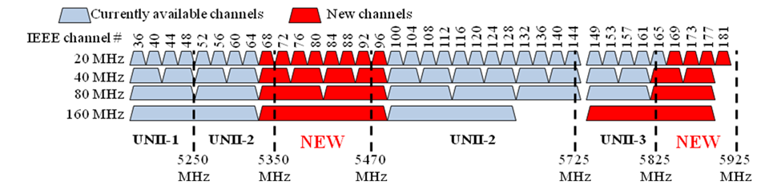

**3.3 Need for Additional Spectrum**

IEEE 802 notes that Recommendation ITU-R M.1450-4 states:

“Speeds of notebook computers and hand-held computing devices continue to increase. Many of these devices are able to provide interactive communications between users on a wired network but sacrifice portability when connected. Multimedia applications and services require broadband communications facilities not only for wired terminals but also for portable and personal communications devices. Wired local area network standards, i.e. IEEE 802.3ab 1000BASE‑T, are able to transport high rate, multimedia applications. To maintain portability, future wireless LANs will need to transport higher data rates.”

IEEE 802.11 standards have evolved to provide these higher data rates. IEEE802.11ac specifies enhancements to the 802.11 Media Access Control (MAC) and Physical (PHY) layers to support very high throughput in the 5 GHz bands. Products based upon IEEE 802.11ac can deliver data rates at over 1 Gbps using 80 MHz channels, which would be ideal for home digital applications like video. IEEE 802.11ac products are required to support 20, 40, and 80 MHz channels, with the use of 160 MHz channels optional but supported by the standard as well.

Recommendation M.1450-4 also states “In addition, mobile devices such as cellular telephones are beginning to incorporate the ability to connect to wireless LANs when available to supplement traditional cellular networks.”

The need for wider channel sizes to support higher throughput to end users, along with increasing cellular offloading, are driving burgeoning demand for RLANs. Some usage cases such as Peer2Peer (which may include video streaming) and others also require significantly higher data rates. As stated in Section 3.2 above, additional channels in the 5 GHz range are particularly attractive to meet this demand for terrestrial mobile broadband (excluding IMT) applications as they are adjacent to existing RLAN operation and significant efficiency benefits could be achieved by providing contiguous spectrum. Therefore, IEEE 802 sees a need for additional channels in the 5350-5470 MHz and 5850-5925 MHz frequency ranges.

**4 Proposal**

IEEE 802 provides this information on IEEE 802 based RLAN systems for consideration by ITU-R Working Party 5A during the development of any response to JTG 4-5-6-7 regarding *further decides 4* of the CPM15-1 decision on the establishment and terms of reference of Joint Task Group 4-5-6-7.

IEEE 802 looks forward to the ongoing cooperation with ITU-R Working Party 5A.

**Contact:** Michael LYNCH **E-mail:** [freqmgr@ieee.org](mailto:freqmgr@ieee.org)

____________