|  |  |  |
| --- | --- | --- |
|  |  | |
| Title | ***Proposed LS to ITU-R WP 5D: Toward development of Handbook on Global Trends in IMT – ITU-R [IMT.HANDBOOK]*** | |
| Date Submitted | **2014-09-16** | |
| Source(s) | Roger B. Marks  EthAirNet Associates  4040 Montview Blvd  Denver, CO 80207 USA | Voice: +1 802 capable E-mail: roger@ethair.net  *<<http://standards.ieee.org/faqs/affiliationFAQ.html>> |
| Re: | ITU-R WP 5D development of Handbook on Global Trends in IMT | |
| Abstract | This document proposes a contribution to ITU-R Working Party 5D, in response to a liaison statement of 2 July 2014 on “Work Progress on development of Handbook on Global Trends in IMT – ITU-R [IMT.HANDBOOK]” <<http://ieee802.org/secmail/msg17606.html>>. The content is drawn from IEEE Std 802.16.1-2012. | |
| Purpose | This contribution requests approval of the IEEE 802.18 Technical Advisory Group on 1 October 2014 for review of the IEEE 802 Executive Committee (7 October 2014) under OM Subclause 8.2.2 as an intended contribution from IEEE to ITU-R Working Party 5D **for submission by the deadline of 8 October 2014, 16:00 hours UTC**. | |
| Notice | *This document represents only the views of the participants listed in the “Source(s)” field above. It is offered as a basis for discussion. It is not binding on the contributor(s), who reserve(s) the right to add, amend or withdraw material contained herein.* | |
| Copyright Policy | The contributor is familiar with the IEEE-SA Copyright Policy <http://standards.ieee.org/IPR/copyrightpolicy.html>. | |
| Patent Policy | The contributor is familiar with the IEEE-SA Patent Policy and Procedures:  <<http://standards.ieee.org/guides/bylaws/sect6-7.html#6>> and <<http://standards.ieee.org/guides/opman/sect6.html#6.3>>.  Further information is located at <<http://standards.ieee.org/board/pat/pat-material.html>> and <<http://standards.ieee.org/board/pat>>. | |

|  |  |
| --- | --- |
| **Radiocommunication Study Groups** |  |
|  |  |
|  |  |
| Received: XXX | **Document 5D/XXX-E** |
| **7 October 2014** |
| **English only** |
| Institute of Electrical and Electronics Engineers (IEEE) | |
| WirelessMAN-Advanced Information for Handbook on Global Trends in IMT | |
|  | |

# 1 Source information

This contribution was developed by IEEE Project 802®, the Local and Metropolitan Area Network Standards Committee (“IEEE 802”), an international standards development committee organized under the IEEE and the IEEE Standards Association (“IEEE-SA”).

The content herein was approved for submission by the IEEE 802.18 Radio Regulatory Technical Advisory Group and the IEEE 802 Executive Committee, in accordance with the IEEE 802 policies and procedures, and represents the view of IEEE 802.

# 2 Background

This contribution responds to the liaison statement of 2 July 2014 (Attachment 3.4 to Document 5D/726, “Work Progress on development of Handbook on Global Trends in IMT – ITU-R [IMT.HANDBOOK]”) seeking information relevant to section 3.3.1.2.2 of Attachment 3.2 to Document 5D/726 (“Working Document towards a Handbook on Global Trends in IMT - ITU-R [IMT.HANDBOOK]”).

# 3 Proposal

We propose that the information in Annex 1 be incorporated as section 3.3.1.2.2 of “Working Document towards a Handbook on Global Trends in IMT - ITU-R [IMT.HANDBOOK]”.

**Contact:** Michael Lynch **E-mail:** [freqmgr@ieee.org](mailto:freqmgr@ieee.org)

**Annex 1**

#### 3.3.1.2.2 WirelessMAN-Advanced

The IEEE standard relevant for WirelessMAN-Advanced, designated as IEEE Std 802.16.1, is developed and maintained by the IEEE 802.16 Working Group on Broadband Wireless Access. It is published by the IEEE Standards Association (IEEE-SA) of the Institute of Electrical and Electronics Engineers (IEEE).

Figure X illustrates the protocol layering of IEEE Std 802.16.1-2012. The medium access control (MAC) common part sublayer (CPS) provides the core MAC functionality of system access, bandwidth allocation, connection establishment, and connection maintenance. It receives data from the various convergence sublayers (CSs), through the MAC service access point (SAP), classified to particular MAC connections. Quality of service (QoS) is applied to the transmission and scheduling of data over the physical layer (PHY). The MAC also contains a separate security sublayer providing authentication, secure key exchange, and encryption. Data, PHY control, and statistics are transferred between the MAC CPS and the PHY via the PHY SAP. The MAC comprises three sublayers. The service-specific CS provides any transformation or mapping of external network data, received through the CS SAP, into MAC service data units (SDUs) received by the MAC CPS through the MAC SAP. This includes classifying external network SDUs and associating them to the proper MAC service flow identifier (SFID) and, for an advanced base station (ABS) or advanced mobile station (AMS), a Station Identifier + Flow Identifier (STID + FID) combination. It may also include such functions as payload header suppression (PHS). Multiple CS specifications are provided for interfacing with various protocols. The internal format of the CS payload is unique to the CS, and the MAC CPS is not required to understand the format of or to parse any information from the CS payload.

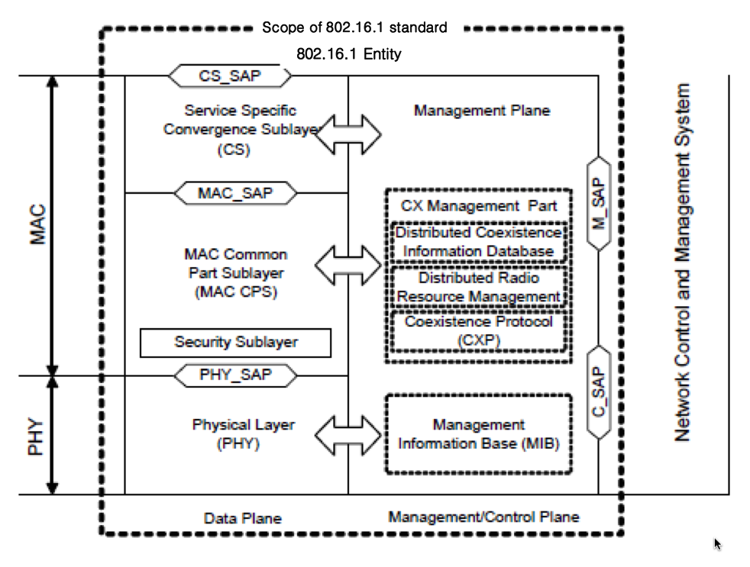

**Figure X—****IEEE 802.16.1 protocol layering, showing service access points (SAPs)**