Project | IEEE 802.16 Broadband Wireless Access Working Group <http://ieee802.org/16>
Title | Small BS State Diagram
Date Submitted | 2014-07-16
Source(s) | Jaesun Cha, Eunkyung Kim, Jae-joon Park, Seungkwon Baek, Sungcheol Chang  ETRI | E-mail: jscha@etri.re.kr  *<http://standards.ieee.org/faqs/affiliationFAQ.html>
Re: | Call for Reply Comments on IEEE 802.16 Working Group Letter Ballot #39
Abstract | This contribution proposes a new state diagram for small BS to clarify the transition among operation states and modes.
Purpose | To discuss and adopt the proposed texts in IEEE P802.16q draft
Notice | This document does not represent the agreed views of the IEEE 802.16 Working Group or any of its subgroups. It represents only the views of the participants listed in the “Source(s)” field above. It is offered as a basis for discussion. It is not binding on the contributor(s), who reserve(s) the right to add, amend or withdraw material contained herein.
Release | The contributor grants a free, irrevocable license to the IEEE to incorporate material contained in this contribution, and any modifications thereof, in the creation of an IEEE Standards publication; to copyright in the IEEE’s name any IEEE Standards publication even though it may include portions of this contribution; and at the IEEE’s sole discretion to permit others to reproduce in whole or in part the resulting IEEE Standards publication. The contributor also acknowledges and accepts that this contribution may be made public by IEEE 802.16.
Patent Policy | The contributor is familiar with the IEEE-SA Patent Policy and Procedures:  <http://standards.ieee.org/guides/bylaws/sect6-7.html#6> and <http://standards.ieee.org/guides/opman/sect6.html#6.3>.  Further information is located at <http://standards.ieee.org/board/pat/pat-material.html> and <http://standards.ieee.org/board/pat>.

Small BS State Diagram
Jaesun Cha, Eunkyung Kim, Jae-joon Park, Seungkwon Baek, Sungcheol Chang
ETRI

Introduction
This contribution proposes a new small BS state diagram to respond with some LB #39 comments that pointed out problems in the current state diagram. Main changes are as follow:
- Addition of reference for service primitives included in the state diagram
- Addition of more detailed information on service primitives in the state diagram
- Clarification of small BS states (Power on/off is not a state)
- Removal of Annex R

Proposed Texts
----------------- Start of the text proposal --------------------------------------------------------------------------------------
[Remedy: Change subclause 17.1.2 as follows:]
An SBS transitions through multiple states during its operation, as illustrated in Figure 17-1. On Power-on, it enters the Initialization State. In this state, procedure such as configuration of radio interface parameters and time/frequency synchronization should be performed. After attachment to the service provider’s core network, which may include synchronization to the Macro BS, it enters the Operational State. In the Operational State, if the SBS becomes unattached to the service providers network or if it fails to meet operational requirements (may include failed synchronization), it reverts to the Initialization State.
In the Operational State, both normal mode and duty-cycle mode are supported. In duty-cycle mode, the SBS reduces radio interface activity in order to reduce interference to neighbor cells. A further functional description of duty-cycle mode of SBS and related service primitives can be found in 17.4.2 and 14.2.12, respectively.
In Standby mode, only standby mode is supported. In standby mode, the SBS deactivates its air interface except backbone network interface to reduce power consumption and interference to neighbor cells. A further functional description of standby mode of SBS and related service primitives can be found in 17.4.3 and 14.2.12, respectively.

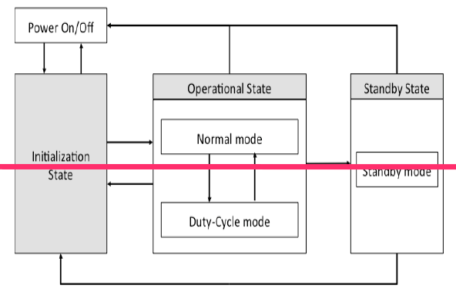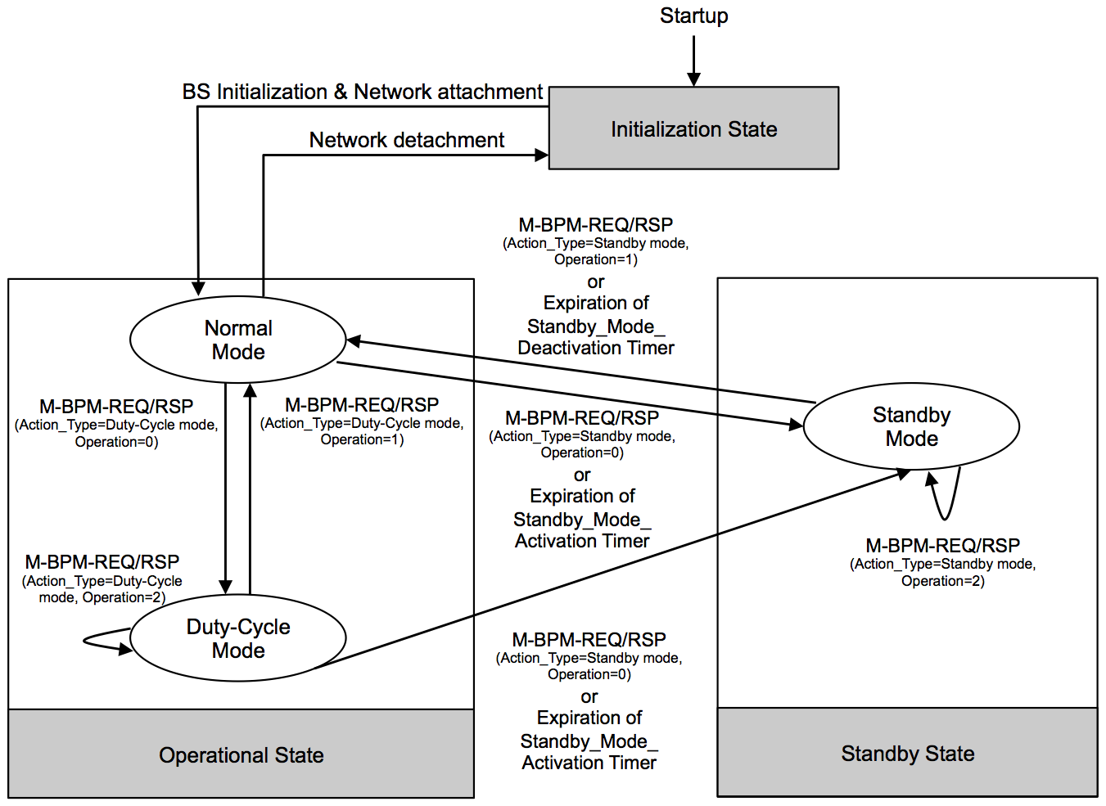
Figure 17-1 – Functional overview of SBS states and operational modes

[Remedy: Remove Annex R]

----------------- End of the text proposal --------------------------------------------------------------------------------------

