Project | IEEE 802.16 Broadband Wireless Access Working Group <http://ieee802.org/16>
Title | Normal mode transition of BS power management
Date Submitted | 2013-07-12
Source(s) | Jisoo Park, Youngjo Bang, Younok Park  ETRI | E-mail: jsp@etri.re.kr  *<http://standards.ieee.org/faqs/affiliationFAQ.html>
Re: | In response to the IEEE 802.16 Working Group Call for Contributions: IEEE Project P802.16q Multi-tier Networks (IEEE 802.16-13-0108-01-000q)
Abstract | The contribution proposes the text changes related to the normal mode transition of the BS power management.
Purpose | To discuss and adopt the proposed texts in IEEE P802.16q AWD
Notice | This document does not represent the agreed views of the IEEE 802.16 Working Group or any of its subgroups. It represents only the views of the participants listed in the “Source(s)” field above. It is offered as a basis for discussion. It is not binding on the contributor(s), who reserve(s) the right to add, amend or withdraw material contained herein.
Release | The contributor grants a free, irrevocable license to the IEEE to incorporate material contained in this contribution, and any modifications thereof, in the creation of an IEEE Standards publication; to copyright in the IEEE’s name any IEEE Standards publication even though it may include portions of this contribution; and at the IEEE’s sole discretion to permit others to reproduce in whole or in part the resulting IEEE Standards publication. The contributor also acknowledges and accepts that this contribution may be made public by IEEE 802.16.
Patent Policy | The contributor is familiar with the IEEE-SA Patent Policy and Procedures:  <http://standards.ieee.org/guides/bylaws/sect6-7.html#6> and <http://standards.ieee.org/guides/opman/sect6.html#6.3>.  Further information is located at <http://standards.ieee.org/board/pat/pat-material.html> and <http://standards.ieee.org/board/pat>.

Normal mode transition of BS power management
Jisoo Park, Youngjo Bang, Younok Park
ETRI

- Introduction
This contribution proposes the text changes to the BS power management defined in draft AWD document [1] in response to the IEEE 802.16 Working Group Call for Contributions on IEEE Project P802.16q Multi-tier Networks (IEEE 802.16-13-0108-01-000q).
The BS power management primitives are specified about a set of primitives for supporting BS power management except normal mode transition between IEEE 802.16 entity (BS) and NCMS. Therefore, this contribution proposes the text changes related to the normal mode transition of BS power management.
- References
- IEEE 802.16-13-0026-01-000q, IEEE P802.16q, Part 16: Air Interface for Broadband Wireless Access Systems: Amendment for Multi-tier Networks, May 21, 2013
- Proposed Texts on IEEE 802.16q AWD

[Added texts and figures marked in blue font with underline and removed texts and figures marked in red font with strikeout]
------------------------------------------- Start of Proposed Text Changes --------------------------------------------
[Remedy #1: Adopt the following modification text in line 33 on page 13 subclause 14.2.12 in draft AWD [1] ]
  - Management and control functions
Insert new subclause 14.2.12 as indicated:
    - BS Power Management
The BS power management primitives are a set of primitives for supporting BS power management between IEEE 802.16 entity (BS) and NCMS. BS power management uses BS power management Services in the NCMS.
…
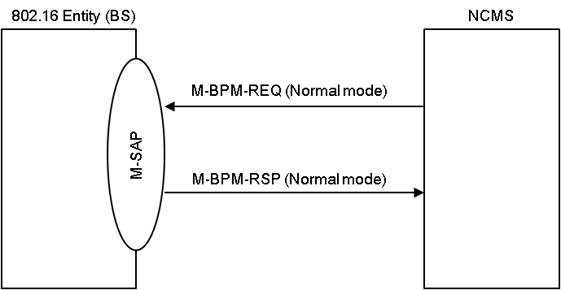
Figure 14.xx Primitive flow for normal mode transition
…
14.2.12.1 M-BPM-REQ
This primitive is used by the NCMS to configure operation parameters required for BS power management operation or request the IEEE 802.16 entity (BS) to change its operation mode. The possible Action_Types for this primitive are listed in table below:
Action_Type | Description
BPM Configuration | Configuration procedure between BS and NCMS for BS power management.
Normal mode | Normal mode transition procedure between BS and NCMS.
Duty-cycled mode | Duty-cycled mode transition procedure between BS and NCMS.
Standby mode | Standby mode transition procedure between BS and NCMS

14.2.12.2 M-BPM-RSP
This primitive is used by the IEEE 802.16 entity (BS) in response to M-BPM-REQ primitive for BS power management. The possible Action_Types for this primitive are listed in table below:
Action_Type | Description
BPM Configuration | Configuration procedure between BS and NCMS for BS power management.
Normal mode | Normal mode transition procedure between BS and NCMS.
Duty-cycled mode | Duty-cycled mode transition procedure between BS and NCMS.
Standby mode | Standby mode transition procedure between BS and NCMS

------------------------------------------- End of Proposed Text Changes --------------------------------------------

