Project | IEEE 802.16 Broadband Wireless Access Working Group <http://ieee802.org/16>
Title | Operation of Standby Mode
Date Submitted | 2013-05-08
Source(s) | Jaesun Cha, Eunkyung Kim, Jae-joon Park, Huyn Lee, Kwangjae Lim, Sungcheol Chang  ETRI | E-mail: jscha@etri.re.kr  *<http://standards.ieee.org/faqs/affiliationFAQ.html>
Re: | Call for Contributions: Multi-tier Networks (16-13-0064-01-000q)
Abstract | This contribution proposes detailed operations of standby mode defined as BS power saving mechanism in IEEE P802.16q
Purpose | To discuss and adopt the proposed texts in IEEE P802.16q AWD
Notice | This document does not represent the agreed views of the IEEE 802.16 Working Group or any of its subgroups. It represents only the views of the participants listed in the “Source(s)” field above. It is offered as a basis for discussion. It is not binding on the contributor(s), who reserve(s) the right to add, amend or withdraw material contained herein.
Release | The contributor grants a free, irrevocable license to the IEEE to incorporate material contained in this contribution, and any modifications thereof, in the creation of an IEEE Standards publication; to copyright in the IEEE’s name any IEEE Standards publication even though it may include portions of this contribution; and at the IEEE’s sole discretion to permit others to reproduce in whole or in part the resulting IEEE Standards publication. The contributor also acknowledges and accepts that this contribution may be made public by IEEE 802.16.
Patent Policy | The contributor is familiar with the IEEE-SA Patent Policy and Procedures:  <http://standards.ieee.org/guides/bylaws/sect6-7.html#6> and <http://standards.ieee.org/guides/opman/sect6.html#6.3>.  Further information is located at <http://standards.ieee.org/board/pat/pat-material.html> and <http://standards.ieee.org/board/pat>.

Operation of Standby Mode
Jaesun Cha, Eunkyung Kim, Jae-joon Park, Huyn Lee, Kwangjae Lim, Sungcheol Chang
ETRI

Introduction
Standby mode has been defined in IEEE P802.16q AWD as one of BS power saving operation mode but detailed operation of the standby mode has not been defined yet. The purpose of this contribution is to provide detailed description on standby mode operation in IEEE 802.16 entities. Service primitives required to support standby mode have been proposed in other contribution (See IEEE 802.16-13-0089-00-000q).

Operation Scenarios
In order to define detailed operation of standby mode, we have considered two operation scenarios for standby mode based on how the standby mode is activated.

Time-based mode transition
During initialization or configuration phase of a BS, a BS power controller may assign a standby mode activation/deactivation time to the BS. The BS power controller is a unit that belongs to the BS power management service in NCMS and it manages the BS power saving operation and defines the standby mode activation/deactivation time based on statistical information on user density, traffic load and interference level according to location and operation hour of the BS.
After configuration, the BS operates in normal mode and enters standby mode at the pre-defined activation time. Afterward the BS in the standby mode goes back to normal mode at the pre-defined deactivation time. The BS conducts such mode transition continuously unless the BS power controller requests to change the value of pre-defined the activation/deactivation time or trigger condition for event-based mode transition described in the next subclause is met.

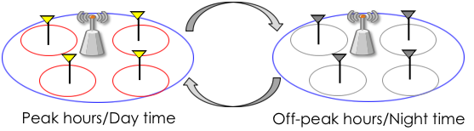
Figure 1 – an example of time-based mode transition

Once trigger condition for time-based mode transition is met, the BS blocks new initial network entry and network reentry from HO and idle mode. If there are active MSs attached to the BS, the BS requests the MSs to perform HO to one of its neighbor BSs. After all MSs attached to the BS are handed over to neighbor BSs, then the BS transits to standby mode, which means the BS deactivates its air interface.
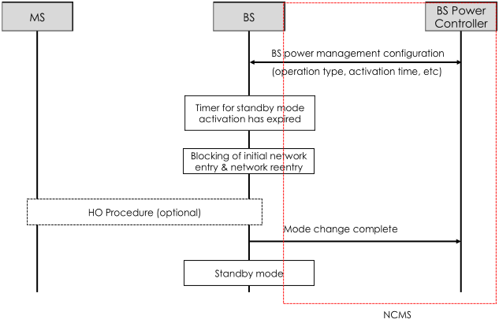
Figure 2 – procedure of time-based mode transition

Dynamic mode transition
In this operation scenario, a BS power controller makes a decision on operation mode of a specific BS whenever a certain event happens. The possible events for deciding operation mode include the followings:
- Traffic load of a BS decreases (Idle time of a BS increases)
- MS deregistration
- Dynamic service flow deletion/change
- HO of a MS attached to the BS
- Increase of interference from a small BS to a macro BS
- Movement of an active MS to cell edge

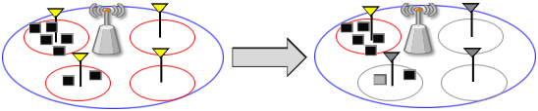
Figure 3 – an example of event-based mode transition

Operation procedure is almost same as one of time-based mode transition. Only difference is that the BS power controller transmits a request for mode transition to a BS when trigger condition is met. The BS responds to the request right after it receives the request and notify the BS power controller of the completion of mode transition after all actions required for mode transition such as blocking and HO are completed.
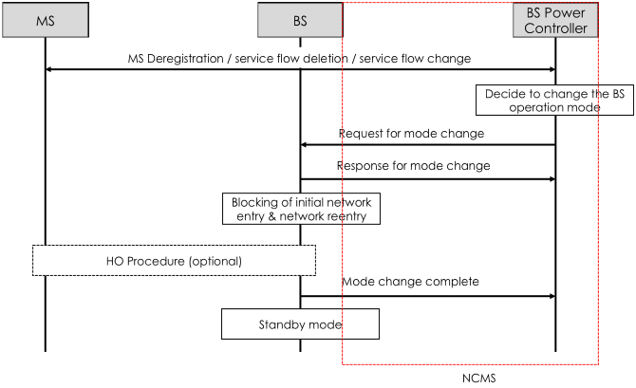
Figure 4 – procedure of time-based mode transition

Editorial Instruction
- Black text: the text is existing in the base standard
- Red text: with strike-through: the texts is removed from the amendment standard
- Blue text without underline:the text is added in the amendment standard without underline
- Blue text with underline: the text is added in the amendment standard and underline shall be added under the added text

Proposed Texts
----------------- Start of the text proposal --------------------------------------------------------------------------------------
[Remedy 1: Insert the following definition on page 13]
3. Definitions
BS power controller: BS power controller is a unit that belongs to the BS power management services in the NCMS.

[Remedy 2: Change section 11 on page 17 as follows:]
11. TLV encodings
11.3 UCD management message encodings
11.3.1 UCD channel encodings

Insert the following parameter at the end of Table 11-15 as indicated:

Table 11-15 – UCD PHY-specific channel encodings – WirelessMAN-OFDMA
Name | Type  (1 byte) | Length | Value
Cell Bar | 225 | 1 | 0: this cell is allowed for network entry or reentry.  1: this cell is not allowed for network entry or reentry

[Remedy 3: Change subclause 17.4 on page 22 as follows:]
17.4 BS power management
17.4.1 General Description
This subclause describes the power management functions of base stations for energy efficient operation. The power management function under this subclause details not only operation of single base station but also cooperative operations of adjacent base stations.
Base stations including macro and small base stations always operate in Normal mode when the base station power management is not supported at the base stations.
Base stations supporting the base station power management in this subclause can operate in one of the power saving operation modes such as Duty-cycled mode or Standby mode when the operation condition is met.

17.4.2 Duty-cycled Mode
Duty-cycled mode is one of power saving operation mode in which a base station changes its operation state between active period and inactive period. A base station in the inactive period does not transmit/receive data to/from its subordinate mobile stations. A base station may enter Duty-cycled mode when the base station has small number of subordinate mobile stations and small traffic demands from the mobile stations.
The base station in the Duty-cycled mode goes into the inactive period when all of its associated mobile stations are in unavailability interval. The inactive period of the base station shall be informed to the mobile stations to prevent UL attempts of mobile stations during inactive period of the base station.
To increase the inactive period of the base station (i.e. a common unavailability interval of mobile stations), base station may adjust the configurations of Sleep mode (i.e. start frame number, window sizes, etc.) of associated mobile stations.

17.4.3 Standby Mode
Standby mode is an another power saving operation mode in which a base station deactives its air interface to conserve energy consumption. A base station may enter Standby mode when the base station has no subordinate mobile stations.
Base stations in Standby mode wake up (i.e. change its operation mode into the Normal mode) when predefined inactive period timer expires or the network requests changes of state of the base station.
Besides the normal mode and duty-cycled mode, a BS may support standby mode to reduce power consumption and interference to neighbor cell. The BS may enter standby mode if there are no MSs attached to the BS or a small number of MSs are attached to the BS. If the BS enters standby mode, it deactivates its air interface to conserve energy consumption but keep its network interface active to exchange control information with neighbor BSs or network entities.

17.4.3.1 Standby mode initiation
A BS that supports standby mode shall receive configuration information of standby mode from a BS power controller before operating in normal mode. If a time-based transition included in the configuration information is set to 1, the BS shall initiate and terminate the standby mode based on activation and deactivation time included in the configuration information. If an event-based transition included in the configuration information is set to 1, the BS shall initiate and terminate the standby mode based on a request from the BS power controller. A BS may support the time-based transition and event-based transition simultaneously.
If the time-based transition is enabled, the BS power controller shall assign activation and deactivation time of the standby mode to the BS. The activation and deactivation time for the BS is determined based on statistical information on user density, traffic load, interference to/from neighbor cells, etc. Algorithms or policies for determining activation/deactivation time of the standby mode are out of scope of this standard.
If the time-based mode transition is enabled and activation and deactivation time of standby mode is specified during configuration phase, the BS shall activate Standby_Mode_Activation timer with the assigned activation time as soon as it starts normal operation. If only event-based transition is enabled, the BS stays in normal mode until it receives a request from the BS power controller to transit to standby mode.
The BS in normal mode shall disable the air interface to its subordinated MSs if the Standby_Mode_Activation timer is expired or it receives a request from a BS power controller. Before disabling the air interface, the BS shall set the cell bar TLV in UCD message to 1 to prevent MS (re)entry and may perform BS-initiated HO procedure as defined in 6.3.20 to hand over active MSs attached to the BS to neighbor BSs. If HO procedures for all MSs attached to the BS are completed, the BS shall disable the air interface and notify the BS power controller of the completion of the mode transition from normal mode to standby mode. If the mode transition is triggered by the expiration of Standby_Mode_Activation timer, the BS shall activate Standby_Mode_Deactivation timer with the deactivation time assigned by the BS power controller during configuration phase as soon as it enters the standby mode.
During standby mode, the air interface of the BS is disabled and the BS does not perform any PHY/MAC operation. But, the BS shall not disable a network interface with neighbor BSs or network entities to perform management operation.

17.4.3.2 Standby mode termination
A BS in standby mode shall go back to normal mode if Standby_Mode_Deactivation tiemr is expired or it receives a transition request from the BS power controller. The BS shall initialize and activate the air interface before going back to normal mode. The details of the BS initialization procedure including scanning, synchronization and obtaining configuration parameters for the BS air interface operation through the backhaul connection is [TBD]. The BS shall activate Standby_Mode_Activation timer if time-based transition is enabled.

17.4.4 Cooperation of Base Stations for Power Management
The base stations cooperate with other adjacent base stations and/or NCMS (Network Control and Management System) to increase the power saving performance and to prevent the performance degradation (e.g. throughput decreases and coverage holes) due to the power saving operation of base stations.
----------------- Start of the text proposal --------------------------------------------------------------------------------------

